**-----------------------------**

**S**tandard **O**perating **P**rocedure

for

‘*Creating A Ticket to Establish a VPN Connection to work from home’*

**-----------------------------**

**PURPOSE**

This document is a standardized procedure for the creation of a ticket to request a VPN connection for remote work. A secure VPN connection ensures data privacy in addition to preventing intrusions and leaks of confidential data.

**APPROVAL TABLE**

|  |  |  |  |
| --- | --- | --- | --- |
| **Version** | **Date** | **Name** | **Designation** |
| **1.0** | *24-02-13* | Gabriel Linski ([G_Linski@hotmail.com](mailto:G_Linski@hotmail.com))  Navjot Kaur ([chohan.navjot@mitt.ca](mailto:chohan.navjot@mitt.ca)) | Author |
| **1.1** | *24-02-17* | Jashanpreet Kaur ([kaur.jashanpreet@mitt.ca](mailto:kaur.jashanpreet@mitt.ca))  Dupanshu ([dupansh.15@mitt.ca](mailto:dupansh.15@mitt.ca))  Md Fahim ([md.fahim@mitt.ca](mailto:md.fahim@mitt.ca)) | Reviewer |
| **1.2** | *24-02-20* | Justin Ducharme ([justin.ducharme@mitt.ca](mailto:justin.ducharme@mitt.ca)) | Approver |

**SCOPE AND OBJECTIVES**

The document outlines a simple and understandable approach to the creation of a ticket for establishing a VPN connection to work from home. It includes detailed steps for:

1. Logging into Ticket Creation Platform (Freshdesk, in this case)
2. Creating and Submitting the Ticket
3. Confirmation and Tracking
4. Agent Follow-Up
5. Ticket Resolution and Closure

In addition, the steps to set up a VPN connection after the company addresses the ticket are also provided in this document.

**RACI CHART**

|  |  |  |  |  |  |
| --- | --- | --- | --- | --- | --- |
|  | **IT Support Desk**  *Jake Sisko* | **Tech Storeroom Manager**  *Kira Nerys* | **IT Support** | **IT Supervisor** | **IT Senior Manager**  *Miles O’Brien* |
| **Ticket Creation** | R |  | IC | I | I |
| **Company Issued Device** | AI | R | I | I | I |
| **VPN Credentials** | AI | I | RI | C | I |
| **Connection Establishment** |  |  | R | AC |  |
| **Connection Testing** |  |  | R | AC |  |

R = Responsible, A = Accountable, C = Consulted, I =Informed

**People**

* IT Help Desk: Janice Smith
* System Admin: Mark Pullman

**PREREQUISITES:**

* *Access to Freshdesk*: Either through a company account or as an authorized user.
* *VPN Service Information*: Including the VPN server address, VPN protocol (e.g., OpenVPN, IKEv2, etc.), and any required authentication credentials (username, password, certificate, etc.)
* *Network Connectivity*: A stable internet connection to access Freshdesk and download necessary VPN configuration files or software.
* *Device Information*: Details about the device(s) intended to be used for remote work, such as the operating system (Windows, macOS, Linux, etc.) and device specifications (if relevant).
* *Knowledge of VPN Setup*: Basic understanding of how to set up a VPN connection on the local device. The company’s IT department or support team can also assist with this.

**EXECUTION STEPS**

***Steps for Ticket Creation***

1. **Login to Freshdesk**:

* Open your web browser and navigate to the Freshdesk login page.
* Enter your credentials (username and password) to access your Freshdesk dashboard.

1. **Navigate to Tickets**:

* Once logged in, you'll land on your Freshdesk dashboard.
* Locate and click on the "*Tickets*" tab in the top navigation bar. This will take you to the ticket management interface.

1. **Create New Ticket**:

* Within the Tickets interface, look for the "*New Ticket*" button or link and click on it.

1. **Enter Ticket Details**:

* *Subject*: Provide a clear and concise subject for the ticket. For example, "Request to Establish VPN Connection for Remote Work".
* *Description*: In the description field, specify the reason for needing the VPN connection for remote work. Include details such as the purpose of the VPN, any specific configurations required, and any deadlines or urgency.
* *Priority*: Select an appropriate priority level for the ticket based on the urgency of the request.
* *Category*: Choose the relevant category or department for the ticket. This might be IT Support, Network Services, or similar.
* *Attachments* (optional): If there are any documents or screenshots that can help clarify the request, attach them to the ticket.

1. **Assign Agent**:

* Assign the ticket to the appropriate agent or group responsible for handling VPN-related requests. If there's a specific IT support team or individual who manages VPN setups, assign the ticket to them.

1. **Submit Ticket**:

* Once all necessary details are filled in, review the information to ensure accuracy.
* Click the "Submit" or "Create Ticket" button to submit the ticket.

1. **Confirmation and Tracking**:

* After submitting the ticket, you'll receive a confirmation message indicating that the ticket has been successfully created.
* Track the status of the ticket from your Freshdesk dashboard.

1. **Agent Follow-Up**:

* The assigned support agent or team responsible for VPN setups will review the ticket.
* They may reach out to you for further clarification or updates if needed.

1. **Resolution and Closure**:

* Once the VPN connection is successfully established, the support agent will update the ticket with details of the resolution.
* You'll be notified of the completion, and the ticket will be marked as resolved or closed.

***Steps for Establishing a VPN Connection***

1. From your company-issued device, click the ‘*Windows Start Menu*’ in the lower left and select the ‘**Control Panel**’:

1. In the control panel settings, select ‘**Network & Internet’**:

1. On the left-hand side, click **VPN**.

1. Click ‘Add a VPN connection’.

1. In the ‘Add a VPN connection screen’, you will be required to fill out the form according to the company's VPN configuration standards. A username and a temporary password will be provided. The user will need to change the password after the initial connection login.

1. Connect to the VPN using the preceding credentials.

**SAMPLE TICKET**

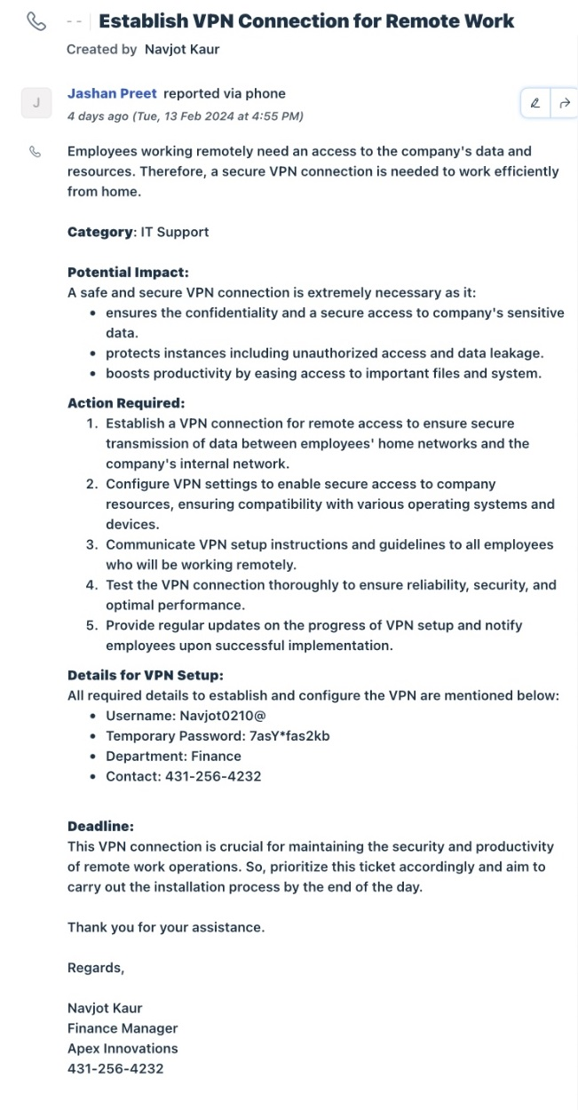

**REVISION HISTORY**

|  |  |  |  |
| --- | --- | --- | --- |
| **Version** | **Date** | **Changes Made By** | **Summary of Changes** |
| **1.0** | *24-02-13* | *Gabriel Linski* | *Initial Release of Document* |
| **1.1** | *24-02-16* | *Navjot Kaur* | *Added steps for creating the ticket* |
| **1.2** | *24-02-18* | *Gabriel Linski* | *Minor edits.* |