--QUESTION1--

--CREATE DATABASE--

CREATE DATABASE ADC;

--CREATE TABLES--

CREATE TABLE Customers (

cust_id VARCHAR2(20) PRIMARY KEY,

cust_fname VARCHAR2(50) NOT NULL,

cust_sname VARCHAR2(50) NOT NULL,

cust_address VARCHAR2(100) NOT NULL,

cust_contact VARCHAR2(20) NOT NULL

);

CREATE TABLE Dive (

dive_id NUMBER PRIMARY KEY,

dive_name VARCHAR2(50) NOT NULL,

dive_duration VARCHAR2(50) NOT NULL,

dive_location VARCHAR2(50) NOT NULL,

dive_exp_level NUMBER NOT NULL,

dive_cost NUMBER NOT NULL

);

CREATE TABLE Instructors (

ins_id NUMBER PRIMARY KEY,

ins_fname VARCHAR2(50) NOT NULL,

ins_sname VARCHAR2(50) NOT NULL,

ins_contact VARCHAR2(20) NOT NULL,

ins_level NUMBER NOT NULL

);

CREATE TABLE DiveEvent (

dive_event_id VARCHAR2(10) PRIMARY KEY,

dive_date DATE NOT NULL,

dive_participants NUMBER NOT NULL CHECK (dive_participants > 0 AND dive_participants <= 20),

dive_id NUMBER NOT NULL,

cust_id VARCHAR2(20) NOT NULL,

ins_id NUMBER NOT NULL,

FOREIGN KEY (dive_id) REFERENCES Dive(dive_id),

FOREIGN KEY (cust_id) REFERENCES Customers(cust_id),

FOREIGN KEY (ins_id) REFERENCES Instructors(ins_id)

);

--INSERT INTO TABLES--

--Insert into Instructors table

INSERT ALL

INTO Instructors (ins_ID, ins_fname, ins_sname, ins_contact, ins_level) VALUES (101, 'James', 'Willis', '0843569851', 7)

INTO Instructors (ins_ID, ins_fname, ins_sname, ins_contact, ins_level) VALUES (102, 'Sam', 'Wait', '0763698521', 2)

INTO Instructors (ins_ID, ins_fname, ins_sname, ins_contact, ins_level) VALUES (103, 'Sally', 'Gumede', '0786598521', 8)

INTO Instructors (ins_ID, ins_fname, ins_sname, ins_contact, ins_level) VALUES (104, 'Bob', 'Du Preez', '0796369857', 3)

INTO Instructors (ins_ID, ins_fname, ins_sname, ins_contact, ins_level) VALUES (105, 'Simon', 'Jones', '0826598741', 9)

SELECT * FROM dual;

-- Insert into Customers table

INSERT ALL

INTO Customers (cust_id, cust_fname, cust_sname, cust_address, cust_contact) VALUES ('C115', 'Heinrich', 'Willis', '3 Main Road', '0821253659')

INTO Customers (cust_id, cust_fname, cust_sname, cust_address, cust_contact) VALUES ('C116', 'David', 'Watson', '13 Cape Road', '0769658547')

INTO Customers (cust_id, cust_fname, cust_sname, cust_address, cust_contact) VALUES ('C117', 'Waldo', 'Smith', '3 Mountain Road', '0863256574')

INTO Customers (cust_id, cust_fname, cust_sname, cust_address, cust_contact) VALUES ('C118', 'Alex', 'Hanson', '8 Circle Road', '0762356587')

INTO Customers (cust_id, cust_fname, cust_sname, cust_address, cust_contact) VALUES ('C119', 'Kuhle', 'Bitterhout', '15 Main Road', '0821235258')

INTO Customers (cust_id, cust_fname, cust_sname, cust_address, cust_contact) VALUES ('C120', 'Thando', 'Zolani', '88 Summer Road', '0847541254')

INTO Customers (cust_id, cust_fname, cust_sname, cust_address, cust_contact) VALUES ('C121', 'Philip', 'Jackson', '3 Long Road', '0745556658')

INTO Customers (cust_id, cust_fname, cust_sname, cust_address, cust_contact) VALUES ('C122', 'Sarah', 'Jones', '7 Sea Road', '0814745745')

INTO Customers (cust_id, cust_fname, cust_sname, cust_address, cust_contact) VALUES ('C123', 'Catherine', 'Howard', '31 Lake Side Road', '0822232521')

SELECT * FROM dual;

-- Insert into Dive table

INSERT INTO Dive (DIVE_ID, DIVE_NAME, DIVE_DURATION, DIVE_LOCATION, DIVE_EXP_LEVEL, DIVE_COST) VALUES (550, 'Shark Dive', '3 hours', 'Shark Point', 8, 500);

INSERT INTO Dive (DIVE_ID, DIVE_NAME, DIVE_DURATION, DIVE_LOCATION, DIVE_EXP_LEVEL, DIVE_COST) VALUES (551, 'Coral Dive', '1 hour', 'Break Point', 7, 300);

INSERT INTO Dive (DIVE_ID, DIVE_NAME, DIVE_DURATION, DIVE_LOCATION, DIVE_EXP_LEVEL, DIVE_COST) VALUES (552, 'Wave', '2 hours', 'Ship wreck ally', 3, 800);

INSERT INTO Dive (DIVE_ID, DIVE_NAME, DIVE_DURATION, DIVE_LOCATION, DIVE_EXP_LEVEL, DIVE_COST) VALUES (553, 'Underwater Exploration', '1 hour', 'Coral ally', 2, 250);

INSERT INTO Dive (DIVE_ID, DIVE_NAME, DIVE_DURATION, DIVE_LOCATION, DIVE_EXP_LEVEL, DIVE_COST) VALUES (554, 'Underwater Adventure', '3 hours', 'Sandy Beach', 3, 750);

INSERT INTO Dive (DIVE_ID, DIVE_NAME, DIVE_DURATION, DIVE_LOCATION, DIVE_EXP_LEVEL, DIVE_COST) VALUES (555, 'Deep Blue Ocean', '30 minutes', 'Lazy Waves', 2, 120);

INSERT INTO Dive (DIVE_ID, DIVE_NAME, DIVE_DURATION, DIVE_LOCATION, DIVE_EXP_LEVEL, DIVE_COST) VALUES (556, 'Rough Seas', '1 hour', 'Pipe', 9, 700);

INSERT INTO Dive (DIVE_ID, DIVE_NAME, DIVE_DURATION, DIVE_LOCATION, DIVE_EXP_LEVEL, DIVE_COST) VALUES (557, 'White Water', '2 hours', 'Drifts', 5, 200);

INSERT INTO Dive (DIVE_ID, DIVE_NAME, DIVE_DURATION, DIVE_LOCATION, DIVE_EXP_LEVEL, DIVE_COST) VALUES (558, 'Current Adventure', '2 hours', 'Rock Lands', 3, 150);

SELECT * FROM dual;

-- Insert into DiveEvents table

INSERT ALL

INTO DiveEvents (dive_event_id, dive_date, dive_participants, ins_ID, cust_id, dive_ID) VALUES ('de_101', TO_DATE('15-Jul-17', 'DD-Mon-YY'), 5, 103, 'C115', '558')

INTO DiveEvents (dive_event_id, dive_date, dive_participants, ins_ID, cust_id, dive_ID) VALUES ('de_102', TO_DATE('16-Jul-17', 'DD-Mon-YY'), 7, 102, 'C117', '555')

INTO DiveEvents (dive_event_id, dive_date, dive_participants, ins_ID, cust_id, dive_ID) VALUES ('de_103', TO_DATE('18-Jul-17', 'DD-Mon-YY'), 8, 104, 'C118', '552')

INTO DiveEvents (dive_event_id, dive_date, dive_participants, ins_ID, cust_id, dive_ID) VALUES ('de_104', TO_DATE('19-Jul-17', 'DD-Mon-YY'), 3, 101, 'C119', '551')

INTO DiveEvents (dive_event_id, dive_date, dive_participants, ins_ID, cust_id, dive_ID) VALUES ('de_105', TO_DATE('21-Jul-17', 'DD-Mon-YY'), 5, 104, 'C121', '558')

INTO DiveEvents (dive_event_id, dive_date, dive_participants, ins_ID, cust_id, dive_ID) VALUES ('de_106', TO_DATE('22-Jul-17', 'DD-Mon-YY'), 8, 105, 'C120', '556')

INTO DiveEvents (dive_event_id, dive_date, dive_participants, ins_ID, cust_id, dive_ID) VALUES ('de_107', TO_DATE('25-Jul-17', 'DD-Mon-YY'), 10, 105, 'C115', '554')

INTO DiveEvents (dive_event_id, dive_date, dive_participants, ins_ID, cust_id, dive_ID) VALUES ('de_108', TO_DATE('27-Jul-17', 'DD-Mon-YY'), 5, 101, 'C122', '552')

INTO DiveEvents (dive_event_id, dive_date, dive_participants, ins_ID, cust_id, dive_ID) VALUES ('de_109', TO_DATE('28-Jul-17', 'DD-Mon-YY'), 3, 102, 'C123', '553')

SELECT * FROM dual;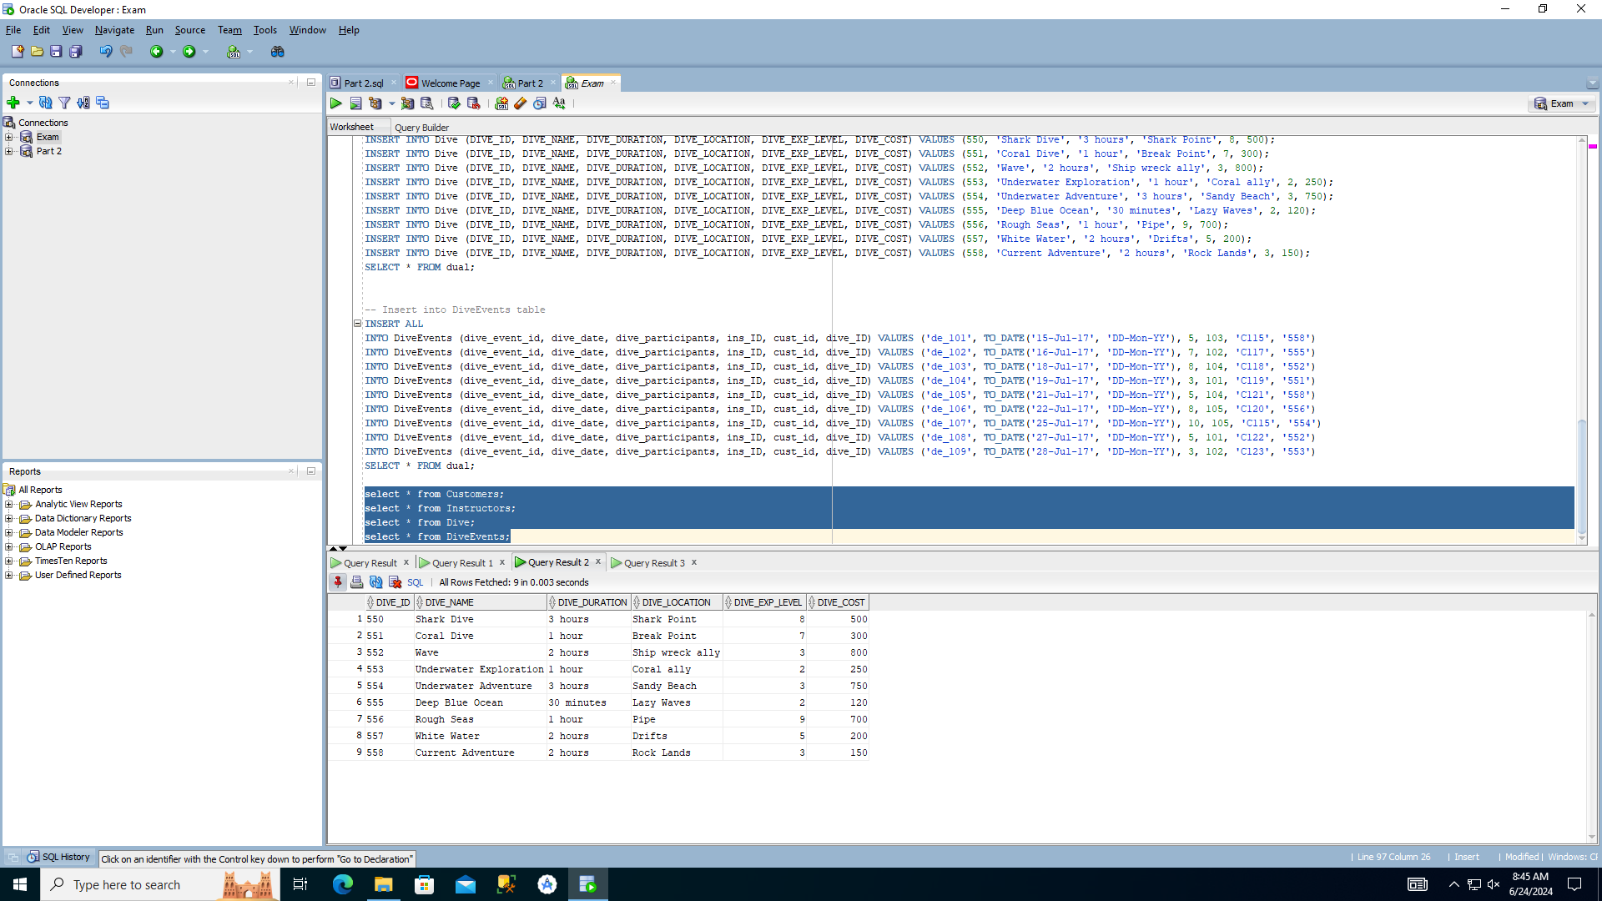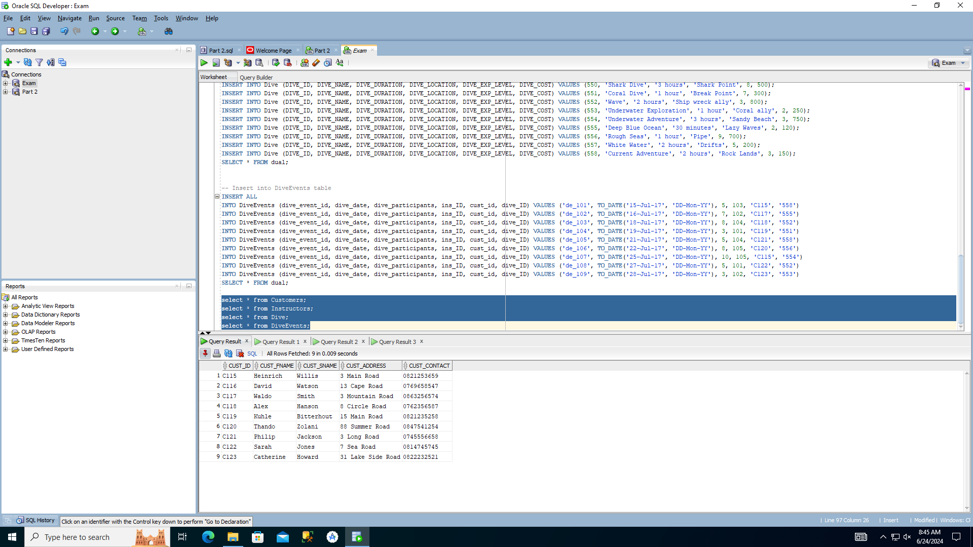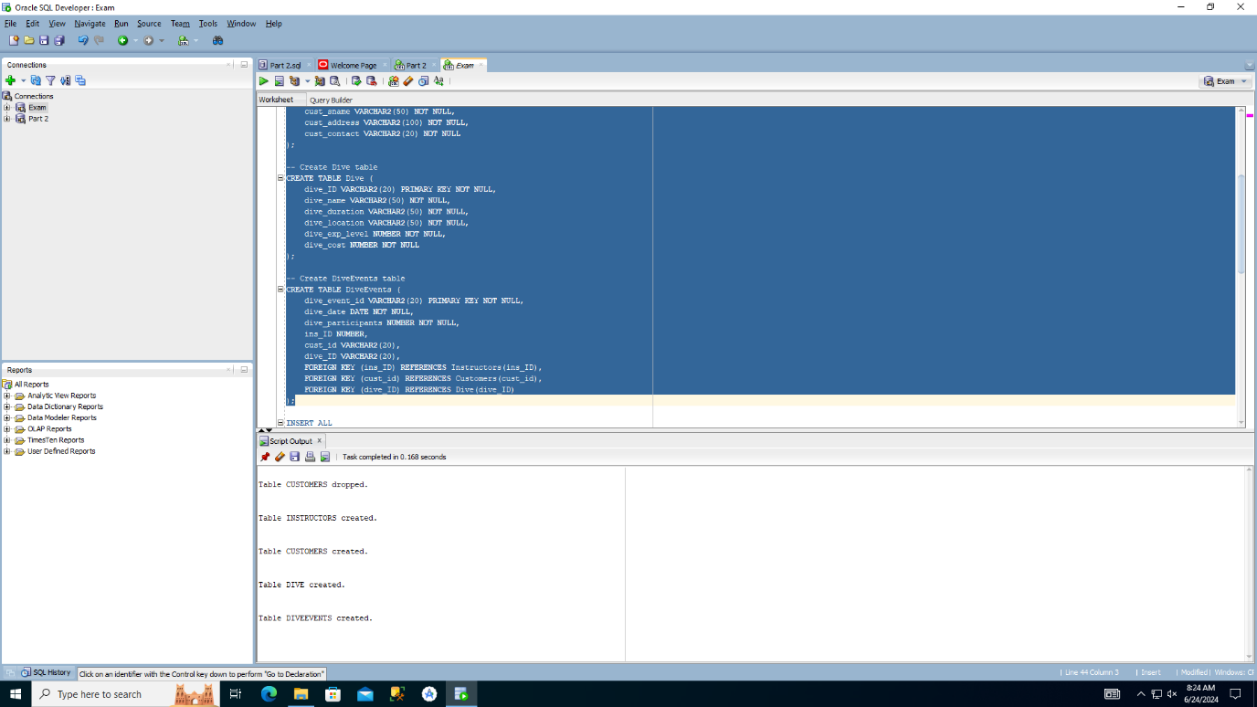

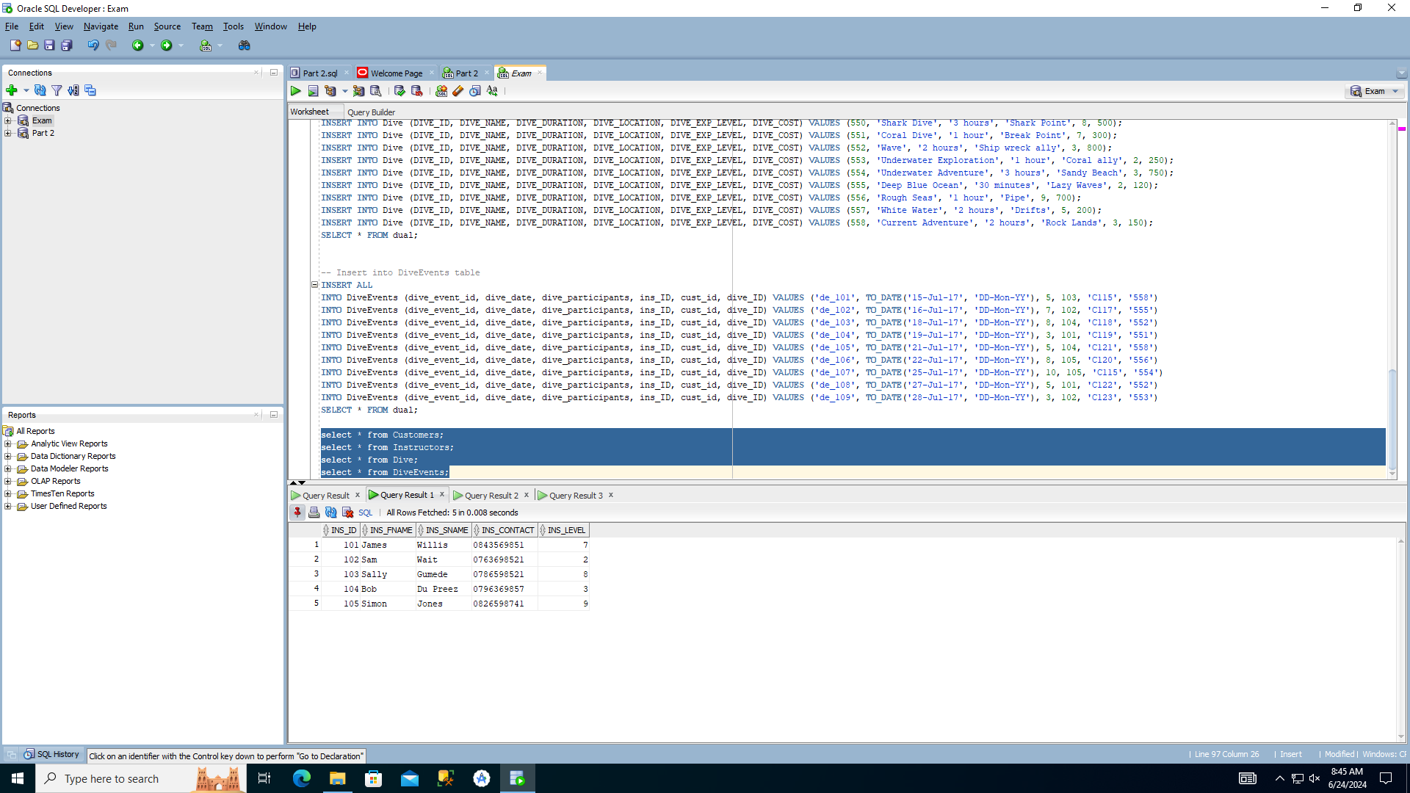

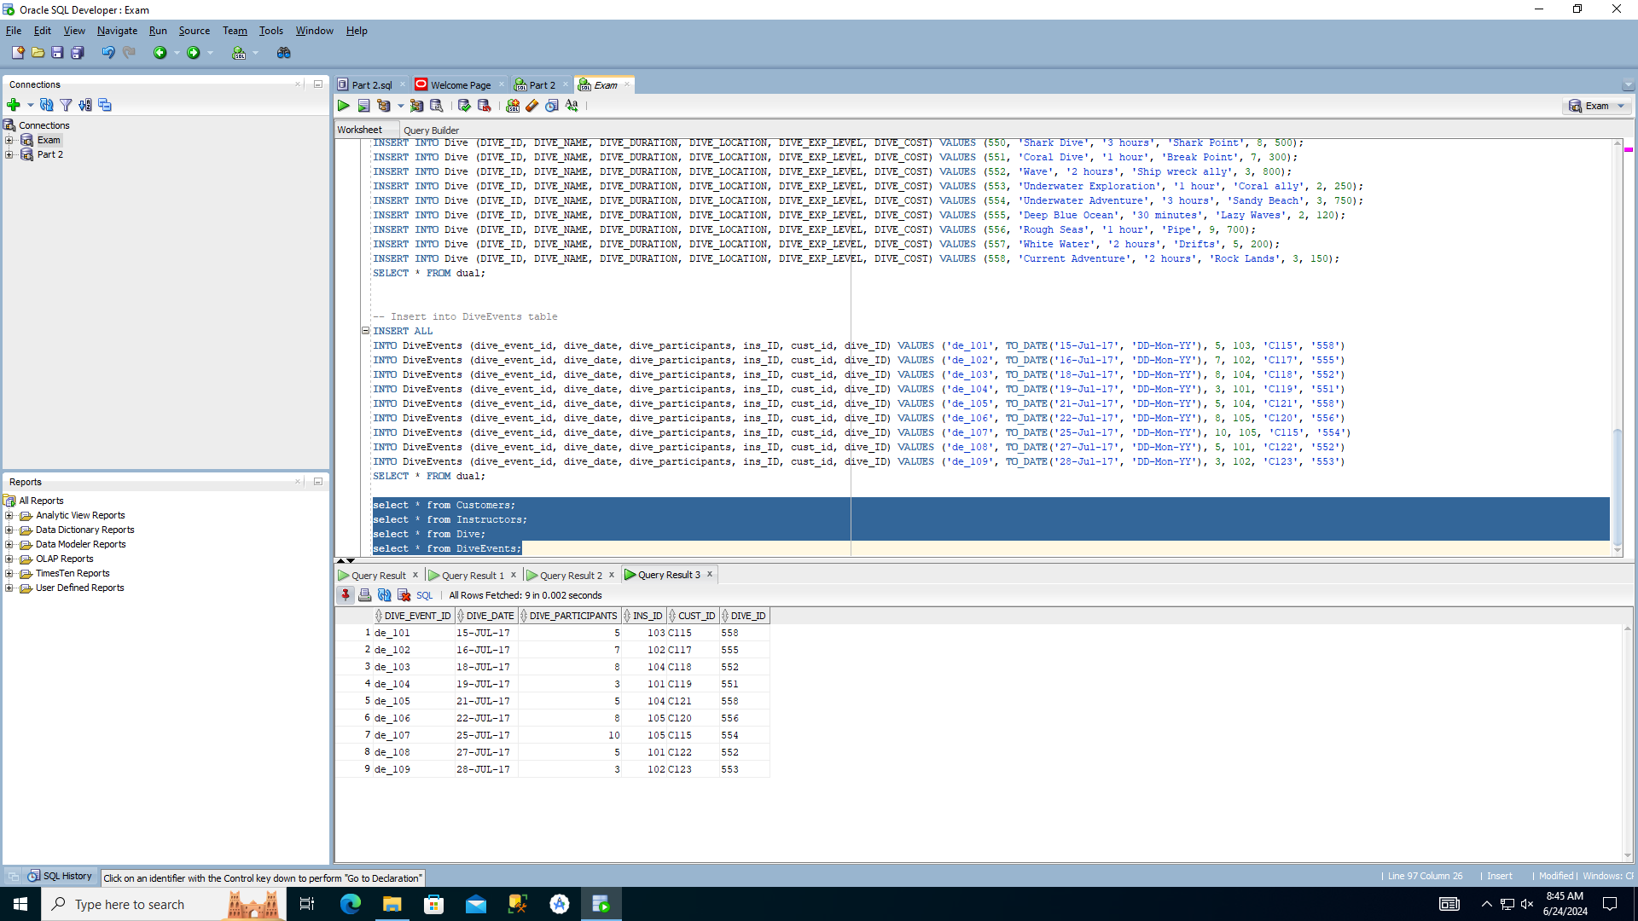

select * from Customers;

select * from Instructors;

select * from Dive;

select * from DiveEvents;

--ENTITY RELATIONSHIP DIAGRAM—

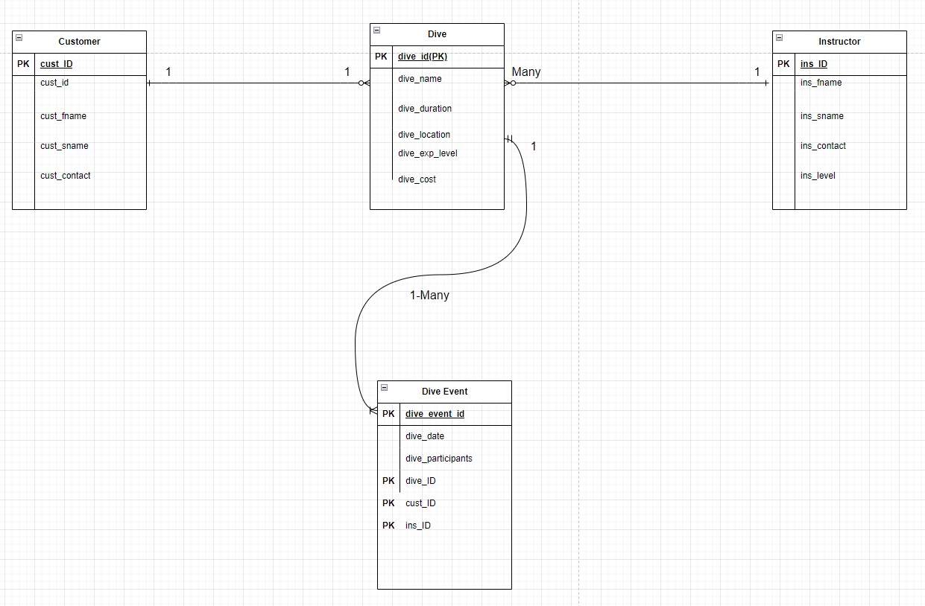

--QUESTION 2—

-- Creating the admin role with elevated privileges

CREATE ROLE admin_role;

-- Creating the general user role with limited privileges

CREATE ROLE general_user_role;

-- Granting privileges to admin_role

GRANT CREATE SESSION TO admin_role;

GRANT SELECT, INSERT, UPDATE, DELETE ON Dive TO admin_role;

GRANT SELECT, INSERT, UPDATE, DELETE ON Customers TO admin_role;

GRANT SELECT, INSERT, UPDATE, DELETE ON Instructors TO admin_role;

GRANT SELECT, INSERT, UPDATE, DELETE ON DiveEvent TO admin_role;

GRANT CREATE, ALTER, DROP TABLE TO admin_role;

GRANT CREATE USER, DROP USER, GRANT ANY PRIVILEGE, REVOKE ANY PRIVILEGE TO admin_role;

-- Granting privileges to general_user_role

GRANT CREATE SESSION TO general_user_role;

GRANT SELECT, INSERT, UPDATE, DELETE ON Dive TO general_user_role;

GRANT SELECT, INSERT, UPDATE, DELETE ON Customers TO general_user_role;

GRANT SELECT, INSERT, UPDATE, DELETE ON Instructors TO general_user_role;

GRANT SELECT, INSERT, UPDATE, DELETE ON DiveEvent TO general_user_role;

-- Creating the admin user and assigning the admin role

CREATE USER admin_user IDENTIFIED BY password;

GRANT admin_role TO admin_user;

-- Creating the general user and assigning the general user role

CREATE USER general_user IDENTIFIED BY password;

GRANT general_user_role TO general_user;

-- Enable server output to display the result

SET SERVEROUTPUT ON;

-- Connect as admin_user

CONNECT admin_user/password;

-- Verify privileges

SELECT * FROM Dive;

INSERT INTO Dive (DIVE_ID, DIVE_NAME, DIVE_DURATION, DIVE_LOCATION, DIVE_EXP_LEVEL, DIVE_COST) VALUES (559, 'New Dive', '2 hours', 'New Location', 4, 400);

CREATE TABLE TestTable (id NUMBER);

-- Connect as general_user

CONNECT general_user/password;

-- Verify privileges

SELECT * FROM Dive;

INSERT INTO Dive (DIVE_ID, DIVE_NAME, DIVE_DURATION, DIVE_LOCATION, DIVE_EXP_LEVEL, DIVE_COST) VALUES (560, 'Another Dive', '1 hour', 'Another Location', 3, 300);

-- The following should fail

CREATE TABLE AnotherTestTable (id NUMBER);

--QUESTION 3—

SELECT

i.ins_fname || ' ' || i.ins_sname AS instructor_name,

c.cust_fname || ' ' || c.cust_sname AS customer_name,

d.dive_location,

de.dive_participants

FROM

DiveEvent de

JOIN Instructors i ON de.ins_ID = i.ins_ID

JOIN Customers c ON de.cust_id = c.cust_id

JOIN Dive d ON de.dive_ID = d.DIVE_ID

WHERE

de.dive_participants BETWEEN 8 AND 10;

--QUESTION 4—

SET SERVEROUTPUT ON;

DECLARE

-- Declare a cursor to select dive name and dive date for dive events with 10 or more participants

CURSOR dive_event_cursor IS

SELECT d.dive_name, de.dive_date

FROM DiveEvent de

JOIN Dive d ON de.dive_ID = d.DIVE_ID

WHERE de.dive_participants >= 10;

-- Variables to hold the fetched data

v_dive_name Dive.DIVE_NAME%TYPE;

v_dive_date DiveEvent.dive_date%TYPE;

BEGIN

-- Open the cursor

OPEN dive_event_cursor;

-- Loop through the cursor and fetch each row

LOOP

FETCH dive_event_cursor INTO v_dive_name, v_dive_date;

-- Exit the loop when no more rows are found

EXIT WHEN dive_event_cursor%NOTFOUND;

-- Display the dive name and dive date

DBMS_OUTPUT.PUT_LINE('Dive Name: ' || v_dive_name || ', Dive Date: ' || TO_CHAR(v_dive_date, 'DD-Mon-YYYY'));

END LOOP;

-- Close the cursor

CLOSE dive_event_cursor;

END;

/

--QUESTION 5—

SET SERVEROUTPUT ON;

DECLARE

CURSOR dive_cursor IS

SELECT c.cust_fname || ' ' || c.cust_sname AS customer_name,

d.dive_name,

de.dive_participants,

CEIL(de.dive_participants / 5) AS instructors_required

FROM DiveEvent de

JOIN Dive d ON de.dive_ID = d.DIVE_ID

JOIN Customers c ON de.cust_id = c.cust_id

WHERE d.dive_cost > 500;

v_customer_name VARCHAR2(100);

v_dive_name VARCHAR2(100);

v_dive_participants NUMBER;

v_instructors_required NUMBER;

BEGIN

OPEN dive_cursor;

DBMS_OUTPUT.PUT_LINE('Customer Name | Dive Name | Participants | Status');

DBMS_OUTPUT.PUT_LINE('-------------------------------------------------------------');

LOOP

FETCH dive_cursor INTO v_customer_name, v_dive_name, v_dive_participants, v_instructors_required;

EXIT WHEN dive_cursor%NOTFOUND;

DBMS_OUTPUT.PUT_LINE(v_customer_name || ' | ' || v_dive_name || ' | ' || v_dive_participants || ' | ' || v_instructors_required);

END LOOP;

IF dive_cursor%ROWCOUNT = 0 THEN

DBMS_OUTPUT.PUT_LINE('No records found.');

END IF;

IF dive_cursor%ISOPEN THEN

CLOSE dive_cursor;

END IF;

END;

/

--QUESTION 6—

CREATE VIEW Vw_Dive_Event AS

SELECT

de.ins_ID,

c.cust_address,

d.dive_duration

FROM

DiveEvent de

JOIN Customers c ON de.cust_id = c.cust_id

JOIN Dive d ON de.dive_ID = d.DIVE_ID

WHERE

de.dive_date < TO_DATE('19-Jul-2017', 'DD-Mon-YYYY');

SELECT * FROM Vw_Dive_Event;

--QUESTION 7—

CREATE OR REPLACE TRIGGER New_Dive_Event

BEFORE INSERT OR UPDATE ON DiveEvent

FOR EACH ROW

BEGIN

IF :NEW.dive_participants <= 0 OR :NEW.dive_participants > 20 THEN

RAISE_APPLICATION_ERROR(-20001, 'Number of participants must be between 1 and 20.');

END IF;

END;

/

-- Test case: Insert with 0 participants (should fail)

BEGIN

INSERT INTO DiveEvent (dive_event_id, dive_date, dive_participants, ins_ID, cust_id, dive_ID)

VALUES ('de_110', TO_DATE('30-Jul-17', 'DD-Mon-YY'), 0, '101', 'C115', 558);

EXCEPTION

WHEN OTHERS THEN

DBMS_OUTPUT.PUT_LINE(SQLERRM);

END;

/

-- Test case: Insert with 21 participants (should fail)

BEGIN

INSERT INTO DiveEvent (dive_event_id, dive_date, dive_participants, ins_ID, cust_id, dive_ID)

VALUES ('de_111', TO_DATE('31-Jul-17', 'DD-Mon-YY'), 21, '102', 'C116', 555);

EXCEPTION

WHEN OTHERS THEN

DBMS_OUTPUT.PUT_LINE(SQLERRM);

END;

/

-- Test case: Insert with 5 participants (should succeed)

BEGIN

INSERT INTO DiveEvent (dive_event_id, dive_date, dive_participants, ins_ID, cust_id, dive_ID)

VALUES ('de_112', TO_DATE('01-Aug-17', 'DD-Mon-YY'), 5, '103', 'C117', 554);

EXCEPTION

WHEN OTHERS THEN

DBMS_OUTPUT.PUT_LINE(SQLERRM);

END;

/

-- Test case: Update to 0 participants (should fail)

BEGIN

UPDATE DiveEvent

SET dive_participants = 0

WHERE dive_event_id = 'de_112';

EXCEPTION

WHEN OTHERS THEN

DBMS_OUTPUT.PUT_LINE(SQLERRM);

END;

/

-- Test case: Update to 15 participants (should succeed)

BEGIN

UPDATE DiveEvent

SET dive_participants = 15

WHERE dive_event_id = 'de_112';

EXCEPTION

WHEN OTHERS THEN

DBMS_OUTPUT.PUT_LINE(SQLERRM);

END;

/

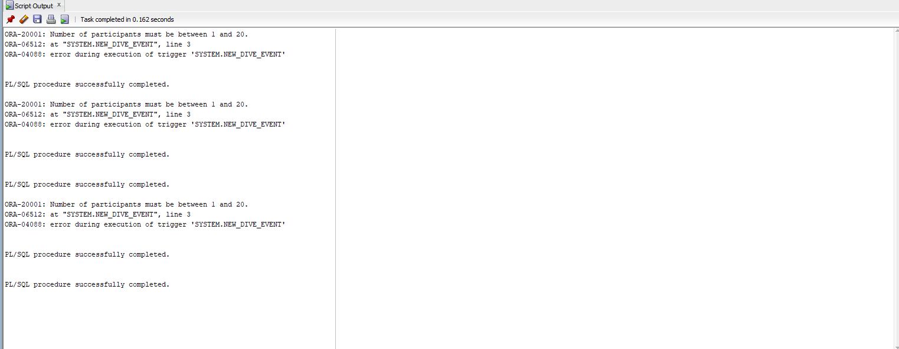

--QUESTION 8—

CREATE OR REPLACE PROCEDURE sp_Customer_Details (

p_cust_id IN Customers.cust_id%TYPE,

p_dive_date IN DiveEvent.dive_date%TYPE

)

IS

v_customer_name VARCHAR2(100);

v_dive_name VARCHAR2(100);

BEGIN

SELECT c.cust_fname || ' ' || c.cust_sname,

d.dive_name

INTO v_customer_name, v_dive_name

FROM DiveEvent de

JOIN Customers c ON de.cust_id = c.cust_id

JOIN Dive d ON de.dive_ID = d.DIVE_ID

WHERE de.cust_id = p_cust_id

AND de.dive_date = p_dive_date;

DBMS_OUTPUT.PUT_LINE('Customer Name: ' || v_customer_name);

DBMS_OUTPUT.PUT_LINE('Dive Name: ' || v_dive_name);

EXCEPTION

WHEN NO_DATA_FOUND THEN

DBMS_OUTPUT.PUT_LINE('No booking found for customer ID ' || p_cust_id || ' on date ' || TO_CHAR(p_dive_date, 'DD-Mon-YYYY'));

WHEN OTHERS THEN

DBMS_OUTPUT.PUT_LINE('An unexpected error occurred: ' || SQLERRM);

END sp_Customer_Details;

/

-- Setting server output to display the result

SET SERVEROUTPUT ON;

-- Test case 1: Valid customer ID and dive date

BEGIN

sp_Customer_Details('C115', TO_DATE('15-Jul-2017', 'DD-Mon-YYYY'));

END;

/

-- Test case 2: Valid customer ID but no booking on the given date

BEGIN

sp_Customer_Details('C115', TO_DATE('01-Jan-2022', 'DD-Mon-YYYY'));

END;

/

-- Test case 3: Invalid customer ID

BEGIN

sp_Customer_Details('C999', TO_DATE('15-Jul-2017', 'DD-Mon-YYYY'));

END;

/

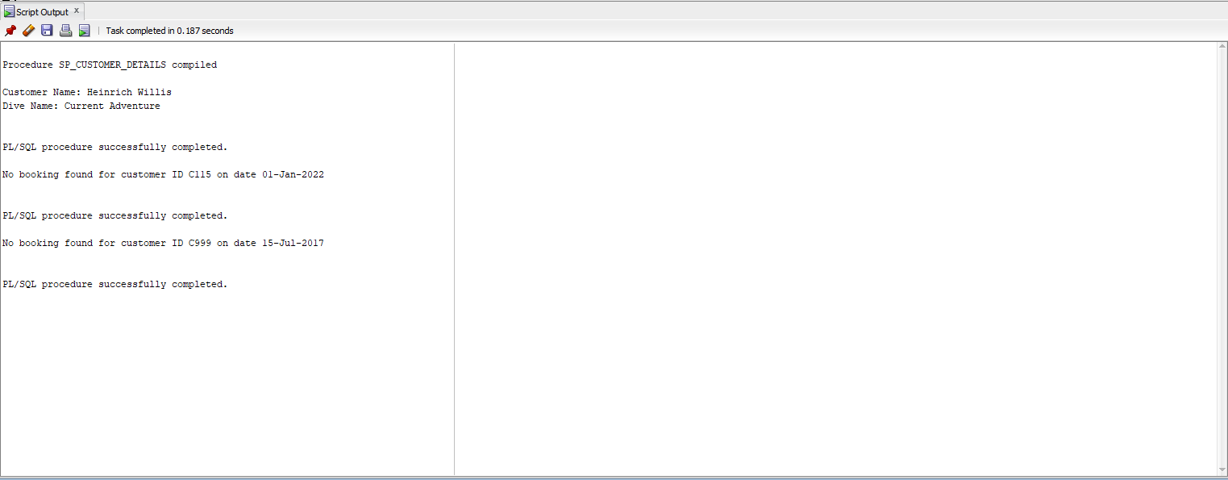

--QUESTION 9—

CREATE OR REPLACE FUNCTION fn_Calculate_Dive_Cost (

p_dive_event_id IN DiveEvent.dive_event_id%TYPE

) RETURN NUMBER

IS

v_dive_cost_per_participant NUMBER;

v_dive_participants NUMBER;

v_total_cost NUMBER;

BEGIN

-- Retrieve the cost per participant and the number of participants

SELECT d.dive_cost, de.dive_participants

INTO v_dive_cost_per_participant, v_dive_participants

FROM DiveEvent de

JOIN Dive d ON de.dive_ID = d.DIVE_ID

WHERE de.dive_event_id = p_dive_event_id;

-- Calculate the total cost

v_total_cost := v_dive_cost_per_participant * v_dive_participants;

-- Return the total cost

RETURN v_total_cost;

EXCEPTION

WHEN NO_DATA_FOUND THEN

-- Handle the case where no dive event is found for the given ID

RAISE_APPLICATION_ERROR(-20002, 'Dive event not found for ID: ' || p_dive_event_id);

WHEN OTHERS THEN

-- Handle any other unexpected errors

RAISE_APPLICATION_ERROR(-20003, 'An unexpected error occurred: ' || SQLERRM);

END fn_Calculate_Dive_Cost;

/

-- Test case 1: Valid dive event ID

DECLARE

v_total_cost NUMBER;

BEGIN

v_total_cost := fn_Calculate_Dive_Cost('de_101');

DBMS_OUTPUT.PUT_LINE('Total Cost for dive event de_101: ' || v_total_cost);

EXCEPTION

WHEN OTHERS THEN

DBMS_OUTPUT.PUT_LINE(SQLERRM);

END;

/

-- Test case 2: Invalid dive event ID

DECLARE

v_total_cost NUMBER;

BEGIN

v_total_cost := fn_Calculate_Dive_Cost('de_999');

DBMS_OUTPUT.PUT_LINE('Total Cost for dive event de_999: ' || v_total_cost);

EXCEPTION

WHEN OTHERS THEN

DBMS_OUTPUT.PUT_LINE(SQLERRM);

END;

/

SET SERVEROUTPUT ON;

