**Industrial Internship Report on**

**‘‘QUIZ GAME”**

**Prepared by**

**Gunti Mohan Krishna**

|  |
| --- |
| *Executive Summary* |
| This report provides details of the Industrial Internship provided by upskill Campus and The IoT Academy in collaboration with Industrial Partner Uni Converge Technologies Pvt Ltd (UCT).  This internship was focused on a project/problem statement provided by UCT. We had to finish the project including the report in 6 weeks’ time.  My project was “QUIZ GAME’’ Using python GUI . The quiz game is a Python project that quizzes users on various topics. It reads questions and answers from a file or database, presents them to the user, and keeps track of their score.  This internship gave me a very good opportunity to get exposure to Industrial problems and design/implement solution for that. It was an overall great experience to have this internship. |

**TABLE OF CONTENTS**

1 Preface 3

2 Introduction 5

2.1 About UniConverge Technologies Pvt Ltd 5

i. UCT IoT Platform 5

2.2 About upskill Campus (USC) 9

2.3 The IoT Academy 11

2.4 Objectives of this Internship program 11

2.5 Reference 11

2.6 Glossary 11

3 Problem Statement 13

4 Existing and Proposed solution 14

4.1 Code submission (Github link) 15

4.2 Report submission (Github link) : first make placeholder, copy the link. 15

5 Proposed Design/ Model 16

5.1 Low Level Diagram (if applicable) 17

5.2 Interfaces (if applicable) 18

6 Performance Test 19

6.1 Test Plan/ Test Cases 20

6.2 Test Procedure 21

6.3 Performance Outcome 21

7 My learnings 22

8 Future work scope 23

# Preface

Summary of the whole 6 weeks’ work.

Throughout the 6 weeks, I have learnt many new things about the python. Starting with basics syntaxes revision, going through OOPs in python and then going through different datatypes, and their syntaxes. Learning about the Tkinter module and widgets of it, accessing files and their handling syntaxes, exploring ideas how to implement the project. Started working on design and code. Implementing the code and tests the code so that it should not have any logical errors. So that getting desired output.

About need of relevant Internship in career development.

As of now, I am interested to do ML internship as I have chosen it as my specialization, by doing that domain related internship I can explore and learn more things about it. Also, it needs different python libraries to use. As this python internship be the base for me for doing any other internship in future.

Brief about Your project/problem statement.

The quiz game is a Python project that quizzes users on various topics. It reads questions and answers from a file or database, presents them to the user, and keeps track of their score. By using tkinter module, and it’s widgets gives user friendly outputs.

Opportunity given by USC/UCT.

When I am searching for internships, over 1 month seeing different internships opportunities but not selected or it may be not interested domain to do for me, then this USC/UCT gave me this golden opportunity to learn and explore many things about Python in this internship.

How Program was planned

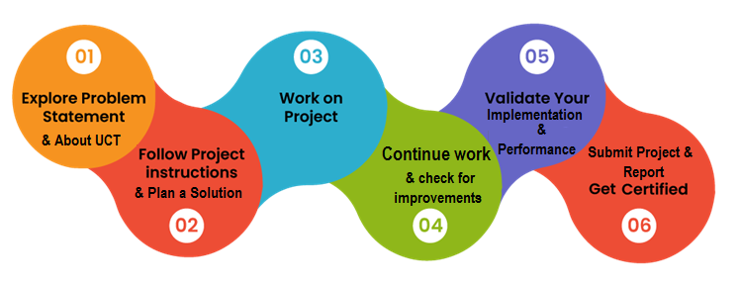

Your Learnings and overall experience.

By doing this internship, I have learnt many new things like technical and problem-solving skills, and explored through different things like how to explore and do the necessary work to do the project.

Thank to all (with names), who have helped you directly or indirectly.

I am very thankful to Upskill Campus and Kaushlendra Singh Sir (UCT), and all other staff for helping and responsible for any doubts clearing, and how to go through this internship and all.

Your message to your juniors and peers.

I just want to tell, please be smart and learn how to manage the things while doing internship. We should be planned and go through that, so that we do not face any issues.

# Introduction

## About UniConverge Technologies Pvt Ltd

A company established in 2013 and working in Digital Transformation domain and providing Industrial solutions with prime focus on sustainability and RoI.

For developing its products and solutions it is leveraging various**Cutting Edge Technologies e.g. Internet of Things (IoT), Cyber Security, Cloud computing (AWS, Azure), Machine Learning, Communication Technologies (4G/5G/LoRaWAN), Java Full Stack, Python, Front end**etc.



1. UCT IoT Platform **(****)**

**UCT Insight** is an IOT platform designed for quick deployment of IOT applications on the same time providing valuable “insight” for your process/business. It has been built in Java for backend and ReactJS for Front end. It has support for MySQL and various NoSql Databases.

* It enables device connectivity via industry standard IoT protocols - MQTT, CoAP, HTTP, Modbus TCP, OPC UA
* It supports both cloud and on-premises deployments.

It has features to  
• Build Your own dashboard  
• Analytics and Reporting  
• Alert and Notification  
• Integration with third party application (Power BI, SAP, ERP)  
• Rule Engine

 

1. **Smart Factory Platform (****)**

Factory watch is a platform for smart factory needs.

It provides Users/ Factory

* with a scalable solution for their Production and asset monitoring
* OEE and predictive maintenance solution scaling up to digital twin for your assets.
* to unleased the true potential of the data that their machines are generating and helps to identify the KPIs and also improve them.
* A modular architecture that allows users to choose the service that they what to start and then can scale to more complex solutions as per their demands.

Its unique SaaS model helps users to save time, cost and money.

 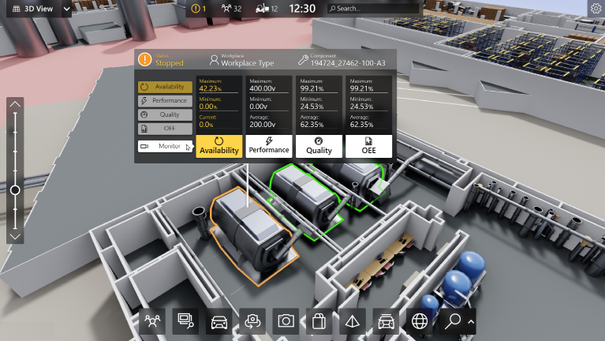

1.  based Solution

UCT is one of the early adopters of LoRAWAN teschnology and providing solution in Agritech, Smart cities, Industrial Monitoring, Smart Street Light, Smart Water/ Gas/ Electricity metering solutions etc.

1. Predictive Maintenance

UCT is providing Industrial Machine health monitoring and Predictive maintenance solution leveraging Embedded system, Industrial IoT and Machine Learning Technologies by finding Remaining useful life time of various Machines used in production process.



## About upskill Campus (USC)

upskill Campus along with The IoT Academy and in association with Uniconverge technologies has facilitated the smooth execution of the complete internship process.

USC is a career development platform that delivers **personalized executive coaching** in a more affordable, scalable and measurable way.



Seeing need of upskilling in self paced manner along-with additional support services e.g. Internship, projects, interaction with Industry experts, Career growth Services

<https://www.upskillcampus.com/>

upSkill Campus aiming to upskill 1 million learners in next 5 year

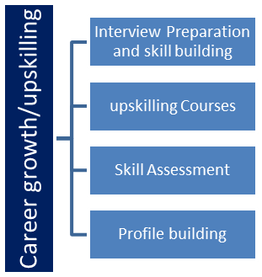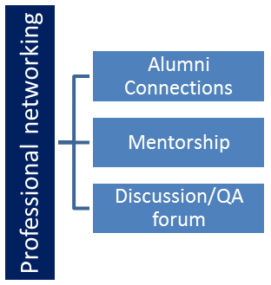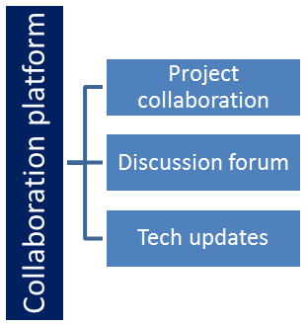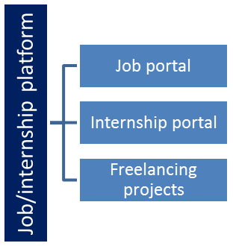

## The IoT Academy

The IoT academy is EdTech Division of UCT that is running long executive certification programs in collaboration with EICT Academy, IITK, IITR and IITG in multiple domains.

## Objectives of this Internship program

The objective for this internship program was to

 ☛ get practical experience of working in the industry.

 ☛ to solve real world problems.

 ☛ to have improved job prospects.

 ☛ to have Improved understanding of our field and its applications.

 ☛ to have Personal growth like better communication and problem solving.

## Reference

[1] W3Schools. (https://www.w3schools.com/python/default.asp)

[2] GeeksForGeeks (https://www.geeksforgeeks.org/python-gui-tkinter/)

## Glossary

|  |  |
| --- | --- |
| Terms | Acronym |
| OOP | Object-Oriented Programming (OOP)is a programming paradigm that revolves around the concept of "objects." It allows developers to model real-world entities and their interactions in the form of classes and objects. |
| GUI | Graphical user interface (GUI) is a type of user interface that allows users to interact with a computer or electronic device through graphical elements such as icons, buttons, windows, and menus, instead of using text-based command-line interfaces. |
| Tkinter | Tkinter is a standard GUI (Graphical User Interface) library in Python. It comes bundled with the Python standard library and provides a simple way to create graphical desktop applications. |
|  |  |
|  |  |

# Problem Statement

In the assigned problem statement

[Explain your problem statement]

The quiz game is a Python project that quizzes users on various topics. It reads questions and answers from a file or database, presents them to the user, and keeps track of their score.

The scope of this project involves designing a user interface to display questions and collect user answers, implementing a database or file system to store quiz data, and developing a scoring algorithm to track the user's progress and calculate their final score.

So, user will enter to QUIZ GAME home page first and then, he can choose topic and go through the quiz and final score will be get displayed to him.

# Existing and Proposed solution

Provide summary of existing solutions provided by others, what are their limitations?

Already existing solutions are having just question input direct in the code itself. So that if we want to change any Question, we need to go through the all code and correct it.

**Limitations of existing solutions**:

Limited Number of Questions: Storing questions directly within the code means that the number of questions is fixed and cannot be easily changed without modifying the code itself. This restricts the scalability of the quiz game.

Code Maintenance: As the number of questions increases, the code can become lengthy and hard to maintain. Editing or adding new questions directly in the code can be error-prone and time-consuming.

Difficulty in Sharing or Collaborating: Storing questions directly in the code makes it challenging to share the quiz with others for collaboration or to reuse the code for different quizzes.

Limited Question Types: Writing questions directly in the code may limit the complexity and variety of question types. It can be more challenging to include multimedia elements like images or audio, or interactive question formats.

Version Control Challenges: Keeping track of changes and version control can be more difficult when questions are stored directly in the code.

Limited Customization: Customizing the quiz for different themes or subjects might require modifying the code directly, which can be cumbersome.

What is your proposed solution?

According to my solution, as the problem statement given to me says to deal with the file management. I will get the Questions from the files and display them to the user. And checks the answer with the correct answer and final score will be displayed.

What value addition are you planning?

Also, at last when score is displayed, user wants to play again so for that I also created a way it will get it to home page so that user can play Quiz Game as many times he wants.

Flexibility and Scalability: Storing questions in an external file allows you to add, edit, or remove questions without modifying the code. This provides greater flexibility and scalability, as you can easily update the quiz content without the need to change the program's logic.

Easy Content Management: Managing the quiz content becomes much more straightforward when questions are stored in a separate file. Content creators or subject matter experts can work on the questions independently, and developers can focus on the code without getting involved in content-related changes.

Easy Customization: External files enable easy customization of the quiz content for different themes or subjects. You can have multiple question files for different quiz categories, making it simple to switch between different quizzes.

## Code submission (Github link)

https://github.com/G-MOHANKRISHNA/QUIZ-GAME-/blob/main/QUIZ_GAME_PROJECT.py

## Report submission (Github link) : first make placeholder, copy the link.

https://github.com/G-MOHANKRISHNA/QUIZ-GAME-/blob/main/FINAL_REPORT_QUIZGAME.docx

# Proposed Design/ Model

Given more details about design flow of your solution. This is applicable for all domains. DS/ML Students can cover it after they have their algorithm implementation. There is always a start, intermediate stages and then final outcome.

## Low Level Diagram (if applicable)

Display Question fun ()

Reading from file and display question

Next question ()

It updates to display next question

Check answer ()

It checks the answer correct or wrong and update score

Show score ()

It displays final score and then choose exit or go to home page

## Interfaces (if applicable)

Update with Block Diagrams, Data flow, protocols, FLOW Charts, State Machines, Memory Buffer Management.

# Performance Test

This is very important part and defines why this work is meant of Real industries, instead of being just academic project.

Here we need to first find the constraints.

How those constraints were taken care in your design?

What were test results around those constraints?

The constraints are:

Memory Constraints:

The size of the quiz questions and associated data in the file should be manageable to fit within the available memory of the target device. Large files may cause memory overflow or slowdowns.

MIPS (Speed and Operations per Second):

The quiz game should be optimized for efficient file reading, parsing, and processing of questions to achieve a desirable speed (measured in MIPS). Consider using efficient data structures and algorithms to minimize processing time and maximize the number of operations per second.

Accuracy:

The quiz game must accurately read and interpret the questions and answers from the file. Any inaccuracies in parsing or displaying questions can lead to incorrect quiz outcomes.

Durability and Error Handling:

The application should be robust and handle various scenarios, such as invalid file formats, missing data, or corrupted files. Graceful error handling is necessary to prevent crashes.

File Format Support:

Consider supporting multiple file formats (e.g., plain text, CSV, JSON) to provide flexibility for quiz creators when preparing the quiz questions.

Power Consumption:

Efficient file reading and processing are important to minimize power consumption, especially on devices with limited battery life like mobile devices.

Security:

Ensure that the file reading mechanism does not introduce security vulnerabilities, such as file injection or unauthorized access to sensitive files.

File Access and Permissions:

Define appropriate access and permission controls to restrict unauthorized access to quiz files and prevent unintended modifications.

Data Integrity:

Ensure the quiz file's data integrity by implementing mechanisms to detect and handle data corruption or tampering.

Compatibility:

Verify that the quiz game can read and process quiz files created on different platforms and operating systems.

## Test Plan/ Test Cases

Quiz Creation:

Test case: Verify that the quiz creator can successfully create a new quiz with valid questions and answers.

Test case: Verify that mandatory fields (such as quiz title and questions) are validated during quiz creation.

Test case: Verify that the maximum number of questions allowed in a quiz is enforced.

Quiz Taking:

Test case: Verify that a user can start a quiz and progress through each question.

Test case: Verify that the quiz ends after the last question, and the final score is displayed.

Answer Validation:

Test case: Verify that the correct answer is validated, and the user's score is updated accordingly.

Test case: Verify that incorrect answers are handled appropriately, and the correct feedback is given.

Score Calculation:

Test case: Verify that the final score is calculated correctly based on the number of correct answers.

Quiz Editing:

Test case: Verify that the quiz creator can edit and save changes to an existing quiz.

Test case: Verify that only the quiz creator can edit their own quiz, and others are restricted.

User Experience:

Test case: Verify that the quiz game has a user-friendly and intuitive interface (GUI).

Test case: Verify that the application is responsive and functions well on desktop.

## Test Procedure

All test cases implemented and followed the design/model.

## Performance Outcome

Finally, the outcome is as follows

* start
* User can see the home page first
* Home page consists of different topics, out of them user should choose one to play Quiz
* Then, display of Quiz Questions
* Final score display
* After that, user can get back to home page or exit as his/her wish.
* stop

# My learnings

You should provide summary of your overall learning and how it would help you in your career growth.

* During this internship, I gained valuable hands-on experience in developing and implementing Python applications.
* This internship gave me the opportunity to strengthen my coding skills, learn new libraries(tkinter) and file management, etc.
* Also provided me with a deeper understanding of software development methodologies.
* Overall, it was an enriching experience that has prepared me for a promising career in Python development.

# Future work scope

You can put some ideas that you could not work due to time limitation but can be taken in future.

Yes, there are many ideas that can work it out on my project “QUIZ GAME”. Some of them are:

* Can set a timer for each question.
* Login and so that it stores the number of times a particular user gave that particular topic of Quiz and what his/her score status maintain in database.
* Can rank and give analysis upon accuracy and time that his/her taking to answer for a question.
* So that user can get aware of how much knowledge does others have so that they get motivated to study.
* It also can be made as mobile app.

These are my ideas that my project can be developed.