STEP1:编写MAP MICRO程序.请注意,三要素:DFHMSD, DFHMDI, DFHMDF. 分别代表MAPSET, MAP和里面的FIELD.
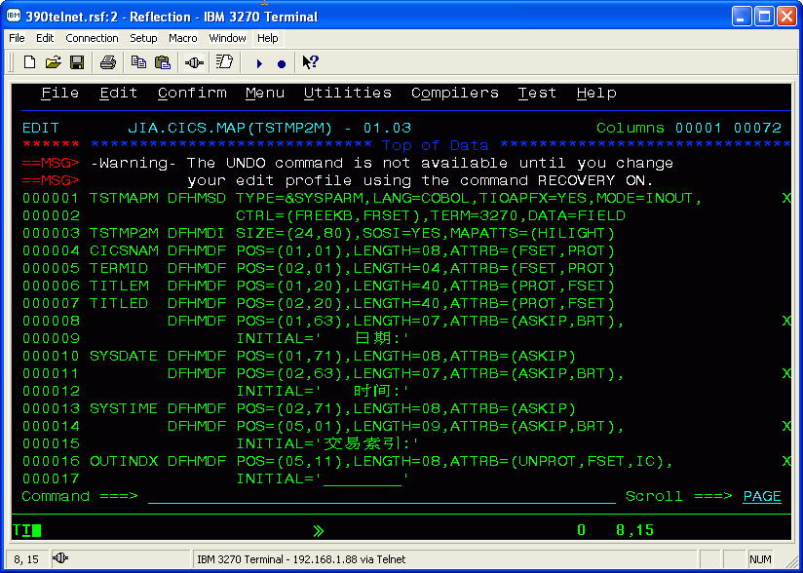
STEP2:编译MAP MICRO.事实上会生成2个咚咚:一个叫做PHYSICAL MAP,一个叫做SYMBOLIC MAP. 请注意:PHYSICAL MAP是二进制文件,给CICS调用;而SYMBOLIC MAP是COPYBOOK,给COBOL程序引用里面的变量.
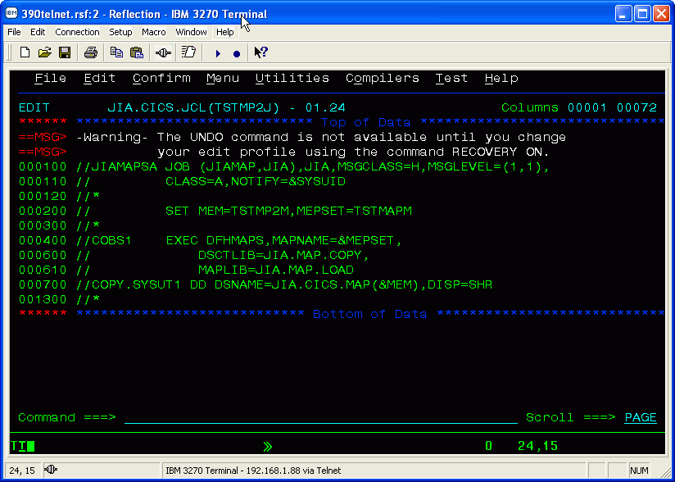
STEP3:生成的physical map,二进制文件
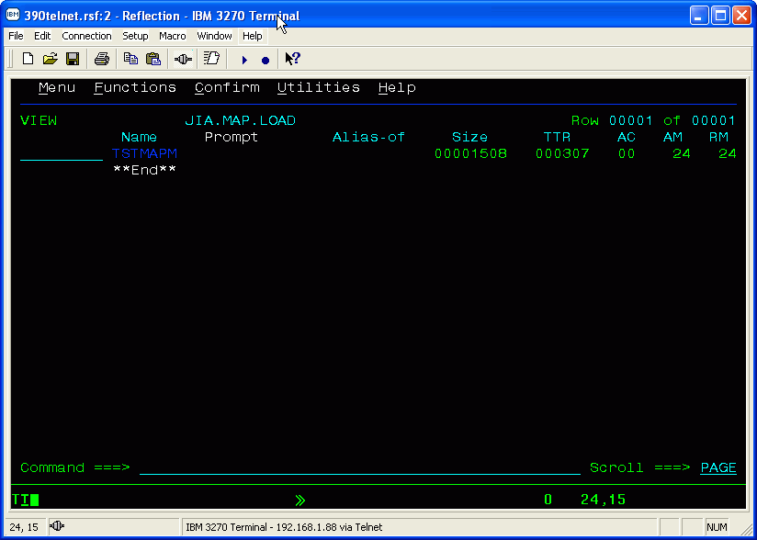
STEP4:生成的symbolic map,是cobol copybook
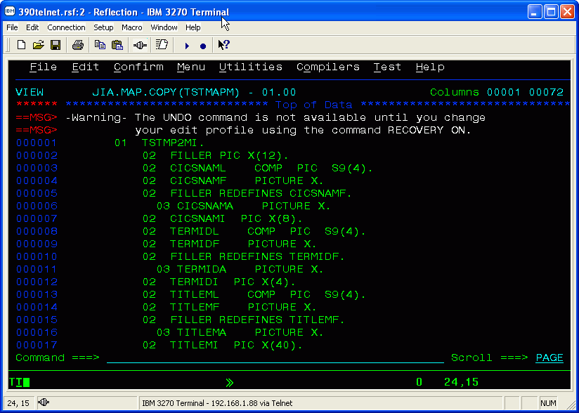
STEP5:下面进入CICS环境去定义刚才生成的MAP
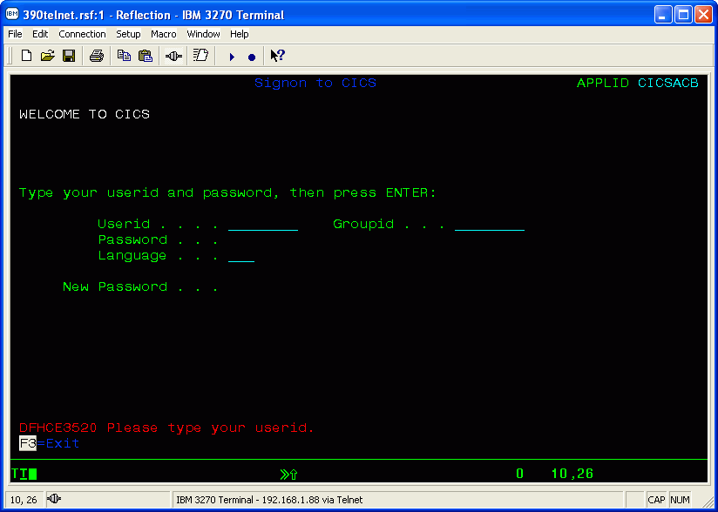
STEP5.5:这里要插播一下,CICS存在一个库列问题.怎样能让CICS知道您的MAP是在那个库下呢?我刚才编译的PHYSICAL MAP在JIA.MAP.LOAD下,必须要去启动CICS的系统进程去加入这个库列.(这步很关键,本人尝试了一个下午才发现).今后大家要建立自己的程序,请把PHYSICAL MAP定义到ALLUSER.MAP.LOAD
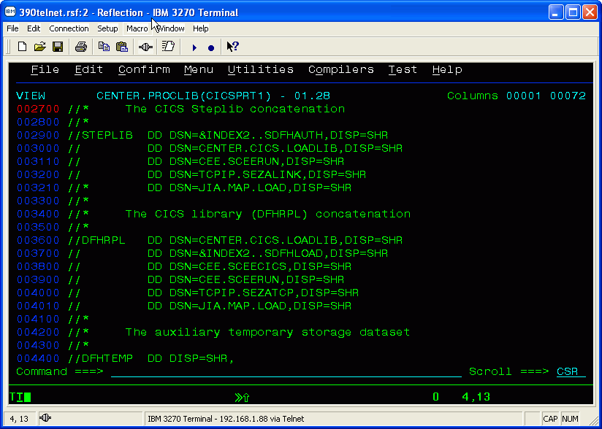
STEP6:用CEDA DEF MAPSET(TSTMAPM) GROUP(TEST)去定义这个MAP.为啥要这样定义呢?因为CICS是高层应用,它需要知道调用的MAP是指向外面的哪个程序.
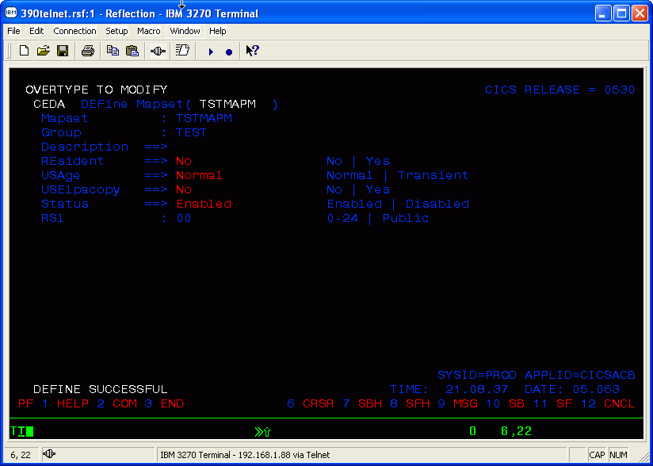
STEP7:定义完了以后要安装,用CEDA INS MAPSET(TSTMAPM) GROUP(TEST)
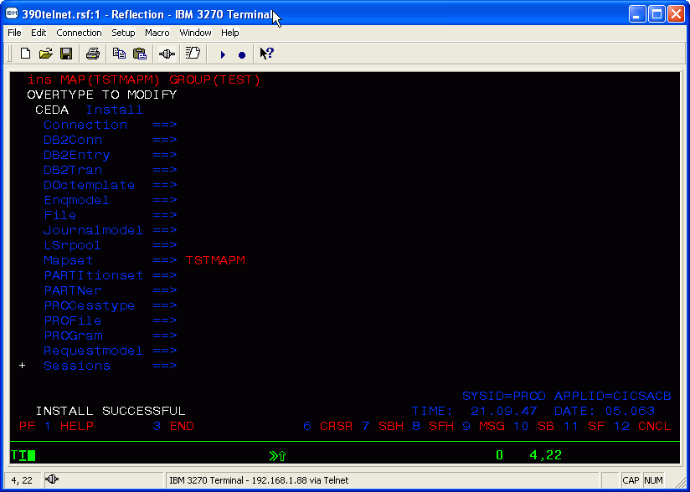
STEP8:可以很高兴的看看MAP了....用SEND MAP(TSTMP2M) MAPSET(TSTMAPM)....慢着,怎么刚才的改动没生效?还是原来的map?
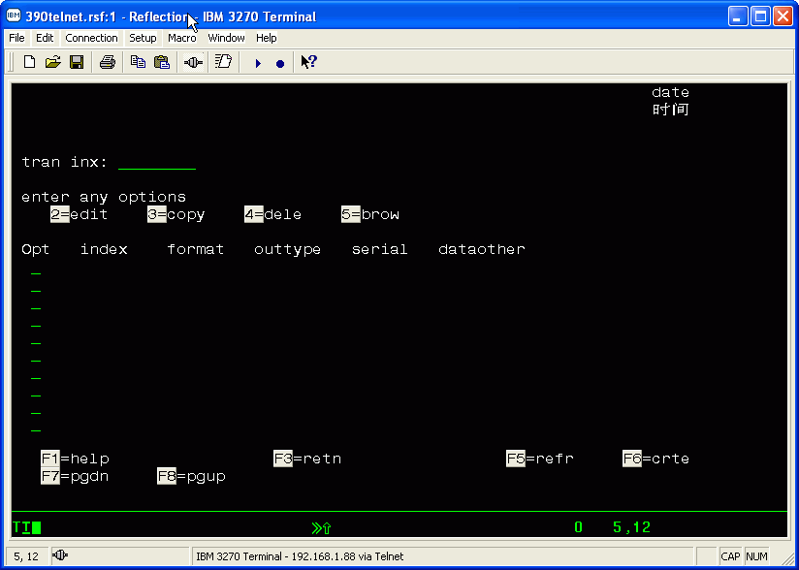
STEP9:这时候必须要刷新MAP,才能使刚改动过的MAP生效,用CECI SET PROG(TSTMAPM) NEW
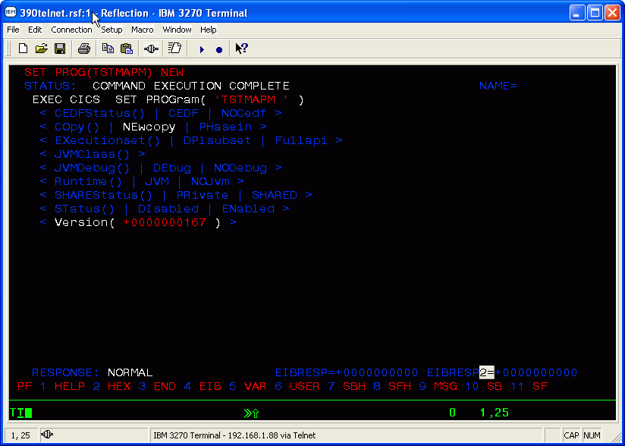
STEP10:现在看到的才是您改动过MAP,编译,定义,安装后的结果...呵呵,长时间的辛苦终于有回报了.
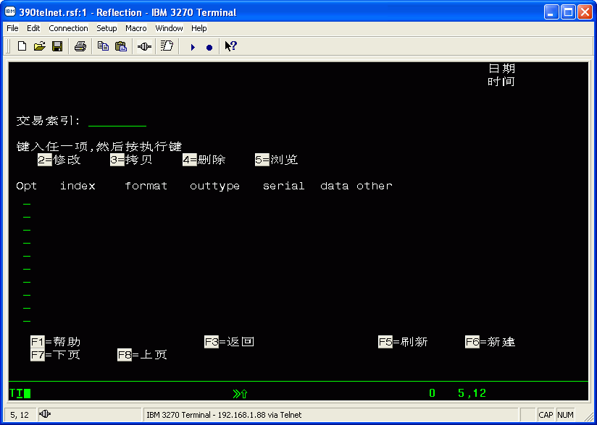
In this handout we follow step-by-step instructions in creating
a COBOL program. Job Control Language (JCL) is used to demonstrate
file linkage as well as program execution. For the purpose of this
handout, we assume you have successfully accessed the ISPF/PDF
PRIMARY OPTION MENU shown below:
GEORGIA STATE UNIVERSITY COMPUTER CENTER
--------------------ISPF/PDF PRIMARY OPTION MENU-----------------------
OPTION ===>
USER ID -userid
0 ISPF PARAMS -Specify terminal and user parameters TIME -14:42
1 BROWSE -Display source data or output listing TERMINAL -3278
2 EDIT -Create or change source data PF KEYS -24
3 UTILITIES -Perform utility functions
4 FOREGROUND -Invoke language procedures in foreground
5 BATCH -Submit job for language processing
6 COMMAND -Enter TSO command or CLIST
7 DIALOG TEST -Perform dialog testing
8 LM UTILITIES-Perform library management utility functions
C CHANGE -Display summary of changes for this release
T TUTORIAL -Display information about ISPF/PDF
X EXIT -Terminate ISPF using log and list defaults
Enter END command or PF3 to terminate ISPF.
SECTION ONE: Creating your COBOL program.
1.1) Enter 6 at the "OPTION ===>" prompt of the ISPF/PDF PRIMARY OPTION
MENU, and press return to go to TSO COMMAND PROCESSOR panel.
1.2) Type CREATE at the cursor, and press return. Next, type your initial
when you are asked to "ENTER LIBRARY/APPLICATION NAME ===>". Press
return, and type COBOL at the next prompt. Press return one more
time when you see three asterisks displayed (press return anytime
you see *** displayed).
1.3) Use the F4 key to go back to the primary menu. Then, enter 2 at
the "OPTION ===>" prompt to go to the EDIT - ENTRY PANEL.
Fill the sections of this panel as shown below:
------------------------- EDIT - ENTRY PANEL ---------------------------
COMMAND ===>
ISPF LIBRARY:
PROJECT ===> your userid
GROUP ===> your initials ===> ===> ===>
TYPE ===> COBOL
MEMBER ===> program name (Blank for member selection list)
OTHER PARTITIONED OR SEQUENTIAL DATA SET:
DATA SET NAME ===>
VOLUME SERIAL ===> (If not catalogued)
DATA SET PASSWORD ===> (If password protected)
PROFILE NAME ===> (Blank defaults to data set type)
Press return and you will see an empty file as shown below:
EDIT --- User-id.Initial.COBOL(member) ------------- COLUMNS 001 072
COMMAND ===> SCROLL ===>PAGE
****** *********************** TOP OF DATA **************************
''''''
''''''
''''''
''''''
''''''
''''''
.
.
Type UNNUM at the cursor and press return. Press the TAB key twice,
type the letter "I" (insert), and press return. Tab back then type
COLS and press return. Use the right arrow key to move the cursor
to the right. The first line of the body of a COBOL program will
start in column 8. The first line in the body of the COBOL program
will be the IDENTIFICATION DIVISION.
EDIT --- User-id.Initial.COBOL(member) ------------- COLUMNS 001 072
COMMAND ===> SCROLL ===>PAGE
****** ********************** TOP OF DATA ***************************
=COLS>----+----1----+----2----+----3----+----4----+----5----+----6----+
''''''
****** *********************BOTTOM OF DATA **************************
Press return followed by the HOME key. This will take your cursor
back to the COMMAND line. Type the command RES which stands for
RESEQUENCE. This will cause the rulers to disappear.
Upon entering successive lines of text, the cursor will be placed
under the first non-blank character of the previous line. Since
many of the lines of COBOL start in either column 8 or 12, this
is most convenient. You don't need to use the cursor keys or
space key near as much when entering successive lines of text.
After typing your program you should press the home key and type
the word SAVE on the COMMAND line. You may type CANCEL on the COMMAND
line to leave the EDIT screen without saving your program or changes
that you made to an existing program. The SAVE command may be used
as an extra precaution in saving text to disk. It is, however, not
necessary. The very act of moving from one ISPF/PDF panel to the
next will automatically SAVE your text to disk when exiting the
Editor.
In writing the File Description (FD) sections of your COBOL
program, there are certain conventions that must be followed
when interfacing with the IBM operating system. The FD phrase
'BLOCK CONTAINS 0 CHARACTERS' allows record and block size to be
controlled by the Dataset Definition (DD) statements in the
JCL rather than the COBOL program.
Use the example below to help you with your own program.
EDIT --- user-id.init.COBOL(TEST1) - 01.01 --------- COLUMNS 001 072
COMMAND ===> SCROLL ===>PAGE
****** ******************** TOP OF DATA **************************
000001//STEP0 EXEC WORKFILE,DSN=OUTFILE,LRECL=133,BLKSIZE=13300,
000002// RECFM=FBA
000003//STEP1 EXEC COBUCLG,PARM='LANGLVL(2),APOST'
000004 IDENTIFICATION DIVISION.
000005 PROGRAM-ID. TINY-PROGRAM.
000006 AUTHOR. GORDON HOWELL.
000007
000008 ENVIRONMENT DIVISION.
000009 CONFIGURATION SECTION.
000000 SOURCE-COMPUTER. IBM-370.
000011 OBJECT-COMPUTER. IBM-370.
000012 INPUT-OUTPUT SECTION.
000013 FILE-CONTROL.
000014 SELECT INPUT-FILE ASSIGN TO UT-S-INFILE.
000015 SELECT OUTPUT-FILE ASSIGN TO UT-S-OUTFIL.
000016
000017 DATA DIVISION.
000018 FILE SECTION.
000019
000020 FD INPUT-FILE LABEL RECORDS ARE OMITTED
000021 BLOCK CONTAINS 0 CHARACTERS.
000022 01 INPUT-RECORD PIC X(80).
000023
000024 FD OUTPUT-FILE LABEL RECORDS ARE OMITTED
000025 BLOCK CONTAINS 0 CHARACTERS.
000026 01 PRINT-LINE PIC X(132).
000027
000028 WORKING-STORAGE SECTION.
000029 01 END-OF-FILE-SWITCH PIC X(3).
000030
000031 PROCEDURE DIVISION.
000032
000033 000-MAINLINE-DRIVER.
000034 PERFORM 100-INITIALIZE.
000035 PERFORM 200-PROCESS-DATA
000036 UNTIL END-OF-FILE-SWITCH = 'YES'.
000037 PERFORM 900-END-JOB.
000038 STOP RUN.
000039
000040 100-INITIALIZE.
000041 OPEN INPUT INPUT-FILE.
000042 OPEN OUTPUT OUTPUT-FILE.
000043 MOVE 'NO' TO END-OF-FILE-SWITCH
000044 READ INPUT-FILE
000045 AT END MOVE 'YES' TO END-OF-FILE-SWITCH.
000046
000047 200-PROCESS-DATA.
000048 MOVE INPUT-RECORD TO PRINT-LINE.
000049 WRITE PRINT-LINE
000050 AFTER ADVANCING 1 LINE.
000051 READ INPUT-FILE
000052 AT END MOVE 'YES' TO END-OF-FILE-SWITCH.
000053
000054 900-END-JOB.
000055 CLOSE INPUT-FILE.
000056 CLOSE OUTPUT-FILE.
000057//GO.INFILE DD DSN=CISCOB.COBOL.DATA(FOURUP),DISP=SHR
000058//GO.OUTFIL DD DSN=YOUR-ID.DAY.OUTFILE,DISP=OLD
000059//GO.SYSOUT DD SYSOUT=*
000060/*JOBPARM FORMS=F600
****** ********************** BOTTOM OF DATA **************************
In the example above, the lines that contain "//" in
columns one and two, are the JCL statements. JCL statements
perform the operations necessary to compile, link and execute
your program.
Notice that STEP0 executes a JCL procedure called WORKFILE.
This procedure will create an output file named DAY.OUTFILE.
The procedure takes the Data Set Name (DSN) OUTFILE and prefixes
it with the USERID and a Group name of DAY. Disk space for this
file is not charged against your permanent userid space. The disk
space allocation is charged against a system pool. The Group name
of DAY is used to indicate that this file will remain for at least
24 hours from the time it was created.
The RECFM parameter on the WORKFILE procedure is used to create
the output file as a print file when the option FBA is specified.
FBA is the acronym for Fixed Block ASCII. Column one of the print
file is then reserved for printer carriage control. If the output
file is not a print file, I.E. a report to be printed, but is a file
that will be read as input to another program, the option FBA should
be changed to FB. The record length should also be changed in the
LRECL parameter to match that of the record length given in the
COBOL program's File Description 'FD'.
The LRECL parameter on the WORKFILE procedure is used to create
a record length of 133 characters for the output file. This enables
one to use 132 columns for output with the first column reserved for
printer control. When the output file is printed, the printer will
look at the first column to determine the appropriate number of lines
to space and when to paginate.
Notice that STEP1 executes a JCL procedure called COBUCLG.
This procedure will compile, link, and execute a COBOL program.
Within this procedure there are two steps called LNK and GO.
JCL Dataset Definitions and library references may be inserted
into the procedure by prefixing them with the step name followed
by a period. The LNK step contains all the JCL necessary to
to form an executable load module. The GO step contains all of the
JCL necessary in linking input and output data files.
In the example above, GO.INFILE tells the operating system that the
internal link name INFILE is to be used as the link name to the COBOL
program. The Data Set Name (DSN) parameter for GO.INFILE is used
to specify the name of the input file found on disk. In the example
above, the name of the input file on disk is CISCOB.COBOL.DATA(FOURUP).
The link name used for the COBOL program is found in the SELECT clause
on line 14 of the COBOL program.
In the example above, GO.OUTFIL tells the operating system that the
internal link name OUTFIL is to be used as the link name to the COBOL
program. The Data Set Name (DSN) parameter for GO.OUTFIL is used
to specify the name of the output file found on disk. In the example
above, the name of the output file on disk is CISCOB.DAY.OUTFIL.
The link name used for the COBOL program is found in the SELECT clause
on line 15 of the COBOL program.
The Disposition of the file informs the operating system whether or
not the file currently exists. The input file has a file disposition
equal to SHR (DISP=SHR). The output file has a file disposition equal
to OLD (DISP=OLD). This means that we have to create the input and
output files before we execute our program.
SECTION TWO: Creating your data files.
2.1) Type =3.2 at the "COMMAND ===>" prompt to go to the next panel.
Use the TAB key to tab to the "TYPE ===>" prompt. Enter the name
of your input file. Press the HOME key and enter "A" (for
allocation) and press return. another panel will be displayed
as the one shown below. Use these same parameters as input
to your panel.
------------------------ ALLOCATE NEW DATA SET -------------------------
COMMAND ===>
DATA SET NAME: User-id.Initial.Type
VOLUME SERIAL ===> (Blank for authorized default volume)
SPACE UNITS ===>TRKS (BLKS, TRKS or CYLS)
PRIMARY QUAN ===>1 (in above units)
SECONDARY QUAN ===>1 (in above units)
DIRECTORY BLOCKS===>0 (zero for sequential data set)
RECORD FORMAT ===>FB
RECORD LENGTH ===>80 >
BLOCK SIZE ===>80 >
For the RECORD LENGTH and BLOCK SIZE sections, enter the same
number you used in the RECORD CONTAINS clause of this file.
Press return to go back to the DATA SET UTILITY panel. Tab
to the "TYPE ===>" prompt and enter the name of your output file.
2.2) Create your output file the same way you created your input file.
SECTION THREE: Filling in your data.
3.1) Type =2 at the "OPTION ===>" prompt to go to EDIT panel. Enter
the name of your input file. The file name should be entered
at the "TYPE ===>" prompt. This name has to be the same
as the one used in the DSN parameter of your input file. Now,
press return to enter your input data.
3.2) Press the return key. Your screen should have two rows of
asterisks. Move you cursor to the first asterisk on the first
line and type the letter I. After pressing return you will
subsequently be prompted for each line of data. If no data
is entered prompting will stop. You may then move your cursor
to a line number while typing the letter I in order to resume
prompting.
3.3) When you are finished creating your input file, go back to the
EDIT - ENTRY PANEL by typing =2. At the "COMMAND ===>" prompt,
type the name of your output file (this name should be the same
one used in the DSN parameter).
Next, press return, and type SAVE to save the empty output file.
If your Job stream uses a WORKFILE procedure to create the output
file, this step is not necessary.
SECTION FOUR: Executing your COBOL program.
4.1) To execute your program, enter =2 at the "COMMAND ===>" prompt.
Press return to go to the EDIT - ENTRY PANEL.
4.2) Enter the word COBOL at the "TYPE ===>" prompt of this panel.
Then, enter the name of your COBOL program at the "MEMBER ===>"
prompt. Press return and your program will be displayed at
the terminal.
4.3) Enter the command 'SUBT A,10' at the "COMMAND ===>" prompt of
this panel and press return to submit your program to the system.
The "A" is the jobname character that will be suffixed to
your userid. The batch job is to use no more than 10 seconds
of central processing time.
EDIT --- user-id.init.COBOL(TEST1) - 01.01 --------- COLUMNS 001 072
COMMAND ===> SUBT A,10 SCROLL ===>PAGE
****** ******************** TOP OF DATA **************************
000001//STEP0 EXEC WORKFILE,DSN=OUTFILE,LRECL=133,BLKSIZE=13300,
000002// RECFM=FBA
000003//STEP1 EXEC COBUCLG,PARM='LANGLVL(2),APOST'
000004 IDENTIFICATION DIVISION.
000005 PROGRAM-ID. TINY-PROGRAM.
000006 AUTHOR. GORDON HOWELL.
000007
000008 ENVIRONMENT DIVISION.
000009 CONFIGURATION SECTION.
000000 SOURCE-COMPUTER. IBM-370.
000011 OBJECT-COMPUTER. IBM-370.
000012 INPUT-OUTPUT SECTION.
000013 FILE-CONTROL.
000014 SELECT INPUT-FILE ASSIGN TO UT-S-INFILE.
000015 SELECT OUTPUT-FILE ASSIGN TO UT-S-OUTFIL.
000016
000017 DATA DIVISION.
000018 FILE SECTION.
000019
000020 FD INPUT-FILE LABEL RECORDS ARE OMITTED
000021 BLOCK CONTAINS 0 CHARACTERS.
000022 01 INPUT-RECORD PIC X(80).
000023
000024 FD OUTPUT-FILE LABEL RECORDS ARE OMITTED
000025 BLOCK CONTAINS 0 CHARACTERS.
000026 01 PRINT-LINE PIC X(132).
000027
000028 WORKING-STORAGE SECTION.
000029 01 END-OF-FILE-SWITCH PIC X(3).
000030
000031 PROCEDURE DIVISION.
000032
000033 000-MAINLINE-DRIVER.
000034 PERFORM 100-INITIALIZE.
000035 PERFORM 200-PROCESS-DATA
000036 UNTIL END-OF-FILE-SWITCH = 'YES'.
000037 PERFORM 900-END-JOB.
000038 STOP RUN.
000039
000040 100-INITIALIZE.
000041 OPEN INPUT INPUT-FILE.
000042 OPEN OUTPUT OUTPUT-FILE.
000043 MOVE 'NO' TO END-OF-FILE-SWITCH
000044 READ INPUT-FILE
000045 AT END MOVE 'YES' TO END-OF-FILE-SWITCH.
000046
000047 200-PROCESS-DATA.
000048 MOVE INPUT-RECORD TO PRINT-LINE.
000049 WRITE PRINT-LINE
000050 AFTER ADVANCING 1 LINE.
000051 READ INPUT-FILE
000052 AT END MOVE 'YES' TO END-OF-FILE-SWITCH.
000053
000054 900-END-JOB.
000055 CLOSE INPUT-FILE.
000056 CLOSE OUTPUT-FILE.
000057//GO.INFILE DD DSN=CISCOB.COBOL.DATA(FOURUP),DISP=SHR
000058//GO.OUTFIL DD DSN=YOUR-ID.DAY.OUTFILE,DISP=OLD
000059//GO.SYSOUT DD SYSOUT=*
000060/*JOBPARM FORMS=F600
****** ********************** BOTTOM OF DATA **************************
Press the Enter key and the computer will respond with
IKJ56250I JOB useridA(JOBnumber) SUBMITTED
***
SECTION FIVE: Accessing your job output.
5.1) At the "COMMAND ===>" prompt, type =o.h to go to the SDSF or System
Display and Search Facility PANEL H option.
_____________________________________________________________________________
|SDSF HELD OUTPUT DISPLAY ALL CLASSES 406 LINES LINE 1-1 (1)
|COMMAND INPUT ===> SCROLL ===> HALF
|NP JOBNAME TYPE JNUM #DSNS CRDATE C FCB DEST ROUTE #RECORDS RNUM RD-
| S USERIDA JOB 1139 5 8/15/91 X **** GSUMVS1 350 0275
|____________________________________________________________________________
5.2) Tab to the field under the NP heading and type in the letter
S to view you job output.
Below is a facsimile of a successful COBOL execution as viewed
from the SDSF menu option H.
BROWSE - USGHND.DAY.SPF235.OUTLIST ------------ LINE 000000 COL 001 080
COMMAND ===> SCROLL ===>HALF
********************************** TOP OF DATA ************************
1 J E S 2 J O B L O G -- S Y S T E M G S U 1 -- N O
0
11.12.36 JOB 2185 ICH70001I USGHND LAST ACCESS AT 11:09:25 ON TUESDAY, OC
11.12.36 JOB 2185 $HASP373 USGHNDX STARTED - INIT A - CLASS A - SYS GSU1
11.12.45 JOB 2185 - --TIMING
(
11.12.45 JOB 2185 -JOBNAME STEPNAME PROCSTEP RC EXCP CONN CPU
11.12.45 JOB 2185 -USGHNDX COB 00 332 1851 .00
11.12.45 JOB 2185 -USGHNDX LKED 00 332 1851 .00
11.12.45 JOB 2185 -USGHNDX GO 00 332 1851 .00
11.12.45 JOB 2185 -USGHNDX ENDED. NAME-USGHND / TOTAL CPU TIME=
11.12.46 JOB 2185 $HASP395 USGHNDX ENDED ]]
0------ JES2 JOB STATISTICS ------ ]]
- 18 OCT 88 JOB EXECUTION DATE ]]-------------------
- 9 CARDS READ ] A RETURN CODE (RC)
- 152 SYSOUT PRINT RECORDS ] OF ZERO MEANS YOUR
- 0 SYSOUT PUNCH RECORDS ] PROGRAM EXECUTED
- 8 SYSOUT SPOOL KBYTES ] WITHOUT ERRORS.
- 0.17 MINUTES EXECUTION TIME ]
1 //USGHNDX JOB I994998,USGHND, ]--------------------
// NOTIFY=USGHND,CLASS=A,MSGLEVEL=(1,1),
// USER=USGHND,TIME=(0,5)
5.3) To print your Job Stream output, type O under the NP heading.
Your Job Stream output contains such information as the results of
compilation, linkage and execution of your COBOL program. Some COBOL
debugging messages may also be found in your Job Stream Output.
Your Job Stream output will normally be printed on one of the
production laser printers located on the ground floor of the Library
South building. You can change the destination by toggling to the
field under the DEST header and overlaying the GSUMVS1 destination.
For example, if you want your output printed on the high-speed printer
located in LS109, overlay the GSUMVS1 with TRM1.
See the SDSF handout for further information.
5.4) To print your Report file, You might want to use the TSO CLIST
Procedure PRINTOFF.
For example:
SYNTAX:
TSO PRINTOFF Disk-file-name FORMS(form-number)
Note: If no forms are specified, the standard laser print form will
be used. This constitutes four logical pages of output printed
for ever one page of paper. There will be two print images
printed on the front and two print images printed on the
back. For further do*****entation pertaining to laser print
forms, please refer to the do*****entation under the Handouts
procedure.
If the Report file name on disk is DAY.OUTFILE, you would use the
Printoff procedure from any COMMAND===> line as follows:
COMMAND===> TSO PRINTOFF DAY.OUTFILE FORMS(F601)
Note: The Form# F601 is a landscape duplex form. The output will be
printed on the front and back side of the paper lengthwise.
This Form# is often chosen because the legibility of the printer
output is much better.
5.5) An alternative to the TSO PRINTOFF procedure is to use Option 3.6
which will display the HARDCOPY UTILITY screen. This screen may
also be used to print output reports. The following screen sample
demonstrates the printing of the report file named, DAY.OUTFILE,
using Form# F601.
------------------------ HARDCOPY UTILITY -----------------------------
OPTION ==>pk
PK - Print and keep data set
PD - Print and delete data set
DATA SET NAME ===> day.outfile
VOLUME SERIAL ===> (If not catalogued)
DATA SET PASSWORD ===> (If password protected PDS)
PRINT MODE ===> BATCH (BATCH or LOCAL)
SYSOUT CLASS ===> A
LOCAL PRINTER ID ===>
JOB STATEMENT INFORMATION: (If not to local printer, verify before proceeding)
====>/*JOBPARM FORMS(F601)
====>
====>
====>
-----------------------------------------------------------------------
SECTION SIX: Logging off.
To LOGOFF, enter =X at the "COMMAND ===>" or "OPTION ===>"
prompt of any panel. Once the operating system displays the
message READY, you may then type the command LOGOFF.
At this point you will be disconnected from the system.
IMPORTANT NOTE:
The program, input and output files that you have created are
saved in the system. Therefore subsequent executions should
reference sections 4.1 through 5.4.
METHODS OF DEBUGGING
There are two popular ways to debug a COBOL program on the
MVS operating system.
METHOD #1:
If the program compiles with no syntax errors, but continues
to execute beyond the time allocated on the SUBT command, the
program may be in an infinite loop. In order to isolate the
looping pattern you may make use of the COBOL statement
READY TRACE. This command is always placed in column 12
of your program and is placed, just like any other COBOL
statement, within a paragraph. Upon execution of the program,
the name of each paragraph will be written to your SYSOUT.
With this information, you may be able to establish some sort
of looping pattern based on the names of the paragraphs.
The READY TRACE statement requires an additional line of JCL
in order to work. This statement should be typed at the bottom
of your program as follows:
//SYSOUT DD SYSOUT=*
METHOD #2:
If you want to take a peek at a given variable in your program,
you may do this using the COBOL DISPLAY statement. If you have
a variable named CNTR, you may look at the contents of this
variable using the DISPLAY statement. It might look as follows:
DISPLAY CNTR.
The DISPLAY statement also starts in column 12. The DISPLAY
statement also requires an additional line of JCL in order to
work. This statement should be typed at the bottom of your
program as follows:
//SYSOUT DD SYSOUT=*
MOST FREQUENTLY ENCOUNTERED ERROR MESSAGES
WHEN USING COBOL ON AN IBM MVS/XA OPERATING SYSTEM
Job streams used to compile COBOL programs are capable of generating
four types of error messages. They are listed as follows:
1. Job Control Language (JCL) syntax errors:
A JCL syntax error is flagged by the operating system. Think of it as
a grammatical error. These errors will be flagged on those statement
lines containing '//'. The line numbers for which syntax errors are
flagged will be placed at the bottom of your Outlist file.
Common JCL syntax errors include missing commas, or incorrect Disposition
parameters.
2. Job Control Language (JCL) run time errors:
A JCL run time error is an error that is generated once the JCL job stream
successfully passes the syntax checker. Common JCL run time errors
include missing Data Definition DD statements, the Region size for core
memory is not large enough, not enough disk space available for
output files, and not enough time allocated to the batch job.
3. COBOL syntax errors:
A COBOL syntax error is flagged by the COBOL compiler upon compilation of
the program. Think of it as a grammatical error of the COBOL language.
These are COBOL statements written by the programmer for which the compiler
does not understand. A listing of all statement errors and the line
number for which they are found will be appended to the bottom of the
COBOL listing.
4. COBOL run time errors:
A COBOL run time error is usually the last of the errors that will be
generated. Before this kind of error is generated all JCL syntax and
run time errors have been corrected. COBOL run time errors, however,
may be found in conjunction with COBOL syntax errors. If a COBOL program
is compiled without FATAL errors but still contains one or more serious
errors, executable code may be generated by the compiler and executed.
This code, while not correct, may partially run and eventually produce
a run time error which should be ignored until all COBOL syntax errors
have been corrected, otherwise, the run time diagnostics will be
meaningless as well as misleading.
COMMON COBOL RUN TIME ERRORS
At the top of the output listing, you should look for the lines that contain
a Return Code for each JCL step. This will be the letters "RC" followed by
a two digit number. If this number is "00" then the step completed normally.
If the RC code is other than "00", then you may assume the JCL step may have
a problem. The only time you should not be concerned is when a JCL step
used to create a DAY file generated a return code of "04". This Return Code
will be generated if the DAY file from a previous run currently exists. It
should not be cause for alarm. Since the DAY file already exist it will not
be created again. If, however, you wish to change the record length of that
DAY file, you should physically erase the file and re-submit the Job stream.
You will then receive a return code of "00". Even though you have changed
the record length in your JCL for the DAY file, the record length will not
be changed until the file has been deleted and re-created.
Return codes greater than "00" on the COBOL compiler step are reason for
concern and usually represent the presence of COBOL syntax errors that may
be found at the bottom of the COBOL listing.
The error message ABEND followed by a three character code is generated
by the Operating system. ABEND - stands for Abnormal End.
ABEND (0C1) - OPERATION EXCEPTION.
COBOL programs that contain logic errors often trigger
Operation Exception errors.
The following are some common causes:
* Attempting to read or write a file before it has been
opened or after it has been closed.
* Failure to close files before the STOP RUN statement is
executed.
SOLUTION: Make sure files are opened before any Read or
Write is issued. Make sure the program does
in fact have a STOP RUN to terminate the execution
of the program. Without this statement, the files
are usually closed and logic execution continues
dropping thru one paragraph and then the other
until the program encounters a READ or WRITE
operation which then results with an ABEND (OC1)
ABEND (OC4) - PROGRAM INTERRUPTION
The COBOL program has attempted to access or move data to an
area of storage that does not belong to the program.
* The virtual segment or page was never allocated.
SOLUTION: Make sure that all vectors and arrays have been
dimensioned using the OCCURS clause.
Make sure that counter variables used in subscripting
the vectors and arrays do not access storage beyond
the maximum storage allocation as defined by the
OCCURS clause.
ABEND (OC7) - DATA EXCEPTION
The COBOL program is trying to manipulate data in some illegal
fashion.
* A numeric field has not been initialized and it is being
used in some numeric computation.
* An edited numeric field is being moved to a non-numeric field.
* An edited numeric field is being used in a numeric computation.
* Input data fields are misaligned with the data being read.
Arithmetic computations encounter data with non-numeric
information.
* Division by zero.
SOLUTION: Make sure that all edited numeric fields are used
only for output.
Make sure that all counters and ac*****ulator variables
have been initialized to zero.
Check your input fields and make sure they match
the record description as defined on disk.
ABEND (0C8) - FIXED POINT OVERFLOW EXCEPTION
* High-order significant bits are lost in a fixed-point add,
subtract, shift, or sign-control operation.
SOLUTION: Increase the size of the resultant numeric field.
We recommend that you use an ON SIZE error phrase
with computational formulas that might present a
problem.
ABEND (0C9) - FIXED POINT DIVIDE EXCEPTION
* A quotient exceeds the register size in fixed-point division,
including division by zero, or the result of a Convert to
Binary (CVB) instruction exceeds 31 bits.
SOLUTION: Check for looping problem or numbers in formulas that
may grow in some exponential fashion. If a large
numeric calculation is possible, consider using
packed decimal COMP-3 for numeric calculations.
This not only saves on space but also allows for
larger numbers to be used in computations.
It is a good practice to validate the divisor field
to ensure that it does not contain a zero.
ABEND (OCA) - DECIMAL-OVERFLOW EXCEPTION.
* The destination field is too small to contain the result field
in a decimal operation.

**********************************************＊＊＊＊＊＊＊＊＊＊＊＊＊
CICSのプログラミングHELLO WORLD
STEP1:编写MAP MICRO程序.请注意,三要素:DFHMSD, DFHMDI, DFHMDF. 分别代表MAPSET, MAP和里面的FIELD.
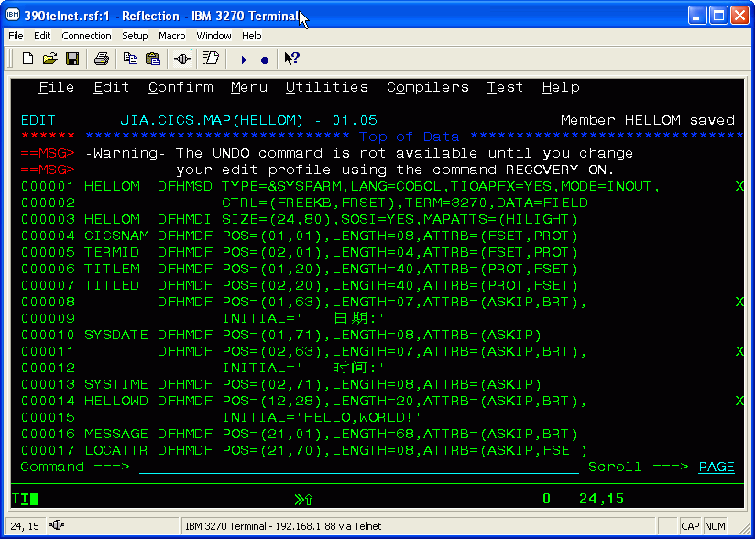
STEP2:编译MAP MICRO.事实上会生成2个咚咚:一个叫做PHYSICAL MAP,一个叫做SYMBOLIC MAP. 请注意:PHYSICAL MAP是二进制文件,给CICS调用;而SYMBOLIC MAP是COPYBOOK,给COBOL程序引用里面的变量.
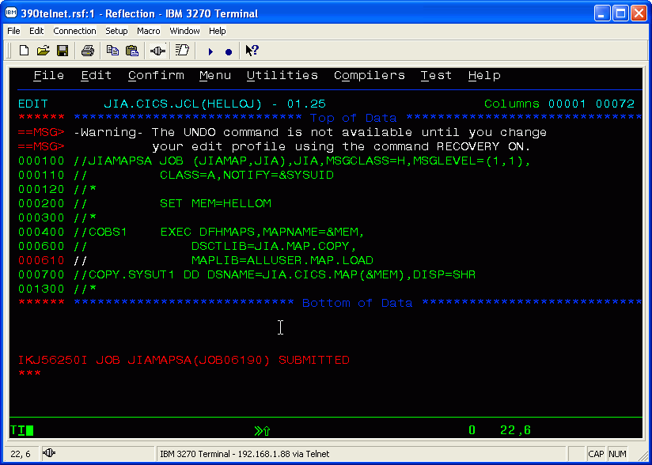
STEP3:下面进入CICS环境去定义刚才生成的MAP,命令CEDA DEF MAPSET(HELLOM) GROUP(TEST) ,为啥要这样定义呢?因为CICS是高层应用,它需要知道调用的MAP是指向外面的哪个程序.
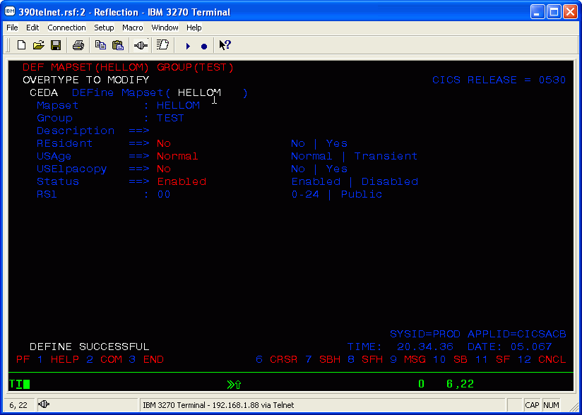
STEP4:定义完了以后要安装,用CEDA INS MAPSET(HELLOM) GROUP(TEST)
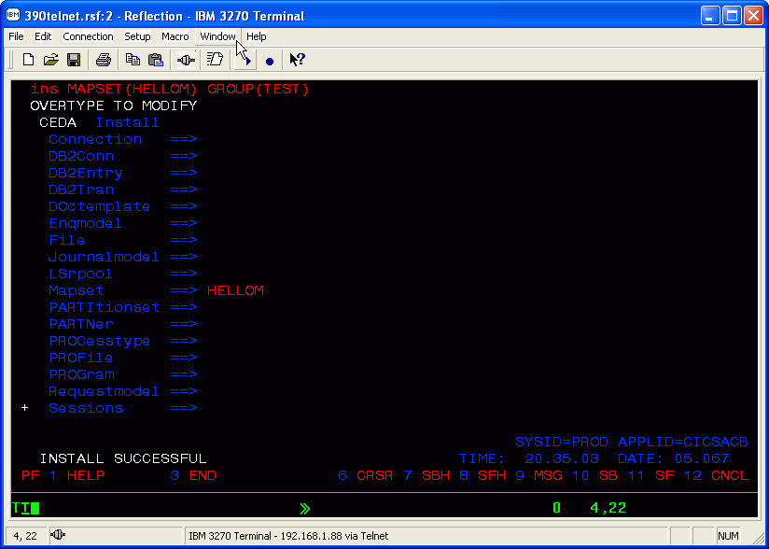
STEP5:开始编写Hello world的COBOL程序
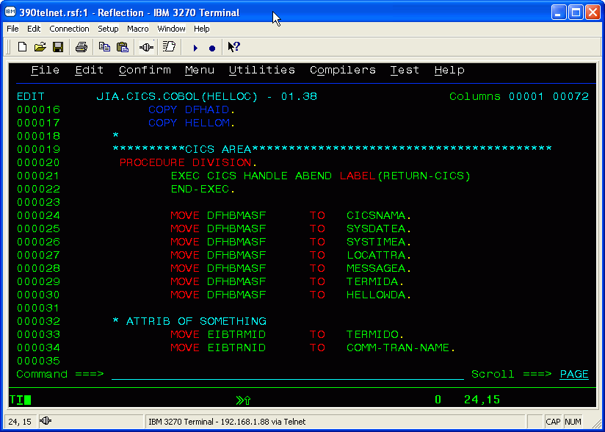
STEP6:编译cobol程序的作业流. 因为系统已经提供了一个proc名为DFHEITVL,因此作业流可以写得非常简单,这里请注意,有个参数'OUT=H'一定要写,否则编译出来的OUTPUT看不到编译过程和错误细节. 这一点是经过HUNTER大虾的帮助才明白的,让我少走了不少弯路
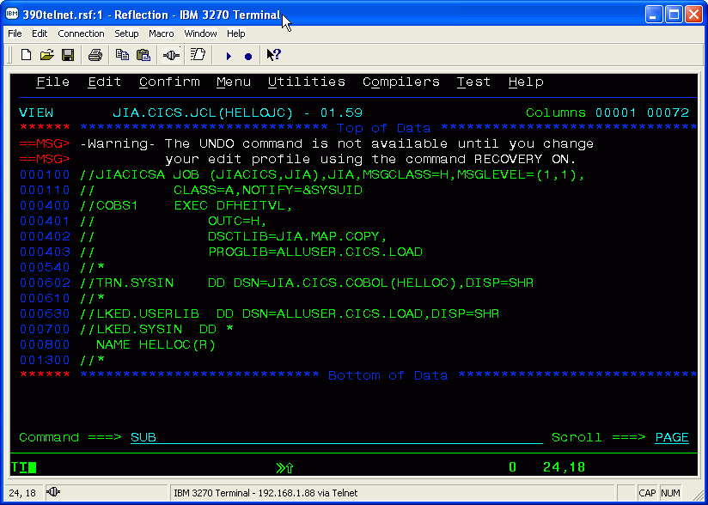
STEP7:程序编译完成,放在alluser.cics.load库下,此库已经定义到CICS启动作业流中,因此可以直接引用里面的module,也就是刚编译出来的HELLOC.这时候进入CICS, 用CEDA DEF PROG(HELLOC) GROUP(TEST)来定义程序. 和MAP的原理一样,CICS需要知道,在他自己CICS内部的程序名对应于哪个外部的MODULE
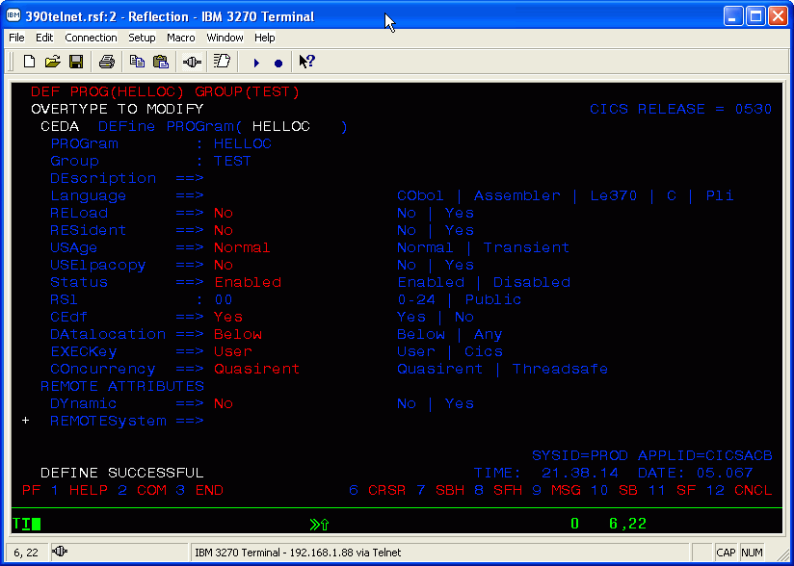
STEP8:和MAP一样,程序HELLOC定义完以后要安装,用CEDA INS PROG(HELLOC) GROUP(TEST)来安装
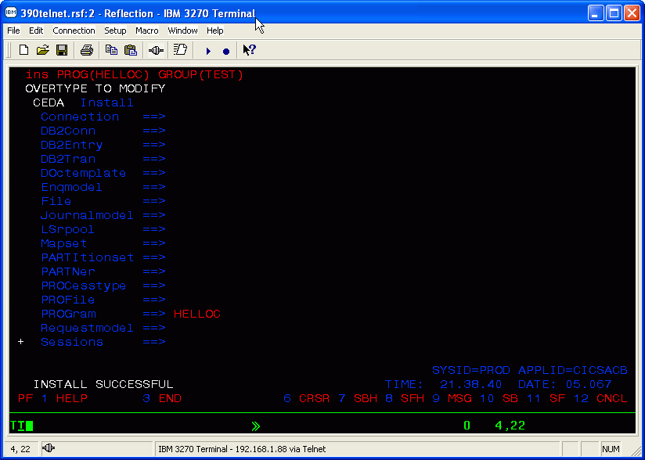
STEP9:这时候要定义一个CICS交易,命名为'HLLO'.此交易调用程序'HELLOC',用CEDA DEF TRANS(HLLO) PROG(HELLOC) GROUP(TEST)来定义
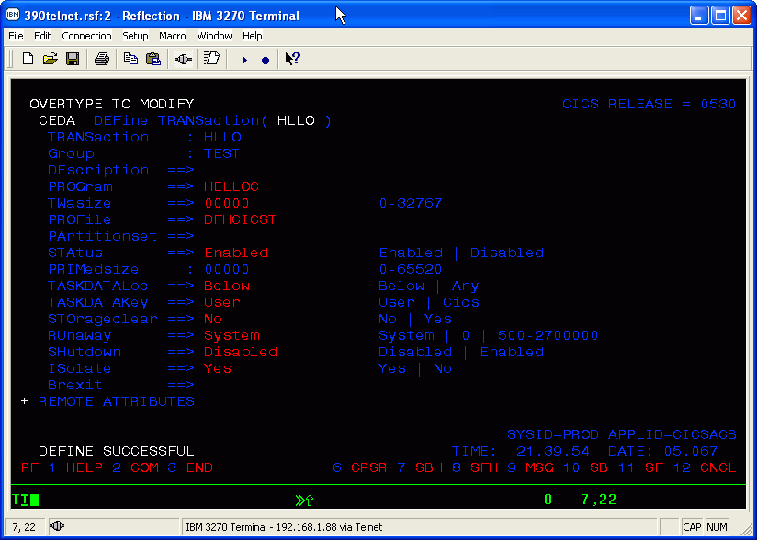
STEP10:同理,定义完交易以后要安装,用CEDA INS TRANS(HLLO) GROUP(TEST)
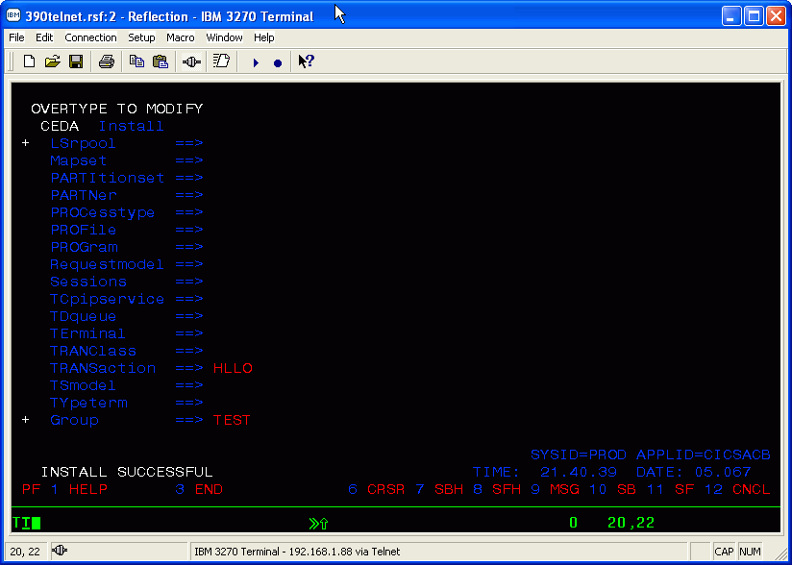
STEP11:最后一步,运行交易HLLO,哈哈!终于看到画面了...试试看能否响应你的键盘输入? F1,F7,F8.... br>
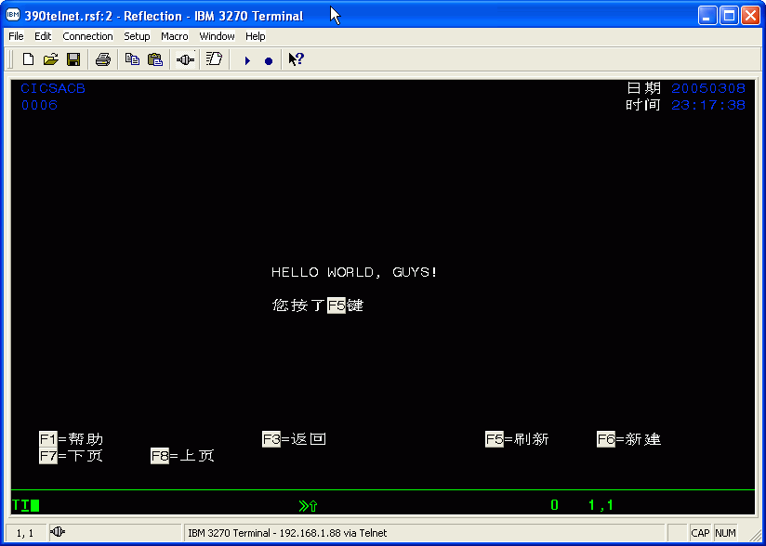
****************************************************＊＊＊＊＊＊＊＊＊
经过前面基础知识入门的朋友,一定想知道典型的ONLINE程序是如何的. 下面的文章即将展现最典型的基于CICS,COBOL,DB2和MAPS MICRO的交易 ---纪录加油的交易. 此交易具有所有银行应用的功能,包括上下翻屏,增加/显示/修改/拷贝 数据库记录.
STEP1:首先我们要先规划一下要做的事情:两张MAP和对应着的两个程序,分别是上下翻屏的画面和显示明细的画面; 两个CICS交易,分别对应着两个程序;4个JCL,分别编译MAPS和PROGRAMS;两个DB2 DBRM和一个PLAN; 两个CICS的DB2 ENTRY和DB2 TRANS.
其中MAPS,PROGRAMS,JCLS,TRANSACTIONS不需多说,前面基础入门的文章已经提到.在这里要提一下什么是DB2 DBRM, PLANS和CICS DB2 ENTRY & DB2 TRANS.
DB2 DBRM: 负责进行程序和数据库之间的交流,可以打开DBRM来看看,看到的是一些SQL语句,比如SELECT, CURSOR等等
PLANS: 一个PLANS可以包含多个DBRM或者PACKAGE.PLAN里面包括一些授权信息,这可以理解为运行程序的时候需要以某种权限去访问数据库,比如SELECT权限,UPDATE权限等.
CICS DB2 ENTRY & DB2 TRANS: 要让CICS和外部的DB2进行通讯,除了要定义DB2 CONNECTION之外,还需要定义DB2 ENTRY & TRANS. 其中DB2 ENTRY里面定义了ENTRY名字,所属GROUP名字,还有要用到的PLAN名字; DB2 TRANS定义了该交易对应于CICS里面哪个已定义的交易,以及要用到的DB2 ENTRY名字.有了这两个定义,CICS内部交易就可以访问外部数据库了.
STEP2: COBOL程序里面要实现上下翻屏,不能像AS/400 RPG+DISPLAY FILES那样简单定义SUBFILE,而必须要自己写出算法.一般来说是定义SQL CURSOR,在打开CURSOR的时候每次读几条记录,然后记录下第一条和最后一条记录,以便下一次上下翻屏,实例如下
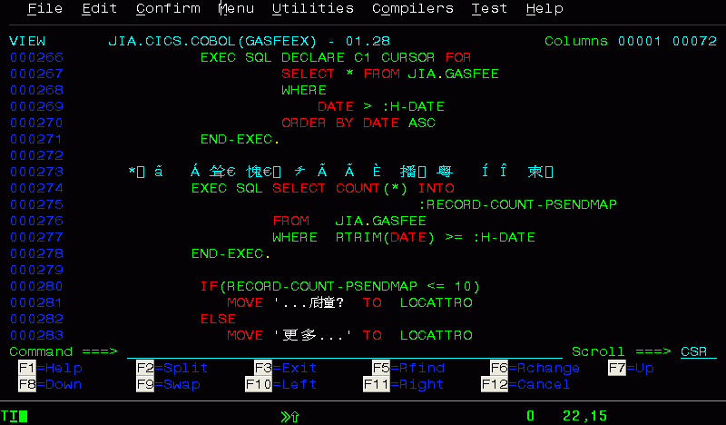
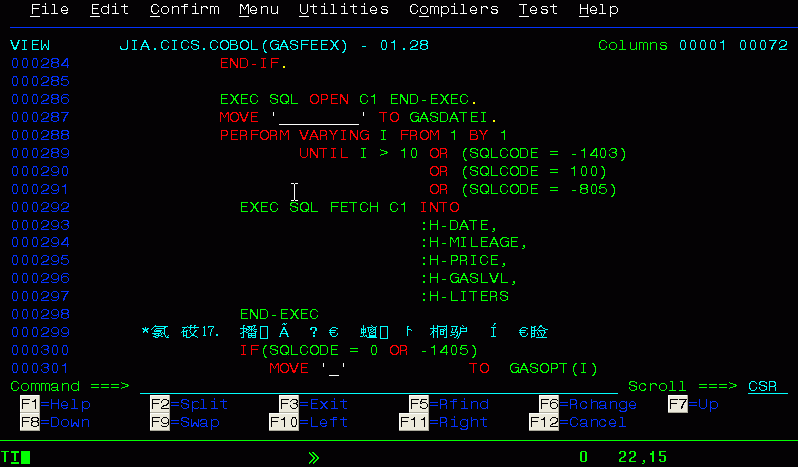
STEP3:编写上下翻屏屏幕文件和显示明细文件如下 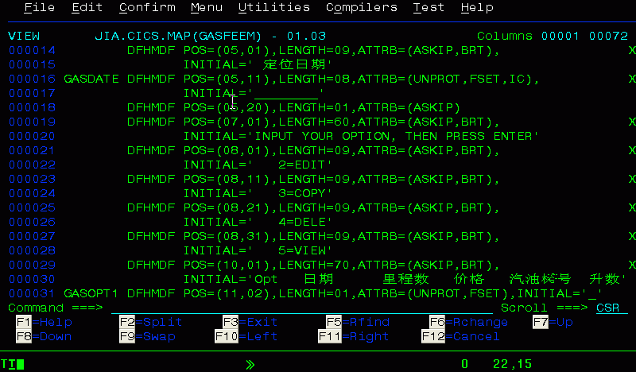
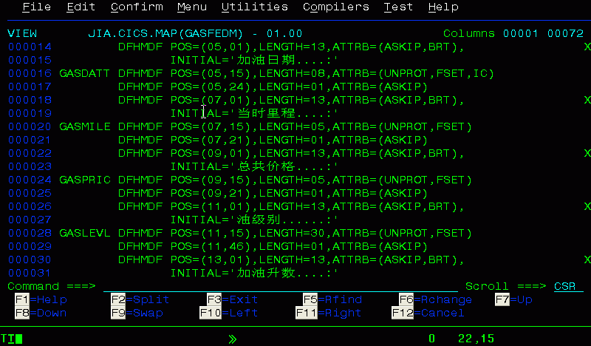
STEP4:编写主控程序,实现上下翻屏; 编写显示明细程序. 在这里要请读者注意程序之间调用的几个方法: XCTL, LINK和RETURN的区别. 一般来说,CICS RETURN(TRANSID)是表示在CICS TRANSACTION结束之后,下一个即将运行的交易的名字.请注意是'即将',就是说,RETURN之后,实际上交易已经不占用内存和CPU资源. 另外就是XCTL和LINK: XCTL是把控制权交给另外一个程序,XCTL有点像GOTO,去了就不回来了.而LINK是相当于执行一个子程序,执行完之后还是会回来的.
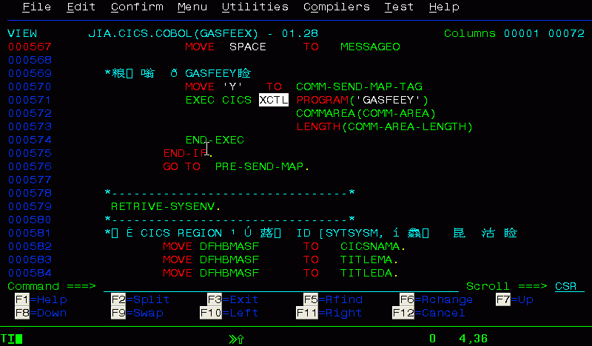
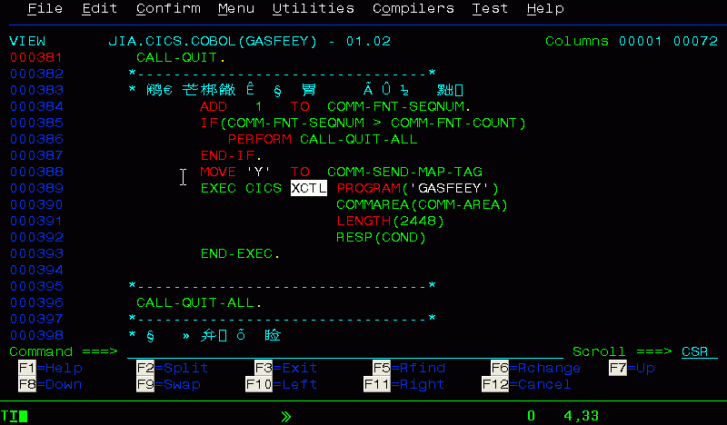
STEP5:MAP的编译作业流在这里就不再多说,前面入门的文章已经有说明;这里要说的是COBOL的编译作业流.这个作业流包括预编译SQL,预编译CICS,LINK和BIND等过程. 这里的BIND是把两个程序相关的DBRM都一起BIND进来了，如果相关程序多的话，也可以在ISPF菜单下用DB2I的BIND PLAN功能去做。
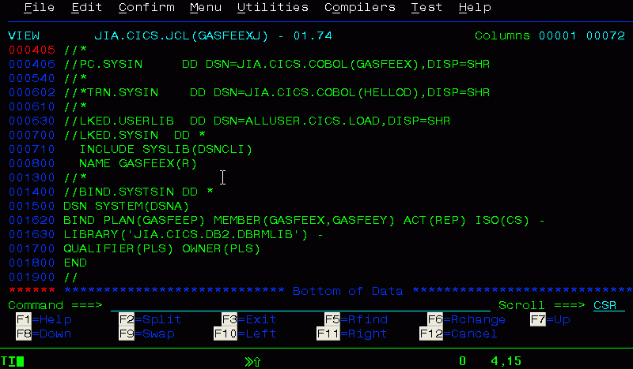
STEP6:在CICS下分别定义、安装MAPS,PROGRAMS,TRANSACTION，DB2 ENTRY, DB2TRANS，在这里给出DB2 ENTRY的画面
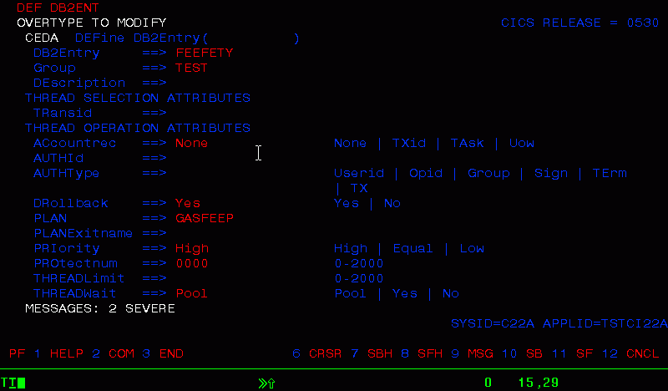
STEP7:相关功能演示:
入口画面 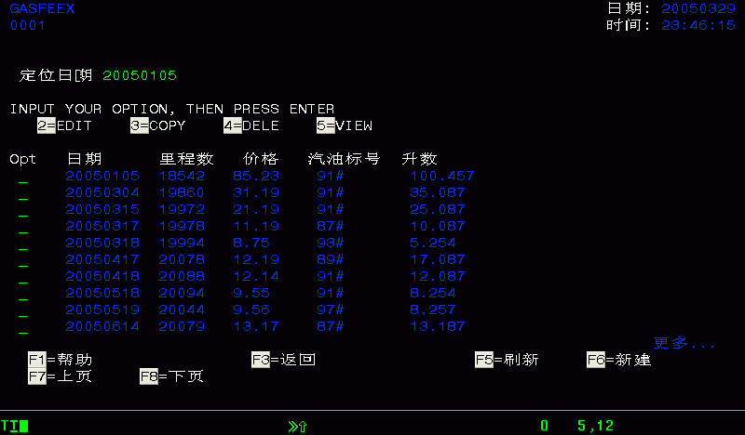
向下翻屏 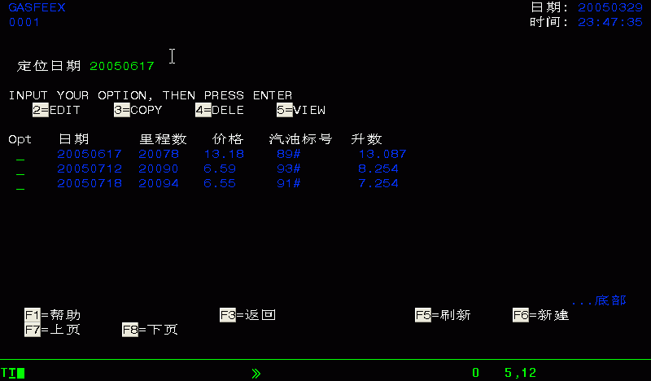
显示明细 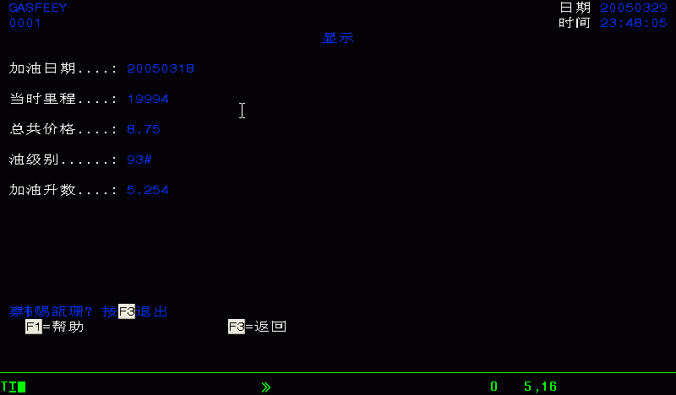
编辑明细 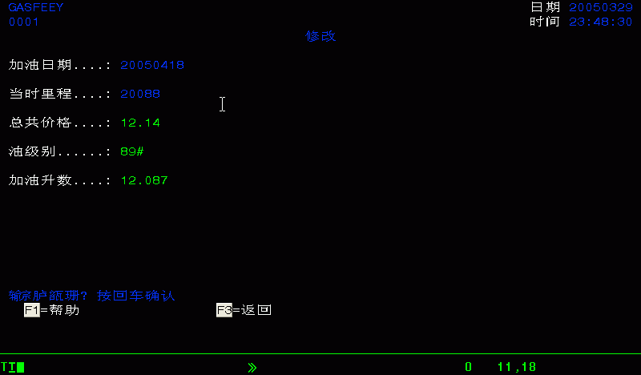
删除 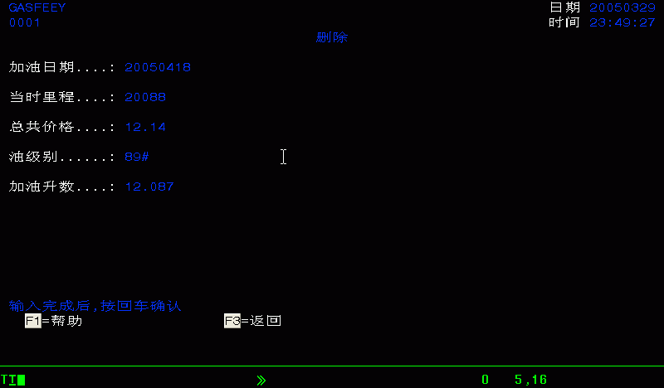
新建 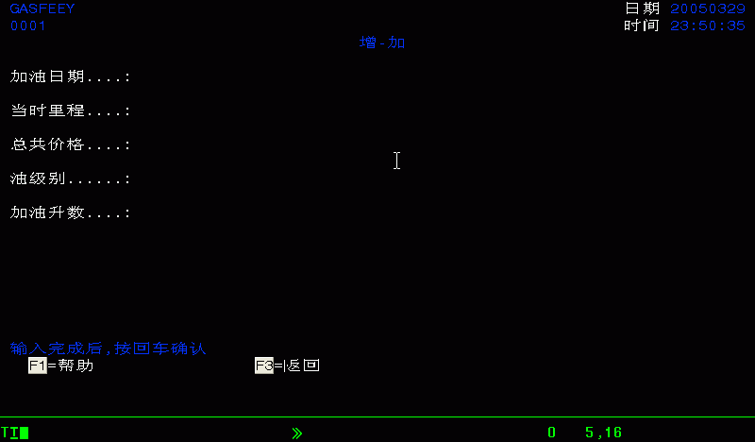
拷贝 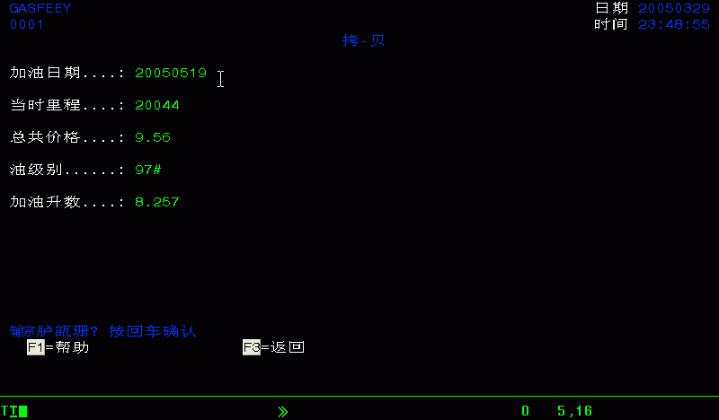
如何在OS/390上创建新文件
很多时候我们都需要自己的PDS 文件，下面是几种常用的PDS文件：
1、JCL文件库，这是专门用来放自己的JCL作业的地方。
2、源文件库，这是专门用来放自己的源文件的地方，例如COBOL, 汇编和REXX文件等。
3、执行文件库，这是专门用来放自己的执行文件或者目标文件的地方，例如LOADLIB, LINKLIB, OBJECT文件等。
下面讲的是利用ISPF panel来建立自己的PDS文件。
第一步、登陆TSO
你应该会直接进入ISPF Primary Menu. 如下图所示
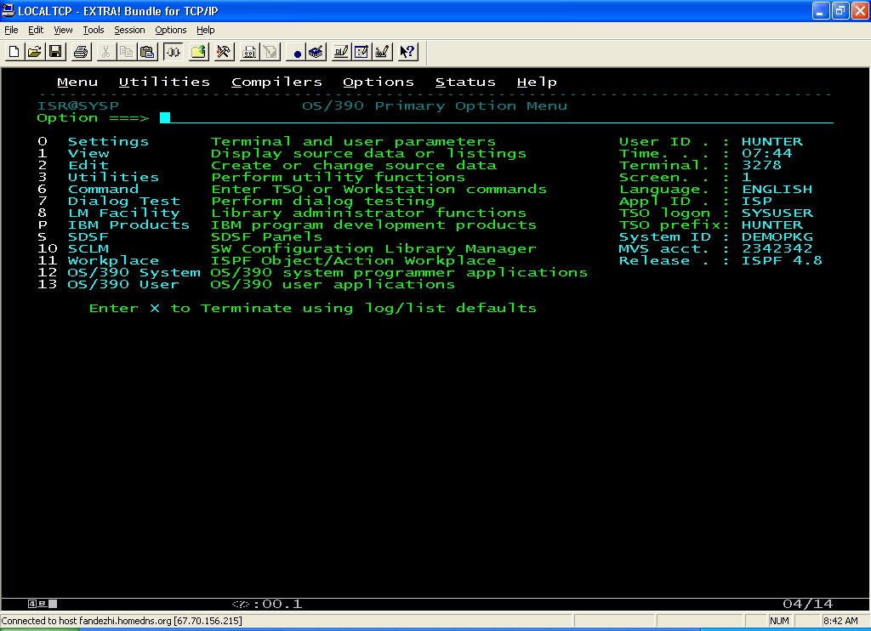
第二步、使用=3.2，直接进入Data Set Utility Panel
=3.2是一个简洁命令，此单个命令实现以下步骤：
1、=将转到ISPF Primary Menu。
2、3将进入Option 3 (Utilities)。
3、2将进入该Option(Utilities)下面的Option 2 (Data Set).
其他有用的简洁命令还有：
简洁命令 | 命令描述
=S | 进入SDSF
=S;H | 进入SDSF的HOLD Queue
=3.4 | 进入ISPF的文件列表菜单
=x;x; | 退出ISPF,进入TSO Prompt, 准备Logoff
下面是图例：
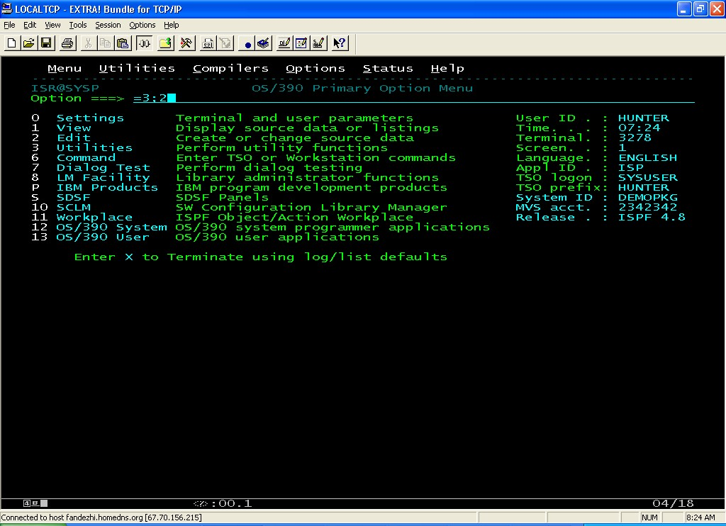
第三步、在Data Set Utility Panel中，在Option中输入A
即Allocate new data set，然在Data set name 下输入你要建立的新文件的名字。
注意一般应该冠以单引号，例如 'HUNTER.ASM.SOURCE’。
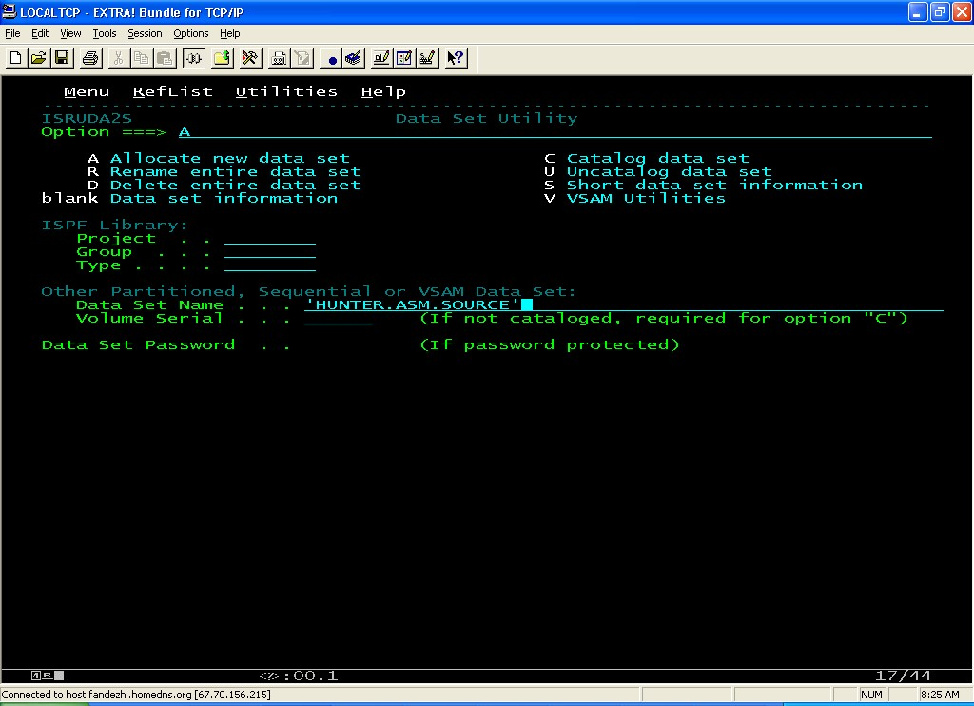
第四步、在Allocate New Data Set Panel中，输入你要建立的文件的参数
下面是建议的几种文件的参数设置：
源文件库，JCL文件库(SOURCE, JCL,REXX,CLIST)：
参数 | 建议的值
Management Class | blank
Storage Class | blank
Data Class | blank
SPACE UNIT | TRACK
Primary Quantity | 60
Secondary Quantity | 45
Directory Blocks | 30
Record Format | FB
Record Length | 80
Block Size | blank
Data set name type | LIBRARY
执行文件库(LOADLIB,OBJECT,LINKLIB)：
参数 | 建议的值
Management Class | blank
Storage Class | blank
Data Class | blank
SPACE UNIT | TRACK
Primary Quantity | 60
Secondary Quantity | 45
Directory Blocks | 30
Record Format | U
Record Length | 0
Block Size | 23200
Data set name type | LIBRARY
顺序数据文件(DATA)：
参数 | 建议的值
Management Class | blank
Storage Class | blank
Data Class | blank
SPACE UNIT | TRACK
Primary Quantity | 60
Secondary Quantity | 45
Directory Blocks | 0
Record Format | FB
Record Length | 80
Block Size | blank
Data set name type | blank
下面是建立源文件的例子：
回车以后，该文件就应该建立起来了。
下面是建立源文件的例子，注意在屏幕右上方的Message “Data set allocated”.
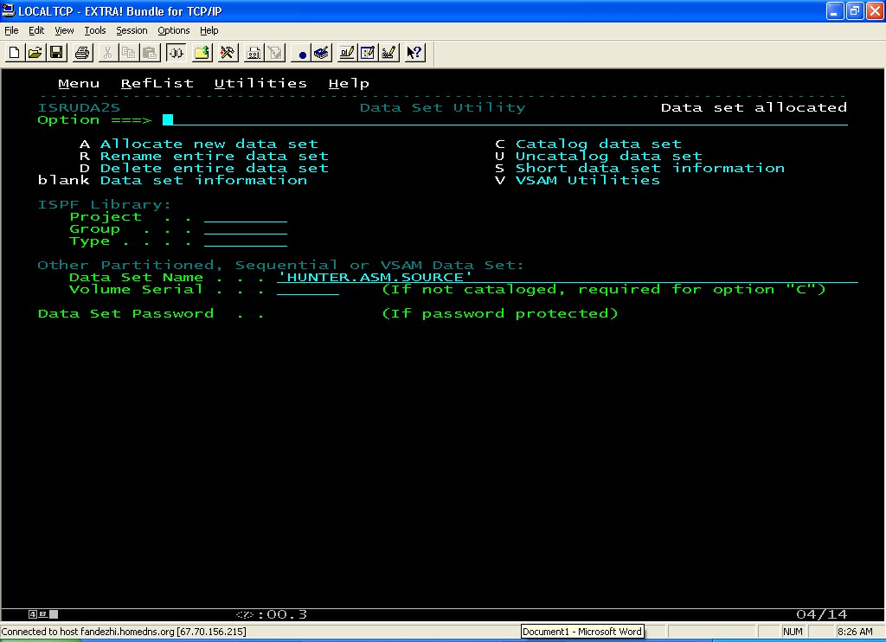
其他
在=3.2( Dataset Utility) 中，你还可以进行如下操作：
选项 | 功能
D | 删除文件
R | 给文件改名
C | Catalog 文件
U | Uncatalog 文件
V | 对VSAM文件进行操作(定义，删除等)
主机OS/390 汇编程序曾经风靡一时。它曾应用于很多商业应用系统，特别是联机应用系统。随着高级语言的普及，以及计算机硬件资源的成本日趋下降，汇编语言不再是人们开发的首选，但是汇编语言还是有它的优点，现在仍然有着它用武之处。汇编语言适合于下面的几个方面：
１、任务需要很快的执行速度，例如驱动程序，ASCII to EBCDIC 转换程序，EXIT程序等。
２、需要利用系统底层接口，例如JES2 Exits，和MVS的大部分接口。
３、一些ＭＶＳ系统只提供汇编语言接口，例如TCP/IP NPF Exit.
４、一些应用系统只提供汇编语言接口，例如用户的一些已有的系统的开发和维护的等。
此文的目的在于展现给大家如何在OS/390系统上开发一个简单的汇编程序。此文也适应于MVS系统和Z/OS 系统。
第一步、建立自己的库文件
首先你需要建立自己的文件库，下面的文件库是一般必须的：
1、汇编语言源文件库
2、JCL文件库
3、执行文件库
若想知道如何建立自己的这些文件，请参阅我的大作：
新手入门：如何在OS/390中建立自己的新文件
第二步、编写汇编程序”HELLO”
这是一个巨简单的汇编程序，显示“HELLO, THE WORLD!”.
按照下面步骤编辑该程序：
1、在ISPF中，输入=2, 进入Edit Entry Panel
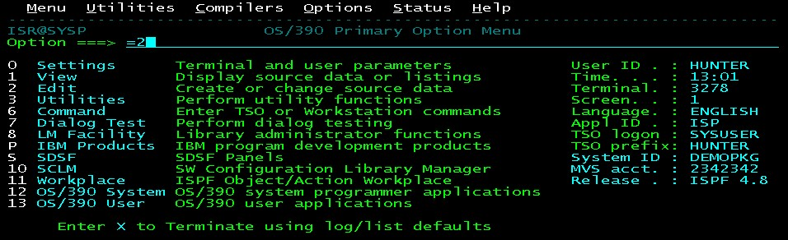
2、输入你的源文件名称和HELLO, 如下所示：
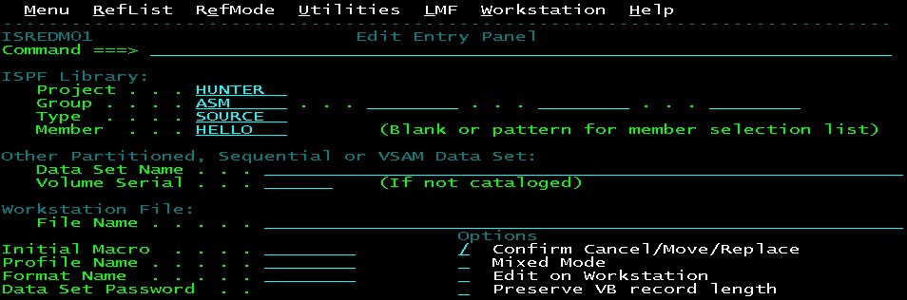
3、进入ISPF Edit Panel, 如下所示。
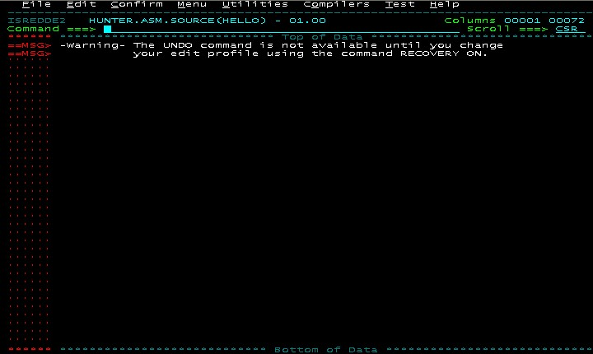
4、输入HELLO源程序。有关ISPF EDIT 的用法，请参照HELP(键入F1). 你也可以从这里拷过去(Copy/Paste)。 另外，建议使用ＨＩＬＩＴＥ ＯＮ命令使得程序易读。该命令同样适用于所有Ｍａｉｎｆｒａｍｅ的高级语言。
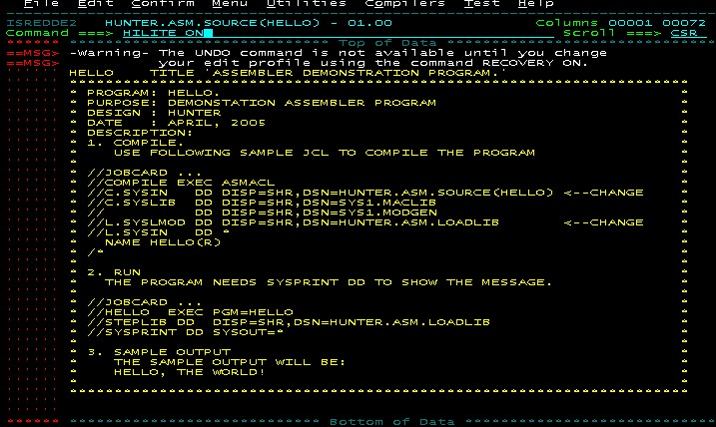
下面是这个HELLO的源程序：
HELLO TITLE 'ASSEMBLER DEMONSTRATION PROGRAM.' ********************************************************************* * PROGRAM: HELLO. * * PURPOSE: DEMONSTATION ASSEMBLER PROGRAM * * DESIGN : HUNTER * * DATE : APRIL, 2005 * * DESCRIPTION: * * 1. COMPILE. * * USE FOLLOWING SAMPLE JCL TO COMPILE THE PROGRAM * * * * //JOBCARD ... * * //COMPILE EXEC ASMACL * * //C.SYSIN DD DISP=SHR,DSN=HUNTER.ASM.SOURCE(HELLO) <--CHANGE * * //C.SYSLIB DD DISP=SHR,DSN=SYS1.MACLIB * * // DD DISP=SHR,DSN=SYS1.MODGEN * * //L.SYSLMOD DD DISP=SHR,DSN=HUNTER.ASM.LOADLIB <--CHANGE * * //L.SYSIN DD * * * NAME HELLO(R) * * /* * * * * 2. RUN * * THE PROGRAM NEEDS SYSPRINT DD TO SHOW THE MESSAGE. * * * * //JOBCARD ... * * //HELLO EXEC PGM=HELLO * * //STEPLIB DD DISP=SHR,DSN=HUNTER.ASM.LOADLIB * * //SYSPRINT DD SYSOUT=* * * * * 3. SAMPLE OUTPUT * * THE SAMPLE OUTPUT WILL BE: * * HELLO, THE WORLD! * * * ********************************************************************* HELLO CSECT * DEFINE REGISTER EQUALS USING IBM STANDARD MACRO YREGS * YREGS * BUILD UP BASE REGISTERS FOR THE PROGRAM * USING HELLO,R15 ;R15 IS CURRENT ADDRESS, USING IT SAVE (14,12) ;SAVE CALLER'S REGISTERS USING SAVE LR R12,R15 ;COPY THE CURRENT CSECT LOCATION DROP R15 ;DROP THE TEMPORARY USING USING HELLO,R12 ;USE R12 AS BASE REG FROM NOW ON * BUILD LINKAGE OF THIS PROGRAM AND THE CALLER. ST R13,SAVEAREA+4 ;SET OUR BACKWARD LINK IN OUR SAVE LA R15,SAVEAREA ;LOAD ADDR OF OUR SAVEAREA TO R15 ST R15,8(R13) ;SET CALLER(MYSELF)'S FORWARD LINK LR R13,R15 ;LOAD OUR SAVEAREA ADDR TO R13. * MAIN PROGRAM BEGINS HERE OPEN (SYSPRINT,(OUTPUT)) ;OPEN THE SYSPRINT FILE. PUT SYSPRINT,HELLOMSG ;WRITE THE MESSAGE CLOSE SYSPRINT ;CLOSE SYSPRINT FILE * RETURN LINKAGE TO THE CALLER L R13,4(R13) ;LOAD ADDR OF CALLER'S SAVEAREA RETURN (14,12),RC=0 ;RESTORE CALLER'S REGS AND RETURN * STATIC STORAGE AREA SAVEAREA DS 18F ;REGISTER SAVE AREA HELLOMSG DC CL133' HELLO, THE WORLD!' SYSPRINT DCB DSORG=PS,MACRF=PM,DDNAME=SYSPRINT,RECFM=FBA,LRECL=133 END HELLO
第三步、编译汇编程序”HELLO”
在你的JCL库中，建立下面的JCL member HELLOCPL, 下面是编辑JCL步骤：
1、在ISPF中，输入=2, 进入Edit Entry Panel
2、输入你的JCL库文件和HELLOCPL。
3、进入ISPF Edit Panel。
4、输入JCL语句。有关ISPF EDIT 的用法，请参照HELP(键入F1). 你也可以从这里拷过去(Copy/Paste)。
使用下面的JCL HELLOCPL 来编译这个程序：
//youridCP JOB (),YOUR.NAME,MSGCLASS=H,MSGLEVEL=(1,1), // CLASS=A,NOTIFY=&SYSUID //***************************************************************//COMPILE EXEC ASMACL //C.SYSIN DD DISP=SHR,DSN=HUNTER.ASM.SOURCE(HELLO) ? CHANGE!!//C.SYSLIB DD DISP=SHR,DSN=SYS1.MACLIB // DD DISP=SHR,DSN=SYS1.MODGEN //L.SYSLMOD DD DISP=SHR,DSN=HUNTER.ASM.LOADLIB ? CHANGE!!//L.SYSIN DD * NAME HELLO(R) /*
下面是如何察看编译结果：
1、使用=S;H到SDSF的HOLD Queue中。
2、使用命令PREFIX yourid* 显示所有输出。
3、使用命令SORT CRDATE D 显示最近的输出在开头。
4、在作业youridCP的行命令处输入?
5、在DDNAME SYSPRINT行命令处输入S, 你将看到编译的输出。假若有错误信息，使用命令F ASMA和F5键来查看错误信息。
第四步、运行汇编程序”HELLO”
在你的JCL库中，建立下面的JCL member HELLOCPL, 下面是编辑JCL：
1、SPF中，输入=2, 进入Edit Entry Panel
2、输入你的JCL库文件和HELLORUN。
3、进入ISPF Edit Panel。
4、输入JCL语句。有关ISPF EDIT 的用法，请参照HELP(键入F1). 你也可以从这里拷过去(Copy/Paste)。
使用下面的JCL HELLORUN运行这个程序：
//youridRN JOB (),YOUR.NAME,MSGCLASS=H,MSGLEVEL=(1,1), // CLASS=A,NOTIFY=&SYSUID //HELLO EXEC PGM=HELLO //STEPLIB DD DISP=SHR,DSN=HUNTER.ASM.LOADLIB <-- CHANGE!!//SYSPRINT DD SYSOUT=*
该程序的执行结果将在该程序的执行结果将保存在SYSPRINT DD中。下面是如何察看执行结果：
1、使用=S;H到SDSF的HOLD Queue中。
2、使用命令PREFIX yourid* 显示所有输出。
3、使用命令SORT CRDATE D 显示最近的输出在开头。
4、在作业youridRN的行命令处输入?
5、在DDNAME SYSPRINT行命令处输入S，你将看到下面的程序输出： HELL, THE WORLD!
调试汇编程序
在程序编译出问题时，可以到编译的SYSPRINT 输出中，查找ASMA关键字，来查看有关错误信息。错误信息可以到下面网站查找到解释： HLASM Users Guide
当程序运行出错时，使用以下方法：
1、程序ABEND，在程序输出中找到ABEND Code 和Reason, 然后到下面网站查找： MVS System Codes
2、使用SYSPRINT 输出，将向查看的数据输出到SYSPRINT DD中。
3、使用WTO信息。该方法适合于测试程序运行的逻辑路径，例如测试程序是否执行到了此处。下面的一段程序在HELLO中加入两个WTO信息：
WTO 'SHOW HELLO MESSAGE.' ；SHOW DEBUG MESSAGE OPEN (SYSPRINT,(OUTPUT)) ;OPEN THE SYSPRINT FILE PUT SYSPRINT,HELLOMSG ;WRITE THE MESSAGE CLOSE SYSPRINT ;CLOSE SYSPRINT FILE WTO 'END OF HELLO MESSAGE.' ；SHOW DEBUG MESSAGE
Mainframe主机系统之间的文件传输方式很多。下面的方法适应于MVS, OS/390和Z/OS系统。
最常见的有以下几种情况：
1、两个系统在同一个Sysplex中。
2、两个系统共享磁盘。
3、两个系统相互独立。
下面分别就每种方式的文件传输加以介绍。
两个系统在同一个Sysplex中
这两个系统共享同一个Catalog，所有文件都是共享的，所以不存在文件传输的问题。
两个OS/390系统共享磁盘
方法一
假如两个系统是彼此独立，但是共享磁盘，而且各自有不同的磁盘卷(VOLSER)和Catalog name。
这种情况下可以使用Import Catalog的方法来拷贝文件：
1、将目的系统的Ｃａｔａｌｏｇ卷Ｏｎｌｉｎｅ
２、ＩＭＰＯＲＴ目的系统的Ｃａｔａｌｏｇ
３、利用ＤＳＳ拷贝文件
４、ＥＸＰＯＲＴ目的系统的Ｃａｔａｌｏｇ
５、将目的系统的Ｃａｔａｌｏｇ卷Ｏｆｆｌｉｎｅ
下面的例子将生产系统的IODF文件(VSAM)拷贝到测试系统。IODF文件存在于Master Catalog中。
该作业在生产系统上执行。
方法二
对于不需要Ｃａｔａｌｏｇ的文件，例如Sequential, PDS等类型文件，也可以使用共享卷来拷贝。
不共享Ｃａｔａｌｏｇ的系统可以使用一个共享卷，该卷在两个系统同时Ｏｎｌｉｎｅ．
下面的拷贝的步骤：
１、在第一个系统，将文件先拷到共享卷上。
２、在第二个系统，将文件从共享卷拷走。
３、在第一个系统，将共享卷上的文件删除。
两个相互独立的OS/390系统
下面主要介绍当两个系统不共享磁盘，例如两个单位的不同主机系统的情况下的文件传输。
这里是大概的步骤：
第一，将要拷的文件用DSS打包到一个文件中，有点像WinZIP。
第二，用TSO XMIT命令将该文件转换成可以传输的格式。
第三，将该文件传到另外一个ＯＳ/390系统上。
第四，用TSO RECEIVE命令将该文件还原为DSS格式。
第五，用DSS将文件还原。
这里是作业的实例：
首先，将要拷的文件用DSS打包到一个文件中
用DSS的好处是同时可以拷多个不同格式的文件，而且使用压缩来节省磁盘。
下面的例子将文件打包到文件SP2487.FILE.DUMP中。
第二，用TSO XMIT命令将该文件转换成可以传输的格式
使用ＴＳＯ的ＴＲＡＮＳＭＩＴ命令将该ＤＳＳ ＤＵＭＰ文件转换成ＸＭＩＴ格式。
１、在ＩＳＰＦ中，使用=6命令到ＴＳＯ命令提示中。
２、使用下面命令:
xmit jes2node.userid dataset('source.dataset') outdsn('xmitout.dataset')
下面是该命令的注释:
参数 | 参数描述
jes2node | 这是你当前系统的ＪＥＳ２ ＮＯＤＥ Ｎａｍｅ． 通过下面的方法得到你的ＪＥＳ２ ＮＯＤＥ Ｎａｍｅ：  到ＳＤＳＦ中，使用ｎｏｄｅ命令，(例如=S;NODE)，或者使用ＭＶＳ命令$D NODE  Ｓｔａｔｕｓ属于ＯＷＮＮＯＤＥ的NodeName就是你当前系统的ＪＥＳ２ Ｎｏｄｅｎａｍｅ. 例如PRODSYS1  SDSF NODE的输出示例：  JES2 命令'$D NODE'的输出示例：  Display Filter View Print Options Help -------------------------------------------------------------------------------SDSF SYSLOG 4317.101 OFD1 OFD1 04/25/2005 0W 29334 COLUMNS 1 80 COMMAND INPUT ===> /$D NODE SCROLL ===> CSR$HASP826 NODE(1) 886 $HASP826 NODE(1) NAME=PRODSYS1,STATUS=(OWNNODE), $HASP826 AUTH=(DEVICE=YES,JOB=YES,NET=NO,SYSTEM=YES), $HASP826 TRANSMIT=BOTH,RECEIVE=BOTH,HOLD=NONE, $HASP826 PENCRYPT=NO,ENDNODE=NO,REST=0,SENTREST=ACCEPT, $HASP826 COMPACT=0,LINE=0,LOGMODE=,LOGON=0, $HASP826 PASSWORD=(VERIFY=(SET),SEND=(FROM_OWNNODE)), $HASP826 PATHMGR=YES,PRIVATE=NO,SUBNET=,TRACE=YES  -------------------------------------------------------------------------------SDSF NODE DISPLAY SYS9 OSHAWA1 N1 LINE 1-5 (5) COMMAND INPUT ===> SCROLL ===> CSR NP NUMBER NodeName Status Authority Trans Recv Hold N1 PRODSYS1 OWNNODE (D=Y,J=Y,N=N,S=Y) BOTH BOTH NONE N2 TESTSYS1 UNCONNECTED (D=Y,J=Y,N=N,S=Y) BOTH BOTH NONE N3 N3 UNCONNECTED (D=Y,J=Y,N=N,S=Y) BOTH BOTH NONE N4 N4 UNCONNECTED (D=Y,J=Y,N=N,S=Y) BOTH BOTH NONE N5 N5 UNCONNECTED (D=Y,J=Y,N=N,S=Y) BOTH BOTH NONE
ｕｓｅｒｉｄ | 这是你当前使用的TSO用户名，例如SP2487。
source.dataset | 这是你要转换的源文件名, 例如SP2487.FILE.DUMP。
xmitout.dataset | 这是经XMIT转换以后的文件名称, 例如SP2487.FILE.XMIT。
例子：
xmit prodsys1.sp2487 dataset('sp2487.file.dump') outdsn('sp2487.file.xmit')
注意XMIT生成的文件的属性是： RECFM=FB,LRECL=80,BLKSIZE=3120 。在另一个系统上的XMIT文件一定要有与此相同的文件属性。
第三、将该文件传到另外一个ＯＳ/390系统上
两个系统在同一个网络中
当两个系统在同一个网络中时，最常用的方法是利用FTP。
下面是从源系统执行FTP命令的例子：
=6到ISPF的TSO命令行，执行下面FTP命令：
这个FTP命令会把源文件的属性传给目标文件。
两个系统在不再同一个网络中
1、用FTP将该文件从OS/390上传到你的PC上，刻一个CD或软盘。
此时注意要使用BINARY的方式下载源文件：
2、将该CD或者软盘上的文件上传到另一个OS/390上。
使用下面的FTP命令将PC上的文件传到主机上：
ftp os390s2.company.comtso tsouserpasswordbinaryquote site RECFM=FB LRECL=80 BLKSIZE=3120 quote site CYLINDERS PRIMARY=100 SECONDARY=100put c: empdssdump.xmi 'hunter.file.xmit' quit
第四，用TSO RECEIVE命令将该文件还原为DSS格式
在目的系统上，使用下面的命令将XMIT文件还原为DSS 的DUMP文件:
这样，DSS文件就恢复到了目的系统上。
第五，用DSS将文件还原
在目的系统上，你可以使用下面的作业将DUMP文件中的所有文件恢复到目的系统上。
很多时候由于两个系统的HLQ(Higher Level Qualifier, 第一级文件名) 定义不一致。这时需要将一些文件的HLQ改名，可以使用下面的作业：
在此例子中，作业将所有以SP2487开头的文件(或者HLQ为SP2487)的文件恢复，并将他们的HLQ改为HUNTER。
总结
以上总结了在不同情况下，在两个Mainframe系统之间进行文件传递的方法。

//**************************************************//RESTORE EXEC PGM=ADRDSSU //SYSPRINT DD SYSOUT=* //DUMPFILE DD DISP=SHR,DSN=HUNTER.FILE.DUMP //DASD DD DISP=OLD,UNIT=SYSDA,VOL=SER=TSTMCT //SYSIN DD * RESTORE DATASET(INCLUDE(SP2487.**)) - RENAMEU(HUNTER) - INDDNAME(DUMPFILE) - OUTDDNAME(DASD) - CATALOG /*
//**************************************************//RESTORE EXEC PGM=ADRDSSU //SYSPRINT DD SYSOUT=* //DUMPFILE DD DISP=SHR,DSN=HUNTER.FILE.DUMP //DASD DD DISP=OLD,UNIT=SYSDA,VOL=SER=TSTMCT //SYSIN DD * RESTORE DATASET(INCLUDE(**)) - INDDNAME(DUMPFILE) - OUTDDNAME(DASD) - CATALOG /*
receive indsn('hunter.file.xmit')dataset('hunter.file.dump')
ftp os390s1.company.comtso tsouserpasswordbinaryget 'sp2487.file.xmit' c: empdssdump.xmiquit
ftp os390s2.company.comtso tsouserpasswordput 'sp2487.file.xmit' 'hunter.file.xmit'quit
//DELETE EXEC PGM=IDCAMS //SYSPRINT DD SYSOUT=* //SYSIN DD * DELETE SP2487.FILE.DUMP IF LASTCC<=8 THEN SET MAXCC=0 //* //BACKUP EXEC PGM=ADRDSSU,COND=(0,NE) //SYSPRINT DD SYSOUT=* //DUMPDS DD DISP=(NEW,CATLG),// UNIT=SYSDA,RECFM=U,LRECL=32760,// SPACE=(CYL,(100,100),RLSE), <--- CHANGE // VOL=SER=SYSWRK, <--- CHANGE// DSN=SP2487.FILE.DUMP <--- CHANGE//SYSIN DD * <--- CHANGE DUMP DATASET(INCLUDE( - SYS1.IPLPARM - SYS1.PARMLIB - SYS1.TCPPARMS - SYS1.USER.** - SP2487.ZHOUGH.JCL - SP2487.ZHOUGH.REXX - SP2487.ASM.** - )) - OUTDDNAME(DUMPDS) - TOLERATE(ENQF) - COMPRESS /*
//*********************************************************************//* VARY THE MASTER CATALOG VOLUME OF TEST SYSTEM ONLINE //*********************************************************************//ONLINE EXEC PGM=IKJEFT01,PARM='VARY 2102,ONLINE' //SYSEXEC DD DISP=SHR,DSN=SYS1.USER.CMDPROC //SYSTSPRT DD SYSOUT=* //SYSTSIN DD DUMMY //*********************************************************************//* IMPORT TEST SYSTEM MASTER CATALOG TO PRODUCTION SYSTEM. //*********************************************************************//IMPTMCAT EXEC PGM=IDCAMS //SYSPRINT DD SYSOUT=* //SYSIN DD * IMPORT CONNECT OBJECTS((SYS1.TEST.MASTCAT - VOLUMES(TSTMCT) DEVICETYPE(3390))) /* //*********************************************************************//* COPY THE PRODUCTION IODF DATASET FROM PRODUCTION TO TEST SYSTEM. //*********************************************************************//COPYIODF EXEC PGM=ADRDSSU //SYSPRINT DD SYSOUT=* //SYSIN DD * COPY DATASET(INCLUDE(SYS1.IODF00.CLUSTER)) - INDYNAM(SYSMCT) OUTDYNAM(TSTMCT) - RECAT(SYS1.TEST.MASTCAT) TOL(ENQF) REPLACE /* //*********************************************************************//* EXPORT TEST SYSTEM MASTER CATALOG FROM PRODUCTION SYSTEM. //*********************************************************************//EXPTMCAT EXEC PGM=IDCAMS //SYSPRINT DD SYSOUT=* //SYSIN DD * EXPORT SYS1.TEST.MASTCAT DISCONNECT /* //*********************************************************************//* VARY TARGET MASTER CATALOG VOLUME OFFLINE //*********************************************************************//OFFLINE EXEC PGM=IKJEFT01,PARM='VARY 2102,OFFLINE' //SYSEXEC DD DISP=SHR,DSN=SYS1.USER.CMDPROC //SYSTSPRT DD SYSOUT=* //SYSTSIN DD DUMMY

