Bioinformatic Pipeline for Circular RNA Analysis
Leidy Alejandra González Molano
IDIBELL Bioinformatic Unit (IBU)
Jose Luis Mosquera Mayo
Jose Franscisco Abril Ferrando

Ciències Biomèdiques

SUMMARY
The study of circular RNAs (circRNAs) is a novel research area that have create rising expectations around the implications and possibilities that these molecules may offer. To gain further insight into their biology, RNA sequencing experiments have been conducted to profile their expression in both physiological and pathological conditions. However, the actual methods to analyse the resulting data from these high-throughput experiments have not been well integrated, generating a broad repertoire of circRNA-related tools which can easily increment the disparity between investigations, not to mention the difficulty to perform the computational analysis. Therefore, a bioinformatic pipeline has been constructed. The workflow consist in seven different modules, where each one attempts to implement the most current and efficient procedures to deeply study circRNAs from RNA-seq data.
LOGS ODS

covid 19 adapatation
ABBREVIATURES/GLOSSARY

Table of Contents
1 Introduction 1
2 Objectives 5
3 Methods 6
4 Results 13
5 Discussion 14
6 Conclusions 17
7 Bibliography 18

Introduction
Circular RNAs (circRNAs) are a type of RNA molecule that exists in a covalently closed ring and lacks a polyadenylated tail and five-prime cap (5’ cap) (1; 2). Initially, they were considered as a by-product of an aberrant splicing event, but in light of the investigations over the past decade, it has become clear that at least some circRNAs can play important roles in physiological and pathological conditions (3). Indeed, these molecules have been implicated in several human diseases, including diabetes mellitus, cancer, autoimmune and cardiovascular diseases (4). Furthermore, they have been pointed as promising biomarkers for pathological processes owing to their long-life cycle, cell- and tissue-specific enrichment and detection in various body fluids (3)(5).

Biogenesis
Most circRNAs are non-linear transcripts derived from known protein-coding genes, containing either a single or multiple exons (exonic circRNAs), a single intron (intronic circRNAs) or a combination of intron and exon molecules (exon-intron circRNAs). Among these types, exonic circular RNAs (ecircRNAs) are the predominant molecules since they account for the majority of the discovered circRNAs (4)(1).
Despite the uncertainty about the mechanism that underpin circRNA expression, a type of alternative splicing event, called back-splicing, has been proposed as the main mechanism of circRNA biogenesis (4)(1). Briefly, back-splicing event consist in the attachment of an upstream splice-acceptor(SA) site with a downstream splice-donor(SD) site, which differs from the canonical splicing that attaches an upstream SD site with a downstream SA site (5)(6). As a result (figure 1), a circular transcript is formed, containing a junction site between two exons oriented in a inverted order from their linear counterparts. This particular junction site contains a 3’-5’ phosphodiester bound and is called the back-spliced junction (BSJ) (1). In addition to BSJ, circRNAs also contain forward-spliced junctions (FSJ), which are the standard junction sites between two canonically spliced exons. Moreover, FSJ are also present in linear transcripts.

Regulation
Back-splicing can be regulated by cis and trans elements. Cis elements are mainly constituted by the intronic complementary sequences (ICS) included in introns flanking exon-deriving circRNAs. ICSs can derive from repetitive sequences such as Alu elements or from non-repetitive complementary sequences (1)(7; 2). These RNA pairs between ICSs are thought to boost circRNA formation by bringing distal splice sites into close proximity and hence promoting back-splicing event (1)(7). Furthermore, back-splicing can be also modulated by trans elements that regulate the biogenesis of circRNA by binding to ICSs in flanking introns or by directly bringing together distal splice sites (1)(7; 1; 2). This regulation is mainly conducted by RNA-binding proteins (RBPs) that form dimers or contain double-stranded RNA (dsRNA)-binding domains(dsRBDs). An example of RBPs could be the proteins quaking (QKI) and FUS, acting as dimers, and proteins such as the nuclear factor NF90 and NF110, containing dsRBDs (figure 1). Moreover, this second group of proteins containing dsRBDs might hamper circRNA formation by destabilizing RNA pairing,as it has been observed with the nuclear RNA helicase DHX9 (1)(7; 1; 2).
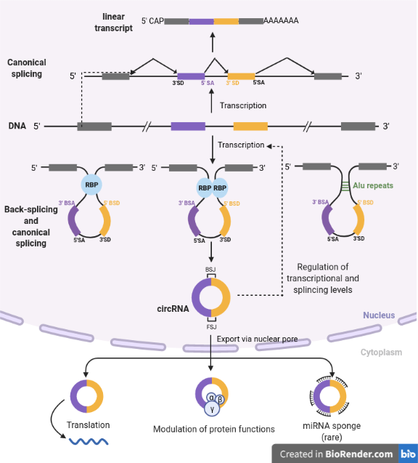Figure 1. circRNA at glance. During the biogenesis of RNA molecules, precursor mRNA(pre-mRNAs) can undergo either canonical splicing to generate linear transcripts (top) or back-splicing to generate circRNAs (bottom). The generation of circRNA produces back-spliced junction sites (BSJ) and it can be promoted either by cis elements (e.g. Alu repeats) or by trans elements (e.g. RNA binding proteins forming dimers or containing double-stranded RNA-binding sites). Additionally, circRNA formation also demands canonical splicing to merge forward-splicing junction sites (FSJ). The potential functions of circRNAs includes the regulation of both transcriptional and splicing levels, the modulation of protein functions, and in few cases, the function as either miRNA sponge or template for translation. Abbreviations: SD, splice-donor site, SA, splice-acceptor site, BSA, back-splicing acceptor site, BSD, back-splicing donor site, RBP, RNA-binding proteins, BSJ, back-spliced junction, FSJ, forward-spliced junction, circRNA, circular RNA, miRNA, micro-RNA. This image was created using BioRender.

Expression patterns and functions
Once the circular molecules have been synthesized in the nucleus, they are mainly exported to the cytoplasm. However, exon-intron and intron circRNA are frequently retained in the nucleus where they are thought to modulate the expression of their parental genes (6)(1; 2).
Circular RNAs molecules are expressed in all human tissues, presenting particular steady-state levels in different cell types (6)(2; 3). This particular pattern of expression have been correlated with the levels of nascent circRNAs (1)(7; 2).
In contrast to the poor efficiency of back-splicing (1-3% of the canonical), circRNAs can accumulate to high-levels post-transcriptionally owing to their high molecular stability. Their circular structure yield resistance to degradation by most RNA decay machineries.
Although much uncertainty about the molecular functions of the vast majority of circRNAs still exists, some non-coding functions has been suggested, including the regulation of both transcriptional and splicing levels, the modulation of protein functions and, in few cases, the function as miRNA sponges (1)(2; 3). Even so, cases where some circRNAs can as s template for protein translation have been reported (7; 2)(8), however, the function of circRNA-encode peptides is still fairly elusive (7; 2)(2; 8).

Characterization of circRNAs
To address the little scientific understanding of circRNAs, genome-wide experiments such as RNA sequencing (RNA-seq), have been the method of choice for profiling circRNA expression (7)(7; 1). RNA-seq allows the discovering and annotating of novel circRNAs, as it provides a set of candidates that can be further validated by locus-specific technologies, such as Nothern-Blot and Real-Time PCR (7)(1).

Experimental procedure
RNA-seq experiments aim to obtain the sequence of the RNA present in samples. The laboratory procedure of RNA-seq consists in the construction of a library and its subsequently sequencing. During the construction of the library, RNA-samples are purified following a protocol, fragmented, converted to cDNA and attached to adapters. Then, cDNA fragments tagged with adapters are amplified and sequenced (7; 1; 2)(9). The final result of this process is summarized in a special type of files, called fastq files, which contain data about the sequencing reads and their associated quality scores (figure 2) (7; 1; 2)(9).
However, to assess the identification of circRNA, fundamental considerations have to be taken in the experimental design of RNA-seq experiments. To begin with, owing to the lack of 3’ polyadenylated tail, most circRNAs cannot be detected in classical poly(A)-selected datasets (7; 1; 2)(7; 6) (fig. 2a). Therefore, it is important to implement other purification protocols that avoid the poly(A) purification library step, such as the Ribo⁻ RNA-seq protocol (fig. 2b), which removes ribosomal RNA and retains linear and circular transcripts. Other interesting protocol is the RNase R-treated RNA-seq (fig. 2c), which enriches RNA-samples with circRNAs by digesting linear mRNAs (7; 1; 2)(6).
In addition to the biochemical purification, the type of reads selected are important, as paired-end (PE) reads provide more information to reduce false positives, improving the performance of circRNA identification tools (1; 2)(10; 11). Another consideration to take into account during the experimental design is the sequencing depth and the length of the reads. Due to the low expression of circRNAs, to enable an acceptable prediction of circRNA reads a substantial sequencing depth and reads of at least 100-bp length is recommended (1; 2)(1).

Computational procedure
As stated above, the final results of RNA-seq experiments are fastq files, which contain data but not human-readable information about samples. Therefore, an intensive procedure of data analysis must be performed to obtain useful information about circRNAs. To being with, fastq files are typically submitted to a quality control process to remove low-quality reads and sequencing adapter residues. Afterwards, resulting reads are mapped and a further detection of circRNA is conducted.
More specifically, preprocessed RNA-seq reads are aligned to the available reference genome and two types of reads are generated (fig. 2d): 1) reads mapping within exons and 2) reads mapping to exon-exon junctions (chimeric reads) (2; 3)((2; 3)11; 12)(11; 12)(11; 13). Inside this last group, we can find either reads mapping to collinear exon-exon junction (FSJ) or scrambled exon-exon junction (BSJ). However, whereas reads spanning FSJ can be found in both circular and linear mRNAs, only reads spanning BSJ are exclusive from circRNAs and are reversibly aligned to the reference genome (7; 2)((7; 2)11; 12)(11; 12)(11; 13). Therefore, identification methods focus on capturing reads spanning BSJ as they allows to distinct circRNAs form their linear counterparts.

Objectives
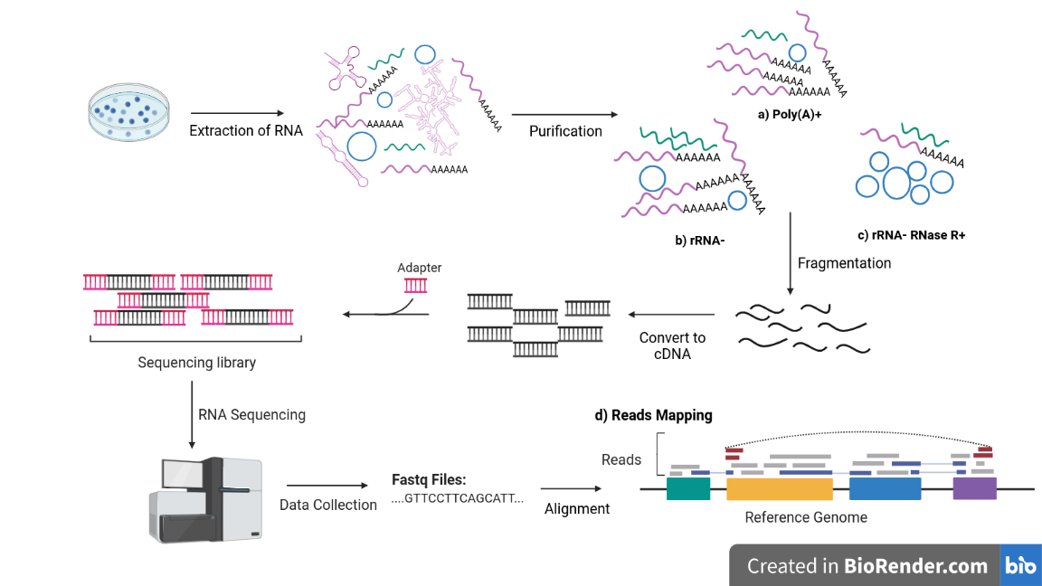
Figure 2. Standard RNA-seq workflow of circRNA study. In the first step, total RNA is extracted from a sample. Subsequently, RNA is purified following a particular protocol: (a) Poly(A)+ selection, (b) Depletion of ribosomal rRNA (rRNA-), (c) Digestion of both rRNA and linear mRNA by RNase R (rRNA- RNase R+). Afterwards, the selected population of RNA is fragmented and the resulting segments are retrotranscripted to generate cDNA. Then, cDNA fragments are attached with adapters, creating a sequencing library that will be amplified and sequenced. As a result, fastq files containing read information are generated. Tipically, those files are submitted to quality control programs and possible sequencing adapter residues and low-quality reads are removed (not shown). (d) Next, resulting reads are aligned to a reference genome, creating three situations : reads mapping within exons (grey), reads spanning collinear exon-exon junctions (blue), also called forward-spliced junctions (FSJ), and reads spanning scrambled exon-exon junctions (red), also called back-spliced junctions (BSJ). This image was created using BioRender.
However, the detection of circRNAs in RNA-seq data have to confront some particular challenges. In fact, more than 15 computational methods to identify circRNAs have been released and published, each one implementing different algorithms to overcome the two main limitations of these tools: the high-positive false rate and the elevated computational costs (2; 3)((2; 3)10; 13)(10; 13)(10; 15). Nevertheless, studies evaluating their performance have shown a lack of state-of-the-art method, as no single algorithm achieves the best metrics in their evaluation (8)((8)10; 13)(10; 13)(10; 15).
Furthermore, not only the identification step of circRNAs from RNA-seq data have shown controversy, other key steps of data analysis, such as the quantification of circRNA reads, have been discussed (2; 8)((2; 8)14)(14)(16). Hence, the wide repertoire of available circRNA-related tools with their own set of heuristics can easily increment the disparity of results between investigations, not to mention the difficulty on conducting the computational analysis. Therefore, there is a urgent need to integrate the circRNA-related tools that have shown the best performance to evaluate circRNAs, in order to increase the robustness and reproducibility of circRNA analysis, as well as, to facilitate the computational analysis of circRNAs in further investigations. As a result, in this work we aim to implement an integrative bioinformatic pipeline to detect and further analyse the circRNA expression of RNA-seq data.

Methods

Used Data
Initially, two different open-source RNA-seq datasets were selected to asses the functionality of the developed workflow, taking into account the fundamental considerations for experimental designs of circRNA studies (see Experimental procedure).
The first dataset is derived from a Ribo⁻ RNA-seq study from leukocyte’s healthy controls and patients suffering from multiple sclerosis(GSE159225) (29)(12)⁠. This study aimed to profile the linear and circular transcriptome of multiple sclerosis patients. The datasets consists of 50 samples, divided in 30 patients and 20 healthy controls. As a supplementary content, the raw count matrix from both linear and circular transcripts are provided.
The second one is derived from a total RNA-seq study from circulant monocytes of healthy controls and COVID-19 patients(GSE160351) (30)(14)⁠. The aim of this study was to profile the expression of COVID-19 patients. The dataset consists of 9 samples, divided in 6 patients and 3 healthy controls.
Of note, although these two mentioned datasets were initially thought to be analysed, because of lack of time, only the first one has been examined. Therefore, in the following section, the workflow module results are related to the multiple sclerosis dataset.

Workflow modules
To construct the pipeline for circRNA analysis, the Snakemake (7; 1)((7; 1)15)(15)(17) workflow management system (v6.1.1) has been used.
The workflow is divided in seven different modules, where each one executes a particular group of programs and it is associated to one or more sub-snakefiles. The developed modules are integrated in one main Snakefile and their execution is controlled by the configuration file. Detailed information of workflow programs can be found in table 1.
Module 1. Preprocessing: Quality control and Trimming
To generate comprehensive reports from fastq files, FastQC(v0.11.9) (1)((1)16)(16)(18) and MultiQC(v1.10.1) (9)((9)17)(17)(19) programs with the default parameters were executed. Of note, the classification of quality value scores is the following: very good quality (values between 40-27), reasonable quality (28-20) and poor quality (20-0).
To process raw RNA-seq reads, Trim Galore(v0.6.4) (9)((9)18)(18)(20) (with default parameters) for paired data was executed.
Module 2. Alignment and identification
To obtain genome mapped reads Burrows Wheeler Alignment(v0.7.17) (7; 6)((7; 6)19)(19)(21) tool was executed (BWA-MEM algorithm) with the parameters mem -T 19. The reference, annotation and genome index files used for this module were obtained from NCBI repository and were derived from hg38 reference genome (GCA_000001405.15). Those files were selected following the recommendations of the alignment tool author (6)((6)20)(20)(22). Detailed information can be found in table 2.
For the identification step of circRNAs, SAM output files from BWA-MEM aligner were processed by two different tools: CIRI2(v2.0.6) (10; 11)((10; 11)21)(21)(23) and CircExplorer2(v2.3.8) (1)((1)22)(22)(24). In order to compare the results from both algorithms, the start coordinate from CircExplorer2 output data was converted from 0-based to 1-based format.
The results from each sample were merged using filter parameters: sample threshold = 2; merged threshold = 2. Sample threshold indicates the minimum number of circRNAs read in one sample, whereas the merged threshold indicates the minimum number of circRNA reads across all samples. The script used to merge the output form circRNA predictions was downloaded from ncRNAlab github repository (link).
Module 3. Quantification
For aligning and quantifying linear reads, as well as, re-quantifying the counts of circular reads CIRIquant(v1.1.2) {Formatting Citation}⁠ was executed, with the following parameters: -l 2 --circ <file> --tool CIRI2.
For the quantification of circRNAs, CIRIquant performed a pseudo-alignment from circRNA candidates obtained from the above module, using HISAT2 (11; 12)((11; 12)23)(23)(25). Specifically, the read pairs that were considered as circular counts are the ones spanning 10bp anchor length and aligning to the back-spliced region in a reversed order. Moreover, the non-circular reads spanning back-spliced junction sites were used to calculate the BSJ ratio. BSJ ratio corresponds to:

On the other hand, CIRIquant also performed the alignment and quantification of linear RNAs, using HISAT2 and StringTie (10; 13)((10; 13)24)(24)(26) protocols.
The reference, annotation and genome index files used for this module were obtained from NCBI repository and were derived from hg38 reference genome (GCA_000001405.15) (table 2).
In order to merge the results from circRNA quantification, an upgraded version of CIRIquant.py was used. The original script only allows the incorporation of one metadata variable (i.e. group), whereas our upgraded version allows the optional incorporation of sex variable. The resulting count matrix , containing all the circRNAs counts across all samples was filtered with a sample threshold of 2.
Module 4. Differential expression analysis
The differential expression analysis module implements a upgraded version of the CIRIquant differential expression analysis, as it allows to incorporate the experimental design. This DE analysis performs a trimmed mean of gene expression M-values to normalize the abundance of circRNAs with the expression of their linear counterparts. Afterwards, the default protocol of edgeR (10; 13)(25)⁠ DE analysis is conducted to infer true differences in circRNA expression.
However,for the better comparison between DE circRNAs obtained from the quantification module and the DE circRNAs described in the multiple sclerosis study(10; 13){Formatting Citation}⁠, the statistical significance test of circRNAs and linear RNAs, edgeR(v.130.1) and Deseq2(v.) were used. To visualize the results, a volcano plot and heatmap are generated.
Module 5. Database annotation
To incorporate other circRNA features, the manually accurate CircBase (14)((14)26)(26)(27) database was used. The version of CircBase was the latest available, corresponding to the update performed on Dec 15th 2015. As CircBase is based on the hg19 reference genome, the conversion of hg38 genomic coordinates of identified circRNAs was required. Hence, in order to convert hg38 coordinates to hg19, the UCSC hg38-to-hg19 chain file was used (table 2) .
Module 6. QC visualization
To enhance biological interpretation of data, some graphics were generated: histogram, boxplot, violinchart and principal component analysis graphics. Counts were normalizing using DESeq2 normalization, although the user can directly use a count matrix normalized with other method. To enhance the visualization, the counts of both boxplots and violincharts were logarithmic scaled (log10).
Module 7. Network and enrichment analysis
To gain further insight into possible functional properties of circRNA, network and enrichment analysis were initially thought to be implemented in the pipeline, executing NetMiner (15)((15)27)(27)(28) and GOrilla (16)((16)28)(28)(29) tools.

Code availability
The bioinformatic pipeline for circRNA analysis developed in this work is available at gitlab_link. All the scripts created and used to implement the workflow can be found in this repository. Moreover, results from the analysed dataset and a user manual are also available.
Table 1. Summary of the implemented programs in the pipeline. Differential expression analysis and QC visualization module programs are not considered in this table due to their dependence on custom scripts. Abbreviation: Ref, reference.
Workflow module | Category | Software | Version | Dependencies | Ref. | Link
Workflow system manager |  | Snakemake | 6.1.1 | Python(v3.8.5) | (17)((17)15)(15)(17) | https://snakemake.github.io/
1. Preprocessing | Quality Control | FastQC | 0.11.9 | Java Runtime Environment (JRE, build 11.0.9.1+1) | (18)((18)16)(16)(18) | http://www.bioinformatics.babraham.ac.uk/projects/fastqc/
1. Preprocessing | Quality Control | MultiQC | 1.10.1 | Python(v3.8.5) | (19)((19)17)(17)(19) | https://multiqc.info/
1. Preprocessing | Trimming | TrimGalore | 0.6.4 | FastQC(v.0.11.9)  CutAdapt(v.2.8) | (20)((20)18)(18)(20) | https://github.com/FelixKrueger/TrimGalore
2. Alignment and Identification | Circular Read Alignment | Burrow-Wheeler Aligner | 0.7.17-r1188 | -- | (21)((21)19)(19)(21) | https://github.com/lh3/bwa
2. Alignment and Identification | Circular Identification | CIRI2 | 2.0.6 | Perl(v5.32.0) | (22)((22)21)(21)(23) | https://sourceforge.net/projects/ciri/files/CIRI2/
2. Alignment and Identification | Circular Identification | CIRCexplorer2 | 2.3.8 | Cufflinks(v2.2.1), bedtools(v2.30.0), genePredToGtf | (14)((14)22)(22)(24) | https://github.com/YangLab/CIRCexplorer2
3. Expression quantification | Linear Read Alignment  Linear gene expression  Circular quantification | CIRIquant | 1.1.2 | Python(v2.7.18), hisat2(v7.50), stringtie(v2.1.5), samtools(v1.12) | (23)((23)14)(14)(16) | https://github.com/bioinfo-biols/CIRIquant
4. Differential expression analysis | Circular DE | Custom Script | -- | R(v4.0.3), edgeR(v3.32.1), DESeq2(1.30.1) | -- | Github link
4. Differential expression analysis | Linear DE | Custom Script | -- |  |  | Github link

Table 1. Continues
Workflow module | Category | Software | Version | Dependencies | Ref. | Link
5. Database annotation | Annotate CircBase Features | Custom Script | -- | R(v4.0.3) + other packages  CircBase file  UCSC hg38-to-hg19 chain file | (24)((24)26)(26)(27) | Github link  http://www.circbase.org/  ftp://hgdownload.cse.ucsc.edu/goldenPath/hg38/liftOver/hg38ToHg19.over.chain.gz
6. QC visualization | Visualization | Custom Script | -- | R(v4.0.3) | -- | Github link
7. Network and enrichment analysis | Coexpression evaluation | NetMiner | 1.0.0 | R(v4.0.3) + other packages | (29)((25)27)(27)(28) | https://github.com/czllab/NetMiner
7. Network and enrichment analysis | Enrichment analysis | GOrilla | -- | Web-based | (26)((26)28)(28)(29) | http://cbl-gorilla.cs.technion.ac.il/#ref

Table 2. Detailed information about reference, index and annotation genome files implemented in the pipeline. These files are required for the alignment and identification, as well as, for the expression quantification module. For executing those mentioned modules, the user can specify their own files or automatically obtain them through the workflow. For this last option, the user can chose between the version 37 or 38 of the reference genome. In the table, the first column specifies the different type of files employed in the workflow modules. Second column gives a brief description of the files, such as their associated reference genome version and the annotation format used (in brackets). The third column mentions the workflow-related tool that require those files as an mandatory input. Fourth column describes the method of obtention: NCBI repository or pipeline calculation. Of note, GRCh38-related files have been tested with the analysed dataset, whereas hg19-related files still remain in development phase.
Files | Description | Tool requirements | Source | Accessed date
Reference genome (FASTA) | GRCh37 (hg19) [ensEMBL-style] | BWA, CIRI2, CIRIquant | https://ftp.ncbi.nlm.nih.gov/1000genomes/ftp/technical/reference/human_g1k_v37.fasta.gz
Reference genome (FASTA) | GRCh38 (hg38) [UCSC-style] | BWA, CIRI2, CIRIquant | https://ftp.ncbi.nlm.nih.gov/genomes/all/GCA/000/001/405/GCA_000001405.15_GRCh38/seqs_for_alignment_pipelines.ucsc_ids/GCA_000001405.15_GRCh38_no_alt_analysis_set.fna.gz

Table 2. Continues
Files | Description | Tool requirements | Source | Accessed date
Reference genome (FASTA.fai) | GRCh37 (hg19) [ensEMBL-style] | CIRIquant | Pipeline calculation
Reference genome (FASTA.fai) | GRCh38 (hg38) [UCSC-style] | CIRIquant | https://ftp.ncbi.nlm.nih.gov/genomes/all/GCA/000/001/405/GCA_000001405.15_GRCh38/GO_TO_CURRENT_VERSION/GRCh38_major_release_seqs_for_alignment_pipelines/GCA_000001405.15_GRCh38_no_alt_analysis_set.fna.fai
BWA Index genome files | GRCh37 (hg19) [ensEMBL-style] | BWA, CIRIquant | Pipeline calculation
BWA Index genome files | GRCh38 (hg38) [UCSC-style] | BWA, CIRIquant | https://ftp.ncbi.nlm.nih.gov/genomes/all/GCA/000/001/405/GCA_000001405.15_GRCh38/seqs_for_alignment_pipelines.ucsc_ids/GCA_000001405.15_GRCh38_no_alt_analysis_set.fna.bwa_index.tar.gz
HISAT2 Index genome files | GRCh37 (hg19) [ensEMBL-style] | CIRIquant | https://hgdownload.soe.ucsc.edu/goldenPath/hg19/bigZips/analysisSet/hg19.p13.plusMT.no_alt_analysis_set.hisat2_index.tar.gz
HISAT2 Index genome files | GRCh38 (hg38) [UCSC-style] | CIRIquant | https://ftp.ncbi.nlm.nih.gov/genomes/all/GCA/000/001/405/GCA_000001405.15_GRCh38/GO_TO_CURRENT_VERSION/GRCh38_major_release_seqs_for_alignment_pipelines/GCA_000001405.15_GRCh38_no_alt_analysis_set.fna.hisat2_index.tar.gz
Annotation files (GTF) | GRCh37 (hg19) [ensEMBL-style] | CIRI2, CIRIquant | http://ftp.ensembl.org/pub/grch37/current/gtf/homo_sapiens/Homo_sapiens.GRCh37.87.gtf.gz
Annotation files (GTF) | GRCh38 (hg38) [RefSeq, UCSC-sytle] | CIRI2, CIRIquant | https://ftp.ncbi.nlm.nih.gov/genomes/all/GCA/000/001/405/GCA_000001405.15_GRCh38/seqs_for_alignment_pipelines.ucsc_ids/GCA_000001405.15_GRCh38_full_analysis_set.refseq_annotation.gtf.gz
RefFlat annotation (genePred table format) | GRCh37 (hg19) | CircExplorer2 | Pipeline calculation
RefFlat annotation (genePred table format) | GRCh38 (hg38) | CircExplorer2 | https://hgdownload.cse.ucsc.edu/goldenpath/hg38/database/refFlat.txt.gz

Results
The developed bioinformatic pipeline consists in six different modules: preprocessing, alignment and identification, expression quantification, database annotation, differential expression analysis and QC visualization (fig.3). Each module executes a set of programs and scripts to perform their specific tasks (see Methods).
The following section will describe the purpose of each workflow module and the results obtained from their execution. As described in the method section, the results are related to a dataset derived from a circRNA profiling in patients suffering from multiple sclerosis (see Error: Reference source not found).
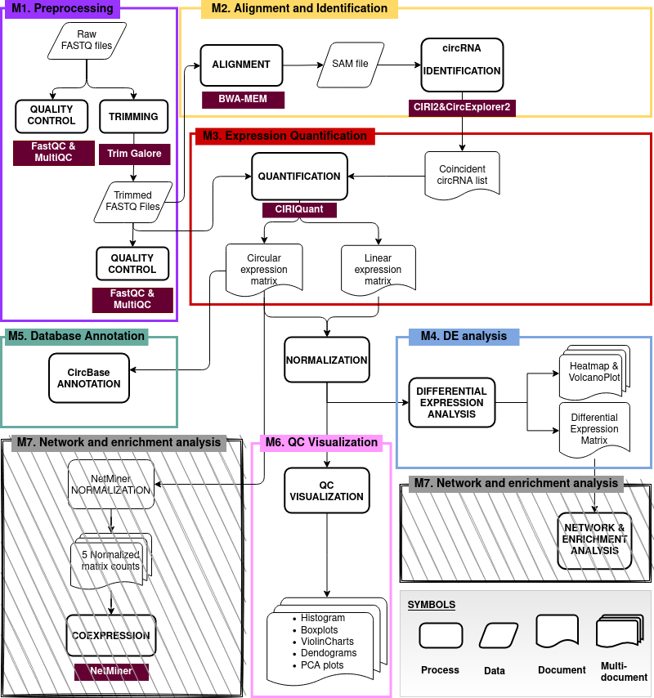Figure 3. Schematic representation of workflow modules. Each implemented module is reported with a different color. Module 7 (M7) is fullfiled with grey lines, illustrating the future implementation of module 7. An extended version of this schema can be founded in supplementary file.
Module 1. Preprocessing
For avoiding the introduction of biased data due to issues related with RNA-seq experiments, such as problems in RNA extraction, library preparation, sequencing or imaging performance, a quality control on raw data (fastq files) is required. Hence, if some abnormality is detected during the quality control, the execution of the trimming process will be conducted. Therefore, first of all, the data was submitted to the preprocessing workflow module, which includes the quality control (conducted by FastQC and MultiQC programs) and the trimming process.
Quality Control
The quality control analysis is mainly performed by FastQC, program that executes a series of module and generates one report for every single sample. Therefore, MultiQC is used to get a general overview of the whole set of samples, as it generates a single report that summarizes all the results.
For each sample, FastQC executes ten different modules to analyse sequencing read features. The mentioned features include the length, the total amount, the GC content, the level of duplicates, the presence of overrepresented and adapter sequences, as well as, the quality scores associated to these reads. Additionally, FastQC compare each module result with the expected results from a random and diverse sequencing library in order to evaluate their normality. Then, each module is assigned with a status: normal (green), slightly abnormal (orange) and very unusual (red). Similarly, a module can be classified as passed, warned or failed, respectively. On the other hand, as reviewing the individual results of each sample can be tedious, MultiQC program was executed to aggregate FastQC results across all samples into a unique report.
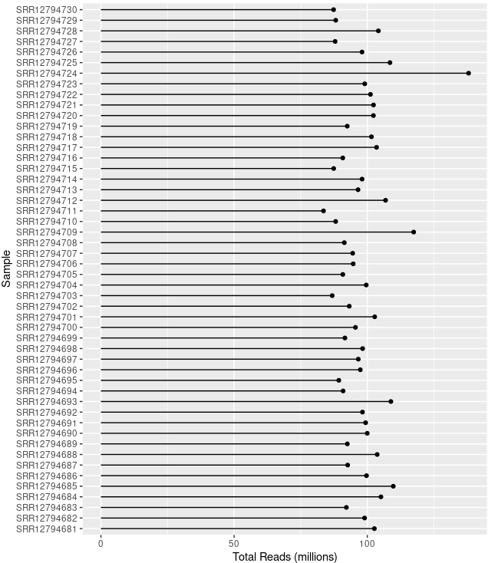Figure 4. Lollipop plot showing the total number of reads in millions (x) for each sample (y)
MultiQC report revels that the 50 analysed samples have an average of 98 +/- 9.01 millions of reads with a unique length of 151bp. Interesting, the SRR12794724 sample outliers with148.2 million of reads.
Regarding to the quality scores associated to the reads, the mean quality value across each base position in the reads was no lower than 30, comprehending values between 40 and 32. These results indicate that a very good quality score is maintained during the whole length of sequences. Similarly, the average quality score across reads range from 35 to 38 values, indicating that the majority of the reads present very good quality scores.
The number of failed modules across all samples was around the 30%, which means that, as an average, 3 out of 10 FastQC modules have presented very unusual results. The read features that include very unusual results include the GC content, the sequence duplication levels and the presence of adapter sequences. The average of duplicated reads was around 47%. Similarly, the average of GC content in all sequences was 47%, presenting a distribution with 2 peaks around the 40 and 60 %. The adapter sequences founded in reads was attributed to the Universal Illumina Adapter, which were located at the 3’ end of the reads (positions 100-151).
In summary, these results shows read sequences with a single length of 151bp, high quality scores and a presence of Universal Illumina Adapter contamination.
Trimming
Due to the fact that adapter contamination may led to low mapping read efficiency (27)((27)12)(12)(13), the removal of that sequences was conducted with Trim Galore tool, generating a set of trimmed fastq files. To ensure the proper development of the trimming process, the automatic execution of quality control module on those trimmed fastq files was performed.
MultiQC report shows that the average percentage of total trimmed base pairs was around the 4.5%, which represents the removal of 6-7 bp from the original 151-length reads. Accordingly, the mean of read length was around 144-145 bp. On the other hand, the number of failed modules across all sample presented a 10% reduction (30 to 20%), suggesting that 1 of the 3 failed FastQC modules have improved the normality of the results. Indeed, when examining carefully the 3 modules that have reported very unusual results in the previous analysis, only the presence of adapter sequences showed changes. Specifically, there were no found samples with an adapter contamination > 0.1%.
Overall, these results indicates that adapter sequence removal has been successfully conducted.
Module 2. Alignment and identification
For the identification of circRNAs from the RNA-seq dataset, raw data was aligned against the reference genome and CIRI2 and CircExplorer2 identification algorithms were executed, scrutinizing the BWA-MEM aligner information contained in SAM files. To decrease the high-positive false rate of both algorithms, their results were combined and only the common identified circRNA were selected from CIRI2 results. A brief description of the identification tools is available at table 3.
Table 3. Overview of the identification tools. Abbreviations: BSJ, back-spliced junction, FSJ, forward-spliced junction, Ref, reference.
Tool | Category | Approach | BSJ reads | Filtering rules | Drawbacks | Ref.
CIRI2 | Split-alignment based | Multiple-seed matching, using maximum likelihood estimation(MLE). | Key segments having larger MLE in BSJ region than in FSJ region. | - Range of genomic region covering a junction: 50-200kb  - Additional matching threshold of matched seeds.  - Consider relative positions of matched seeds | Memory requirements, computational speed. | (28)((28)21)(21)(23)
CircExplorer2 | Split-alignment based | Employment of chimeric reads. | Junction reads that aligned reversed to canonical splice sites. | Removal of reads aligning on different genes or non-canonical splice sites (derived from trans-splicing or PCR errors). | Mandatory annotation:  CircRNAs using unannotated exons or comprising multiple genes will be not considered. | (29)((29)22)(22)(24)

CircExplorer2 identified a total 84,760 circRNAs, whereas CIRI2 identified 35,827. However, when their results were combined, only a total of 26,546 circRNAs supported by at least two BSJ reads were found by both tools (figure 5). This disparity of results among tools not only corresponds to the total amount of identified circRNAs, but also true differences between circRNA read counts (BSJ counts) was observed. Indeed, when examining the BSJ counts for the common identified circRNAs, significant differences were founded between the mean of CIRI2 (106.25) and the mean of CircExplorer2 (82.49) (pvalue = 6.14e-10).
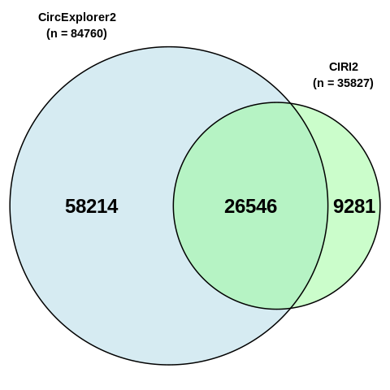Figure 5. Venn diagram comparing the amount of identified circRNAs by the CIRI2 and CircExplorer2 tools. Venn diagrams are automatically generated for each sample. Additionally, a general Venn diagram for the whole dataset is also generated.
Subsequently, the 26,546 common identified circRNAs were extracted from CIRI2 results, containing key features as FSJ and BSJ reads and the BSJ ratio. As a result, the quantification performed by CIRI2 were chose above the CircExplorer2 quantification, as they showed the best correlation with the workflow quantification tool (30)((30)14)(14)(16). However, some key features from CircExplorer2 were added, such as the number of exons within circRNAs and their respective sizes.
Module 3. Quantification

Module 4. Differential Expression Analysis

Module 5. CircBase Annotation
By default, CircBase ID is incorporated as circRNA feature, but extra fields can also be selected: genomic length, spliced sequence, length, samples, repeats, annotation, best transcript, gene symbol and circRNA study.

Discussion
- El ajuste de los datos con las consideracions experimetales comentadas.
- Problemàtica actual amb les eines identificadores:
  - moltes eines però ninguna que combini els millors valors en l’avaluació d’aquestes.
  - Problemàtica dels falsos positius. Quin origen podrien tenir?
  - Acausa de la seva baixa realibilitat, combinació de resultats de les eines. Avantatges que presenta aquesta combinació.
  - Commentar que els alineadors que utilitzen aquestes dues eines identificadores són precisament alineadors desaconsellats per RNA-seq ja que inicialment van ser pensats per alinears DNA.
- Quantificació amb CIRIquant
  - es centra en capturar els BSJ. A la introducció parlar sobre els termes BSJ I FSJ.
  - Discussió sobre la funcionalitat del BSJ ratio. normalize the noise of host gene expression and identify truly functional circRNAs, as circRNA expression based only in BSJ counts overlook the fact that circRNAs can be generated as a by-product of host gene expression[DEBKS citation].
  - Differències entre la quantitat de BSJ reads identificats per CIRI2 vs CIRIquant.
Identification and expression quantification
Following preprocessing module, alignment and identification module, as well as, expression quantification module, were created. Both modules are probably the most relevant part of the workflow, as they attends to integrate the most current methods for circRNA detection and quantification.
Alignment and identification
More than 15 computational methods for circRNA detection have been released and published, but lacking a state-of-the-art method. Each algorithm shows different advantages and shortcomes in the measurements used to evaluate their performance(15)((15)11; 13)(11; 13)(11; 15), and implements a different set of heuristics to confront the two main limitations of circRNA identification tools: high-positive false rates and elevated computational cost. Consequently, it is inevitably that the reliability of the results may be affected by the performance of the method. It is for this reason that we have implemented in the workflow the two approaches (CIRI2 and CircExplorer2) that have shown better balance between precision and sensitivity, as well as, an acceptable RAM consumption and running time(16)((16)13)(13)(15).
Both of them rely on external aligners to obtain input data. CircExplorer2 supports different aligners for circRNA identification, but CIRI2 tool only admits input data from BWA-MEM aligner. Taking into account that different aligners have showed slightly differences in the performance(17)((17)22)(22)(24). BWA-MEM aligner with the default settings recommended by the authors was implemented in the pipeline. Suitably, the use of the same alignment output as an input for circRNA identification tools also represents a dramatic decrease in computational costs.
Following the independent identification of circRNA candidates, results from both identification algorithms are combined and only the common identified circRNAs are considered. This combination of predictions from both algorithms increments the reliability of results and decrease the false-positive rates(18)((18)31)(31)(30).
Quantification
The quantification of circRNAs is focused in capturing the particular feature that distinct these molecules form their linear counterparts: the back-spliced junction (BSJ). BSJ is a junction site between two exons in an inverted order in relation to their positions on the reference genome. Opposite, linear mRNA transcripts present forward-spliced junctions (FSJ), which are junction sites between two exons in the same order in relation to their positions on the reference genome.
In RNA-seq experiment, circRNA molecules containing multiple exons (with both forward and back-spliced junctions) are fragmented and segmented reads are generated. Reads spanning FSJ are collinearly aligned to the reference genome and cannot be distinguished from FSJ present in linear mRNAs. Therefore, only reads spanning BSJ account for circRNA expression, as they are reversed aligned to the reference genome.
Although identification tools include a quantification step to obtain the number of BSJ reads that support each circRNA, an accurate quantification of circRNA can enhance the sensitivity on BSJ read detection and generate a solid core set of predicted circRNAs(19)((19)14)(14)(16). Moreover, the expression quantification module allows the alignment and quantification of linear mRNAs, which can be used to calculate BSJ ratio. BSJ ratio represents the splicing preference of precursor mRNAs between circular and canonical linear RNAs, capturing the whole expression from one host gene. Thus, BSJ ratio can help to understand the biological process that triggers circRNA expression, as they can be affected in different contexts and conditions.
Differential Expression Analysis
To discover quantitative changes in expression levels between experimental groups, a differential expression analysis must be performed. The statistical strategy used to conduct the analysis is mainly determined by the experimental design, since changes in expression might be observed from different perspectives. Here, we propose a modified version of CIRIquant differential expression analysis, which compares circRNA expression levels against all linear mRNAs, using all gene expression levels to calculate normalization factors.

Conclusions
The purpose of the current practicum was to implement an integrative bioinformatic pipeline to detect and further analyse expressed circRNAs from RNA-seq data. Here, we have provided an automative and customizable pipeline to deeply study circRNA from RNA-seq experiments. The workflow was built using the Snakemake workflow manage system and implements different programs and custom scripts to obtain information. To be specific, the workflow offers six different modules to scrutinize the data: preprocessing, alignment and identification, expression quantification, differential expression analysis, database annotation and QC visualization.
First of all, this pipeline recommends to review and improve (if necessary) the quality of RNA-seq reads trough the execution of preprocessing module. Secondly, the alignment and identification module can be executed. There, we have used the output of BWA-MEM aligner as an input for CIRI2 and CircExplorer2 methods, which are the two algorithms that have shown best performance indexes of circRNA identification in different studies. Then, we have proposed the combination of the results from both tools to create a solid circRNA set.
The next important module is the expression quantification one, which offers the quantification of linear counts, the accurate estimation of circRNAs counts and the calculation of BSJ ratio. The acquisition of these three parameters might provide interesting information in downstream analyses.
Additionally, to complement the list of circRNA obtained from the quantification or identification module, the database annotation module can be executed. This module relies on CircBase datasets to collect circRNAs features, such as the CircBase ID, the circRNA length and the spliced sequences.
Finally, differential expression analysis and QC visualization modules might help to deeper insight into the practical implications of circRNAs. Note that network and enrichment analysis module could have not been implemented due to the scarce availability of time. However, continued efforts have been conducting to incorporate this module in the following release of this pipeline, which, undoubtedly, will be very valuable to explore the functionalities of circRNAs.

Bibliography
Falta poner bien la bibliografia de las página web, con su accessed date correspondiente.

1. Kristensen, L. S., Andersen, M. S., Stagsted, L. V. W., Ebbesen, K. K., Hansen, T. B., & Kjems, J. (2019). The biogenesis, biology and characterization of circular RNAs. Nature Reviews Genetics, 20(11), 675–691. https://doi.org/10.1038/s41576-019-0158-7
2. Li, X., Yang, L., & Chen, L. L. (2018). The Biogenesis, Functions, and Challenges of Circular RNAs. In Molecular Cell (Vol. 71, Issue 3, pp. 428–442). Cell Press. https://doi.org/10.1016/j.molcel.2018.06.034
3. Patop, I. L., Wüst, S., & Kadener, S. (2019). Past, present, and future of circ RNA s. The EMBO Journal, 38(16). https://doi.org/10.15252/embj.2018100836
4. Tang, M., Kui, L., Lu, G., & Chen, W. (2020). Disease-Associated Circular RNAs: From Biology to Computational Identification. In BioMed Research International (Vol. 2020). Hindawi Limited. https://doi.org/10.1155/2020/6798590
5. Zhang, Z., Yang, T., & Xiao, J. (2018). Circular RNAs: Promising Biomarkers for Human Diseases. In EBioMedicine (Vol. 34, pp. 267–274). Elsevier B.V. https://doi.org/10.1016/j.ebiom.2018.07.036
6. Szabo, L., & Salzman, J. (2016). Detecting circular RNAs: Bioinformatic and experimental challenges. In Nature Reviews Genetics (Vol. 17, Issue 11, pp. 679–692). Nature Publishing Group. https://doi.org/10.1038/nrg.2016.114
7. Chen, L. L. (2020). The expanding regulatory mechanisms and cellular functions of circular RNAs. In Nature Reviews Molecular Cell Biology (Vol. 21, Issue 8, pp. 475–490). Nature Research. https://doi.org/10.1038/s41580-020-0243-y
8. Pamudurti, N. R., Bartok, O., Jens, M., Ashwal-Fluss, R., Stottmeister, C., Ruhe, L., Hanan, M., Wyler, E., Perez-Hernandez, D., Ramberger, E., Shenzis, S., Samson, M., Dittmar, G., Landthaler, M., Chekulaeva, M., Rajewsky, N., & Kadener, S. (2017). Translation of CircRNAs. Molecular Cell, 66(1), 9-21.e7. https://doi.org/10.1016/j.molcel.2017.02.021
9. EMBL-EBI. (n.d.-i). RNA sequencing || Functional genomics II. https://www.ebi.ac.uk/training/online/courses/functional-genomics-ii-common-technologies-and-data-analysis-methods/rna-sequencing/
10. Chen, L., Wang, C., Sun, H., Wang, J., Liang, Y., Wang, Y., & Wong, G. (2020). The bioinformatics toolbox for circRNA discovery and analysis. Briefings in Bioinformatics. https://doi.org/10.1093/bib/bbaa001
11. Gao, Y., & Zhao, F. (2018). Computational Strategies for Exploring Circular RNAs. In Trends in Genetics (Vol. 34, Issue 5, pp. 389–400). Elsevier Ltd. https://doi.org/10.1016/j.tig.2017.12.016
12. Jakobi, T., & Dieterich, C. (2019). Computational approaches for circular RNA analysis. Wiley Interdisciplinary Reviews: RNA, 10(3), e1528. https://doi.org/10.1002/wrna.1528
13. Zeng, X., Lin, W., Guo, M., & Zou, Q. (2017). A comprehensive overview and evaluation of circular RNA detection tools. PLOS Computational Biology, 13(6), e1005420. https://doi.org/10.1371/journal.pcbi.1005420
14. Zhang, J., Chen, S., Yang, J., & Zhao, F. (2020). Accurate quantification of circular RNAs identifies extensive circular isoform switching events. Nature Communications, 11(1), 1–14. https://doi.org/10.1038/s41467-019-13840-9
15. Mölder, F., Jablonski, K. P., Letcher, B., Hall, M. B., Tomkins-Tinch, C. H., Sochat, V., Forster, J., Lee, S., Twardziok, S. O., Kanitz, A., Wilm, A., Holtgrewe, M., Rahmann, S., Nahnsen, S., & Köster, J. (2021). Sustainable data analysis with Snakemake. F1000Research, 10, 33. https://doi.org/10.12688/f1000research.29032.1
16. Andrews, S., & others. (2016). FastQC: a quality control tool for high throughput sequence data. 2010. In Babraham Institute. http://www.bioinformatics.babraham.ac.uk/projects/fastqc/
17. Ewels, P., Magnusson, M., Lundin, S., & Käller, M. (2016). MultiQC: Summarize analysis results for multiple tools and samples in a single report. Bioinformatics, 32(19), 3047–3048. https://doi.org/10.1093/bioinformatics/btw354
18. Krueger, F. (2016). Trim Galore. In Babraham Bioinformatics (0.6.6; p. on line). https://www.bioinformatics.babraham.ac.uk/projects/trim_galore/
19. Li, H. (2013). Aligning sequence reads, clone sequences and assembly contigs with BWA-MEM. http://arxiv.org/abs/1303.3997
20. Li, H. (2017). Which human reference genome to use? https://lh3.github.io/2017/11/13/which-human-reference-genome-to-use
21. Gao, Y., Zhang, J., & Zhao, F. (2018). Circular RNA identification based on multiple seed matching. Briefings in Bioinformatics, 19(5), 803–810. https://doi.org/10.1093/bib/bbx014
22. Zhang, X.-O., Dong, R., Zhang, Y., Zhang, J.-L., Luo, Z., Zhang, J., Chen, L.-L., & Yang, L. (2016). Diverse alternative back-splicing and alternative splicing landscape of circular RNAs. Genome Research, 26(9), 1277–1287. https://doi.org/10.1101/gr.202895.115
23. Kim, D., Paggi, J. M., Park, C., Bennett, C., & Salzberg, S. L. (2019). Graph-based genome alignment and genotyping with HISAT2 and HISAT-genotype. Nature Biotechnology, 37(8), 907–915. https://doi.org/10.1038/s41587-019-0201-4
24. Pertea, M., Kim, D., Pertea, G. M., Leek, J. T., & Salzberg, S. L. (2016). Transcript-level expression analysis of RNA-seq experiments with HISAT, StringTie and Ballgown. Nature Protocols, 11(9), 1650–1667. https://doi.org/10.1038/nprot.2016.095
25. McCarthy, D. J., Chen, Y., & Smyth, G. K. (2012). Differential expression analysis of multifactor RNA-Seq experiments with respect to biological variation. Nucleic Acids Research, 40(10), 4288–4297. https://doi.org/10.1093/nar/gks042
26. P, G., P, P., & N, R. (2014). circBase: a database for circular RNAs. Rna, 20(11), 1666–1670.
27. Yu, H., Jiao, B., Lu, L., Wang, P., Chen, S., Liang, C., & Liu, W. (2018). NetMiner-an ensemble pipeline for building genome-wide and high-quality gene coexpression network using
massive-scale RNA-seq samples. PLoS ONE, 13(2), e0192613. https://doi.org/10.1371/journal.pone.0192613
28. Eden, E., Navon, R., Steinfeld, I., Lipson, D., & Yakhini, Z. (2009). GOrilla: A tool for discovery and visualization of enriched GO terms in ranked gene lists. BMC Bioinformatics, 10. https://doi.org/10.1186/1471-2105-10-48
29. Iparraguirre, L., Alberro, A., Sepúlveda, L., Osorio-Querejeta, I., Moles, L., Castillo-Triviño, T., Hansen, T. B., Muñoz-Culla, M., & Otaegui, D. (2020). RNA-Seq profiling of leukocytes reveals a sex-dependent global circular RNA upregulation in multiple sclerosis and 6 candidate biomarkers. Human Molecular Genetics, 29(20), 3361–3372. https://doi.org/10.1093/hmg/ddaa219
30. Brunetta, E., Folci, M., Bottazzi, B., De Santis, M., Protti, A., Mapelli, S., Leone, R., My, I., Bacci, M., Zanon, V., Spata, G., Gianatti, A., Sironi, M., Angelini, C., Garlanda, C., Ciccarelli, M., Cecconi, M., & Mantovani, A. (2020). Macrophage expression and prognostic significance of the long pentraxin PTX3 in COVID-19. https://doi.org/10.1101/2020.06.26.20139923
31. Hansen, T. B. (2018). Improved circRNA identification by combining prediction algorithms. Frontiers in Cell and Developmental Biology, 6(MAR), 20. https://doi.org/10.3389/fcell.2018.00020

