Bioinformatic pipeline to study circRNAs from RNA-seq data

Introduction
Circular RNAs (circRNAs) are high-stable RNA molecules produced by a non-canonical splicing event[1]. Initially, they were considered as a by-product of an aberrant splicing event, but deep investigations have suggested non-coding functions, enhancing protein functions or acting as a microRNAs (miRNAs) and protein sponges[2]⁠. Although the vast majority of circRNAs are thought to be non-coding, few cases were circRNAs can be translated have been reported[3]. Even so, the precise molecular and biochemical functions of the greater part of individual circRNA have not yet been identified, remaining elusive.
Most circRNAs are non-linear transcripts from known protein-coding genes, deriving from a single or multiple-exon molecules (exonic circRNAs), from a single (intronic circRNAs), or from a combination of intron and exon molecules (exon-intron circRNAs). Among these types, exonic circular RNAs (ecircRNAs) are the predominantly generated as they account for the majority of the circRNA discovered. The mechanism underlying circRNA expression is still fairly elusive, but a type of alternative splicing event, called back-splicing, has been proposed as the main mechanism of circRNA biogenesis[1]. Briefly, back-splicing event consist in the attachment of an upstream splice-acceptor site (SA) with a downstream splice-donor site (SD), different from their canonical counterpart which attaches an 5’ SD site with a 3’ SA site[4]⁠. Back-splicing is promoted in the presence of inverted repeats elements (e.g., ALU), long intron flanking or certain dimeritzated RNA-binding proteins (RBPs) such as FUS, HQK, NF90 and NF110[1]⁠. Consequently, it is formed a 3’-5’ phosphodiester bound that generates a circular transcript with particular features such as no 5’-to-3’ polarity, an inverted order of exons (distinct from genomic DNA) and with neither polyadenylated tail nor five-prime cap (5’ cap)[4]⁠.
This particular structure properties yield high molecular stability, protecting circRNAs from exonuclease-mediated degradation. Nevertheless, the mechanisms behind their turnover have only recently started to be elucidated and two mains has been proposed[1]: N6-methyladenine (m6A) RNA modification with RNAase P-MRP related and Argonaute 2 cleavage. Exosome clearance has been also suggested as a mechanism, but it is not clear this vesicle-mediated secretion can significantly reduce the cellular levels of circRNAs. Alternatively, these extracellular vesicles can also be an important cell-to-cell communication channel, expanding the functionalities of circRNAs.
In spite of the poorly efficient backsplicing event (1-3% of canonical splicing), circular RNA molecules are widely expressed in all human tissues, having a specific pattern of expression. In neural tissue, circRNAs are upregulated in neurogenesis and some circRNAs are enriched in synapses. This particular amount of circRNA in the nervous system could be explained because circRNAs are actively produced by terminally differentiated cells[2]⁠. Contrarily, there is a downregulation in diseases in which cell proliferation rates are high, such as cancer, possibly by a process of proliferation dilution[1]. Additionally, circRNAs has been implicated in several human diseases, including diabetes mellitus, cancer, autoimmune and cardiovascular diseases, among others. It has also been observed that circRNAs accumulate during ageing[5].
Taking into account all these facts, circRNAs are a new increasingly popular research area where further investigation needs to be done. Indeed, they are promising biomarkers for pathological processes owing to their long-life cycle (high stability), cell- and tissue-specific enrichment and detection in various body fluids[6].

Motivation
Although the acknowledge of the first circRNA was made in the 1970s, it was not until 2012 that circRNAs were found to be overlooked[7]⁠. Since that date, genome-wide profiling of circRNAs was completed uncharacterised owing to poly(A) selection in library preparation step in most RNA-sequencing (RNA-seq) experiments. In addition, in the most widely used bioinformatic algorithms to analyse RNA-seq data, there were present filtering steps which hinder the study of circRNAs[4]⁠. Therefore, the advancement of specialized computational pipelines, together with the adequacy of laboratory library preparation, have contributed to expand circRNA research[4,7]⁠. Of note, RNA-seq has been the method of choice for discovering novel circRNAs, whereas technologies based on locus-specific profiling of circRNAs (e.g., Northern-Blot, Real-time PCR) had been used to validate genome-wide experiments[1,5].
Currently, bioinformatic tools associated to circRNAs includes identification and annotation of circRNAs, network identification and downstream analysis[7]⁠. Downstream analysis consists of splicing detection, circRNA quantification (expression), structure prediction and visualization. Among these tools, the prediction of circRNA in RNA-seq data has been considerably explored, existing a plethora of algorithms to discover circRNAs, but lacking a state-of-the-art method that could achieve the best computational performance[5]⁠. Furthermore, each algorithm implements a distinct set of heuristics to avoid high false-positive rates, as well as, relies on different methods to achieve reasonable running time or memory usage to deal with massive RNA-seq datasets. This disparity between circRNA identification tools lead to highly divergent results.[4]⁠

Hypothesis
As state above, the lacking of gold-standard algorithm for circRNA identification increments the variability in results between circRNA-related articles, hampering the investigation in circRNA field[5,7]. In addition, the ever-increasing bioinformatic toolbox for circRNAs can easily difficult circRNA study, as researcher can find searching the right combination of tools for a bespoke investigation very tiresome. Therefore, there is an urgent need to integrate the available circRNA-related tools to pave the way for further investigations.

Objectives
In this study we aim to develop an integrated bioinformatic pipeline to detect and study the differentially expressed circRNAs from RNA-seq data. This project intends to facilitate further investigations of circRNA studies. To address this issue, the project proposes:
- Design the workflow for circRNA analysis.
- Developing an integrative bioinformatic pipeline to deeply study the differentially expressed circRNA from RNA-seq data.
- Implementation of the developed pipeline.

5 Temporal organization: Working plan
WP1. Design the workflow for circRNA analysis
Partial objectives
- Collection of general information about circRNAs.
- Benchmarking the current state of circRNA tools.
- Selection of adequate circRNA tools for circRNA workflow.
Description of the work
Since circular RNAs is a novel research area, is important to understand the biological process underlying circRNA generation. Therefore, a compilation of general information about circRNA will be done. Afterwards, is necessary to identify specific reviews providing a broad overview and evaluating the latest and available circRNA tools. Taking the collected information into account, the selection of circRNA tools for circRNA workflow will be realized.

WP2. Developing an integrative bioinformatic pipeline to deeply study the differentially expressed circRNA from RNA-seq data.
Partial objectives
- To develop each module of analysis workflow: quality control, alignment and identification, quantification, differential expression analysis, data visualization, database annotation, network and enrichment analysis.
- To construct the circRNA pipeline by integrating each developed module.
Description of the work
To construct the pipeline for circRNA analysis, developed modules will be integrated. The pipeline will consist of seven different modules:
- Quality control. It is recommended to perform some quality control on raw data, especially with data from high throughput sequencing applications, to ensure there is no hidden problems inherent to laboratory performance, which probably will be more difficult to identify at later stages of the workflow. Additionally, quality control involves pre-processing data to remove adapter sequences (adapter trimming) and low-quality reads, which may lead to low mapping read efficiency and hamper downstream analysis. To generate comprehensive reports from FASTAQC file and trimming raw sequences, FASTAQC and TrimGalore programmes will be used, respectively.
- Alignment and identification. To obtain genome mapped reads, Burrows Wheeler Alignment will be used (BWA-MEM algorithm). For the identification process of circular RNAs, sam files from BWA-MEM aligner will be processed by two different tools: CIRI2 and CircExplorer2. Each identification tool will generate a unique list of circRNAs.
- Quantification. Although identification tools include a quantification step to obtain the number of reads that support each circRNA, an accurate quantification of circRNAs is crucial to enhance the reliability of the results. CIRIquant program will be used to improve the expression values for circRNAs and reduce false discovery rate. Afterward, processed results from different identification tools will be merged and coincident results will generate a solidify core set of predicted circRNAs.
- Differential expression analysis. To discover quantitative changes in expression levels between experimental groups, a differential expression analysis must be performed. This module will include the normalization of read count data and the statistical significance test of circRNAs (edgeR package in R).
- Data visualization. To enhance biological interpretation of circRNA data, CircView/SpliceV tool will be used, as well as, generation of heatmap and volcano plot graphics.
- Database annotation. Identified circRNAs will be search in a confident database for circular RNAs (e.g. CircBase or CircFunBase) by matching the back-splicing junction coordinates. Database nomenclature will be incorporated as a feature of circRNA.
- Network and enrichment analysis. To gain further insight into possible functional properties of circRNA, network and enrichment analysis will be performed by NetMiner tool.

WP3. Implementation of the developed pipeline.
Partial objectives
- Assessment of developed pipeline by obtaining results from selected datasets.
- Software deployment
Description of the work
Two different open-source datasets will be identified to assess the functionality of the developed pipeline. With the first dataset, a comparison between original list of differentially expressed circRNA and obtained one from developed workflow will be performed. Additionally, results from other modules will be evaluated. If possible, a second dataset will be analysed by the developed pipeline. Apart from assessment, the deployment of the pipeline must to be done, in order to make the workflow available for use. Therefore, creating a manual user will be required.

WP4. Memory writing
Partial objectives
- To write practicum I and II reports and final degree project memory.
- Prepare presentation of final degree project.

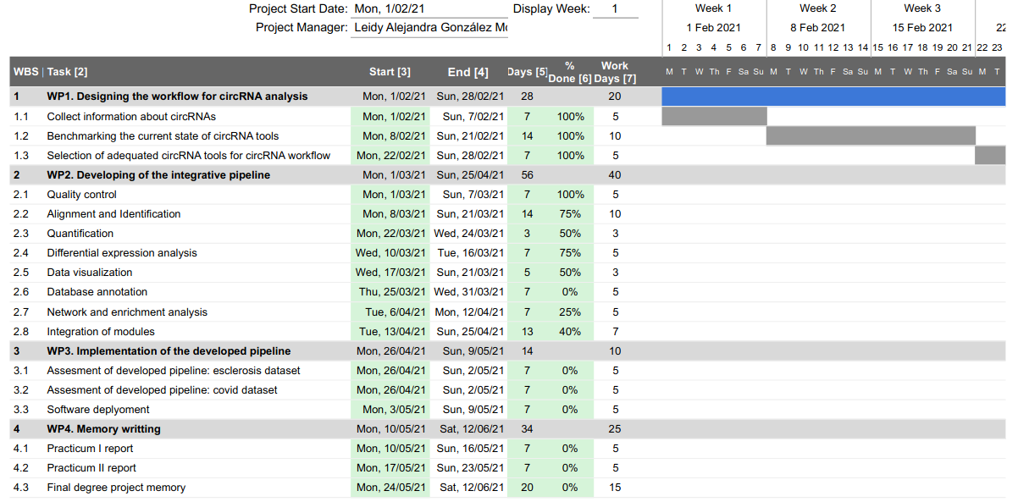

Contingency plan
During the development of the project, some possible problems may arise swiftly. Therefore, having prepared arrangements for mitigate possible negative effects is crucial. The following section will evaluate the potential risks that might occur during the project, as well as, detail the contingency plan for each of them.
The major issue during the development of the project will be the lack of computational potency to deal with massive RNA-seq datasets. All experiments are supposed to be performed in a laptop equipped with 6 CPUs processor (intel i3 processor) and 6GB of RAM memory. BWA-MEM alignment tool requires a minimum of 5GB of RAM usage to works. Worst-case situation is founded in identification tools, where each of them requires a minimum of 10 GB of RAM memory. To mitigate these problems, alignment and identification process will be performed on a external machine.
The second major problem might be the lack of time. The proposed project involves plentiful of interconnected steps, all of them, constructing a pipeline where consecutive inputs are required to generate specific outputs. Since quality control, alignment and identification parts might be the modules requiring a considerable amount of running time, parallel experiments must be conducted. In one dataset, matrix count is available, which allows to perform downstream analysis at the same time identification and quantification tools are still running. Additionally, in the designed workflow for circRNA analysis, there are steps marked in red, which can be skipped if necessary.
Finally, the lack of computational background might represent an inconvenient. Since the majority of circRNA-related tools are written in programming languages such Python and Perl, which I have minimum basics, many unsolved questions and neglected considerations can appear all of a sudden. Additionally, to develop the integrative pipeline, an effort of programming will have to be done.

References

[1] Kristensen, L.S., Andersen, M.S. et al. (2019) The biogenesis, biology and characterization of circular RNAs. Nature Reviews Genetics, Nature Publishing Group. 20, 675–91. https://doi.org/10.1038/s41576-019-0158-7
[2] Patop, I.L., Wüst, S. et al. (2019) Past, present, and future of circ RNA s . The EMBO Journal, EMBO. 38. https://doi.org/10.15252/embj.2018100836
[3] Pamudurti, N.R., Bartok, O. et al. (2017) Translation of CircRNAs. Molecular Cell, Cell Press. 66, 9-21.e7. https://doi.org/10.1016/j.molcel.2017.02.021
[4] Szabo, L. and Salzman, J. (2016) Detecting circular RNAs: Bioinformatic and experimental challenges [Internet]. Nat. Rev. Genet. Nature Publishing Group. p. 679–92. https://doi.org/10.1038/nrg.2016.114
[5] Tang, M., Kui, L. et al. (2020) Disease-Associated Circular RNAs: From Biology to Computational Identification [Internet]. Biomed Res. Int. Hindawi Limited. https://doi.org/10.1155/2020/6798590
[6] Zhang, Z., Yang, T. et al. (2018) Circular RNAs: Promising Biomarkers for Human Diseases. EBioMedicine. Elsevier B.V. p. 267–74. https://doi.org/10.1016/j.ebiom.2018.07.036
[7] Chen, L., Wang, C. et al. (2020) The bioinformatics toolbox for circRNA discovery and analysis. Briefings in Bioinformatics, Oxford University Press (OUP). https://doi.org/10.1093/bib/bbaa001

