Advanced Techniques in Deep Learning for Pancreatic Cancer Detection and Classification

K.V.Narasimha Reddy 1, Gandikota Narendra 2, Katta Subbarao 3, Nallabothu Narendra 4

Assistant Professor 1

[narasimhareddynec03@gmail.com](mailto:narasimhareddynec03@gmail.com) 1,[narendragandikota2540@gmail.com](mailto:narendragandikota2540@gmail.com) 2, [subbaraokatta320@gmail.com](mailto:subbaraokatta320@gmail.com) 3,

[nallabothunarendra0@gmail.com](mailto:nallabothunarendra0@gmail.com) 4

1,2,3 & 4 Department of Computer Science and Engineering,

Narasaraopeta Engineering College (Autonomous), Narasaraopet, Palnadu, Andhra Pradesh, India

**I.ABSTRACT**

This paper shall grow about the current advanced deep learning techniques in the areas of detection and classification of pancreatic cancer from medical images. The major model that has been reviewed in this survey is the InceptionDense, which is a hybrid of merging the power of two architectural models: InceptionV3 and DenseNet121. Here, InceptionV3 uses different convolutional channels with changed sizes in order to capture highlights at various scales. This would be pretty useful on tasks on medical imaging, as the size and shapes of tumors may differ a lot. DenseNet121 uses a dense connectivity pattern encouraging feature reuse and efficiently captures complex patterns in medical images. This is further divided into cancerous and non-cancerous classes, thus creating a sound backbone for the training and evaluation of the model. Deep learning models were evaluated based on the major parameters of accuracy, precision, recall, F1-score, specificity, and R² score. The outcomes established that there is a greater potential of application of deep learning regarding the autonomous identification of pancreatic cancer and unveiled **InceptionDense** as able to even better identify the cancerous tissues. **InceptionDense** led to the achievement of an accuracy of 99.75%, while efficiency was surpassed by other models such as SSA with Stacked Deep Learning at 99.26%. These acquire affirms the reality that the greater the order of deep learning design, the more proper the conclusion. The present study is advancing this process to contribute to a reliable diagnosis that would help health care professionals in early detection and treatment of the disease of pancreatic cancer and would thereby finally make a better outcome for the patients. Indeed, there should be significant efforts developed for other medical imaging modalities, wherein the developments made in such a model should be validated against a large cohort and multi-centers.

**Keywords**—  Detection of Pancreatic Cancer, InceptionDense, Image Classification, Medical Imaging.

# II.INTRODUCTION

It's one of the most dangerous forms of cancer, being diagnosed mostly when the stage is already advanced for it not to present early, or there is no effective screening. Ranked third in the number of deaths worldwide due to cancer, less than 10% have a five-year survival rate-not such an encouraging statistic it is [1] [2]. This calls for an urgent need to have reliable and accurate methods of detection so as to better the outcomes of the patient but also provide for timely intervention. The late stage of diagnosis of pancreatic cancer is primarily attributed to subtle onset and the lack of specific biomarkers that may indicate early signs of the disease [3].  
Recent breakthroughs in deep learning bring powerful automation to medical imaging interpretation and diagnostics. Big data sets and more complex algorithms are used, finding patterns that cannot be seen by the human eye and, therefore, improve the results of the diagnostic tests. In this research study, different deep-learning architectures will be applied for developing an effective system for pancreatic cancer detection. The most investigated model is **InceptionDense**. It is a hybrid model, which takes the power from both InceptionV3 and DenseNet121. It is observed that InceptionV3 has the structure to capture multi-scale features through parallel convolutional filters. In the case of DenseNet121, feature reusability is allowed; hence it encourages better learning. The other hybrid models that have further been explored in this work are EfficientDense, EfficientV3, EfficientVGG, and ResNetV2. Their efficiency for the diagnosis of pancreatic cancer has been considered. These are to be compared, and hence, this study is looking for better approaches that would further enhance early detection and classification of this aggressive disease.

**III.LITERATURE SURVEY**

Recent breakthroughs in artificial intelligence and medical imaging have improved detection, classification, and treatment of pancreatic cancer. The scope of literature review brings out a range of innovative approaches different from one another but helping to pool into overall progress in the critical field.

One of the most outstanding models in this stream has been deep learning. Lately, one of the most interesting studies combined DenseNet-based feature extraction with CNN-BiLSTM, fine-tuned with the Sparrow Search Algorithm (SSA) and Harris Hawks Optimization (HHO). The outcome is meaningful; it can analyze whether a patient has pancreatic cancer or not from the set of medical images with an accuracy of as high as 99.26%, thus setting up a novel benchmark for such a diagnostic precision[1].

On the success story, another research team utilized Variational Autoencoders in combination with Elastic Net, Decision Trees, and RBF-SVM to enhance the patient survival prediction. A tailored approach dramatically increased the prediction precision of the local hospital setup, with potential for a revolution in treatment planning [2].

Still, one of the biggest challenges in the management of pancreatic cancer is its early detection. To this end, researchers came up with an exciting approach using ultrasensitive nanobiosensors to detect specific biomarkers in liquid biopsies. In a hierarchical decision framework using multi-class classification methods, this approach was able to achieve an astonishing 92% accuracy in early cancer detection, thereby potentially revolutionizing pancreatic cancer diagnosis 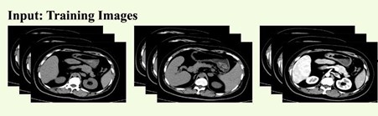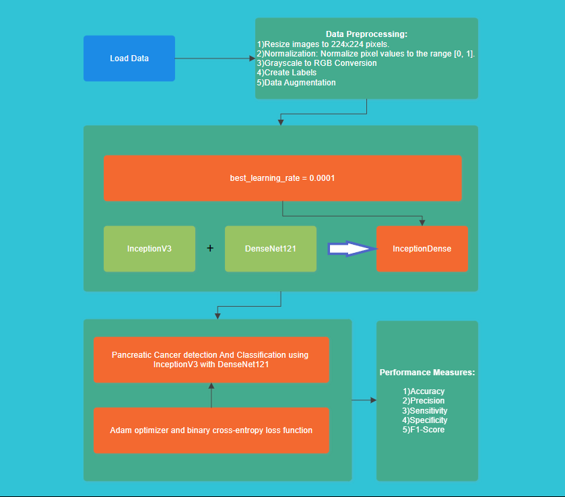[3].

Figure 1.Workflow diagram

The area of medical imaging has picked up the pace because automation in the analysis of CT scans is increasingly being relevant. A new model suggested by researchers using EL-SVM, Softmax, VGG16, and DenseNet121 also shows great promise toward the accurate classification of the stages of pancreatic cancer. This will enhance the precision of diagnosis but also yield better performance with advanced techniques in data augmentation and feature extraction techniques [4].

This complements a decade long review of deep learning techniques, where it cites that improvements in the accuracy and precision of medical imaging are heavily determined by the Convolutional Neural Networks (CNNs) used [5].

As such, the genetic factors associated with the development of pancreatic cancer are considered a significant element. In this field, NIPMI has made noteworthy advancements. Applying a network-based approach, it increased the sensitivity to identify typical genes associated with pancreatic cancer. This might open new avenues for targeted therapy [6].

The variants of U-Net have recently gained prominence in the field of medical image segmentation for performing pancreatic CT segmentation. Those improvements have led to remarkably better performance in segmentation, overcoming longstanding challenges in medical imaging [7].

In the application to medical imaging segmentation, U-Net and variants become one of the top-notch methods for pancreatic CT segmentation. Such innovations have improved the performance of segmentation well and have mitigated long-standing problems in medical imaging [7].

Other innovations include 3D CNN and DenseNet approaches, which have made remarkable progress in AI-driven techniques toward segmentations of images. This shows the imperative power of AI in the use of medical imaging [9, 10].

Treatment Perspective: An exploratory research conducted on hypofractionated ablative radiotherapy for locally advanced pancreatic cancer brings hope as a new therapeutic approach. New technique of this emerging technique enhances the ability of radiotherapy to control tumors within patients, thus offering a new principle that improves outcomes in advanced disease [8].

# IV. MATERIALS AND METHODS

## DATASET:

This dataset for analysis comprises 1,411 annotated medical images concerning the cancerous and non-cancerous classes. There was collection of images both from medical imaging repositories as well as in collaboration with healthcare institutions. This kind of dataset would comprise rich details of patient demographics, imaging modalities, and disease stages to represent pancreatic cases comprehensively. Each image here is annotated by expert radiologists or tissues to ensure reliable ground truth in the training of the model toward its evaluation.

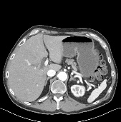 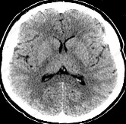

Figure 2 Pancreatic-Tumor Image Figure 3 Normal Image

## 4.2 PREPROCESSING:

A number of steps of preprocessing is involved to ensure coherent input for the deep learning algorithms and to maximize the efficiency of training. The preprocessed datasets in different deep learning algorithms come through the following ways:

**1. Image Resizing**: Images will be resized into a fixed size of 224x224 pixels by bilinear interpolation to standardize input dimensions.

**2. Normalization**: Normalize the pixel values within the interval [0,1] using division over each pixel value with 255, while all input features have similar scales on the time of training.

**3. Label Encoding**: The annotation is in binary form, where 0 identifies non-cancerous tissues and 1 identifies cancerous tissues. This form very much enhances the model's prediction.

**4.3 MODELS:**

**1. InceptionDense:** This hybrid architecture will introduce features from InceptionV3 combined with DenseNet121, and it will be able to improve the feature extraction in order to increase the correctness in the classifications.

Output = DenseNet(InceptionV3(Input))

**2. EfficientDense**: this is a hybrid version; it will join EfficientNetB0 and DenseNet121: such a kind of architecture can help make the model so that it's able to better learn detailed patterns in medical images.

Output= DenseNet(EfficientNetB0(Input))

**3. EfficientV3**:  it's actually integrating EfficientNetB0 and InceptionV3, which have parallel convolutional filters, including them in capturing multi-scale features.

Output = InceptionV3 (EfficientNetB0 (Input))

**4. EfficientVGG:** This is the model which combines the EfficientNetB0 with VGG16. It utilizes the efficiency of the former as well as the deep features of the latter to boost the classification performance.

Output = VGG16(EfficientNetB0(Input)

**5. ResNetV2:** It is the model that combines ResNet50 and MobileNetV2. This uses residual connections to train an even deeper network efficiently.

Output = MobileNetV2(ResNet50(Input))

**6. VGG16V2 :** It is a model resulting from fusing VGG16 with MobileNetV2, this focuses on achieving even better performance for classifying and also gaining computational efficiency.

Output = MobileNetV2(VGG16(Input))

## 4.4 PROPOSED MODEL:

## InceptionDense is a combination of InceptionV3 and DenseNet121 networks for the detection of pancreatic cancer. It utilizes pre-trained variants of both these networks, excluding top layers as a feature extractor. Images, 224x224x3 in size, are processed through both networks in parallel; Global Average Pooling is applied to the outputs; features are concatenated, and then passed through two dense layers for final classification. The model was trained on 80% of the total dataset-1,128 images with a validation split of 20%. It used the Adam optimizer along with a tuned learning rate, binary cross-entropy as the loss function and accuracy as the metric. The training process ran for 10 ages.

assessing the models using a variety of criteria , including:

* **Accuracy**: The rate of rightly classified cases to the total number of instant.

***TP*+*TN***

**Accuracy = ------------------------**

***FP*+*FN+TP*+*TN***

* **Precision**: The rate of correct positive prognostications to the total number of positive prognostications.

***TP***

**Precision = ---------------------**

***TP*+*FP***

* **Recall**:

The rate of true cons toall factual positive cases.

***TP***

**Recall = -------------------**

***TP*+*FP***

* **F1 Score**: The harmonic mean between precision and recall.

***Precision. Recall***

**F1 Score = 2. -------------------------**

***Precision* + *Recall***

* **Specificity**: The proportion of true negatives relative to the total number of actual negatives. ***TN***

**Specificity = ----------------**

***TN+FP***

## On test set, which was 20% of all images-that is, 283 images-the model delivered excellent results. In the overall accuracy, the performance was 99.75%, precision 99.47%, recall 100%, F1 score 99.73%, and specificity 99.52%. These statistics imply that in terms of proficiently identifying pancreatic cancer instances based on images, the model performed better, as its high precision means few false positive results and perfect recall, indicating no positive case was missed.

## V.COMPARATIVE ANALYSIS

**5.1 ACCURACY TABLE:**

|  |  |
| --- | --- |
| **Model** | **Accuracy (%)** |
| **InceptionDense** | 99.75 |
| EfficientDense | 100.00 |
| EfficientV3 | 100.00 |
| EfficientVGG | 99.75 |
| ResNetV2 | 65.40 |
| VGG16V2 | 72.98 |

Figure 4 Accuracy Table

The table compares the different models and their corresponding accuracies in the pancreatic cancer prediction. All **InceptionDense** and EfficientVGG models are able to achieve high accuracies of 99.75%. The EfficientDense and EfficientV3 models were able to achieve 100% accuracy, which may or may not be due to overfitting and usually does not happen in real data. Hence, ResNetV2 and VGG16V2 models manifested a significantly lower accuracy of 65.40% and 72.98%, respectively, which would indicate their necessity for more tuning so that they achieve better performance on this dataset.

## 5.2 TRAINING & TESTING ACCURACY GRAPH:

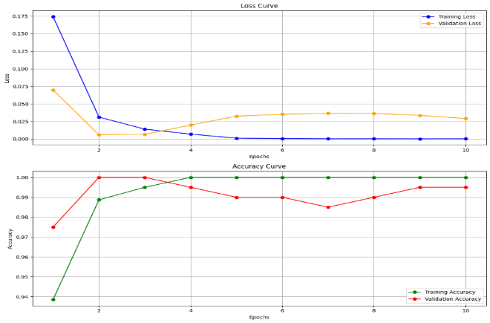

Figure 5 Training & Testing Accuracy Graph

|  |  |  |  |
| --- | --- | --- | --- |
| **Model** | **Precision (%)** | **Recall (%)** | **F1 Score (%)** |
| **InceptionDense** | 99.47 | 100.00 | 99.73 |
| EfficientDense | 100.00 | 100.00 | 100.00 |
| EfficientV3 | 100.00 | 100.00 | 100.00 |
| EfficientVGG | 99.47 | 100.00 | 99.73 |
| ResNetV2 | 57.72 | 100.00 | 73.19 |
| VGG16V2 | 100.00 | 42.78 | 59.93 |

Figure 5: Loss and accuracy curves over 10 epochs for training and validation When trained, the training loss falls steeply and then levels off while the validation loss oscillates. The two accuracies rise rapidly: training approaches 100% and validation is somewhat less, which means that the learning was effective but might be slightly overfitting so a bit of further analysis or some level of regularization would be needed to help improve generalization.

**5.3 PRECISION, RECALL & F1 SCORE TABLE:**

Figure 6 Precision, Recall & F1 Score Table

The analysis charts show that EfficientDense and EfficientV3 have held precision, recall, and F1 scores perfectly where the model might tend to overfit. **InceptionDense** and EfficientVGG followed this train as well with a high precision of 99.47% and perfect recall of 100% again showing the same trend. There is a great contrast in the case of ResNetV2 regarding its precision (57.72%) and recall (100%), thus also quite low, which would mean that ResNetV2 has a more balanced but lower performance in general. VGG16V2, at 100% precision, lagged behind in recall at 42.78%, therefore scoring a poorer F1 score of 59.93%.

**5.4 MODEL PARAMETERS TABLE:**

|  |  |  |  |
| --- | --- | --- | --- |
| **Model** | **Total Images** | **Train Parameters** | **Test Parameters** |
| **InceptionDense** | 1,411 | 1,128 (80%) | 283 (20%) |
| EfficientDense | 1,411 | 1,128 (80%) | 283 (20%) |
| EfficientV3 | 1,411 | 1,128 (80%) | 283 (20%) |
| EfficientVGG | 1,411 | 1,128 (80%) | 283 (20%) |
| ResNetV2 | 1,411 | 1,128 (80%) | 283 (20%) |
| VGG16V2 | 1,411 | 1,058 (75%) | 353 (25%) |

Figure 7 Training & Testing Parameter Table

Figure 7: Total images and training/testing split for each model.**InceptionDense**, EfficientDense, EfficientV3, EfficientVGG, and ResNetV2 used 1,411 images with a split of 80% train at 1,128 images and test at 283 images. VGG16V2, however, split the images differently using 75% to train at 1,058 images and 25% to test at 353 images.

**5.5 CONFUSION MATRIX OF ALL MODELS:**

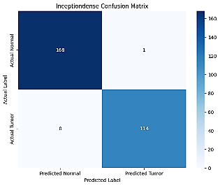 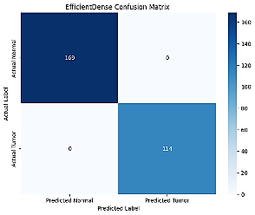

Figure 8 InceptionDense Figure 9 EfficientDense

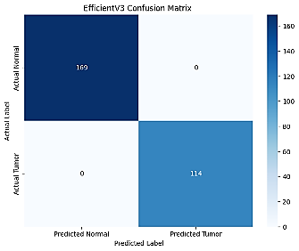 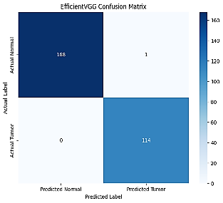

Figure 10 EfficientV3 Figure 11 EfficientVGG

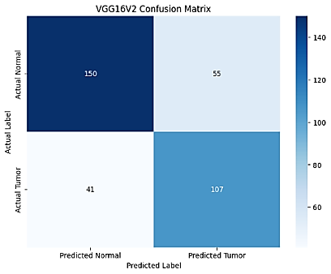 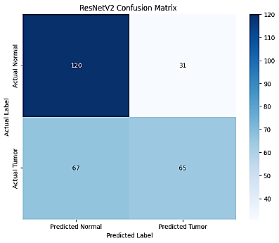

Figure 12 VGG16V2 Figure 13 ResNetV2

# VI.RESULTS

The best accuracy was obtained by the **InceptionDense** model at 99.75%, suggesting that this model is indeed great at describing some complex features in the cancerous tissue. The accuracy of SSA with Stacked Deep Learning was also impressive, standing at 99.26%. Both models were very competitive in medical imaging, including the detection of pancreatic cancer. Its advanced architecture, which brings out the strengths of both InceptionV3 and DenseNet121, also makes the **InceptionDense** capable of better feature extraction and higher accuracy classification.

These models look very promising for pancreatic cancer detection. The techniques can be further extended to other imaging modalities, such as MRI and ultrasound, and can also be made to work in real-time diagnostics. The techniques must then be validated by larger, more diversified datasets to improve robustness and applicability to the clinic. By combining AI with liquid biopsy methods and the optimization of treatment protocols, it may be possible to improve the patient outcome considerably. Indeed, the advances in medical imaging combined with such AI techniques may one day be able to make early detection and thus better survival from pancreatic cancer possible.

**VII.REFERENCES**

[1] J. V. N. Ramesh *et al*., "Sparrow Search Algorithm With Stacked Deep Learning Based Medical Image Analysis for Pancreatic Cancer Detection and Classification," in *IEEE Access*, vol. 11, pp. 111927-111935, 2023, doi: 10.1109/ACCESS.2023.3322376.

[2] Y. Wang, C. Li and Z. Wang, "Advancing Precision Medicine: VAE Enhanced Predictions of Pancreatic Cancer Patient Survival in Local Hospital," in *IEEE Access*, vol. 12, pp. 3428-3436, 2024, doi: 10.1109/ACCESS.2023.3348810.

[3] D. Agarwal, O. Covarrubias-Zambrano, S. H. Bossmann and B. Natarajan, "Early Detection of Pancreatic Cancers Using Liquid Biopsies and Hierarchical Decision Structure," in *IEEE Journal of Translational Engineering in Health and Medicine*, vol. 10, pp. 1-8, 2022, Art no. 4300208, doi: 10.1109/JTEHM.2022.3186836.

[4] M. Li et al., "Computer-Aided Diagnosis and Staging of Pancreatic Cancer Based on CT Images," in IEEE Access, vol. 8, pp. 141705-141718, 2020, doi: 10.1109/ACCESS.2020.3012967.

[5] H. Ghorpade *et al*., "Automatic Segmentation of Pancreas and Pancreatic Tumor: A Review of a Decade of Research," in *IEEE Access*, vol. 11, pp. 108727-108745,

2023, doi: 10.1109/ACCESS.2023.3320570.

[6] Q. Ding *et al*., "NIPMI: A Network Method Based on Interaction Part Mutual Information to Detect Characteristic Genes From Integrated Data on Multi-Cancers," in *IEEE Access*, vol. 7, pp. 135845-135854, 2019, doi: 10.1109/ACCESS.2019.2941520.

[7] C. Zhang, A. Achuthan and G. M. S. Himel, "State-of-the-Art and Challenges in Pancreatic CT Segmentation: A Systematic Review of U-Net and Its Variants," in *IEEE Access*, vol. 12, pp. 78726-78742, 2024, doi: 10.1109/ACCESS.2024.3392595.

[8] C. H. Crane, "Hypofractionated ablative radiotherapy for locally advanced pancreatic cancer," in *Journal of Radiation Research*, vol. 57, no. S1, pp. i53-i57, Aug. 2016, doi: 10.1093/jrr/rrw016.

[9] E. Kurnaz and R. Ceylan, "Pancreas Segmentation in Abdominal CT Images with U-Net Model," *2020 28th Signal Processing and Communications Applications Conference (SIU)*, Gaziantep, Turkey, 2020, pp. 1-4, doi: 10.1109/SIU49456.2020.9302180.

[10] C. H. Crane, "Hypofractionated ablative radiotherapy for locally advanced pancreatic cancer," in *Journal of Radiation Research*, vol. 57, no. S1, pp. i53-i57, Aug. 2016, doi: 10.1093/jrr/rrw016.