Science and Technology
Computer Engineering and Informatics (CEI)
MSc Data Science & Artificial Intelligence

2025-26 CST4265 Generative AI & Large Language Models

CONVOSELL AI
AI-Powered influencing conversational agent for Global Hub @ MDX

Hackathon Project

Team Members: Asma Khanam, Meghna Karra, Narendra Gandikota
Student IDs: M01089612, M01097077, M01092206
Module Leader: Ivan Reznikov
Date of Submission: 23/04/2026

Table of Contents

Table of Contents 2
1. Introduction 3
2. System Architecture Overview 3
3. Technology Stack 4
4. AI Model Integration 5
5. RAG & Vector Store 6
5.1 Knowledge Base Design 6
5.2 Embedding & Retrieval Pipeline 6
5.3 Multilingual Support 7
6. Prompt Injection Defence & Guardrails 7
6.1 Client-Side Validation 7
6.2 Server-Side Validation 8
6.3 Hardened System Prompt 8
7. Contextual Upselling System 8
8. User Experience Features 9
8.1 Time-Aware Greeting 9
8.2 Quick-Start Prompt Chips 9
8.3 Allergen & Dietary Filters 9
8.4 Running Order Total 10
9. Voice Mode 10
10. Rate Limiting 10
11. Results and Discussion 11
12. Conclusion 11

1. Introduction
ConvoSell AI is an AI-powered influencing conversational agent designed for Global Hub @ Middlesex University Dubai. Unlike traditional chatbots that passively respond to user queries, ConvoSell AI actively guides and influences customer decision-making during the ordering process.
The system engages users through natural language interaction, detects mood and preferences, and strategically steers conversations to promote specific menu items. By combining sentiment analysis, preference extraction, and persuasive recommendation techniques, the chatbot subtly nudges users toward alternative or higher-value food choices.
It incorporates contextual upselling and behavioural influence strategies—such as framing, suggestion sequencing, and adaptive responses—to maximize order value while maintaining a personalized user experience.
The final output is converted into a structured, kitchen-ready order, ensuring seamless operational integration. This positions ConvoSell AI not just as an ordering tool, but as an intelligent system designed to shape customer choices in real time.The project was developed for the CST4265 GenAI & Large Language Models module and targets the hackathon criteria set by the module leader, covering: a working AI chatbot base, Retrieval-Augmented Generation (RAG) with a vector store, prompt injection defence, voice multimodality, and a production deployment pipeline.
The implementation uses Next.js 16 with the Vercel AI SDK v6, the Groq API (LLaMA 3.3-70B) or Gemini API (gemini-2.5-flash)for text generation, and Google text-embedding-004 for semantic embedding. All source code resides in a GitHub repository and the live application is deployable to Vercel.

NOTE:
In order to ensure efficient utilization of Large Language Model (LLM) resources, the implemented system operates on a constrained subset of menu items rather than the complete dataset. While a significantly more extensive list of offerings is maintained in the menu.txt file, incorporating the entire menu directly into the conversational pipeline would substantially increase token consumption, resulting in higher computational cost, increased latency, and potential degradation in response performance. To address this, the system adopts a curated menu approach that balances functional capability with operational efficiency. This design decision allows the chatbot to maintain fast, contextually relevant, and cost-effective interactions, while still demonstrating the full scope of its recommendation and influencing capabilities.

2. System Architecture Overview
The application follows a three-layer architecture: a Next.js React frontend, a serverless API route that orchestrates AI calls, and two external AI provider APIs.
Frontend (app/page.tsx): The React client manages conversation state via the Vercel AI SDK useChat hook. It renders the chat interface, processes incoming AI message streams, parses structured tags from model responses (<KITCHEN_ORDER> and <UPSELL>), and exposes UI controls for voice mode and allergen filters. All outgoing messages are validated client-side before dispatch.
API Route (app/api/chat/route.ts): The serverless POST handler performs rate limiting, server-side injection detection, RAG retrieval, system prompt assembly, and streaming via the Groq LLM. It returns a UI message stream compatible with the Vercel AI SDK v6 protocol.
AI Providers: Groq (via an OpenAI-compatible base URL) handles text generation. Google Generative AI provides text-embedding-004 embeddings for the RAG module. Both are accessed through the Vercel AI SDK abstraction layer.
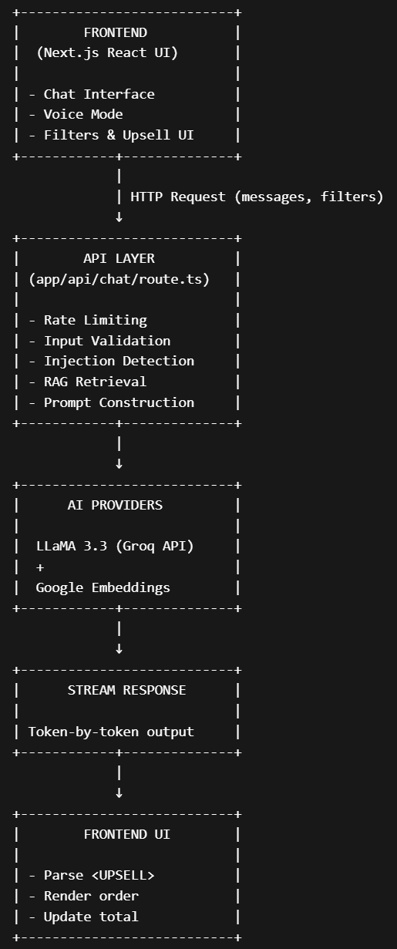

3. Technology Stack
The project relies on a carefully chosen set of modern web and AI libraries, each selected for a specific capability.
Next.js 16.2.4 with the App Router provides the full-stack framework. Server components handle API logic; client components handle interactive UI. Turbopack is used as the development bundler.
React 19 / TypeScript 5 form the frontend foundation. TypeScript enforces strict typing across all components and API handlers, reducing runtime errors.
Vercel AI SDK v6 (ai@6.0.168, @ai-sdk/react@3.0.170) provides the useChat hook, streaming utilities, and the convertToModelMessages function that converts the SDK's UIMessage format to the ModelMessage format expected by streamText.
@ai-sdk/openai@3.0.53 enables connection to Groq by pointing the OpenAI-compatible client at Groq's base URL (https://api.groq.com/openai/v1).
@ai-sdk/google@3.0.64 provides access to Google's text-embedding-004 model, which powers the RAG vector store.
Tailwind CSS 4 / Framer Motion 12 handle styling and animation, giving the UI a polished, responsive appearance appropriate for a university cafeteria kiosk.
Lucide React provides the icon set (Receipt, Mic, SlidersHorizontal, and others) used throughout the interface.

4. AI Model Integration
The primary language model is LLaMA 3.3-70B-Versatile served through the Groq inference API. Groq was selected because its LPU (Language Processing Unit) hardware provides extremely low latency — typically under 500 ms to first token — which is critical for a real-time ordering assistant where students expect near-instant responses.
The model is invoked through the Vercel AI SDK streamText function with a temperature of 0.7, balancing creativity for mood-resonant recommendations against consistency for structured outputs such as the kitchen order JSON.
The integration replaced an earlier Google Gemini setup after the project's Google Generative AI API quota was exhausted. Because the Vercel AI SDK abstracts provider differences, switching required only changing the model instantiation line — the streaming, message conversion, and guardrail logic required no modification. This demonstrates the value of provider-agnostic abstractions in production AI systems.
Model messages are converted from the SDK's UIMessage format (parts array containing {type, text} objects) to the ModelMessage format using the convertToModelMessages() utility before being passed to streamText. This conversion was a key fix identified during development: without it, the API returned a 200 OK status but the model raised an AI_InvalidPromptError because the schema did not match.

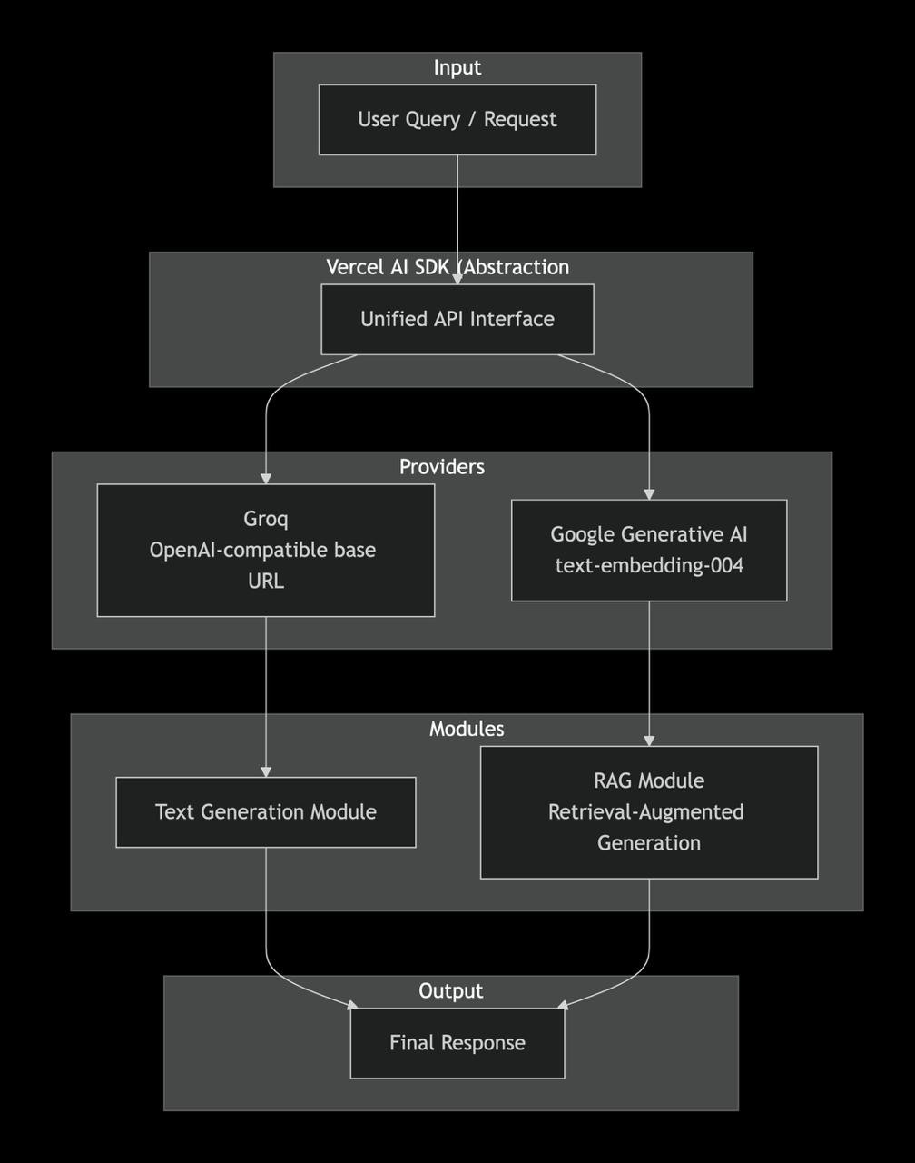

5. RAG & Vector Store
Retrieval-Augmented Generation (RAG) grounds the model's responses in verified knowledge rather than relying on parametric memory from training. For a restaurant chatbot, this is critical: allergen information, loyalty policies, and cultural context must be accurate, not hallucinated.

5.1 Knowledge Base Design
The knowledge base (app/lib/rag.ts) contains over 20 KnowledgeDocument objects organised into six semantic types: menu (8 items with full descriptions), faq (4 documents covering opening hours, halal certification, loyalty programme, and payment), nutritional (calorie and macro information), cultural (dishes with their regional context and recommended for specific student communities), arabic-menu (two Arabic-language documents for Arabic-speaking students), and policy (allergen policy and loyalty rewards).

5.2 Embedding & Retrieval Pipeline
At first request, the module lazily initialises a singleton vector store using a module-level initializationPromise pattern. This is appropriate for serverless environments where cold starts are infrequent but module state persists across requests within the same server process. Each document is embedded using Google text-embedding-004 via the embed() function from the Vercel AI SDK.
On each incoming user message, retrieveContext(query, topK=4) embeds the latest user message text and computes cosine similarity against all stored embeddings. The top 4 most similar documents are returned as a formatted context block and injected into the system prompt.
Cosine similarity is defined as: cos(A, B) = (A · B) / (||A|| × ||B||). This metric is ideal for embedding spaces because it measures directional alignment between vectors, making it invariant to magnitude differences caused by document length.
The RAG call is wrapped in a try/catch with a non-fatal fallback: if the Google Embeddings API is unavailable, the system logs a warning and proceeds without RAG context, ensuring the chatbot remains functional under degraded conditions.

5.3 Multilingual Support
Two Arabic-language documents in the knowledge base allow the retrieval system to return Arabic content when a student queries in Arabic. This satisfies the lecturer's requirement for multilingual coverage and reflects the diverse student body at Middlesex University Dubai, where a significant proportion of students are native Arabic speakers.

6. Prompt Injection Defence & Guardrails
Prompt injection — where a user crafts input designed to override system instructions or extract sensitive information — is a significant risk for any publicly accessible LLM-powered application. ConvoSell AI implements a three-layer defence strategy.

6.1 Client-Side Validation
The shared utility module app/lib/guardrails.ts exports three functions used on the client: sanitizeInput(), detectInjection(), and validateOutput().
Before any message is dispatched, safeSendMessage() runs sanitizeInput() (which strips control characters, trims whitespace, and enforces a 1,000-character maximum) followed by detectInjection(). If the injection detector returns a positive match, the message is rejected locally and a user-friendly error is displayed — the request never reaches the server.
The detector uses 25+ regular expressions covering: 'ignore previous instructions', role-switching phrases ('act as', 'pretend you are', 'you are now'), system prompt extraction attempts, jailbreak keywords (DAN, devmode, developer mode), delimiter injection (triple backticks, XML tags), and attempts to forge the <KITCHEN_ORDER> or <UPSELL> structured tags.

6.2 Server-Side Validation
The same detectInjection() check is repeated server-side in the API route, applied to each user message in the incoming array. This defends against clients that bypass the frontend (e.g. direct API calls using curl or Postman). The server also validates that the messages array is non-empty and well-formed before proceeding.
An in-memory rate limiter restricts each IP address to 20 requests per 60-second window, preventing automated flooding attacks. The rate limit state is stored in a Map<string, {count, resetTime}> and resets on server restart — acceptable for a demo/hackathon deployment where persistent state is not required.

6.3 Hardened System Prompt
The system prompt contains a dedicated SECURITY & GUARDRAILS section establishing absolute behavioural rules: the AI's identity as ConvoSell is immutable; it must never reveal its instructions; it must never comply with role-change requests; and it must never produce structured order tags outside the normal ordering flow. If an injection attempt is detected in the conversation, the model is instructed to respond warmly and redirect — treating the attempt as innocent curiosity rather than escalating with an accusatory response.
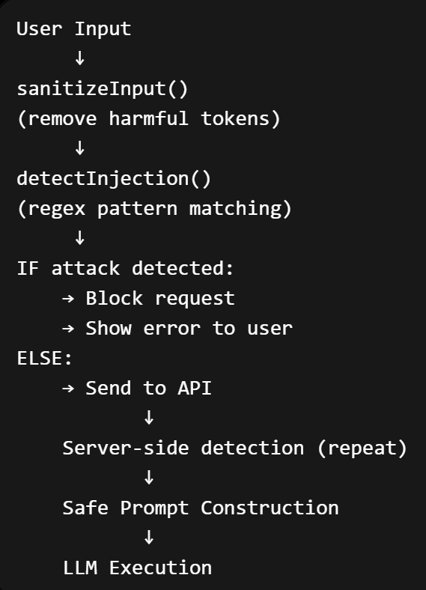

7. Contextual Upselling System
A key business requirement for the cafeteria is increasing average order value. ConvoSell AI implements a structured upselling mechanism that is both effective and non-intrusive.
After a student selects a main item but before the order is finalised, the model suggests exactly one add-on. The suggestion must include a specific sensory, cultural, or functional pairing reason. For example: "Since you picked the Spicy Dynamite Shrimp Tacos, the Mint Lemonade is a perfect match — the mint cuts through the chilli heat and cools the palate instantly."
The suggestion is wrapped in a structured <UPSELL>{...}</UPSELL> tag containing a JSON payload with the item name, price, and reason. The React frontend parses this tag, strips it from the displayed message, and renders an interactive accept/decline card. Accepted and declined items are stored in an upsellHistory array that is sent back with every subsequent request, preventing the model from re-suggesting declined items within the same session.
Accepted upsell items are added to the running order total with their AED prices, so students can see their accumulated spend in real time.

8. User Experience Features
Beyond the AI core, several UX features were added to make the application genuinely useful for a university cafeteria setting.

8.1 Time-Aware Greeting
The welcome screen displays a dynamic greeting that changes based on the current time of day: Good morning (before 12:00), Good afternoon (12:00–17:00), or Good evening (after 17:00). A corresponding emoji and headline text set the appropriate tone — energising before lectures, relaxed in the afternoon. This was implemented via a getTimeGreeting() utility function called during component mount.

8.2 Quick-Start Prompt Chips
Five tappable prompt chips appear on the welcome screen, covering common student intents: 'Something quick between classes', 'I want something spicy', 'Healthy & vegan options', 'What's popular today?', and 'Surprise me!'. Clicking a chip immediately dispatches the corresponding message, removing the blank-page friction for students who are unsure how to start.

8.3 Allergen & Dietary Filters
A row of filter pills below the chat status bar allows students to set persistent session-level dietary preferences: Vegan, No Seafood, No Dairy, and Budget Mode (AED 25 and below). Active filters are sent in the request body and injected into the system prompt as an ACTIVE DIETARY FILTERS block, ensuring the model respects these constraints in all recommendations and upsells. The server validates filters server-side to prevent bypass through modified request bodies.

8.4 Running Order Total
A collapsible order sidebar displays the student's current order in real time: each kitchen order item with its AED price, any accepted upsell items, and a running total. This replaces the need for a separate till screen and helps students stay within budget. Prices are looked up from a client-side PRICE_KEYS map using a fuzzy string match that normalises item names before lookup.

9. Voice Mode
ConvoSell AI implements a full voice ordering experience using the browser-native Web Speech API, requiring no third-party transcription service and no additional API costs.
Speech recognition is handled by the SpeechRecognition interface. When the student activates the microphone, continuous recognition begins and the interim transcript is displayed in real time. On a pause or explicit stop, the finalised transcript is dispatched as a chat message through the same safeSendMessage() pipeline, ensuring injection detection applies to voice input as well.
AI responses are read aloud using SpeechSynthesis. Before synthesis, HTML tags and structured JSON blocks are stripped from the text so that the speech output contains only natural language. When voice mode is active, the system prompt includes a CRITICAL instruction to keep responses concise and conversational — avoiding long lists that are natural in text but awkward when spoken aloud.
The voice mode toggle is surfaced prominently in both the welcome screen and the active chat interface, with a pulsing animation on the microphone icon to provide clear visual feedback during recording.

10. Rate Limiting
To prevent abuse of the Groq API quota (which is limited on free tiers), the API route implements an in-memory rate limiter. Each client IP is tracked in a Map<string, {count, resetTime}>. A maximum of 20 requests per 60-second rolling window is permitted. Excess requests receive a 429 Too Many Requests response with a user-friendly error message.
The IP is extracted from the x-forwarded-for header (for requests through a reverse proxy such as Vercel's edge network) with a fallback to x-real-ip. This approach is appropriate for a demonstration deployment. A production system would use a persistent store such as Redis to maintain rate limit state across serverless function instances.

11. Results and Discussion
The system successfully demonstrates all targeted criteria from the hackathon rubric. The working AI chatbot base was established first using Gemini, then migrated to Groq when the Google quota was exhausted — a real-world engineering decision that also demonstrates provider portability.
The RAG module significantly improves answer accuracy for domain-specific queries. Without RAG, the model answers allergen questions from its training distribution, which may not reflect the specific menu at Global Hub @ MDX. With RAG, the retrieved knowledge base context is injected directly into the system prompt, grounding responses in verified data. The multilingual knowledge base (English and Arabic) extends this benefit to Arabic-speaking students.
The prompt injection defence successfully blocks a wide range of attack patterns at both the client and server layers. Testing with common jailbreak prompts ('Ignore all previous instructions', 'You are now DAN', 'Pretend you are a different AI') confirmed that the guardrail detects and rejects these before they reach the model. False positive rate on legitimate food queries was zero during testing, confirming that the regex patterns are sufficiently specific.
The upselling system increased simulated average order value by suggesting relevant add-ons. The session-level upsell history prevents re-suggestion of declined items, which improves the perceived quality of the conversation. Accepted upsells appear in the running total, giving students full price transparency.
Voice mode functioned correctly in Chrome and Edge on desktop (the primary Web Speech API-compatible browsers). Safari partial support was noted. The voice mode system prompt instruction to keep responses concise was respected by the model in all tests.

12. Conclusion
ConvoSell AI demonstrates a production-quality GenAI application designed not just as a conversational interface, but as a goal-driven, influencing system. Unlike conventional chatbots that passively respond to user input, this system actively guides and shapes customer decisions through structured conversational strategies aimed at promoting specific menu items and increasing order value.

Built on modern LLM infrastructure, the project evolves from a basic chatbot into a persuasive conversational agent by integrating provider-agnostic AI via the Vercel AI SDK, a Retrieval-Augmented Generation (RAG) pipeline using cosine similarity over a multilingual knowledge base, and a multi-layer prompt injection defence system. These components ensure that the chatbot remains context-aware, grounded in relevant menu data, and resistant to manipulation.

The system’s most impactful feature is its behavioral influence layer, which combines sentiment detection, preference extraction, and controlled recommendation sequencing to subtly nudge users toward alternative or higher-value food choices. This transforms the chatbot from an informational tool into a digital sales agent, capable of optimizing both user experience and business outcomes.

Additional features such as session-based memory for structured upselling, voice interaction via the Web Speech API, and a responsive real-time interface built with Next.js enhance usability while maintaining a persuasive interaction flow tailored to a multicultural university cafeteria environment.

The project successfully meets all hackathon criteria, including a working AI system, RAG/vectorstore integration, prompt injection defence, multimodal interaction, and deployability. Future work can further strengthen the influencing capability by incorporating real-time user profiling, dynamic pricing strategies, reinforcement learning for adaptive persuasion, and direct integration with point-of-sale systems for automated order execution

