**Technical aspect of The Website**

**Subsection HTML/CSS & Bootstrap**

In order to create the website with our planned features and design, we have used HTML, CSS and Bootstrap Framework. As mentioned earlier, as a group, in general, our knowledge before the project was below the average level and for that reason, we have used all available time to learn more and more about HTML and CSS and didn’t stop experimenting while making the website.

Initially, we have decided to create HTML files for every page and only keep one CSS file which would be linked to all the files, however, throughout the development of our website we realized that keeping a CSS file for each page is easier. We have also planned to have a header HTML that would have the navigation bar in it and we would copy and paste it onto all our pages.

As mentioned earlier, we decided to create four pages: Homepage, University Response, Personal Experience and Covid-19 page.

In this section, code parts that had a crucial impact on the look and the working of the website will be described and shown.

**Subsubsection Menu/Navigation bar**

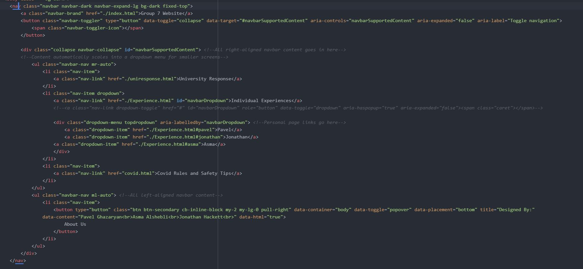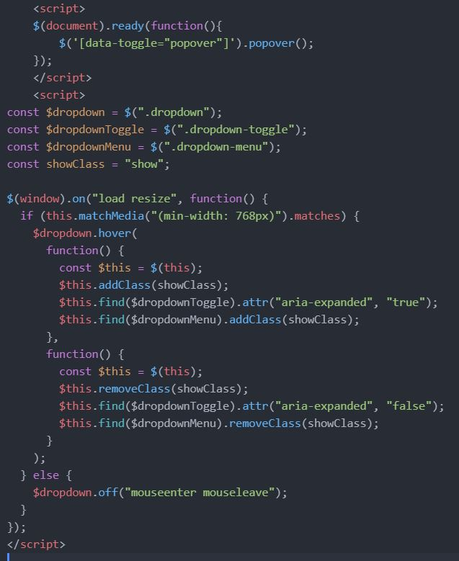One of the elements which are repeated in all the HTML pages is the menu/navigation bar. It may be seen in Figure 4.1 below.

Figure 1. Navbar & JS

We have used **nav** and **ul/li** tags to create the general layout of the menu bar and used div elements for adding the dropdown menu. For the navigation bar to have the look that we wanted, we have used some Bootstrap ready classes such as **fixed-top** and nav-item. We have also researched a bit further about JavaScript to create the dropdown menu and popover of the “About us” button that would look more professional. We have linked our JavaScript code using the script tag which may be seen in Figure 1.

Besides creating a function for the dropdown to work properly, we have also come up with another one so that the dropdown would disappear after the mouse pointer left the dropdown element.

The code for the menu bar along with the JavaScript part was reused into all pages. We thought of making it more efficient and tried to find in which way we can include HTML from multiple files into the same page without copy-pasting it but found out that it is done with JavaScript/JQuery and decided not to get along with it and get possibly lost.

**Carousel & Gridlines**

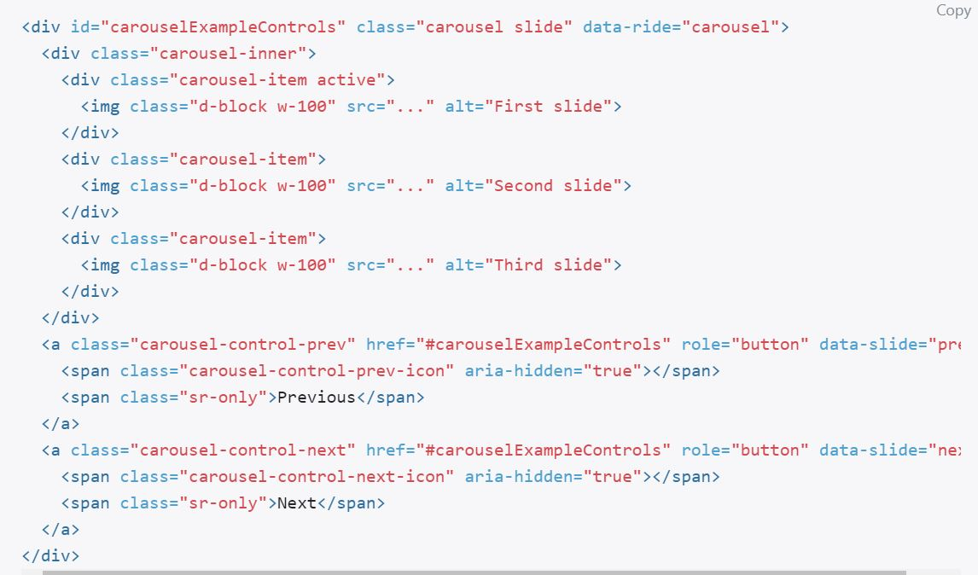In all our pages we have used **carousel** which is already written bootstrap element with all the classes for creating a slideshow. We decided to use a carousel because it would let us show more information in one given space and also would present our knowledge in Bootstrap and HTML/CSS. A default carousel code may be seen in Figure 3 below.

Figure 2. Carousel (Image taken from getbootstrap.com)

In the carousel, we have modified some of the default bootstrap elements so that it would have a proper look. We have added link tags to carousel items so that the user could navigate to other pages by clicking on the carousel slides. The most important CSS modification of the carousel that we used in our code is the image fit modification. We needed the image to cover the whole allocated space and keep the high resolution instead of stretching. For this reason, the image object-fit property was put to be cover. In the carousel, we have also added more li tags in order to have the specific number of slides that we wanted to show. This modified carousel was also used in the same way on all other pages of the website.

We have also used the positioning feature of bootstrap which is called ‘gridlines’ in the Bootstrap environment. The positioning helped us to put elements in the layout that we wanted without using any CSS modification such as **float-left** and **display block**. We have used this to create the personal experience section of the Homepage. In that section of the Homepage, it can be seen that there is a header and three equal columns with equal width. Furthermore, we have used this feature to depict different sections in the University Response page. An example of a default Bootstrap gridline HTML code and code for our website may be seen in Figure 4.

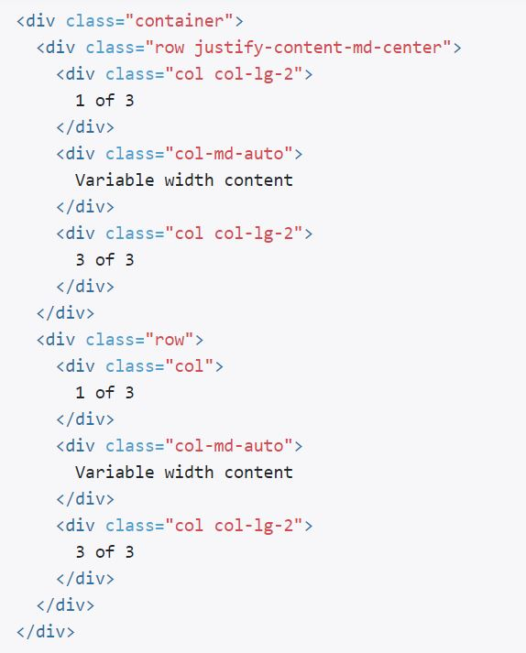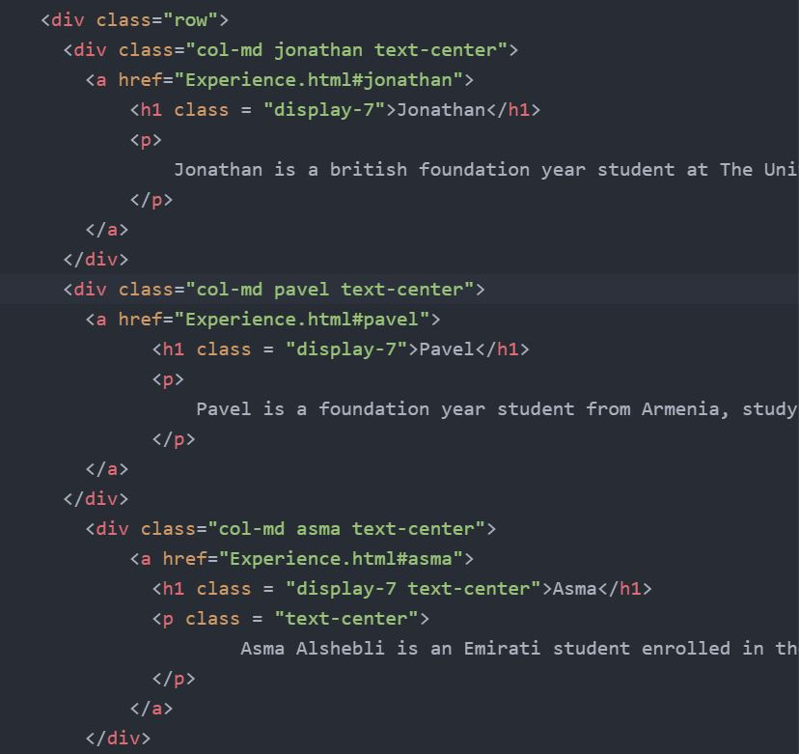

Figure 3. Gridlines (Image taken from getbootstrap.com)

On the right side of Figure 4, it may be seen that gridlines default code was used with the addition of paragraph and heading tags.

**CSS Hover & Animations**

We have worked a lot on the aesthetics of the website so that user will enjoy navigating through it. For example, on the homepage, hovering over the images in personal experience will zoom in the background image which gives the website a more developed and eye-catching look. The hovering effects are present on all pages, for example, on the University Response page, hovering over the elements will scale them to become bigger and have a darker background color to feel more real. In Covid-19 page, hovering over country names will show their flags in the background. An example code for hovering in the Homepage can be seen in Figure 5.

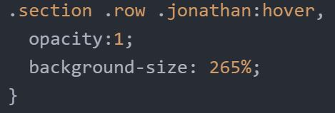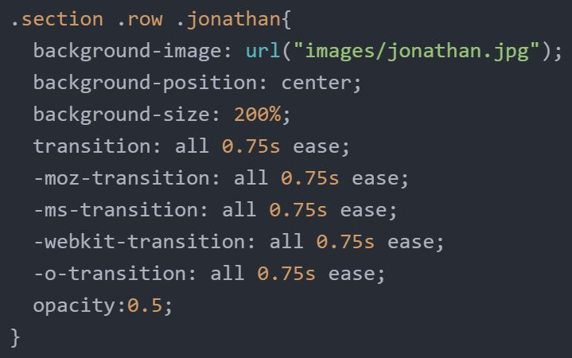

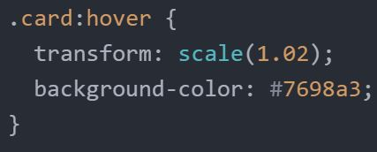

Figure 4. Hover CSS

In Figure 5, on the left side, we may see that background-size is put 200%. This allows the image to zoom in, otherwise the image will not take up the whole div element and would repeat. Transition properties were also assigned to the div elements so that when hovering, the image zoom-in will take place smoothly and not instantly. On the right side of Figure 5, it may be seen the CSS code for hovering on different objects. The hover effect increases the background-size to 265%, which results in the zoom in effect.

Another interesting CSS3 feature that we have implemented is animations. We have made animations for the content to fade in when opened or hover effects to take place after a given interval. All these modifications made our website more dynamic and interesting to use. Examples of such kind of animation codes may be seen in Figure 6 shown below.

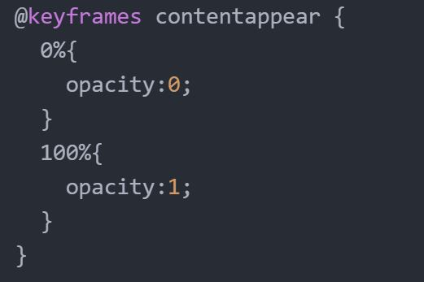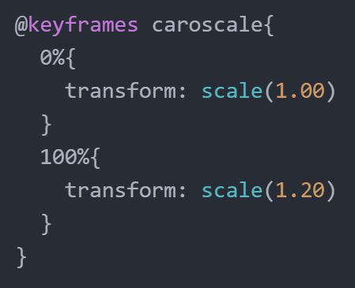

Figure 5. CSS Animations

The first animation code above was used to make objects appear by modifying their opacity. The second animation was used to make the object scale bigger when selected.

At this stage, we have realized that using one CSS file for all HTML files is getting complicated. The issue was that some of the CSS modifications were conflicting with each other and the website was not working properly. CSS that was meant only for one element also affected other elements on different pages. In order to sort out this issue, we decided to create a CSS file for each working HTML file meaning each page on the website would have its own CSS file with its own CSS modifications and avoid clashing.

**Using Gitlab & LaTex**

**Gitlab**

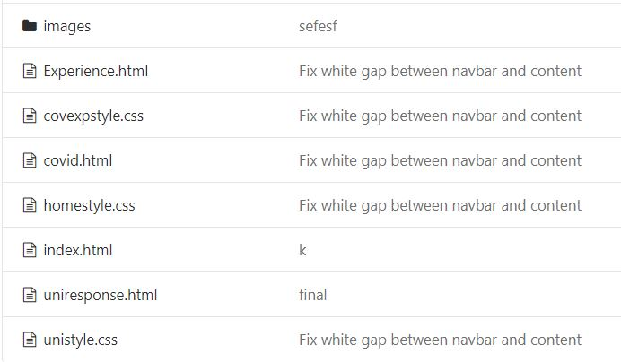In order to collaborate as a group in an online environment, we have used Gitlab. We have created a Project that can be accessed by all group members. In the Project master branch, we created a folder where we stored all the HTML and CSS codes. We have also added a separate folder for images. The structure of our master branch may be seen in Figure 6 below.

Figure 6. Git master Structure

We used this environment along Git Bash to push and pull all the latest code changes, and through this feature, we were able view and check any modifications made by each member.

**LaTex**

We have used the \LaTex\ typesetting system to make our Final Project report look more organized and professional. Due to the need for collaboration, we decided to try and find an online environment that would let us contribute at the same time to one specific LaTex document. Fortunately, one of the TAs recommended us a website called Overleaf (https://www.overleaf.com/) which allowed us to work simultaneously on a single LaTex document. This made writing our report to be more efficient and less time-consuming.

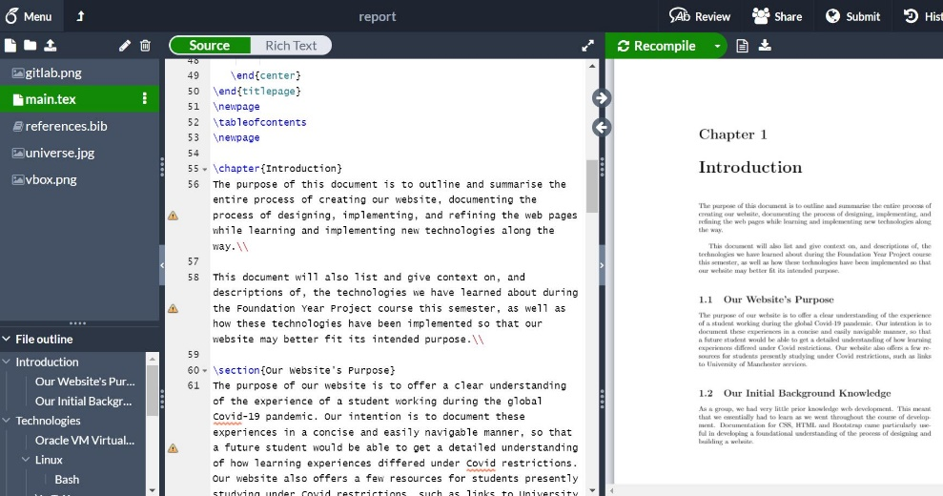

Figure 7. Overleaf overview

**Publishing our Website**

In order to publish our website on University of Manchester servers, we have accessed the Web Dashboard (<https://web.cs.manchester.ac.uk/dashboard/manage>) and written down the clone-URL of our Git master repository.

To access our website, we have downloaded the specific VPN and ran it through the Linux terminal. After having the VPN working we were able to access the link shared in University‘s private network.