Self-Directed
Learning
Contract
For
My Project

Author: Gregory Pomeroy
Date: January 14, 2023

Table of Contents
1. Project Overview 1
2. Self-Directed Requirements 1
3. Progress 2
3.1. Milestone 1 Completed: 2
3.1.1. Sub-Paragraphs 2
3.2. Milestone 2 Completed: 2
3.2.1. Sub-Paragraphs 2
3.3. Milestone 3 Completed: 2
3.3.1. Sub-Paragraphs 2
3.4. Milestone 4 Completed: 2
3.4.1. Sub-Paragraphs 3
4. Demonstration Paragraphs 3
Appendix A. Requirements Traceability 4

List of Tables
No table of figures entries found.

List of Figures

3.1.1. Milestone 1 Sub-Paragraph: Web Application Flow Chart

Project Overview

The topic for the Capstone Project is an example web application that is based off energy industry information from the Greener Homes Initiative as it’s featured in Nova Scotia and employed by NRCan. This initiative allows homeowners to apply to the program to receive benefits and rebates to make their homes more energy efficient.

The purpose of this web application is to offer a solution to the higher call volumes and inquires the initiative receive due to the many different programs available and the different requirements to receive them. The web application will offer a series of dropdown boxes to receive the user’s household income, ages, if the house is a primary or secondary residence, and other profiling questions. Once all the questions have been completed, the application will reach a local database and retrieve the information to the program that the user would be most suited for. This will also include contact information for that program, as well as a list of service providers to begin the process within that program.

This project will reflect a need for a real company based on industry professional opinions and feedback, as well as involving full-stack development to display a complete skillset.

Self-Directed Requirements

The requirements for this program will be to familiarize myself with JavaScript, and how it interacts with a database using specific technologies that will work with node.js in a model, view, and controller organizational structure. I will also need to construct the front-end website using HTML and CSS.

Progress
Provide whatever level of detail makes sense. Note the paragraph numbering, and stay in the 1.x paragraphs for Requirements, if you wish.

Milestone 1 Completed:

The first milestone has been completed. This includes building a first draft of the front-end website, mapping out how I would like the database to gather, store and retrieve all information, and how the stack will interact with all elements.

Sub-Paragraphs
To begin, I’ve created a document in the form of a flow chart that will help me map out how I would like the flow of the web application to be completed, so that it will make the most sense to every user.

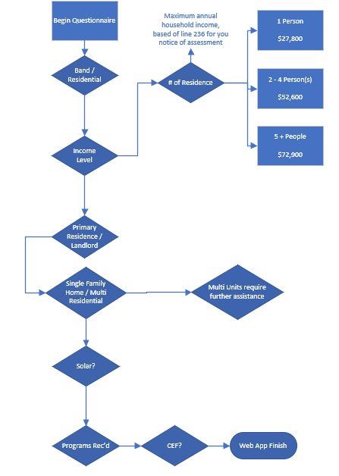

Along with this, I have completed the first rough draft of the website that will be accessed by users. I wanted to create a page that is highly visible and not bogged down with too many graphics or unnecessary colors. I kept the background white with a highly readable text but included a transparent graphic on the side to help add some visual appeal.

For this project, I will be connecting the MySQL database with node.js and have been learning at a steady pace to begin planning all the required files I will need to keep in line with the MVC model. The stack will be very similar to previous projects but will be more in line with the technologies commonly used with JavaScript.

Milestone 2 Completed:

Summary of what I did for Milestone 2

Sub-Paragraphs
Again, break down the subparagraphs in a way that makes sense. Include diagrams and tables as needed.

Milestone 3 Completed:

Summary of what I did for Milestone 3

Sub-Paragraphs
Again, break down the subparagraphs in a way that makes sense. Include diagrams and tables as needed.

Milestone 4 Completed:

Summary of what I did for Milestone 4

Sub-Paragraphs
Again, break down the subparagraphs in a way that makes sense. Include diagrams and tables as needed.

Demonstration Paragraphs

You don’t need to call it testing, but show the end results of what you built.

Requirements Traceability

- Code snippets, GUI snippets, other stuff placed here to be informative, but reduce the clutter inside the main document

