**Problem Statement:**

This case study is regarding the creation of a COVID Assessment tool consisting of a genie which interacts as a chatbot for voice and text-based interactions. Covid Assessment bot is a tool that leverages multiple features of AI such a voice,

Natural language processing and decision making to provide a solution that can scale to serve multiple people and help them.

**Services Used:**

1. Amazon Lex
2. AWS DynamoDB
3. AWS Cloudfront
4. AWS Amplify
5. AWS Lambda
6. AWS Cloud9
7. AWS CodeCommit
8. AWS S3
9. AWS CloudFront
10. AWS AppSync

**Architecture Diagram:**

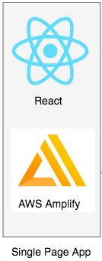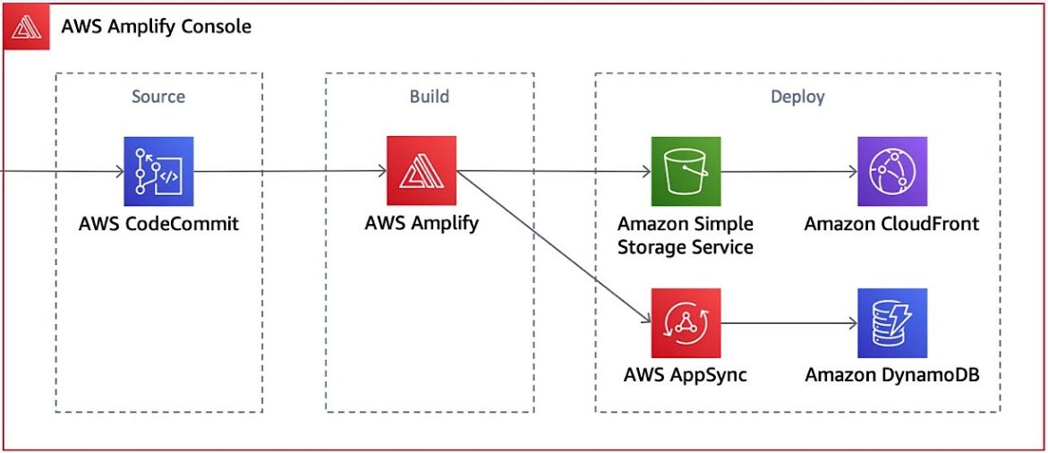

**Introduction:**

With COVID-19 impacting healthcare systems around the world, patients are looking to their healthcare providers for information related to the novel coronavirus, guidance on when to be tested for the virus, and instructions on what to do if they have a confirmed positive result. As a result, health systems across the World have quickly become overburdened with calls and questions related to the novel coronavirus. The challenge for hospitals and health systems is getting accurate, trusted information to individuals in the community and directing them to the appropriate education and/or care, all at scale. For example, patients that have not had any known exposure or symptoms might be directed towards general prevention information to learn how to reduce exposure risk, while a patient with known exposure to COVID-19 with respiratory symptoms is recommended to be further screened by a clinician..

To help address this spike in call volume placed on hospitals and nurse hotlines, many healthcare organizations throughout the United States have started to build tools or technologies, such as triage chatbots, to help scale the education and engagement with the general population who may have symptoms. These bots are designed to collect information from patients and help route them to the most appropriate level of care based on their answers.

**Implementation:**

This blog provides an overview on how healthcare organizations can embed their clinical protocols into and deploy an AWS-powered chatbot to triage individuals calling in about COVID-19. At the foundation of the COVID-19 conversational chatbot are trusted and validated clinical triage protocols that healthcare organizations have adopted to assess their patients for the novel coronavirus. These protocols often include frameworks on assessing likelihood for an individual to have a condition and paths to escalate for further attention. The clinical triage protocols are wrapped with core components of the chatbot utilizing Amazon Lex, a service for building conversational interfaces into any application using voice and text, to understand user requests and provide the information. You can deploy the chatbot together alongside Amazon Connect, an easy to use omnichannel cloud contact center that provides users with seamless, consistent experiences across voice and chat, or you can integrate it within your own web or mobile environment

Download the files [COVIDResponseBotTemplate.csv](https://covidbottempaltebucket.s3.amazonaws.com/COVIDResponseBotTemplate.csv) and [CovidTriageBot.json.zip](https://covidbottempaltebucket.s3.amazonaws.com/CovidTriageBot.zip)

Using your existing clinical protocols for COVID-19 triage, the COVIDResponseBotTemplate provides you the flexibility to customize this based on your organization’s protocols. launch an AWS CloudFormation stack in us-east-1 using the template downloaded from the above link.

**Output:**

1. Homepage

1. Bot Interaction

**Visit the following link to access the bot:**

<https://master.dcjrsebf77vbs.amplifyapp.com/Chat>

**Future Prospects:**

Here are some enhancement ideas that you can consider to augment the current feature set:

Add a logging mechanism to capture the question-flow and responses for a given chat session. This data can be stored on Amazon S3 and then later be used for historical as well as predictive analysis.

If you already have a patient facing mobile / web application which authenticates the user, you can integrate this bot with the mobile / web application and start collecting personalized responses. This can help in augmenting the patient’s existing electronic medical record and providing a comprehensive picture.

When the patient is connected to a live agent, Amazon Connect enables you to store call recordings of interactions in Amazon S3. You can then use Amazon Transcribe and Amazon Comprehend to analyze customer sentiment, as highlighted in this blog here.

**Conclusion**

During this unprecedented crisis, using tools and technologies like conversational AI paired with trusted, updated clinical content to scale out triaging services, allows healthcare organizations to provide care at critical points, whether it is a telehealth session or hospital visit, to individuals across the US.

Stay well.

**Bibliography**:

* <https://aws.amazon.com/blogs/industries/building-clinically-validated-conversational-agents-to-address-novel-coronavirus/>
* <https://aws.amazon.com/cloudformation/resources/templates/>
* <https://aws.amazon.com/iam/>
* <https://www.who.int/emergencies/diseases/novel-coronavirus-2019?gclid=Cj0KCQjwnqH7BRDdARIsACTSAdtIyTkN8AuBGajN5Tyrt5L06lZ5Gq1lTdBDhM3n56ZceMZ-nqWzZ-0aAvQlEALw_wcB>

**--------Prachi, Rajat, Ruby have worked on this.**