**Data Analysis and Visualization using AWS QuickSight**

Business intelligence (BI) is a collection of tools and strategies that analyse and convert raw data into actionable and coherent information for use in business analysis to help in decision making. BI tools are types of application software which collect and process large amounts of unstructured data from internal and external systems. BI tools are all about helping you better understand trends and derive insights from data in order to make strategic and tactical business decisions. Here are some popular BI tools. According to Gartner’s Magic Quadrant for Analytics and Business Intelligence platforms 2019, QuickSight had not made a place in it but the following benefits made it a strong contender for 2021 as shown in Figure 2.

|  |  |  |
| --- | --- | --- |
| Power BI | SAP Business Intelligence | Qlik Sense |
| Oracle Analytics Cloud | Tableau | AWS QuickSight |

The following are the major reasons for growth Amazon QuickSight in BI sphere:

1. **Compatible with multiple data sources**

Supported data sources are CSV files, file sources, SaaS data sources or various relational data sources for say Amazon S3, Presto, Amazon Athena, Amazon Redshift etc. Any kind of data which is stored in an internet accessible environment is compatible.

1. **SPICE processing Engine**

SPICE is an acronym for Super-fast, Parallel, In-memory, Calculation Engine. and is quick and easy to use. It uses columnar storage along with the latest hardware which empowers the users to run big data query.

1. **Portability factor**

It is a handy-tool which is accessible anytime and anywhere like from laptop, smart phone, desktop, tablets. It in offline mode as well

1. **Flexible–No space constraints**

QuickSight is designed in such a way that business users are not constrained by a conservative cloud design. Users can play around with massive data without delving much into its behind-the-scenes working. As soon as you login you are directed to the dashboards where you can create you visualisations in a jiffy. With a world class data engine and endless documentation, flexibility of the tool increases with each usage.

1. **Smart interactive visualisations**

The SPICE calculation engine helps to model accurate processes and retrieves the required data faster than usual. It has a built-in visualisation tool generates a string of suggestions by observing patterns in the backend data sets. The feature ‘Autograph’ evolves itself to accurately predict data analyses based on your analytical patterns over time.

1. **Self-service analysis tool**

The need of the hour is self-service facility and the user interface of QuickSight enables slicing and dicing of data according to the needed analysis. This allows to go ahead with story-telling from data with customised options.

1. **High scalability**

It is used across various business domains for measuring the metrics in an independent way. It has the capability to scale up to tens of thousands users.

Fig 1. 2017 BI tool quadrant

Fig 2. 2021 BI tool quadrant

Among these tools in the quadrant, Amazon QuickSight is a very fast and cloud-powered business intelligence service that can help you to build visualizations, perform ad hoc analysis, and get business insights from your data. It is a scalable, serverless, embeddable, machine learning-powered business intelligence (BI) service built for the cloud. QuickSight lets you easily create and publish interactive BI dashboards. Below is the analysis and dashboarding process in QuickSight.

* **Sign up for an AWS account**

Create an AWS account on AWS or if you already have an account then signin to your AWS account.

* **Create AWS QuickSight account**

After signing into your AWS account, open QuickSight service from AWS management console. It is located under Analytics or you can also find it by searching for QuickSight.

1. Click on Sign-up for QuickSight and complete the sign-up procedure.
2. Choose between standard or enterprise version as per your need.
3. Choose your region, enter name, password, email-id to complete signing up.
4. You will get some sample data, analysis and dashboard to quick start with QuickSight.

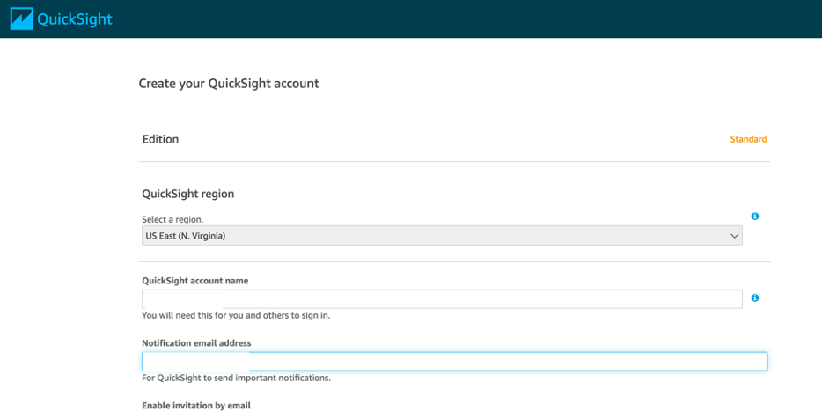

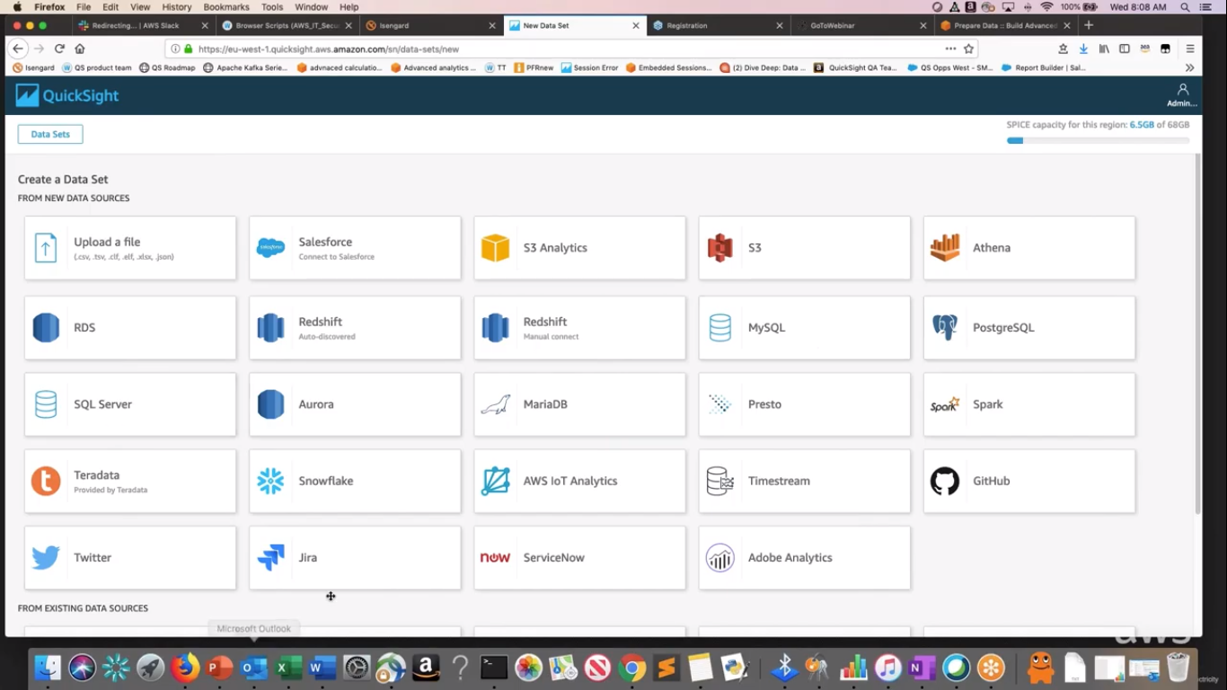

* **Preparation of data sets**

1. Click on datasets from left menu.
2. Click new dataset on right top corner and choose the data source on which you want to create your dashboard. Data sources can be any excel file or you can pull data from other data source as S3, Athena, MySQL, RDS etc. (Here excel sheet data is used)
3. Choose one sheet from multiple sheets and click on edit/preview data to prepare it for analysis.
4. Here you can exclude any field, can change its data type, can add calculated field, can change its name by clicking on the three dots corresponding each field.
5. You can also add filters and calculated fields by clicking on the respective menu.
6. You can add another data set with previously added data set to perform join operation by clicking on “Add data” on top right corner. Once you added new data set, click on two red dots between two datasets available to apply join.
7. You can configure your data set like choosing particular columns from sheet and can also view dataset details by clicking on down arrow on dataset.

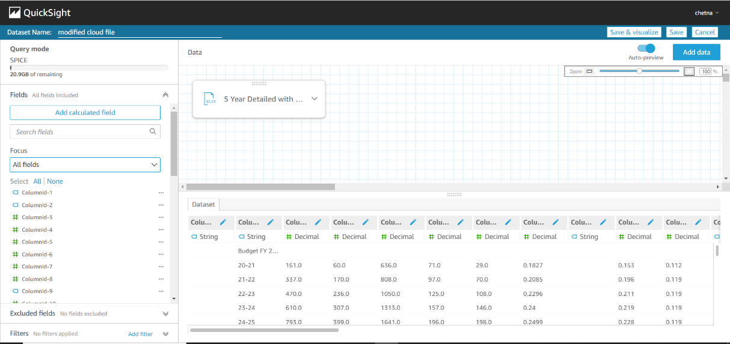

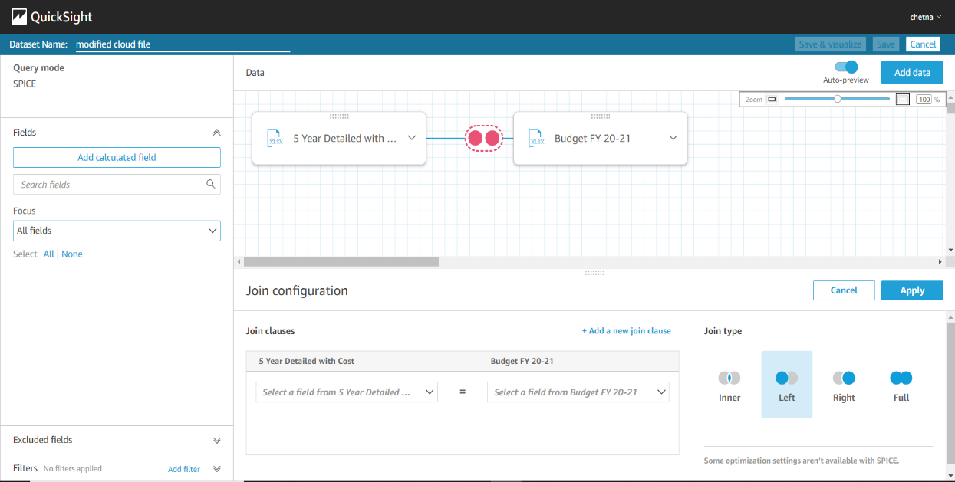

* **Modifying the selected dataset**

You can always edit any dataset you previously added by clicking on the dataset from the list of datasets available.

1. Click on Delete dataset to permanently delete your dataset.
2. Click on duplicate dataset to copy the same dataset.
3. Click on edit dataset to edit your dataset. Here you can edit your dataset same as while creating and preparing.

* **Beginning with analysis**

Now you have your dataset, you can now create visuals, analysis by creating different types of graphs.

1. Click on the analysis on left menu. Click on “New analysis” on top right corner. Choose required dataset and click on create analysis.
2. Choose fields from the field list on which you want to create your graphs. QuickSight have a feature of autograph which create best suitable graph according to the field you choose.
3. QuickSight have a variety of graphs available so that we can choose them according to our requirement and for best analysis of data.

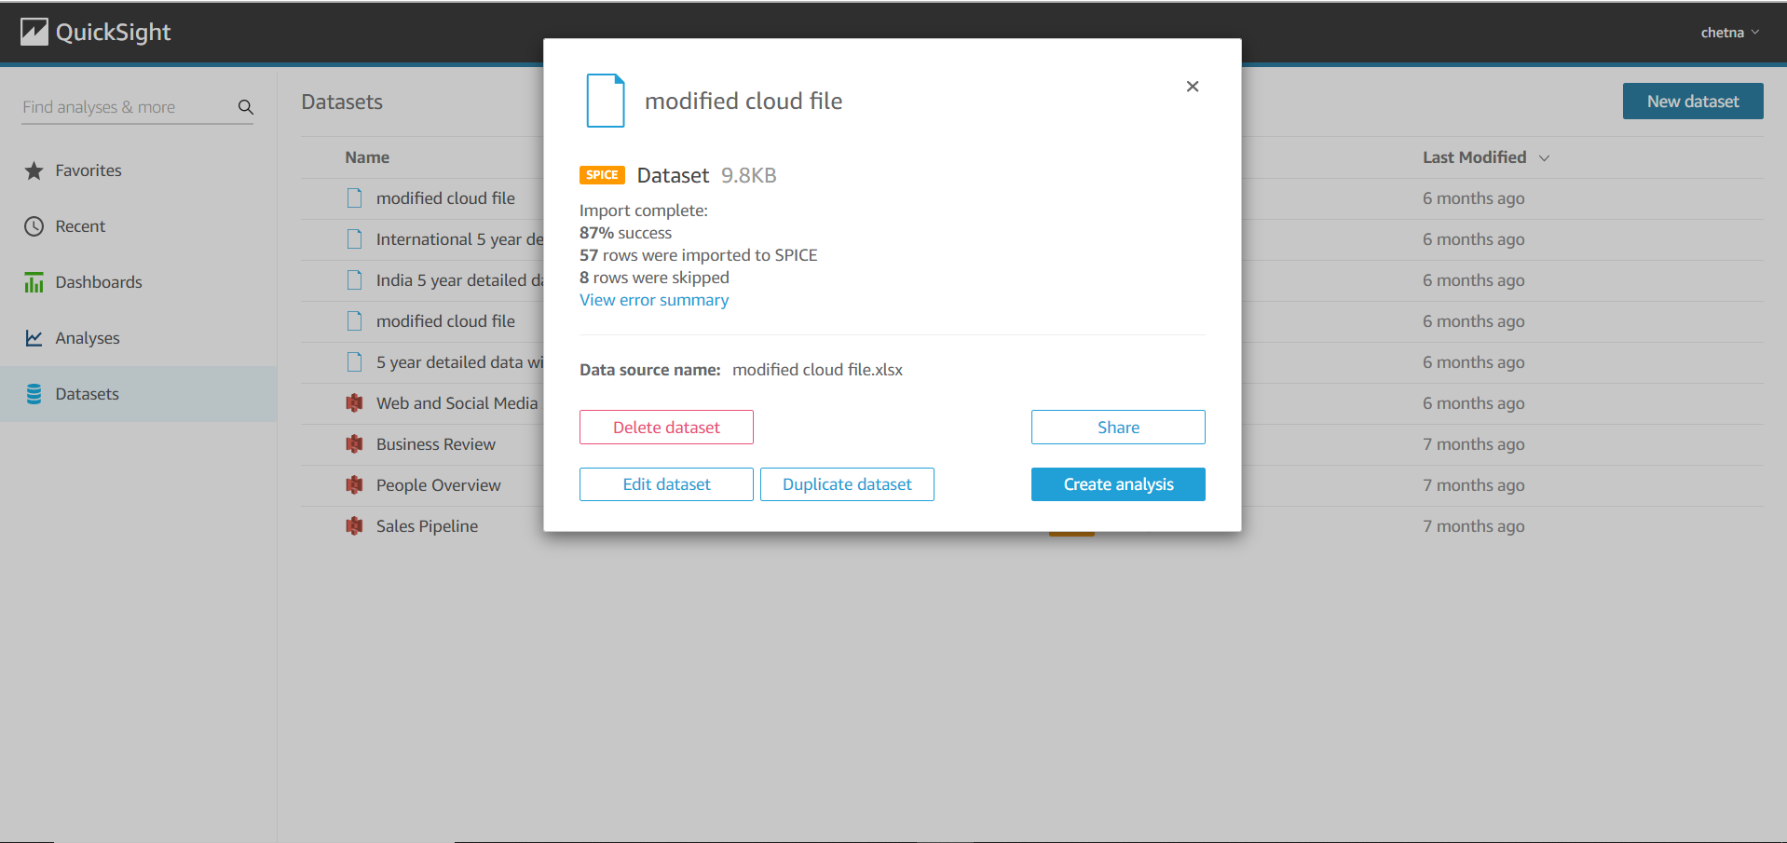

* **Working on visuals**

Now you have your dataset, you can now create visuals, analysis by creating different types of graphs.

1. Choose fields and graph according to your requirement. The area on which the graph is show is sheet. We can add more sheets on our analysis by clicking on “+” sign on top panel. We can also rename and duplicate any sheet.
2. Field wells on top of sheets shows the y-axis, x-axis and colour (in case we choose multiple fields on any axis) of fields we choose. By clicking on the down arrow of each field well, we get the options of aggregation, sort, formatting option. Here we can also remove or add new fields.
3. There can be more than one visual on one sheet. We can choose any visual by simply clicking on that visual. Increase the size of visual by drag and drop the corners. Click on the three dots corresponds to the visual and there we get the options of hide/show legends, export to csv, duplicate visual (in same sheet), actions and delete visual.
4. Click on “Filter” to add filters. Click create one and choose field on which you want to apply filter (Here Business field is chosen). Then choose your filter and apply filter type, filter criteria and value of fields which you want to include or exclude. Click on apply and then close. Now your visual will have filter applied on fields.

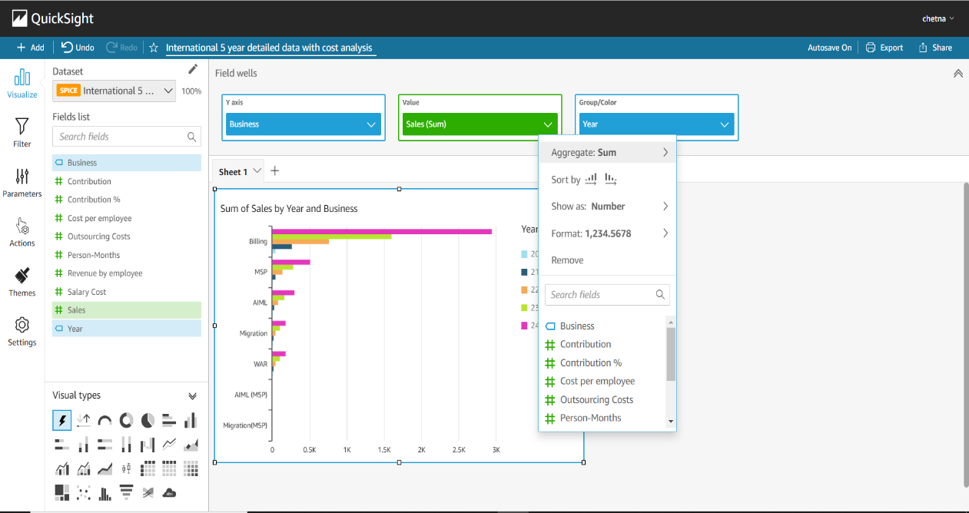

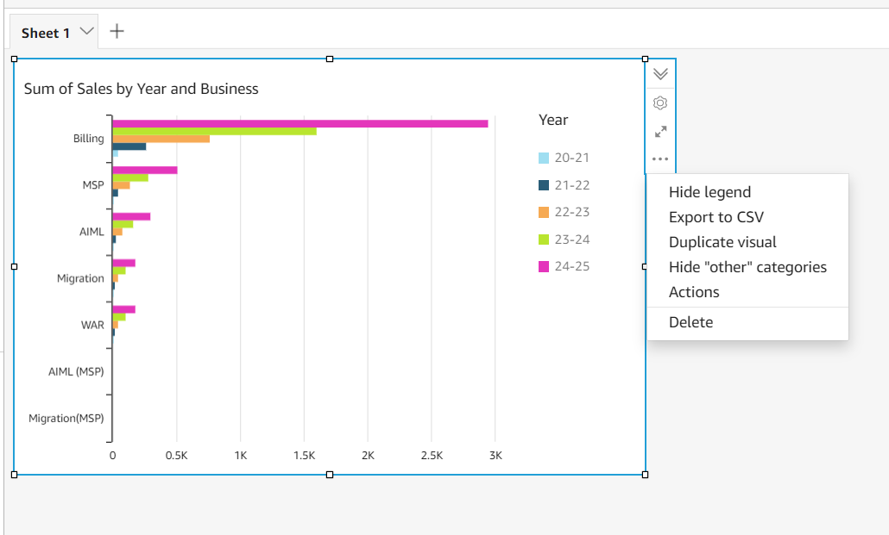 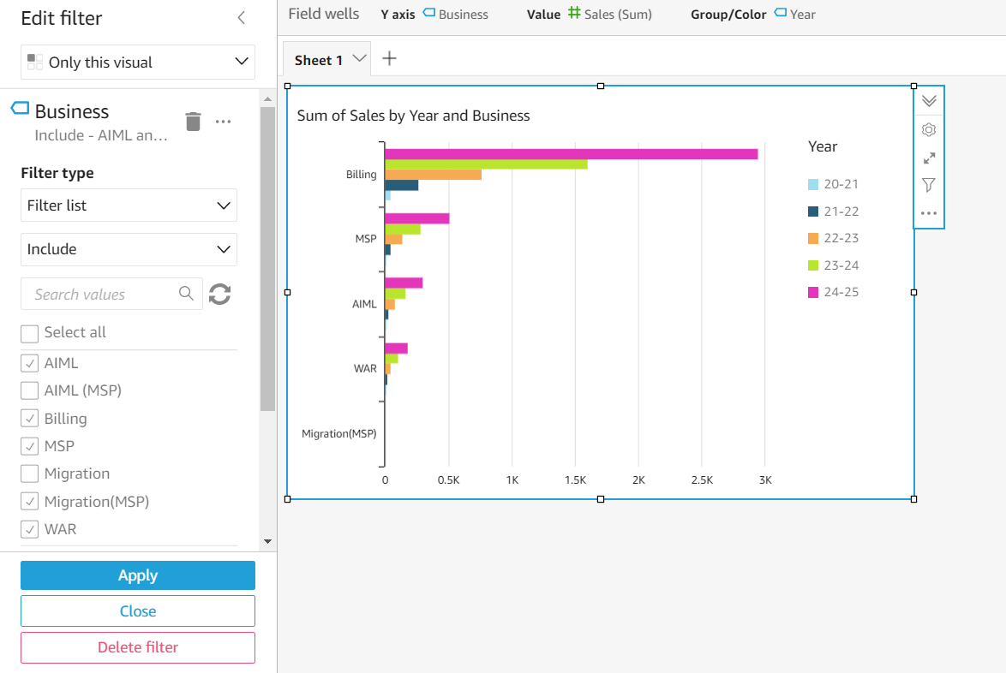

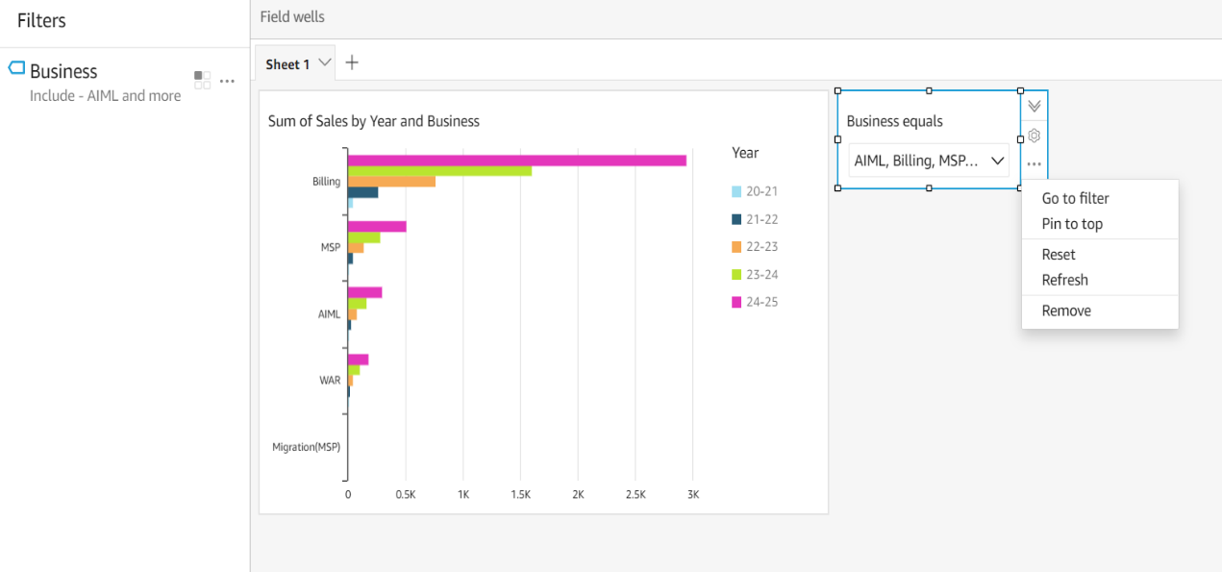

1. We can also add this filter to our sheet as a drill-down menu. Click on three dots of filter and choose “add to sheet” option. We can move this drill-down to top of the sheet, can refresh it, can go to filter from this drill-down or can remove it.
2. We can also customize the graphs or visuals by changing their colours, changing background and foreground, changing font size and type through theme menu. Click on theme from left menu and there you get all the options to customize your viisuals.
3. We can also configure scaling setting by clicking on the setting from left menu. Here two options are there to autofit or optimize according to your requirements.
4. Now we have applied filters, customized our charts. We can perform the same operations by visuals itself. Click on any graph value of visual and you will get all the options related to filters and themes. Here we can focus any field or can exclude any field. They are nothing but the filters itself. When you click on any exclude or focus option, it will create a new filter in filter menu which is same as discussed above. Here you can also change field colour, chart colour as in theme menu.

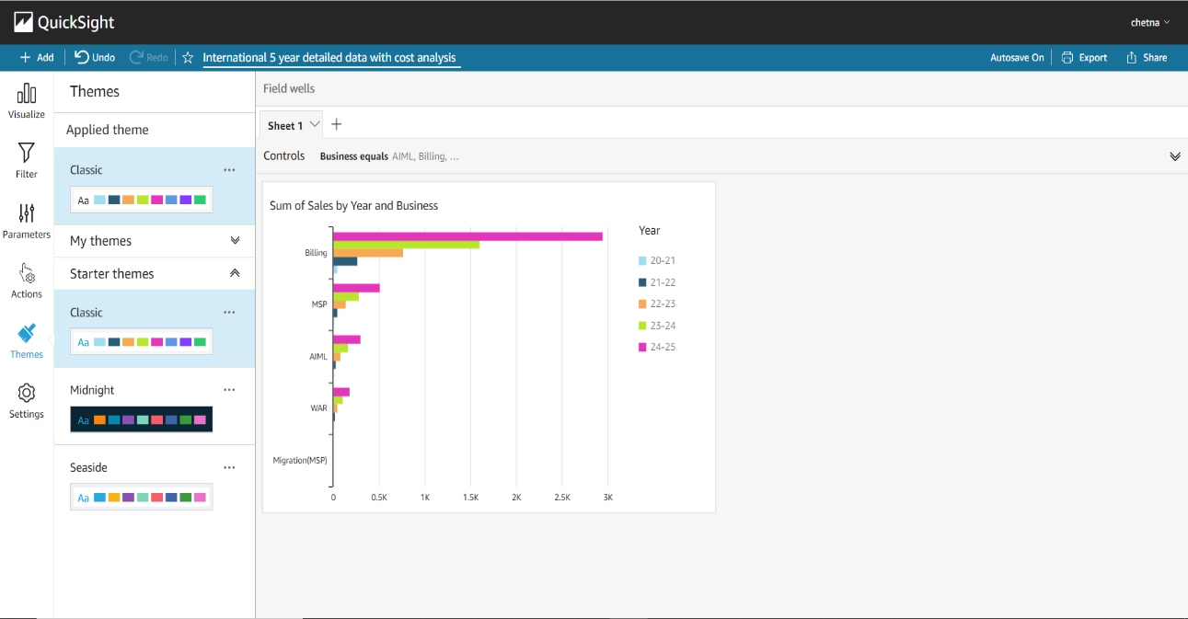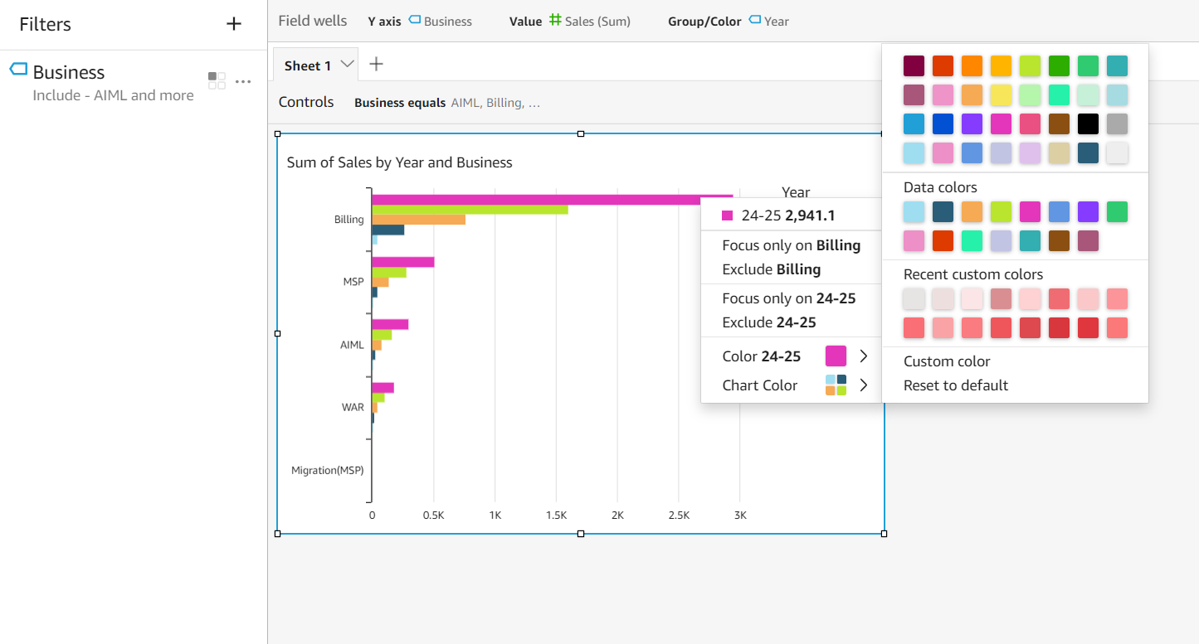

* **Publishing a dashboard**

Now you have created dataset, analysis, visuals, customized your visuals. Now your analysis is ready to publish as a dashboard. A user can only read this dashboard and can also apply drill-down to filter the data but cannot modify our visual.

1. Click on the share on top right corner and click on “publish dashboard”. A popup window will open. Name your dashboard and click publish dashboard.
2. On dashboard, you can filter data from drill- downs applied on visuals. Drill-downs are available at top panel as we have moved them to top of sheets.
3. As we have multiple sheets available to us, we can also move to other sheets to see their visuals.
4. Once our dashboard is saved, it is available on dashboard menu in QuickSight main page. From there, we can access our dashboard and also can delete it. A dashboard will look like this-
5. We can also share our analysis to other user so that they can also modify them as their need. Click on share and then click on Share analysis to share them to other users. You must have permissions to share with other users. Here we can also manage permissions to other user how hey can access our visuals.
6. We can also mark favourite on dashboard and visuals so that we can access the fast whenever needed. Here we have completed creating analysis and dashboard in QuickSight

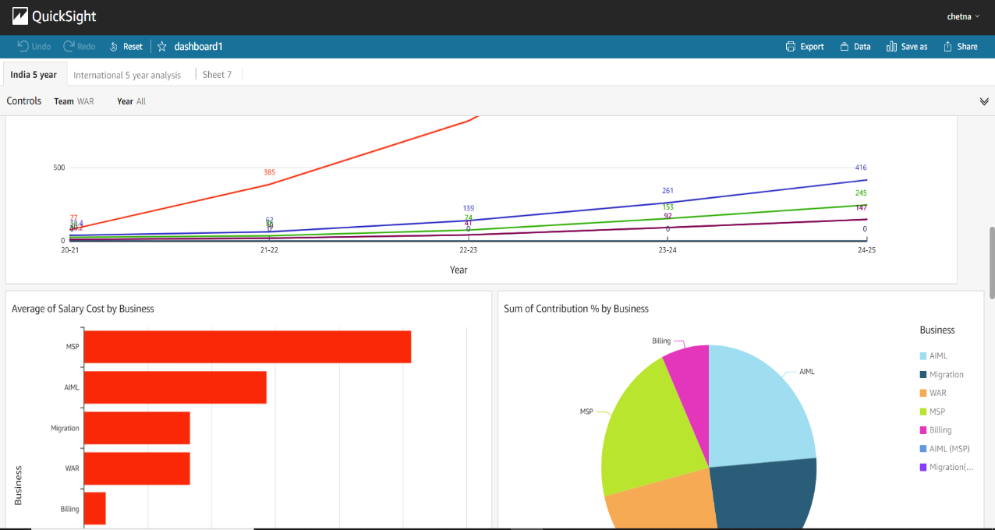

.

* + - 1. Challenges faced and resolutions

SPICE vs Direct connect

With excel, flat files… add filter mode

RLS

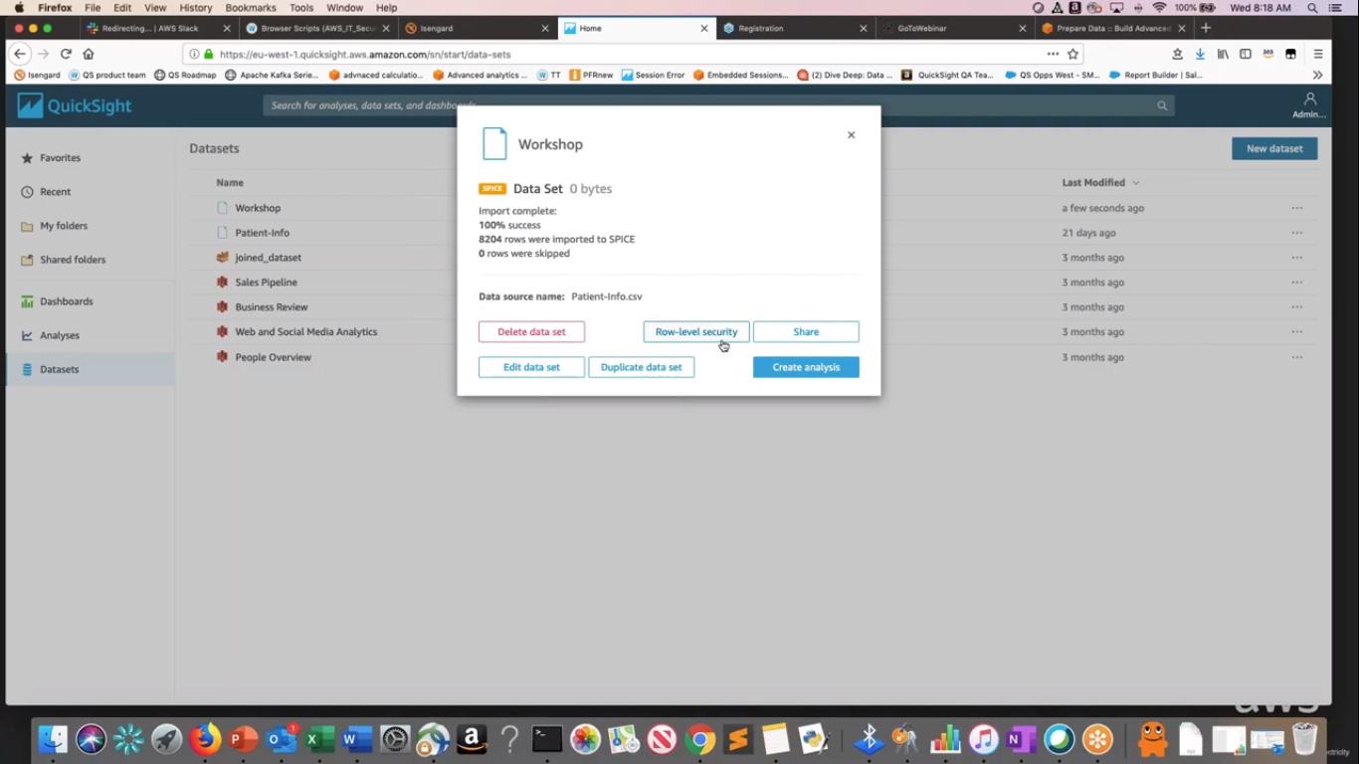

2. Comparison table with Power BI, keep one row comparing prices also