**Data Analysis and Visualization in AWS QuickSight**

Business intelligence (BI) is a collection of tools and strategies that analyse and convert raw data into actionable and coherent information which can be used in businesses to help in decision making. BI tools are application softwares which collect and process large amounts of unstructured data from internal and external systems, they’re all about understanding trends and derive insights from data in order to make strategic and take tactical business decisions. According to Gartner’s Magic Quadrant for Analytics and Business Intelligence’19, QuickSight had not made a place in it. But the following benefits made it a strong contender for 2021 as shown in below graph, these are the major reasons for growth Amazon QuickSight in BI sphere:

1. **Compatible with multiple data sources:** Supported data sources are CSV files, file sources, SaaS data sources or various relational data sources for say Amazon S3, Presto, Amazon Athena, Amazon Redshift etc. Any kind of data which is stored in an internet accessible environment is compatible.
2. **SPICE processing Engine:** SPICE is an acronym for Super-fast, Parallel, In-memory, Calculation Engine. It is quick and easy to use as it uses columnar storage along with the latest hardware which empowers the users to run big data query.
3. **Portability:** It is a handy tool which is accessible anytime and anywhere like from laptop, smart phone, desktop, tablets. It is accessible in offline mode also.
4. **High flexibility & scalability:** There are no space constraints due to cloud design and user need not understand the what’s going on behind the scenes for data processing and visualisation.
5. **Smart and interactive visuals:** It has built-in visualization feature which generates visualization suggestions as per your data set, this feature is called 'Autograph’ which keeps on evolving as the data set matures.

Fig 1. 2017 vs 2021 BI tool quadrant

In summary, QuickSight is a very fast and cloud-powered business intelligence service that helps you to build visualizations, perform ad hoc analysis, and get business insights from your data. It is a scalable, serverless, embeddable, machine learning-powered business intelligence (BI) service built for the cloud which lets you easily create and publish interactive BI dashboards. Below is the analysis and dashboarding process in QuickSight-

* **Sign up for an AWS account**

Create an AWS account or if you already have an account then sign into it.

* **Create QuickSight account**

After signing into your AWS account, open QuickSight service from AWS management console, it is located under Analytics.

1. Click on Sign-up for QuickSight and complete the procedure.
2. Choose between standard or enterprise version as per your need.
3. Select your region, enter name, password, email-id to complete signing up.
4. Some sample data will be available for quick start.

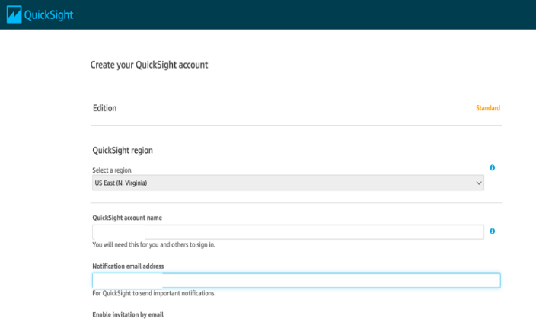 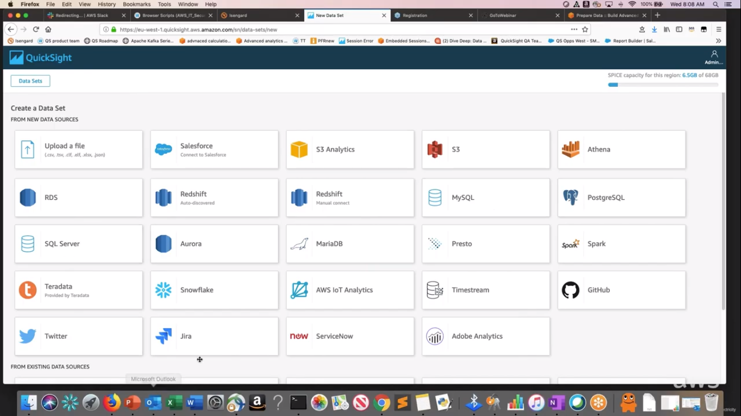

Fig 2. QuickSight account Fig 3. Data sources

* **Preparation of data sets**

1. Click on datasets from left menu.
2. Click new dataset on right top corner and choose the data source on which you want to create your dashboard. Here, excel sheet data is used. Select one sheet from multiple sheets and click on edit/preview data to prepare it for analysis.
3. Here, you can exclude any field, can change its data type, can add calculated field, can change its name by clicking on the three dots corresponding each field, you can also add filters and calculated fields.
4. You can add another data set with previously added data set to perform join operation by clicking on “Add data” on top right corner. Once you added new data set, click on two red dots between two datasets available to apply join.

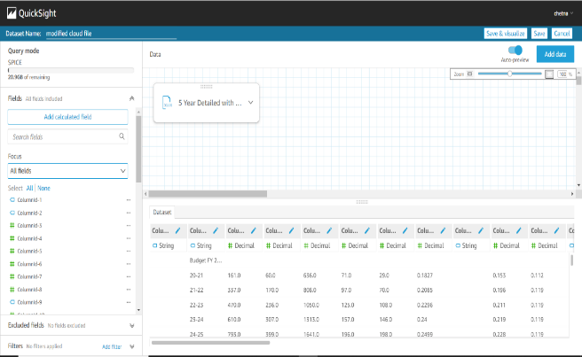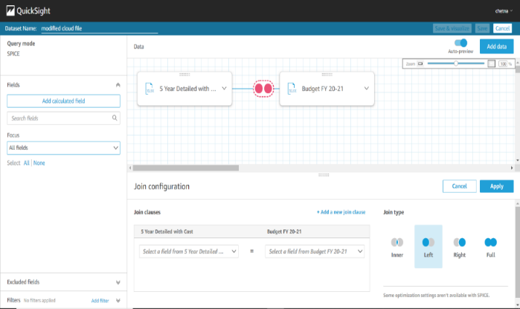

Fig 4. Data set preparation

* **Modifying the selected dataset**

1. You can update any dataset you previously added by clicking on the dataset from the list of datasets available, select edit dataset to edit your dataset.
2. Select Delete dataset to permanently delete your dataset.
3. Select duplicate dataset to copy the same dataset.

* **Beginning with analysis**

Now you have your dataset, you can now create visuals, analysis using different graphs.

1. Click on the analysis on left menu. Click on “New analysis” on top right corner. Choose required dataset and click on create analysis.
2. Choose fields from the field list on which you want to create your graphs.
3. QuickSight has a variety of graphs available to choose from, or you can use autograph which create best suitable graph according to the field you choose.

* **Working on visuals**

1. The area on which the graph is show is sheet, we can add more sheets on our analysis by clicking on “+” sign on top panel. We can also rename and duplicate any sheet.
2. Field value on top of sheets shows the y-axis, x-axis and colour (in case of multiple fields on any axis) of fields. By clicking on the down arrow of each field, we get the aggregation, sort, formatting option. Here, we can remove or add new fields.
3. There can be more than one visual on one sheet and they can be chosen by simply clicking. Click on the three dots corresponds to the visual and there we get the options of hide/show legends, export to csv, duplicate visual (in same sheet), actions and delete visual.
4. Click on “Filter” to add filters. Click create one and choose field on which you want to apply filter, here Business field is chosen. Then choose your filter and apply filter type, filter criteria and value of fields which you want to include or exclude. Click on apply and then close button to have filter applied on fields.

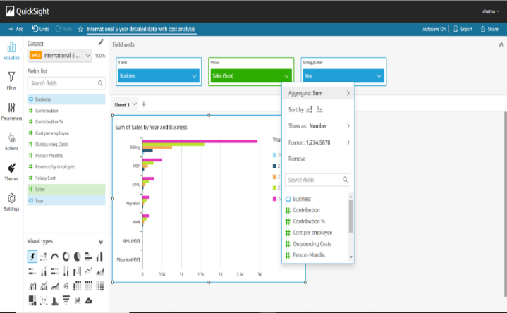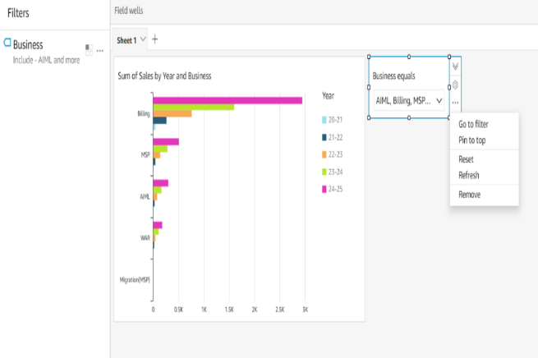

Fig 5. Visual findings

1. We can also add this filter to our sheet as a drill-down menu. Click on three dots of filter and choose “add to sheet” option.
2. We can customize the graphs or visuals by changing their colours, changing background and foreground, changing font size and type through theme menu. Click on theme from left menu for the same.
3. We can also configure scaling setting by clicking on the setting from left menu, two options are there to autofit or optimize according to your requirements.
4. Now as we have applied filters, we can perform the same operations from visuals. Click on any graph to get all the options related to filters and themes.

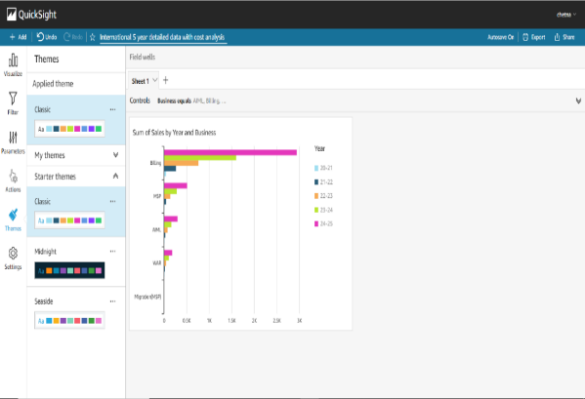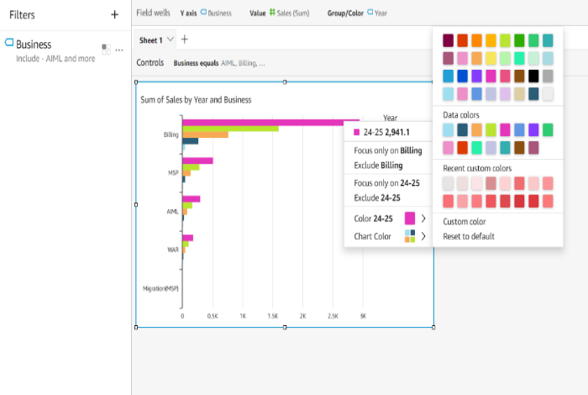

Fig 6. Filtering options

* **Publishing a dashboard**

Now your analysis is ready to be published as a dashboard. A user can only read this dashboard and can also apply drill-down to filter the data but cannot modify it.

1. Click on the share on top right corner and click on “publish dashboard”. A popup window will open, name your dashboard and click publish dashboard.
2. On dashboard, you can filter data from drill- downs applied on visuals and as we’ve multiple sheets, we move to other sheets to see their visuals.
3. Once our dashboard is saved, it is available on dashboard menu in QuickSight main page, we can also share our analysis to other user so that they can also modify them as per their need.
4. Click on share and then select share analysis, here we also manage permissions to other user how they can access our visuals.
5. We can mark important dashboards as favourite to access them faster whenever needed.

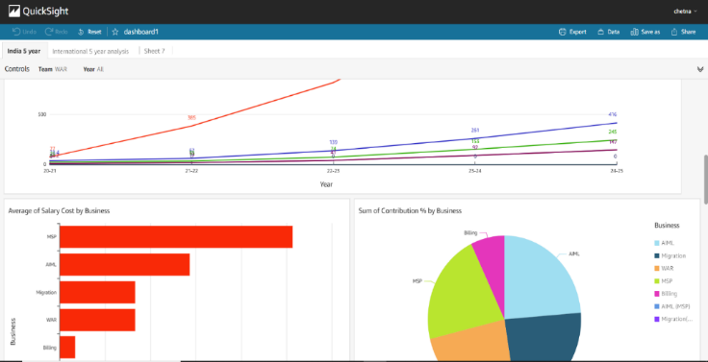

Fig 7. Published dashboard

**Comparison of QuickSight with other BI tools in market:**

|  |  |  |  |  |
| --- | --- | --- | --- | --- |
|  | **Qlik Sense** | **Power BI** | **Tableau** | **QuickSight** |
| **Pricing** | $30/user/month | $9.99/user/month | $70/user/month | $9/user/month |
| **Free trial** | Yes 30-day | Yes 60-day | Yes 14-day | Yes 30-day |
| **Mobile version** | Yes | Yes | Yes | Yes |
| **Point-in-time analytics** | Yes | Yes | Yes | Yes |
| **Real-time analytics** | No | Yes | Yes | Yes |
| **Data prep tools** | Yes | Yes | Yes | Yes |
| **Prompts** | Yes | Yes | No | No |
| **Tools to integrate** | Yes | Yes | Yes | Yes |
| **Formatting queries** | Yes | Yes | Yes | Yes |
| **Data exploration guidance** | Yes | Yes | Yes | No |
| **Semantic Querying** | Yes | No | No | No |
| **Social media analytics** | Yes | Yes | Yes | Yes |
| **Visualization** | Yes | Yes | Yes | Yes |
| **Collaboration** | Yes | Yes | Yes | Yes |

source: https://www.csgpro.com/blog/business-intelligence-tools-comparison-chart/

As can be noticed in the above table, the comparison is made on the basis of key features like real-time analytics, semantic querying, collaboration etc. and certainly AWS Quicksight comes out to be the most feasible option when considering the cost value of BI tools.