|  |  |
| --- | --- |
| **Project Name** | **Ask ICAI** |
| **Aws Service** | ***Amazon Kendra and Lex*** |
| **Technical Features** | **NLP Search engine** **on**: FAQs/HTML/Word/ppt/pdf/image-pdf  **Search categories** defined based on Topics (Publications), Journals, FAQs(students & members)  No. of Search queries in a day  To identify the icai.org content on which Search is to be enabled.(text/video/OCR)  Pricing – Professional Educational usage  Lex –Chat Bot - no. of FAQs trained and no. of queries handled in an hour/day |
| **Business outcomes** | **Documents/content as available on icai.org website**  [ICAI e-Journal (August, 2021 - PDF Download)](https://www.icai.org/post/icai-e-journal-main)  [ICAI Journal (Archives)](https://www.icai.org/post/icai-journal-archives)  [Journal Highlights (Archives)](https://www.icai.org/post/journal-highlights-archives)  For Students:  [FAQs in respect of Revised Scheme of Education and Training](https://resource.cdn.icai.org/45555bos35643faq.pdf)  [FAQs for Provisional Admission to Foundation Course](https://www.icai.org/post/faqs-provisional-admission-to-foundation-course)  [FAQs - BoS - (22-04-2019)](https://resource.cdn.icai.org/54948bosfaq-mcq.pdf)  For Members:  [ICAI - The Institute of Chartered Accountants of India](https://www.icai.org/post/free-download-online-publications)  [Accounting Standards Board](https://www.icai.org/post/icai-publications-accounting-standards-board)  [Auditing & Assurance Standards Board](https://www.icai.org/post/icai-publications-auditing-assurance-standards-board)  [Expert Advisory Committee](https://www.icai.org/post/icai-publications-expert-advisory-committee)  [Committee on Insolvency & Bankruptcy Code](https://www.icai.org/post/icai-publications-committee-on-insolvency-bankruptcy-code)  [Committee on International Taxation](https://www.icai.org/post/icai-publications-committee-on-international-taxation)  [Corporate Laws & Corporate Governance Committee](https://www.icai.org/post/icai-publications-corporate-laws-corporate-governance-committee)  [Ethical Standards Board](https://www.icai.org/post/icai-publications-ethical-standards-board) |

**Queries**-

1. What is use case for Lex, if we are using Kendra based search? Or it is used for voice-based search? Which in takes help from Kendra to give search results in text form?
2. What is quantum of search documents in image-pdf format, as we need it results on these formats if they are supported properly
3. Only English language will be supported for Kendra
4. Screen to be created for display or any other page required for chatbot ?

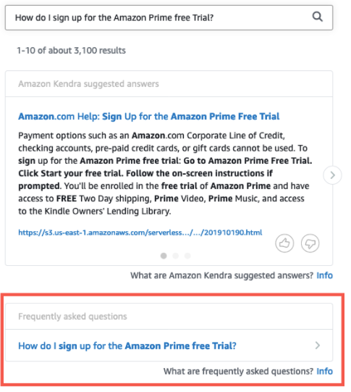

**Assumptions-**

1. Kendra will index search topics appropriately, and this will suffice purpose. What if Quality of search results not good?
2. Chatbot FAQ is already there and we can use as it to configure lex

**Requirement-1: Kendra based Search**

* A web-page to be built, which will have option to search input text/string, on pressing “Search”, Kendra API would be called, and search the AWS S3 for the inputted search string, will return results and display at the page.

**Work to be done:**

* Web page creation
* Kendra will need to be linked with S3 ( configuration)
* Indexes need to be created in Kendra for - (Publications), Journals, FAQs (students & members)  ( configuration)
* Expose Kendra API using API gateway
* Integrate Kendra API with web page

**Requirement-2: (Lex –Chat Bot)  not the case**

Integrate an Amazon Lex with Amazon Kendra using a search intent to provide answers in a conversation (if voice-based queries are used). A chatbot window will be provided on the newly created web page, and each user action will be integrated with Lex API, this will return result and display at webpage.

**Work to be done:**

* Web page creation
* Create intent schema – based on FAQ
* Integrate Lex API with web page
* Configure lex with Kendra

**Relevant Learnings-**

* Kendra is actually only search based , based what?

Yes

* Lex is search based on defined intents?

Lex is used if queries are voice based, then query are converted to text and passed on to Kendra, and then Kendra returns the text response and chatbot gives text response.

* Kendra search output will be documents  and these will be S3 links displayed at web page, clicking on these, page will open, or does return full documents?

Yes, will display answer to query along with top 100 document links , it will s3 links, refer below

* Formats supported –
  + FAQs Yes
  + HTML Yes
  + Word Yes
  + Ppt Yes
  + Pdf Yes
  + image-pdf No

|  |  |
| --- | --- |
| FAQs | Yes |
| Word | Yes |
| HTML | Yes |
| PPT | Yes |
| PDF | Yes |
| Image-pdf | No |

**Relevant links-**

<https://aws.amazon.com/blogs/machine-learning/integrate-amazon-kendra-and-amazon-lex-using-a-search-intent/>

<https://aws.amazon.com/blogs/machine-learning/smarter-faq-bots-with-amazon-kendra/>

<https://medium.com/@info.shwetagupta/query-filter-for-kendrasearchintent-in-amazon-lex-40c8b93ca8c1>

<https://docs.aws.amazon.com/kendra/latest/dg/index-document-types.html>

<https://aws.amazon.com/blogs/machine-learning/enhancing-enterprise-search-with-amazon-kendra/>

<https://aws.amazon.com/getting-started/hands-on/create-query-index-with-amazon-kendra/>

<https://aws.amazon.com/blogs/machine-learning/enhancing-enterprise-search-with-amazon-kendra/>