EXP.NO: 8

Consider an Online Grocery Store System. Develop a JavaScript program that will validate the controls in the forms you have created for the application. State the assumptions you make (business logic you are taking into consideration).

Aim:

To develop a web-based Online Grocery Store application that validates user inputs using JavaScript and connects to a database using Servlets and JSP for storing and displaying grocery orders.

Procedure:

Create an HTML webpage for Online Grocery Store.

Design a form to place grocery orders.

Apply JavaScript validation for all fields.

Create a JSP page to display order details.

Develop a Servlet to handle form submission.

Connect the application to a MySQL database.

Insert validated order data into the database.

Run the project on a server (e.g., Apache Tomcat).

Display success or error messages.

Code:

index.html

HTML

<!DOCTYPE html>
<html>
<head>
<title>Grocery Order Form</title>
<script>
function validateForm() {
let name = document.forms["f"]["name"].value;
let email = document.forms["f"]["email"].value;
let phone = document.forms["f"]["phone"].value;
let item = document.forms["f"]["item"].value;
if(name=="" || email=="" || phone=="" || item==""){
alert("All fields required");
return false;
}
if(phone.length!=10 || isNaN(phone)){
alert("Phone must be 10 digits");
return false;
}
return true;
}
</script>
</head>
<body style="text-align:center;font-family:Arial">
<h2> Online Grocery Order Form</h2>
<form name="f" action="GroceryServlet" method="post" onsubmit="return validateForm()">
<input type="text" name="name" placeholder="Customer Name"><br><br>
<input type="text" name="email" placeholder="Email"><br><br>
<input type="text" name="phone" placeholder="Phone"><br><br>
<input type="text" name="item" placeholder="Grocery Item"><br><br>
<select name="category">
<option>Fruits</option>
<option>Vegetables</option>
<option>Snacks</option>
</select><br><br>
<input type="submit" value="Place Order">
</form>
</body>
</html>

GroceryServlet.java

Java

import java.io.*;
import javax.servlet.*;
import javax.servlet.http.*;
import java.sql.*;
public class GroceryServlet extends HttpServlet {
public void doPost(HttpServletRequest req, HttpServletResponse res)
throws IOException {
String name = req.getParameter("name");
String email = req.getParameter("email");
String phone = req.getParameter("phone");
String item = req.getParameter("item");
String category = req.getParameter("category");
res.setContentType("text/html");
PrintWriter out = res.getWriter();
try {
Class.forName("com.mysql.cj.jdbc.Driver");
Connection con = DriverManager.getConnection(
"jdbc:mysql://localhost:3306/grocerydb","root","password");
PreparedStatement ps = con.prepareStatement(
"insert into orders values(?,?,?,?,?)");
ps.setString(1,name);
ps.setString(2,email);
ps.setString(3,phone);
ps.setString(4,item);
ps.setString(5,category);
int i = ps.executeUpdate();
if(i>0){
res.sendRedirect("display.jsp");
} else {
out.println("Error inserting");
}
} catch(Exception e){
out.println(e);
}
}
}

display.jsp

JSP

<%@ page import="java.sql.*" %>
<html>
<head>
<title>Grocery Orders</title>
</head>
<body>
<h2> Grocery Orders</h2>
<table border="1">
<tr>
<th>Name</th>
<th>Email</th>
<th>Phone</th>
<th>Item</th>
<th>Category</th>
</tr>
<%
try{
Class.forName("com.mysql.cj.jdbc.Driver");
Connection con = DriverManager.getConnection(
"jdbc:mysql://localhost:3306/grocerydb","root","password");
Statement stmt = con.createStatement();
ResultSet rs = stmt.executeQuery("select * from orders");
while(rs.next()){
%>
<tr>
<td><%=rs.getString(1)%></td>
<td><%=rs.getString(2)%></td>
<td><%=rs.getString(3)%></td>
<td><%=rs.getString(4)%></td>
<td><%=rs.getString(5)%></td>
</tr>
<%
}
}catch(Exception e){
out.println(e);
}
%>
</table>
</body>
</html>

web.xml

XML

<web-app>
<welcome-file-list>
<welcome-file>index.html</welcome-file>
</welcome-file-list>
<servlet>
<servlet-name>GroceryServlet</servlet-name>
<servlet-class>GroceryServlet</servlet-class>
</servlet>
<servlet-mapping>
<servlet-name>GroceryServlet</servlet-name>
<url-pattern>/GroceryServlet</url-pattern>
</servlet-mapping>
</web-app>

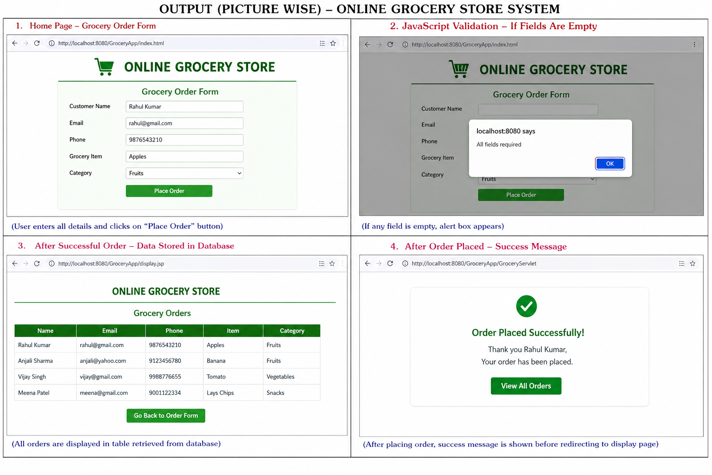

Result:

Thus, the Online Grocery Store system with JavaScript validation and database connectivity using Servlet and JSP was successfully developed and executed.

Output:

