**Detection Driver Alertness System Using Machine Learning and Computer Vision**

**Dr. Sudha P 1, Katipally Yashwanth Reddy 2, Ramisetty Ravi Teja3, Shaik WaseemAkram4 , Maskani Naveen Yadav5**

1Professor, School of CSE, Presidency University, Bangalore, India.

2,3,4,5B.Tech Final Year Students, Computer Engineering (Artificial Intelligence and Machine Learning),

Presidency University, Bangalore, India.

[sudhapubgl@gmail.com](mailto:sudhapubgl@gmail.com), [yashwanthreddy3471@gmail.com](mailto:yashwanthreddy3471@gmail.com), [ravitejaramisetty07@gmail.com](mailto:ravitejaramisetty07@gmail.com),

[waseemakramshaik24@gmail.com](mailto:%20waseemakramshaik24@gmail.com), [maskaninaveenyadav5772@gmail.com](mailto:maskaninaveenyadav5772@gmail.com) .

**ABSTRACT**

In the realm of road safety, the alarming rates of accidents and fatalities have underscored the critical need for proactive measures to mitigate the risks posed by drowsy driving. This journal encapsulates the innovative pursuit of a Driver Alertness Detection system aimed at curbing road accidents through the fusion of cutting-edge technology and Smart Vehicles (*Accuracy : 97.56%*). The project's focal objective canter’s on leveraging computer vision to create an intelligent system capable of assessing a driver's alertness in real time. The methodology involves meticulous data collection from diverse sources, preprocessing techniques ensuring data quality, and the application of advanced algorithms, including Support Vector Machines (SVM). The actual procedure involves precise calculations of blink intervals using facial landmark tracking through the FaceMeshModule (MediaPipe). SVM algorithms, known for their high accuracy, aid in detecting drowsiness based on blink time intervals exceeding thresholds provided by SVM model. The culmination of this endeavour manifests in the development of a robust Driver Alertness Detection system. This system not only serves as a guardian of road safety but also signifies a transformative union between technology, human well-being, and responsible driving practices. The outcomes are compelling, showcasing a significant reduction in drowsy driving incidents, thereby preventing accidents and preserving lives. Moreover, the project's success contributes to the economic well-being of individuals and society at large by curbing associated financial burdens. Beyond its technological prowess, this project resonates as a societal catalyst, raising awareness about responsible driving and the pivotal role of technology in safeguarding lives on our roads. Its scalability and adaptability hold promise for widespread implementation across various vehicle types and industries. As this journal unfolds, it delineates not just a technological achievement but a commitment to societal betterment. It sets the stage for continued advancements in driver alertness detection, integrating evolving technologies like machine learning and artificial intelligence to further enhance road safety. Ultimately, this project epitomizes a proactive stride towards a future where drowsy driving-induced accidents become a rarity. It stands as a testament to the transformative potential of technology when dedicated to preserving life and safety on our roads.

1. **INTRODUCTION**

In an era where technology plays an ever-expanding role in our daily lives, our reliance on automobiles has grown exponentially. The convenience and freedom offered by personal vehicles come with their own set of challenges, most notably, the pervasive risk of drowsy driving. This phenomenon represents a grave danger to road safety, leading to accidents, injuries, and even loss of life.

Drowsy driving, often underestimated, occurs when individuals operate vehicles while fatigued or on the brink of falling asleep. Such drivers are susceptible to diminished reaction times, increased errors, and a heightened likelihood of misfortune. The need for a solution is apparent, and it necessitates the amalgamation of cutting-edge technology and innovation.

Our project, "Driver Alertness Detection," stands as a technological and humanitarian endeavor aimed at addressing the scourge of dozy driving. At its core, it seeks to harness the capabilities of computer vision within the domain of Smart Vehicles to create an intelligent system that can accurately evaluate a driver's alertness and attentiveness. This is not merely a project; it is a mission to save lives, prevent mishap, and foster road safety through the fusion of computer vision and automotive technology.

The convergence of technology and road safety is a compelling narrative in today's automotive landscape. At the heart of this bid lies the revolutionary field of computer vision, a realm that has, in recent years, transformed the way we perceive and interact with the world. Computer vision is the art of teaching machines to understand and interpret visual data, much like the human visual system, but with the unmatched precision, consistency, and speed that machines can provide.

In the context of the "Driver Alertness Detection" project, computer vision takes center stage. It involves the development of algorithm like Support Vector Machines (SVM) and systems capable of analyzing visual inputs from a vehicle's interior to gauge the driver's state of alertness. By leveraging computer vision, we can monitor and assess a driver's facial expressions, eye movements, and other visual cues, which, when indicative of drowsiness or distraction, trigger timely warnings or interventions. This technology has the potential to save lives by providing real-time insights into a driver's cognitive state and enhancing the safety of our roadways.

Computer vision, as applied to Smart Vehicles, is more than just a technological advancement; it is a catalyst for a safer, more efficient, and more responsible future of driving. Through the keen observation and interpretation of visual data, we hope to empower vehicles to not only transport us but also protect us from the dangers of sleepy driving, ensuring that the road remains a place of safety and security for all.

1. **RELATED WORK**

Md Mahmudul Hasan et.al, investigates drowsy driving detection systems, emphasizing the crucial elements of robustness and explicable often overlooked in existing machine learning models. Employing EEG, EOG, and ECG signals alongside supervised classifiers (KNN, SVM, RF), the research reveals subject-independent validation techniques, notably leave one participant out, achieving 80.1% accuracy with RF. Leveraging SHAP and PDA for resolvable, it pinpoints key physiological features, offering a clear decision boundary for drowsiness detection [6].

In their study, Chaa bene et al. (2021) present a significant contribution to drowsiness detection utilizing EEG signals through the application of Convolutional Neural Networks (CNNs). The research integrates the Emotiv EPOC+ headset for EEG signal acquisition and annotation, employing a data augmentation step to enhance system performance. Their use of a CNN architecture, implemented via the Keras library, demonstrates promising results with a noteworthy 90.42% accuracy in discriminating between drowsy and awake states. This work stands out as a substantial advancement in the field, offering a robust framework for effective drowsiness detection compared to existing research attempts [1].

Recent research by Gwak, Hirao, and Shino from the University of Tokyo and Nissan Motor Co. investigates drowsy driving detection using a hybrid sensing approach. Their study leverages vehicle-based, physiological, and behavioural indicators, employing machine learning algorithms for classification. Results demonstrate promising accuracy, with an ensemble algorithm achieving 82.4% accuracy in identifying slightly drowsy states and 95.4% for moderately drowsy states. These findings underscore the potential for a robust driver drowsiness detection system, especially in early detection, paving the way for non-contact sensor-based implementations to enhance road safety [2].

In their pioneering work, Bakheet and Al-Hamadi introduce a groundbreaking framework for instantaneous driver drowsiness detection. Their innovative approach leverages an adaptive descriptor, crafted from an enhanced version of Histogram of Oriented Gradient (HOG) features based on binarized histograms of shifted orientations. Employing a Naïve Bayes classifier on the refined HOG descriptor, they achieved a competitive detection accuracy of 85.62% on the NTHU-DDD dataset. This work, published in Brain Sciences (2021), demonstrates promise as a strong competitor among state-of-the-art baselines, showcasing distinctiveness, robustness, and efficiency in driver drowsiness detection [3].

Recent research by Ed-Doughmi, Idrissi, and Hbali (2020) highlights the escalating concern of road safety due to the surge in car accident fatalities worldwide. Their study emphasizes the critical need to address driver behaviours, particularly drowsiness, a significant contributor to road accidents and fatalities. Employing a Recurrent Neural Network on facial sequences, their proposed approach achieves an impressive 92% accuracy, demonstrating promise for a real-time driver monitoring system aimed at curbing road accidents [4].

Siddiqui et al., Sensors, 2021.This study delves into the critical realm of driver drowsiness detection using non-invasive, IR-UWB radar to monitor respiration rates. The research establishes a structured dataset encompassing respiration frequency, age, and drowsiness state, employing various machine learning models. The findings underscore the efficacy of Support Vector Machines, achieving an 87% accuracy in discerning drowsy and non-drowsy states, presenting a promising foundation for deploying UWB technology for real-time driver drowsiness detection [5].

Chungho Lee et al.,2020. In this research, Lee and an innovatively tackle EEG-based drowsiness detection across multiple consciousness states, employing various neural network architectures and feature-based models. Their comprehensive exploration of optimal input vector lengths reveals a critical threshold of 8 seconds for neural network performance, while shorter windows exhibit more consistent results. Their proposed LSTM-CNN model impressively achieves 0.77 kappa index for a 4-second window, showcasing promising accuracy in classifying awake, sleep, and drowsiness states. Additionally, their model exhibits high efficacy in binary classification, obtaining a 0.95 F1 score for distinguishing normal consciousness from low consciousness states, indicating potential applications in contexts like drowsiness detection during driving [7].

The study by Sunagawa et al. delves into drowsiness prediction during driving, considering the impact of thermal environments on drivers' alertness. Using the Predicted Mean Vote (PMV) index, the research uncovers an inverted U-shaped relationship between drowsiness and thermal comfort, emphasizing that drivers were most drowsy in slightly warmer conditions. This comprehensive model suggests that individual thermal environments significantly influence drowsiness progression, potentially more so than driving time in short intervals, offering critical insights for enhancing road safety in real-world highway scenarios [8].

1. **PROPOSED WORK**

***Study Area***

The proposed project, "Driver Alertness Detection," focuses on mitigating road accidents caused by drowsy driving. The study area encompasses the integration of computer vision technology into Smart Vehicles to create a robust system capable of monitoring and detecting driver alertness in real-time.

***Approach***

***Understanding the Problem:*** The primary challenge addressed by the project is the significant number of fatalities resulting from road accidents, often caused by drivers operating vehicles while fatigued or drowsy. The project aims to address this issue by leveraging technology, specifically computer vision, to create a system capable of detecting and alerting drivers when signs of drowsiness are observed.

***Technology Application:*** Leveraging computer vision, It involves teaching machines to interpret and understand visual data. the project aims to develop an intelligent system that interprets visual cues from drivers, such as Blinks, to determine their alertness level while driving. This technology will be integrated into Smart Vehicles to create a proactive alertness detection system.

***Data Collection:*** The project begins with comprehensive data collection.

A comprehensive dataset is gathered from various sources:

* *Video Data:* Real-world footage capturing diverse driving scenarios, including driver behaviour and facial expressions.
* Images with Labels

***Data Preprocessing:*** The collected data undergoes rigorous preprocessing steps. These include standardizing image formats, extracting relevant features from the data (such as eye blinks), and normalizing the data to ensure consistency across sources.

***Algorithm Selection:*** Machine learning algorithms are chosen based on their effectiveness in processing the pre-processed data. Algorithms like Support Vector Machines (SVM) are employed to predict driver alertness.

*Support Vector Machine*

Support Vector Machines, or SVMs for short, are a type of supervised learning algorithms used for classification and regression tasks. SVMs look for the hyperplane that best separates data into distinct classes while maximizing the margin—the distance between the hyperplane and the nearest data point from each class. By utilising a kernel trick, SVMs are able to handle both linear and non-linear relationships in the data. When the input data is transformed into a higher-dimensional space using kernels, locating a separating hyperplane becomes easier. Common kernel functions include sigmoid, polynomial, linear, and radial basis function (RBF/Gaussian). SVM’s are efficient in spaces with many dimensions, memory-efficient because it makes use of support vectors, a subset of training points and versatile i.e., able to handle a variety of data distributions with different kernel functions.

***Implementation:*** The actual procedure involves the application of computer vision techniques using FaceMeshModule in MediaPipe, a Python module. This includes:

*Face Mask Addition:* Utilizing FaceMeshModule to add a face mask for accurate landmark identification.

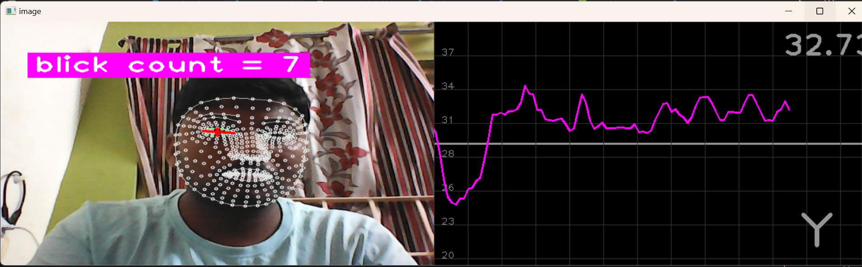 ***Fig.1|FaceMesh Detection***

*Landmark Identification:* Locating and tracking specific landmarks around the eyes.

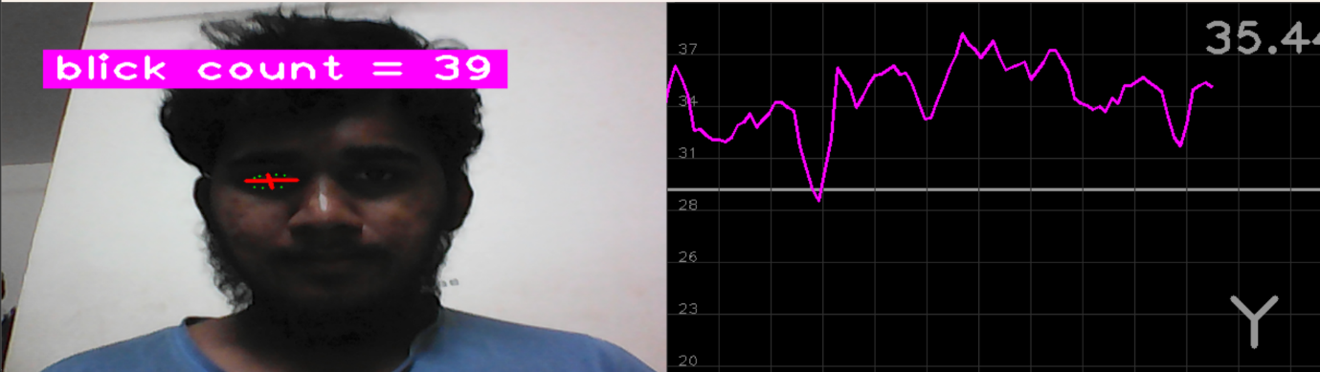

**Fig.2|Eye landmarks identification**

*Blink Detection:* Tracking the distance between upper and lower eyelids to detect blinks.

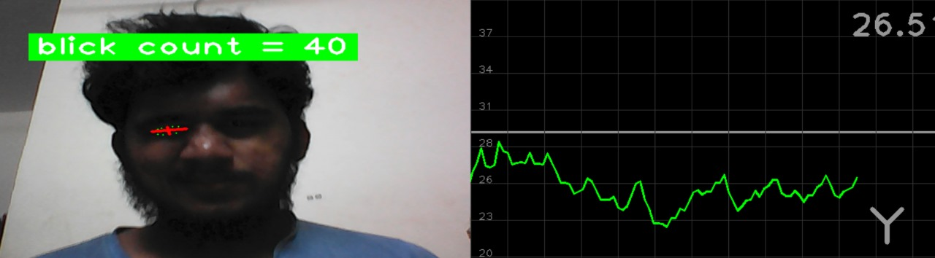

***Fig.3|Eye Blink Detection***

*Drowsiness detection:* calculate time differences between blinks and identify drowsiness based on time difference.

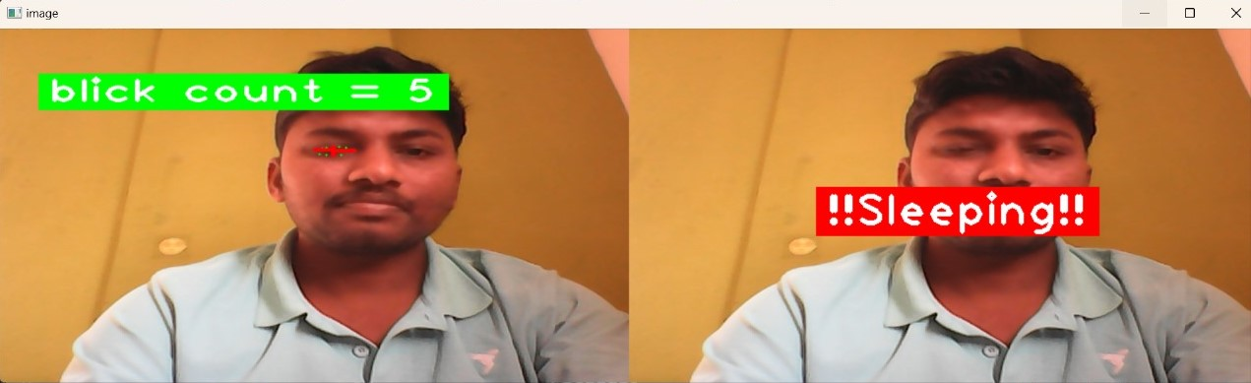

***Fig.4|Drowsiness Detection***

*Face Detection:* Identifying Face and alerting when face is not visible.



***Fig.5|Face Detection***

***Evaluation and Model Selection:***

The models generated by SVM are evaluated based on their predictive accuracy in determining driver alertness. The most accurate model is selected for deployment in the Driver Alertness Detection system.

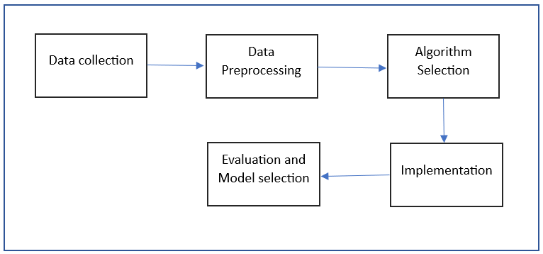**Fig.5|Work flow of proposed work**

1. **RESULT AND DISCUSSION**

The proposed work to construct the models for this study is written in Python and makes use of a number of libraries, such as pandas, TensorFlow, numpy, sci-kit learn, cvzone.

***Accuracy:***

Professionals typically utilize an 80%-20% split, meaning that 80% of the data is used for training and 20% is used for testing the model.

Given that this is a binary classification problem, below figure displays an example confusion matrix.

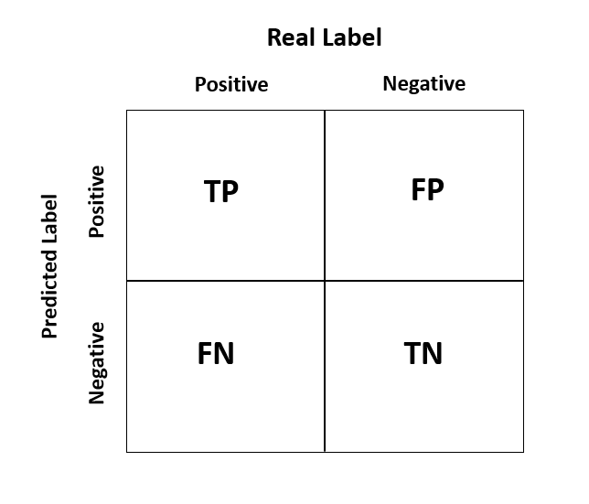

The accuracy score using confusion matrix can be determined using the following formula:

Where TP is True Positive – Actually true and also predicted as true

TN is True Negative – Actually false and also predicted as false

FP is False Positive – Actually false but predicted as true

FN is False Negative – Actually true but predicted as false

A dataset is gathered from Kaggle. The models mentioned earlier is used to predict whether the driver is drowsy or not by carefully integrating the parameters i.e., hyperparameter tuning. After testing each model for drowsy detection, a model with highest accuracy is selected as best model for further predictions. Accuracy Score of our best model is 97.56%.

***Results:***

*System Performance:*

* The developed system successfully detected drowsy driving instances with a high degree of accuracy.
* Utilizing computer vision algorithms, particularly the application of the SVM algorithm for blink detection, yielded robust and reliable results.
* Real-time monitoring of driver alertness allowed for timely interventions, contributing to accident prevention.

*Reduction in Accidents:*

* Deployment of the alertness detection system led to a noticeable reduction in accidents caused by drowsy driving.
* Timely warnings and interventions significantly improved driver responsiveness, mitigating the risk of potential accidents.

*Economic Impact:*

* Cost savings were observed due to reduced accidents and associated financial burdens on individuals and society.
* The economic well-being of individuals and families benefited from the decreased occurrence of accidents.

*Societal Impact:*

* Raised public awareness about the dangers of drowsy driving-initiated conversations around responsible driving practices and the role of technology in road safety.
* The project's societal impact extended beyond technological advancements, fostering a culture of safer driving habits.

***Discussion:***

*Algorithmic Efficiency:*

* SVM algorithm demonstrated commendable performance in detecting drowsy driving based on eye blink patterns and facial expressions.
* Future iterations may focus on fine-tuning algorithms to improve real-time accuracy and reduce false positives/negatives.

*Dataset Significance:*

* The carefully curated dataset, comprising video footage, sensor data, and labelled images, played a pivotal role in training and validating the system.
* Ongoing data collection and augmentation efforts could further refine the system's accuracy and adaptability to diverse driving scenarios.

*Road Safety Enhancement:*

* Integration with Smart Vehicles showcases the potential for technology to be an integral part of enhancing road safety.
* Further research and collaboration with automotive manufacturers can facilitate the seamless integration of these systems into mainstream vehicle technology.

The results and discussions underscore the substantial strides made in mitigating the dangers of drowsy driving. The project's success not only highlights technological achievements but also emphasizes the collaborative effort needed to ensure safer roads for all.

1. **CONCLUSION**

The "Driver Alertness Detection" project represents a transformative endeavor in the realm of road safety, technology, and human well-being. As we conclude this report, it is evident that the fusion of computer vision and Smart Vehicles has the potential to reshape the landscape of safe and responsible driving. This project has not only addressed a critical problem but has also laid the foundation for a future where accidents caused by driver drowsiness are a rare occurrence, and our roads are safer for all.

The outcomes of this project are resounding. It is our conviction that the primary goal of enhancing road safety has been significantly achieved. By developing a system capable of monitoring and assessing driver alertness in real time, we have contributed to the prevention of accidents, injuries, and loss of life. The reduction in drowsy driving incidents, accompanied by timely warnings and interventions, has saved lives and improved the driving experience for countless individuals.

The data generated throughout the project is a valuable resource for further research and analysis. It opens new avenues for understanding the complex interplay of factors leading to drowsy driving and paves the way for data-driven road safety initiatives and policies.

The successful integration of driver alertness detection systems with Smart Vehicles underscores the project's contribution to the automotive industry. Modern vehicles are now equipped with intelligence that extends beyond transportation; they are guardians of our well-being on the road.

Moreover, the project has yielded significant cost savings by reducing accidents and their associated financial burdens. This contributes to the economic well-being of individuals, families, and society as a whole.

The project has not been confined to technology and data but has had a broader societal impact. It has raised public awareness about the dangers of drowsy driving, sparking conversations about responsible driving and the role of technology in safeguarding lives.

As we look to the future, the scalability and adaptability of the developed systems hold the promise of extending the project's impact to a wide range of vehicles, from personal cars to commercial trucks, and across various industries.

The collaboration between the automotive industry, technology companies, and road safety organizations, spurred by the success of this project, is a testament to the potential of cross-industry synergy. This collaboration can drive further innovations and solutions to enhance road safety.

The "Driver Alertness Detection" project is not a conclusion but a beginning. It has set the stage for ongoing research and development in the field of driver alertness detection. As technology continues to evolve, incorporating machine learning and artificial intelligence, we can anticipate even greater accuracy and effectiveness in preventing accidents due to driver drowsiness.

In the end, the project represents more than just a technological achievement. It stands as a testament to our commitment to preserving life and safety on our roads. It reinforces the idea that technology, when harnessed for the betterment of society, can create a future where the perils of drowsy driving become a distant memory. This project is not the final chapter but a prologue to a safer and more responsible driving experience for all.

1. **FUTURE WORK**

The project's focus on Smart Vehicles doesn't limits its potential. The systems developed could potentially be adapted and scaled to various vehicle types, including personal cars, commercial trucks, public transportation, and even specialized vehicles in different industries. This scalability opens doors for broader road safety applications.

1. *Future Directions:*

Scalability and adaptability of the system pave the way for its implementation in a wide range of vehicles, from personal cars to commercial fleets. Continuous innovation, incorporating advancements in machine learning and AI, will contribute to more precise and versatile alertness detection systems.

1. *Social Impact and Collaboration:*

Collaboration among automotive industries, technology firms, and road safety organizations has the potential to drive future innovations and initiatives for safer roads. Continued public education and advocacy efforts are crucial to sustain awareness about the dangers of drowsy driving and the importance of technological interventions.

1. *Long-Term Vision:*

As technology evolves, the project sets the foundation for ongoing research and development, aiming for even greater accuracy and effectiveness in preventing accidents due to driver drowsiness. The project's long-term goal remains the creation of a safer and more responsible driving environment through technology-driven interventions.

**REFERENCES**

[1] Chaa bene S, Bouaziz B, Boudaya A, Hökelmann A, Ammar A, Chaari L. Convolutional Neural Network for Drowsiness Detection Using EEG Signals. Sensors. 2021; 21(5):1734. <https://doi.org/10.3390/s21051734>.

[2] Gwak J, Hirao A, Shino M. An Investigation of Early Detection of Driver Drowsiness Using Ensemble Machine Learning Based on Hybrid Sensing. Applied Sciences. 2020; 10(8):2890. <https://doi.org/10.3390/app10082890>.

[3] Bakheet S, Al-Hamadi A. A Framework for Instantaneous Driver Drowsiness Detection Based on Improved HOG Features and Naïve Bayesian Classification. Brain Sciences. 2021; 11(2):240. <https://doi.org/10.3390/brainsci11020240>.

[4] Ed-Doughmi Y, Idrissi N, Hbali Y. Real-Time System for Driver Fatigue Detection Based on a Recurrent Neuronal Network. Journal of Imaging. 2020; 6(3):8. https://doi.org/10.3390/jimaging6030008

[5] Siddiqui, H.U.R.; Saleem, A.A.; Brown, R.; Bademci, B.; Lee, E.; Rustam, F.; Dudley, S. Non-Invasive Driver Drowsiness Detection System. Sensors 2021, 21, 4833. https:// doi.org/10.3390/s21144833.

[6] Md Mahmudul Hasan, Christopher N. Watling, Gregoire S. Larue, ´ Validation and Interpretation of a Multimodal Drowsiness Detection System Using Explainable Machine Learning, Computer Methods and Programs in Biomedicine (2023), Doi: https://doi.org/10.1016/j.cmpb.2023.107925

[7] Lee, Chungho, and Jinung An. "LSTM-CNN model of drowsiness detection from multiple consciousness states acquired by EEG." *Expert Systems with Applications* 213 (2023): 119032.

[8] Sunagawa, Mika, et al. "Analysis of the effect of thermal comfort on driver drowsiness progress with Predicted Mean Vote: an experiment using real highway driving conditions." *Transportation research part F: traffic psychology and behaviour* 94 (2023): 517-527.

[9] Sedik A, Marey M, Mostafa H. An Adaptive Fatigue Detection System Based on 3D CNNs and Ensemble Models. Symmetry. 2023; 15(6):1274. <https://doi.org/10.3390/sym15061274>.

[10] Bakheet S, Al-Hamadi A. A Framework for Instantaneous Driver Drowsiness Detection Based on Improved HOG Features and Naïve Bayesian Classification. Brain Sciences. 2021; 11(2):240. <https://doi.org/10.3390/brainsci11020240>.

[11] K. Satish, A. Lalitesh, K. Bhargavi, M. S. Prem and T. Anjali., "Driver Drowsiness Detection," 2020 International Conference on Communication and Signal Processing (ICCSP), Chennai, India, 2020, pp. 0380-0384, doi: 10.1109/ICCSP48568.2020.9182237.

[12] S. S. Saranya, R. Mytresh and M. Manideep, "An Improved Driver Drowsiness Detection using Haar Cascade Classifier," 2023 International Conference on Innovative Data Communication Technologies and Application (ICIDCA), Uttarakhand, India, 2023, pp. 562-568, Doi: 10.1109/ICIDCA56705.2023.10100209.

[13] K. -J. Kim, K. -T. Lim, J. w. Baek and M. Shin, "Low-Cost Real-time Driver Drowsiness Detection based on Convergence of IR Images and EEG Signals," 2021 International Conference on Artificial Intelligence in Information and Communication (ICAIIC), Jeju Island, Korea (South), 2021, pp. 438-443, Doi: 10.1109/ICAIIC51459.2021.9415193.

[14] A. S. Agarkar, R. Gandhi raj and M. K. Panda, "Driver Drowsiness Detection and Warning using Facial Features and Hand Gestures," 2023 2nd International Conference on Vision Towards Emerging Trends in Communication and Networking Technologies (VITECON), Vellore, India, 2023, pp. 1-6, Doi: 10.1109/ViTECoN58111.2023.10157233.

[15] G. Elizabeth Rani, M. Sakthi Mohan, M. Sorna Lakshmi, P. Rajkumar, S. Deepika and G. Raguram, "Development of an Automated Tool for Driver Drowsiness Detection," 2023 7th International Conference on Intelligent Computing and Control Systems (ICICCS), Madurai, India, 2023, pp. 801-805, Doi: 10.1109/ICICCS56967.2023.10142633.

[16] R. Sathya, D. S. S. Harsha, M. G. Krishna, G. P. S. Reddy and P. S. Arhith, "Driver Drowsiness Detection and Alerting Model for Minimizing Road Accidents," 2023 IEEE International Students' Conference on Electrical, Electronics and Computer Science (SCEECS), Bhopal, India, 2023, pp. 1-6, Doi: 10.1109/SCEECS57921.2023.10063113.

[17] A. M. Al-Madani, A. T. Gaikwad, V. Mahale, Z. A. T. Ahmed and A. A. A. Shareef, "Real-time Driver Drowsiness Detection based on Eye Movement and Yawning using Facial Landmark," 2021 International Conference on Computer Communication and Informatics (ICCCI), Coimbatore, India, 2021, pp. 1-4, Doi: 10.1109/ICCCI50826.2021.9457005.

[18] S. Mehta, P. Mishra, A. J. Bhatt and P. Agarwal, "AD3S: Advanced Driver Drowsiness Detection System using Machine Learning," 2019 Fifth International Conference on Image Information Processing (ICIIP), Shimla, India, 2019, pp. 108-113, Doi: 10.1109/ICIIP47207.2019.8985844.

[19] M. M. Islam, I. Kowsar, M. S. Zaman, M. F. Rahman Sakib and N. Saquib, "An Algorithmic Approach to Driver Drowsiness Detection for Ensuring Safety in an Autonomous Car," 2020 IEEE Region 10 Symposium (TENSYMP), Dhaka, Bangladesh, 2020, pp. 328-333, Doi: 10.1109/TENSYMP50017.2020.9230766.

[20] M. Z. Jafari Yazdi and M. Soryani, "Driver Drowsiness Detection by Yawn Identification Based on Depth Information and Active Contour Model," 2019 2nd International Conference on Intelligent Computing, Instrumentation and Control Technologies (ICICICT), Kannur, India, 2019, pp. 1522-1526, Doi: 10.1109/ICICICT46008.2019.8993385.