AI StudyBuddy API
Project Documentation

1. Introduction
- Project Title: AI StudyBuddy API
- Team ID: SWTID-2026-6259
- Team Leader: SAKTHIPRIYA G (Id: 24bsccs18@cttewc.edu.in)
- Team Members:
- SAADHIYA A (Id: 24bsccs07@cttewc.edu.in)
- Sandhiya D (Id: 24bsccs04@cttewc.edu.in)
- J Natasha Esther (Id: 24bsccs27@cttewc.edu.in)

2. Project Overview
The AI StudyBuddy API is a backend REST API system built using Node.js, Express.js, MongoDB, and Google Gemini AI. This system allows users to register, log in, upload study materials (PDFs/notes), and automatically generate study summaries, quizzes, flashcards, and personalized study plans using AI.
It uses JWT (JSON Web Token) authentication to secure API endpoints.

3. Objectives of the Project
- Develop an AI-powered backend system to simplify and enhance student learning processes.
- Implement user authentication and authorization using JWT.
- Process uploaded study materials to generate automated summaries and quizzes via Gemini AI.
- Create custom, goal-oriented 7-day study plans tailored to user schedules.
- Seamlessly integrate REST APIs with AI models and database management.

4. Technologies Used
- Node.js – JavaScript runtime environment for server-side execution.
- Express.js – Web framework for creating RESTful API routes.
- MongoDB (MongoDB Atlas) – NoSQL database to store user profiles, uploaded materials, and AI-generated results.
- JWT (JSON Web Token) – Secured user authentication and authorization token mechanism.
- Google Gemini AI API – AI model used to analyze study text and generate summaries, quizzes, and study schedules.
- Postman – API testing tool for sending HTTP requests and validating endpoints.

5. System Architecture
The AI StudyBuddy API backend is built using the MVC (Model-View-Controller) pattern:
- Model: Defines the data schemas for Users, Study Materials, and AI-generated outputs in MongoDB.
- View: As a pure Backend REST API, views are not directly rendered; response data is returned in standard JSON format.
- Controller / Routes: Manages request logic, JWT authentication, and interactions with the Gemini AI API.
Execution Flow
User → API Request (Postman) → Auth Middleware → Controller → Gemini AI / MongoDB → JSON Response

6. Features
- User Registration and Login.
- JWT Access and Refresh Token management.
- Study material and PDF file upload handling.
- AI-driven study content summarization.
- Automated Quiz&Flashcard generation.
- Goal and time-based 7-day personalized Study Plan generation.
- Protected API routes using middleware authorization.

7. Project Setup
- Set up Node.js and MongoDB Environment
- Initialize the Project:
npm init -y
- Install Required Packages:
npm install express mongoose jsonwebtoken bcryptjs dotenv @google/generative-ai multer
- Install Dependencies:
npm install
- Start the Server:
npm start

8. API Development

Authentication APIs:
- POST /api/auth/register – Register a new user account.
- POST /api/auth/login – Authenticate user and receive a JWT token.

Study Material&AI APIs:
- POST /api/materials/upload – Upload study notes or PDF documents.
- POST /api/materials/:id/summarize – Generate AI summaries for uploaded content.
- POST /api/materials/:id/flashcards – Generate interactive study flashcards.
- POST /api/materials/:id/quiz – Generate AI multiple-choice quizzes.
- POST /api/materials/:id/study-plan – Generate a custom study schedule.
(Note: Protected routes require passing the Bearer Token in the HTTP Authorization header).

9. Middleware
- Auth Middleware: Verifies the user's JWT token prior to providing access to protected endpoints.
- Error Middleware: Captures API request errors and sends appropriate HTTP status codes (e.g., 200 Success, 201 Created, 400 Bad Request, 401 Unauthorized/Expired Token, 500 Internal Server Error).

10. Database Development
MongoDB Atlas is used to store user profiles, uploaded material details, and generated study artifacts. The connection string is stored securely in the .env configuration file and established using mongoose.connect().

11. Project Execution Steps
- Ensure the MongoDB Atlas cluster is online and reachable.
- Launch the Node.js server using npm start.
- Test API endpoints using Postman:
- Create a user account (/register).
- Log in to retrieve the Bearer JWT Token (/login).
- Attach the Bearer Token to access study material upload, summarization, quiz generation, and study planning endpoints.

12. Output Screenshots
Phase 2:
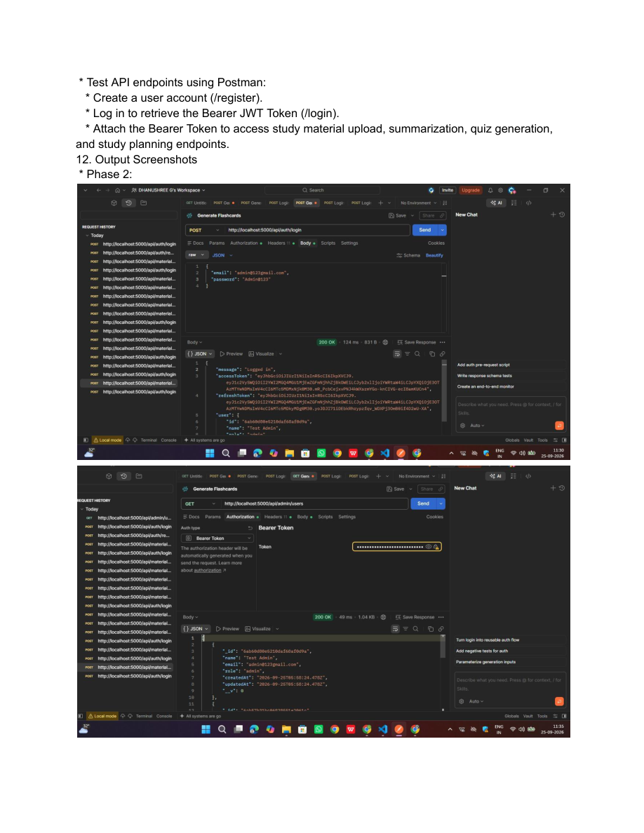

Phase 3:
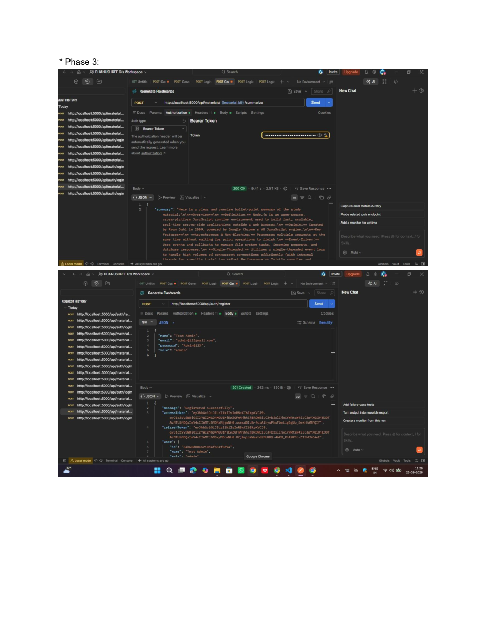

Phase 4:
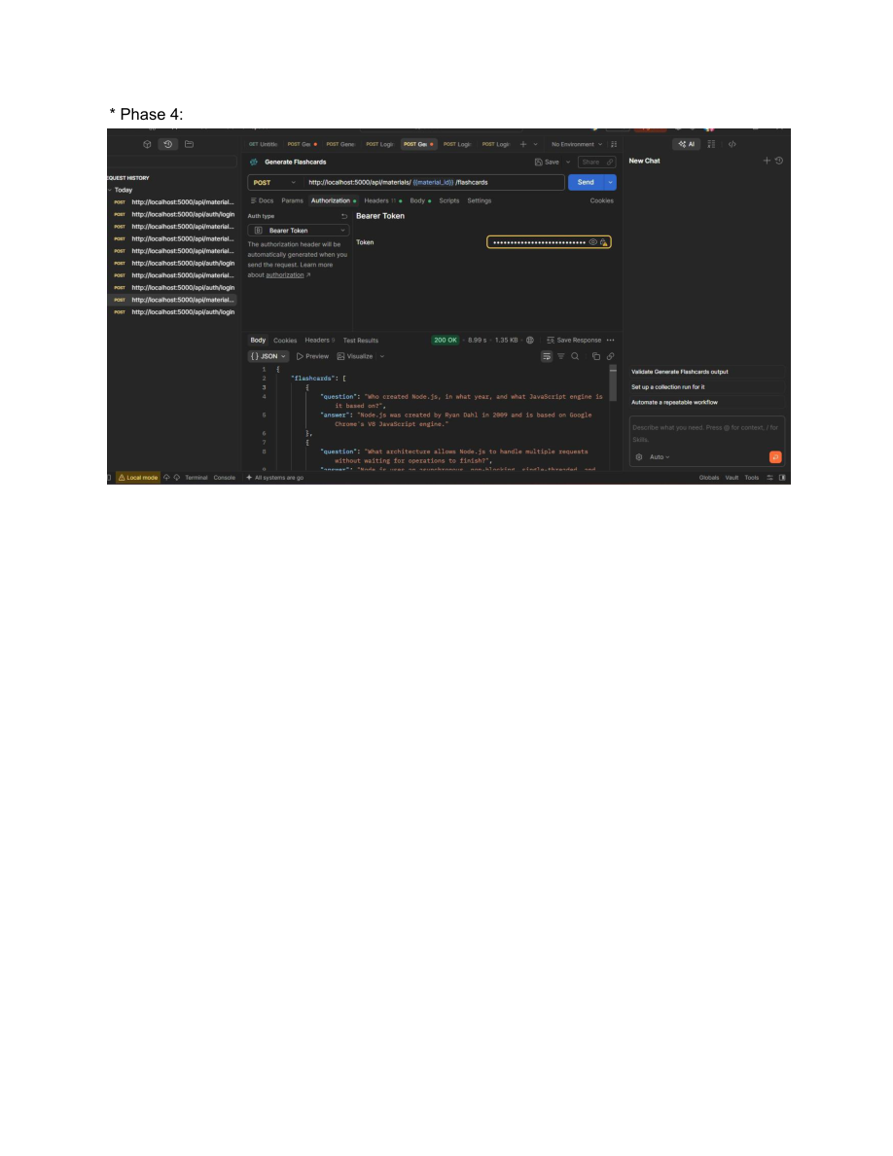

Demo Video
https://drive.google.com/file/d/1eZbD7E9B-DPXbpUUh1jtRZ9964_nJVtZ/view?usp=drivesdk

