# Assignment-based Subjective Questions

1. **From your analysis of the categorical variables from the dataset, what could you infer about**

**their effect on the dependent variable? (3 marks)**

* The year box plots indicate that more bikes are rent during 2019.
* The season box plots indicate that more bikes are rent during fall season.
* The working day and holiday box plots indicate that more bikes are rent during normal working days than on weekends or holidays.
* The month box plots indicate that more bikes are rent during September month.
* The weathersit box plots indicates that more bikes are rent during Clear, Few clouds, Partly cloudy weather.

1. **Why is it important to use drop_first=True during dummy variable creation? (2 mark)**

It important to use, as it helps in reducing the extra column created during dummy variable creation. Hence it reduces the correlations created among dummy variables.

Let’s say we have 3 types of values in Categorical column and we want to create dummy variable for that column. If one variable is not furnished and semi_furnished, then It is obvious unfurnished. So, we do not need 3rd variable to identify the unfurnished.

**Example:**

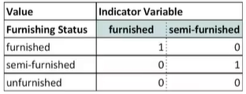

Hence if we have categorical variable with **n-levels,** then we need to use **n-1 columns** to represent the dummy variables.

1. **Looking at the pair-plot among the numerical variables, which one has the highest correlation with the target variable? (1 mark)**

temp and atemp both have same correlation with target variable of 0.63 which is the highest among all numerical variables

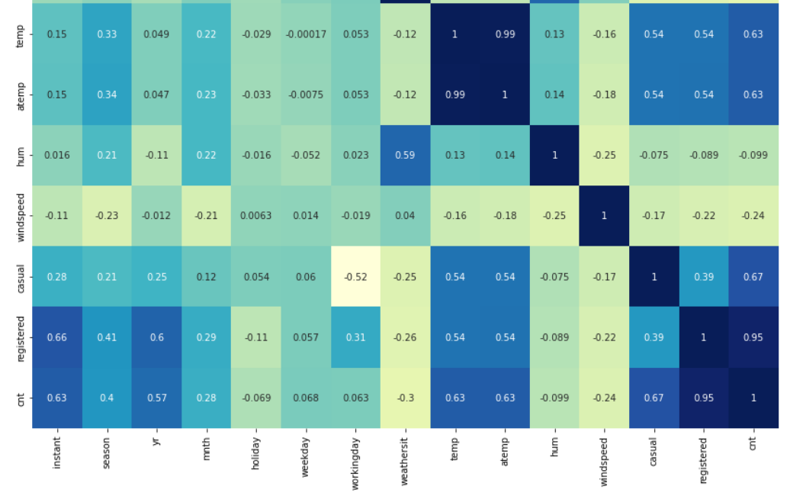;

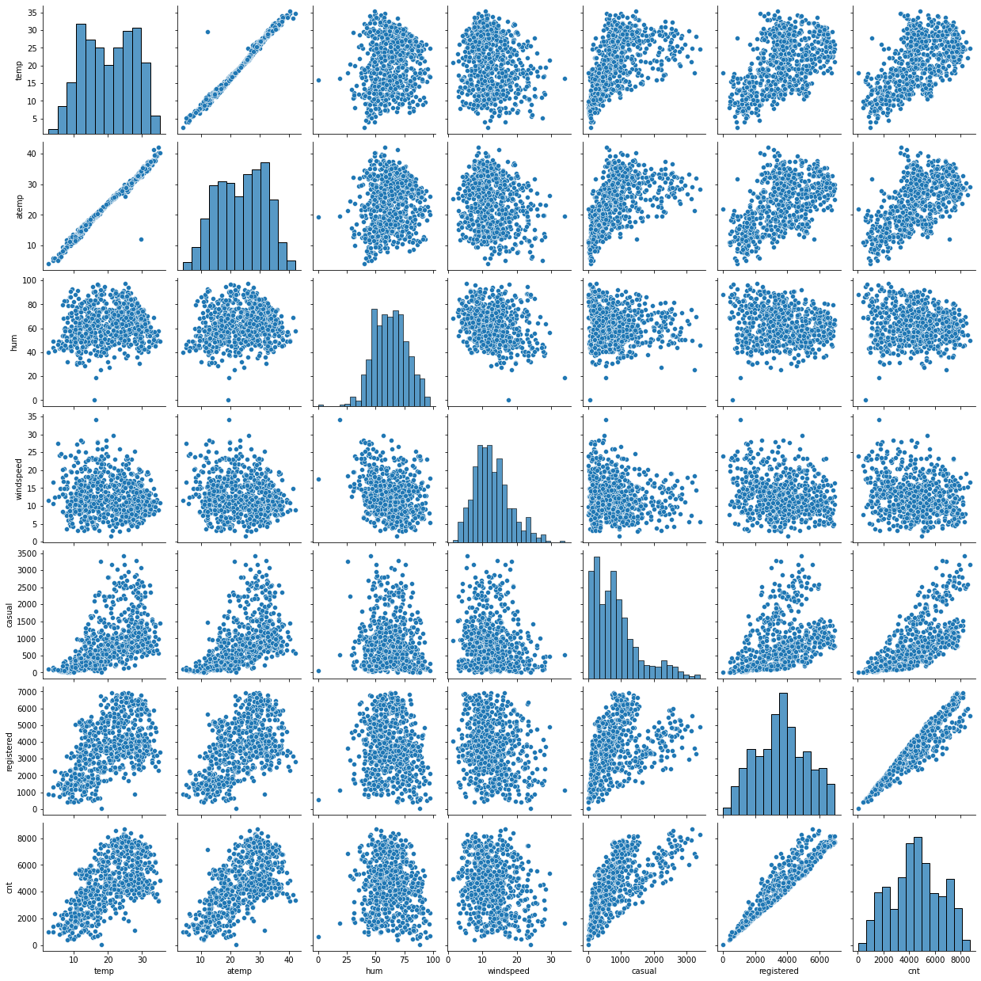

1. **How did you validate the assumptions of Linear Regression after building the model on the**

**training set? (3 marks)**

One of the assumptions that we studied was that the error terms should be normally distributed with mean equal to 0. So, once you have built the model, you'd need to verify if your model is not violating this assumption.

For verifying that we just plot a**histogram of the error terms** to check whether they are normally distributed.

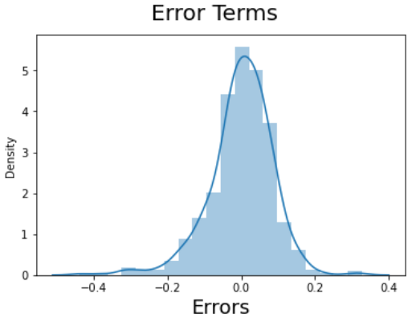

Another assumption was that the error terms should be independent of each other. Again, for this, you need to plot the error terms, this time with either of X or y to check for any patterns. In short, we should not be able to identify any patterns.

1. **Based on the final model, which are the top 3 features contributing significantly towards**

**explaining the demand of the shared bikes? (2 marks)**

# General Subjective Questions

1. **Explain the linear regression algorithm in detail.**  **(4 marks)**

Linear Regression:

**Linear Regression**is a machine learning algorithm based on**supervised learning**.

It performsa**regression task.** Regression models a target prediction value based on independent variables. It is mostly used for finding out the relationship between variables and forecasting.

Different regression models differ based on – the kind of relationship between dependent and independent variables they are considering, and the number of independent variables getting used.  
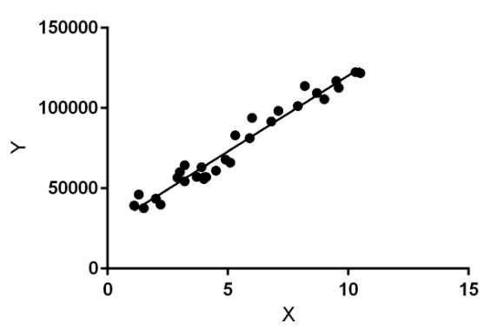

Linear regression models can be classified into two types depending upon the number of independent variables:

* Simple linear regression: When the number of independent variables is 1
* Multiple linear regression: When the number of independent variables is more than 1

In the figure above, X (input) is the work experience and Y (output) is the salary of a person. The regression line is the best fit line for our model.

**Hypothesis function for Linear Regression:**  
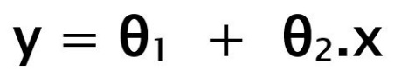

While training the model we are given:  
**x:** input training data (univariate – one input variable(parameter))  
**y:** labels to data (supervised learning)

When training the model – it fits the best line to predict the value of y for a given value of x. The model gets the best regression fit line by finding the best θ1 and θ2 values.  
**θ1:** intercept  
**θ2:** coefficient of x

Once we find the best θ1 and θ2 values, we get the best fit line. So, when we are finally using our model for prediction, it will predict the value of y for the input value of x.

**How to update θ1 and θ2 values to get the best fit line?**

**Cost Function (J):**  
By achieving the best-fit regression line, the model aims to predict y value such that the error difference between predicted value and true value is minimum. So, it is very important to update the θ1 and θ2 values, to reach the best value that minimize the error between predicted y value (pred) and true y value (y).

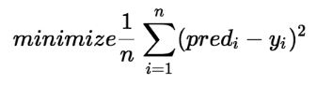

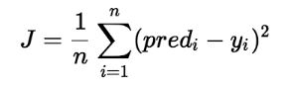

Cost function(J) of Linear Regression is the **Root Mean Squared Error (RMSE)** between predicted y value (pred) and true y value (y).

**Gradient Descent:**  
To update θ1 and θ2 values in order to reduce Cost function (minimizing RMSE value) and achieving the best fit line the model uses Gradient Descent. The idea is to start with random θ1 and θ2 values and then iteratively updating the values, reaching minimum cost.

1. **Explain the Anscombe’s quartet in detail. (3 marks)**

Anscombe’s Quartet can be defined as a group of four data sets which are nearly identical in simple descriptive statistics, but there are some peculiarities in the dataset that fools the regression model if built. They have very different distributions and appear differently when plotted on scatter plots.

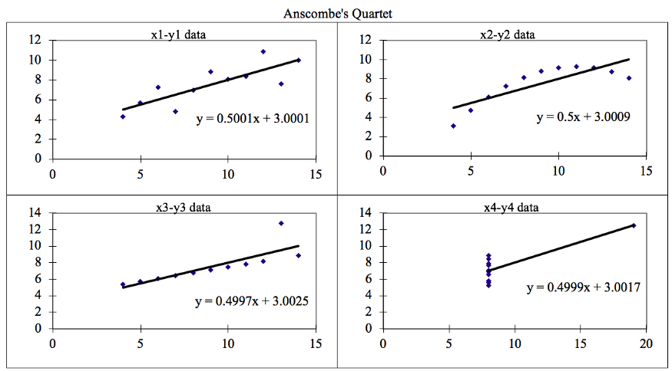

It was constructed to illustrate the importance of plotting the graphs before analysing and model building, and the effect of other observations on statistical properties. There are these **four data set plots** which have **nearly same statistical observations**, which provides same statistical information that involves variance, and mean of all x, y points in all four datasets.

This tells us about the **importance of visualising the data before applying various algorithm**s out there to build models out of them which suggests that the data features must be plotted in order to see the distribution of the samples that can help you identify the various anomalies present in the data like outliers, diversity of the data, linear separability of the data, etc. Also, the Linear Regression can be only be considered a fit for the data with linear relationships and is incapable of handling any other kind of datasets. These four plots can be defined as follows:

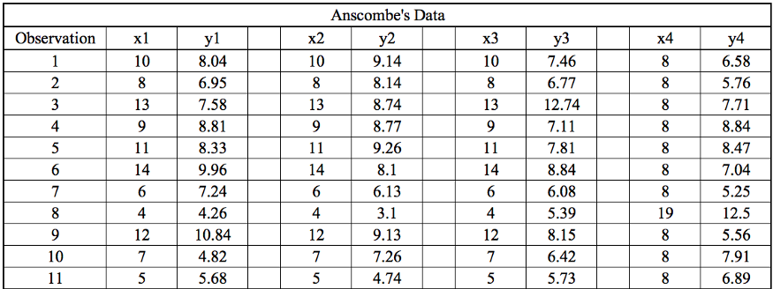

The statistical information for all these four datasets are approximately similar and can be computed as follows:

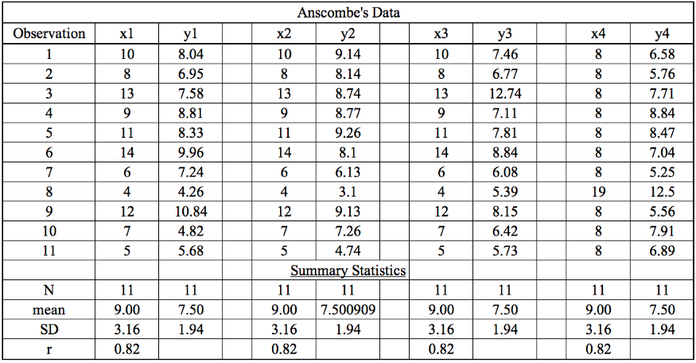

The four datasets can be described as:

**Dataset 1:** this fits the linear regression model pretty well.

**Dataset 2:** this could not fit linear regression model on the data quite well as the data is non-linear.

**Dataset 3:** shows the outliers involved in the dataset which cannot be handled by linear regression model

**Dataset 4:** shows the outliers involved in the dataset which cannot be handled by linear regression model

We have described the four datasets that were intentionally created to describe the importance of data visualisation and how any regression algorithm can be fooled by the same. Hence, all the important features in the dataset must be visualised before implementing any machine learning algorithm on them which will help to make a good fit model.

1. **What is Pearson’s R? (3 marks)**

In statistics, the Pearson correlation coefficient (PCC), also referred to as Pearson's r, the Pearson product-moment correlation coefficient (PPMCC), or the bivariate correlation, is a measure of linear correlation between two sets of data. **It is the covariance of two variables, divided by the product of their standard deviations**; thus, it is essentially a normalised measurement of the covariance, such that the result always has a value between −1 and 1.

The Pearson's correlation coefficient varies between -1 and +1 where:

| **Pearson correlation coefficient (*r*)** | **Correlation type** | **Interpretation** | **Example** |
| --- | --- | --- | --- |
| Between 0 and 1 | Positive correlation | When one variable changes, the other variable changes in the **same direction**. | Baby length & weight:  The longer the baby, the heavier their weight. |
| 0 | No correlation | There is **no relationship** between the variables. | Car price & width of windshield wipers:  The price of a car is not related to the width of its windshield wipers. |
| Between 0 and –1 | Negative correlation | When one variable changes, the other variable changes in the **opposite direction**. | Elevation & air pressure:  The higher the elevation, the lower the air pressure. |

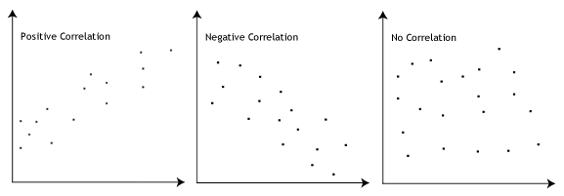

**Pearson r Formula**

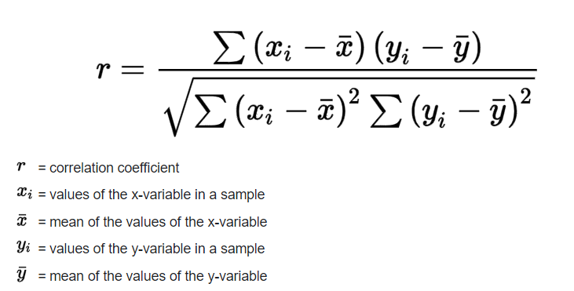

1. **What is scaling? Why is scaling performed? What is the difference between normalized scaling and standardized scaling?** **(3 marks)**

Scaling:

It is a step of data Pre-Processing which is applied to independent variables to normalize the data within a particular range. It also helps in speeding up the calculations in an algorithm.

Why Scaling?

Most of the times, collected data set contains features highly varying in magnitudes, units and range. If scaling is not done then algorithm only takes magnitude in account and not units hence incorrect modelling. To solve this issue, we have to do scaling to bring all the variables to the same level of magnitude.

It is important to note that scaling just affects the coefficients and none of the other parameters like t-statistic, F-statistic, p-values, R-squared, etc.

Normalization/Min-Max Scaling:

* It brings all of the data in the range of 0 and 1.
* **sklearn.preprocessing.MinMaxScaler**helps to implement normalization in python.

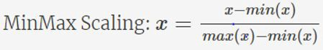

Standardization Scaling:

* Standardization replaces the values by their Z scores. It brings all of the data into a standard normal distribution which has mean (**μ)** zero and standard deviation one (**σ**).

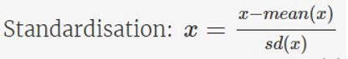

* **sklearn.preprocessing.scale** helps to implement standardization in python.
* One disadvantage of normalization over standardization is that it **loses** some information in the data, especially about **outliers**.

**Example:**

Below shows example of Standardized and Normalized scaling on original values.

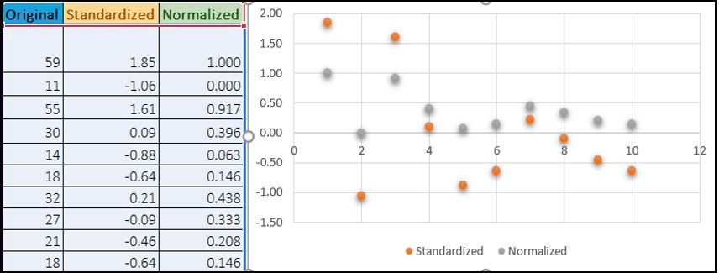

Normalization typically means rescales the values into a range of [0,1]. Standardization typically means rescales data to have a mean of 0 and a standard deviation of 1 (unit variance).

| **S.NO.** | **Normalisation** | **Standardisation** |
| --- | --- | --- |
| 1. | Minimum and maximum value of features are used for scaling | Mean and standard deviation is used for scaling. |
| 2. | It is used when features are of different scales. | It is used when we want to ensure zero mean and unit standard deviation. |
| 3. | Scales values between [0, 1] or [-1, 1]. | It is not bounded to a certain range. |
| 4. | It is really affected by outliers. | It is much less affected by outliers. |
| 5. | Scikit-Learn provides a transformer called MinMaxScaler for Normalization. | Scikit-Learn provides a transformer called StandardScaler for standardization. |
| 6. | This transformation squishes the n-dimensional data into an n-dimensional unit hypercube. | It translates the data to the mean vector of original data to the origin and squishes or expands. |
| 7. | It is useful when we don’t know about the distribution | It is useful when the feature distribution is Normal or Gaussian. |
| 8. | It is an often called as Scaling Normalization | It is an often called as Z-Score Normalization. |

1. **You might have observed that sometimes the value of VIF is infinite. Why does this happen? (3 marks)**

If there is perfect correlation, then VIF = infinity. This shows a perfect correlation between two independent variables. In the case of perfect correlation, we get R2 =1, which lead to 1/(1-R2) infinity. To solve this problem, we need to drop one of the variables from the dataset which is causing this perfect multicollinearity.

An infinite VIF value indicates that the corresponding variable may be expressed exactly by a linear combination of other variables (which show an infinite VIF as well).

1. **What is a Q-Q plot? Explain the use and importance of a Q-Q plot in linear regression.**

**(3 marks)**

The Q-Q plot or quantile-quantile plot is a graphical technique for determining if two data sets come from populations with a common distribution.

A Q-Q plot is a scatterplot created by plotting two sets of quantiles against one another. If both sets of quantiles came from the same distribution, we should see the points forming a line that’s roughly straight. Here’s an example of a Normal Q-Q plot when both sets of quantiles truly come from Normal distributions.

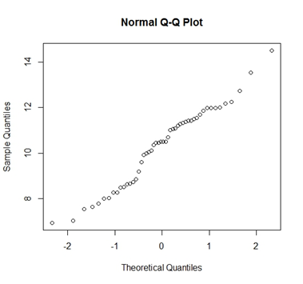

Use of Q-Q plot in Linear Regression: The Q-Q plot is used to see if the points lie approximately on the line. If they don’t, it means, our residuals aren’t Gaussian (Normal) and thus, our errors are also not Gaussian.

Importance of Q-Q plot in Linear Regression:

1. The sample sizes do not need to be equal.
2. Many distributional aspects can be simultaneously tested. For example, shifts in location, shifts in scale, changes in symmetry, and the presence of outliers.
3. The q-q plot can provide more insight into the nature of the difference than analytical methods