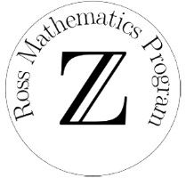 Ross Mathematics Program/Asia

[www.rossmathasia.org](http://www.rossmathasia.org)

info@rossmathasia.org

**Introduction to Nanjing and the Happy Villa hotel**

**THE CITY OF NANJING**

Nanjing, the capital of Jiangsu Province, is located in eastern China, on the banks of the Yangtze River. People settled in this area more than 6,000 years ago, and the city of Nanjing was founded 2,500 years ago. Nanjing is encircled by mountains and rivers and is known today for its mix of natural beauty and modern culture, blending traditional Chinese architecture with towering skyscrapers.

For many centuries, Nanjing was the political and cultural center of its region. It was the capital of six Chinese dynasties, and is considered an important cradle of Chinese civilization.

Nanjing has been the site of many advances in science, technology, and culture. For instance, Zu Chongzhi (429 - 500 AD) proved that π is closely approximated by 355/113, an amazing achievement for the time. He also made major strides in astronomy and established a more accurate calendar. The Porcelain Pagoda, a tower in Nanjing, was built during the Ming Dynasty and is currently being restored.

Nanjing is also famous for several traditional crafts, like the weaving of Yunjin Brocade, the art of intricate paper cutting, and artworks made from thin gold leaf.

In recent years, Nanjing has attracted many young entrepreneurs working in a variety of industries.

In August 2014, the Youth Olympic Games (YOG) were held in Nanjing. Thousands of young athletes from all over the world assembled to challenge themselves, compete with one another, and get a better understanding of sportsmanship and friendship. The vigor and passion brought by the YOG have invigorated the city during the past few years.

**TRANSPORTATION**

Railway stations: Nanjing Railway Station (Metro Line 1 & 3)  
 Nanjing South Railway Station (Metro Line 1 & 3 & S1)

Airport: Nanjing Lukou International Airport (Metro Line S1)

Many buses and taxis provide transportation in the city, as well as an extensive system of Metro Lines.

Five Metro Lines run through the city: Metro Line 1, 2, 3, 10, S1, and S8 pictured on the Nanjing Metro System map:

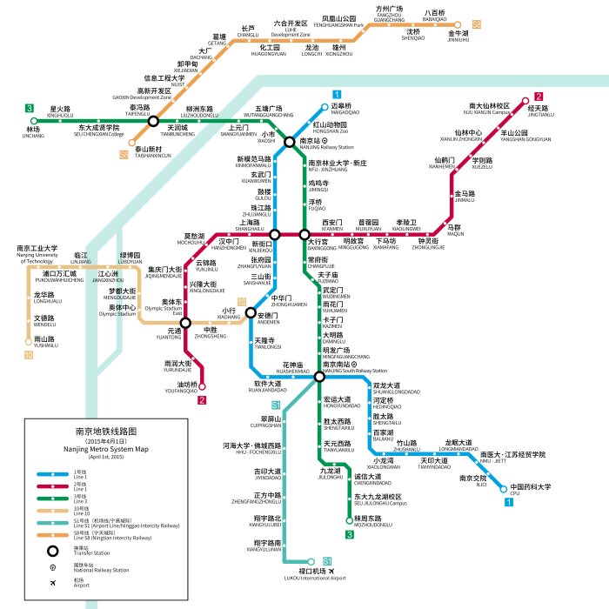

**AN INTRODUCTION TO HAPPY VILLA**

Ross Program participants will stay at Happy Villa, a hotel that belongs to Jiangsu Broadcasting Corporation. It is about nine kilometers from Nanjing Lukou International Airport (about 20-minutes by car) and about 40 kilometers from Nanjing South Railway Station (about 45-minutes by car), where we can take Metro Line 1 or 3 to the center of the city.

Happy Villa is located in a suburban / rural area. Nearby streets do not have much traffic, and air pollution is not noticeable there.

Happy Villa can be found in Google Maps by entering “Jiangsu Future Movie and TV Serial Cultural Originality Industry Zone”.

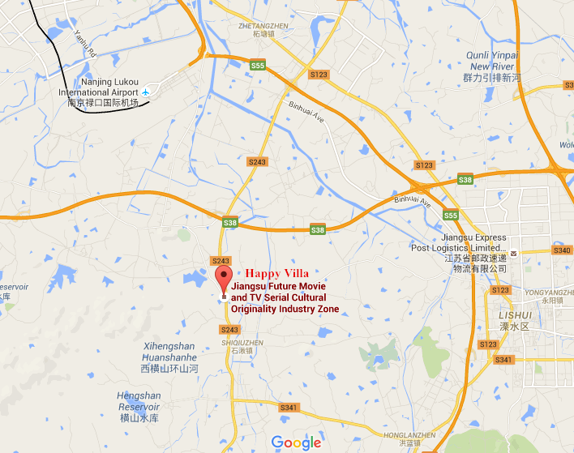

Location of Happy Villa

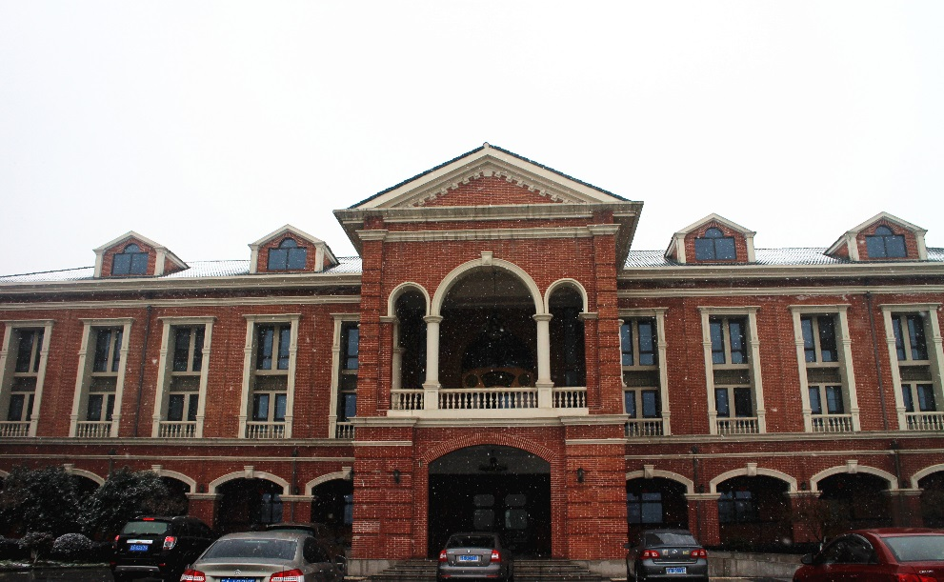

Main Building of Happy Villa

All rooms in the hotel are air-conditioned. Ross participants will live in double or triple rooms (with one or two roommates). Each room has chairs, desks, closets, and a bathroom with shower. Sheets, pillows, pillowcases, blankets, and clothes-hangers are provided. Refrigerators and microwave ovens are also available at the hotel.

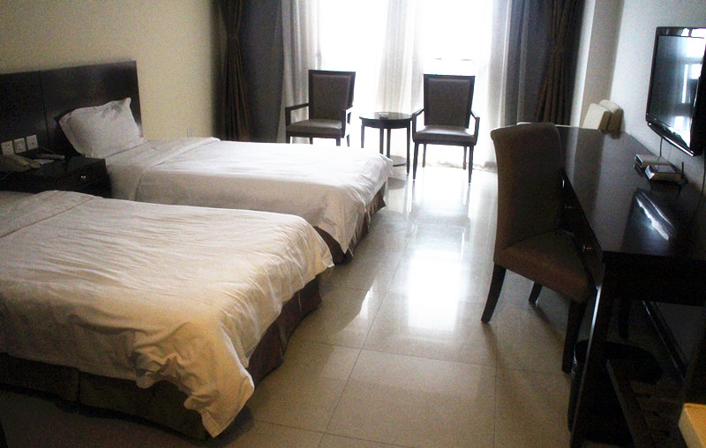

A room in Happy Villa

The hotel’s cafeteria serves three meals a day at fixed times, offering a variety of foods in a standard buffet style. Vegetables, tofu, and other vegan foods are available at every meal. Ross participants who miss a meal may purchase some snacks in the hotel lobby.

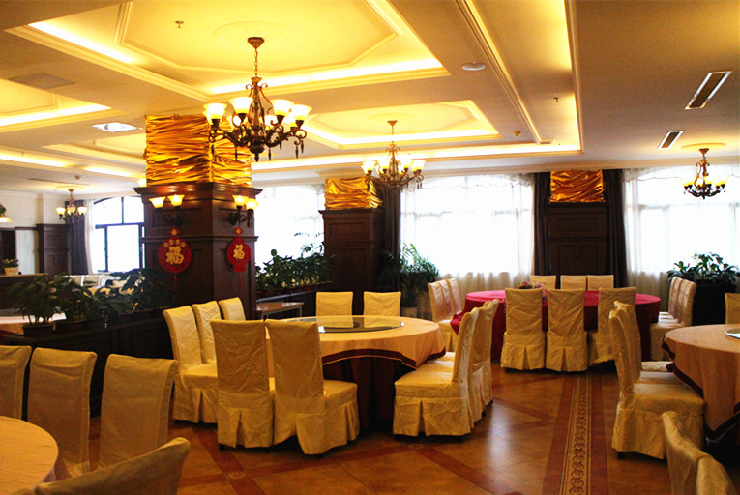

Cafeteria of Happy Villa

**TRADITIONAL SOUVENIRS FROM NANJING**

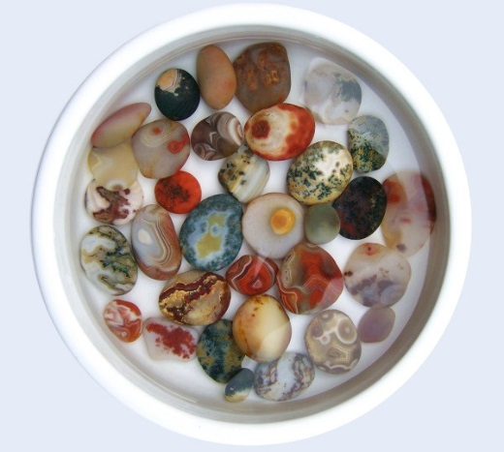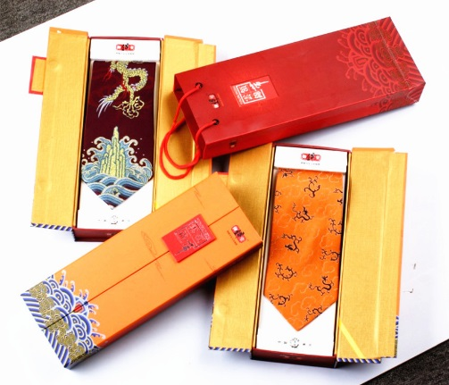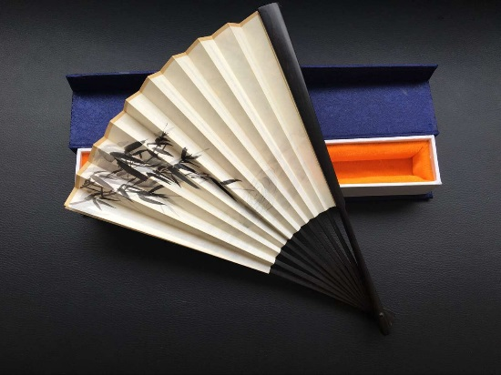

Yunjin Brocade (南京云锦) Yuhua Pebbles (雨花石)

Jinling Folding Fan (金陵折扇)

**SIGHTSEEING ADVICE**

Here are pictures of some of the sights in the Nanjing area.

**(1)** The Zhongshan Mountain National Park includes Dr. Sun Yat-sen’s Mausoleum, Ming Tomb Scenic Area, Linggu Scenic Area, Meiling Palace, Open-air Music Hall, etc.

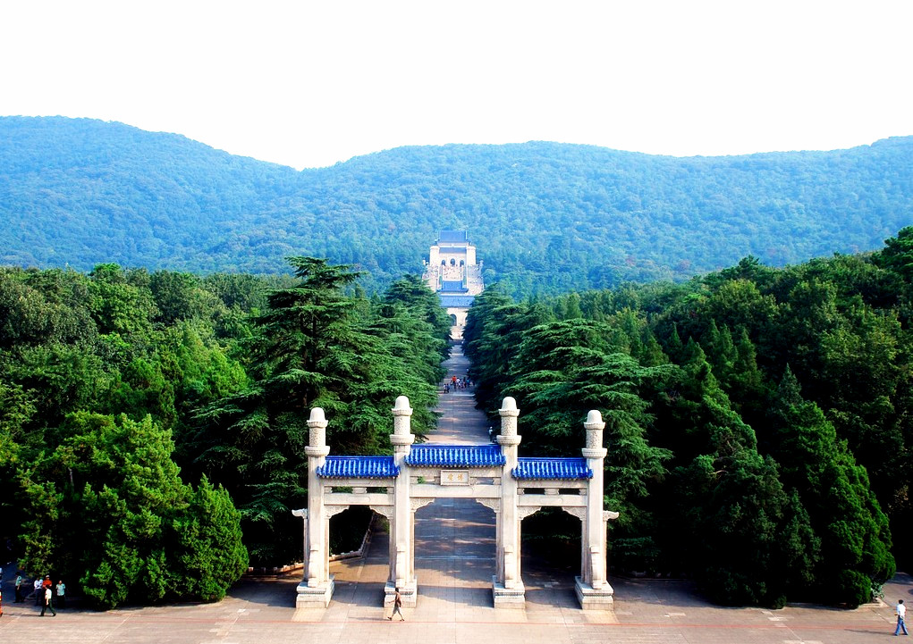

Dr. Sun Yat-sen’s Mausoleum

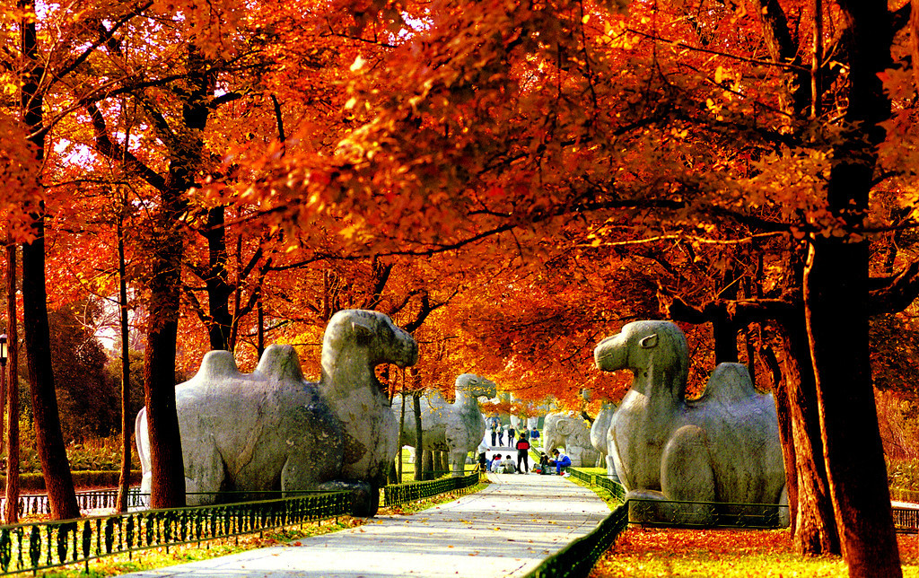

Ming Tomb Scenic Area

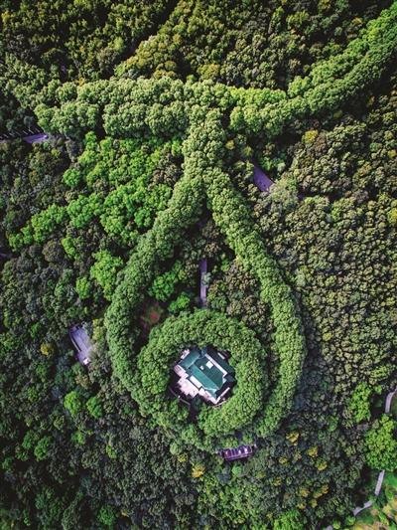

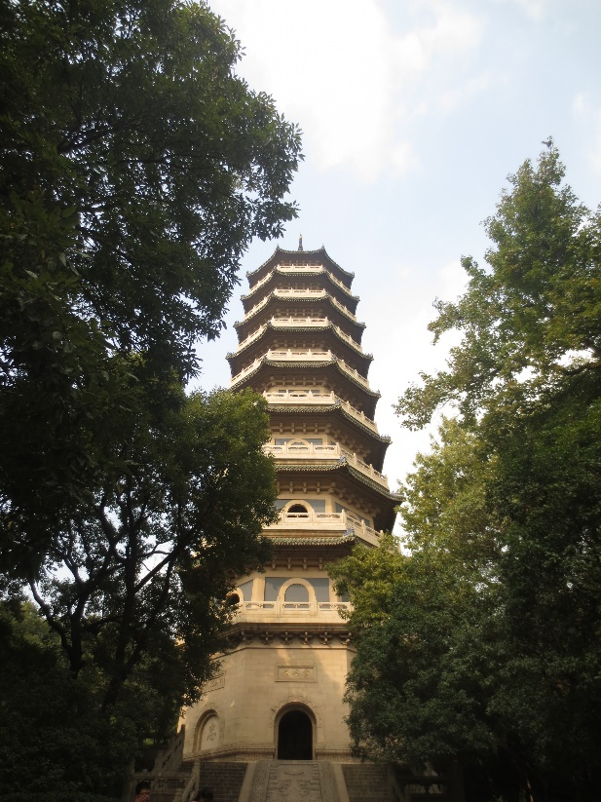

Linggu Scenic Area Meiling Palace

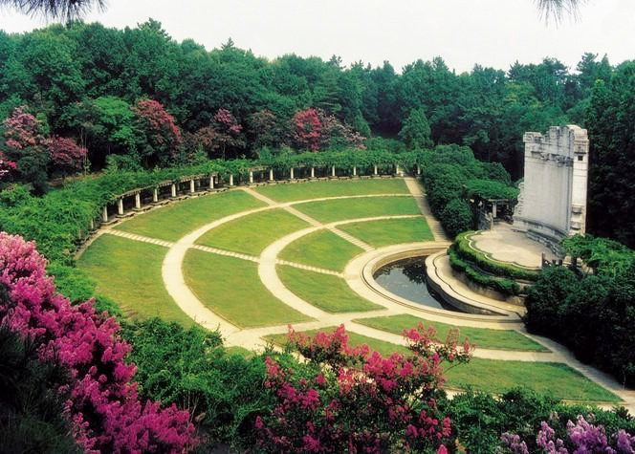

Open-Air Music Hall

**(2)** The Qinhuai River Scenic Belt includes:

Confucius Temple, Laomendong Scenic Area, etc.

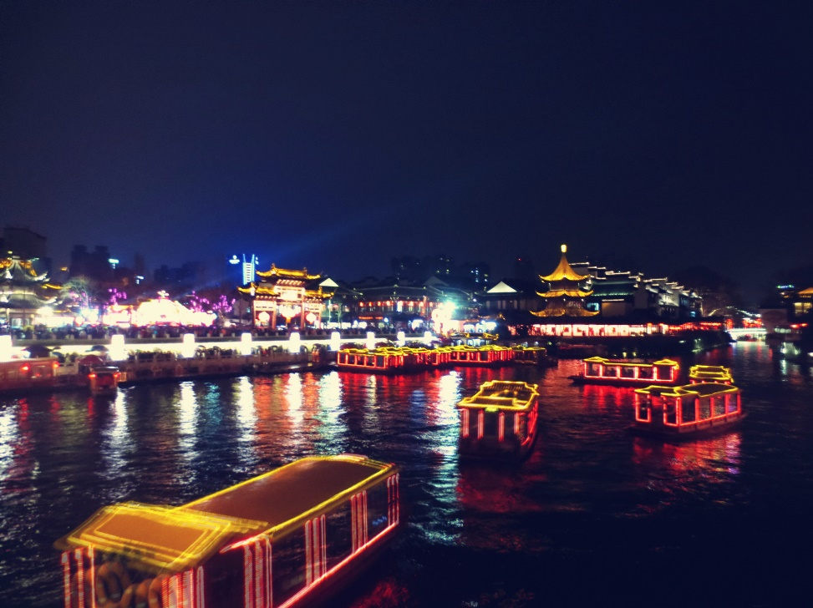

Confucius Temple - Qinhuai River Scenic Area

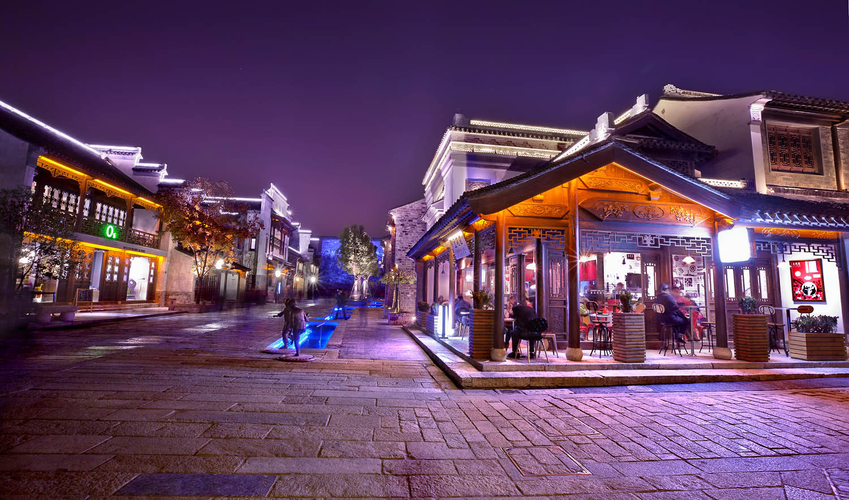

Laomendong Scenic Area

**(3)** Some picturesque lakes are located near Nanjing:

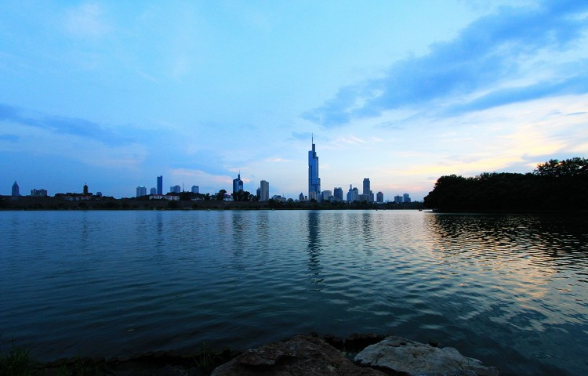

Xuanwu Lake Scenic Area

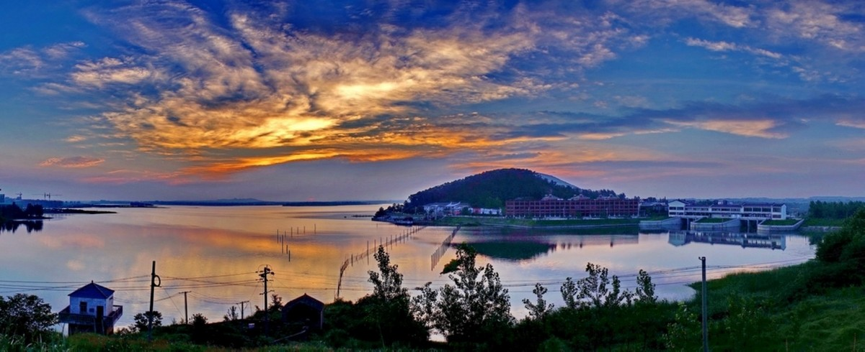

Jinniu Lake Scenic Area

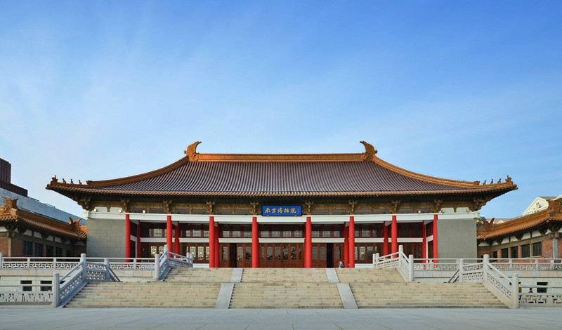**(3)** The city also hosts several museums:

Nanjing Museum

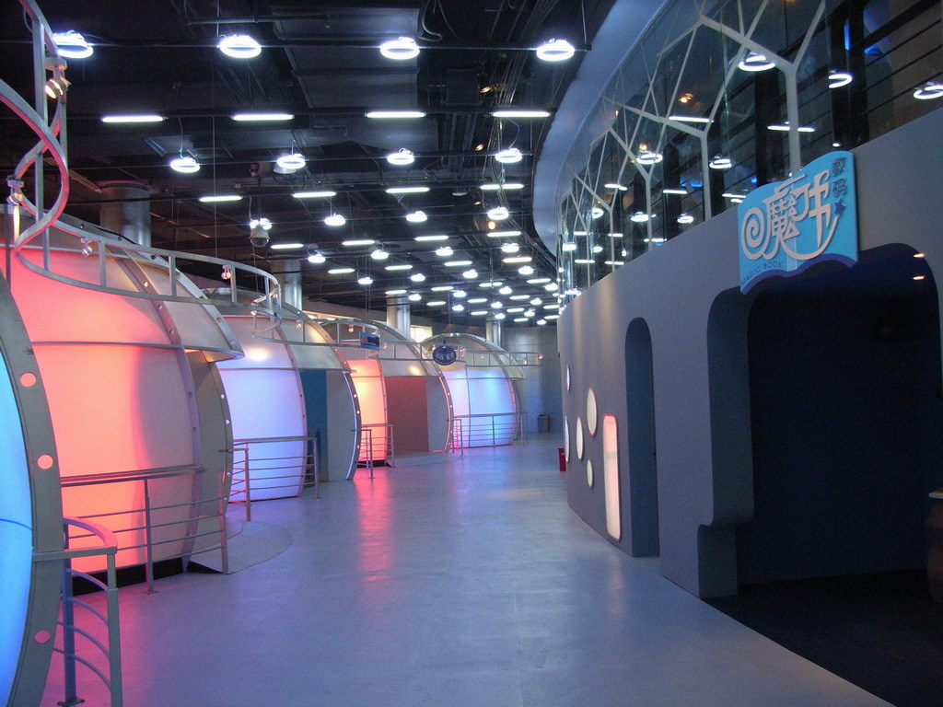

Jiangsu Science & Technology Museum

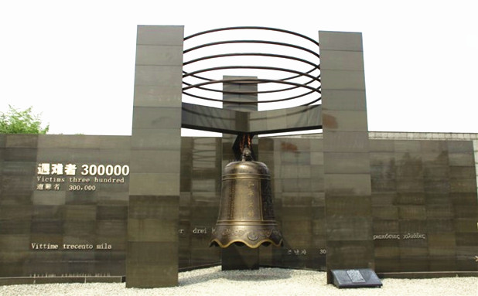

Memorial Hall for Victims in the Nanjing Massacre by Japanese Invaders