## Table of Contents

Contents

Chapter I: Introduction 2

* 1. Introduction 2
  2. Objective 2
  3. Needs of Ecommerce 3
  4. Methodology Development Model 3
  5. Tools and Technique 4

1.6.1 External Interfaces 7

Figure: Schema Diagram 14

Chapter II: Task and Activities Performed 17

* 1. Profile of Problems 17
  2. Structure of the project 17
  3. Scope and Feasibility 18
  4. System Analysis 19
  5. System Design 19
  6. Implementation 19
  7. Test Generation 20
  8. Problem Analysis 20

Chapter III: Discussion and Conclusion 21

* 1. Conclusion 21
  2. Screen Shot 21

## Chapter I: Introduction

# Introduction

## Computer plays an important role in our daily life. Anything we want we can get only in one mouse click. Speed, reliability and accuracy of the computer make it a powerful tool for different purposes. A very important and basic need of today’s modern business world is the quick availability and processing of information using computer. One can easily get the type of required information within a fraction of a second. The project that I have taken is also in this category which is used in our daily life whenever we want to purchase some items we can easily get them at our home.

E-commerce (electronic commerce) is the buying and selling of goods and services, or the transmitting of funds or data, over an electronic network, primarily the internet. These business transactions occur either as business-to-business ([B2B](https://searchcio.techtarget.com/definition/B2B)), business-to-consumer ([B2C](https://searchcustomerexperience.techtarget.com/definition/B2C)), consumer- to-consumer or consumer-to-business. The terms e-commerce and e-business are often used interchangeably. The term e-tail is also sometimes used in reference to the [transactional](https://searchcio.techtarget.com/definition/transaction) [processes](https://searchcio.techtarget.com/definition/transaction) for online shopping.

# Objective

Developing a GUI based automated system, which will cover all the information Related to the all products which is used in our daily life. For example – Mobiles Phones, Laptops, Clothes, Books, Electronic Items and many more. So by this GUI based automated system a user want to purchase something then it only a mouse click away to purchase these products.

The e-commerce is mainly useful for ho haven’t time to go shopping or for comfortably to the customers. Those are just entered into this website and bought they want at any time they can visit the web-site.

Customer will choose different items like mobile, laptops, etc. This website is based on this formal. After chosen items they pay bill thorough pay pal process. Customer will get their items just sitting at home.

# Needs of Ecommerce

The “**Ecommerce**” is developed according the current need in different Fields. This is Ecommerce Website which provides facility for purchasing Mobiles, Laptops, tabs and many more items. So by using this system users which want to purchase some products will first Register an account on this portal then Login through their Username and Password, and then Select items which they want to purchase and add them to cart and finally checkout by giving payment details. So by using this portal users can easily purchase products from their home.

# Methodology Development Model

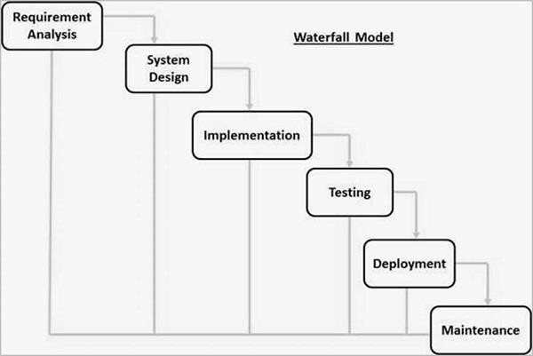

The sequential phases in Waterfall model are −

**Requirement Gathering and analysis** − All possible requirements of the system to be developed are captured in this phase and documented in a requirement specification document.

* + - **System Design** − The requirement specifications from first phase are studied in this phase and the system design is prepared. This system design helps in specifying hardware and system requirements and helps in defining the overall system architecture.
    - **Implementation** − With inputs from the system design, the system is first developed in small programs called units, which are integrated in the next phase. Each unit is developed and tested for its functionality, which is referred to as Unit Testing.
    - **Integration and Testing** − All the units developed in the implementation phase are integrated into a system after testing of each unit. Post integration the entire system is tested for any faults and failures.
    - **Deployment of system** − Once the functional and non-functional testing is done; the product is deployed in the customer environment or released into the market.
    - **Maintenance** − There are some issues which come up in the client environment. To fix those issues, patches are released. Also to enhance the product some better versions are released. Maintenance is done to deliver these changes in the customer environment.

# Tools and Technique

1. Php
2. Xampp
3. Mysql yog
4. HTML
5. Bootstrap
6. Sublime text
7. Git hub
8. Java Script
9. Css

Php

**Hypertext Preprocessor** (or simply **PHP**) is a [server-side scripting](https://en.wikipedia.org/wiki/Server-side_scripting) language designed for [Web](https://en.wikipedia.org/wiki/Web_development) [development,](https://en.wikipedia.org/wiki/Web_development) but also used as a [general-purpose programming language.](https://en.wikipedia.org/wiki/General-purpose_programming_language) It was originally created

by [Rasmus Lerdorf](https://en.wikipedia.org/wiki/Rasmus_Lerdorf) in 1994[,]](https://en.wikipedia.org/wiki/PHP#cite_note-History_of_PHP-5) the PHP [reference implementation](https://en.wikipedia.org/wiki/Reference_implementation) is now produced *by* The PHP Group. PHP

originally stood for Personal *Home Page*[,]](https://en.wikipedia.org/wiki/PHP#cite_note-History_of_PHP-5) but it now stands for the [recursive acronym](https://en.wikipedia.org/wiki/Recursive_acronym) *PHP: Hypertext Preprocessor*.

PHP code may be embedded into [HTML](https://en.wikipedia.org/wiki/HTML) code, or it can be used in combination with various [web](https://en.wikipedia.org/wiki/Web_template_system) [template systems,](https://en.wikipedia.org/wiki/Web_template_system) web content management systems, and [web frameworks](https://en.wikipedia.org/wiki/Web_framework). PHP code is usually processed by a PHP [interpreter](https://en.wikipedia.org/wiki/Interpreter_(computing)) implemented as a [module](https://en.wikipedia.org/wiki/Plugin_(computing)) in the web server or as a [Common Gateway](https://en.wikipedia.org/wiki/Common_Gateway_Interface) [Interface](https://en.wikipedia.org/wiki/Common_Gateway_Interface) (CGI) executable. The web server combines the results of the interpreted and executed PHP code, which may be any type of data, including images, with the generated web page. PHP code may also be executed with a [command-line interface](https://en.wikipedia.org/wiki/Command-line_interface) (CLI) and can be used to

implement [standalone](https://en.wikipedia.org/wiki/Computer_software) [graphical applications](https://en.wikipedia.org/wiki/Graphical_user_interface).

Xampp

XAMPP is a [free and open source](https://en.wikipedia.org/wiki/Free_software) [cross-platform](https://en.wikipedia.org/wiki/Cross-platform) [web server](https://en.wikipedia.org/wiki/Web_server) [solution stack](https://en.wikipedia.org/wiki/Solution_stack) package developed by Apache Friends, consisting mainly of the [Apache HTTP Server,](https://en.wikipedia.org/wiki/Apache_HTTP_Server) [MariaDB](https://en.wikipedia.org/wiki/MariaDB) [database](https://en.wikipedia.org/wiki/Database), and [interpreters](https://en.wikipedia.org/wiki/Interpreter_(computing)) for scripts written in the [PHP](https://en.wikipedia.org/wiki/PHP) and [Perl](https://en.wikipedia.org/wiki/Perl) [programming languages](https://en.wikipedia.org/wiki/Programming_language). XAMPP stands for Cross-Platform (X), Apache (A), MariaDB (M), PHP (P) and Perl (P). It is a simple, lightweight Apache distribution that makes it extremely easy for developers to create a local web server for testing and deployment purposes. Everything needed to set up a web server – server application (Apache), database (MariaDB), and scripting language (PHP) – is included in an extractable file. XAMPP is also cross-platform, which means it works equally well on Linux, Mac and Windows. Since most actual web server deployments use the same components as XAMPP, it makes transitioning from a local test server to a live server extremely easy as well.

Mysql yog

MySQL Workbench is a unified visual tool for database architects, developers, and DBAs. MySQL Workbench provides data modeling, SQL development, and comprehensive administration tools for server configuration, user administration, backup, and much more. MySQL Workbench is available on Windows, Linux and Mac OS X.

HTML

Hypertext Markup Language (HTML) is the standard [markup language](https://en.wikipedia.org/wiki/Markup_language) for creating [web pages](https://en.wikipedia.org/wiki/Web_page) and [web](https://en.wikipedia.org/wiki/Web_application) [applications.](https://en.wikipedia.org/wiki/Web_application) With [Cascading Style Sheets](https://en.wikipedia.org/wiki/Cascading_Style_Sheets) (CSS) and [JavaScript](https://en.wikipedia.org/wiki/JavaScript), it forms a triad of cornerstone technologies for the [World Wide Web](https://en.wikipedia.org/wiki/World_Wide_Web)[.[4]](https://en.wikipedia.org/wiki/HTML#cite_note-4)

[Web browsers](https://en.wikipedia.org/wiki/Web_browser) receive HTML documents from a [web server](https://en.wikipedia.org/wiki/Web_server) or from local storage and [render](https://en.wikipedia.org/wiki/Browser_engine) the documents into multimedia web pages. HTML describes the structure of a web page [semantically](https://en.wikipedia.org/wiki/Semantic_Web) and originally included cues for the appearance of the document.

[HTML elements](https://en.wikipedia.org/wiki/HTML_element) are the building blocks of HTML pages. With HTML constructs, [images](https://en.wikipedia.org/wiki/HTML_element#Images_and_objects) and other objects such as [interactive forms](https://en.wikipedia.org/wiki/Fieldset) may be embedded into the rendered page. HTML provides a means to

create [structured documents](https://en.wikipedia.org/wiki/Structured_document) by denoting structural [semantics](https://en.wikipedia.org/wiki/Semantics) for text such as headings, paragraphs, lists, [links,](https://en.wikipedia.org/wiki/Hyperlink) quotes and other items.

Bootstrap

Bootstrap is a [free and open-source](https://en.wikipedia.org/wiki/Free_and_open-source_software) front-end framework for designing [websites](https://en.wikipedia.org/wiki/Website) and [web applications](https://en.wikipedia.org/wiki/Web_application). It contains [HTML](https://en.wikipedia.org/wiki/HTML)- and [CSS](https://en.wikipedia.org/wiki/CSS)-based design templates for [typography](https://en.wikipedia.org/wiki/Typography), forms, buttons, navigation and other interface components, as well as optional [JavaScript](https://en.wikipedia.org/wiki/JavaScript) extensions. Unlike many web frameworks, it concerns itself with [front-end development](https://en.wikipedia.org/wiki/Front-end_web_development) only.

Java Script

JavaScript often abbreviated as JS, is a [high-level,](https://en.wikipedia.org/wiki/High-level_programming_language) [interpreted](https://en.wikipedia.org/wiki/Interpreted_language) [programming language](https://en.wikipedia.org/wiki/Programming_language). It is a language which is also characterized as [dynamic,](https://en.wikipedia.org/wiki/Dynamic_programming_language) [weakly typed,](https://en.wikipedia.org/wiki/Weak_typing) [prototype-based](https://en.wikipedia.org/wiki/Prototype-based_programming) and [multi-paradigm](https://en.wikipedia.org/wiki/Multi-paradigm_programming_language).

Alongside [HTML](https://en.wikipedia.org/wiki/HTML) and [CSS,](https://en.wikipedia.org/wiki/CSS) JavaScript is one of the three core technologies of the [World Wide](https://en.wikipedia.org/wiki/World_Wide_Web)

[Web.](https://en.wikipedia.org/wiki/World_Wide_Web) JavaScript enables interactive [web pages](https://en.wikipedia.org/wiki/Web_page) and thus is an essential part of [web applications](https://en.wikipedia.org/wiki/Web_application). The vast majority of [websites](https://en.wikipedia.org/wiki/Website) use it, and all major [web browsers](https://en.wikipedia.org/wiki/Web_browser) have a dedicated [JavaScript engine](https://en.wikipedia.org/wiki/JavaScript_engine) to execute it.

Sublime Text

Sublime Text is a [proprietary](https://en.wikipedia.org/wiki/Proprietary_software) [cross-platform](https://en.wikipedia.org/wiki/Cross-platform) [source code editor](https://en.wikipedia.org/wiki/Source_code_editor) with a [Python](https://en.wikipedia.org/wiki/Python_(programming_language)) [application programming](https://en.wikipedia.org/wiki/Application_programming_interface) [interface](https://en.wikipedia.org/wiki/Application_programming_interface) (API). It natively supports many [programming languages](https://en.wikipedia.org/wiki/Programming_languages) and [markup languages,](https://en.wikipedia.org/wiki/Markup_languages) and functions can be added by users with [plugins,](https://en.wikipedia.org/wiki/Plugins) typically community-built and maintained under [free-software](https://en.wikipedia.org/wiki/Free_software_licenses) [licenses.](https://en.wikipedia.org/wiki/Free_software_licenses)

Github

GitHub is a web-based [hosting service](https://en.wikipedia.org/wiki/Internet_hosting_service) for [version control](https://en.wikipedia.org/wiki/Version_control) using [Git.](https://en.wikipedia.org/wiki/Git) It is mostly used for [computer code.](https://en.wikipedia.org/wiki/Source_code) It offers all of the [distributed version control](https://en.wikipedia.org/wiki/Distributed_version_control) and [source code management](https://en.wikipedia.org/wiki/Source_code_management) (SCM) functionality of Git as well as adding its own features. It provides [access control](https://en.wikipedia.org/wiki/Access_control) and several collaboration features such as [bug](https://en.wikipedia.org/wiki/Bug_tracking_system)

[tracking,](https://en.wikipedia.org/wiki/Bug_tracking_system) [feature requests,](https://en.wikipedia.org/wiki/Software_feature) [task management,](https://en.wikipedia.org/wiki/Task_management) and [wikis](https://en.wikipedia.org/wiki/Wiki) for every project.

GitHub offers plans for both private repositories and free accounts which are commonly used to host [open-](https://en.wikipedia.org/wiki/Open-source) [source](https://en.wikipedia.org/wiki/Open-source) software projects.

Css

Cascading Style Sheets (CSS) is a [style sheet language](https://en.wikipedia.org/wiki/Style_sheet_language) used for describing the [presentation](https://en.wikipedia.org/wiki/Presentation_semantics) of a document written in a [markup language](https://en.wikipedia.org/wiki/Markup_language) like [HTML.](https://en.wikipedia.org/wiki/HTML) CSS is a cornerstone technology of the [World Wide](https://en.wikipedia.org/wiki/World_Wide_Web) [Web,](https://en.wikipedia.org/wiki/World_Wide_Web) alongside HTML and [JavaScript.](https://en.wikipedia.org/wiki/JavaScript)

CSS is designed to enable the separation of presentation and content, including [layout](https://en.wikipedia.org/wiki/Page_layout), [colors](https://en.wikipedia.org/wiki/Color),

and [fonts.](https://en.wikipedia.org/wiki/Typeface) This separation can improve content [accessibility,](https://en.wikipedia.org/wiki/Accessibility) provide more flexibility and control in the specification of presentation characteristics, enable multiple [web pages](https://en.wikipedia.org/wiki/Web_page) to share formatting by specifying the relevant CSS in a separate css file, and reduce complexity and repetition in the structural content.

# Specification Requirement

## External Interfaces

- This interface will be actual interface through which the user will communication with the application and perform the desired tasks.

Admin login

### D:

**Role**: Admin wishes to login to the system

**Precondition**: Username and Password

**Success end Condition**: Main option of screen display

**Failed end Condition**: User has entered incorrect Username and Password or both

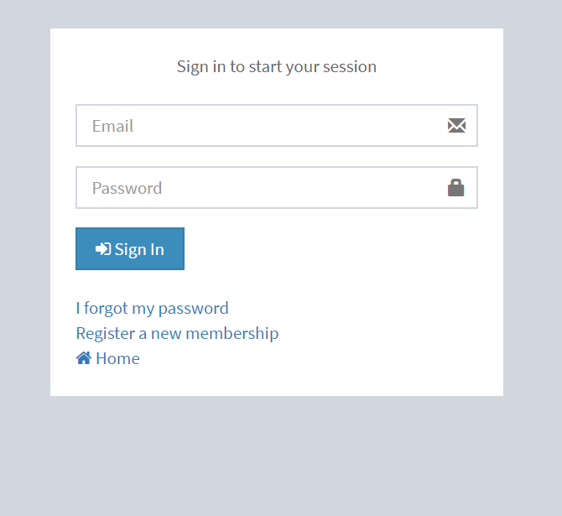

Edit

### ID:

**Precondition:** User has successfully navigated to the

search result

**Success end Condition:** User has successfully made the changes

* + - * 1. To edit user records in the data base, first search the record you want to edit then click on ‘edit’ button.
        2. Edit the particulars user that you want to change and click on’ Save’ button.

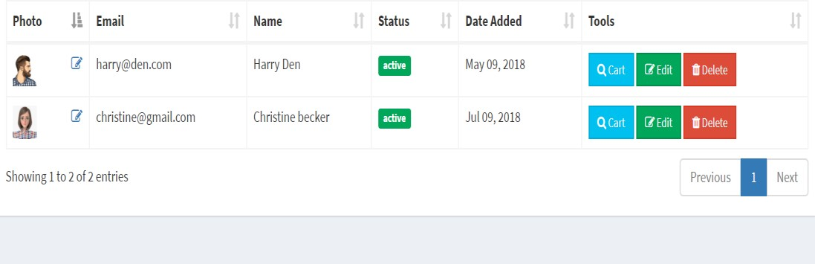

* + 1. Software Product Features

Ecommerce system

Login Information System

* Description

-The system will maintain the login information of its user to enter in to the software

* Validating Checks

-Administrator need to login the unique id and password.

-Contact number should have maximum 10 digits.

-All the details must be fill up.

-Email address should be in the proper format.

* Sequencing information

-Login information should be filled before the user allowed.

* Error Handling

-If user doesn’t filled up validate information then the system display error message for user and request to enter the validate information.

Performance required

* Security

-System should be Protected from unauthorized access Where the validate Username and Password are required so no other can access.

* Maintainability

-System should be design in a maintain order. So it can be easily modified.

Logical Database

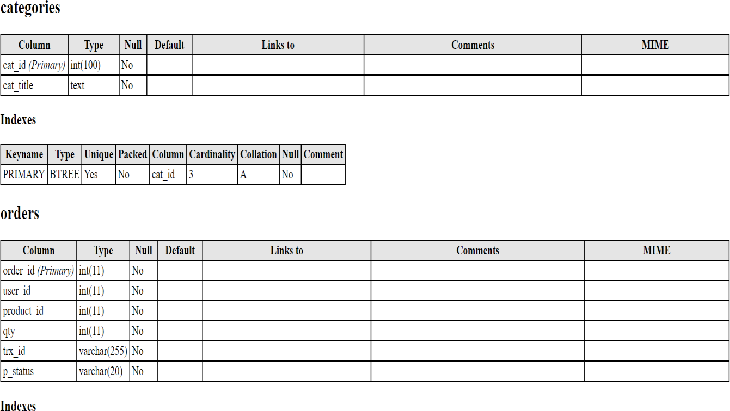

Data Design

Data Model: A database model is a type of data model that determines the logical structure of a database and fundamentally determines in which manner data can be stored, organized and manipulated.

Level 0

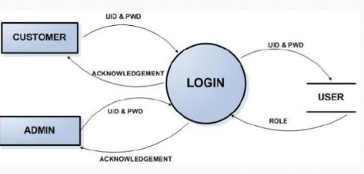

Figure: Data flow

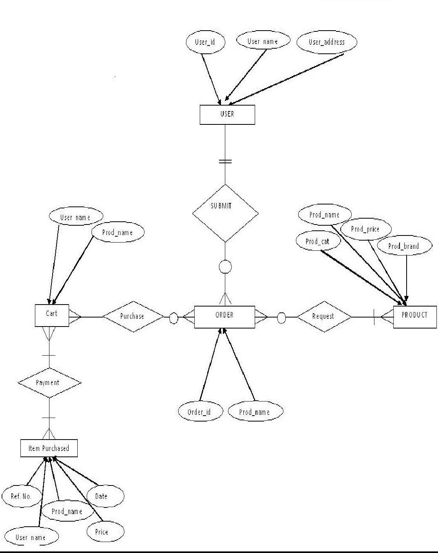

Figure:ER diagram

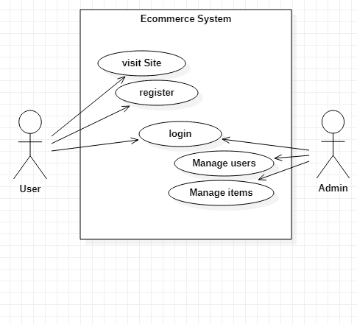

Figure: Use case Diagram of Ecommerce

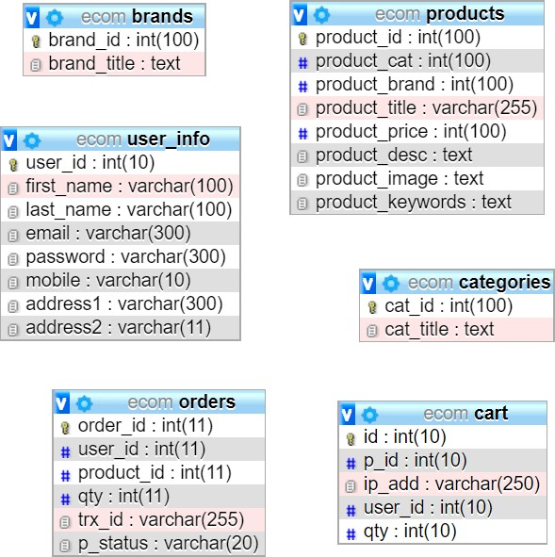

**Figure: Schema Diagram**

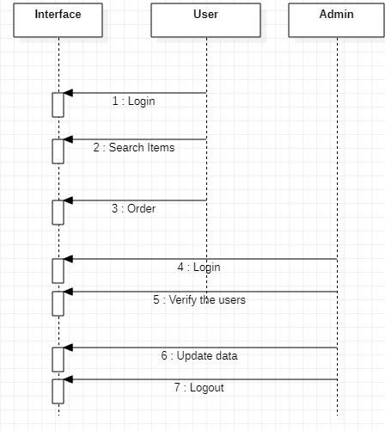

Figure: Sequence Diagram

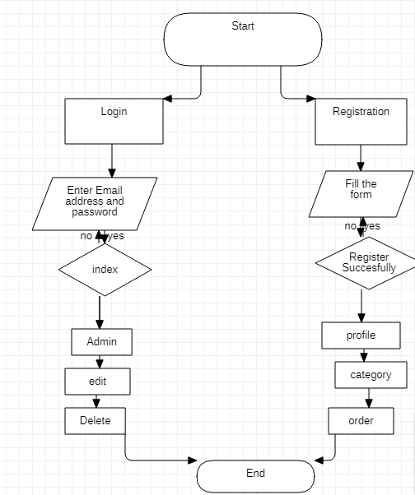

Figure: Flowchart of Ecommerce

## Chapter II: Task and Activities Performed

# Profile of Problems

## One must know what the problem is before it can be solved. The basis for ecommerce is to buy products online and save the timing.

A Ecommerce, who want to buy any product of their need, has to contact different Shoppers, before deciding upon a particular Product that best suit his needs, requirements and satisfaction. Moreover, most of the work involved in this development process has to be done manually which is very time consuming and cumbersome and also, it reduces the efficiency, accuracy.

To know the facts and understanding of the problem in detail, ***System Analysis*** is carried out. It is the process of studying the business processes and procedures, generally referred to as business systems, to see how they can operate and whether improvement is needed.

# Structure of the project

## Before Login

* + Login

## Register

* + Forget Password

## Administrator Login

* + About Us

## Contact Us

* After Administrator Login

## Edit Website Details

* + Add Brands

## Add Category

* + Add Items

## Delete Brands

* + Delete Category

## Delete Items

* + Manage User

## See Users

* + - Users Shopping

## Add Users

* + - Delete Users

## Logout

* After User Login

## My Profile

* + - Edit Profile

## Change Password

* + Buy Products

## Categories (Controlled by Admin. Which can be add it dynamically according to their needs)

* + My Cart

## My Shopping’s

* + Checkout
  + Logout

# Scope and Feasibility

## This activity is also known as the feasibility study. It begins with a request from the user for a new system. It involves the following:

* + - Identify the responsible user for a new system

## Clarify the user request

* + - Identify deficiencies in the current system

## Establish goals and objectives for the new system

* + - Determine the feasibility for the new system
    - Prepare a project charter that will be used to guide the remainder of the Project

# System Analysis

The objective of the system analysis activity is to develop structured system specification for the proposed system. The structured system specification should describe what the proposed system would do; independent of the technology, which will be used to implement these requirements. The structured system specification will be used to implement these requirements. The structured system specification will be called the essential model (also know as logical model).

The essential model may itself consist of multiple models, modeling different aspect of the system. The data flow diagrams may model the data and there relationships and the state transition diagram may model time dependent behavior of the system. The essential model thus consists of the following.

## Context diagram

* + - Leveled data flow diagrams

## Process specification for elementary bubbles

* + - Data dictionary for the flow and stores on the DFDs.

# System Design

## System design involves transformation of the user implementation model into software design. The design specification of the proposed system consists of the following:

* + - Database scheme

## Structure charts

* + - Pseudo codes for the modules in structure charts

# Implementation

This activity includes programming, testing and integration of modules into a progressively more complete system. Implementation is the process of collect all the required parts and assembles them into a major product.

# Test Generation

This activity generates a set of test data, which can be used to test the new system before accepting it. In the test generation phase all the parts are come which are to be tested to ensure that system does not produce any error. If there are some errors then we remove them and further it goes for accepting.

# Problem Analysis

## Ecommerce system is a computerized, online solution to the various problems faced by the Product buyer and seller wishing to outsource their software development work to a Provider at an economical cost, thus achieving high performance, accuracy, reliability and high speed of data retrieval.

In this system, there is a registration process each for the Product buyer and seller. The Administrator of the site verifies the Provider after his registration and if satisfied, assigns him a user name and password.

Our site can be used by anyone who is searching for Products whether he/she is first time visiting our site. Our site also provides some discounted Products as same u get on any shop.

# The software covers the following point while keeping in mind user’s requirement-:

## Fast online access of information about various Products.

* + - Search Products by keywords like functional area, experience and also by initials of the Product’s name.
    - Administrator will maintain the database and perform all process.

# There are 2 categories of users-

## General User

1. Registered Users

## Chapter III: Discussion and Conclusion

# Conclusion

To conclude the description about the project : The project, developed using PHP and MySQL is based on the requirement specification of the user and the analysis of the existing system, with flexibility for future enhancement. The expanded functionality of today’s software requires an appropriate approach towards software development. This ecommerce software is designed E- commerce site project is developed using PHP, CSS, Bootstrap, and JavaScript. Talking about the project, it has all the required essential features. This project has a user side where he/she can view product category and add products to cart and proceed for checkout whereas from administration side he/she can view sales, number of product, users, daily sales report, add product and categories. The user can also leave comments on each product if he/she wants. In this project, all the main functions are performed from the Admin side.User Friendly.

# Screen Shot

Home Page

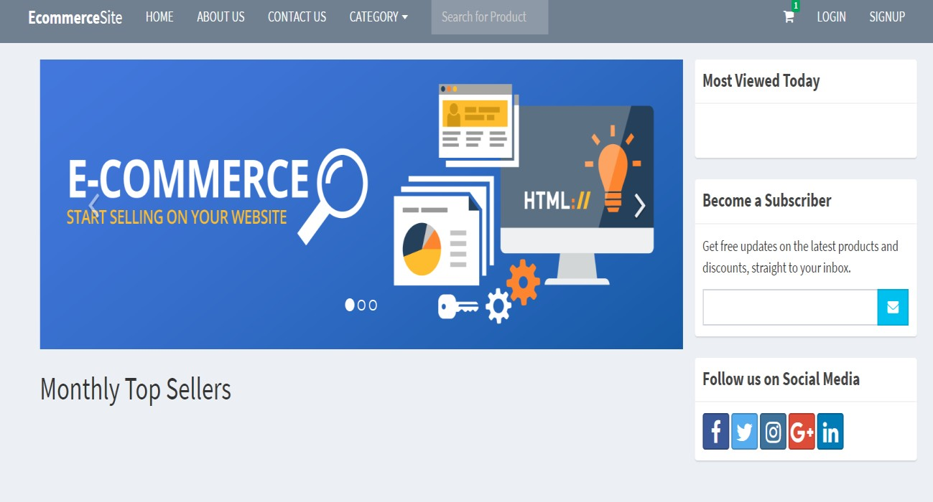

Admin Page

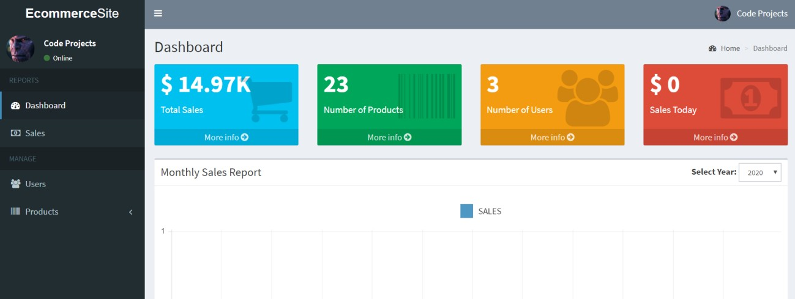

Product List

