Hybrid Neural versus Purely Autoregressive Packet Loss Concealment for Networked Music: An Evaluation on Real Loss Traces
Omar Ali Elgabry
October 2026
Abstract
Packet loss concealment (PLC) is indispensable in networked music performance, where retransmission is impossible within the latency budget and a lost 512-sample packet must be replaced causally, from past audio only. This report compares two causal concealers that share the same autoregressive (AR) linear predictor: AR prediction alone, and PARCnet, a hybrid model that adds a convolutional neural network's estimate of the AR residual [1]. Both were evaluated on 673 music recordings from the IEEE-IS² 2024 Music PLC Challenge test set with their real packet-loss traces (10.6% of packets lost overall), using two physical metrics (SNR and multi-resolution STFT distance) and two perceptual metrics (PLCMOS and ViSQOL), paired non-parametric statistics, a per-burst analysis over every real loss event, one-at-a-time hyperparameter sweeps and a real-time cost analysis. After Holm correction (α = 0.05, n = 673 files), quality was significantly better with the neural residual on MR-STFT dist. and PLCMOS; significantly better with AR alone on SNR (dB) and ViSQOL MOS-LQO. Gap SNR decreased from 7.86 dB (AR) / 7.75 dB (hybrid) for single-packet losses to 0.80 / 0.45 dB for bursts of 8+ packets; the hybrid model's gap-SNR advantage was negative for bursts of 1, 4-7 and 8+ packets (95% CI excluding zero). On the evaluation CPU, concealing one 11.6 ms packet took a median of 1.51 ms with AR alone (real-time factor 0.13) and 42.5 ms with the hybrid model (real-time factor 3.66), i.e. the hybrid model cannot run in real time on this hardware.
Keywords: packet loss concealment; networked music performance; linear prediction; hybrid neural networks; PARCnet; objective audio quality

Contents
Right-click here and choose 'Update Field' to build the table of contents.

1 Introduction
In networked music performance (NMP), musicians at different locations play together over the internet. Audio is sent in small packets, and every network hop can drop or delay one. Unlike speech calls or streaming, NMP leaves no room for retransmission or large jitter buffers: the end-to-end latency must stay within a few tens of milliseconds for ensemble playing to remain possible. A lost packet must therefore be replaced, on the fly, by a plausible estimate computed only from audio that has already arrived. This task is packet loss concealment (PLC) [3].
A classic and computationally cheap approach is to fit an autoregressive (AR) model, i.e. a linear predictor, to the most recent audio and extrapolate it across the gap [4]. Linear prediction captures the stationary, resonant part of a musical signal well, but it cannot anticipate changes such as note onsets, and its extrapolation decays during long gaps. PARCnet [1] keeps the linear predictor and adds a lightweight convolutional network that is trained to estimate what the predictor gets wrong, its residual. A modified PARCnet is the official baseline of the IEEE-IS² 2024 Music PLC Challenge [2], whose settings (512-sample packets at 44.1 kHz, i.e. 11.6 ms, and strictly causal processing) are adopted here.
Because the hybrid model contains the AR predictor as a component, comparing the two isolates exactly one question: what does the neural residual add? This report answers it through four research questions:
- RQ1 (quality). Does the neural residual improve concealment quality over AR prediction alone, as measured by physical and by perceptual metrics, on real loss traces?
- RQ2 (conditions). How does any advantage depend on the length of the loss burst and on the complexity of the music signal?
- RQ3 (sensitivity). How sensitive are both methods to their main hyperparameters (AR order, context length, diagonal loading, crossfade length)?
- RQ4 (cost). Can each method run in real time on a general-purpose CPU?
The main contributions are: (i) two independently implemented concealers that are verified to be bit-identical at the AR level, so that every measured difference is attributable to the neural network; (ii) an evaluation on whole files with their real packet traces rather than synthetic losses; (iii) paired statistical testing with multiple-comparison correction and effect sizes; (iv) a per-burst analysis over every real loss event in the evaluated files; and (v) hyperparameter sensitivity and real-time cost analyses.

2 Methods

2.1 Problem formulation
A mono music signal x[n], sampled at f_{s} = 44.1 kHz, is divided into packets of P = 512 samples (11.6 ms). A binary packet trace l_{k} ∈ {0, 1} marks packet k as received (0) or lost (1); lost packets arrive as zeros. A concealer must output an estimate of each lost packet using only samples before it (received or previously concealed). Because concealed samples become context for the next prediction, both methods are causal and recursive: a burst of N lost packets is concealed by N successive predictions, each conditioned on the previous ones.

2.2 AR (linear-prediction) concealment
For every lost packet, an AR model of order p is fitted to the most recent C = 8 packets (4096 samples, 93 ms) of the output signal:
x̂[n] = Σᵢ₌₁ᵖ aᵢ · x[n − i] (1)
The coefficients a = (a₁, …, aₚ) are obtained with the autocorrelation method and solved with the Levinson-Durbin recursion, after adding a diagonal loading term λ to the zero-lag autocorrelation (white-noise compensation), which improves the conditioning of the system [4]:
(R + λI) a = r, Rᵢⱼ = rₓₓ(|i − j|) (2)
The model is then run forward recursively, feeding each predicted sample back as input, to produce P + E = 768 samples: the lost packet plus E = 256 extra samples (5.8 ms). The extra samples are used for a linear crossfade: the tail of the prediction fades out while the next packet fades in, so that no discontinuity is heard where concealment hands back to real audio. Within a burst, the next prediction likewise fades in over the previous prediction's tail. The default hyperparameters (Table 1) are those of the challenge baseline.
Table 1. Default hyperparameters (IEEE-IS² 2024 challenge baseline configuration).
Hyperparameter | Symbol | Default | Meaning
AR order | p | 256 | number of past samples in the linear predictor
Context length | C | 8 packets (4096 samples) | audio used to fit the AR model and as NN input
Diagonal loading | λ | 0.001 | regularization of the autocorrelation matrix
Crossfade length | E | 256 samples (5.8 ms) | extra predicted samples used for crossfading
NN fade-in | - | 64 samples | fade-in of the NN contribution (hybrid only)

2.3 Hybrid AR + neural concealment (PARCnet)
The hybrid model computes the same AR prediction and adds the output of a neural network fθ that receives the same past context c:
ŝ = ŝ_AR + f_θ(c) (3)
The network is a lightweight, fully convolutional 1-D encoder-decoder ('lite' configuration, 8 base channels): four dilated residual blocks with ×2 downsampling, a bottleneck of six gated linear unit (GLU) blocks with dilations 1 to 32, four upsampling dilated residual blocks, and a tanh output. It was trained by the challenge organizers on Medley-solos-DB [5] to minimize
L = 100 · ‖s − ŝ‖₁ + ½ (L_SC + L_mag) (4)
where L_SC and L_mag are the spectral-convergence and log-magnitude terms of a multi-resolution STFT loss [7]. Because the target of the network is s − ŝ_AR, it learns the residual of an AR predictor with the default configuration. The pretrained challenge checkpoint is used unchanged; it was not retrained for any of the swept configurations (Section 2.8). The NN output is faded in over its first 64 samples, and the same crossfade as in Section 2.2 is applied to the combined prediction.

2.4 Implementation and verification
The two concealers are separate code paths. The AR concealer is a standalone implementation with no dependency on the neural network or its framework; the hybrid concealer is the unmodified challenge implementation with the network always enabled. With identical hyperparameters, the standalone AR concealer was verified to produce output identical to the hybrid model's internal AR branch (mean squared error 0.0). Every difference reported below can therefore be attributed to the neural residual alone, and not to implementation details.

2.5 Dataset and loss traces
Experiments use the example test set released with the IEEE-IS² 2024 Music PLC Challenge [2]: 674 single-channel recordings of solo instrumental music at 44.1 kHz, each provided as a clean file, a lossy file and the packet trace that produced it. The traces are real network traces, repurposed by the challenge from the INTERSPEECH 2022 Audio Deep PLC Challenge [6], so no synthetic loss model is involved. Table 2 summarizes the loss statistics over all 674 traces.
Table 2. Packet-loss statistics of the real traces of the test set.
Statistic | Value
Recordings (clean / lossy / trace triplets) | 674
Total packets | 899,460
Lost packets (overall packet loss rate) | 95,066 (10.57%)
Per-file loss rate: median (min-max) | 8.31% (0.53-60.80%)
Files without any loss | 0
Loss bursts (runs of consecutive lost packets) | 65,031
Mean / maximum burst length | 1.46 / 16 packets
Bursts of 1 packet / of at most 2 packets | 72.4% / 91.2%
Bursts of 8 packets or more | 373

The main comparison uses 673 of these files (random seed 0). Files are drawn by a seeded shuffle; when fewer files are requested than the candidate pool holds, the sample is stratified across five quantile bins of spectral flatness, so that tonal and noise-like material are both represented. Every file is concealed whole, against its own real trace.

2.6 Objective quality metrics
Two families of metrics are used, because a concealment can be close to the original waveform without sounding natural, and vice versa:
- SNR (dB, higher is better). Time-domain signal-to-noise ratio between the clean and the concealed signal. It rewards an exact waveform match, including phase.
- Multi-resolution STFT distance (lower is better). Spectral convergence plus mean absolute log-magnitude error, averaged over FFT sizes of 512, 1024 and 2048 [7]. It compares magnitude spectra and ignores phase.
- PLCMOS (≈1-5, higher is better). A non-intrusive neural estimate of the mean opinion score, designed specifically for packet loss concealment [8]; computed at 16 kHz.
- ViSQOL MOS-LQO (≈1-5, higher is better). An intrusive perceptual similarity model, used in its full-band audio mode at 48 kHz [9].
PLCMOS and ViSQOL need seconds of audio and are therefore computed on whole files. To study individual loss events, the SNR is also computed inside each gap G (the lost samples only):
SNR_gap = 10 · log₁₀( Σₙ∊G x[n]² / Σₙ∊G (x[n] − x̂[n])² ) (5)
Gaps whose clean signal is quieter than −60 dBFS RMS are excluded from this analysis, because an SNR of near-silence is meaningless. Signal complexity is quantified by the mean spectral flatness of the clean file (ratio of geometric to arithmetic mean of the power spectrum; 0 = tonal, 1 = noise-like) [10].

2.7 Statistical analysis
The design is paired: both methods conceal the same files. For each metric, the per-file difference is oriented so that a positive value always means 'the hybrid model is better'. Differences are tested with the two-sided Wilcoxon signed-rank test [11] (ties dropped), which does not assume normality. Because four metrics are tested, p-values are adjusted with the Holm-Bonferroni procedure [12] and compared with α = 0.05. Effect size is the matched-pairs rank-biserial correlation [13],
r = (W⁺ − W⁻) / (W⁺ + W⁻) (6)
where W⁺ and W⁻ are the rank sums of positive and negative differences (|r| < 0.1 negligible, < 0.3 small, < 0.5 medium, otherwise large). The mean difference is reported with a 95% percentile bootstrap confidence interval (10,000 resamples) [14]. In the per-burst analysis, bursts from the same file are not independent, so confidence intervals there use a cluster bootstrap that resamples whole files.

2.8 Hyperparameter sweeps
Each hyperparameter was varied on its own while the others were held at their defaults (one-at-a-time design). At every value, the same files were concealed whole with their real traces by both methods and scored with all four metrics; compute time was recorded per file (Table 3). Burst length is deliberately not swept: in a causal, recursive concealer it is a property of the network, not a design choice, and its effect is instead measured on the real bursts (Section 3.4).
Table 3. Hyperparameter sweep design.
Hyperparameter | Default | Values tested | Files
AR order p | 256 | 32, 64, 128, 256, 384, 512, 768, 1024, 1536, 2048, 3072, 3840 | 200
Context length (packets) | 8 | 1, 2, 4, 8, 16, 32, 64, 96, 128, 192, 256 | 200
Diagonal loading λ | 0.001 | 1e-06, 1e-05, 0.0001, 0.001, 0.01, 0.1, 1 | 200
Crossfade length E (samples) | 256 | 16, 32, 64, 128, 192, 256, 384, 512, 768, 1024 | 200

2.9 Computational cost
The wall-clock time of each method's concealment of each file was measured after a warm-up run (model loading excluded). Since both methods only do work on lost packets, the time per file divided by its number of lost packets gives the cost of concealing one packet. The real-time factor is
RTF = t_packet / (P / f_s) = t_packet / 11.6 ms (7)
A method can keep up with live audio only if RTF < 1. All timings were measured on CPU (Linux-6.12.111+deb13-cloud-amd64-x86_64-with-glibc2.41, 32 logical cores, PyTorch using 1 threads).

3 Results

3.1 Characteristics of the real loss traces
Figure 1 shows the burst-length distribution and the per-file loss rate over all 674 traces. Losses are dominated by isolated packets (72.4% of bursts) and 91.2% of all bursts are at most two packets (23.2 ms) long; the longest burst spans 16 packets (186 ms), and only 373 bursts reach 8 packets or more. Typical concealment therefore has to bridge one or two packets, but the rare long bursts are where errors accumulate in a recursive concealer.
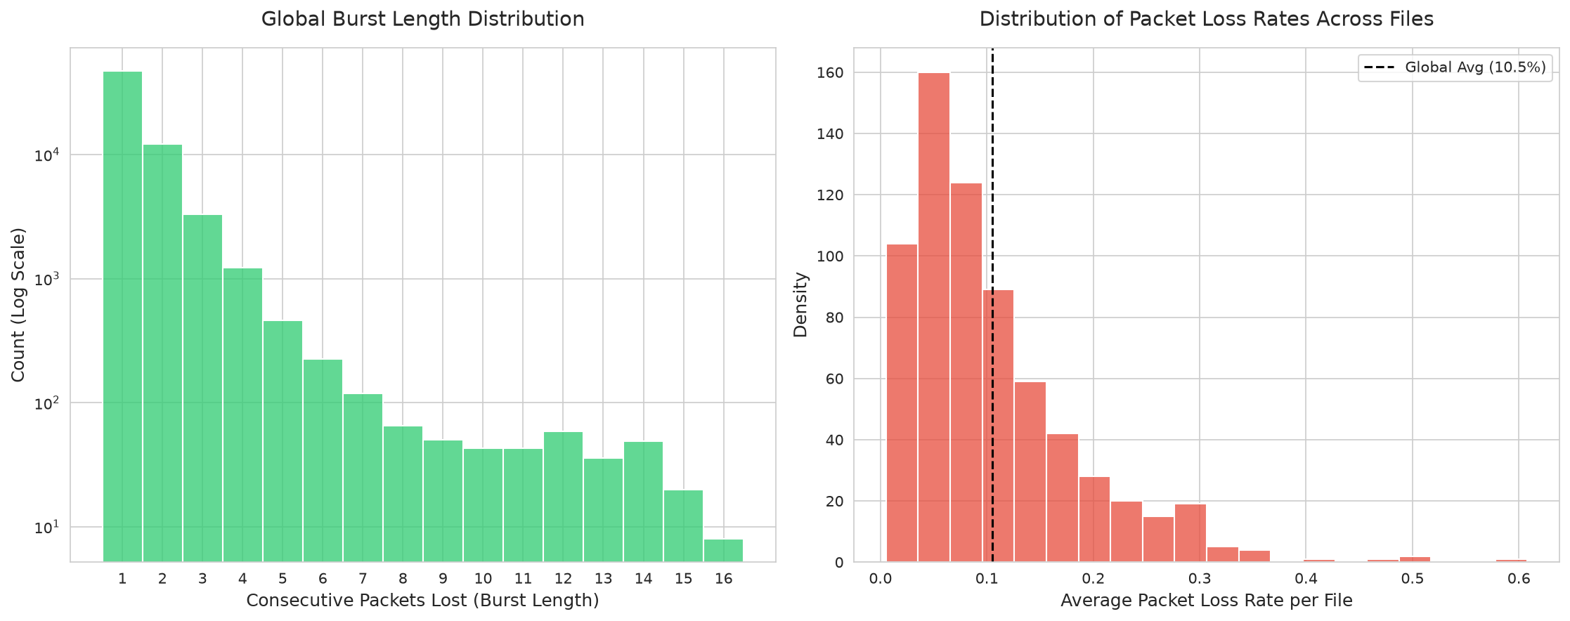
Figure 1. Loss statistics of the real packet traces. Left: number of loss bursts per burst length (log scale). Right: distribution of the packet loss rate across files; the dashed line marks the mean.

3.2 Overall concealment quality (RQ1)
Table 4 summarizes the paired comparison over 673 files. After Holm correction (α = 0.05, n = 673 files), quality was significantly better with the neural residual on MR-STFT dist. and PLCMOS; significantly better with AR alone on SNR (dB) and ViSQOL MOS-LQO.
Table 4. Paired comparison of AR-only and hybrid (AR + NN) concealment over 673 files.
Metric | AR (mean) | Hybrid (mean) | Hybrid advantage [95% CI] | Hybrid wins | p (Holm) | Effect size r | Verdict
SNR (dB) | 15.572 | 15.416 | -0.157 [-0.224, -0.089] | 40% | < 0.001 | -0.22 (small) | LPC better
MR-STFT dist. | 0.477 | 0.360 | +0.117 [+0.103, +0.133] | 92% | < 0.001 | +0.92 (large) | NN better
PLCMOS | 2.445 | 2.501 | +0.056 [+0.044, +0.068] | 68% | < 0.001 | +0.43 (medium) | NN better
ViSQOL MOS-LQO | 4.520 | 4.498 | -0.022 [-0.032, -0.013] | 46% | < 0.001 | -0.19 (small) | LPC better
Advantage = hybrid minus AR, sign-flipped for MR-STFT so that positive always favours the hybrid model. CI: bootstrap 95% confidence interval of the mean. p: two-sided Wilcoxon signed-rank test, Holm-corrected over the four metrics. r: matched-pairs rank-biserial correlation.

The win rate (Figure 2) only tells which method was better on each file. The per-file distributions (Figure 3) and the paired differences (Figure 4) show how large the differences are and how consistent they are across files.
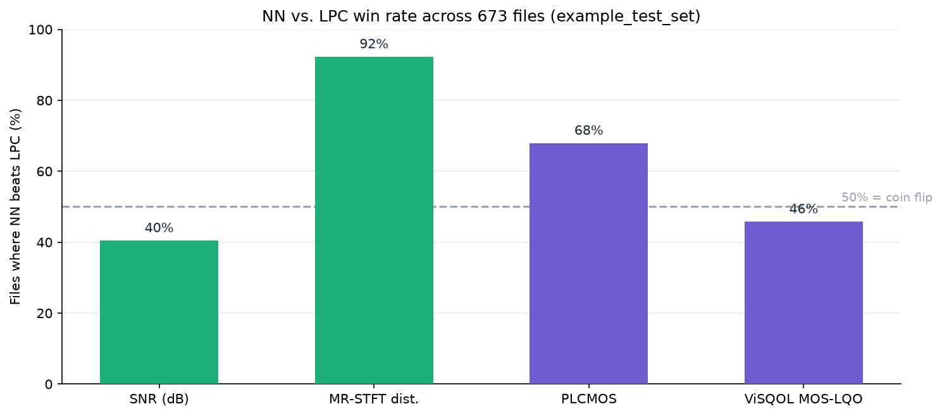
Figure 2. Percentage of files on which the hybrid model scores better than AR alone, per metric. The dashed line marks 50% (no systematic difference).
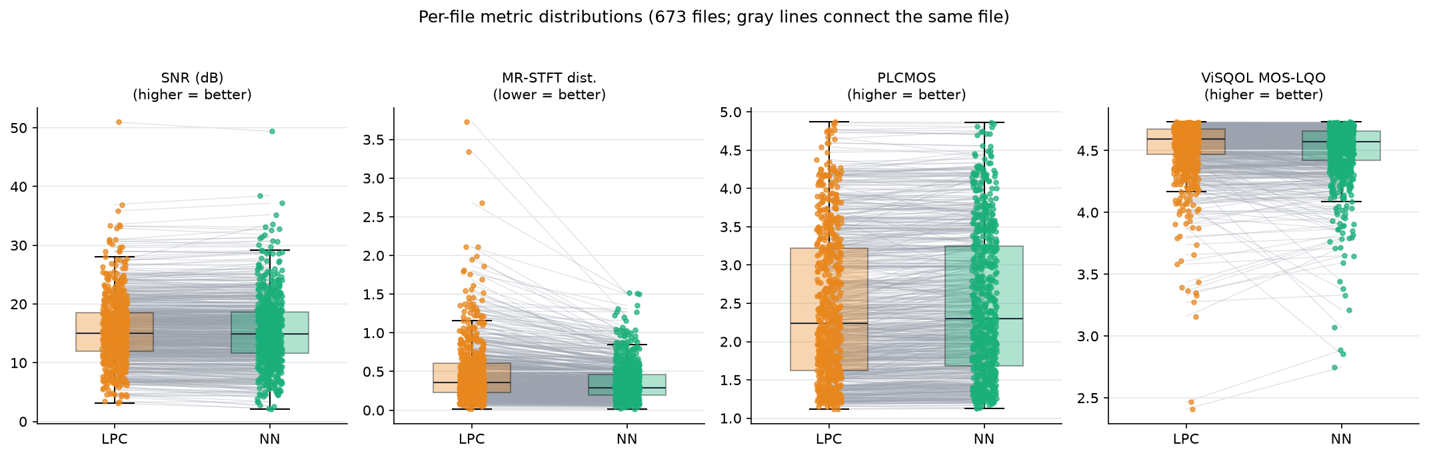
Figure 3. Per-file metric values of both methods (boxes: median and interquartile range; whiskers: 1.5 IQR). Gray lines connect the two results of the same file.
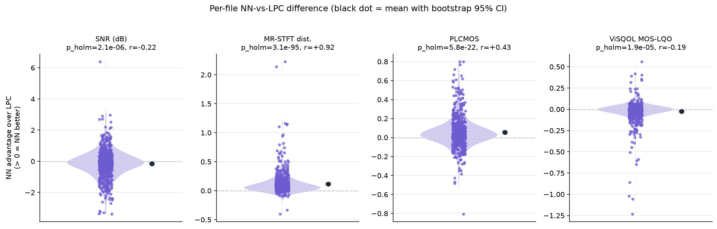
Figure 4. Per-file difference between the methods, oriented so that values above zero favour the hybrid model. Black marker: mean with bootstrap 95% confidence interval. Panel titles give the Holm-corrected Wilcoxon p-value and the rank-biserial effect size.

3.3 Dependence on signal complexity (RQ2)
Figure 5 plots each metric against the spectral flatness of the clean file, and Table 5 gives the Spearman rank correlation between flatness and the hybrid model's advantage. The advantage correlated significantly with signal complexity for SNR (dB) (ρ = +0.09), MR-STFT dist. (ρ = +0.08), PLCMOS (ρ = -0.19) and ViSQOL MOS-LQO (ρ = -0.18).
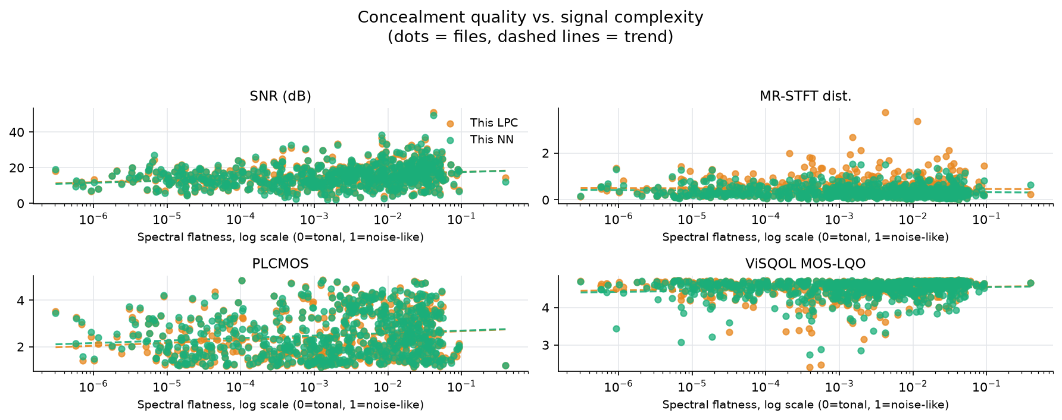
Figure 5. Concealment quality versus signal complexity (mean spectral flatness of the clean file, log scale). One dot per file and method; dashed lines are least-squares trends in log-flatness.
Table 5. Correlation between signal complexity and the hybrid model's advantage.
Metric | Spearman ρ (flatness vs. hybrid advantage) | p (uncorrected)
SNR (dB) | +0.09 | 0.025
MR-STFT dist. | +0.08 | 0.034
PLCMOS | -0.19 | < 0.001
ViSQOL MOS-LQO | -0.18 | < 0.001

3.4 Dependence on burst length (RQ2)
Every real burst in the evaluated files was scored with the gap SNR: 58,016 bursts from 673 files after excluding 6,939 near-silent gaps (Figure 6, Table 6). Gap SNR decreased from 7.86 dB (AR) / 7.75 dB (hybrid) for single-packet losses to 0.80 / 0.45 dB for bursts of 8+ packets; the hybrid model's gap-SNR advantage was negative for bursts of 1, 4-7 and 8+ packets (95% CI excluding zero).
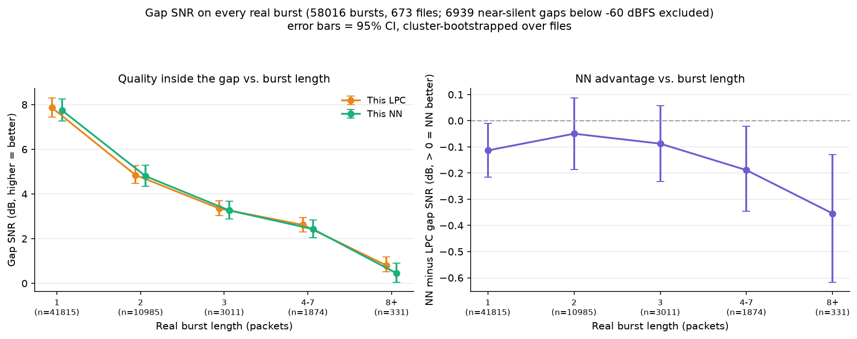
Figure 6. Gap SNR versus real burst length. Left: mean gap SNR of each method. Right: mean difference (hybrid minus AR). Error bars: 95% confidence intervals from a cluster bootstrap over files; n is the number of bursts per bin.
Table 6. Gap SNR by burst length (mean [95% cluster-bootstrap CI]).
Burst (packets) | Bursts | Files | AR gap SNR (dB) | Hybrid gap SNR (dB) | Hybrid advantage (dB) | Hybrid wins
1 | 41815 | 673 | 7.86 [7.43, 8.31] | 7.75 [7.27, 8.25] | -0.11 [-0.22, -0.01] | 49%
2 | 10985 | 642 | 4.85 [4.47, 5.26] | 4.80 [4.35, 5.29] | -0.05 [-0.19, +0.09] | 49%
3 | 3011 | 530 | 3.35 [3.02, 3.70] | 3.26 [2.87, 3.67] | -0.09 [-0.23, +0.06] | 47%
4-7 | 1874 | 443 | 2.62 [2.30, 2.95] | 2.43 [2.05, 2.84] | -0.19 [-0.35, -0.02] | 44%
8+ | 331 | 90 | 0.80 [0.52, 1.18] | 0.45 [0.05, 0.91] | -0.35 [-0.62, -0.13] | 38%

3.5 Hyperparameter sensitivity (RQ3)
Figures 7-10 show every metric and the compute time as a function of each hyperparameter, and Table 7 lists the best value found for SNR and PLCMOS. Because the network was trained on the residual of the default AR configuration, values away from the default change both the AR prediction and the input statistics the network sees; the hybrid results at non-default settings therefore measure robustness to this mismatch, not the performance of a network retrained for that setting.

3.5.1 AR order p
Over the 12 values tested (200 files per value), the hybrid model had the higher mean SNR at 2 and the higher mean PLCMOS at 10 of them. Mean SNR ranged from 11.65 to 16.57 dB for AR and from 11.73 to 15.41 dB for the hybrid model.
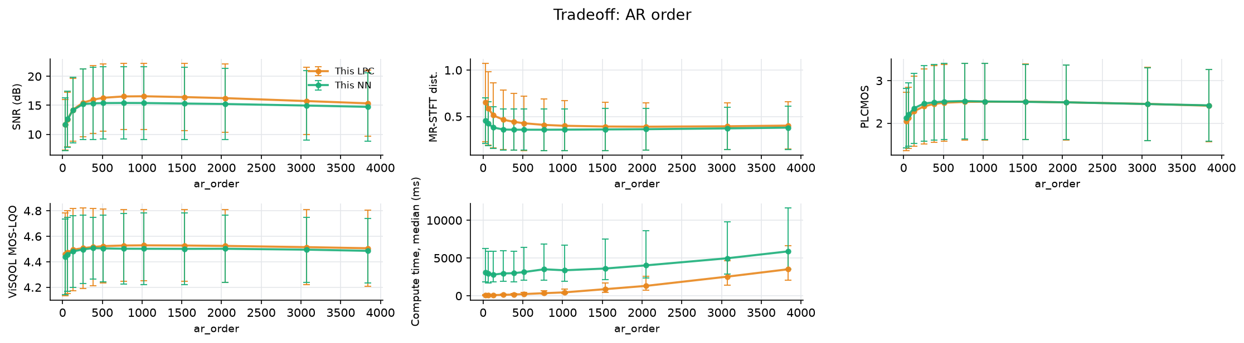
Figure 7. Sweep of the AR order p (default 256; other hyperparameters at their defaults; 200 files per value). Panels: SNR, MR-STFT distance, PLCMOS and ViSQOL (mean ± 1 SD across files) and compute time per file (median and interquartile range).

3.5.2 Context length (packets)
Over the 11 values tested (200 files per value), the hybrid model had the higher mean SNR at 0 and the higher mean PLCMOS at 8 of them. Mean SNR ranged from 12.56 to 15.45 dB for AR and from 12.47 to 15.21 dB for the hybrid model.
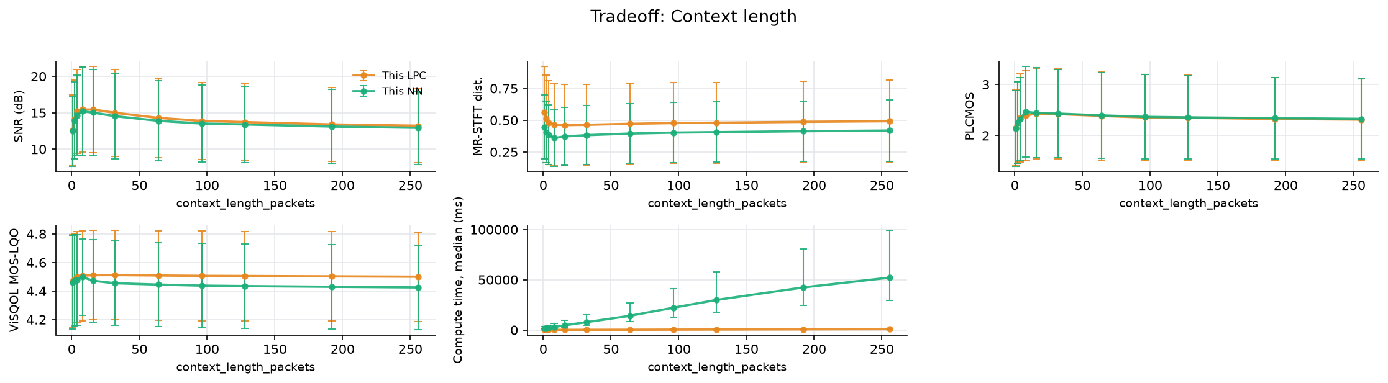
Figure 8. Sweep of the Context length (packets) (default 8; other hyperparameters at their defaults; 200 files per value). Panels: SNR, MR-STFT distance, PLCMOS and ViSQOL (mean ± 1 SD across files) and compute time per file (median and interquartile range).

3.5.3 Diagonal loading λ
Over the 7 values tested (200 files per value), the hybrid model had the higher mean SNR at 0 and the higher mean PLCMOS at 7 of them. Mean SNR ranged from 15.27 to 15.45 dB for AR and from 15.09 to 15.22 dB for the hybrid model.
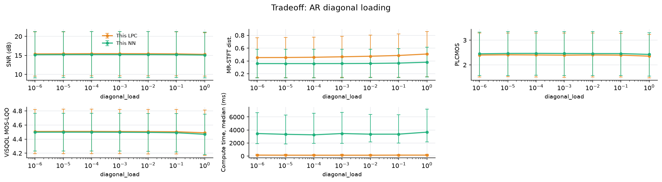
Figure 9. Sweep of the Diagonal loading λ (default 0.001; other hyperparameters at their defaults; 200 files per value). Panels: SNR, MR-STFT distance, PLCMOS and ViSQOL (mean ± 1 SD across files) and compute time per file (median and interquartile range).

3.5.4 Crossfade length E (samples)
Over the 10 values tested (200 files per value), the hybrid model had the higher mean SNR at 0 and the higher mean PLCMOS at 10 of them. Mean SNR ranged from 13.10 to 16.30 dB for AR and from 12.95 to 16.03 dB for the hybrid model.
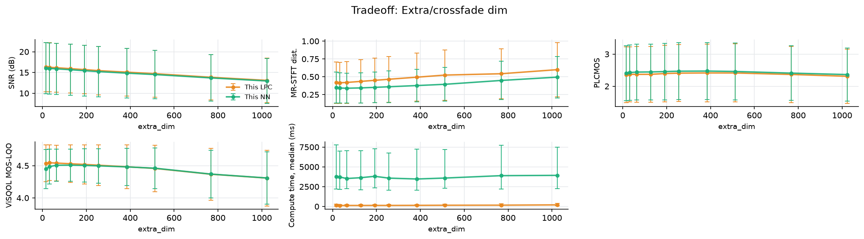
Figure 10. Sweep of the Crossfade length E (samples) (default 256; other hyperparameters at their defaults; 200 files per value). Panels: SNR, MR-STFT distance, PLCMOS and ViSQOL (mean ± 1 SD across files) and compute time per file (median and interquartile range).
Table 7. Best value of each hyperparameter and gain over the default (positive = better than default).
Hyperparameter | Method | Best for SNR (gain) | Best for PLCMOS (gain) | Time/file (ms), default → best
AR order p | AR | 1024 (+1.117) | 1536 (+0.112) | 132 → 457
AR order p | Hybrid | 768 (+0.197) | 768 (+0.056) | 2964 → 3513
Context length (packets) | AR | 8 (+0.000) | 16 (+0.035) | 137 → 137
Context length (packets) | Hybrid | 8 (+0.000) | 8 (+0.000) | 2943 → 2943
Diagonal loading λ | AR | 0.001 (+0.000) | 1e-05 (+0.014) | 127 → 127
Diagonal loading λ | Hybrid | 0.0001 (+0.001) | 0.0001 (+0.005) | 3454 → 3257
Crossfade length E (samples) | AR | 16 (+0.854) | 384 (+0.006) | 130 → 144
Crossfade length E (samples) | Hybrid | 16 (+0.818) | 384 (+0.004) | 3579 → 3777
Gains are differences of means across files and are not tested for significance. Time is the median per-file concealment time at the best SNR value. The full table for all four metrics is in Appendix C.

3.6 Computational cost (RQ4)
Table 8 and Figure 11 report the cost of concealing one packet. On the evaluation CPU, concealing one 11.6 ms packet took a median of 1.51 ms with AR alone (real-time factor 0.13) and 42.5 ms with the hybrid model (real-time factor 3.66), i.e. the hybrid model cannot run in real time on this hardware. The neural residual multiplies the per-packet cost by a factor of about 28. The challenge rules do not disqualify slower-than-real-time systems but encourage real-time operation [2].
Table 8. Per-packet concealment cost (packet duration 11.6 ms).
Method | Median ms / packet | IQR (ms) | Median RTF | Real time?
AR only | 1.51 | 1.25-1.94 | 0.130 | yes
Hybrid (AR + NN) | 42.49 | 37.70-47.85 | 3.659 | no

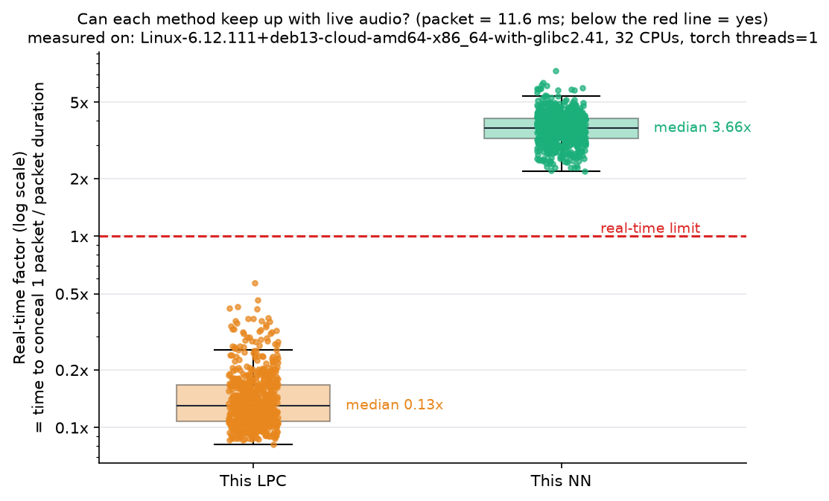
Figure 11. Real-time factor (time to conceal one packet divided by the packet duration) per file, log scale. Below the red line a method keeps up with live audio on this machine.

3.7 Qualitative examples
To show what the metrics above summarize, one real burst of each length was selected and plotted in three ways: the waveform and spectrogram around the gap (shaded) for both methods; the sample-wise difference between the two concealments; and a zoom on the hand-back point where concealment crossfades into the next received packet, together with the clean reference. Table 9 lists the mean squared difference between the two methods inside each gap.
Table 9. Selected example bursts.
Burst (packets) | File | Start packet | Gap MSE between methods
1 | 9f3Qjw-657-129013-78427-3487… | 10 | 9.601e-07
2 | 9f3Qjw-657-129013-78427-3487… | 521 | 3.126e-04
4 | 9f3Qjw-657-129013-78427-3487… | 719 | 3.265e-05
8 | YuwChp-152-8651-147603-37935… | 901 | 8.601e-08
16 | bAzeFf-484-123704-325632-334… | 1608 | 9.166e-05

3.7.1 1-packet burst (11.6 ms)
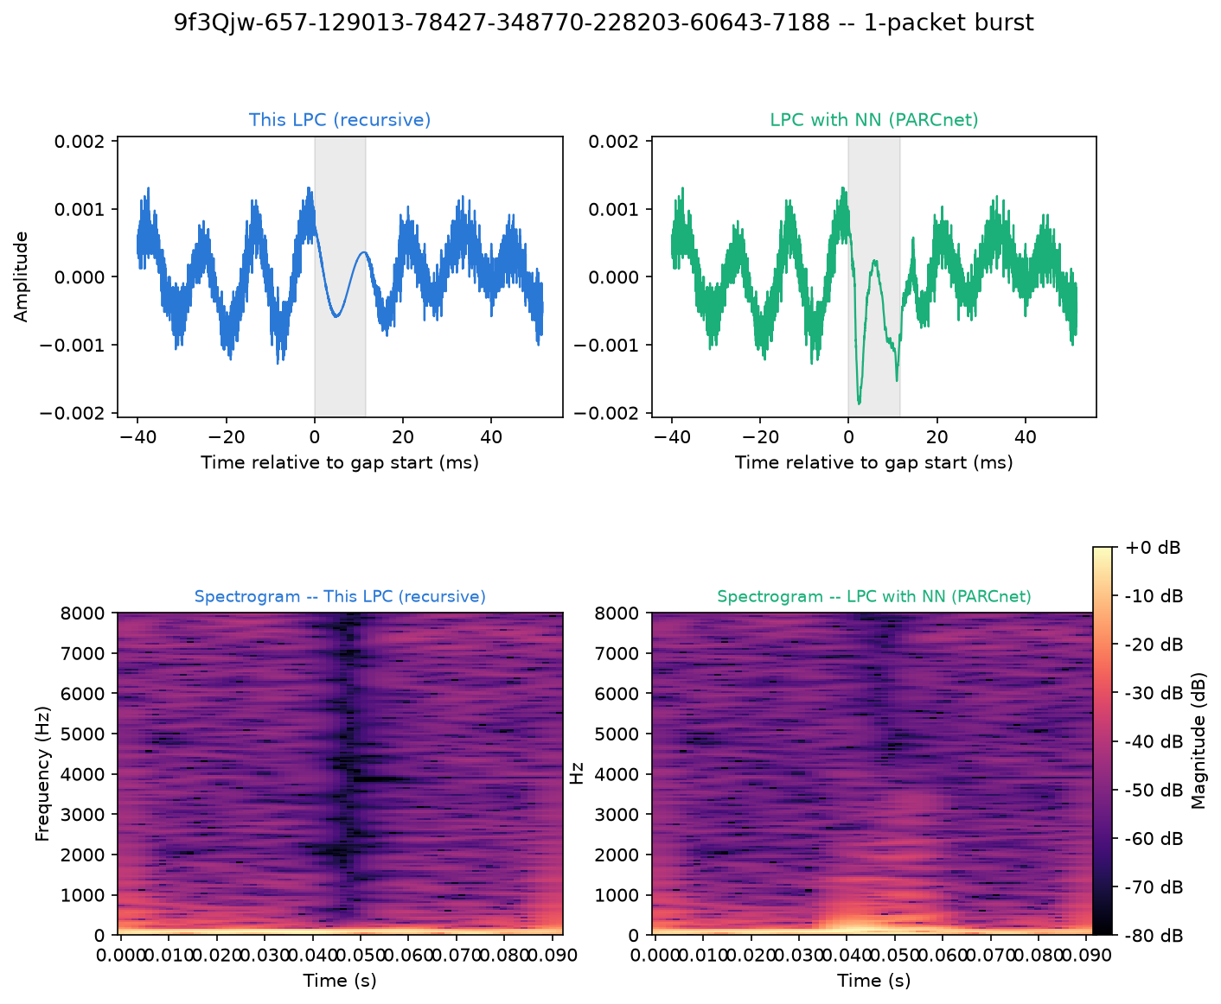
Figure 12. 1-packet burst in file 9f3Qjw-657-129013-78427-348770-228203-60643-7188: waveform (top) and spectrogram (bottom) of the AR (left) and hybrid (right) concealment. Shaded: lost samples.
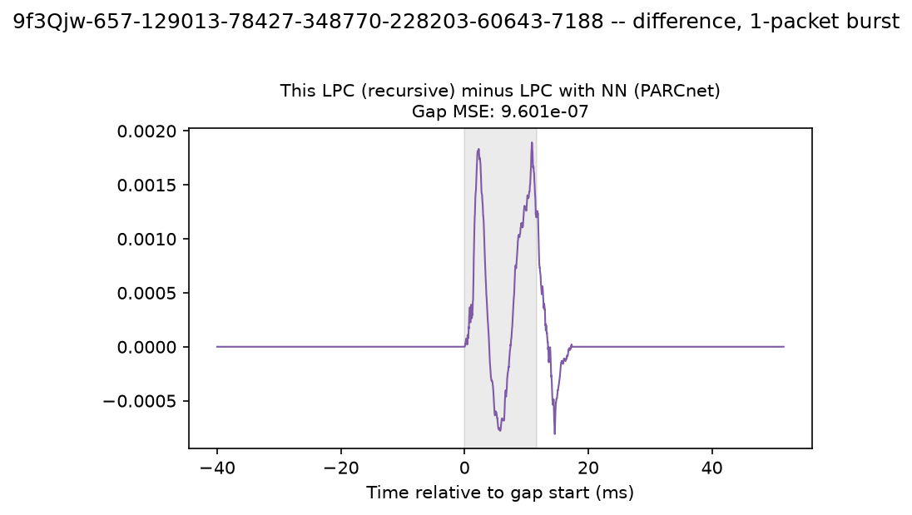
Figure 13. 1-packet burst: AR concealment minus hybrid concealment; the gap-MSE in the title quantifies the neural contribution.
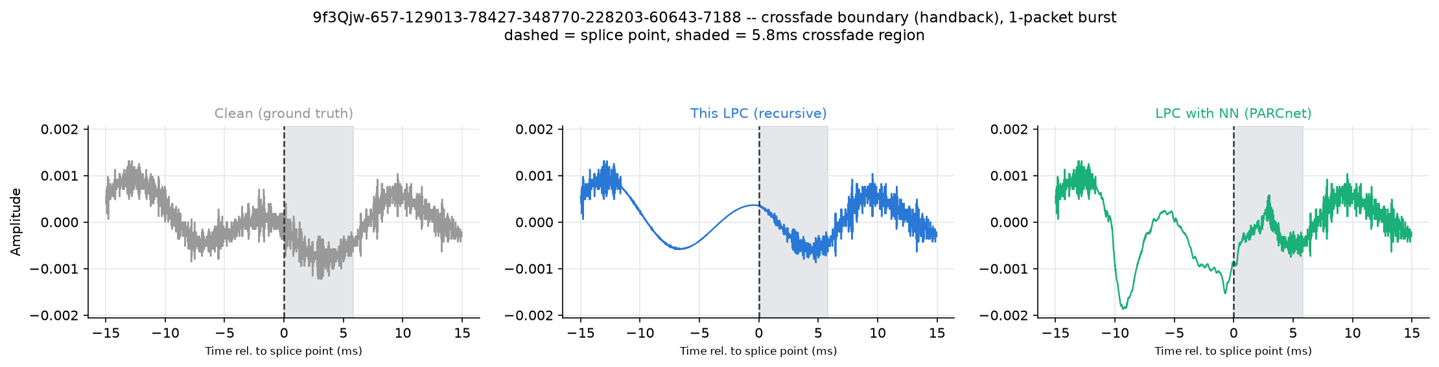
Figure 14. 1-packet burst: zoom on the hand-back point (dashed line) where concealment ends; the shaded region is the 256-sample crossfade into the received packet.

3.7.2 2-packet burst (23.2 ms)
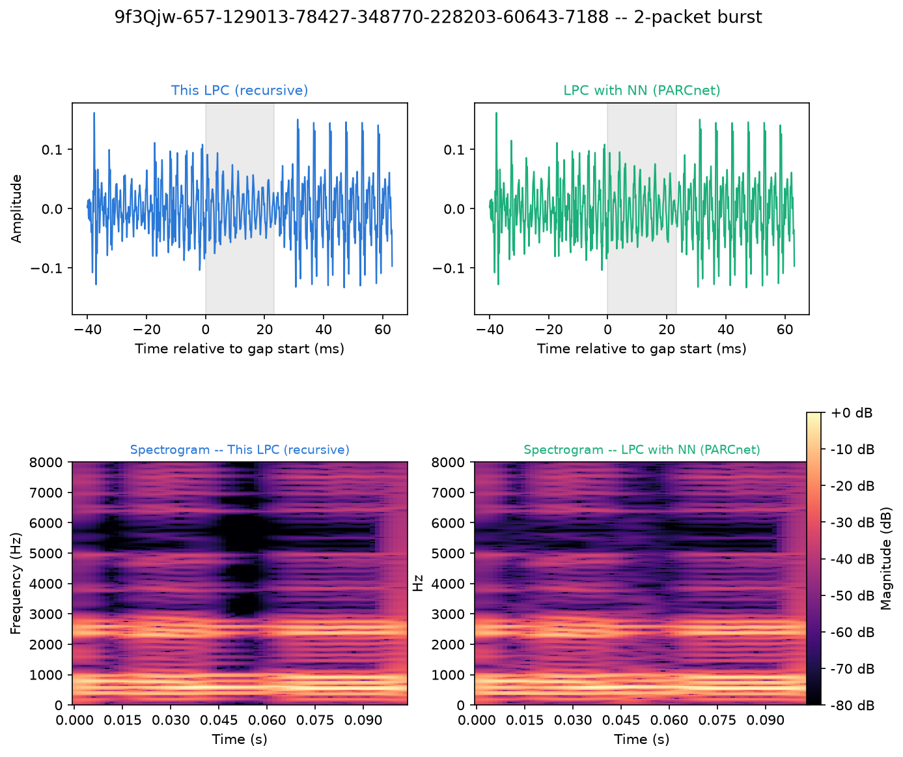
Figure 15. 2-packet burst in file 9f3Qjw-657-129013-78427-348770-228203-60643-7188: waveform (top) and spectrogram (bottom) of the AR (left) and hybrid (right) concealment. Shaded: lost samples.
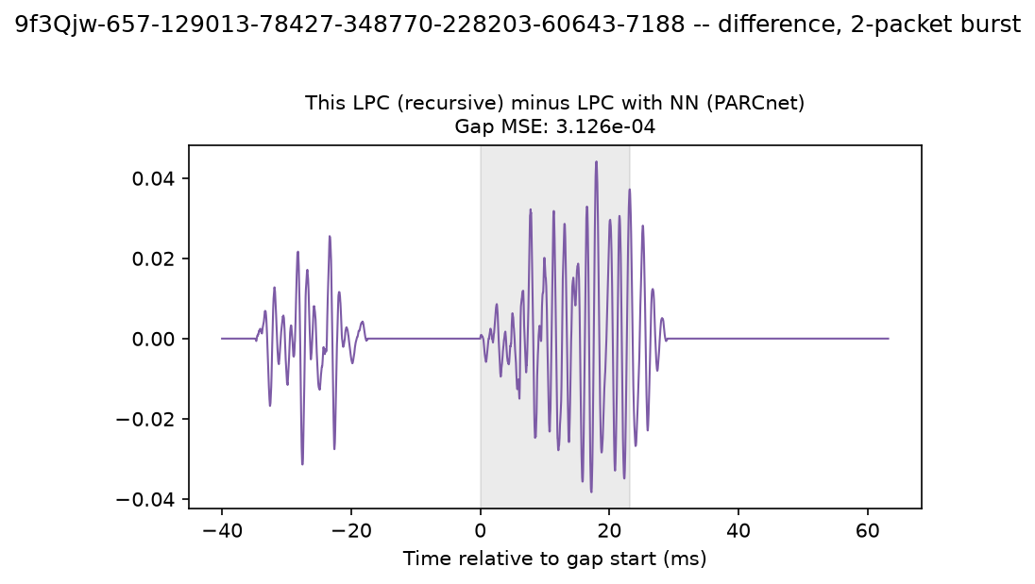
Figure 16. 2-packet burst: AR concealment minus hybrid concealment; the gap-MSE in the title quantifies the neural contribution.
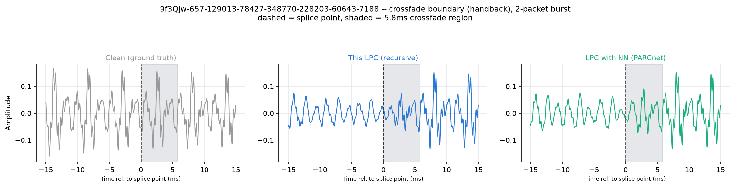
Figure 17. 2-packet burst: zoom on the hand-back point (dashed line) where concealment ends; the shaded region is the 256-sample crossfade into the received packet.

3.7.3 4-packet burst (46.4 ms)
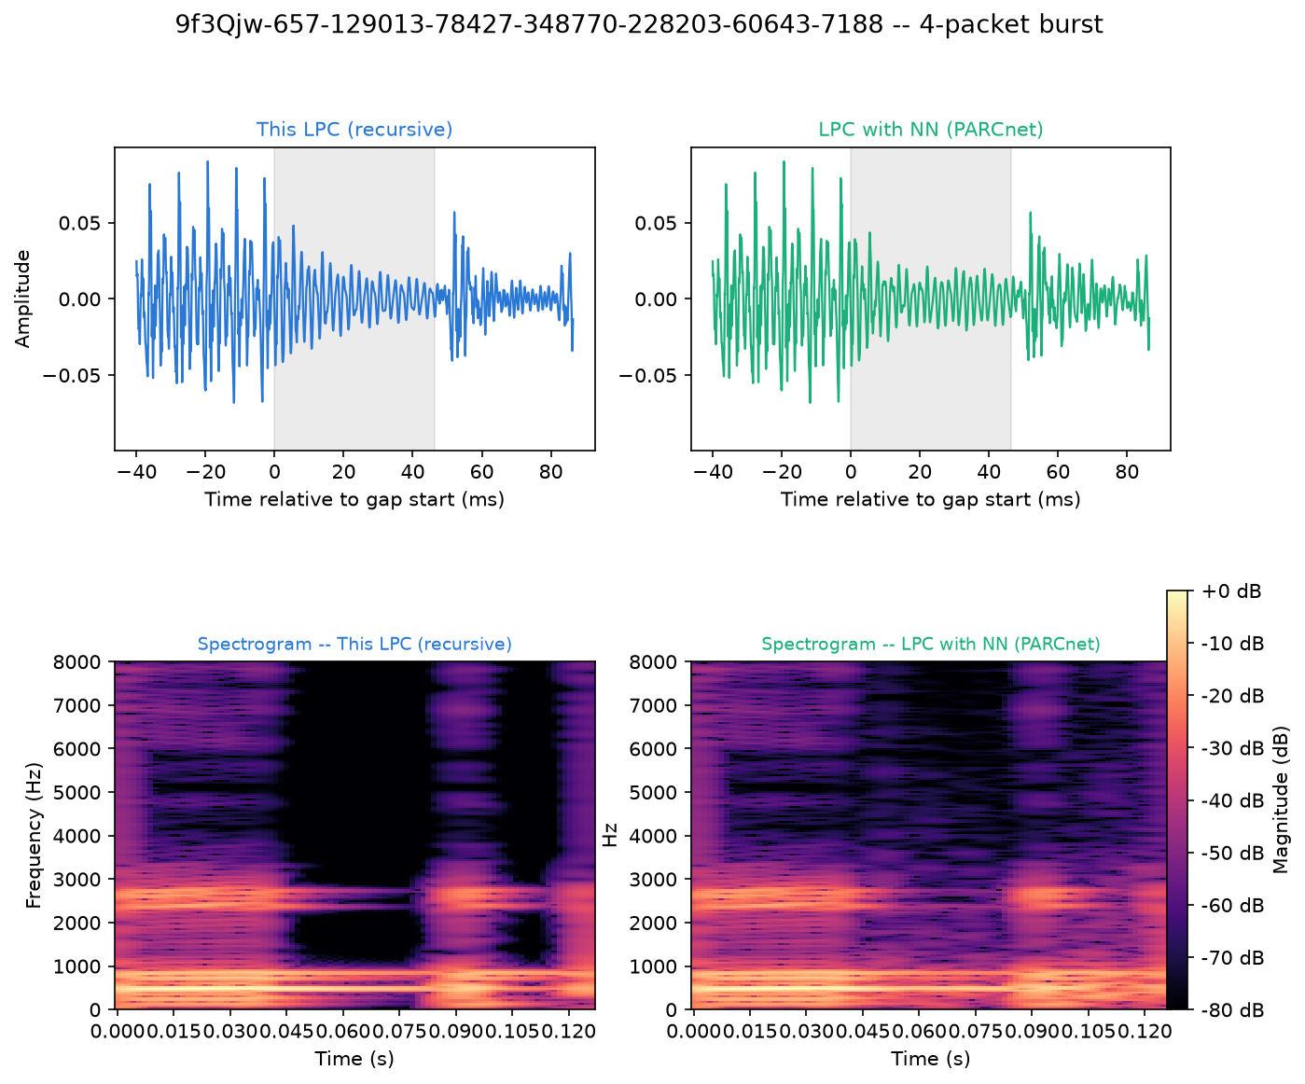
Figure 18. 4-packet burst in file 9f3Qjw-657-129013-78427-348770-228203-60643-7188: waveform (top) and spectrogram (bottom) of the AR (left) and hybrid (right) concealment. Shaded: lost samples.
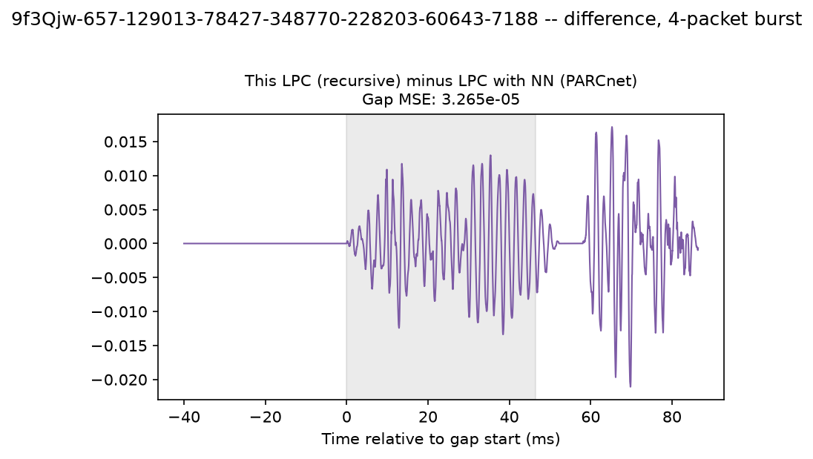
Figure 19. 4-packet burst: AR concealment minus hybrid concealment; the gap-MSE in the title quantifies the neural contribution.
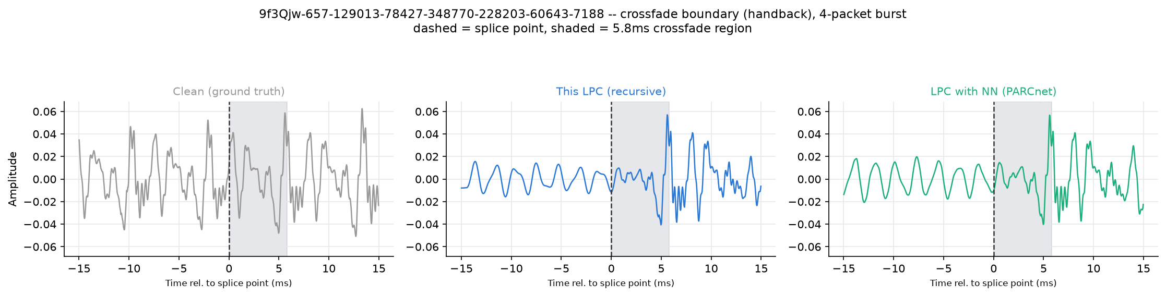
Figure 20. 4-packet burst: zoom on the hand-back point (dashed line) where concealment ends; the shaded region is the 256-sample crossfade into the received packet.

3.7.4 8-packet burst (92.9 ms)
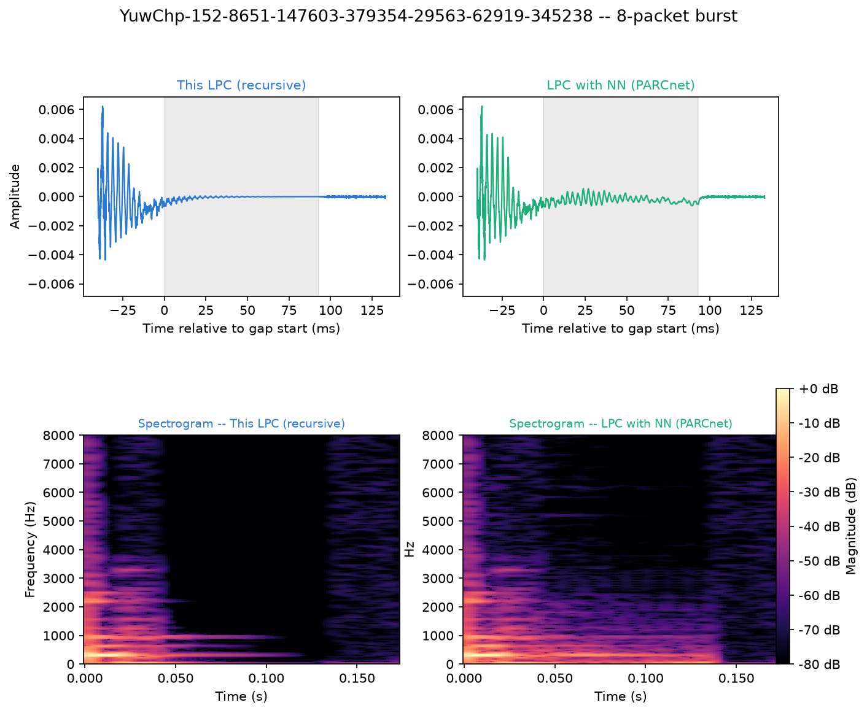
Figure 21. 8-packet burst in file YuwChp-152-8651-147603-379354-29563-62919-345238: waveform (top) and spectrogram (bottom) of the AR (left) and hybrid (right) concealment. Shaded: lost samples.
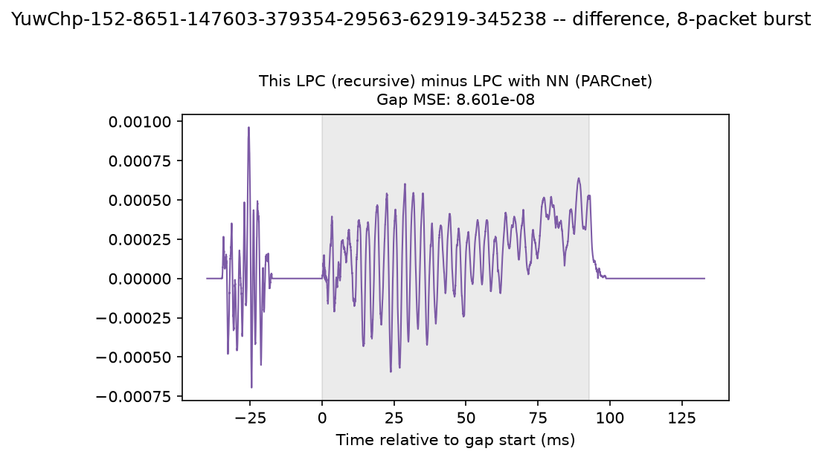
Figure 22. 8-packet burst: AR concealment minus hybrid concealment; the gap-MSE in the title quantifies the neural contribution.
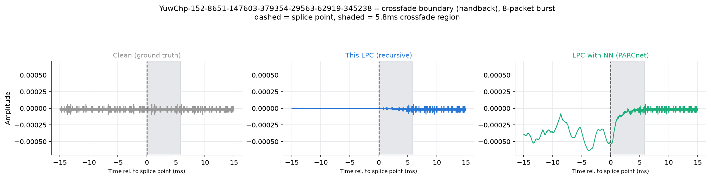
Figure 23. 8-packet burst: zoom on the hand-back point (dashed line) where concealment ends; the shaded region is the 256-sample crossfade into the received packet.

3.7.5 16-packet burst (185.8 ms)
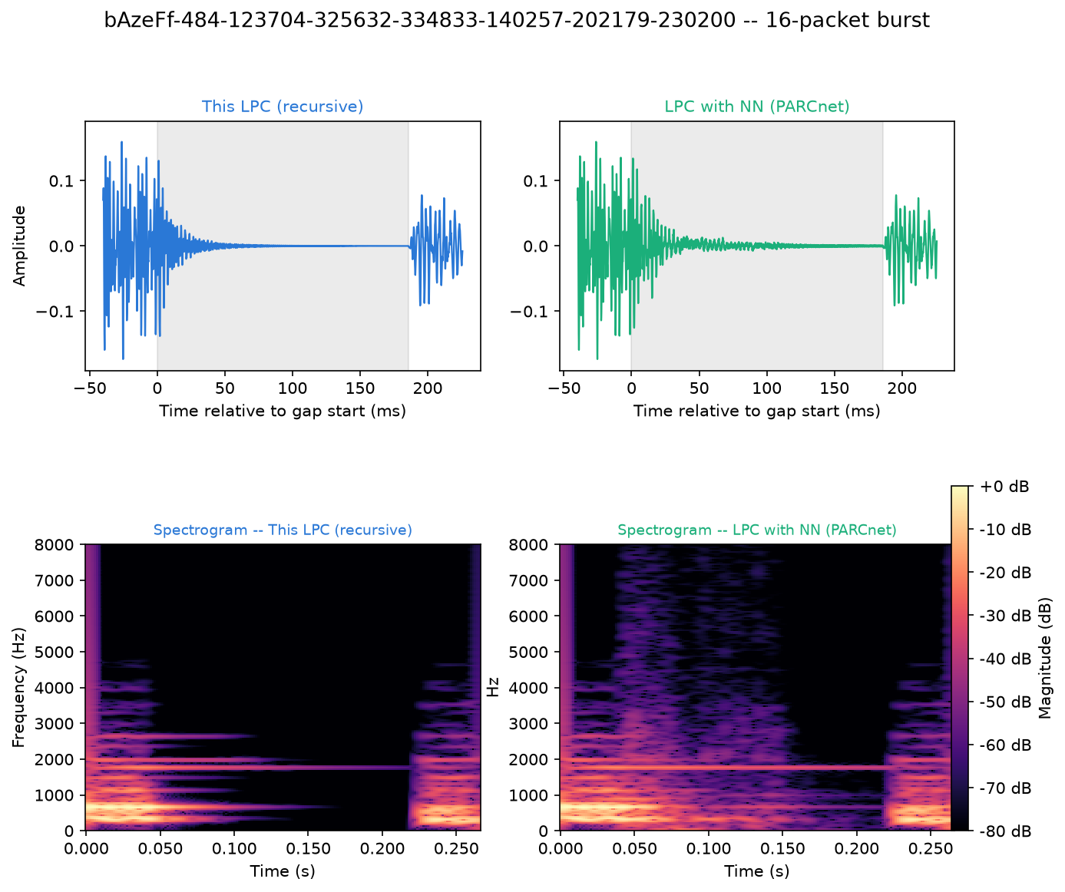
Figure 24. 16-packet burst in file bAzeFf-484-123704-325632-334833-140257-202179-230200: waveform (top) and spectrogram (bottom) of the AR (left) and hybrid (right) concealment. Shaded: lost samples.
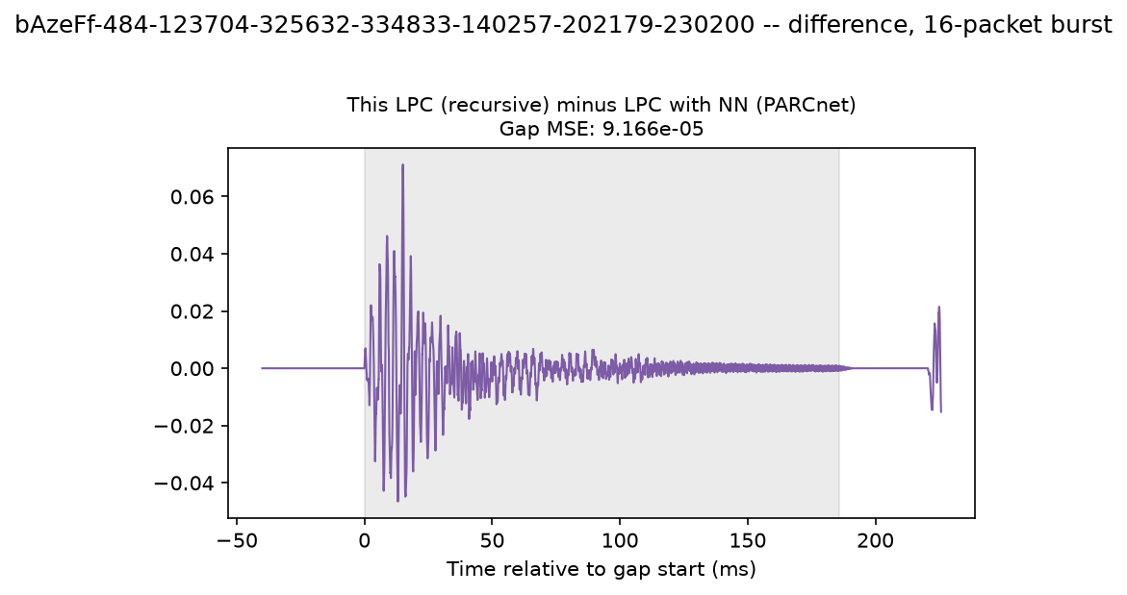
Figure 25. 16-packet burst: AR concealment minus hybrid concealment; the gap-MSE in the title quantifies the neural contribution.
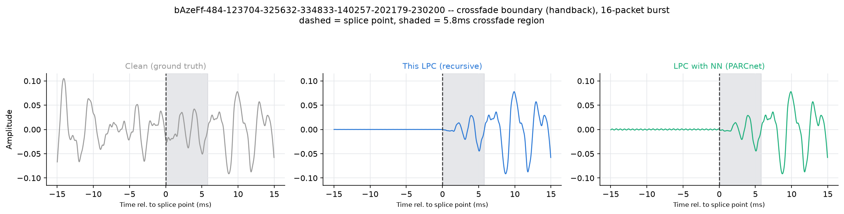
Figure 26. 16-packet burst: zoom on the hand-back point (dashed line) where concealment ends; the shaded region is the 256-sample crossfade into the received packet.

3.8 Failure cases
Reporting only favourable examples would bias the picture. The 3 files on which AR alone beat the hybrid model by the largest SNR (dB) margin are listed in Table 10; for each, the burst with the largest AR advantage in gap SNR is plotted. Their spectral flatness ranged from 2.85e-04 to 8.05e-03 (median of all evaluated files: 3.10e-03), and their loss rates from 3.2% to 14.9% (median 8.3%).
Table 10. Files with the largest AR advantage on SNR (dB).
Case | File | AR SNR (dB) | Hybrid SNR (dB) | Advantage | Flatness | Loss rate | Plotted burst
1 | 859Dyi-517-347380-1656… | 8.44 | 5.07 | -3.38 | 1.38e-03 | 14.9% | 3 pkt @ 655
2 | HxFzMp-357-24999-34333… | 18.23 | 14.86 | -3.36 | 8.05e-03 | 12.7% | 1 pkt @ 480
3 | Mtnx5i-515-495971-2797… | 16.14 | 12.83 | -3.31 | 2.85e-04 | 3.2% | 1 pkt @ 1

3.8.1 Failure case 1
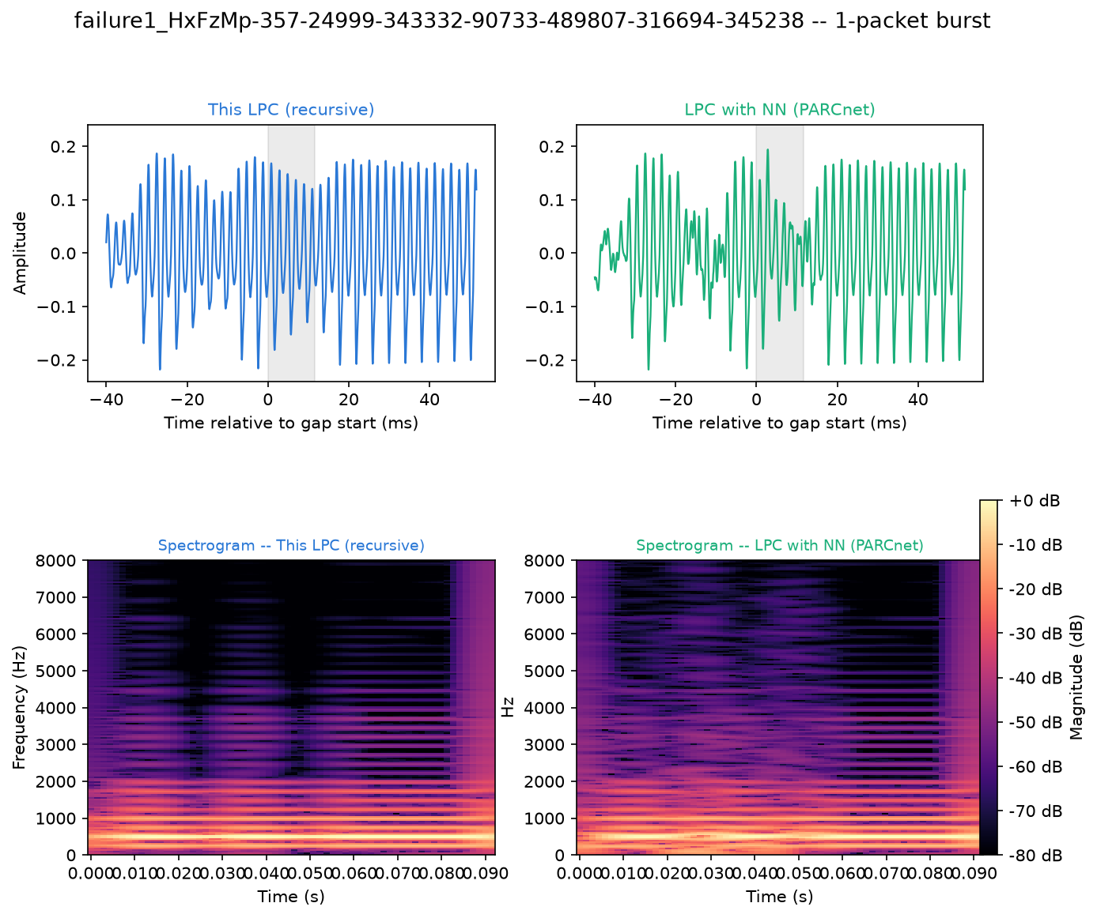
Figure 27. Failure case 1: waveform and spectrogram around the plotted 1-packet burst, AR (left) and hybrid (right).
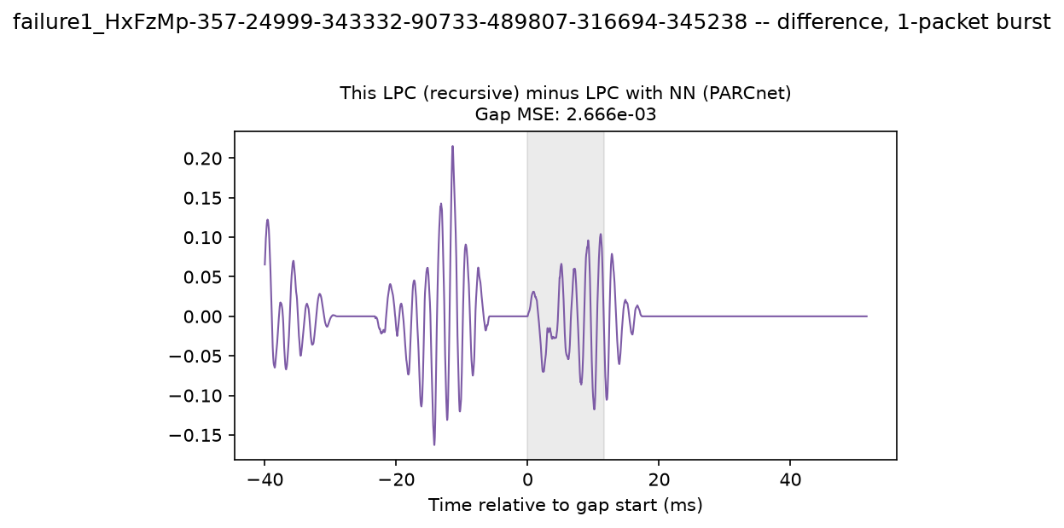
Figure 28. Failure case 1: AR minus hybrid concealment.
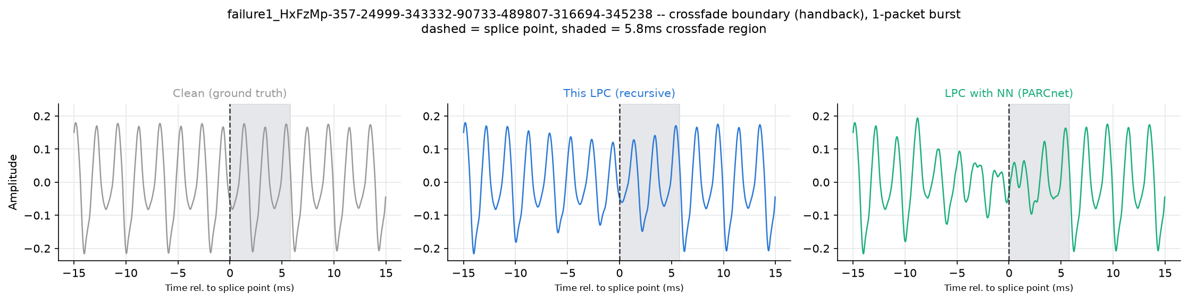
Figure 29. Failure case 1: hand-back crossfade with the clean reference.

3.8.1 Failure case 1
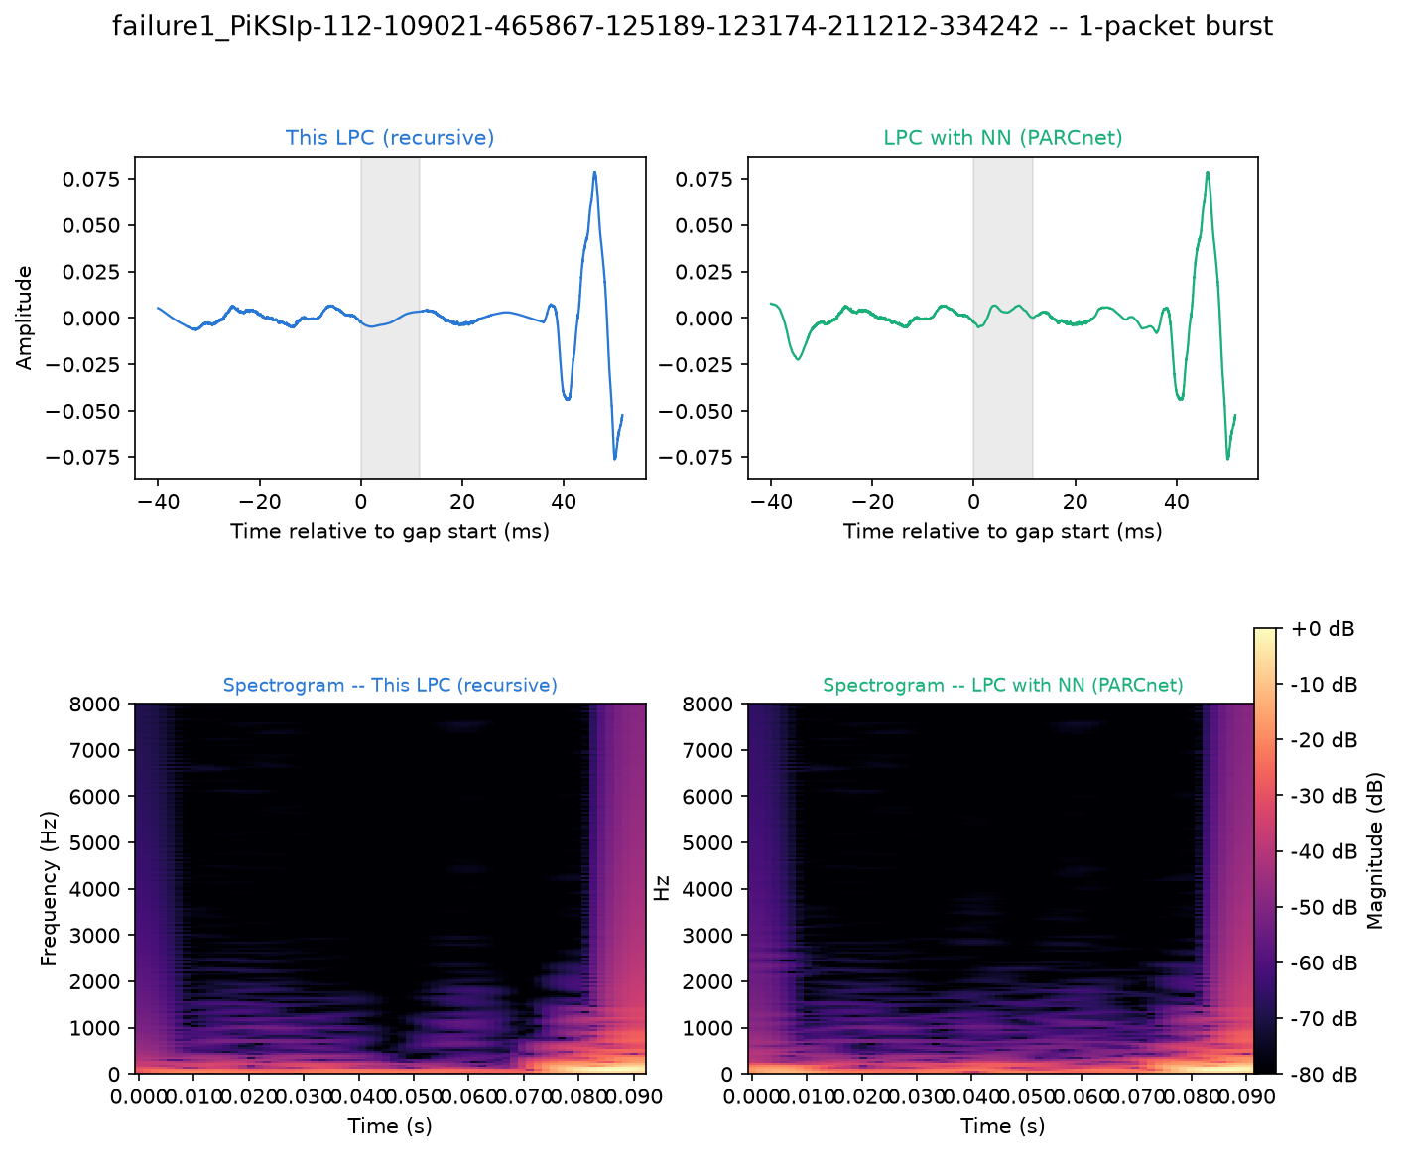
Figure 30. Failure case 1: waveform and spectrogram around the plotted 1-packet burst, AR (left) and hybrid (right).
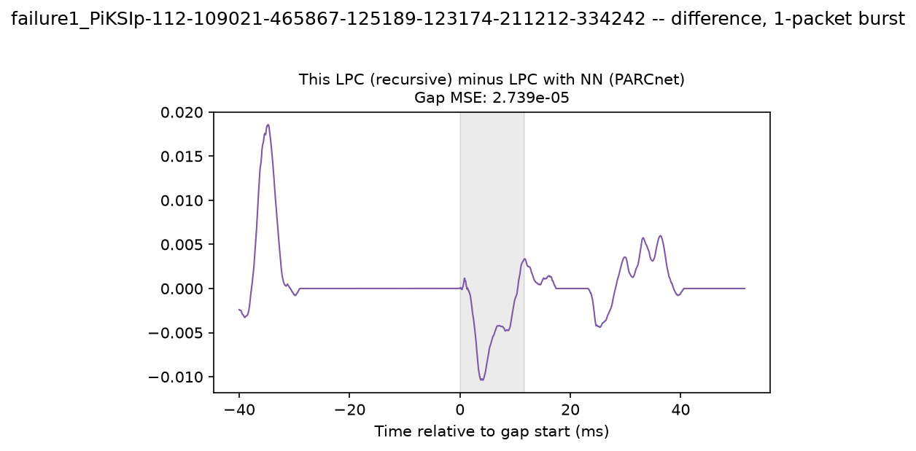
Figure 31. Failure case 1: AR minus hybrid concealment.
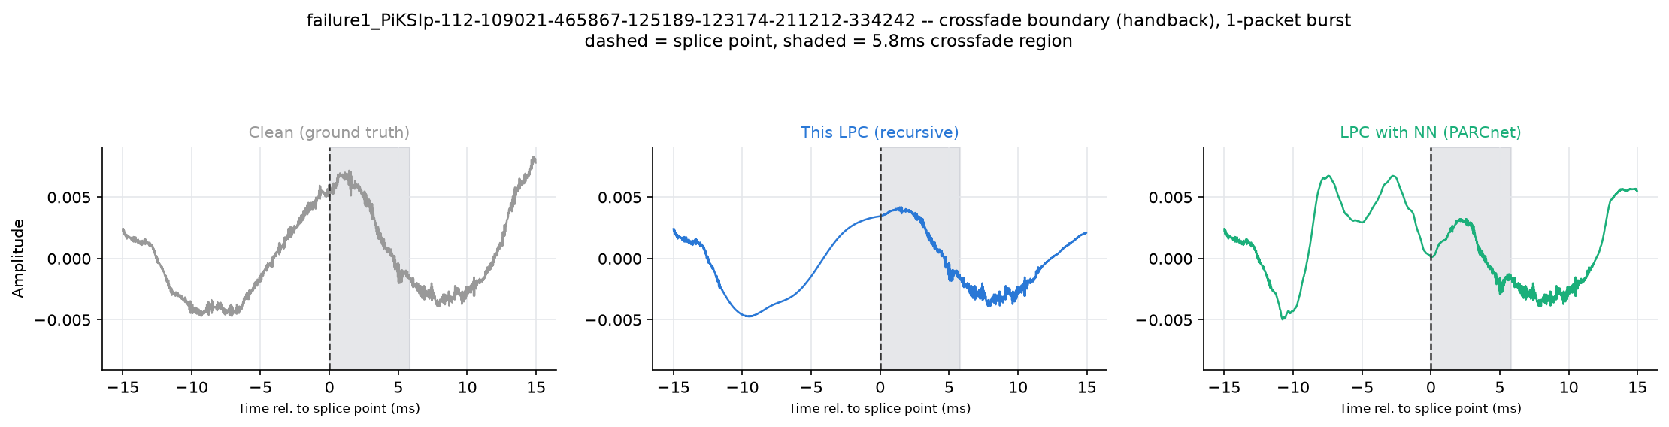
Figure 32. Failure case 1: hand-back crossfade with the clean reference.

3.8.2 Failure case 2
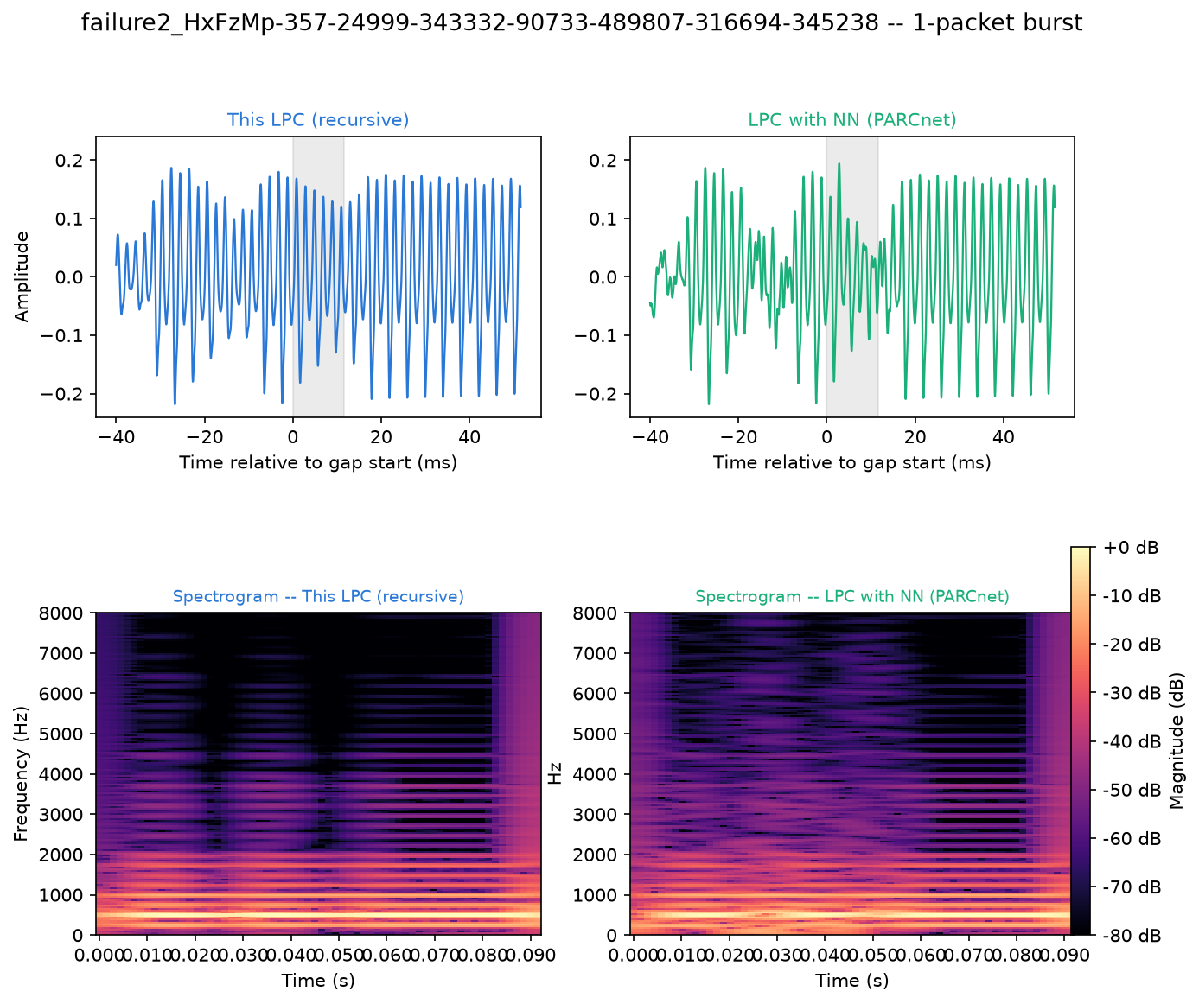
Figure 33. Failure case 2: waveform and spectrogram around the plotted 1-packet burst, AR (left) and hybrid (right).
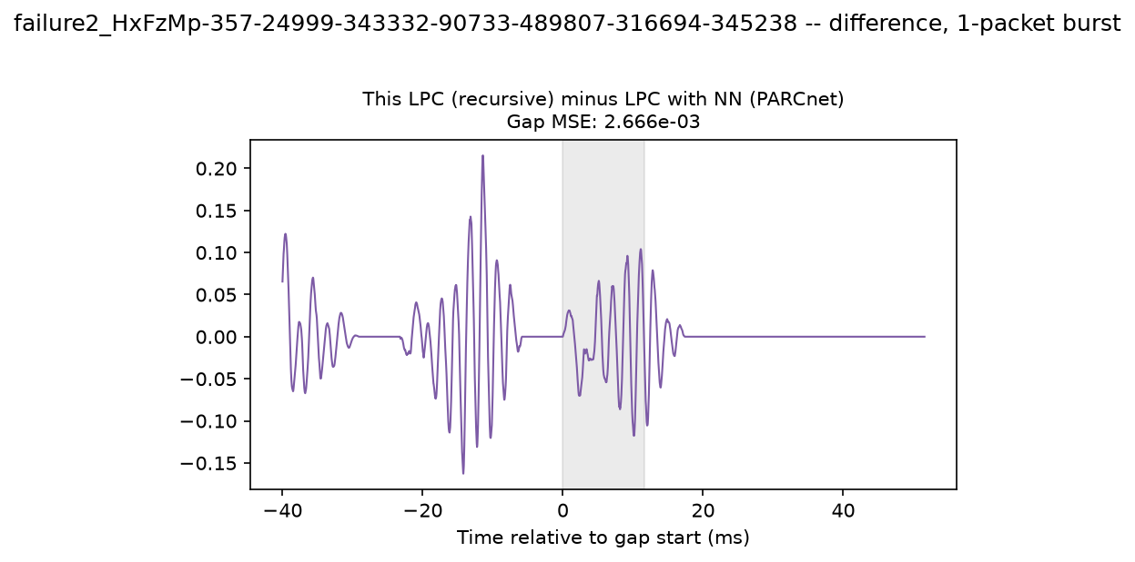
Figure 34. Failure case 2: AR minus hybrid concealment.
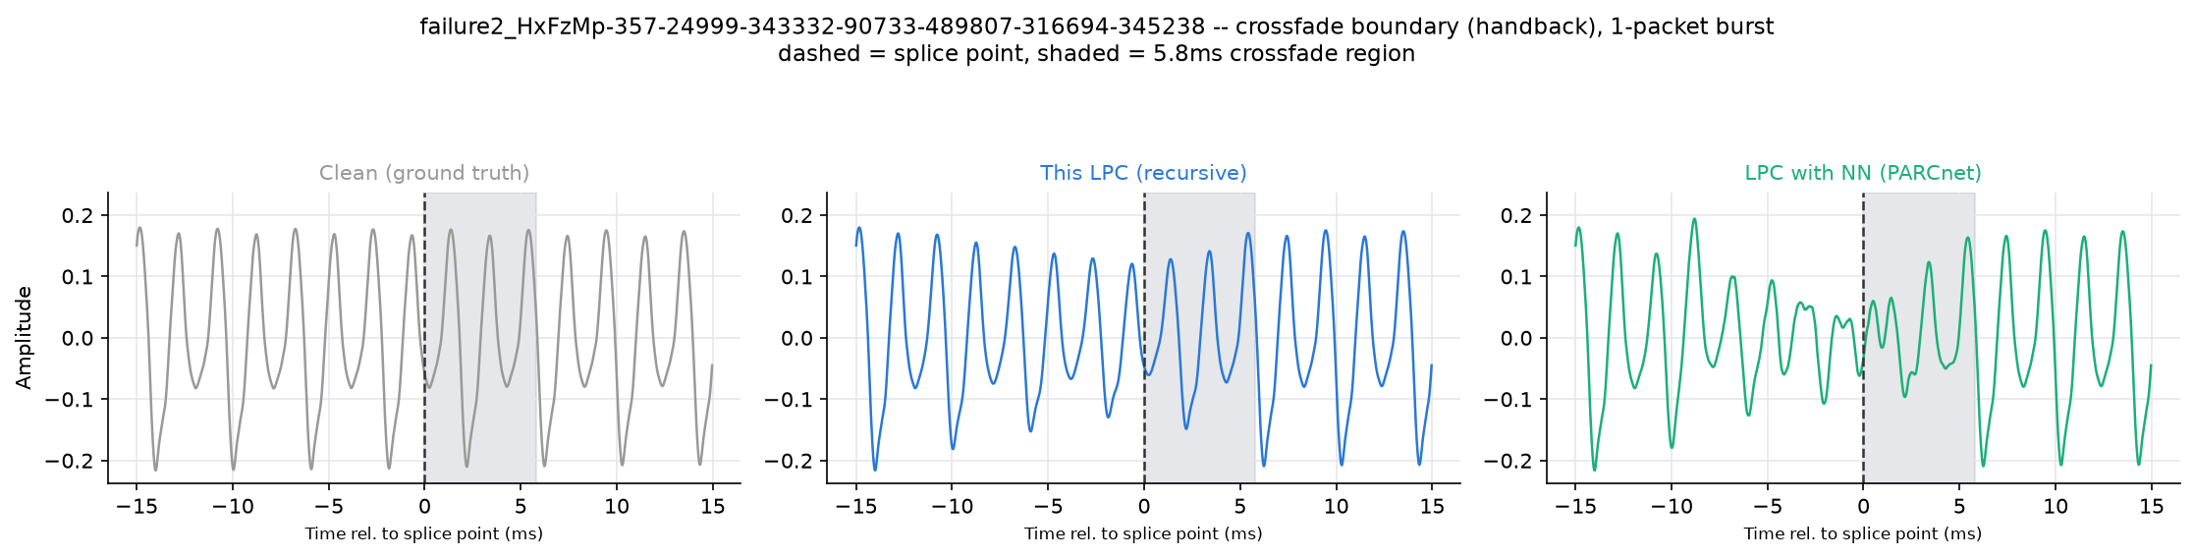
Figure 35. Failure case 2: hand-back crossfade with the clean reference.

3.8.2 Failure case 2
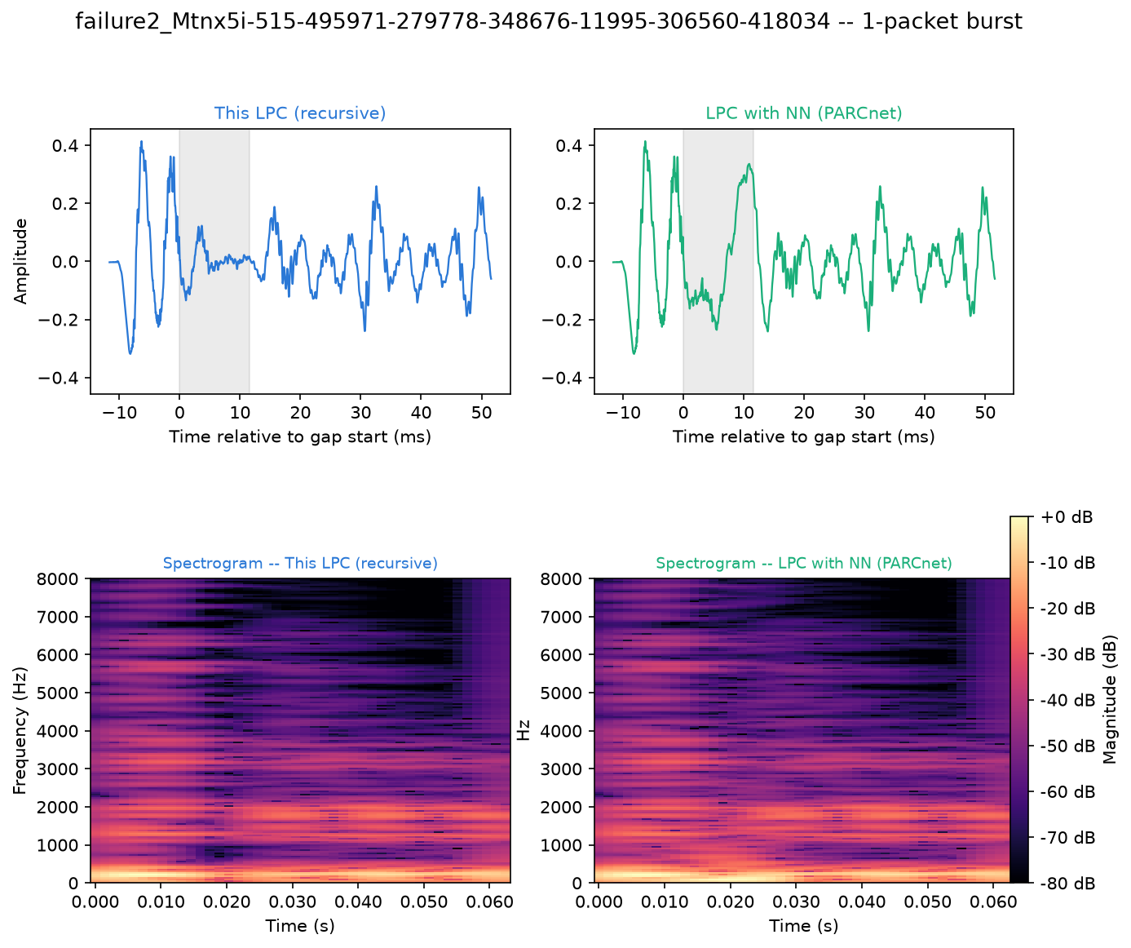
Figure 36. Failure case 2: waveform and spectrogram around the plotted 1-packet burst, AR (left) and hybrid (right).
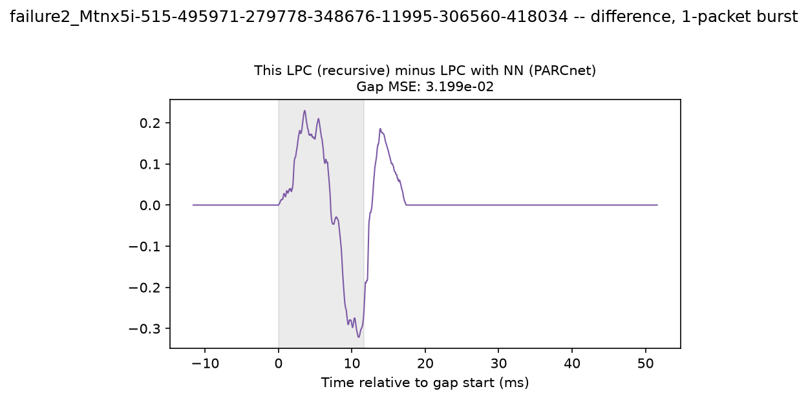
Figure 37. Failure case 2: AR minus hybrid concealment.
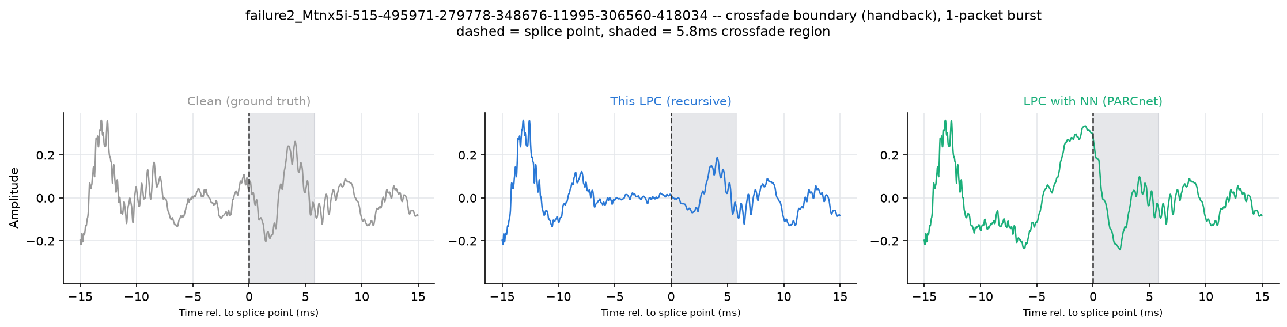
Figure 38. Failure case 2: hand-back crossfade with the clean reference.

3.8.2 Failure case 2
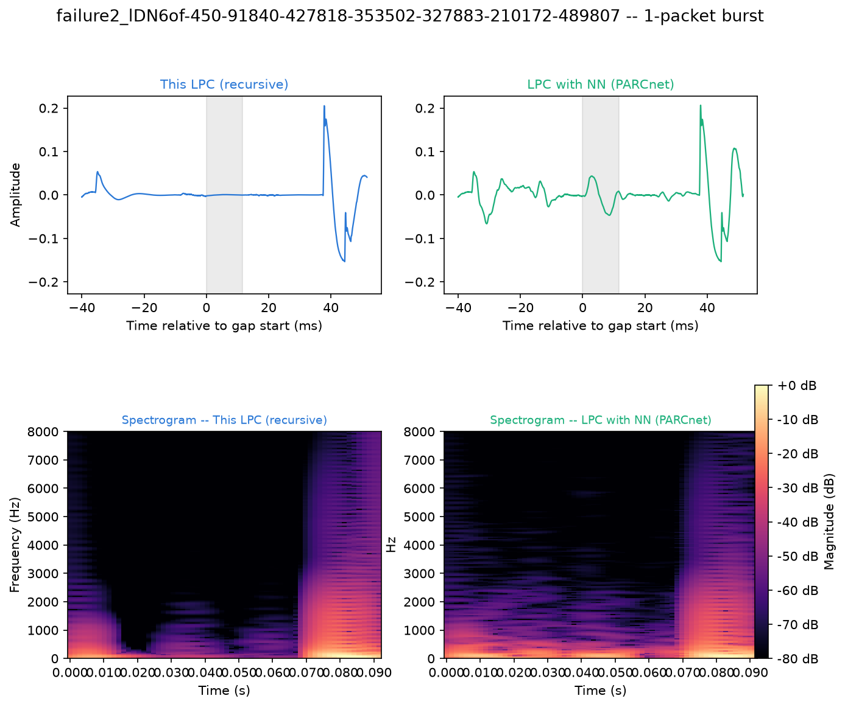
Figure 39. Failure case 2: waveform and spectrogram around the plotted 1-packet burst, AR (left) and hybrid (right).
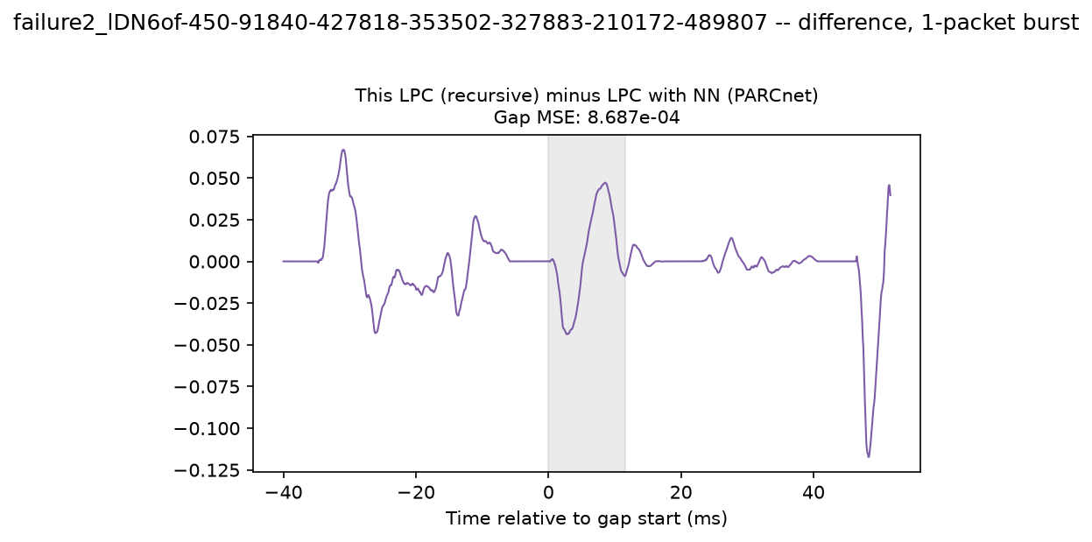
Figure 40. Failure case 2: AR minus hybrid concealment.
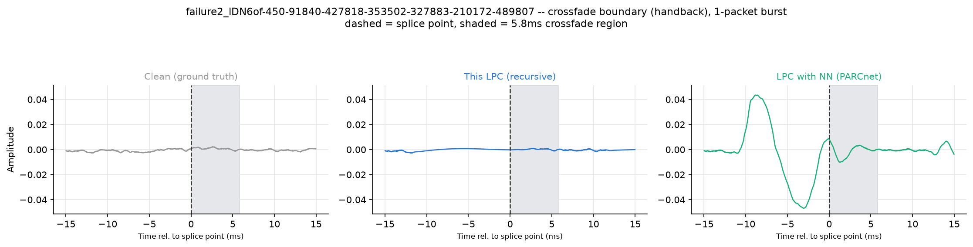
Figure 41. Failure case 2: hand-back crossfade with the clean reference.

3.8.2 Failure case 2
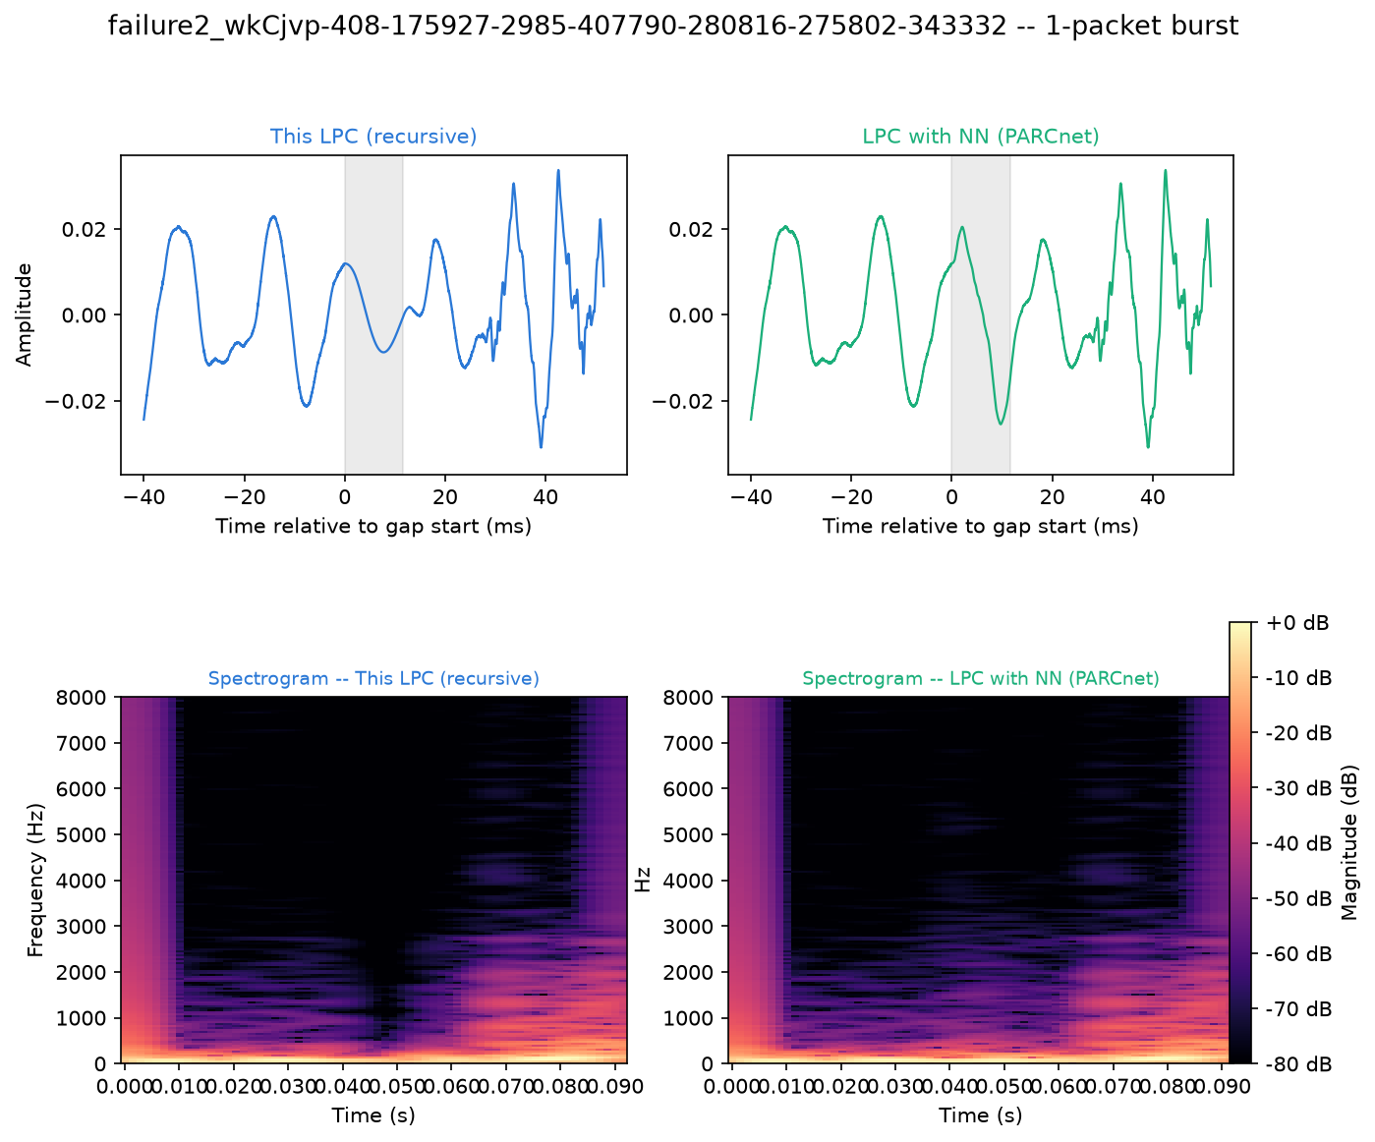
Figure 42. Failure case 2: waveform and spectrogram around the plotted 1-packet burst, AR (left) and hybrid (right).
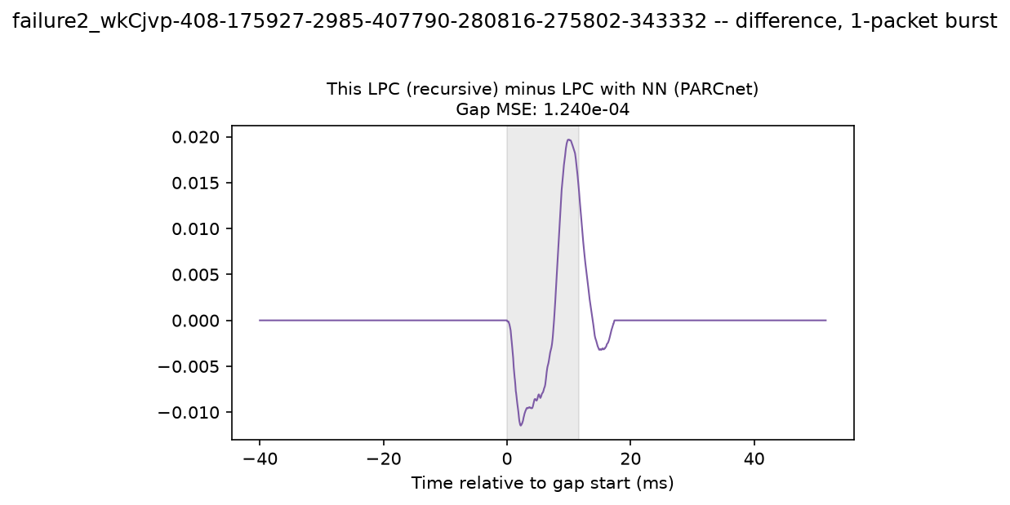
Figure 43. Failure case 2: AR minus hybrid concealment.
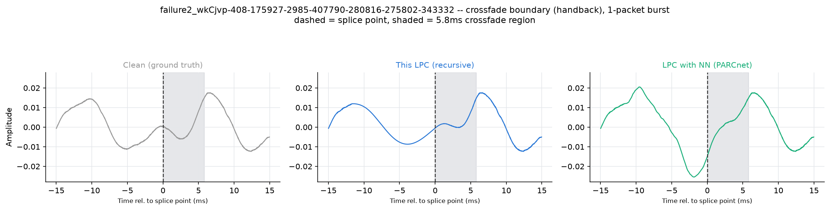
Figure 44. Failure case 2: hand-back crossfade with the clean reference.

3.8.3 Failure case 3
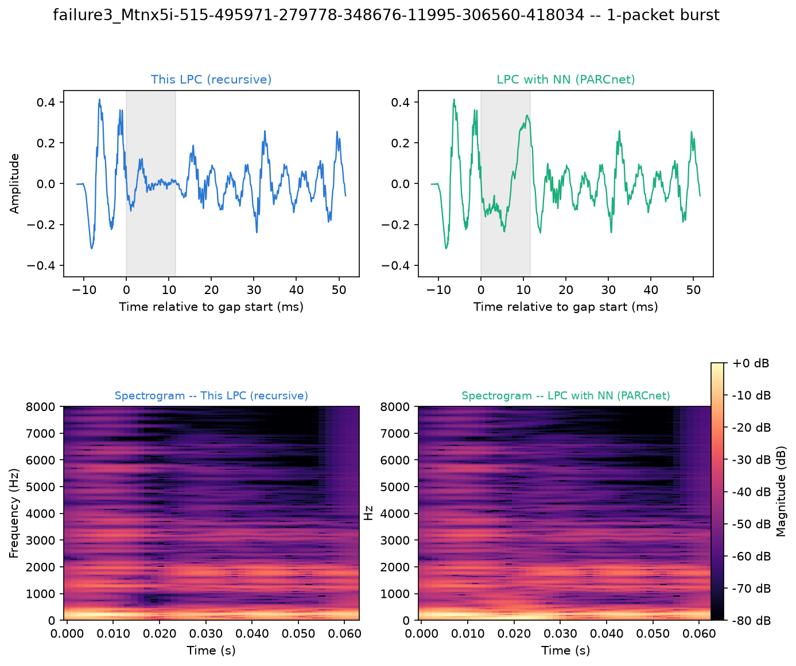
Figure 45. Failure case 3: waveform and spectrogram around the plotted 1-packet burst, AR (left) and hybrid (right).
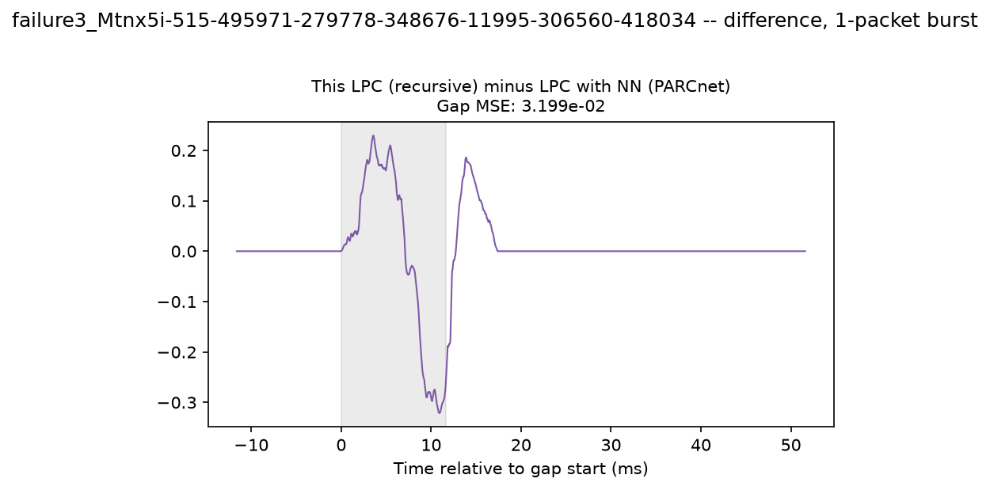
Figure 46. Failure case 3: AR minus hybrid concealment.
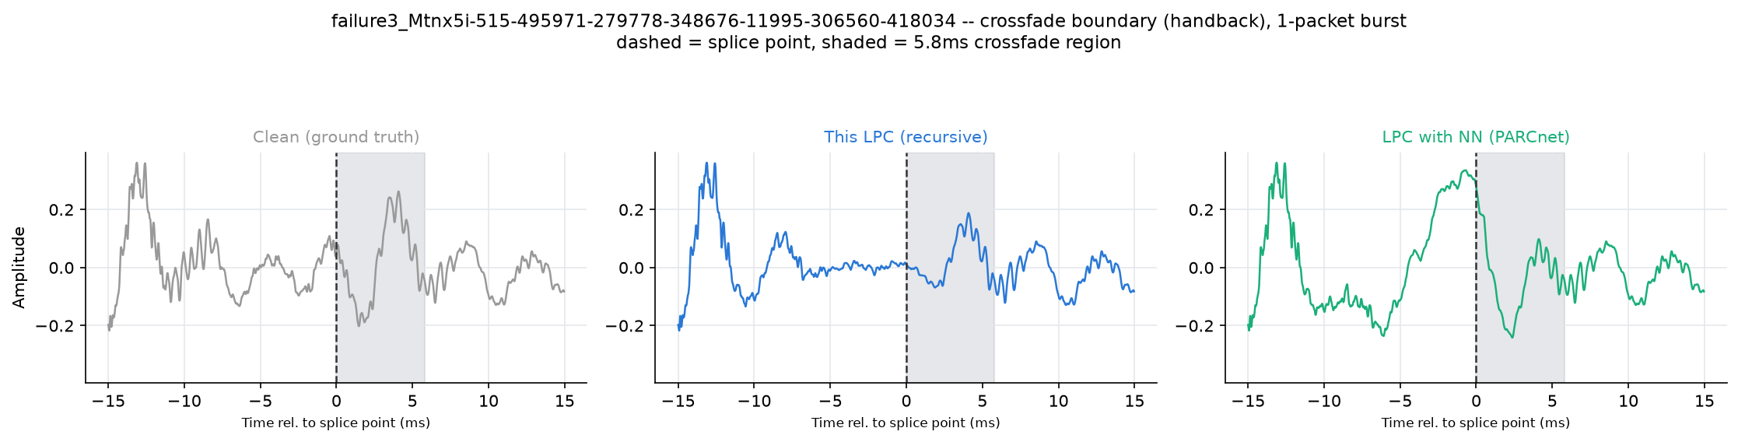
Figure 47. Failure case 3: hand-back crossfade with the clean reference.

3.8.3 Failure case 3
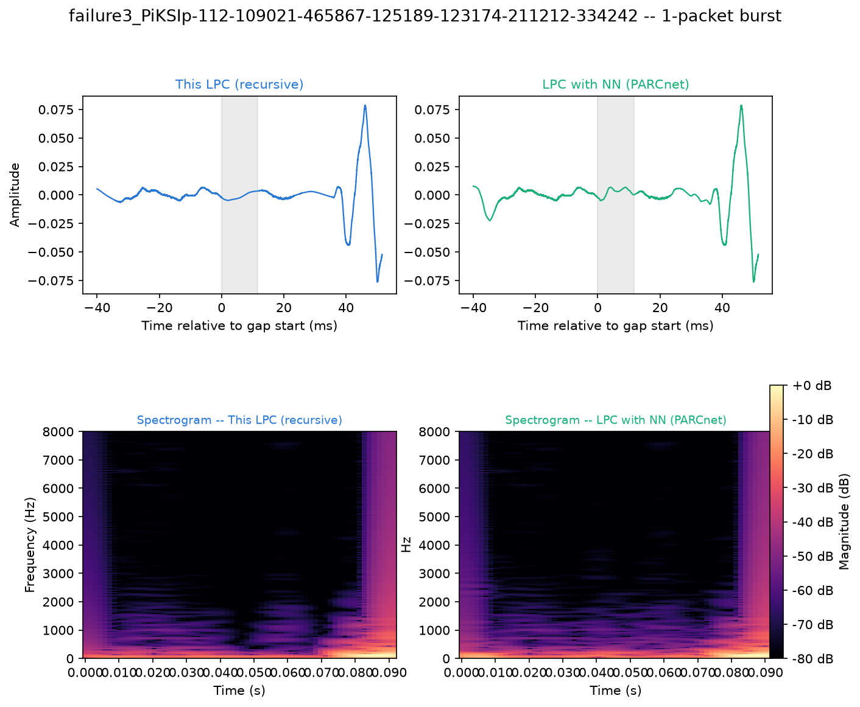
Figure 48. Failure case 3: waveform and spectrogram around the plotted 1-packet burst, AR (left) and hybrid (right).
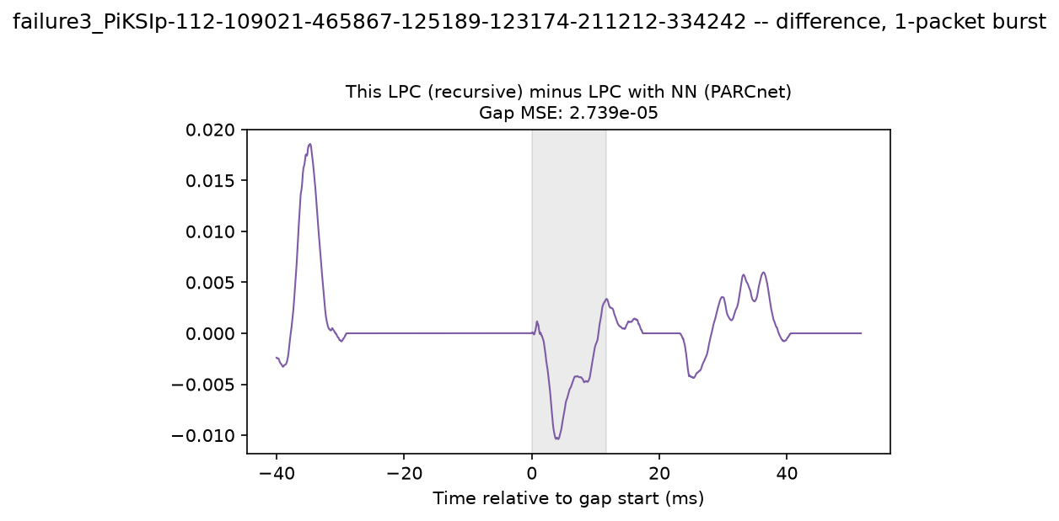
Figure 49. Failure case 3: AR minus hybrid concealment.
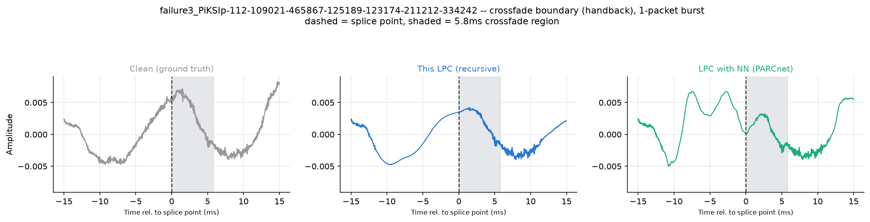
Figure 50. Failure case 3: hand-back crossfade with the clean reference.

3.8.3 Failure case 3
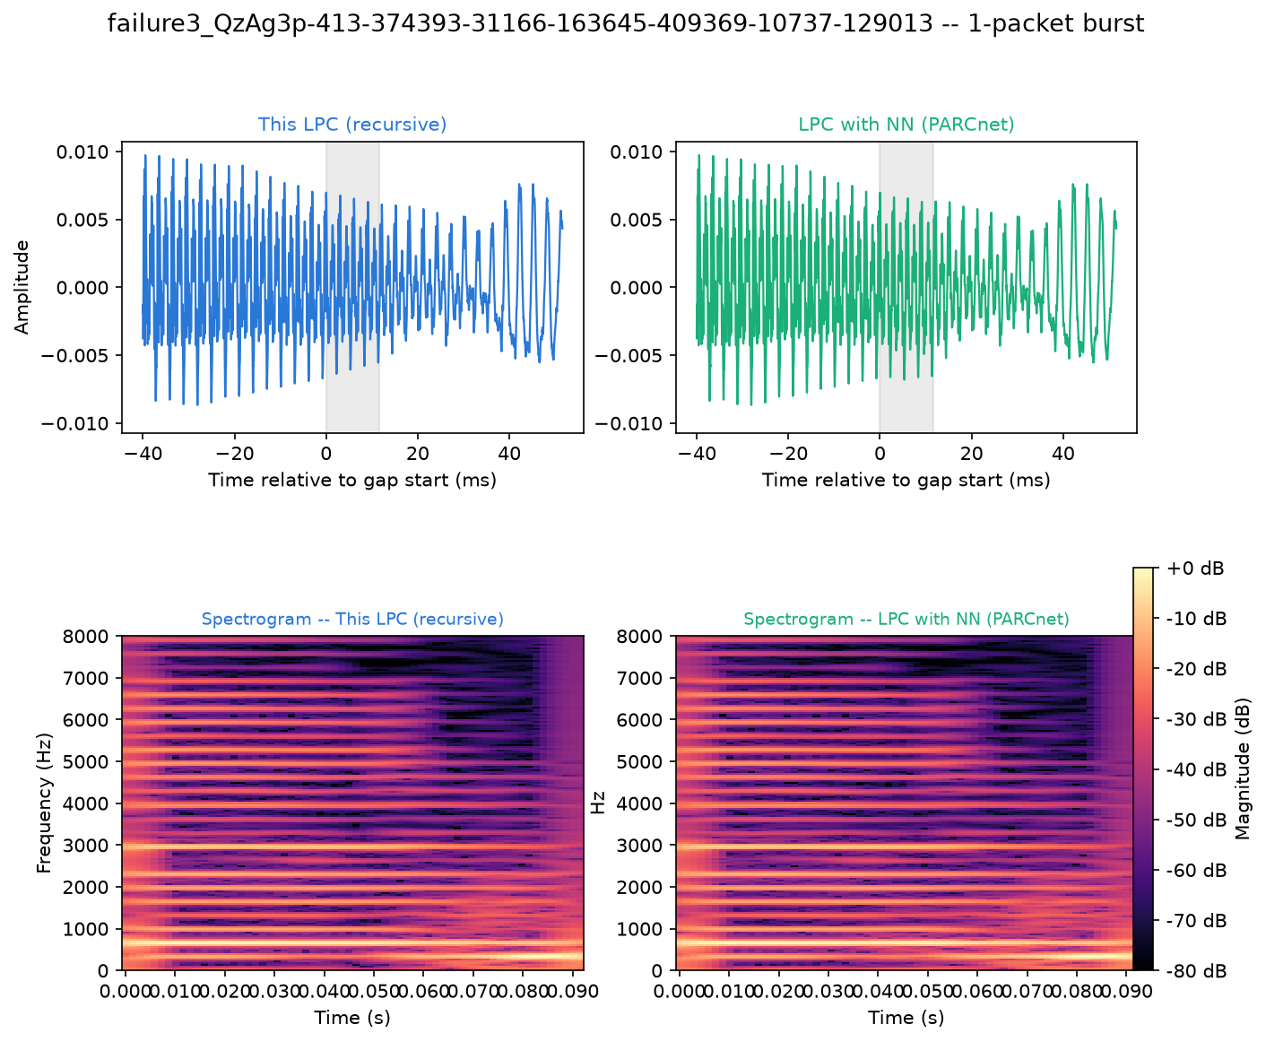
Figure 51. Failure case 3: waveform and spectrogram around the plotted 1-packet burst, AR (left) and hybrid (right).
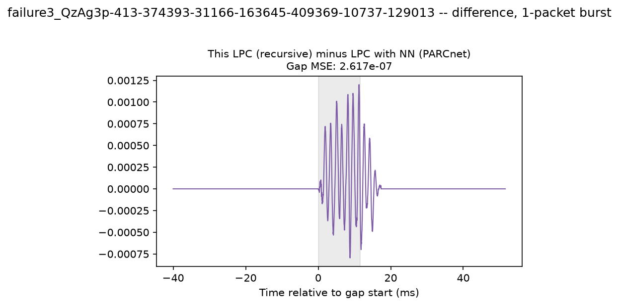
Figure 52. Failure case 3: AR minus hybrid concealment.
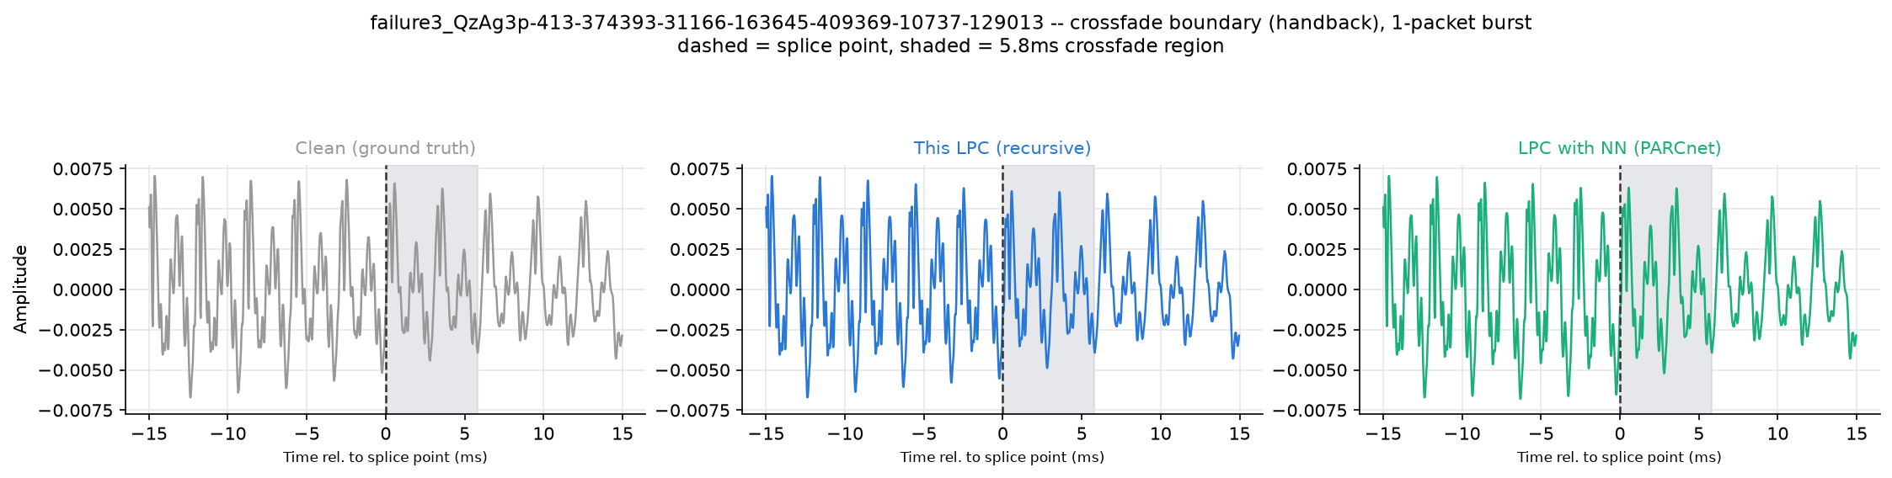
Figure 53. Failure case 3: hand-back crossfade with the clean reference.

3.8.3 Failure case 3
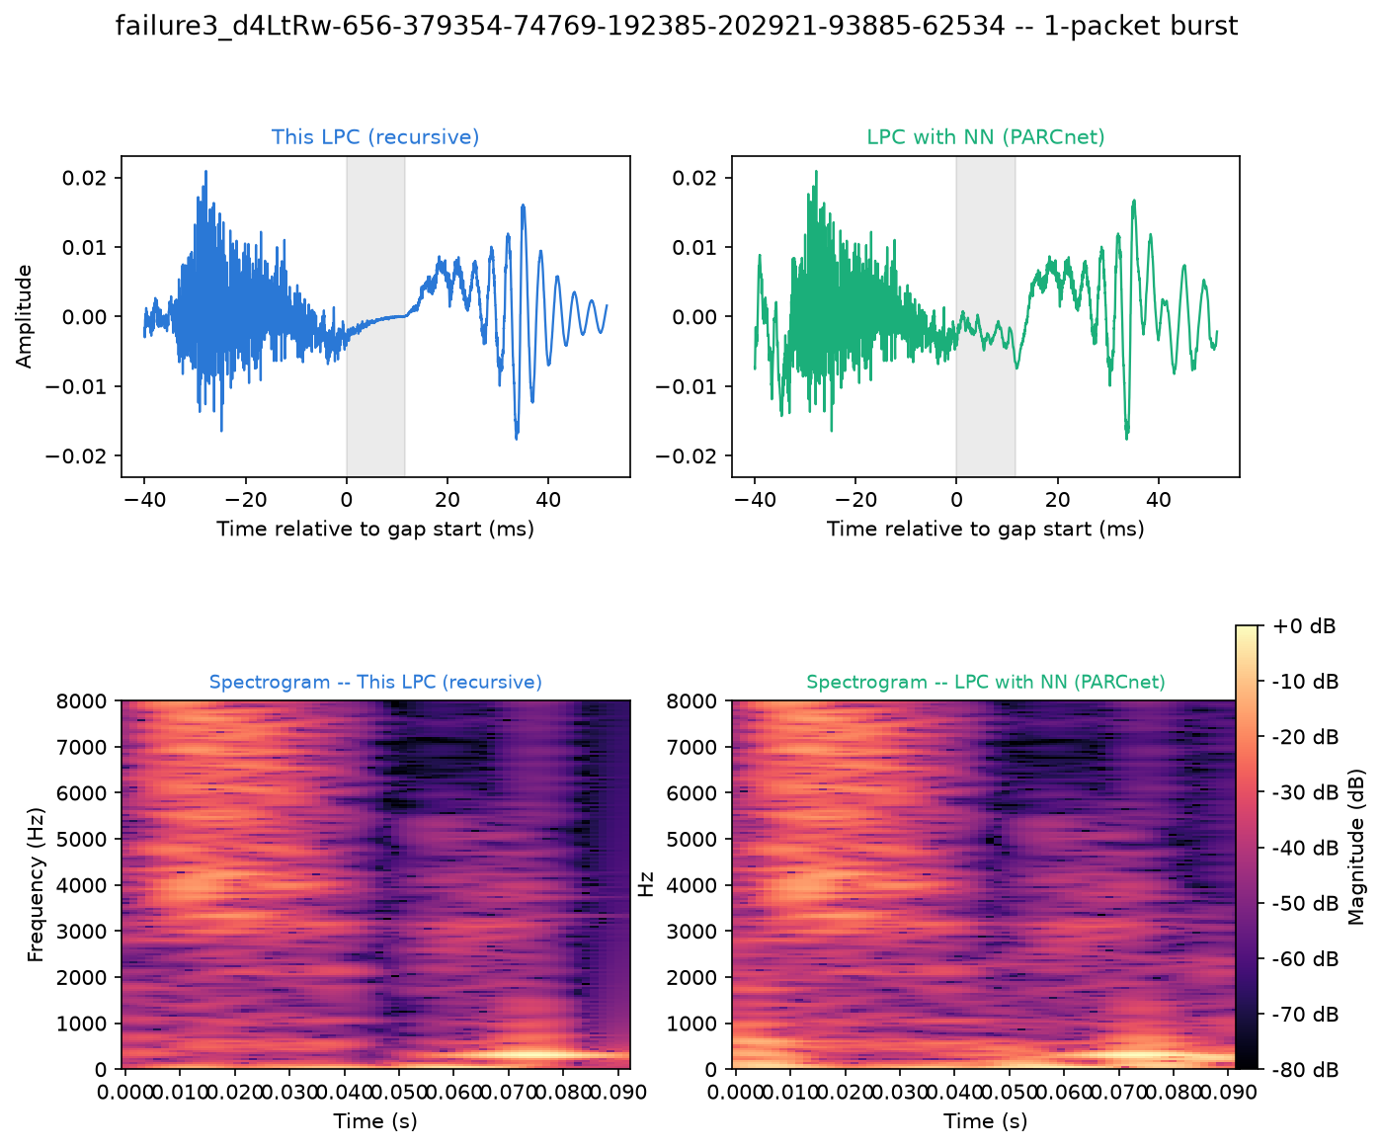
Figure 54. Failure case 3: waveform and spectrogram around the plotted 1-packet burst, AR (left) and hybrid (right).
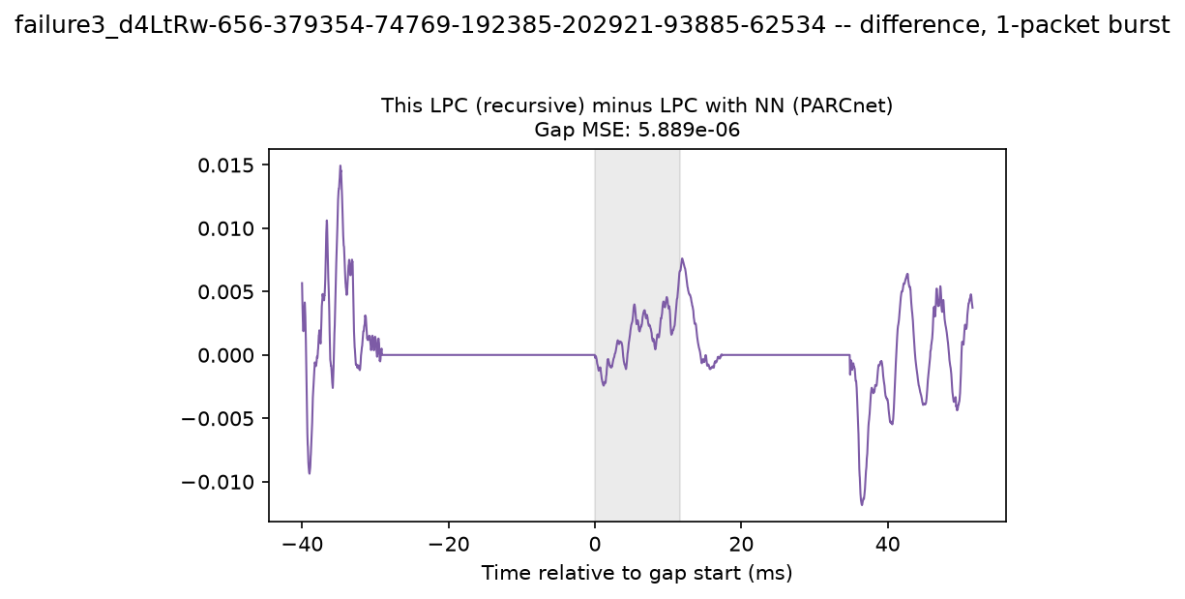
Figure 55. Failure case 3: AR minus hybrid concealment.
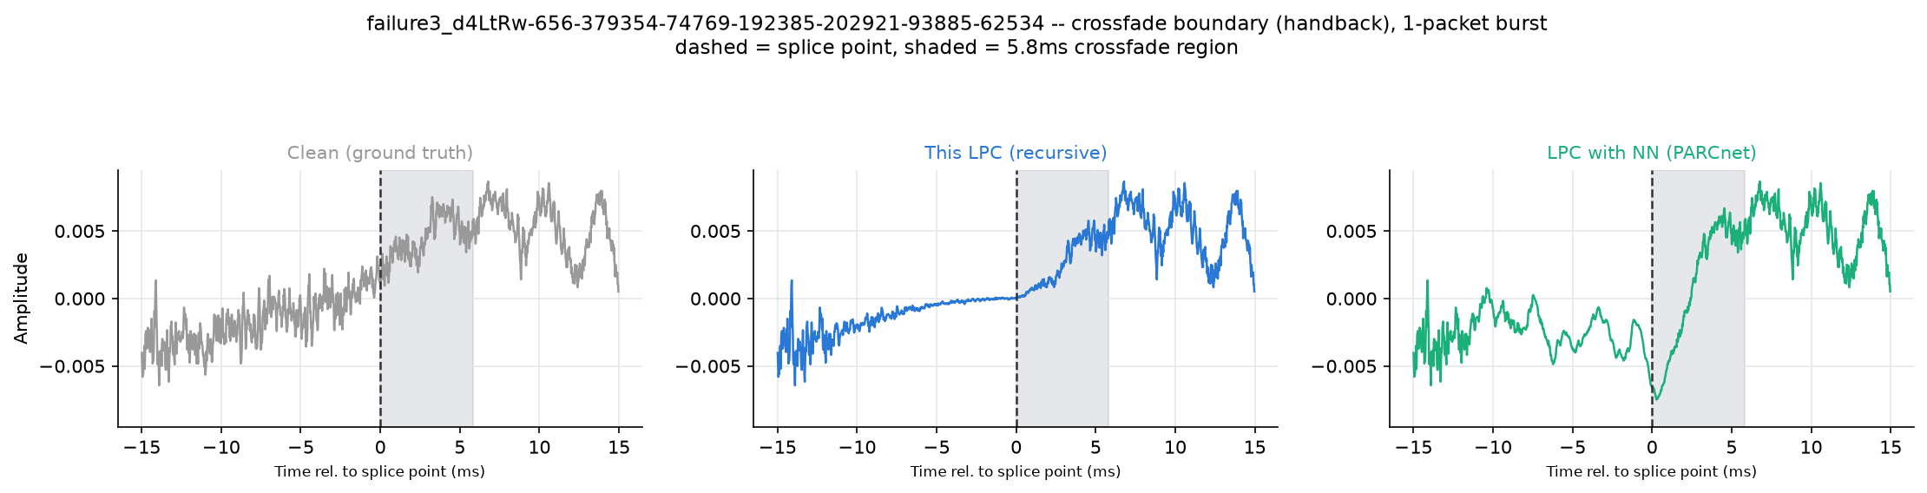
Figure 56. Failure case 3: hand-back crossfade with the clean reference.

3.8.1 Failure case 1
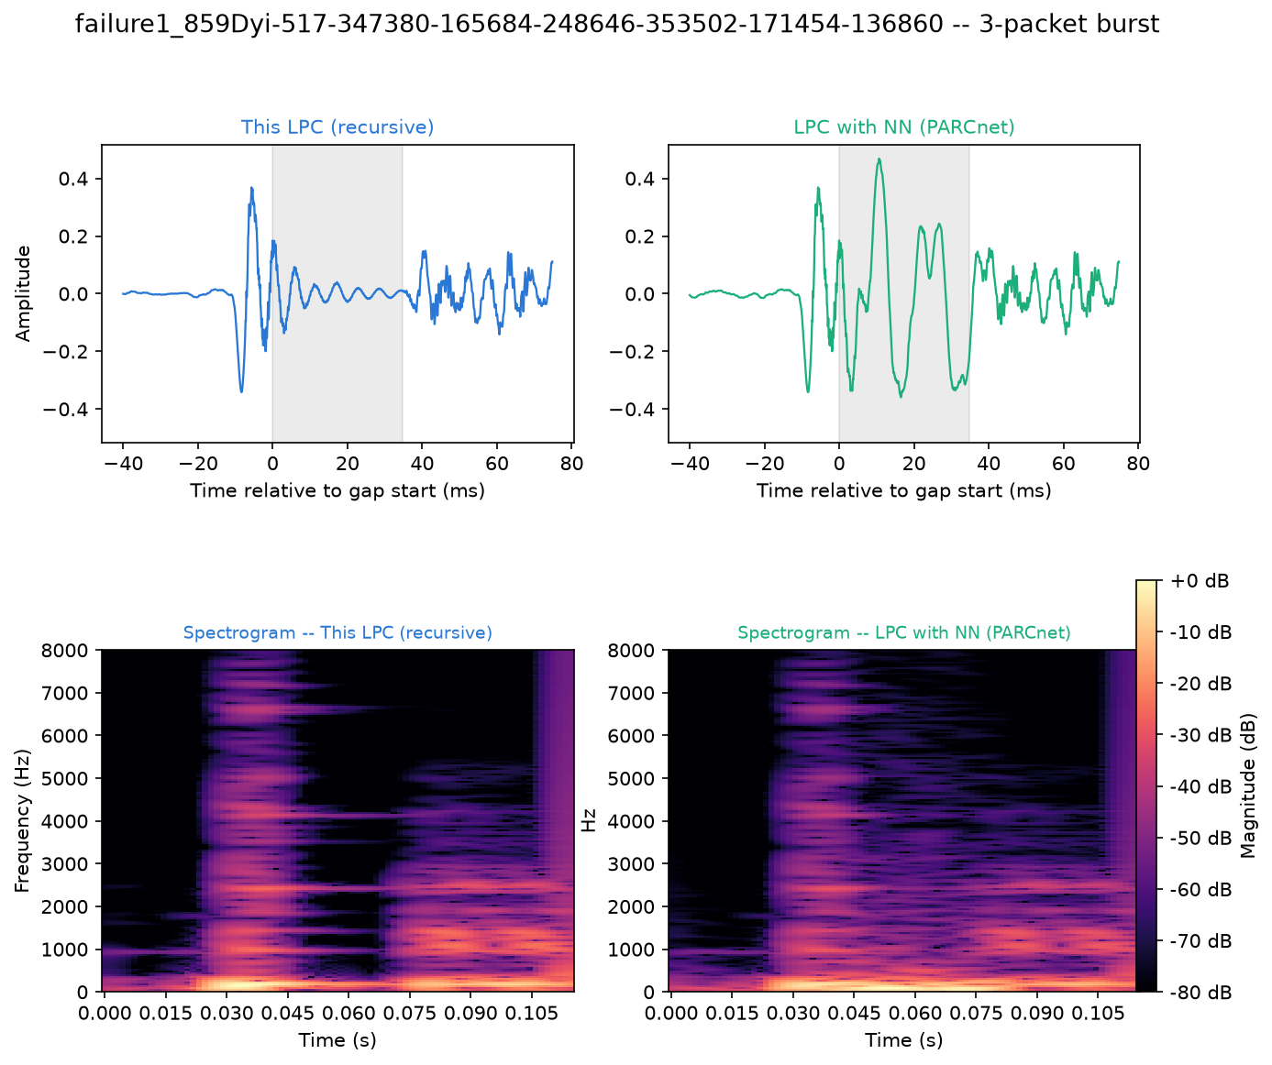
Figure 57. Failure case 1: waveform and spectrogram around the plotted 3-packet burst, AR (left) and hybrid (right).
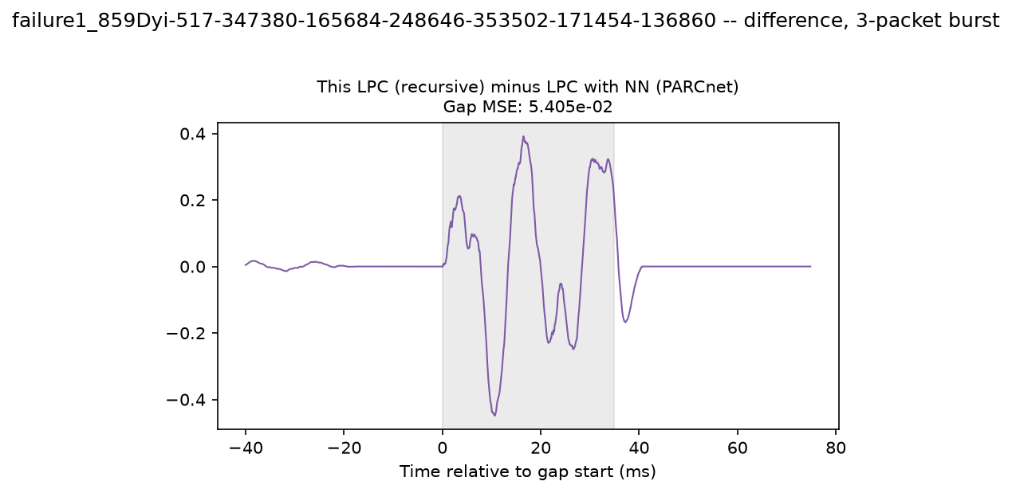
Figure 58. Failure case 1: AR minus hybrid concealment.
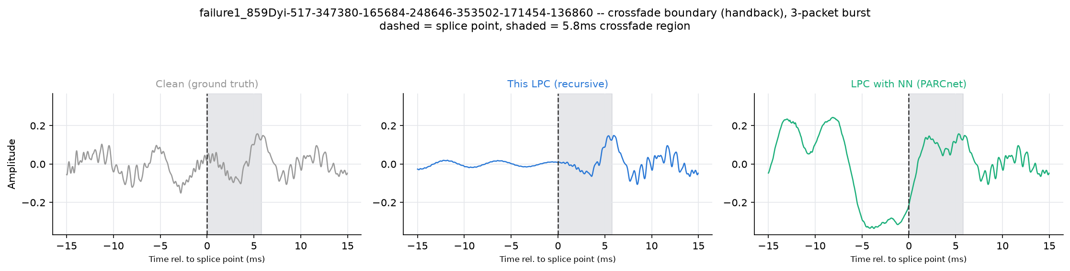
Figure 59. Failure case 1: hand-back crossfade with the clean reference.

3.8.1 Failure case 1
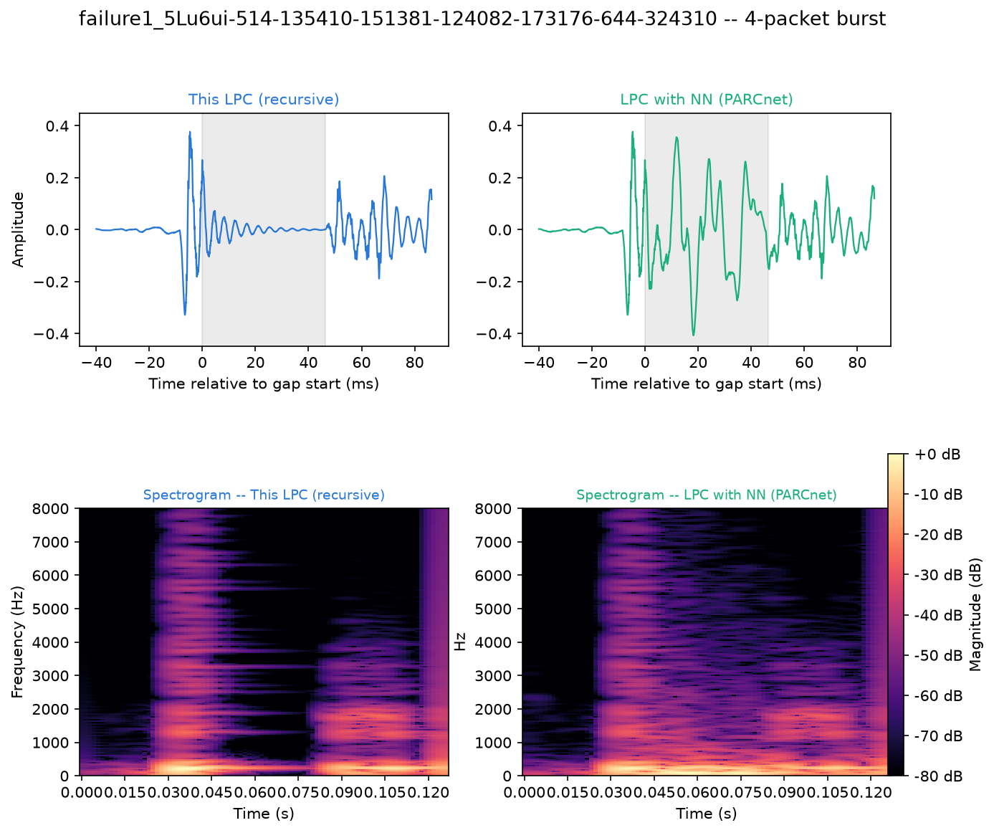
Figure 60. Failure case 1: waveform and spectrogram around the plotted 4-packet burst, AR (left) and hybrid (right).
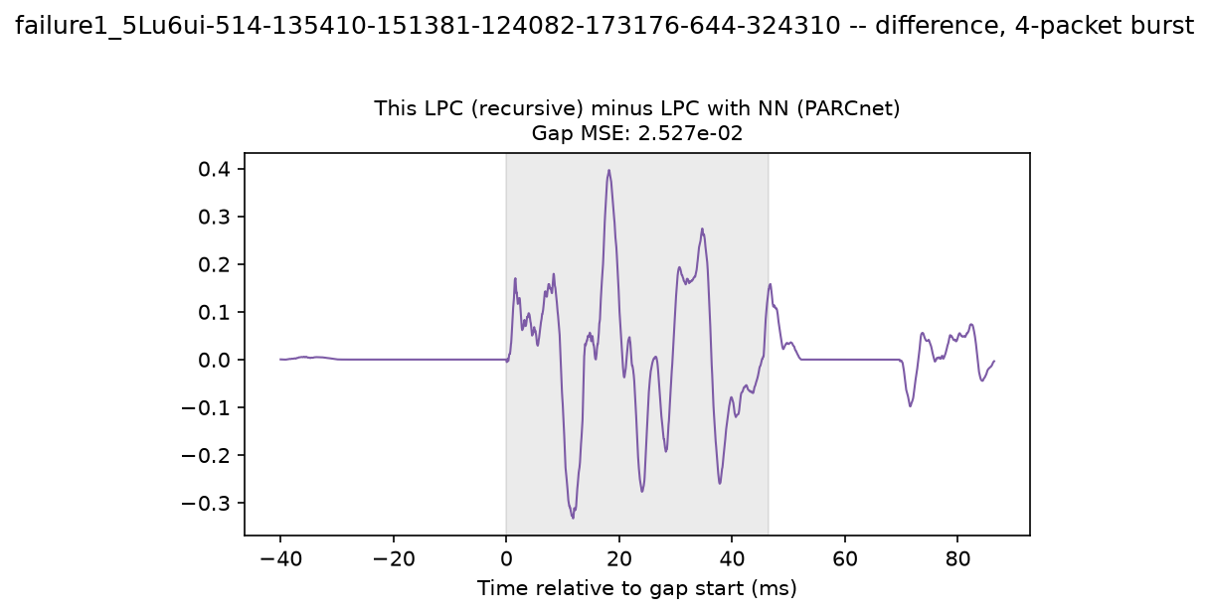
Figure 61. Failure case 1: AR minus hybrid concealment.
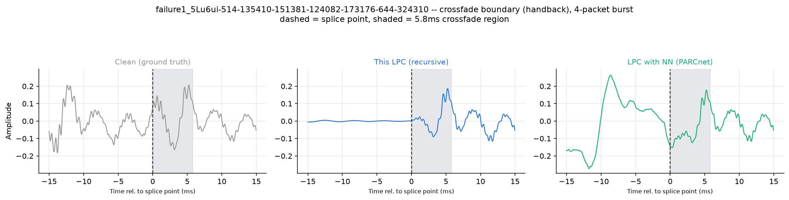
Figure 62. Failure case 1: hand-back crossfade with the clean reference.

4 Discussion

4.1 What the neural residual adds
The two metric families point in different directions. On average the hybrid model lowered the waveform SNR (-0.16 dB, LPC better) while it improved multi-resolution STFT distance and PLCMOS. This pattern is consistent with how the network is trained: its loss includes a spectral term, and a spectral improvement can coexist with a larger sample-wise error, because a prediction whose spectrum is right but whose phase drifts is penalized by SNR and not by magnitude-based or perceptual measures. One interpretation is that the residual makes the concealment more plausible rather than more exact; testing this directly would require a listening test (Section 5).

4.2 Burst length, complexity and recursion
Because both concealers are recursive, every packet of a burst is predicted from the previous predictions, so errors accumulate and gap quality is expected to fall with burst length, as observed here for both methods. Whether the neural residual helps more on long bursts is the practically important question, but long bursts are rare in real traces (Table 2), which makes the long-burst bins the least certain ones; their confidence intervals should be read accordingly.

4.3 Cost-quality trade-off
The AR concealer runs in real time on the evaluation CPU (median RTF 0.13), whereas the hybrid model exceeded the real-time budget (median RTF 3.66). Any quality benefit of the residual must therefore be weighed against a cost about 28 times higher; options such as multi-threaded or GPU inference, model quantization or a smaller network would need to be considered for live deployment.

4.4 Coupling between the AR configuration and the network
The network was trained on residuals of the default AR configuration. Changing the AR order, context length or regularization changes those residuals, so the hybrid model operates outside its training conditions. The sweeps therefore measure how robust a fixed network is to such changes; a fair test of a different AR configuration for the hybrid model would require retraining the network for it.

5 Limitations and future work
- No listening test. The challenge itself evaluates submissions with a MUSHRA listening test [15], noting that no objective metric has been shown to correlate reliably with perception for music PLC [2]. PLCMOS was designed for speech, so the perceptual metrics here are proxies; a MUSHRA test is the natural next step.
- One dataset, one checkpoint. All results come from one music test set and the pretrained challenge baseline. Generalization to other content (for example the speech validation set of the ICASSP 2024 PLC Challenge, which uses 48 kHz audio and 20 ms packets) and to retrained networks remains to be tested.
- Gap SNR is phase-sensitive. The per-burst analysis uses SNR because the perceptual models need longer inputs; it penalizes plausible but phase-shifted concealments.
- One-at-a-time sweeps. Interactions between hyperparameters (for example AR order and context length) are not explored; a joint search would be needed to find a global optimum.
- Timing on one CPU. Real-time factors depend on hardware, threading and implementation; they are indicative of the relative cost, not of every deployment.

6 Conclusion
This report compared AR-only and hybrid AR + neural (PARCnet) packet loss concealment for networked music on real loss traces, using two independently implemented concealers that are identical except for the neural residual. After Holm correction (α = 0.05, n = 673 files), quality was significantly better with the neural residual on MR-STFT dist. and PLCMOS; significantly better with AR alone on SNR (dB) and ViSQOL MOS-LQO. Gap SNR decreased from 7.86 dB (AR) / 7.75 dB (hybrid) for single-packet losses to 0.80 / 0.45 dB for bursts of 8+ packets; the hybrid model's gap-SNR advantage was negative for bursts of 1, 4-7 and 8+ packets (95% CI excluding zero). On the evaluation CPU, concealing one 11.6 ms packet took a median of 1.51 ms with AR alone (real-time factor 0.13) and 42.5 ms with the hybrid model (real-time factor 3.66), i.e. the hybrid model cannot run in real time on this hardware.

References
[1] A. I. Mezza, M. Amerena, A. Bernardini, and A. Sarti, "Hybrid packet loss concealment for real-time networked music applications," IEEE Open Journal of Signal Processing, vol. 5, pp. 266-273, 2024, doi: 10.1109/OJSP.2023.3343318.
[2] A. I. Mezza et al., "Report on the IEEE-IS² 2024 Music Packet Loss Concealment Challenge," arXiv:2409.18564, 2024.
[3] C. Perkins, O. Hodson, and V. Hardman, "A survey of packet loss recovery techniques for streaming audio," IEEE Network, vol. 12, no. 5, pp. 40-48, 1998.
[4] J. Makhoul, "Linear prediction: A tutorial review," Proceedings of the IEEE, vol. 63, no. 4, pp. 561-580, 1975.
[5] V. Lostanlen and C. E. Cella, "Deep convolutional networks on the pitch spiral for musical instrument recognition," in Proc. ISMIR, 2016.
[6] L. Diener, S. Sootla, S. Branets, A. Saabas, R. Aichner, and R. Cutler, "INTERSPEECH 2022 Audio Deep Packet Loss Concealment Challenge," in Proc. Interspeech, 2022.
[7] R. Yamamoto, E. Song, and J.-M. Kim, "Parallel WaveGAN: A fast waveform generation model based on generative adversarial networks with multi-resolution spectrogram," in Proc. IEEE ICASSP, 2020.
[8] L. Diener, M. Purin, S. Sootla, A. Saabas, R. Aichner, and R. Cutler, "PLCMOS - a data-driven non-intrusive metric for the evaluation of packet loss concealment algorithms," in Proc. Interspeech, 2023.
[9] M. Chinen, F. S. C. Lim, J. Skoglund, N. Gureev, F. O'Gorman, and A. Hines, "ViSQOL v3: An open source production ready objective speech and audio metric," in Proc. QoMEX, 2020.
[10] A. H. Gray and J. D. Markel, "A spectral-flatness measure for studying the autocorrelation method of linear prediction of speech analysis," IEEE Trans. Acoustics, Speech, and Signal Processing, vol. 22, no. 3, pp. 207-217, 1974.
[11] F. Wilcoxon, "Individual comparisons by ranking methods," Biometrics Bulletin, vol. 1, no. 6, pp. 80-83, 1945.
[12] S. Holm, "A simple sequentially rejective multiple test procedure," Scandinavian Journal of Statistics, vol. 6, no. 2, pp. 65-70, 1979.
[13] D. S. Kerby, "The simple difference formula: An approach to teaching nonparametric correlation," Comprehensive Psychology, vol. 3, 2014.
[14] B. Efron and R. J. Tibshirani, An Introduction to the Bootstrap. Chapman & Hall/CRC, 1993.
[15] ITU-R Recommendation BS.1534-3, "Method for the subjective assessment of intermediate quality level of audio systems (MUSHRA)," 2015.

Appendix A Reproducibility
All results were produced with the scripts in the research/ folder of the project repository, in this order:
python -m research.run_metrics_comparison --n-files 673 --seed 0
python -m research.run_hparam_sweeps --n-files 200
python -m research.plot_burst_comparison
python -m research.run_statistical_analysis
python -m research.build_report
Table 11. Hardware of the main evaluation run and software versions.
Item | Value
Platform | Linux-6.12.111+deb13-cloud-amd64-x86_64-with-glibc2.41
Processor
Logical cores | 32
PyTorch threads | 1
Python | 3.11.17
numpy | 2.4.6
scipy | 1.17.1
pandas | 3.0.5
librosa | 0.11.0
torch | 2.14.0+cpu
pytorch-lightning | 2.6.5
numba | 0.67.0
speechmos | 0.0.1.1
visqol-python | 3.8.0
matplotlib | 3.11.1
seaborn | 0.13.2
python-docx | 1.2.0

Appendix B Descriptive statistics
Table 12. Descriptive statistics of all metrics over 673 files.
Metric | Method | Mean | SD | Median | IQR | Range
SNR (dB) | AR | 15.572 | 5.666 | 15.071 | 11.907-18.555 | 3.071-50.984
SNR (dB) | Hybrid | 15.416 | 5.931 | 14.914 | 11.593-18.622 | 2.108-49.406
MR-STFT dist. | AR | 0.477 | 0.393 | 0.355 | 0.228-0.603 | 0.015-3.726
MR-STFT dist. | Hybrid | 0.360 | 0.246 | 0.290 | 0.191-0.457 | 0.014-1.521
PLCMOS | AR | 2.445 | 0.954 | 2.242 | 1.619-3.217 | 1.118-4.869
PLCMOS | Hybrid | 2.501 | 0.949 | 2.296 | 1.687-3.247 | 1.123-4.865
ViSQOL MOS-LQO | AR | 4.520 | 0.251 | 4.595 | 4.468-4.673 | 2.409-4.732
ViSQOL MOS-LQO | Hybrid | 4.498 | 0.252 | 4.572 | 4.423-4.659 | 2.748-4.731

Appendix C Full hyperparameter sweep summary
Table 13. Best value per hyperparameter, method and metric.
Hyperparameter | Method | Metric | Best value | At default | At best | Gain
AR order p | AR | SNR (dB) | 1024 | 15.449 | 16.566 | +1.117
AR order p | AR | MR-STFT dist. | 2048 | 0.465 | 0.391 | +0.075
AR order p | AR | PLCMOS | 1536 | 2.394 | 2.506 | +0.112
AR order p | AR | ViSQOL MOS-LQO | 1024 | 4.507 | 4.529 | +0.022
AR order p | Hybrid | SNR (dB) | 768 | 15.214 | 15.411 | +0.197
AR order p | Hybrid | MR-STFT dist. | 768 | 0.360 | 0.358 | +0.002
AR order p | Hybrid | PLCMOS | 768 | 2.463 | 2.520 | +0.056
AR order p | Hybrid | ViSQOL MOS-LQO | 384 | 4.497 | 4.507 | +0.010
Context length (packets) | AR | SNR (dB) | 8 | 15.449 | 15.449 | +0.000
Context length (packets) | AR | MR-STFT dist. | 16 | 0.465 | 0.461 | +0.004
Context length (packets) | AR | PLCMOS | 16 | 2.394 | 2.429 | +0.035
Context length (packets) | AR | ViSQOL MOS-LQO | 32 | 4.507 | 4.511 | +0.004
Context length (packets) | Hybrid | SNR (dB) | 8 | 15.214 | 15.214 | +0.000
Context length (packets) | Hybrid | MR-STFT dist. | 8 | 0.360 | 0.360 | +0.000
Context length (packets) | Hybrid | PLCMOS | 8 | 2.464 | 2.464 | +0.000
Context length (packets) | Hybrid | ViSQOL MOS-LQO | 8 | 4.497 | 4.497 | +0.000
Diagonal loading λ | AR | SNR (dB) | 0.001 | 15.449 | 15.449 | +0.000
Diagonal loading λ | AR | MR-STFT dist. | 1e-06 | 0.465 | 0.452 | +0.013
Diagonal loading λ | AR | PLCMOS | 1e-05 | 2.395 | 2.409 | +0.014
Diagonal loading λ | AR | ViSQOL MOS-LQO | 0.0001 | 4.507 | 4.508 | +0.001
Diagonal loading λ | Hybrid | SNR (dB) | 0.0001 | 15.214 | 15.215 | +0.001
Diagonal loading λ | Hybrid | MR-STFT dist. | 1e-05 | 0.360 | 0.359 | +0.001
Diagonal loading λ | Hybrid | PLCMOS | 0.0001 | 2.462 | 2.467 | +0.005
Diagonal loading λ | Hybrid | ViSQOL MOS-LQO | 1e-05 | 4.497 | 4.498 | +0.001
Crossfade length E (samples) | AR | SNR (dB) | 16 | 15.449 | 16.303 | +0.854
Crossfade length E (samples) | AR | MR-STFT dist. | 32 | 0.465 | 0.415 | +0.050
Crossfade length E (samples) | AR | PLCMOS | 384 | 2.408 | 2.414 | +0.006
Crossfade length E (samples) | AR | ViSQOL MOS-LQO | 32 | 4.507 | 4.545 | +0.038
Crossfade length E (samples) | Hybrid | SNR (dB) | 16 | 15.214 | 16.032 | +0.818
Crossfade length E (samples) | Hybrid | MR-STFT dist. | 64 | 0.360 | 0.339 | +0.021
Crossfade length E (samples) | Hybrid | PLCMOS | 384 | 2.468 | 2.472 | +0.004
Crossfade length E (samples) | Hybrid | ViSQOL MOS-LQO | 128 | 4.497 | 4.508 | +0.011

