Week 2 Task
Advanced Data Visualization and Storytelling with Python
Who Survived the Titanic — and Why? A Data Story
Prepared by: Shridhar Raj S
B.E. Computer Science Engineering, Priyadarshini Engineering College
Date: September 2026

1. Introduction
This report builds on the Week 1 data-cleaning work and shifts focus to the harder problem: turning a cleaned dataset into a story a non-technical reader can follow in five minutes. The dataset is the same Titanic passenger dataset (773 cleaned records) used in Week 1, chosen again here because it has everything a good data story needs — a clear human stakes (who lived, who didn't), several intersecting factors (class, gender, age, family, fare), and patterns that are genuinely surprising even to readers who already know the broad outline of the disaster.
The goal was not just to make charts that are technically correct, but to make each one answer a specific question a curious, non-technical reader would actually ask — and to sequence them so the report reads as a narrative arc rather than a slideshow of disconnected plots.

2. Methods
All visualizations were built in Python using Matplotlib and Seaborn for statistical charts, and squarify (a treemap layout library built on Matplotlib) for the hierarchical multi-factor view. Each chart follows the same design language: a headline-style title that states the finding (not just the variable names), a muted grey/blue/red palette so color always means the same thing (blue = survived, red = did not), and direct data-label annotations so the reader never has to cross-reference an axis to get the number that matters.
- Chart 1 — Donut/KPI chart: sets the overall stakes before any breakdown.
- Chart 2 — Grouped bar chart with annotated gap: compares two categorical factors (class, gender) side by side.
- Chart 3 — Violin plot: shows a full distribution shape, not just an average, for a continuous variable (age).
- Chart 4 — Strip plot + boxplot overlay (log scale): shows both the spread of individual data points and the summary statistic for a skewed variable (fare).
- Chart 5 — Annotated bar chart: reveals a non-obvious, non-linear relationship (family size) that a simple correlation coefficient would miss entirely.
- Chart 6 — Treemap: combines three factors (class, gender, outcome) into a single view, for readers who want the full picture after seeing the individual pieces.
This progression — overall picture, then two-factor comparisons, then distribution shape, then a non-linear twist, then a combined view — mirrors how a human explains a complex result out loud: start simple, add one variable at a time, save the most complex view for last.

3. The Data Story

3.1 Setting the Stakes
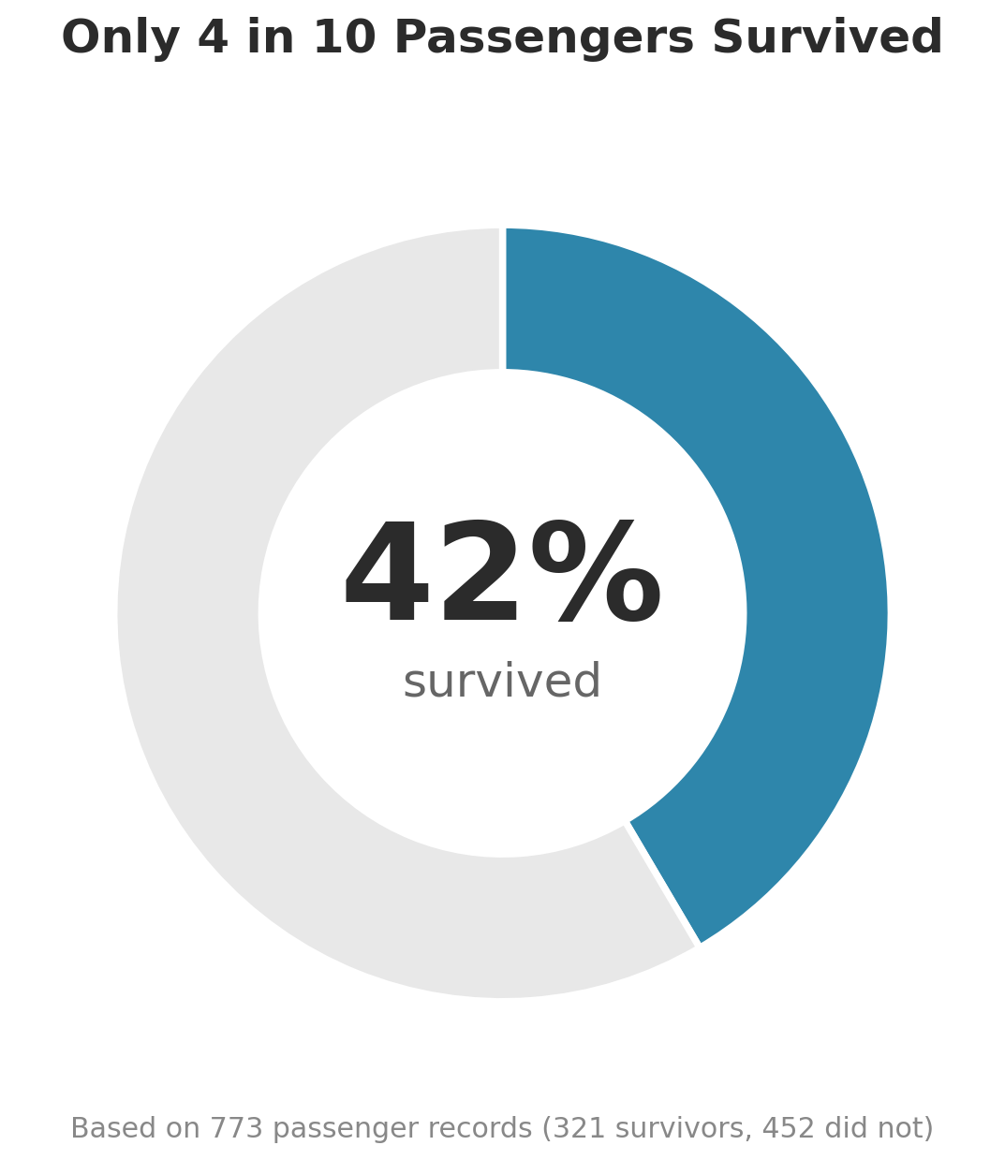
Figure 1: Overall survival rate across all 773 cleaned passenger records.
Why this chart: before showing any breakdown, the reader needs one number to anchor everything else. A donut chart with the number embossed in the center reads instantly, even to someone who has never opened a spreadsheet — no axis, no legend required. It also sets up every later chart as a departure from this 42% baseline, which is exactly how the story is structured from here on.

3.2 Gender and Class — the Two Biggest Factors
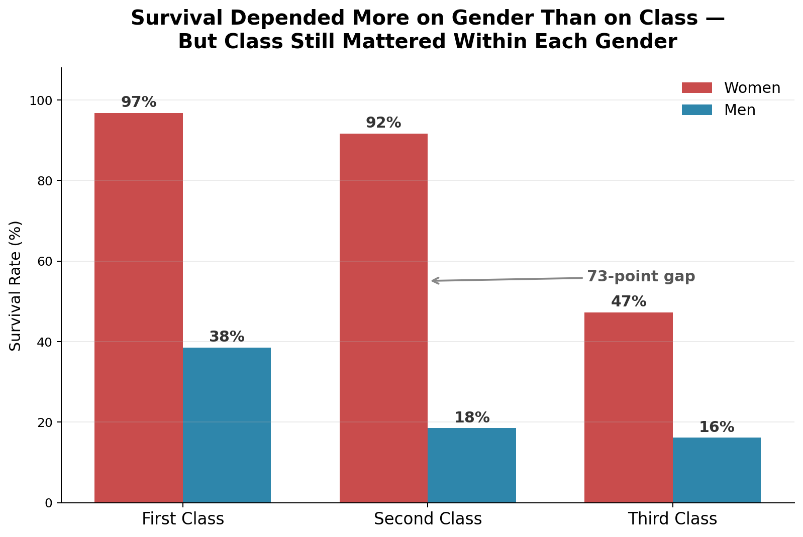
Figure 2: Survival rate by passenger class and gender.
Why this chart: this is the single most important comparison in the dataset, so it earns the second slot. Grouping bars by class (not by gender) makes the takeaway impossible to miss: the tallest bars are all women, in every class, and the gap between women and men is far bigger than the gap between First and Third class within a gender. The annotated 73-point gap callout does the work of a caption in one glance — a reader doesn't need to compute the difference themselves.
"A woman in Third Class (47%) was almost as likely to survive as a man in First Class (38%) — gender outweighed money."

3.3 Age — Beyond the Average
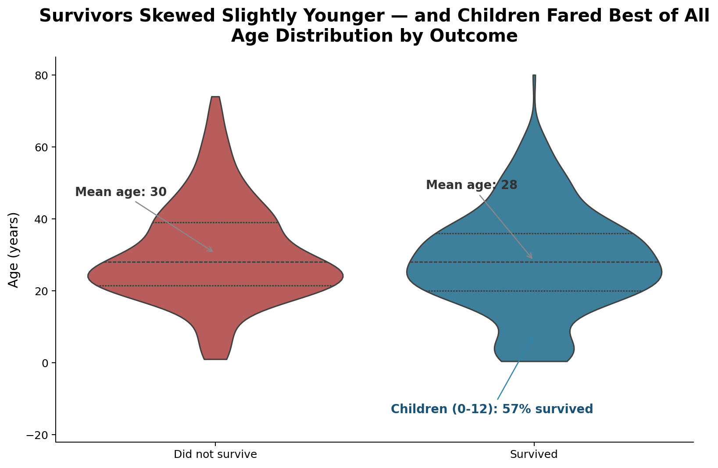
Figure 3: Age distribution split by outcome, with children called out separately.
Why this chart: a simple bar of average ages would show almost no difference (30 vs. 28) and would actually undersell the story. A violin plot shows the full shape of each distribution, so the reader can see the extra bulge near age 0–10 on the survivors' side that a single average completely hides — and the annotation states outright that 57% of children survived, well above the 42% baseline. This is a case where the 'boring' summary statistic would have missed the real finding.

3.4 Money Mattered, Too
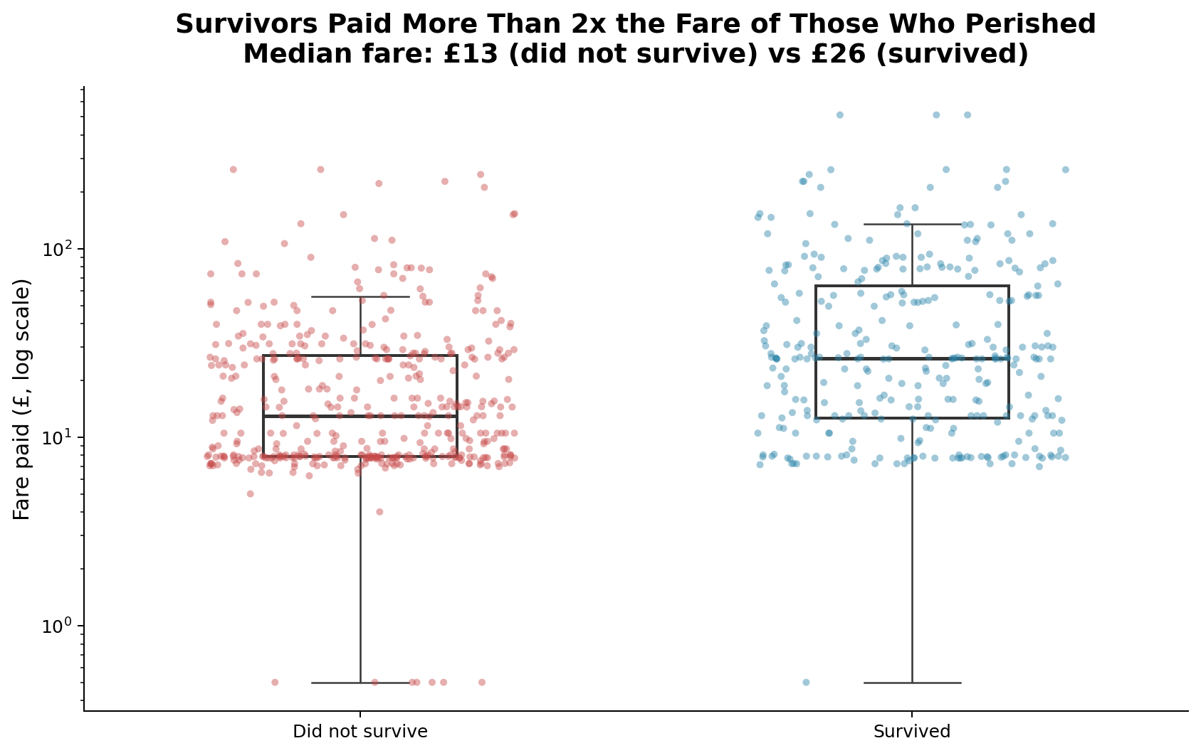
Figure 4: Fare paid, by outcome (log scale), with individual passengers and the summary boxplot overlaid.
Why this chart: fare is a heavily skewed variable — a handful of passengers paid over £500, most paid under £15 — so a log scale is necessary just to make the chart readable. Overlaying individual points (strip plot) underneath the boxplot lets the reader see both the raw spread and the summary statistic in one image, rather than choosing between 'shows everything but is noisy' and 'shows the average but hides the spread.' The finding itself — survivors paid roughly double — reinforces and quantifies the class story from Figure 2 in monetary terms a general reader intuitively understands.

3.5 The Twist: Family Size
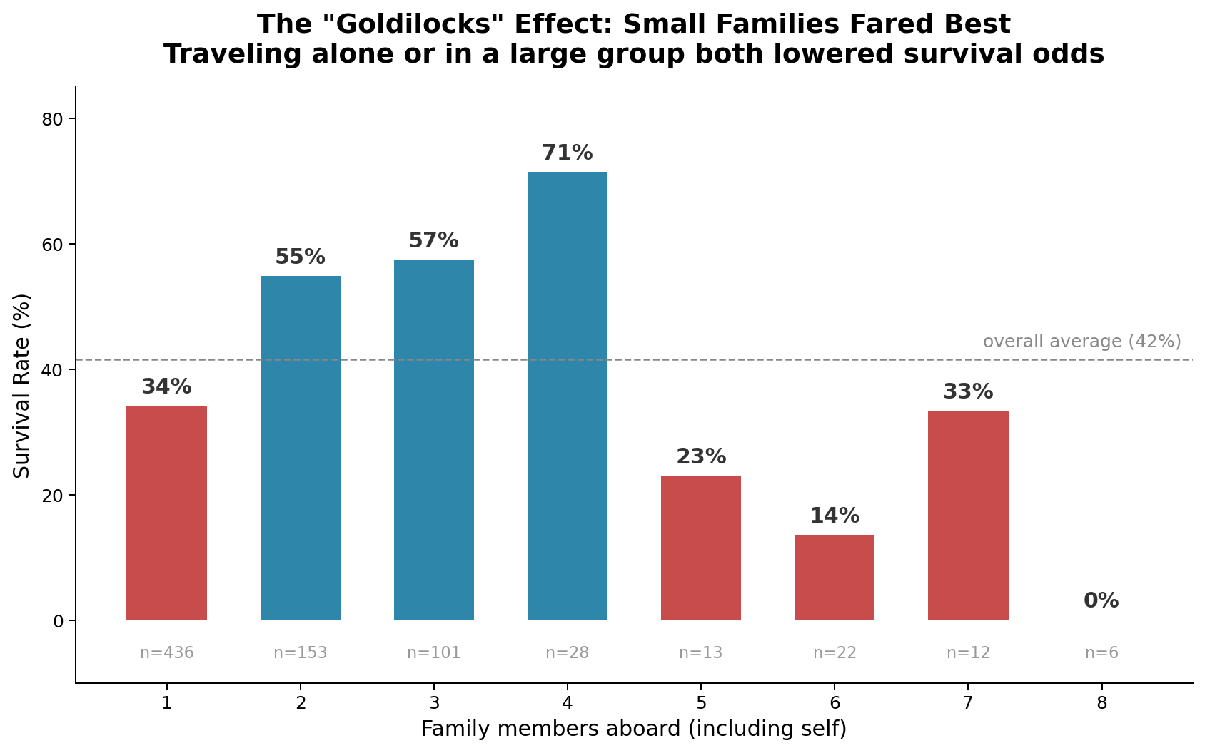
Figure 5: Survival rate by number of family members traveling together.
Why this chart: this is the one relationship in the dataset that is not a straight line, so it's placed right before the finale to give the story a genuine "huh, I didn't expect that" moment. Passengers traveling completely alone survived at below-average rates (34%); so did those in large family groups of 5 or more (as low as 14–18%) — likely because large families struggled to stay together and reach lifeboats in time. The sweet spot was families of 2–4, who survived at 55–71%, comfortably above the 42% baseline. A single correlation coefficient between family size and survival would report something close to zero and completely miss this U-shaped pattern — which is exactly why the visual matters more than the statistic here.

3.6 The Full Picture
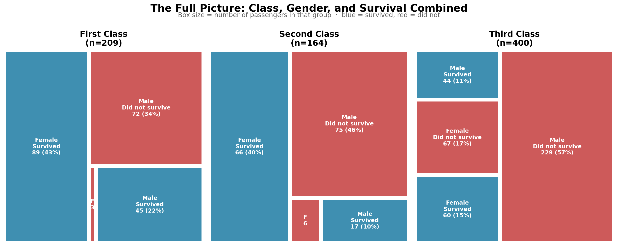
Figure 6: Passengers broken down by class, gender, and outcome simultaneously.
Why this chart: after walking through each factor individually, the treemap lets the reader hold all of them at once. The box sizes make the underlying population imbalance visible too — Third Class (400 passengers) was nearly double the size of First Class (209), so the disaster's raw death toll was concentrated there even though the survival-rate story (Figure 2) already explained why. This chart is deliberately placed last because it only makes sense after the reader has absorbed the individual pieces in Figures 1–5; shown first, it would be overwhelming rather than illuminating.

4. Summary of Insights
Factor | Key Finding
Overall | 41.5% of passengers survived
Gender | Women: 73.9% vs. Men: 22.0% — the single strongest factor
Class | First: 64.1% vs. Third: 26.0% — money and cabin location mattered
Age | Children (0–12): 57.4% survived, well above average
Fare | Median fare of survivors (£26) was roughly double that of non-survivors (£13)
Family size | Sweet spot was 2–4 family members (55–71%); solo or 5+ travelers fared worse

Taken together, the story is not simply "rich people survived" or "women and children first" in isolation — it's that multiple overlapping factors (gender, class, age, and even group size) combined to produce very different odds for different passengers, and the size of some of these effects (a 73-point gender gap; a U-shaped family-size curve) is larger and stranger than most people assume before looking at the data.

5. Business and Analytical Implications
While this is a historical dataset, the analytical patterns generalize directly to problems modern organizations still face:
- Crisis and emergency response planning: the finding that large groups (5+ people) had sharply lower survival rates suggests that evacuation protocols and group-based logistics (airlines, cruise operators, event venues) should specifically plan for slower movement and coordination breakdown in larger family or group units, not just optimize for the 'average' passenger.
- Equity auditing in resource allocation: the 73-point survival gap by gender, even after controlling for class, is a textbook example of why any allocation system (medical triage, insurance underwriting, rescue prioritization) needs to be explicitly audited for disparate impact across subgroups — averages alone can hide very large gaps between groups.
- Customer or risk segmentation: the non-linear family-size effect illustrates why analysts should not assume every relationship is a straight line; segmenting customers or risks by group size (or similar structural variables) rather than fitting a single linear trend can reveal U-shaped or threshold effects that a correlation coefficient alone would miss.
- Pricing and access correlation: the fare-survival relationship is a reminder, relevant to transportation, healthcare, and insurance pricing today, that price tiers often proxy for access to better-located, faster, or higher-priority resources — worth flagging explicitly when evaluating whether a pricing structure has safety or equity implications.

6. Conclusion
This week's task reinforced a distinction that's easy to skip past: a technically correct chart and a chart that tells a story are not the same thing. The six visualizations here use the same underlying dataset as Week 1's cleaning exercise, but each one was chosen and annotated to answer a specific question in plain language, sequenced to build toward a combined view, and captioned to state the 'why' rather than leave the reader to infer it. The Titanic dataset's enduring popularity as a teaching example is itself a small case study in this idea — the raw numbers have been public for decades, but a well-sequenced visual narrative is still what makes the patterns memorable.

7. Methodology & Tools
Tools used: Python 3, pandas, matplotlib, seaborn, and squarify (treemap layout), with Word/docx tooling for this report.
Estimated time spent: approximately 7–9 hours across dataset/story selection, iterating on 6 visualization designs (including two that were revised after an initial draft didn't support the intended narrative clearly enough), writing the accompanying analysis, and assembling the report — within the 30–35 hour guideline provided for the full week's work.

