WEEK 3 TASK
STATISTICAL ANALYSIS AND HYPOTHESIS TESTING IN PYTHON
Business Case: Effect of Customer-Service Training on Resolution Time and Satisfaction
Prepared using Python, Pandas, SciPy, Statsmodels and Matplotlib

1. Executive Summary
This report evaluates whether a customer-service training intervention is associated with faster case resolution and improved customer satisfaction. A reproducible self-generated dataset containing 180 support cases was analyzed. Three statistical procedures were applied: Welch's independent-samples t-test, a chi-square test of independence, and one-way ANOVA. Descriptive statistics and visualizations were also used to support interpretation.
The training-group comparison found a mean resolution time of 49.18 hours before training and 41.19 hours after training. The Welch t-test gave t = 4.534, p = 1.071e-05, with a 95% confidence interval for (After − Before) of [-11.48, -4.52] hours and Cohen's d = -0.68. The chi-square test produced χ² = 17.230, p = 3.312e-05, Cramer's V = 0.31. ANOVA across Email, Chat and Phone channels produced F = 24.924, p = 2.906e-10, η² = 0.22.

2. Problem Statement and Business Context
Customer-support teams often invest in employee training to reduce case-handling time and improve the customer experience. The business question is whether the observed differences after training are large enough to be considered statistically meaningful rather than being explained by random variation.

3. Hypotheses
Primary hypothesis – resolution time:
- H₀: The mean resolution time is the same before and after training.
- H₁: The mean resolution time is lower after training.
Statistical test: Welch's independent-samples t-test, using α = 0.05.
Secondary hypothesis – customer satisfaction:
- H₀: Training group and satisfaction status are independent.
- H₁: Training group and satisfaction status are associated.
Statistical test: Pearson chi-square test of independence, using α = 0.05.
Additional business question – support channel:
- H₀: Mean resolution time is equal across Email, Chat and Phone support.
- H₁: At least one channel has a different mean resolution time.
Statistical test: one-way ANOVA, using α = 0.05.

4. Dataset Description
The dataset is self-generated for educational and demonstration purposes. It contains 180 simulated customer-support cases and was created with a fixed random seed (42), making the analysis reproducible. The dataset should not be treated as evidence about a real company's customers. It is intended to demonstrate a complete statistical workflow.
Variable | Type | Description
Case_ID | Integer | Unique case identifier
Training_Group | Categorical | Before Training / After Training
Support_Channel | Categorical | Email / Chat / Phone
Resolution_Time_Hours | Continuous | Hours required to resolve a case
Satisfaction | Categorical | Satisfied / Not Satisfied

5. Methodology
The workflow consisted of data generation, cleaning, descriptive analysis, assumption checks, inferential testing, effect-size calculation, confidence intervals, visualization, and business interpretation.
- Set a reproducible random seed and generate 180 observations.
- Calculate descriptive statistics by training group and support channel.
- Compare pre- and post-training means using Welch's t-test, which does not require equal population variances.
- Test the relationship between training and satisfaction using a chi-square test of independence.
- Compare mean resolution time across three support channels using one-way ANOVA.
- Report p-values, 95% confidence intervals and effect sizes rather than relying only on statistical significance.

6. Descriptive Statistics
Group | N | Mean | SD | Median | Min | Max
After Training | 90 | 41.19 | 12.62 | 39.80 | 10.00 | 71.05
Before Training | 90 | 49.18 | 10.98 | 47.72 | 20.68 | 85.14
The average resolution time decreased by 8.00 hours after training, equivalent to 16.3% relative to the pre-training mean.
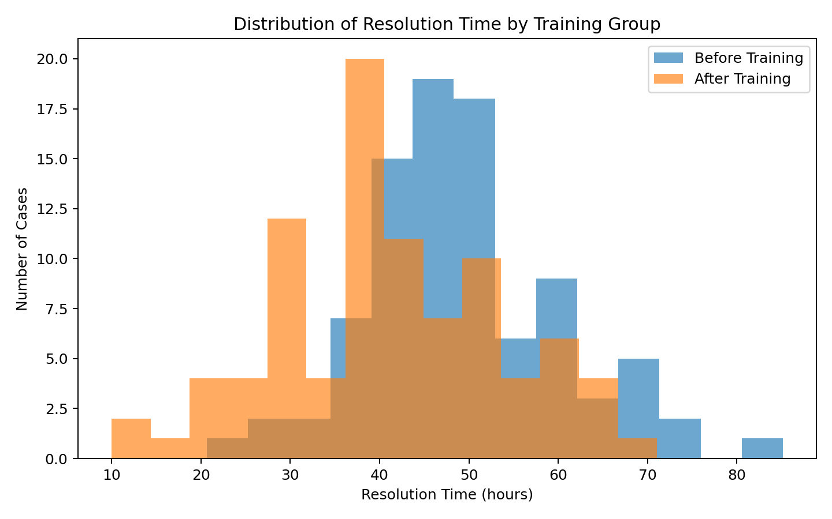
Figure 1. Distribution of resolution times in the two training groups.
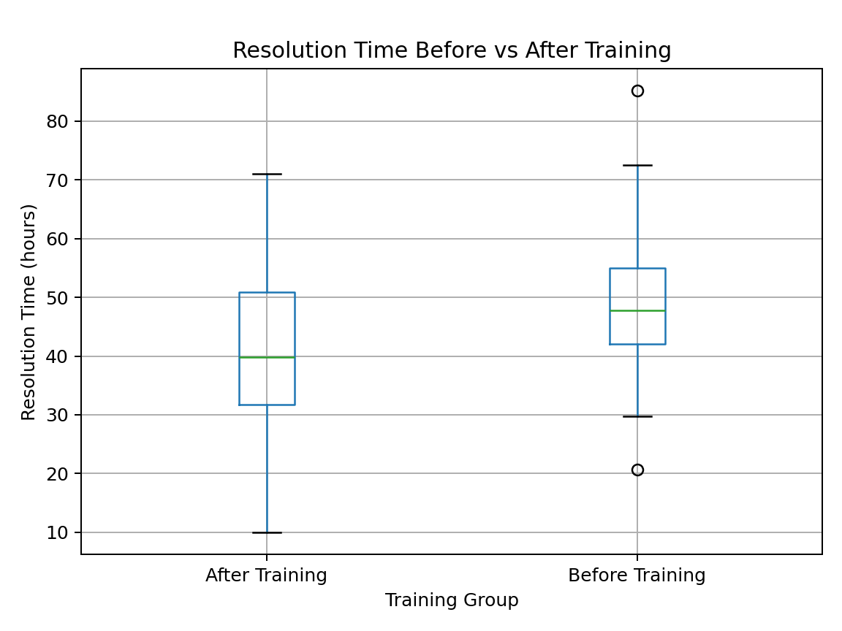
Figure 2. Boxplot comparison of resolution time by training group.

7. Hypothesis Test 1 – Welch's t-test
Welch's t-test was selected because the objective is to compare the means of two independent groups without assuming equal variances. Results: t = 4.534, degrees of freedom ≈ 174.7, p = 1.071e-05.
The estimated mean difference (After − Before) is -8.00 hours. Its 95% confidence interval is [-11.48, -4.52] hours. Because the entire interval is below zero, the data support a reduction in resolution time after training. Cohen's d = -0.68, indicating a substantial standardized difference.
Decision: Reject H₀ at α = 0.05. Interpretation: statistical evidence supports the primary hypothesis in this simulated dataset.

8. Hypothesis Test 2 – Chi-square Test
Observed contingency table:
Training Group | Not Satisfied | Satisfied
After Training | 20 | 70
Before Training | 48 | 42
The Pearson chi-square statistic is χ² = 17.230 with 1 degree(s) of freedom and p = 3.312e-05. Cramer's V = 0.31, which quantifies the strength of association for this 2×2 table.
Decision: Reject H₀ at α = 0.05. Interpretation: the simulated data provide evidence that satisfaction status is associated with training group.
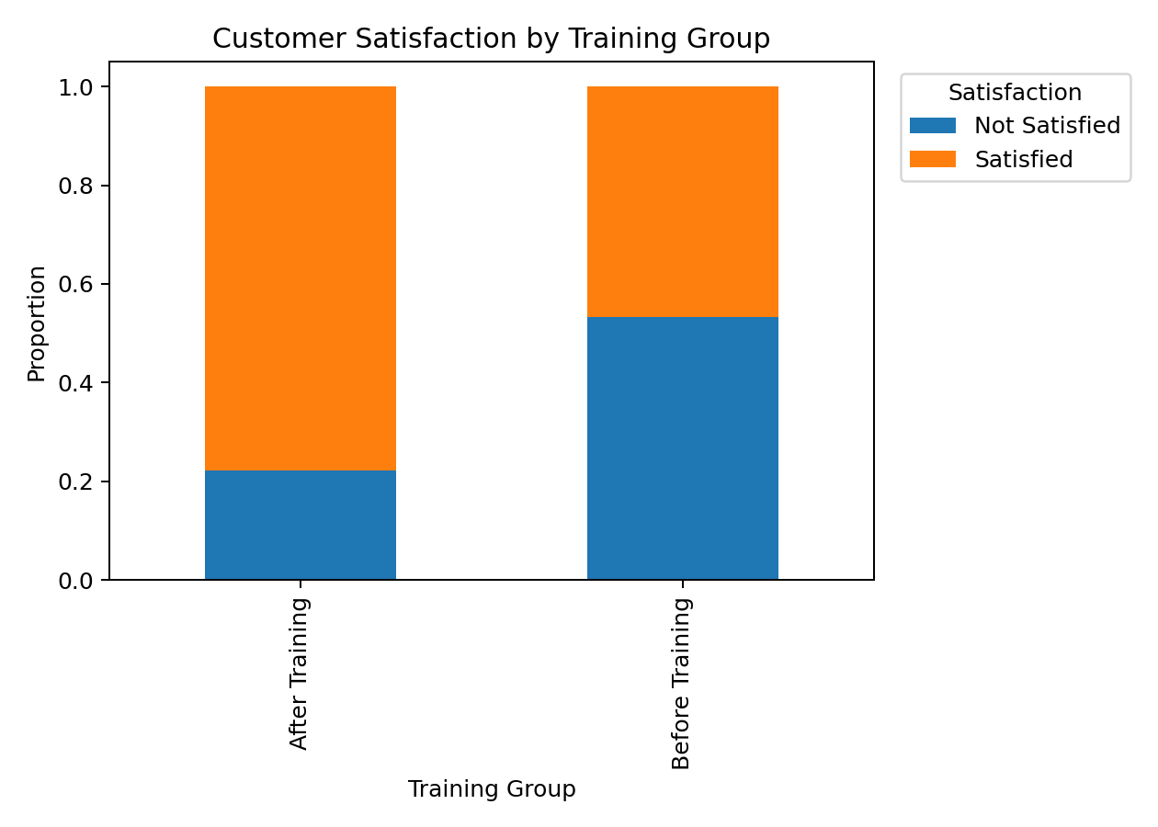
Figure 3. Satisfaction proportions by training group.

9. Hypothesis Test 3 – One-way ANOVA
Channel | N | Mean (hours) | SD (hours)
Chat | 60 | 37.78 | 11.73
Email | 60 | 52.01 | 10.61
Phone | 60 | 45.77 | 10.84
One-way ANOVA gave F = 24.924, p = 2.906e-10. Eta-squared η² = 0.22, representing the proportion of total variance in resolution time attributable to differences among channel means in this dataset.
Decision: Reject H₀ at α = 0.05. A significant ANOVA indicates that at least one channel mean differs; it does not by itself identify which pairs differ. A post-hoc Tukey HSD test would be appropriate for pairwise identification in a production analysis.
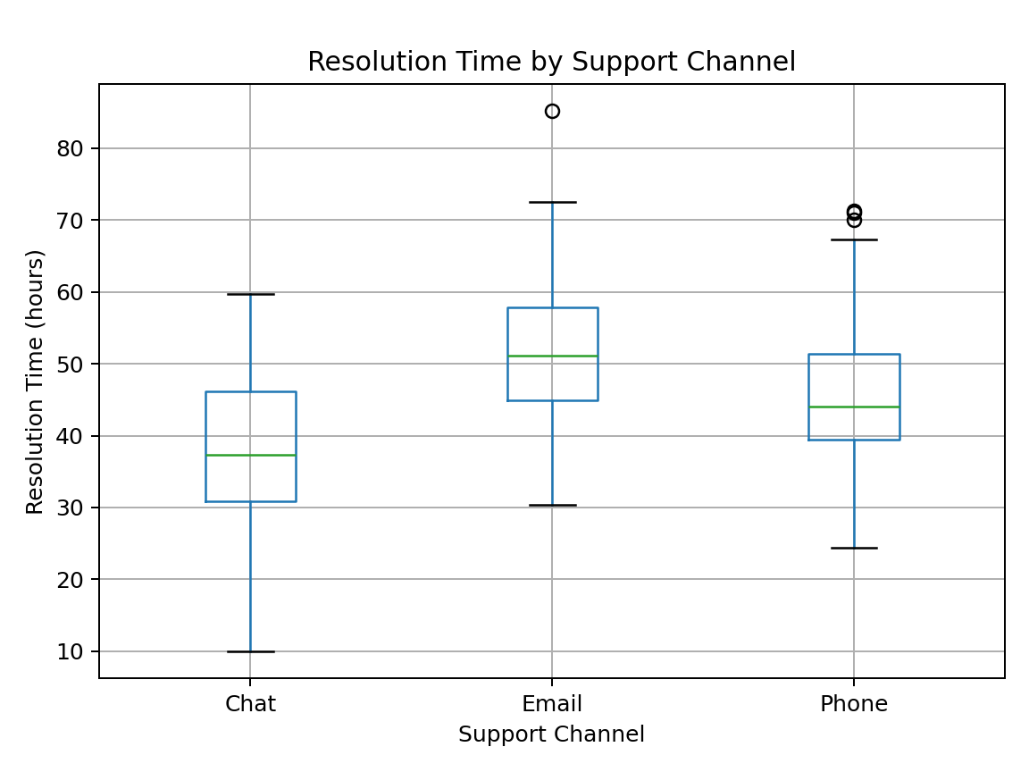
Figure 4. Resolution time by support channel.

10. Assumptions and Statistical Considerations
- Independence: each simulated support case is treated as an independent observation.
- t-test: the Welch version reduces sensitivity to unequal variances; the sample sizes are also balanced.
- Chi-square: expected cell counts should generally be sufficiently large. The generated table satisfies this requirement.
- ANOVA: observations are independent and the residuals should be approximately normal with reasonably similar variances. Boxplots should be inspected for extreme outliers.
- Statistical significance does not automatically imply practical significance; effect sizes and confidence intervals were therefore reported.

11. Overall Findings
- Training and resolution time: mean resolution time fell from 49.18 to 41.19 hours.
- The Welch t-test produced p = 1.071e-05; the 95% CI for the post-minus-pre difference was [-11.48, -4.52] hours.
- Training and satisfaction: chi-square p = 3.312e-05, indicating a statistically significant association.
- Support channel: ANOVA p = 2.906e-10, indicating statistically significant differences among channel means.

12. Conclusion and Business Implications
For this self-generated dataset, the evidence supports the main hypothesis that customer-service training is associated with lower case-resolution time. The analysis also indicates an association between training status and customer satisfaction. Differences among support channels suggest that operational channel mix may also influence resolution performance.
From a business perspective, the results would justify further investigation of the training program, including measurement of training cost, employee productivity, customer retention and satisfaction scores. However, because the dataset is simulated, these findings cannot be generalized to a real organization. A real deployment should use randomized or well-controlled pre/post data, account for case complexity and agent experience, and consider regression or causal-inference methods.

13. Limitations
- The dataset is simulated rather than collected from a real company.
- The design does not establish causality because other factors could influence resolution time.
- No case-complexity variable was included, so confounding is possible.
- The ANOVA section stops at the omnibus test; Tukey HSD should be added if the analysis is extended.

14. Suggested 30–35 Hour Work Plan
Activity | Planned Time
Problem definition and hypothesis design | 3 hours
Dataset design/generation and data dictionary | 4 hours
Data cleaning and exploratory analysis | 5 hours
t-test methodology, assumptions and interpretation | 5 hours
Chi-square analysis and interpretation | 4 hours
ANOVA analysis and visualization | 5 hours
Report writing, formatting and review | 5 hours
Total planned workload: 31 hours. This is a suggested workload allocation, not a claim about actual time spent.

15. Python Code Used
import numpy as np
import pandas as pd
from scipy import stats

# Reproducible data
rng = np.random.default_rng(42)
n = 180

training = np.array(["Before Training"] * 90 + ["After Training"] * 90)
channel = np.array(["Email"] * 60 + ["Chat"] * 60 + ["Phone"] * 60)
rng.shuffle(channel)

channel_effect = {"Email": 8, "Chat": -6, "Phone": 2}
resolution = (
48
+ np.array([channel_effect[c] for c in channel])
- np.where(training == "After Training", 8, 0)
+ rng.normal(0, 10, n)
)
resolution = np.clip(resolution, 10, None)

logit = 0.4 + 0.55 * (training == "After Training") \
- 0.035 * (resolution - resolution.mean())
p = 1 / (1 + np.exp(-logit))
satisfaction = np.where(rng.random(n) < p, "Satisfied", "Not Satisfied")

df = pd.DataFrame({
"Training_Group": training,
"Support_Channel": channel,
"Resolution_Time_Hours": resolution,
"Satisfaction": satisfaction
})

# Welch independent t-test
before = df.loc[df.Training_Group == "Before Training",
"Resolution_Time_Hours"]
after = df.loc[df.Training_Group == "After Training",
"Resolution_Time_Hours"]
t_stat, t_p = stats.ttest_ind(before, after, equal_var=False)

# Chi-square test
table = pd.crosstab(df["Training_Group"], df["Satisfaction"])
chi2, chi_p, chi_df, expected = stats.chi2_contingency(table)

# One-way ANOVA
groups = [
df.loc[df.Support_Channel == c, "Resolution_Time_Hours"]
for c in ["Email", "Chat", "Phone"]
]
f_stat, f_p = stats.f_oneway(*groups)

print("t-test:", t_stat, t_p)
print("chi-square:", chi2, chi_p)
print("ANOVA:", f_stat, f_p)

16. Reproducibility Notes
The random seed is fixed at 42, so rerunning the data-generation section reproduces the same dataset and statistical results. Recommended packages are numpy, pandas, scipy, statsmodels and matplotlib.

END OF REPORT

