Reference Link:- https://drive.google.com/file/d/1Acv3Lx3PtJcOYkUjREWAzIoC- i6w96Tl/view?usp=drive_link

Milestone 2: Backend Development:

- Setup express server
  - Create index.js file in the server (backend folder).
  - Create a .env file and define port number to access it globally.
  - Configure the server by adding cors, body-parser.

User Authentication:
  - Create routes and middleware for user registration, login, and logout.
  - Set up authentication middleware to protect routes that require user authentication.

Define API Routes:
  - Create separate route files for different API functionalities such as users orders, and authentication.
  - Define the necessary routes for listing products, handling user registration and login,managing orders, etc.
  - Implement route handlers using Express.js to handle requests and interact with the database.

Implement Data Models:
  - Define Mongoose schemas for the different data entities like products, users, and orders.
  - Create corresponding Mongoose models to interact with the MongoDB database.
  - Implement CRUD operations (Create, Read, Update, Delete) for each model to perform database operations.

User Authentication:
  - Create routes and middleware for user registration, login, and logout.

  - Set up authentication middleware to protect routes that require user authentication.

Error Handling:
  - Implement error handling middleware to catch and handle any errors that occur during the API requests.
  - Return appropriate error responses with relevant error messages and HTTP status codes.

Reference Link:- https://drive.google.com/file/d/18-
gnCVAZdojBhl7QM0_yShH1JL5A6v32/view?usp=drive_link

Milestone 3: Database:
- Configure MongoDB:
  - Install Mongoose.
  - Create database connection.
  - Create Schemas S Models.

Connect database to backend:
Now, make sure the database is connected before performing any of the actions through the backend. The connection code looks similar to the one provided below.

const mongoose = require("mongoose");

const db= 'mongodb://127.0.0.1:27017/grocery'
// Connect to MongoDB using the connection string

mongoose.connect(db, { useNewUrlParser: true, useUnifiedTopology: true,
}).then(() => {
console.log(`Connection successful`);
}).catch((e) => {
console.log(`No connection: ${e}`);
});

Configure Schema:
Firstly, configure the Schemas for MongoDB database, to store the data in such pattern. Use the data from the ER diagrams to create the schemas.
The schemas are looks like for the Application.
const mongoose = require('mongoose');

const userSchema = new mongoose.Schema({ firstname: { type: String},
lastname: { type: String },
username: { type: String, unique: true }, email: { type: String},
password: { type: String }
});

// category schema
const categorySchema = new mongoose.Schema({ category: { type: String, required: true, unique: true, }, description: { type: String, }
});

const productSchema = new mongoose.Schema({ productname: { type: String, required: true }, description: { type: String, required: true }, price: { type: Number, required: true },
image: { type: String, required: true },
category: { type: String, ref: 'Category', required: true }, countInStock: { type: Number, required: true, min: 0 }, rating: { type: Number, required: true },
dateCreated: { type: Date, default: Date.now }
});

const addToCartSchema = new mongoose.Schema({ userId: { type: String, required: true },
productId: { type: String, required: true },
quantity: { type: Number, minimum: 1, required: true, default: 1 },
});

const orderSchema = new mongoose.Schema({ firstname: { type: String, required: true }, lastname: { type: String, required: true },
user: { type: String, ref: 'User', required: true }, phone: { type: String, required: true }, productId: { type: String, required: true }, productName: { type: String, required: true }, quantity: { type: String, default: 1 },

price: { type: String, required: true },
status: { type: String, enum: ['Pending', 'Confirmed', 'Shipped', 'Delivered', 'Canceled',], default: 'Pending' }, paymentMethod: { type: String, required: true },
address: { type: String, required: true }, createdAt: { type: Date, default: Date.now }
});

const models = {
Users: mongoose.model('User', userSchema),
Category: mongoose.model('Category', categorySchema), Product: mongoose.model('Product', productSchema), AddToCart: mongoose.model('AddToCart', addToCartSchema), Order: mongoose.model('Order', orderSchema),

};

module.exports = models;

Milestone 4: Frontend Development:

- Setup React Application:
  - Create React application.
  - Configure Routing.
  - Install required libraries.

Design UI components:
  - Create Components.
  - Implement layout and styling.
  - Add navigation.

Implement frontend logic:
  - Integration with API endpoints.
  - Implement data binding.

Reference:- https://drive.google.com/file/d/1MFQ7NIQ02ynLioEMySPpEzdX- c0i6Wer/view?usp=drive_link

Milestone 5: Project Implementation:

Finally, after finishing coding the projects we run the whole project to test it’s working process and look for bugs. Now, let’s have a final look at the working of our Darshan Ease.

Landing page:-
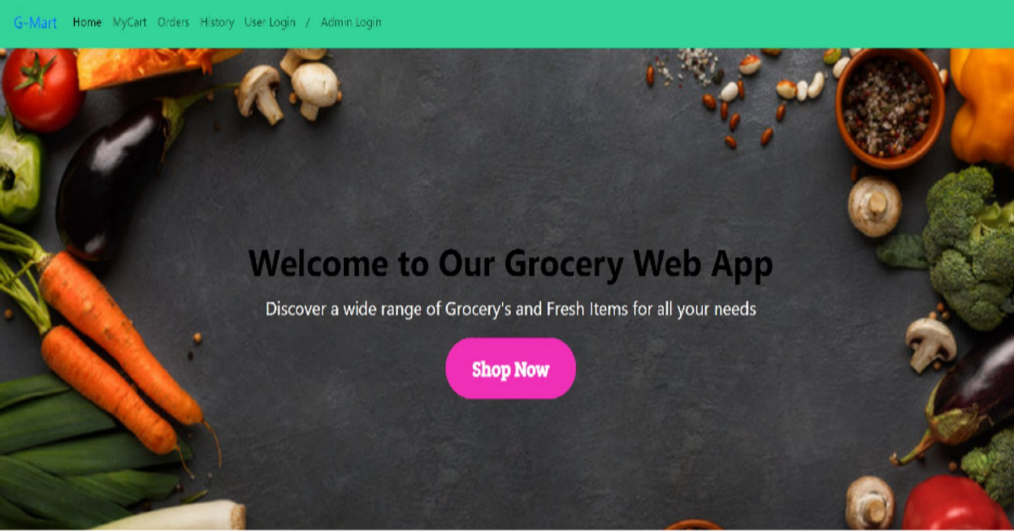
Login Page:-

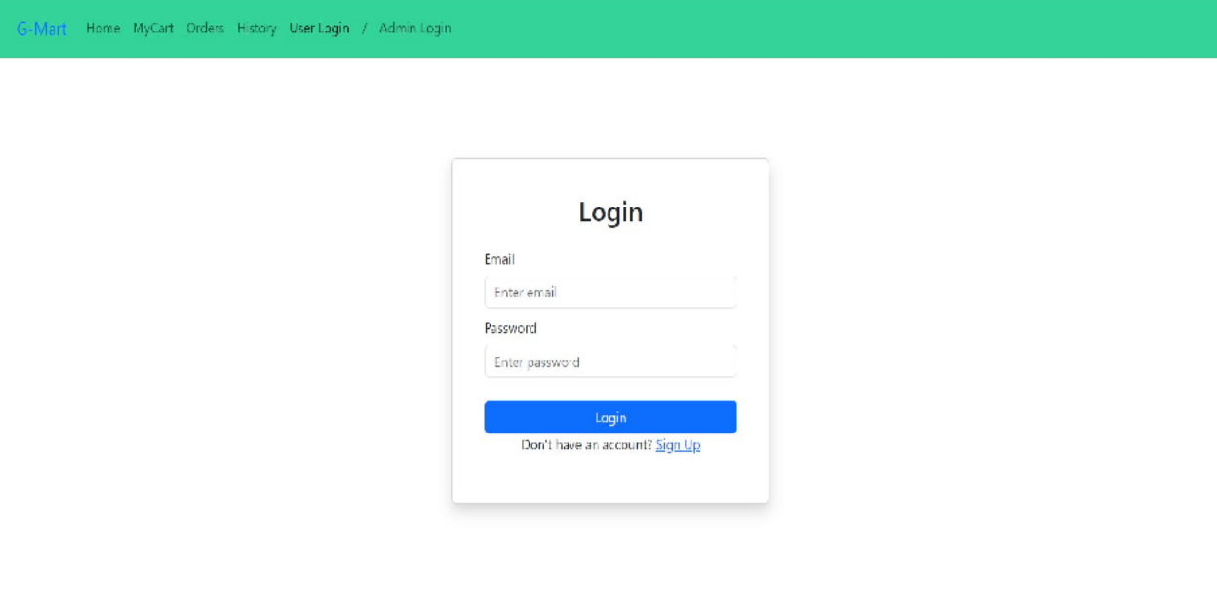
Items Page:-
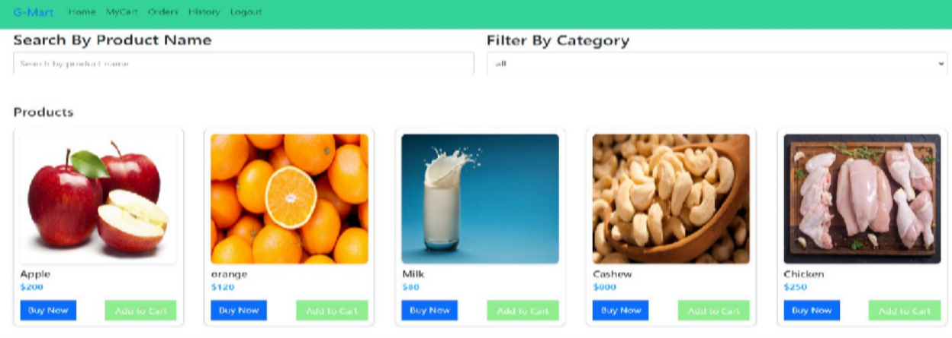
My Cart:-

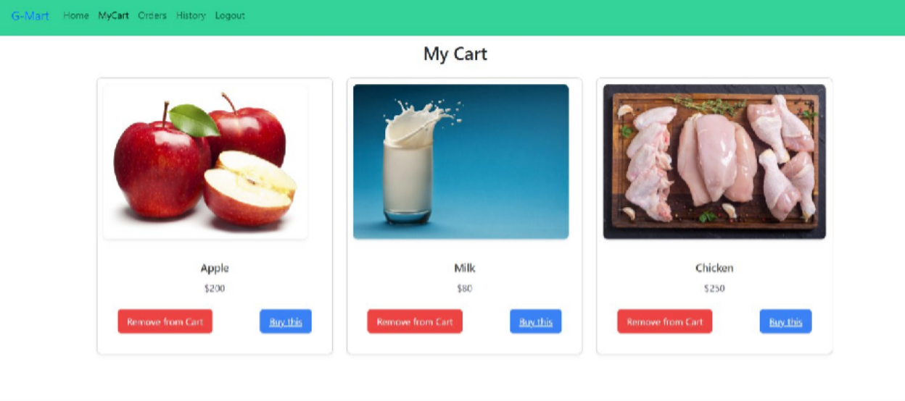
My Orders Page:-
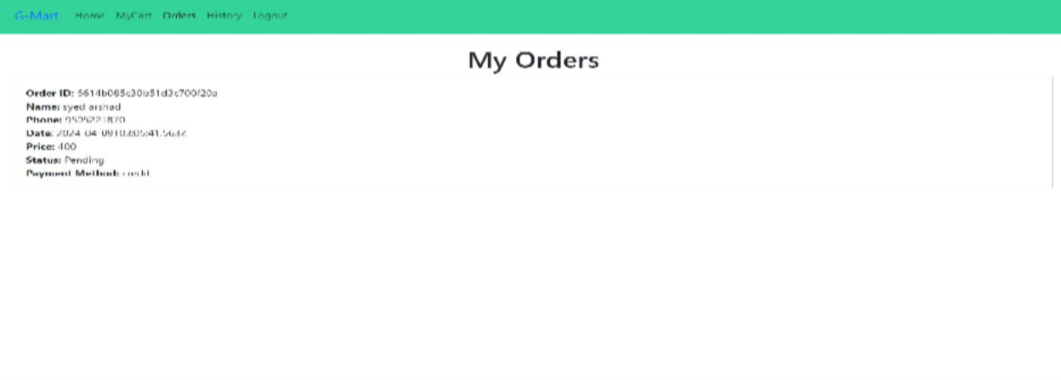
My History Page:-

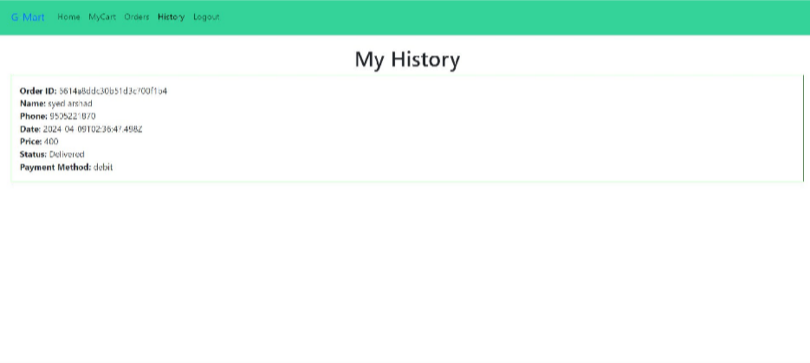
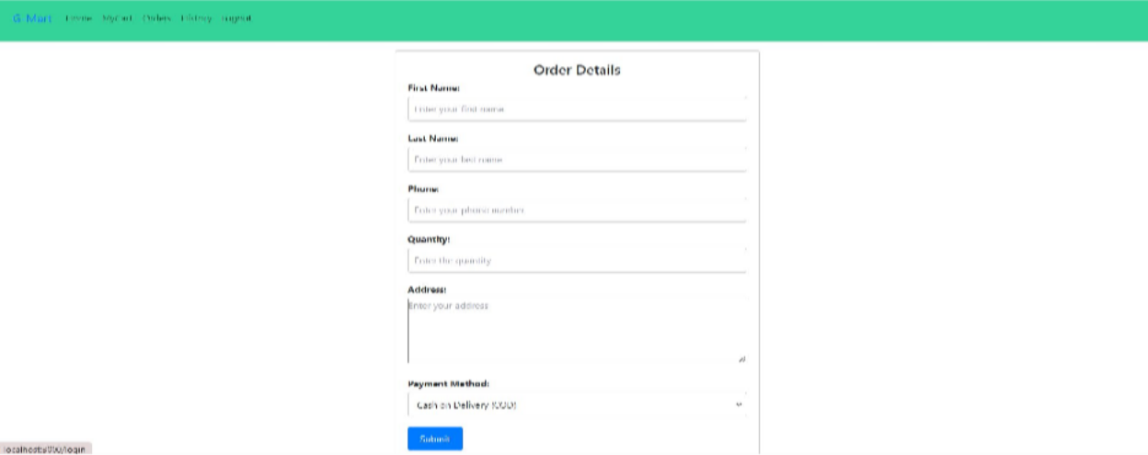
Place Order Page:-
Admin Dashboard Page:
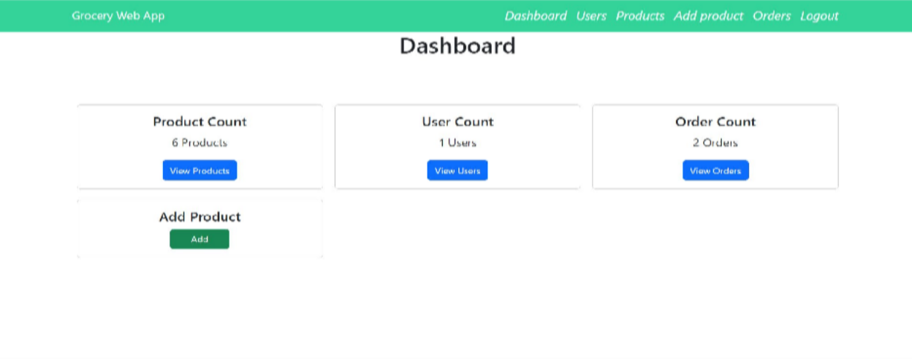
Users Page:-

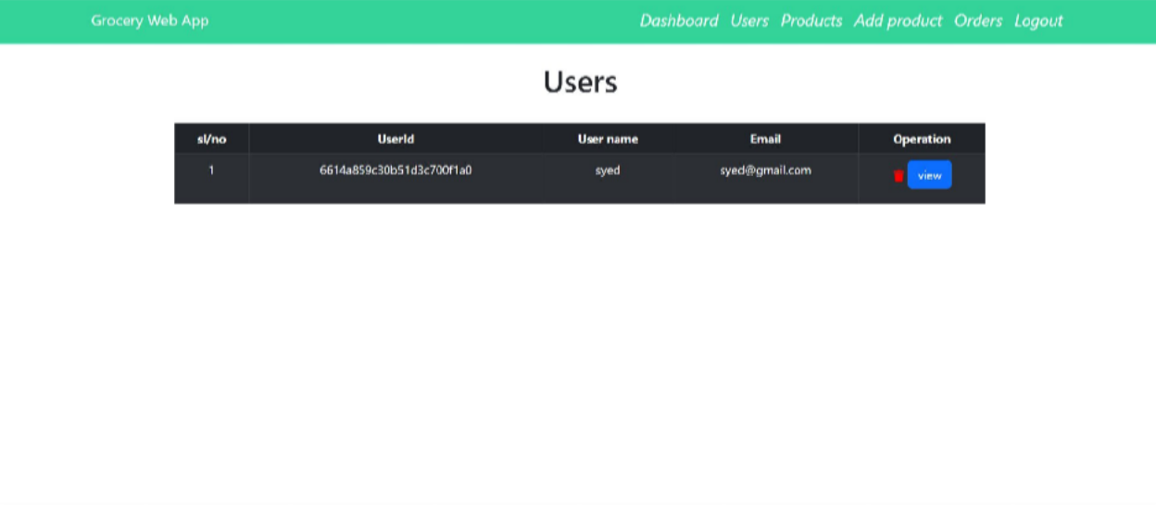
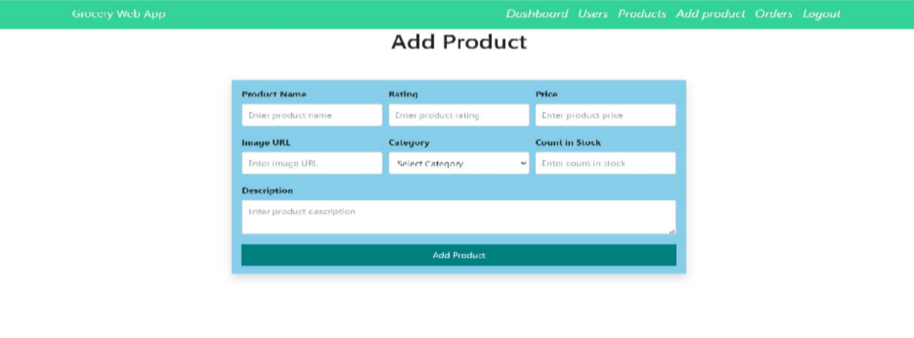
Add Product page:-
Admin Orders Page:-
