Dashboard Interactions: Filter Action and Navigation Action
Both actions are configured on the Regional Performance Summary table on the Sales Pipeline sheet. A single left-click on a region runs the filter action, and right-clicking a region offers the navigation action to the Customer Health sheet.

1. One-Click Filter Action (two or more visuals)
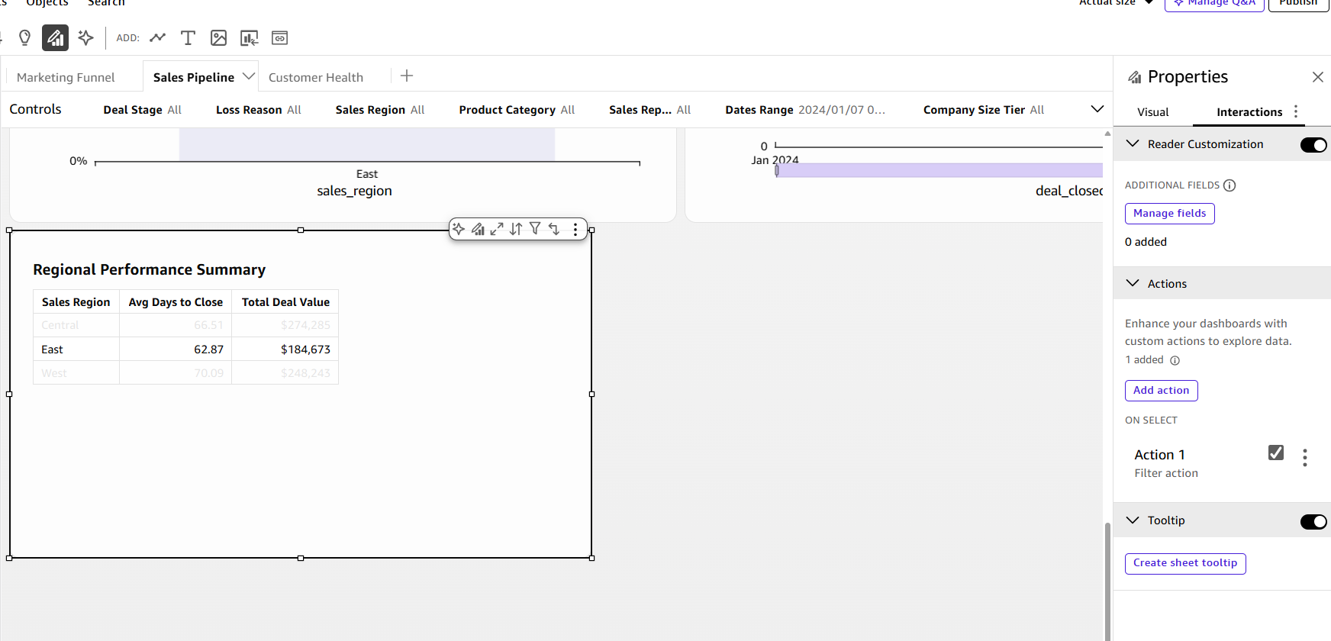
Figure 1. Action 1 is a Filter action listed under "On select," so one click on a row triggers it. Here East has been clicked and the table highlights the selected row.
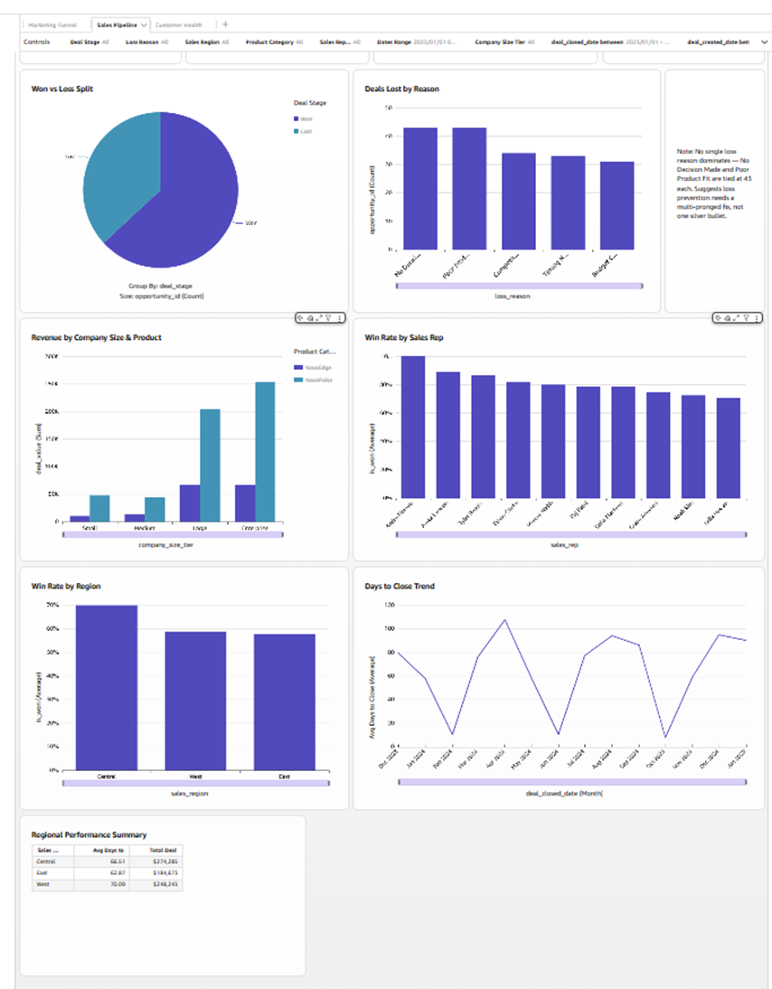
Figure 2. Before: no region selected. Win Rate by Region shows Central, West, and East, and the Revenue by Company Size & Product axis runs to $300K.
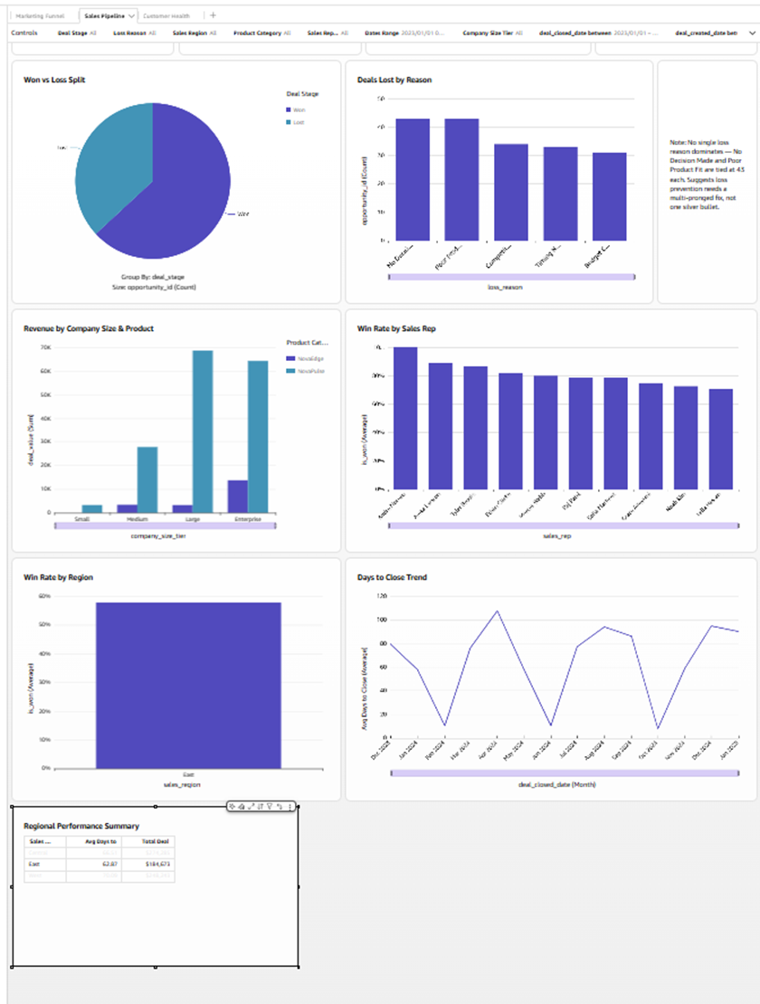
Figure 3. After one click on East in the Regional Performance Summary table: Win Rate by Region now shows East only, and Revenue by Company Size & Product drops to East's figures (axis now tops out near $70K). At least two visuals are filtered by a single click.

2. Cross-Sheet Navigation Action
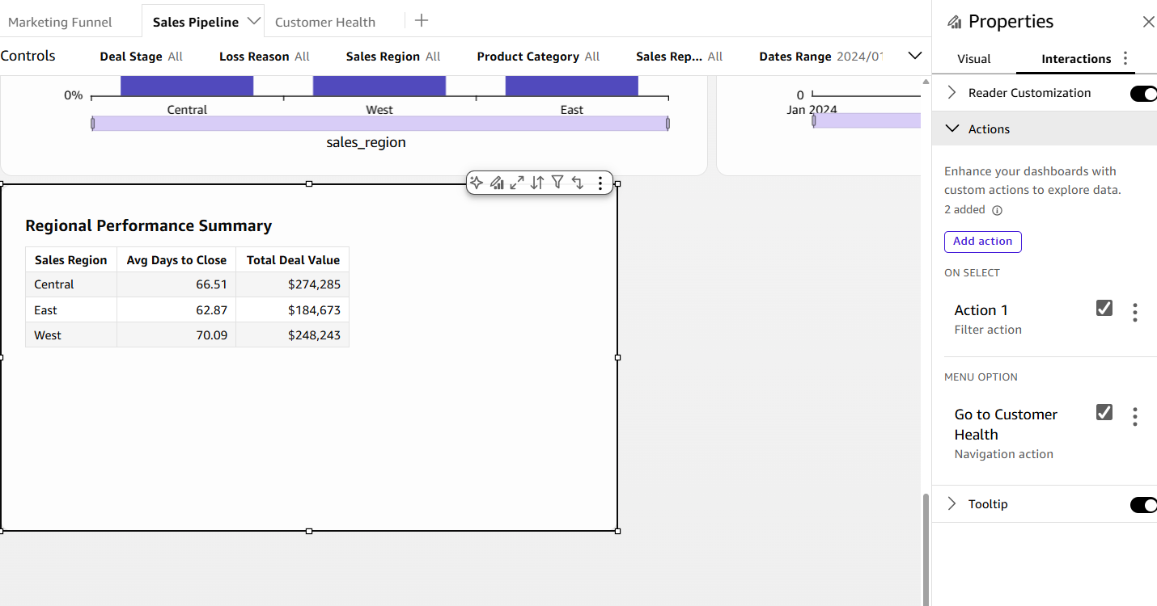
Figure 4. The table carries two actions: Action 1 (Filter action, On select) and "Go to Customer Health" (Navigation action, Menu option), which links the Sales Pipeline sheet to the Customer Health sheet.
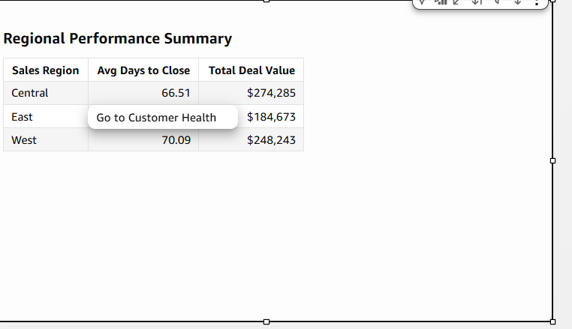
Figure 5. Right-clicking a region shows "Go to Customer Health." Choosing it opens the Customer Health sheet.

