Quick Chat: Baseline vs. Post-Topic Comparison
The same three questions were asked in Quick Chat before the NovaTech Revenue Intelligence Topic was configured (baseline) and again afterward. In the baseline answers, the source chip under each answer names a single raw dataset (novatech_marketing… or novatech_crm_deal…). In the post-Topic answers, every source chip reads "NovaTech Revenue…", confirming the answers now come from the configured Topic.

Baseline (before Topic configuration)
Question 1: Which campaign source has the highest conversion rate?

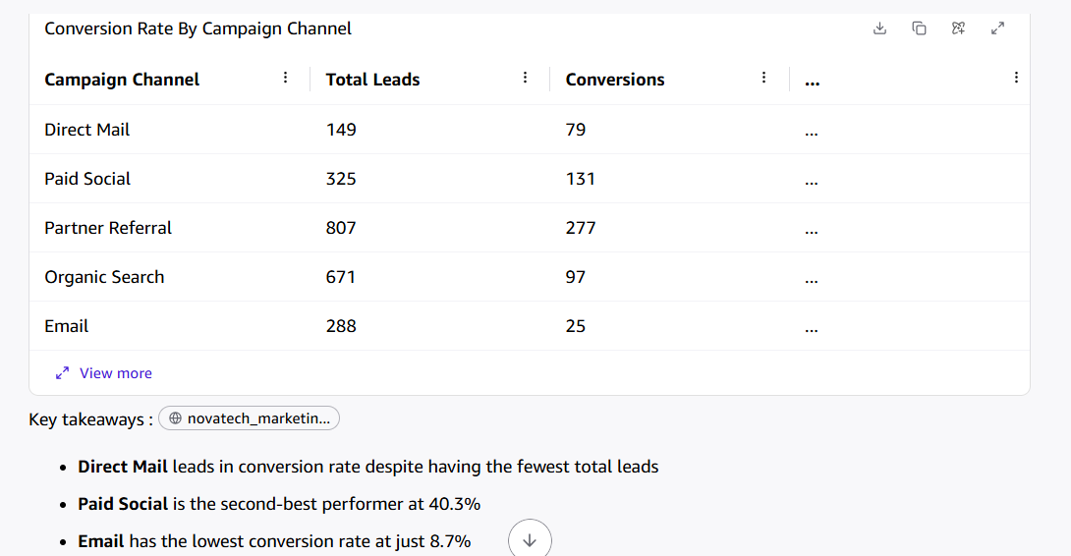
Baseline answer: Direct Mail at 53.0%, sourced from the raw marketing dataset. The table lists lead and conversion counts but not the rate for each channel.
Question 2: What is the average deal size for accounts with more than 3 support tickets in the last 30 days?
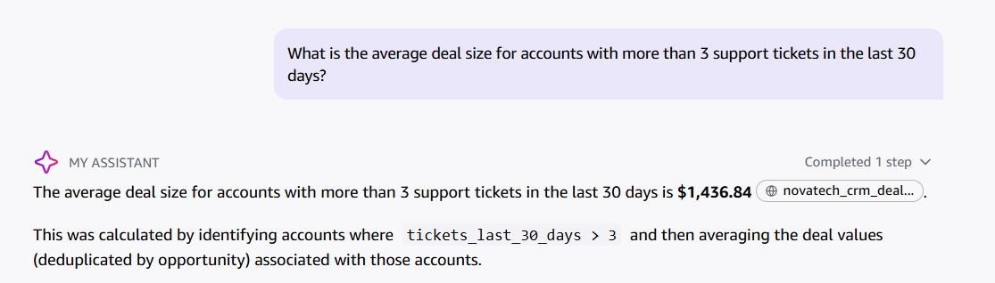
Baseline answer: $1,436.84, sourced from the raw CRM deals dataset.
Question 3: What's our win rate for deals sourced from Partner Referral?

Baseline answer: 65.14% (241 of 370 opportunities), sourced from the raw CRM deals dataset.

After Topic configuration (same three questions)
Question 1: Which campaign source has the highest conversion rate?

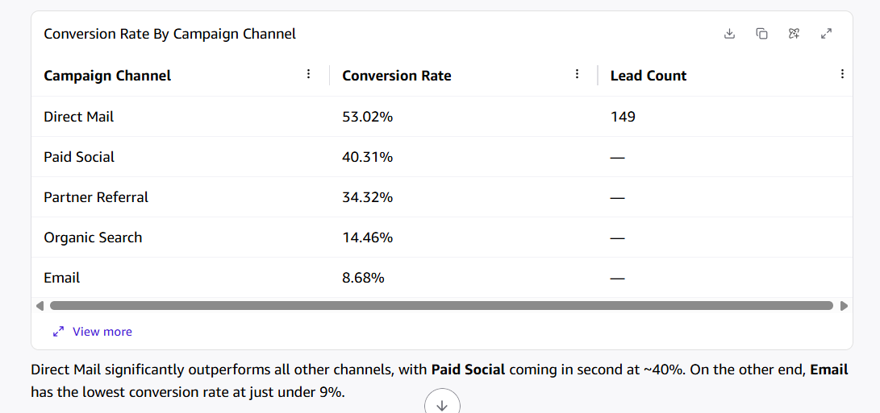
Post-Topic answer: Direct Mail at 53.0%, now sourced from the Topic. The table now shows the conversion rate for all five channels (53.02%, 40.31%, 34.32%, 14.46%, 8.68%), which match the dashboard's Response Rate by Channel table exactly. Changed: the answer uses the Topic and reports rates, not just counts.
Question 2: What is the average deal size for accounts with more than 3 support tickets in the last 30 days?
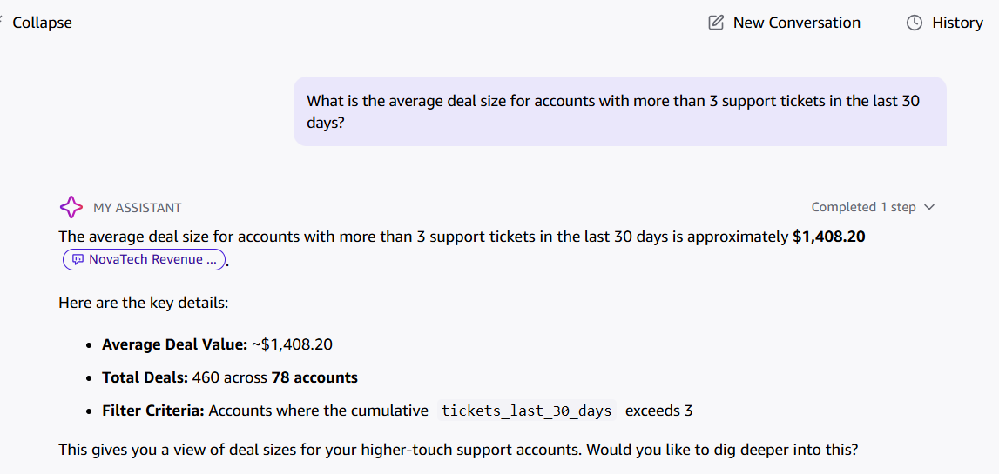
Post-Topic answer: about $1,408.20 across 460 deals and 78 accounts, sourced from the Topic. Changed: the value moved from $1,436.84, and the answer now states the deal and account counts behind it.
Question 3: What's our win rate for deals sourced from Partner Referral?
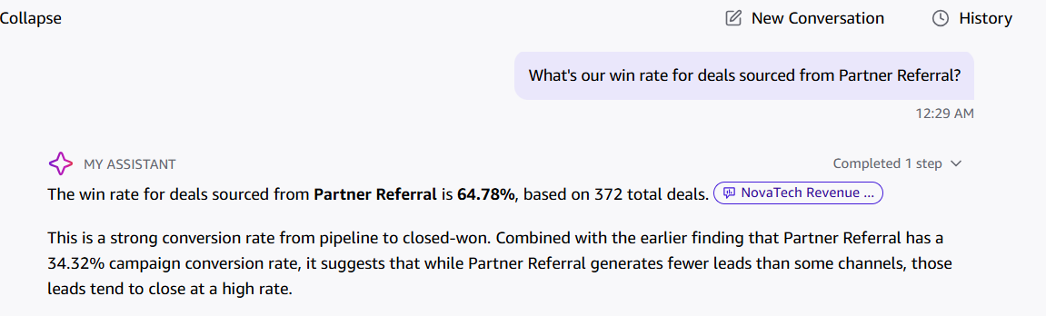
Post-Topic answer: 64.78% based on 372 deals, sourced from the Topic. Changed: the rate moved from 65.14%, and the answer links it to Partner Referral's 34.32% campaign conversion rate.

