Data Transformations: Data Types and Calculated Fields
This document shows how the three NovaTech source files were prepared in QuickSight before they were joined: the data type assigned to each field, and the calculated fields added to support the dashboard metrics. The joins themselves are documented separately in Unified_Dataset_Join_Documentation.docx.

1. Source Datasets
Dataset | File | Rows | Columns | Date range
CRM Deals | novatech_crm_deals.csv | 499 | 20 | 2023-06-17 to 2025-01-25
Marketing Campaigns | novatech_marketing_campaigns.csv | 2,240 | 20 | 2023-01-01 to 2025-01-31
Support Tickets | novatech_support_tickets.csv | 3,000 | 20 | 2023-06-01 to 2025-02-28

2. Data Types
Each field was checked in the dataset editor so that dates are stored as dates, money and rates as decimals, and counts as whole numbers. Correct types are what allow QuickSight to group by month, sum revenue, and average rates.
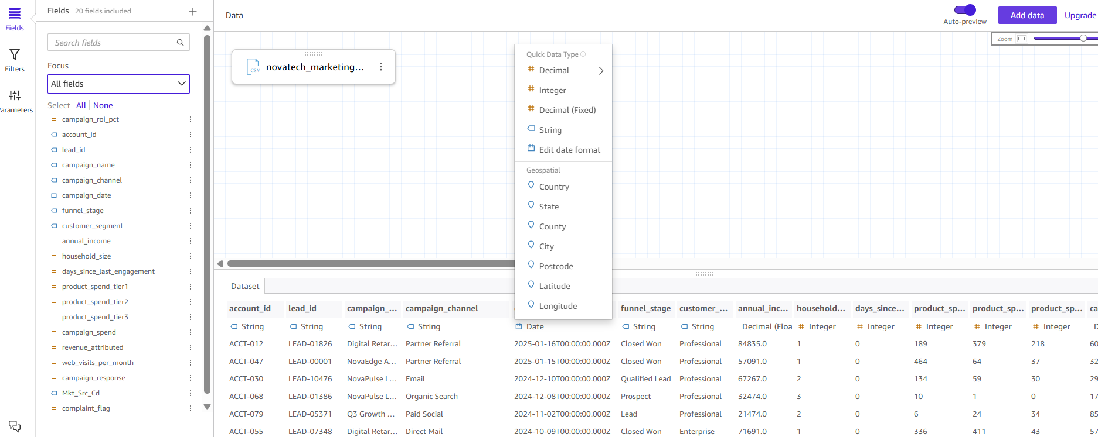
Figure 1. The data type menu for campaign_date in the Marketing Campaigns dataset editor. The column is set to Date (shown under the column name), so campaigns can be grouped and filtered by month.
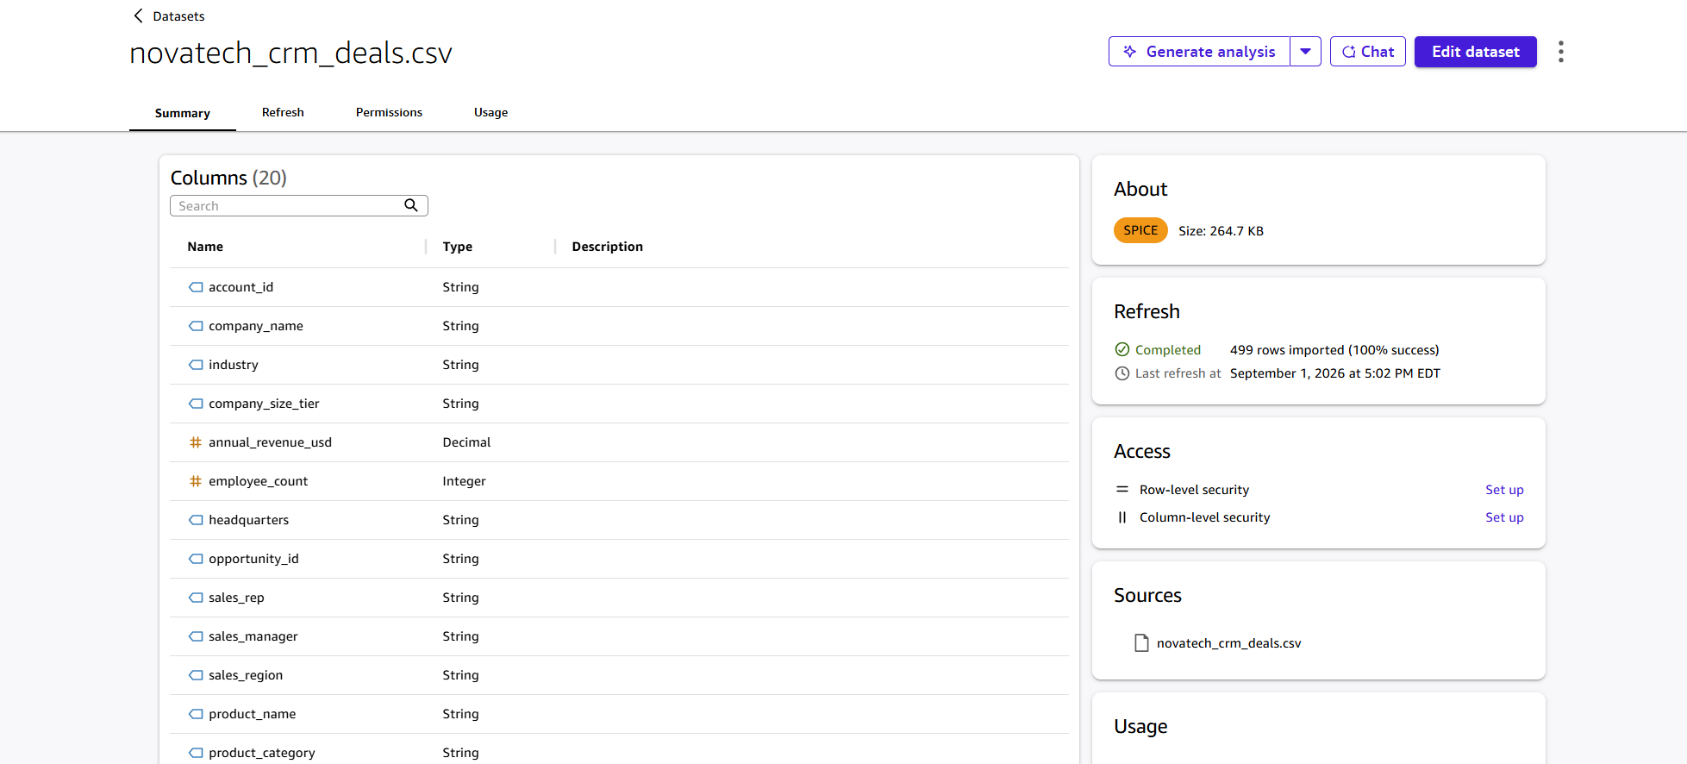
Figure 2. CRM Deals after import: annual_revenue_usd is Decimal and employee_count is Integer, with text fields such as account_id and sales_region as String.
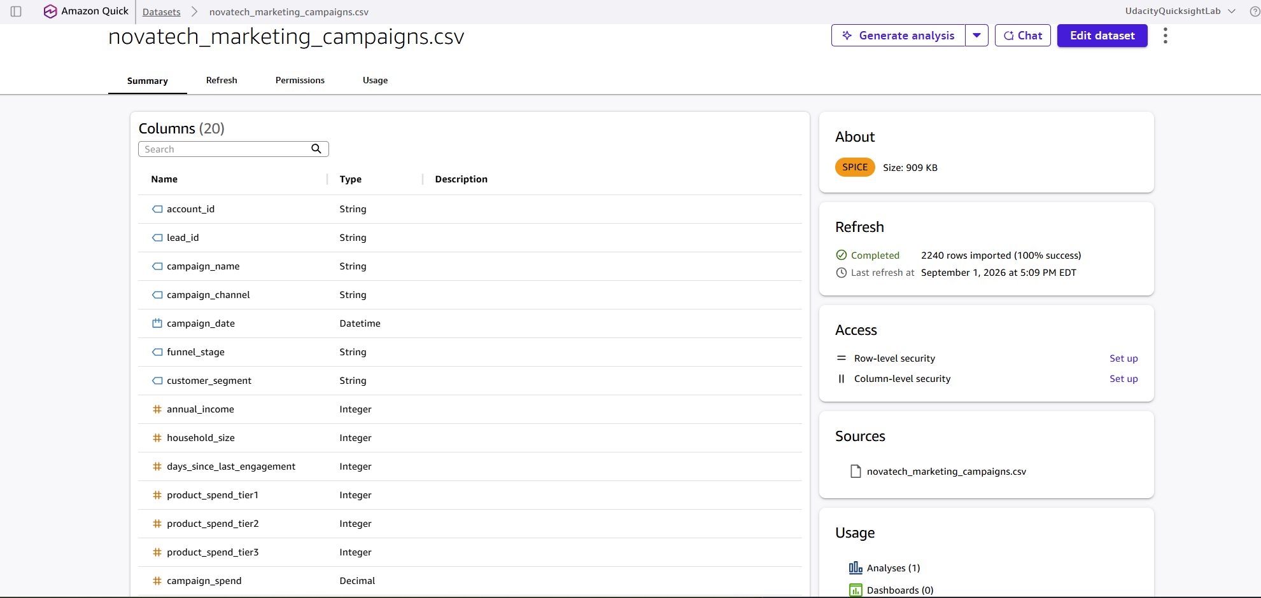
Figure 3. Marketing Campaigns after import: campaign_date is Datetime, campaign_spend is Decimal, and household and engagement counts are Integer.
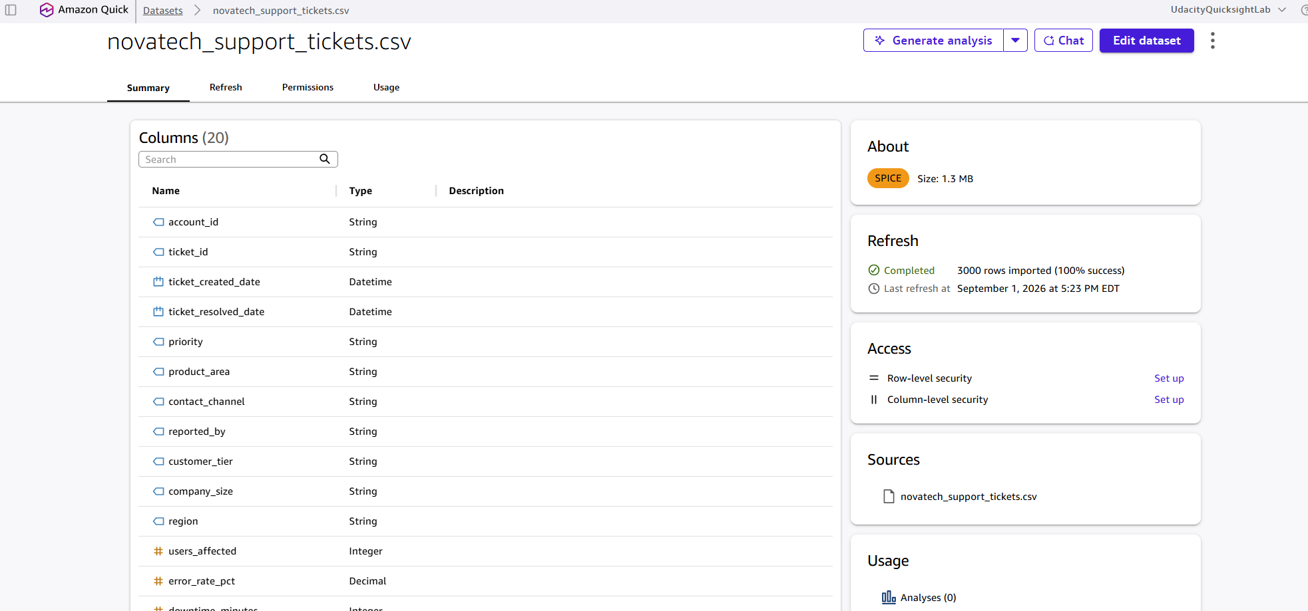
Figure 4. Support Tickets after import: ticket_created_date and ticket_resolved_date are Datetime, users_affected is Integer, and error_rate_pct is Decimal.

3. Calculated Fields
Calculated fields are new columns derived from existing ones. They turn raw records into the measures the dashboard reports.
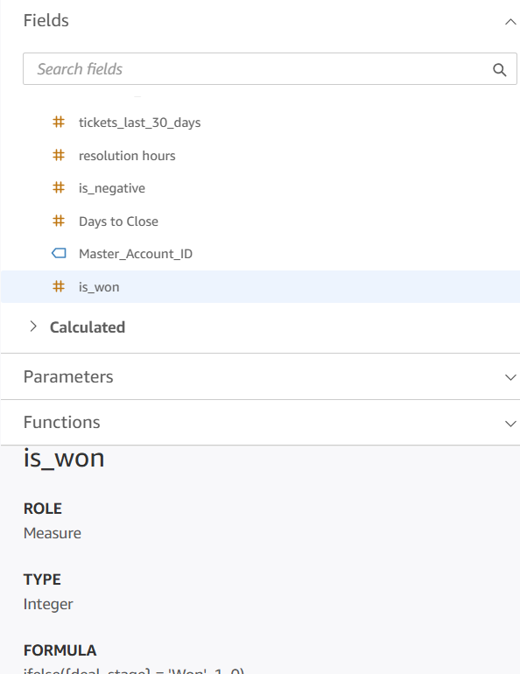
Figure 5. is_won returns 1 for a won deal and 0 otherwise. Averaging it gives the win rate shown on the Sales Pipeline sheet (63.13%).
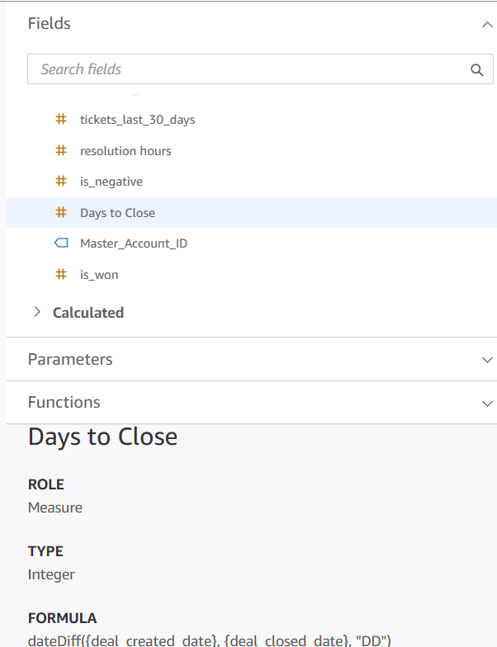
Figure 6. Days to Close counts the days between a deal's created date and closed date. It feeds the Average Days to Close card, the Days to Close Trend, and the Regional Performance Summary.
The field lists above also show the other calculated fields used in the dashboard: resolution hours (whole hours between a ticket being opened and resolved, used in Resolution Time by Priority), is_negative (1 for a negative-sentiment ticket, averaged to give % Negative Sentiment), Master_Account_ID, and campaign_roi_pct in the Marketing dataset (used for Overall Campaign ROI %).

