Q Topic Configuration (Semantic Layer)

Relationships connect all five datasets on account_id.
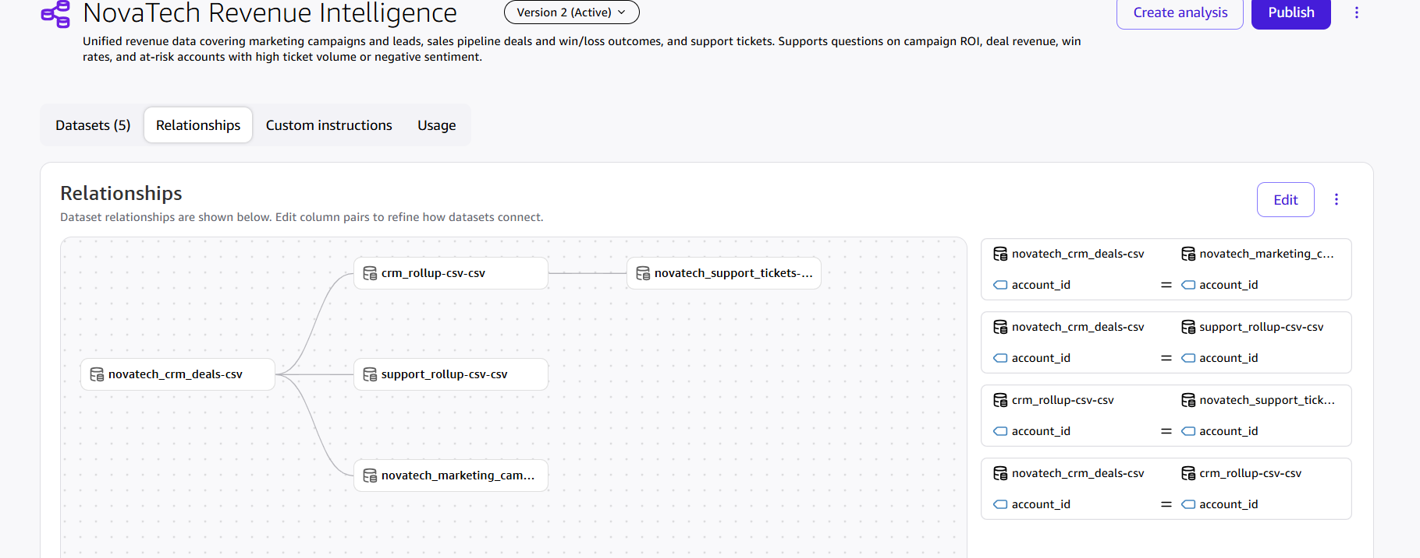

The Topic includes the three source datasets plus two account-level rollups.
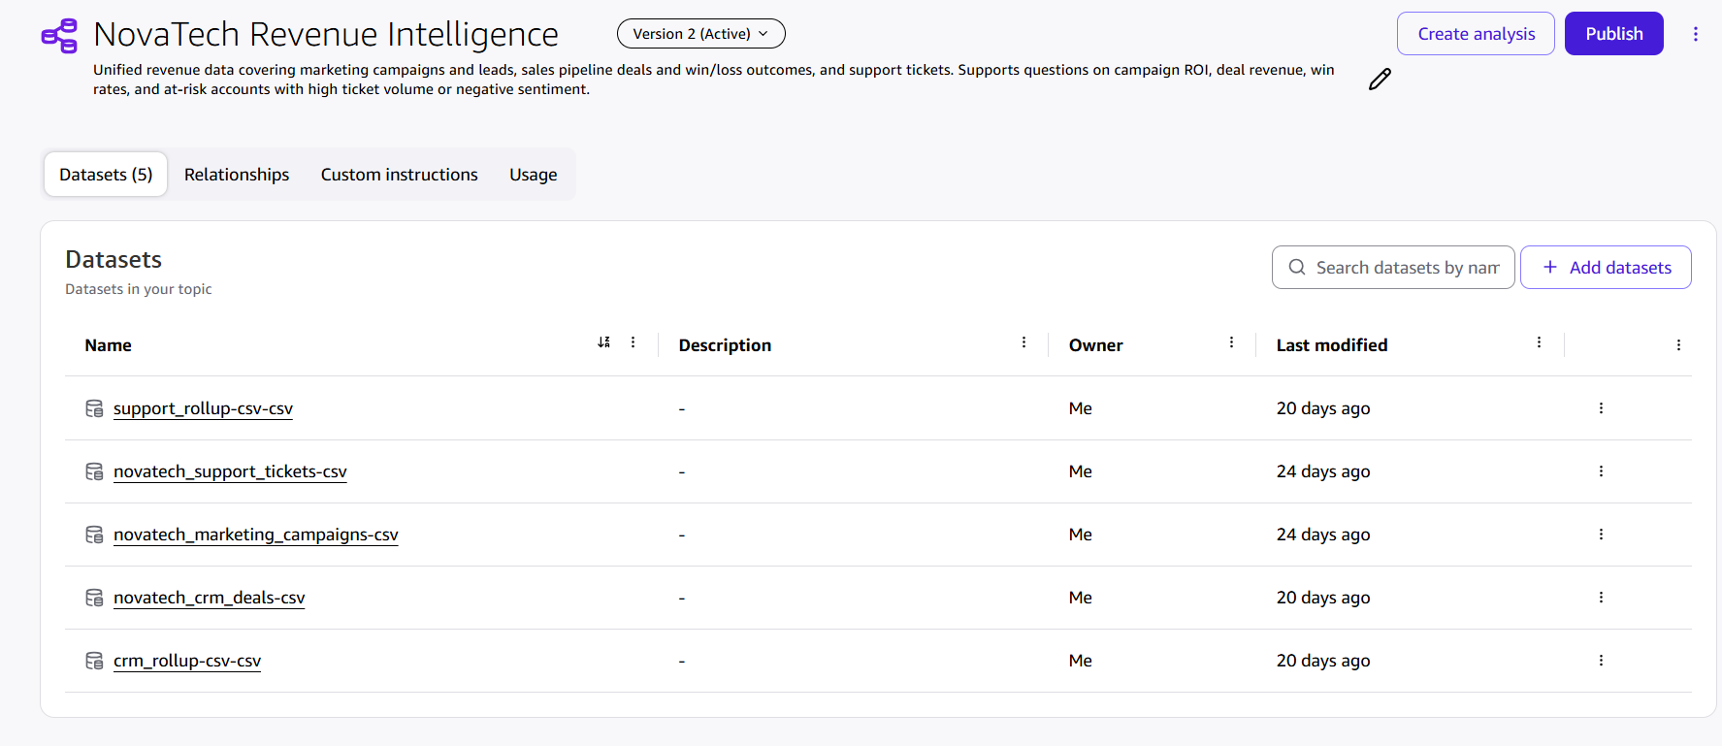

Custom instructions define business-term synonyms, default aggregations, and join rules that stop Q from double-counting revenue.

