Unified Dataset — Join Diagram, Join Configuration & Anchor Table
Anchor table: novatech_crm_deals.csv (CRM Deals) — this is the base table all other sources are joined onto. It contains one row per sales opportunity across NovaTech's 85 accounts and determines the row-level granularity of the unified dataset.
Join key: account_id, present in all three source datasets.
Join type: Left join — CRM Deals (anchor) is left-joined to Marketing Campaigns and left-joined to Support Tickets, so every CRM account is preserved even if it has no matching marketing or support activity.

Screenshot 1: Join Diagram & Configuration (Flat Unified Dataset)
CRM Deals (anchor, left) is joined on account_id to Marketing Campaigns and to Support Tickets (both joined nodes shown to the right). The dataset is saved in QuickSight as unified_novatech_dataset and totals 63 fields and 63,420 rows. Each join icon shows one blue and one grey circle, which is how QuickSight marks a left join.
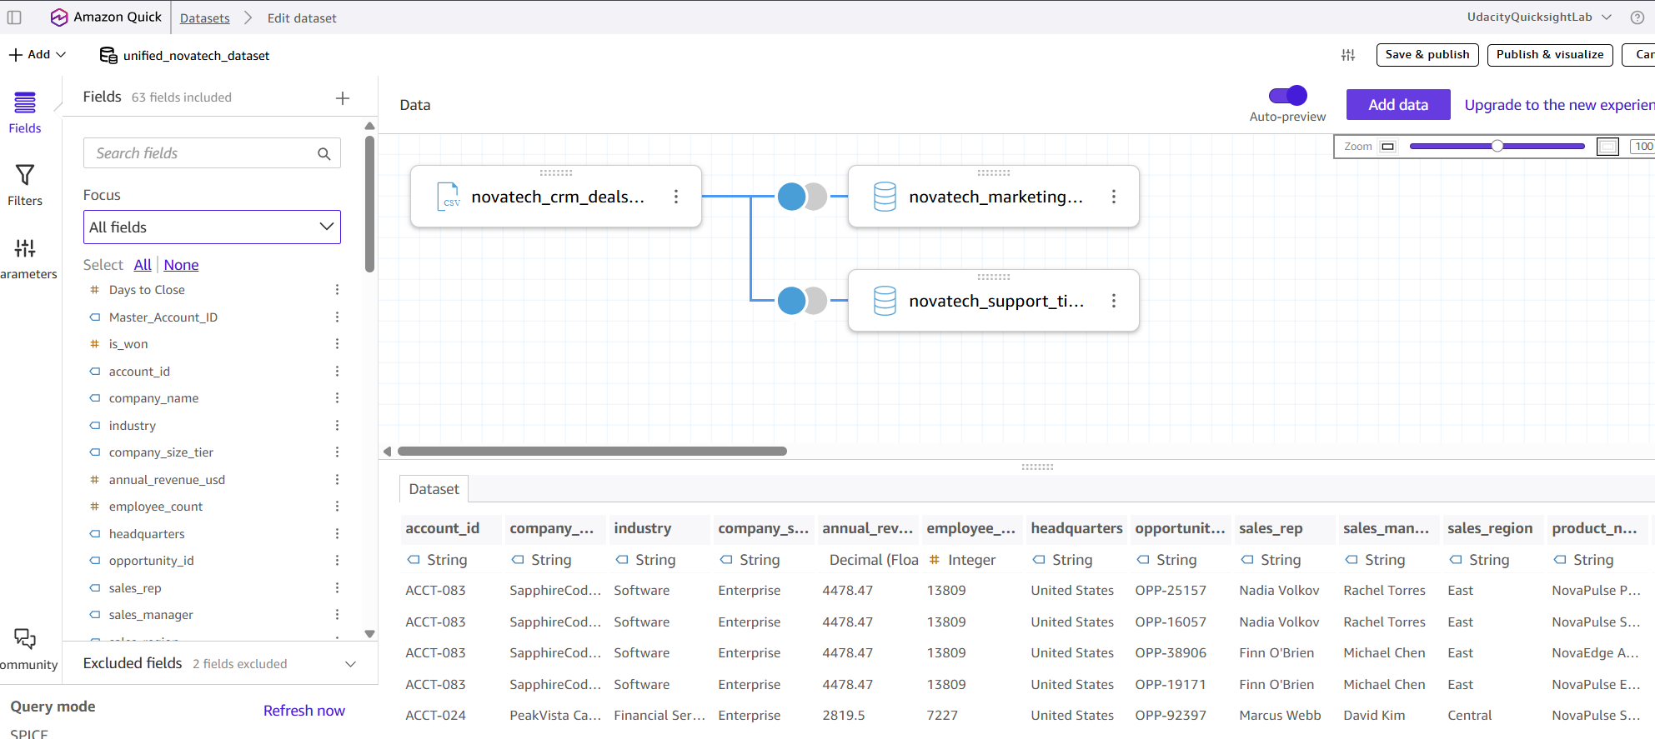

Screenshot 2: Account-Level Rollup Join (used for Customer Health sheet)
To avoid the row-multiplication ("fan-out") that the flat join above produces at the ticket level, a second join pre-aggregates Support Tickets and CRM Deals to one row per account before joining: support_rollup.csv (ticket_count, pct_negative) joined to crm_rollup.csv (total_deal_revenue) on account_id. This is a left join with support_rollup.csv on the left, so all 100 accounts that filed support tickets are kept and all 3,000 tickets are counted; the 15 accounts that have tickets but no deals show blank revenue. This clean, one-row-per-account dataset powers the At-Risk Accounts table on the Customer Health sheet.
