Assignment-2

Below screenshot shows changing password is not possible because user is giving blank input which is not accept by Linux authentication method.

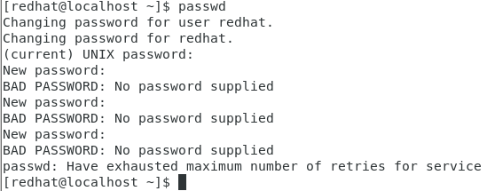

Below screenshot shows changing password is not possible because user is giving less than 8 character input which is not accept by Linux authentication method. So after 3 attempts password changing service is abort

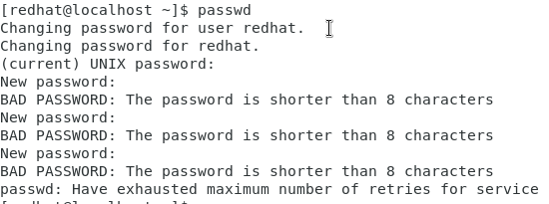

Below screenshot shows changing password is possible because user is giving 8 character input which is accept by Linux authentication method and Linux best practice is also follow.

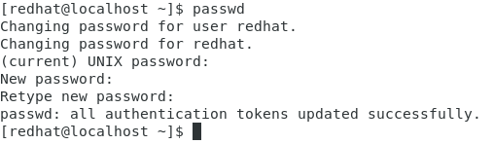

Assignment-3

Below screenshot shows the root directory where system files of Linux like in C: drive of windows.

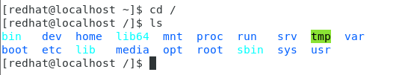

Below screenshot shows the user profile name

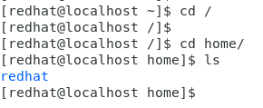

Below screenshot shows when we provide command cd .. it change the current directory.

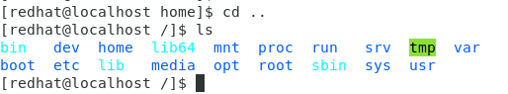

Below screenshot shows when we provide command cd we are back to root files of Linux



Below screenshot shows that from user mode we are not authorize.



Assignment-4

Below screenshot shows that hierarchy of config file. This config files are locally operable.

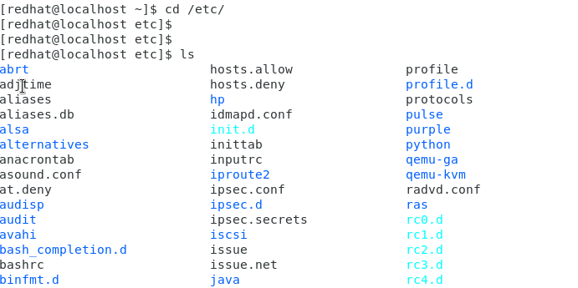

cd /root files are all system files like in c: drive but cd /etc/ is where config file are there like in program files in window.

Below screenshots shows list of files which ends with dot (.) means all files in folder and other one shows the index number of each file like unique identification.

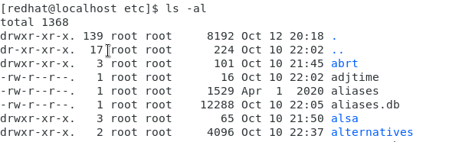

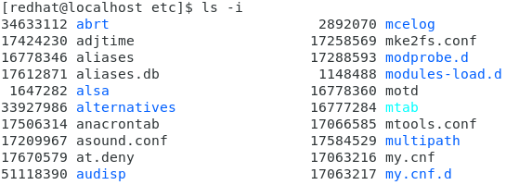

Assignment-5

