AirBenders

Presentation Memo

### Agenda

* What We Heard From You​
* The State of Wind Energy​
* US Wind Energy Market & Operators​
* Wind Turbines in US​
* Recommendation​

### Details

#### Global and US Energy Trends

A brief look at the global energy market shows renewable energy sources still make up the minority of consumption at 14 percent of total as of 2022. Hydro leads that group at 6.7% and wind takes second place at 3.3%.

https://ourworldindata.org/grapher/energy-consumption-by-source-and-country?time=2002..latest

In the US, renewables as a group are a smaller portion of total consumption at just 11.3% but Hydro and Wind swap places, with hydro at 2.5% and wind at 4.3%.

https://ourworldindata.org/grapher/energy-consumption-by-source-and-country?time=2002..latest&country=~USA

#### Operators

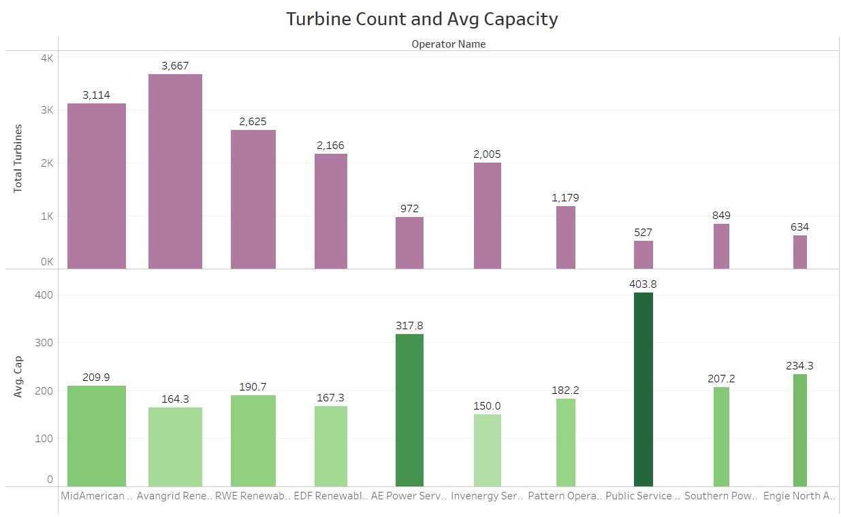

* 1,243 total WND operators as of 2022
* Top 10 with Cap

1. MidAmerican Energy Co: 653648.61
2. Avangrid Renewables LLC: 602660.31
3. RWE Renewables Americas LLC: 580739.56
4. EDF Renewable Asset Holdings, Inc.: 362329.1
5. AE Power Services LLC: 309148.8
6. Invenergy Services LLC: 300765.39
7. Pattern Operators LP: 214818.05
8. Public Service Co of Colorado: 212779.2
9. Southern Power Co: 175951.74
10. Engie North America: 148557.75

Take Overs

1. Brookfield Renewable Trading and Marketing LP:​
   * HYC: 1, WND: 8, SUN: 1​
2. Energy Northwest ​
   * NUC: 1, HYC: 1, WND: 1, OTH: 1, SUN: 1 ​
3. Kodiak Electric Assn Inc​
   * HYC: 1, DFO: 3, WND: 1, OTH: 2​

* Only ~8% have other forms of fuel (95 operators)
  + DFO: 58
  + NG: 56
  + SUN: 46
  + OTH: 36
  + COL: 30
  + HYC: 27
  + WOO: 8
  + RFO: 7
  + NUC: 7
  + HPS: 6
  + MLG: 6
  + WWW: 5
  + PC: 3
  + OOG: 3
  + ORW: 6
  + WOC: 1
  + GEO: 1

#### Turbines

* Wind speeds can vary hourly and seasonally.
* Average wind speeds should be at least 4 meters/second (at least for small turbines).
* Important to note, winds that are too strong (25 meters/second) can cause the turbine to shut down to prevent any damages.

#### Manufactures

Top 10

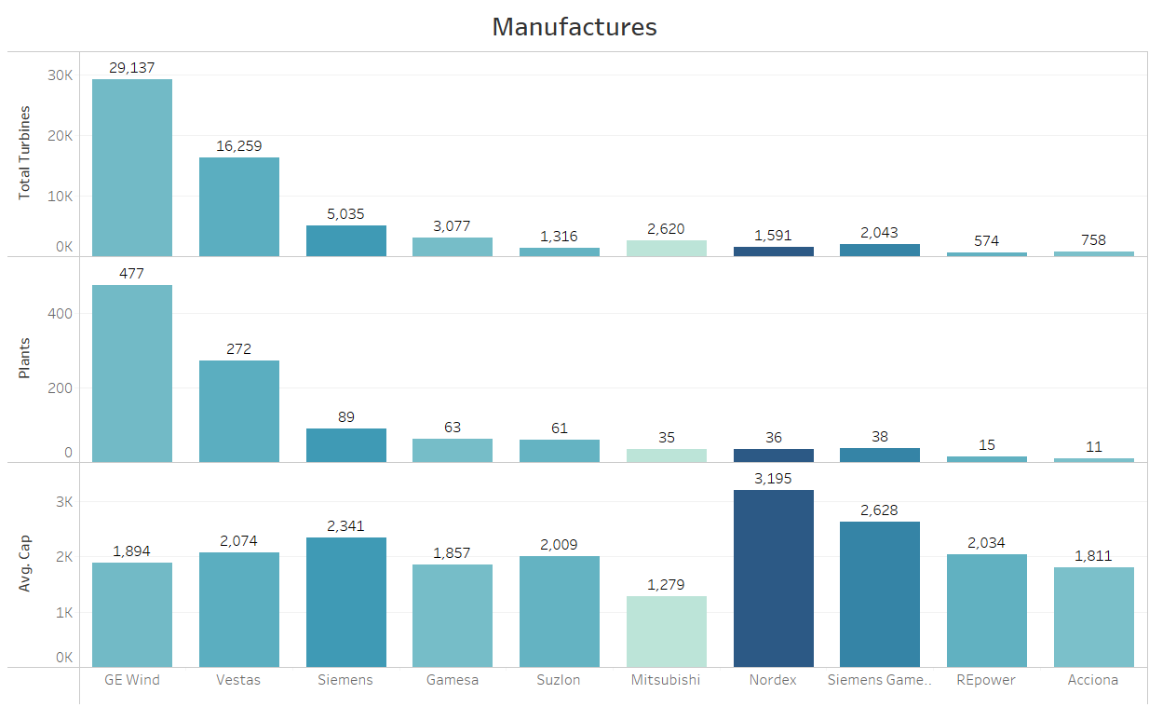

Turbine Ages in Dataset ​

* Min: 1y
* Max: 41y​
* ​Avg years until Retrofit​: 12y​

### Index

#### Fuel Type Codes

* COL: Coal
* NG: Natural Gas
* SUN: Solar
* WND: Wind
* NUC: Nuclear
* HYC: Hydroelectric
* OTH: Other
* GEO: Geothermal
* RFO: Residual Fuel Oil
* DFO: Distillate Fuel Oil
* PC: Petroleum Coke
* MLG: Landfill Gas
* ORW: Other Waste Biomass
* WOO: Wood and Wood Derived Fuels
* WWW: Waste/Refuse
* OOG: Other Gasses
* HPS: Hydrogen
* WOC: Waste Coal
* NUCL: Other Natural Gas
* WC: Waste/Refuse Coal
* WDS: Wood/Wood Waste Solids
* TDF: Tire Derived Fuel
* BFG: Blast Furnace Gas
* BLQ: Black Liquor
* NAW: Non-Wood Solids
* SGP: Sludge Gas
* TPS: Tire-Derived Product
* LFG: Landfill Gas
* WH: Waste Heat
* LNG: Liquified Natural Gas

References:

<https://www.mordorintelligence.com/industry-reports/united-states-wind-energy-market>

<https://ourworldindata.org/grapher/energy-consumption-by-source-and-country?time=2002..latest>

<https://ourworldindata.org/grapher/energy-consumption-by-source-and-country?time=2002..latest&country=~USA>

<https://cleanpower.org/wp-content/uploads/gateway/2024/04/US-wind-energy-monitor_exec-summ_final_2023.pdf>

<https://ourworldindata.org/grapher/modern-renewable-prod?time=earliest..2023&facet=none&country=~USA>

<https://emp.lbl.gov/sites/default/files/emp-files/2023_lbwmr_final.pdf>

<https://www.woodmac.com/news/opinion/wind-industry-faces-a-perfect-storm-of-profit-pressures/>