# Project 2018 Programming and Scripting

# ADARSHA SACHAN 23/03/2108

Introduction Fisher’s Iris data set

Reference 1 <https://en.wikipedia.org/wiki/Iris_flower_data_set>

Reference 2 <https://www.techopedia.com/definition/32880/iris-flower-data-set>

Fisher's Iris data set introduced by the British statistician and biologist Ronald Fisher in his 1936.

This data set consists of 50 samples from each of three species of Iris (Iris setosa, Iris virginica and Iris versicolor). Four features were measured from each sample

The length, width of the sepals and petals, in centimeters, Based on the combination of these four features, Fisher developed a linear discriminant model to distinguish the species from each other.

We have real data 3 species flower.

1 Irish Setosa

2 Irish Versicolor

3 Irish Virginica

In the given attribute data, we have petal length and petal width and Sepal Length and Sepal Width

**Question** what are sepal, Petal Length and width

Reference 3 <https://www.youtube.com/watch?v=mE7MWa6N2Vc>

<https://www.ted.com/talks/linus_torvalds_the_mind_behind_linux/transcript?language=en>

Length

Width

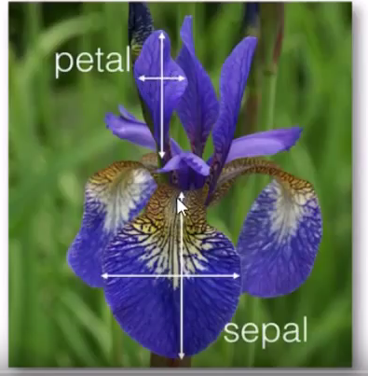

**Research and Analysis**

While analysis the data I can see sepal length is less than 8 Cm and width is less than 4Cm, Petal Length and width less than 7 and 3 in Cm for all the Data Set.

**So user can not provide any other input as per above petal, sepal length and width.**

**Condition 1**

For Iris-SetosaI can see the petal area is less than 1.00

**If any time petal area is less than 2 then it’s Iris-Setos I can guess but if total area is less than 17 then 100 % it’s Iris-Setosa**

**Calculation algorithm** data analysis as per mine

**Petal area = Petal Length * Petal Width**

**Total area = (Petal Length * Petal Width)*(Sepal Length* Sepal Width)**

Other condition I have written in User Story 4 and User Story 5

**I am writing logic in story in agile way**

**User Story 1**

As a user I want to identify what is the flower name

**I want** sepal, Petal Length and width so I can pass this info to my function.

**User story 2**

As I need a full Irish Data set.

**I want** to pass sepal, Petal Length and width in csv read search function.

Irish data set I can copy from wiki or <http://archive.ics.uci.edu/ml/machine-learning-databases/iris/iris.data> copy from this link.

User story 3

As I need search logic functions.

**I want to** write a search function when user will pass input, it look in database or csv file and return the result.

If it dint match, Show the description that data not found

**Second Method for identification for flower**

Below user story will be working base on my algorithm data set

User Story 4

As I need how to find **Iris-Setosa flower**

If any time **petal area** is less than 2 it’s Iris-Setosa

If **total area** is less than 17 then 100 % it’s Iris-Setosa

**Condition 1**

If **petal area** is less than 2 and total area is less than 17 then it’s Iris-Setosa

User Story 5

As I need how to find **ris- virginica and** ris**- versicolorflower**

**Formula for Algorithm**

**Petal area = Petal Length * Petal Width**

**Total area = (Petal Length * Petal Width)*(Sepal Length* Sepal Width)**

**Condition 2**

If Total area greater than 172 **ris- virginica and petal area** is greater than10.10 then **ris- virginica**

Now confusion Total area is less than 172 then it is **virginica flower or Iris-** **versicolor flower**

**Condition 3**

For ris**- versicolorflower**

**If Total** area less than 172 and petal area greater than 7.60 then ris**- versicolorflower**

**Condition 4**

**If Total** area less than 172 and petal area less than 7.60 and Sepal area is greater than 18.40

Then ris**- versicolorflower**

**Condition 5**

**If Total** area less than 172 and petal area less than 7.60 and Sepal area is greater than 16.00

And less than 17.00 then its ris**- versicolorflower**

**Condition 6**

Else

**Iris-** **versicolor flower**

**Conclusion**