Input validation for choice 2 and 7
User input condition code will check if input is <,> ,= if not its show condition again
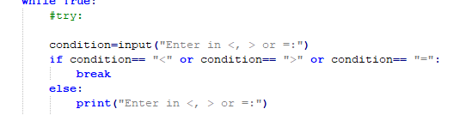

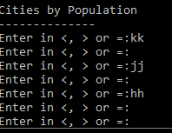

Connecting multiple python modules
In my code there is 3 files mongo.py (mongo query) , world.py (SQL query),python.py (main function)
Program execution through main function (python.py).
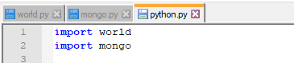

Single My DB connection per each execution of entire program

For SQl we have 5 query for all query I am connecting database once.
