DVWA-物聯網漏洞測試

1. Command Injection

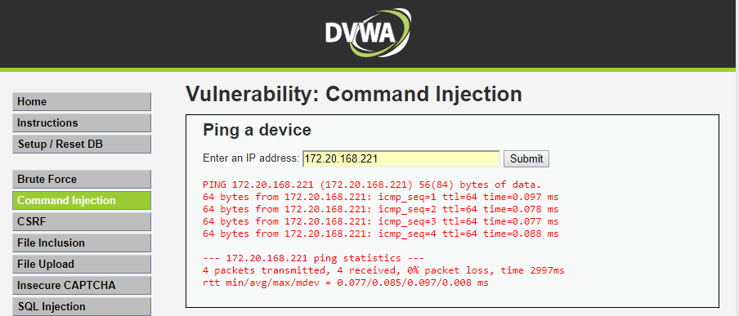

1. Command Injection2

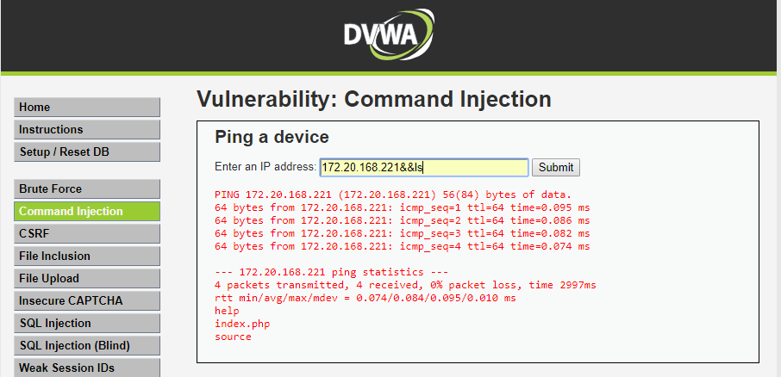

1. cat /var/log/apache2/access.log

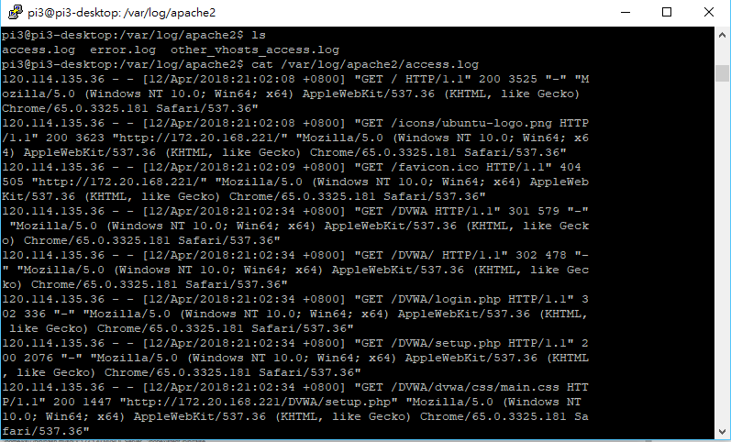

1. SQL Injection

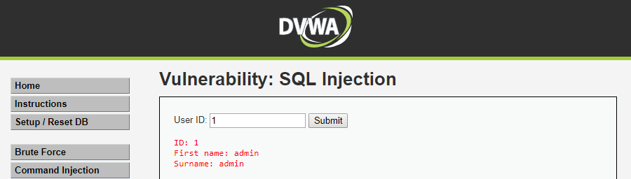

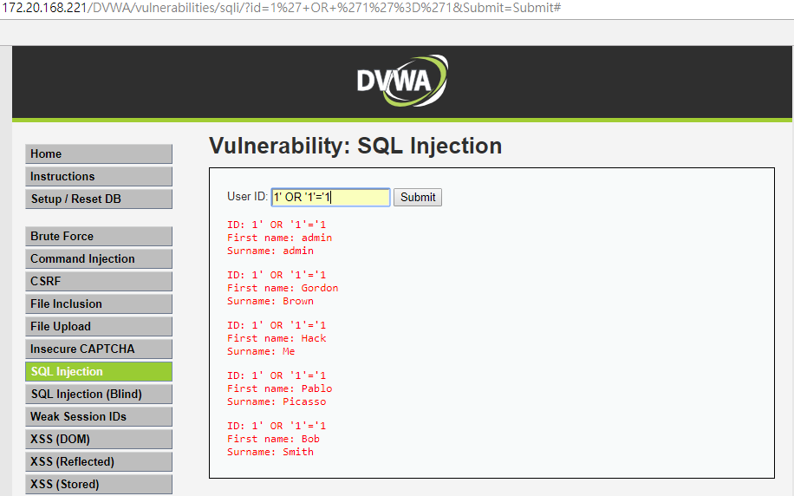 USER_ID = '1' OR '1'='1'

cat /var/log/apache2/access.log

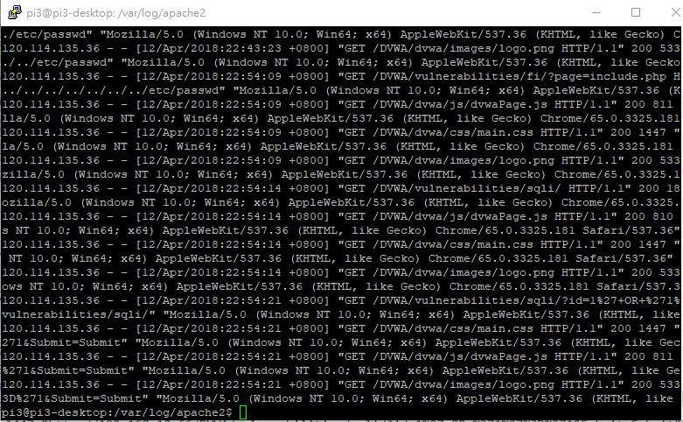

1. File Inclusion

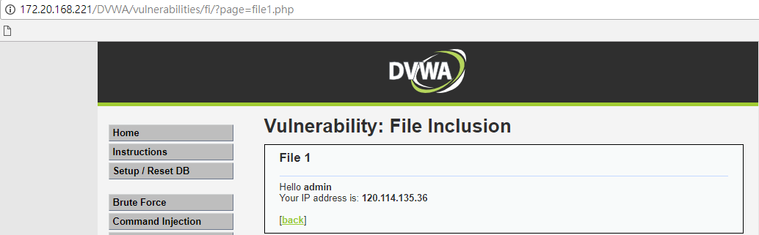

漏洞測試

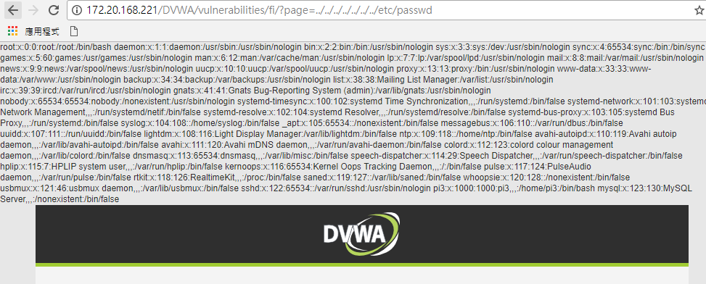

cat /var/log/apache2/access.log

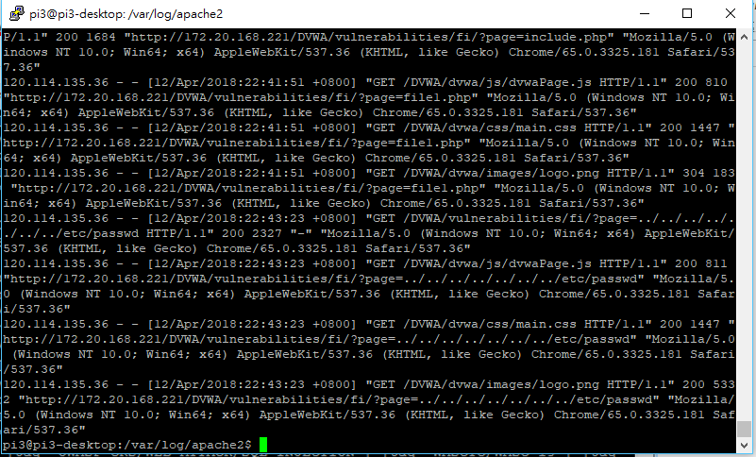

cat /var/log/apache2/error.log

