

**UNIVERSITY OF PETROLEUM & ENERGY STUDIES**

**Dehradun**

**ACO LAB**

**Name-Ritik Kumar**

**Batch- 4 DEVOPS**

**SAP ID- 500097106**

**Roll No- R2142211330**

**SUBMITTED TO- Dr. Hitesh Kumar Sharma**

**Lab Exercise 9– Creating Replica set in Kubernetes**

Below is a lab exercise that will help you understand and practice creating a Replicaset in Kubernetes:

# Step 1: Create a ReplicaSet Configuration File

Create a file named replicaset.yaml with the following configuration:

apiVersion: apps/v1 kind: ReplicaSet metadata:

name: my-nginx-rs

spec:

replicas: 3 selector: matchLabels:

app: lbnginx template:

metadata:

labels: app: lbnginx

spec: containers:

- name: nginx image: nginx

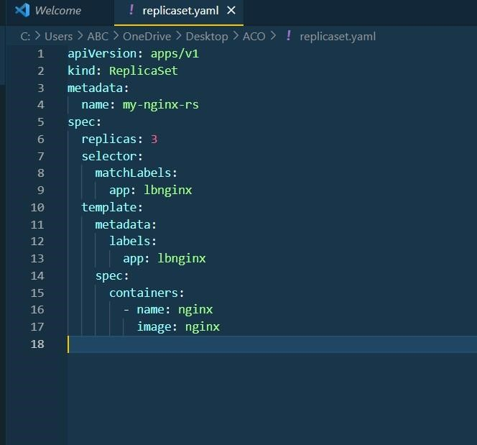

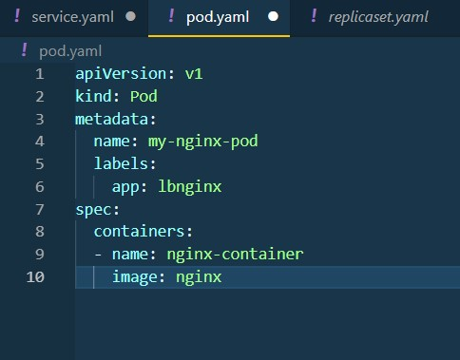

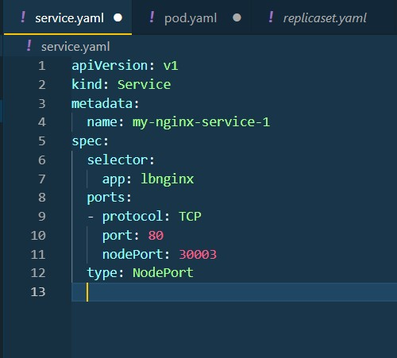

**Step 2: Apply the ReplicaSet Configuration** Apply the configuration to create the ReplicaSet: kubectl apply -f replicaset.yaml

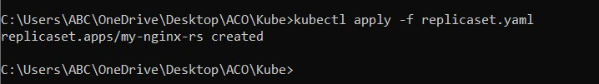

# Step 3: View the ReplicaSet and Pods

View the created ReplicaSet and the associated Pods:

kubectl get replicaset kubectl get pods

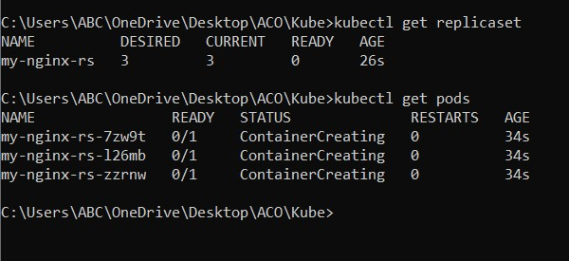

# Step 4: Scale the ReplicaSet

Scale the ReplicaSet to 5 replicas:

kubectl scale replicaset my-nginx-rs --replicas=5

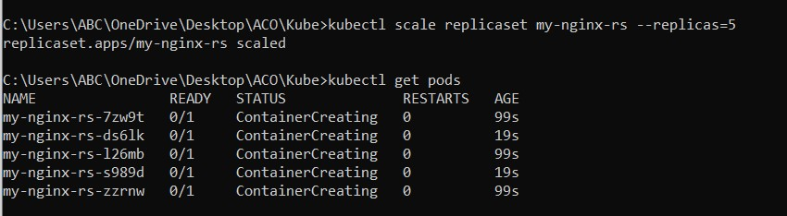

# Step 5: Delete the ReplicaSet

Delete the ReplicaSet:

kubectl delete replicaset my-replicaset

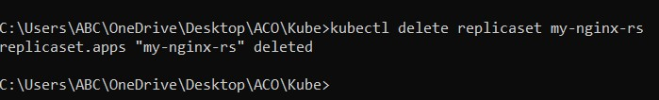

# Conclusion

This exercise demonstrated how to create, manage, and update a ReplicaSet in

Kubernetes. You learned how to scale the ReplicaSet, update the image, and delete the ReplicaSet from the cluster. Experiment further with different configurations and scaling options to deepen your understanding of managing ReplicaSets in Kubernetes.