***EXP-3***

Steps: Step 1: Create a Docker Volume Open a terminal on machine. Run the following command to create a Docker volume named "my_volume"

Step 2: Launch Containers with the Volume Run a container using the volume you created:

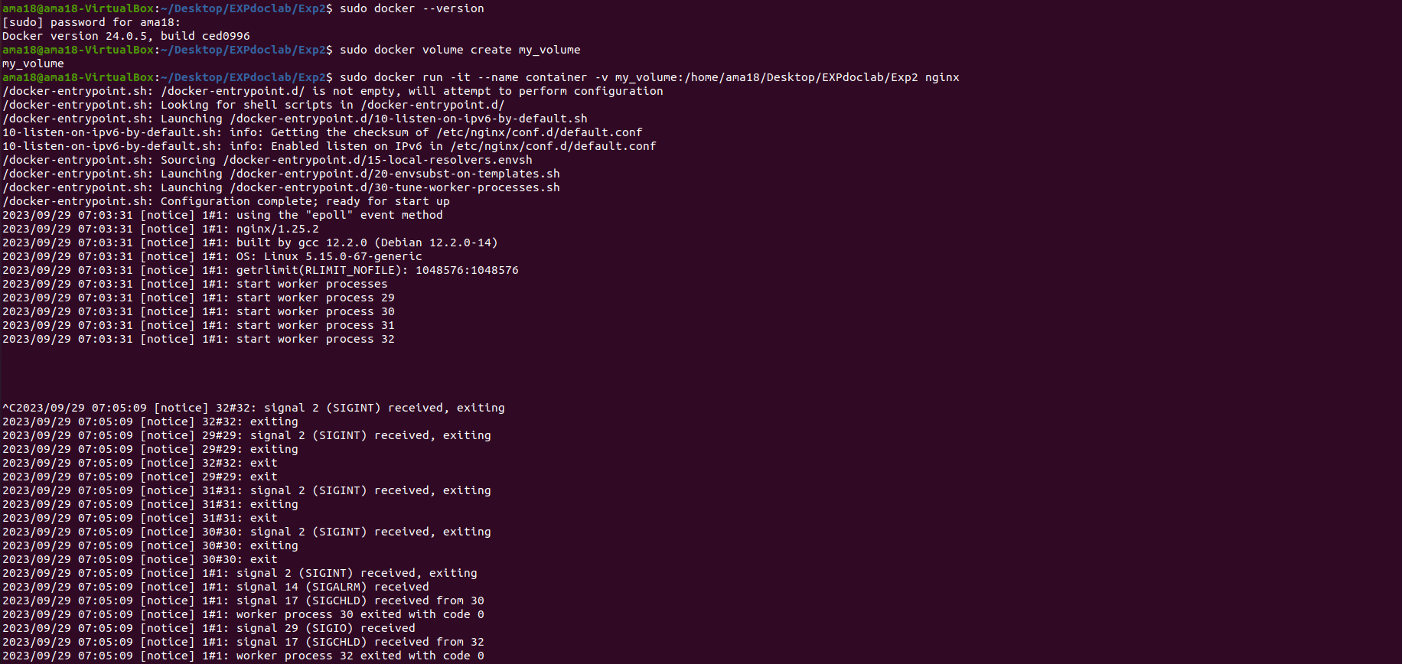

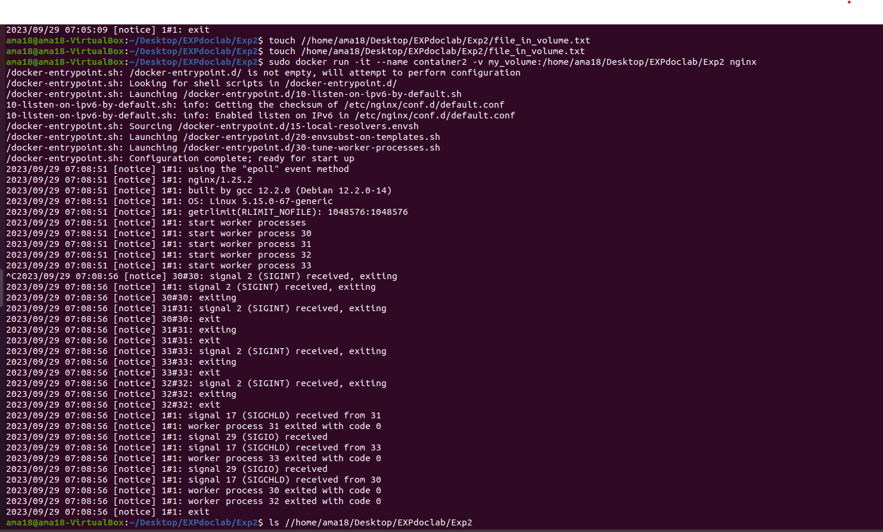

Run a second container, using the same volume, to verify data persistence: docker run -it --name container2 -v my_volume:/app/data nginx Enter the second container and check if the file exists:

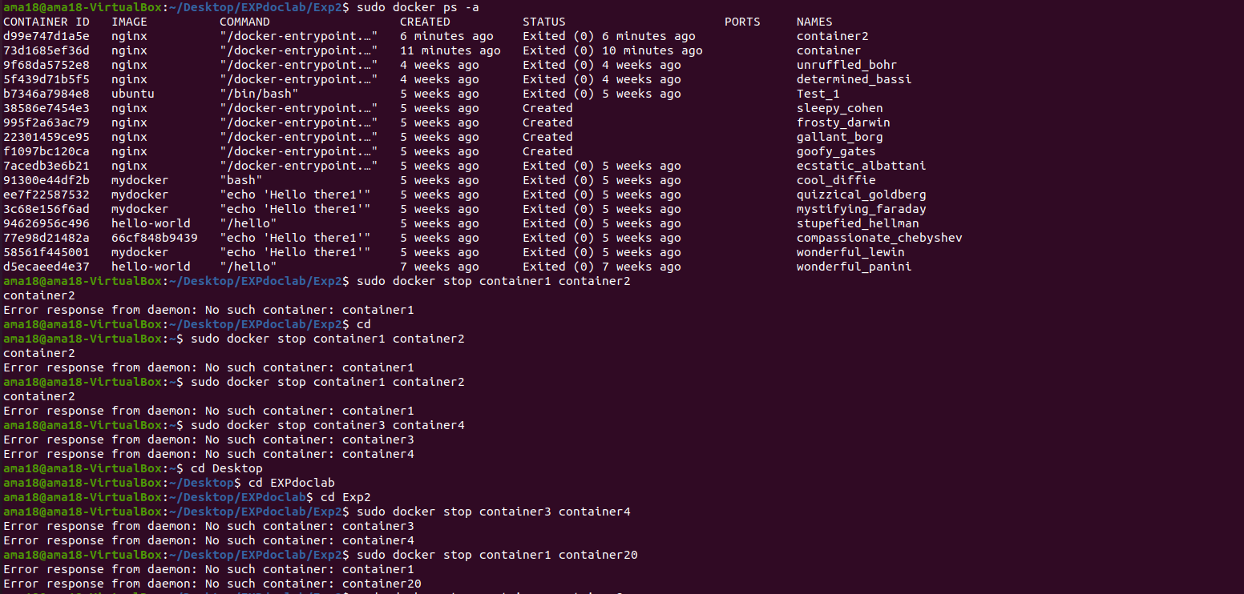

tep 3: Cleanup Stop and remove the containers:

