EXPERIMENT 6

# AIM: Working with Docker Compose File to Control Multiple Containers Steps to Complete:

**Creating compose files**

* Create a directory named nginx in your root.

mkdir nginx

* Switch to that directory and create a file named docker-compose.yaml

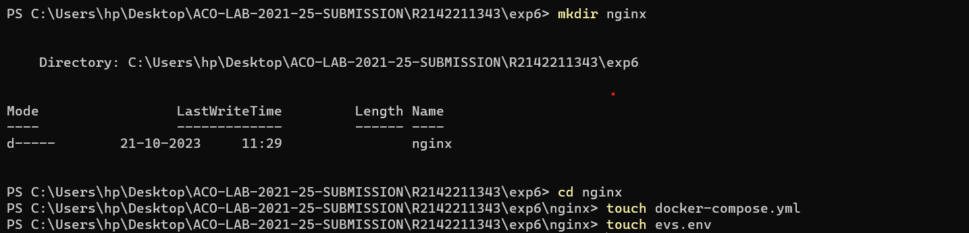 cd nginx vi docker-compose.yml

* Use docker-compose version 2 to create docker-compose.yaml file. Create a service named "databases". Use image named "mysql"

Map container 3306 port to host machine 3306 port.

Add environment variables named "MYSQL_ROOT_PASSWORD", "MYSQL_DATABASE", "MYSQL_USER" and "MYSQL_PASSWORD" along with

corresponding values for all.

cat evs.env MYSQL_ROOT_PASSWORD=redhat08

MYSQL_DATABASE=nginxdb

MYSQL_USER=root

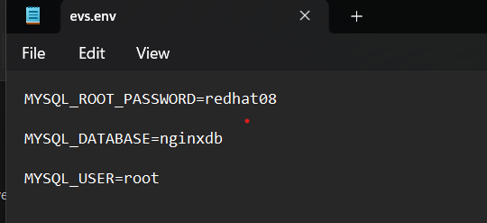

Add another service named "web" Use image "nginx"

cat docker-compose.yml version: '3'

services: databases:

image: mysql ports:

- "3307:3306"

env_file:

- evs.env

web:

image: nginx ports:

- "80:80"

depends_on:

- databases

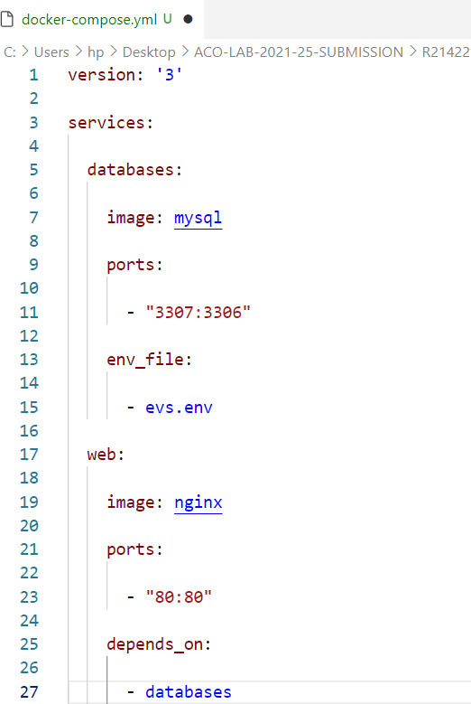

# Running images using docker-compose

* + Save docker-compose.yaml file and do docker-compose up.

docker-compose up -d

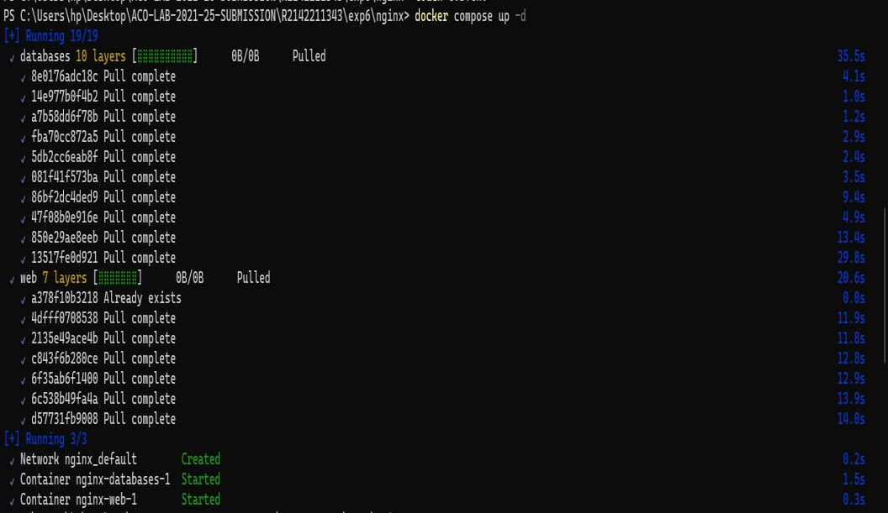

* + Verify nginx service is up and is accessible on machine.

curl localhost:80

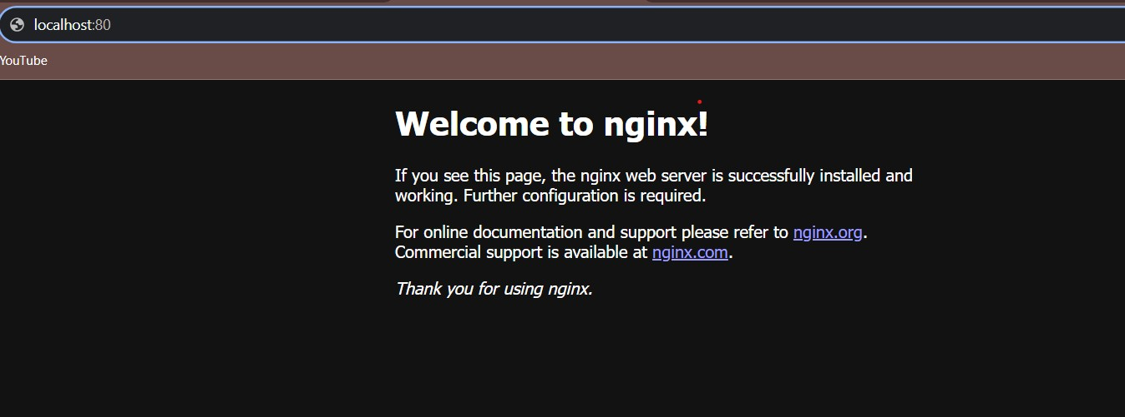

Stop and remove your docker container using docker-compose.

docker-compose down

