**Lab Exercise 1**

Step 1: Pulling a Docker image

1.1 Open the terminal and pull an image using the command:

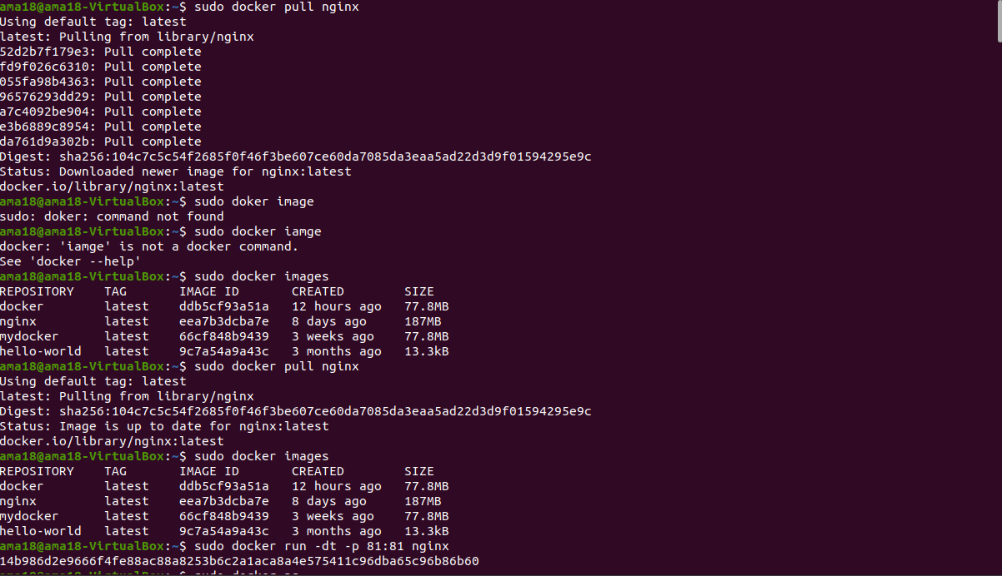

1.2 List all the docker images to check the newly pulled nginx image:

sudo docker images:

Step 2: Creating a new container

2.1 Create a new container from the nginx image:

sudo docker run -dt -p 81:81 nginx

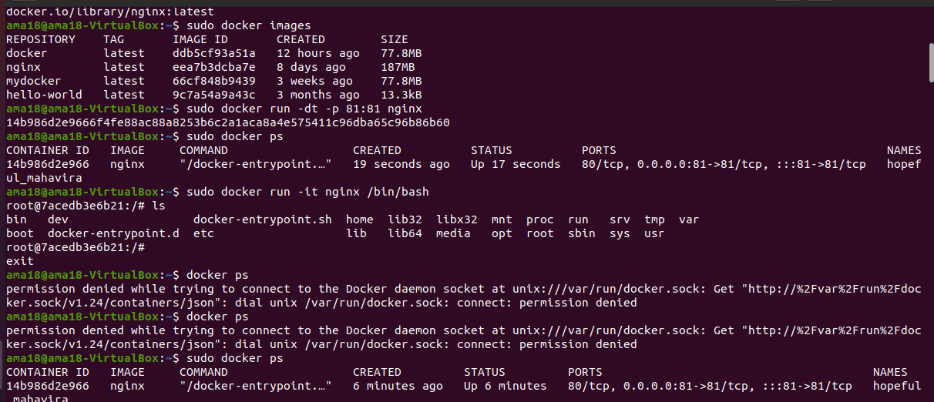

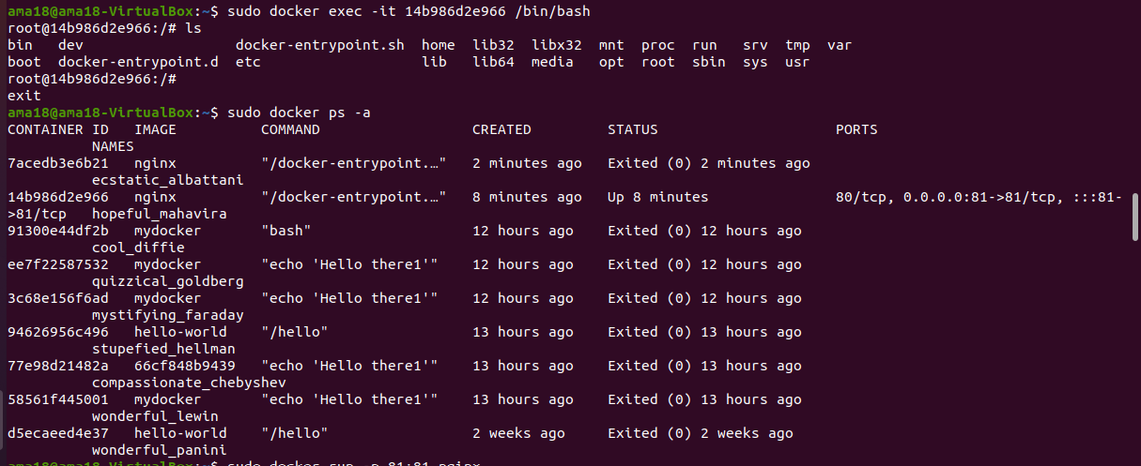

Step 2: Creating a new container

2.1 Create a new container from the nginx image:

sudo docker run -dt -p 81:81 nginx

