**EXPERIMENT -6**

**AIM : Working with Docker Compose File to Control Multiple Containers**

**Steps to Complete:**

# Creating compose files

* + Create a directory named nginx in your root.

# “ mkdir nginx ”

# 

* + Switch to that directory and create a file named docker-compose.yaml

# “ cd nginx ”



**“ vi docker-compose.yml ”**



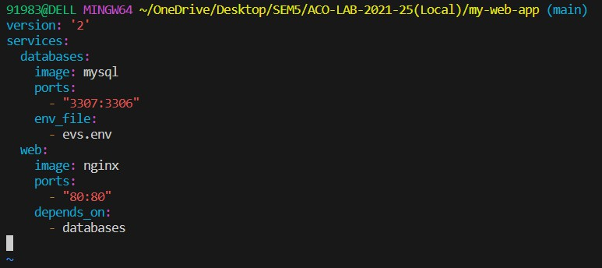

* + Use docker-compose “version 2” to create docker-compose.yaml file.
  + Create a service named "databases". Use image named "mysql"
  + Map container 3306 port to host machine 3307 port.
  + Add environment variables named "MYSQL_ROOT_PASSWORD", "MYSQL_DATABASE", "MYSQL_USER" and "MYSQL_PASSWORD" along with corresponding values for all.

# “ cat evs.env ”

* + Add another service named "web"
  + 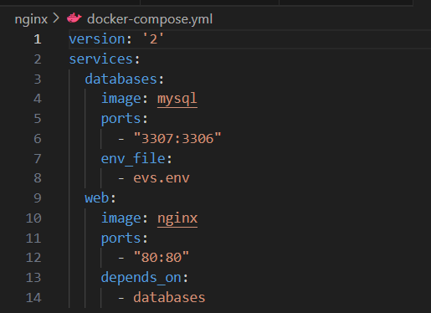Use image "nginx"

# Running images using docker-compose

* + Save docker-compose.yaml file and do “ docker-compose up ” .

# “ docker-compose up -d ”

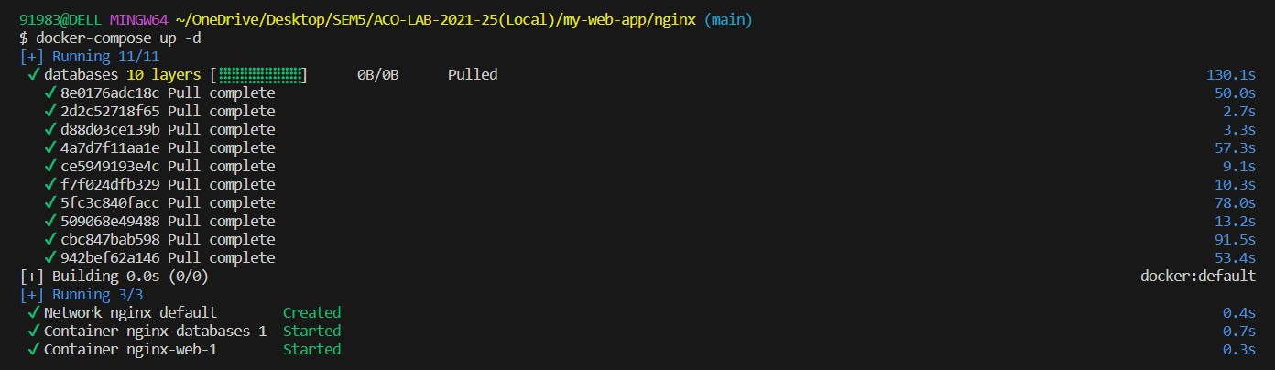

* + Verify nginx service is up and is accessible on machine.

# “ curl localhost:80 ”

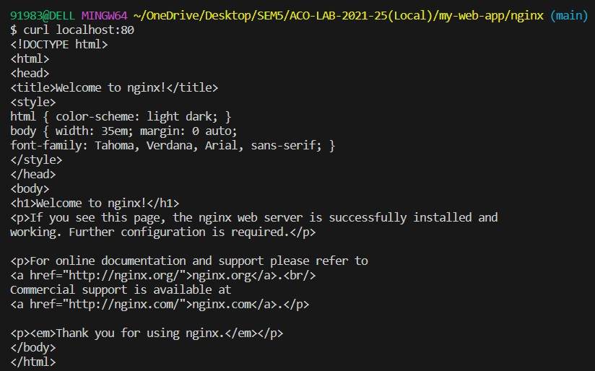

* + Stop and remove your docker container using docker-compose.

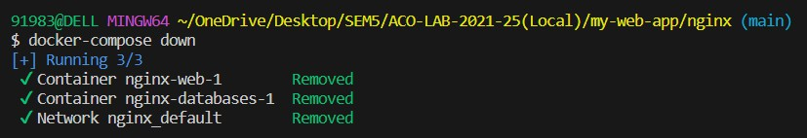**“ docker-compose down ”**

