**EXPERIMENT-5**

**AIM : Working with Dockerfile to Build and Push Docker Image**

**Steps to Complete:**

1. Create following Dockerfile

FROM alpine MAINTAINER SUDIPT

RUN apk update

RUN apk add nodejs RUN mkdir /app COPY index.js /app WORKDIR /app

RUN node index.js

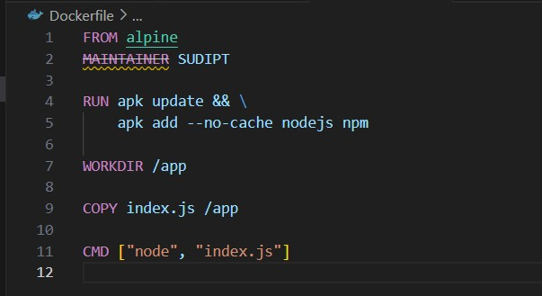

1. Now we have dockerized the app, we will Build image from Dockerfile.

## “ docker build -t myimage:1.0.0 . ”

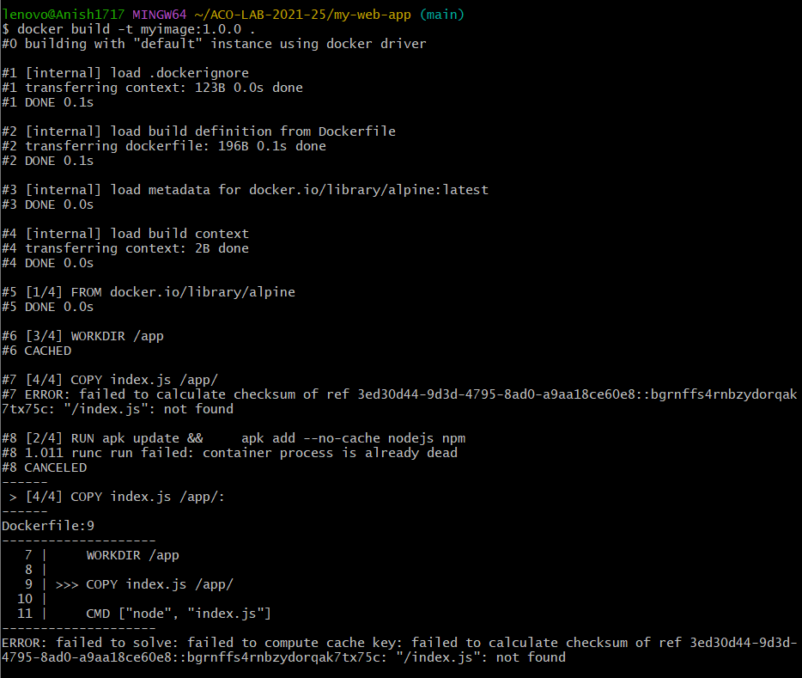

1. Create account on Dockerhub and create a repository in it.

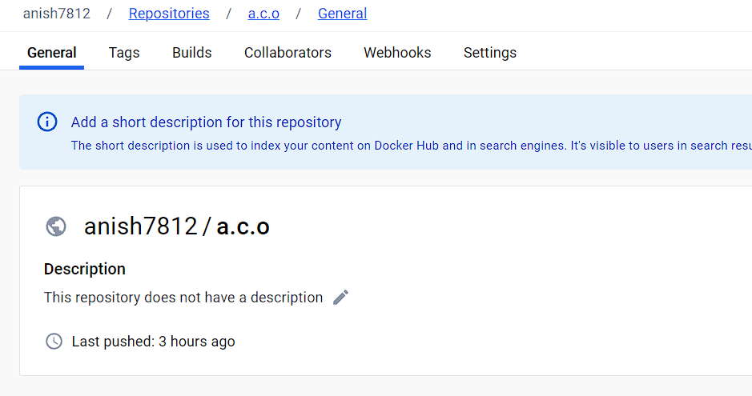

1. Tag the recently created image using following command.

## “ docker tag imageID Repositoryname ”



1. Login to Dockerhub from console using following command.

## “ docker login ”

## 

1. Now push the image on Dockerhub using following command.

## “ docker push RepositoryName ”

