Mongo db

Create a student collection  with all student details.

Create a batch collection with multiple batches and its corresponding details.

Every batch will contain fields representing students attending the batch on a particular date.

A student will belong to only one batch.

Each batch inside the batch collection will contain multiple students attending the respective batch.

Questions

**1.Write a query to insert student details in student collection** .

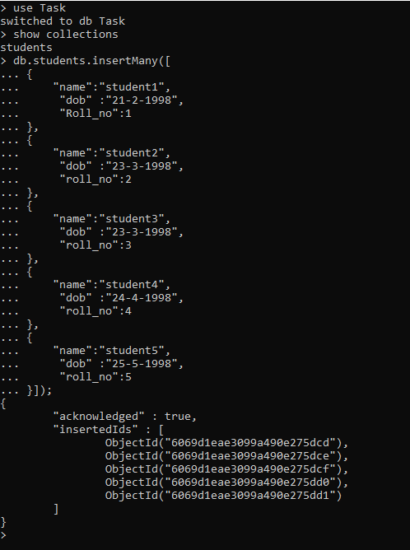

**2.Write a query to insert batch details in batch collection**

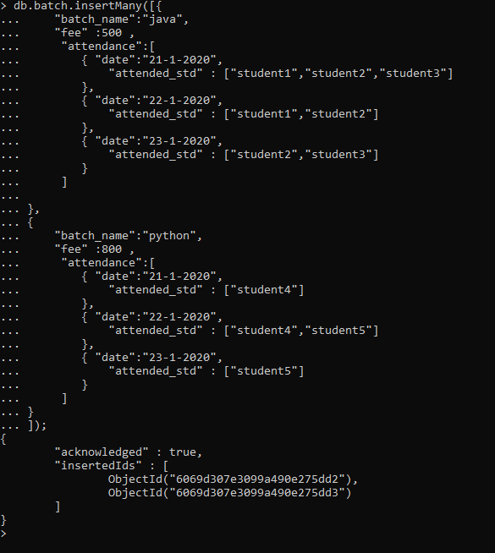

**3.Write a query to Mark attendance for the students at respective batch on Jan 23 2020.**



Attendance has been updated for the date Jan 23

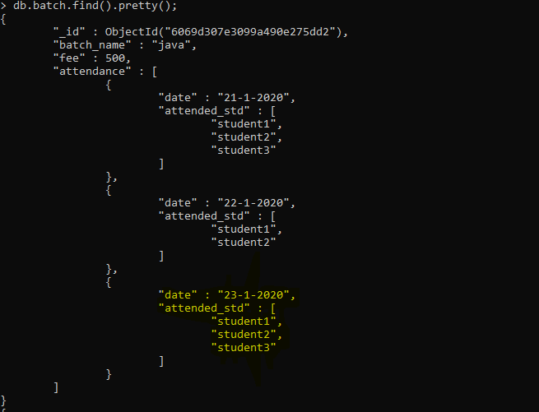

**4.Write a query to display the batch details and attendance history of student 3**.

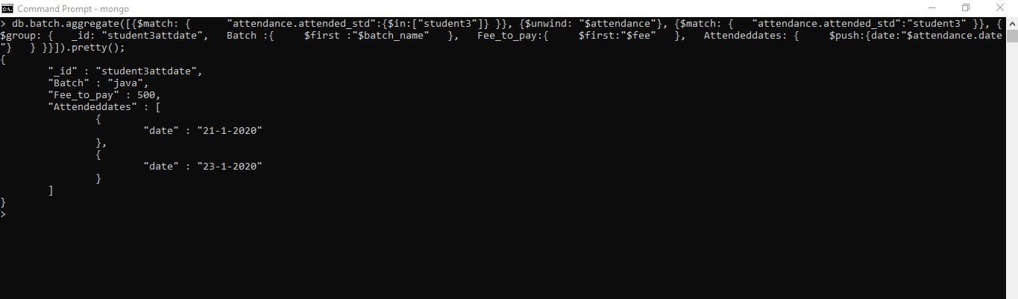

**5.Write a query to display the students attending batch1 along with their attendance history**

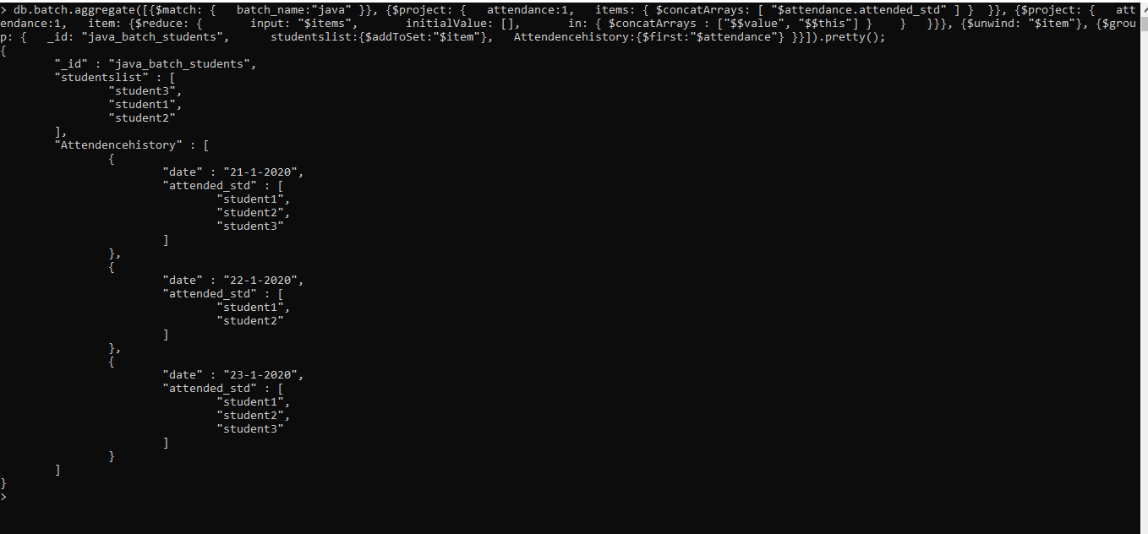

SQL

Create a schema to represent A Student  with all the student details and a Batches with all the batch details with students attending the batches.

Execute the following queries in the schema.

**Write a sql query to display a table containing students attending batch1 along with their attendance history**

**Answer:** select * from students left join attendance on students.idstudents=attendance.student_id where batch_id=1;

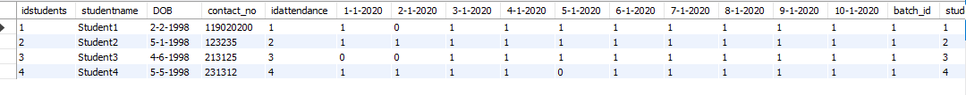

**Write a sql query to display a table containing batch details and attendance history of student 1**

**Answer :** select * from batchs left join attendance on batchs.idbatchs=attendance.batch_id where student_id=1;

