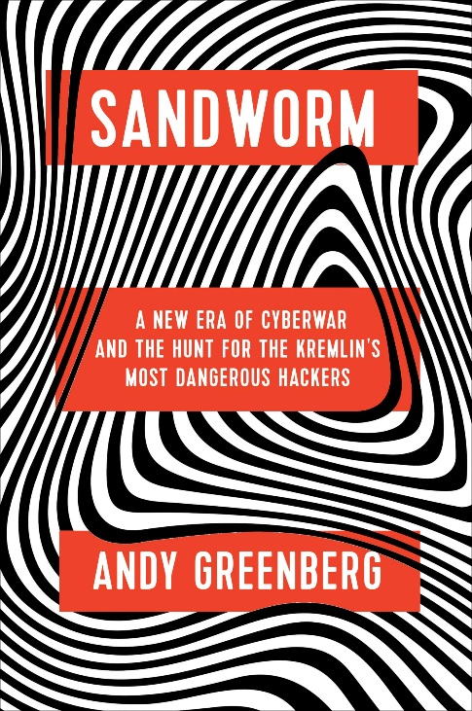
| Sandworm |
Sandworm by Andy Greenberg tells the story of one of the most dangerous and sophisticated cyberattacks in history. It focuses on a hacking group known as Sandworm, believed to be linked to the Russian government. This group has been behind several major cyberattacks, including the 2015 attack on Ukraine’s power grid and the 2017 NotPetya ransomware attack, which caused billions of dollars in damage worldwide. Greenberg goes in-depth into how Sandworm operates, the impact of their attacks, and the growing threat of state-sponsored cyber warfare.
| My Impressions |
What struck me most in Sandworm is the sheer scale and power of these cyberattacks. The group’s ability to take down entire power grids, cause widespread chaos, and destroy critical infrastructure is terrifying. It really opened my eyes to how much damage cyber warfare can do in the real world—more than just stealing data, but shutting down essential services that we all rely on.
Another key takeaway is how governments, especially in the U.S. and Russia, deal with these kinds of attacks. Greenberg discusses how responses to cyberattacks can be slow and sometimes ineffective, especially when they’re linked to state-sponsored actors. Countries often hesitate to take strong action for fear of escalating things further. This makes cyberattacks harder to stop and even harder to predict, leaving us vulnerable to future attacks.
Sandworm was a real page turner for me. By getting a look at the dark side of modern warfare—cyberattacks have real-world consequences. It’s a reminder of how important cybersecurity is in protecting our critical systems and infrastructure, and how global politics can complicate the fight against cybercriminals. If you’re interested in understanding the future of cyber warfare, this book is a must-read.

