



Quiz Application





# LOVELY PROFESSIONAL UNIVERSITY





**Roll Number**: 11

**Section**

: K19JP

**Submitted by**: Abhiraj Sinha **Submitted to** : Sagar Pande Sir **Registration** : 11905148 **Course** : Python



**Report Title** : Quiz Application

Project Report





## Contents



* Declaration
* Certificates
* Acknowledgement
* Abstract



* Images
* References





Abhiraj Sinha

### I the undersigned solemnly declare that the project report Quiz Application Using Tkinter is based on my own work carried out during the course of our study under the supervision of Mr. Sagar Pande. I assert the statements made and conclusions drawn are an outcome of my research work.



Declaration







Abhiraj Sinha

Acknowledgement



I would like to express my very great appreciation to Mr. Sagar Pande sir for his valuable and constructive suggestions during the planning and development of this Project work. His willingness to give his time so generously has been very much appreciated.

Finally, I wish to thank my parents for their support and encouragement throughout my study







* Easy, Medium, Hard (3 Levels ) , if you select a right answer you will be asked to continue or exit the quiz
* If you want to play the quiz then click “YES” and “NO” for quit the quiz.

## Abstract



* This application is a Quiz Application in python this Quiz is Application developed in Python using Tkinter.
* Python offers multiple options for developing GUI (Graphical User Interface). Out of all the GUI methods, tkinter is the most commonly used method. It is a standard Python interface to the Tk GUI toolkit shipped with Python. Python with tkinter is the fastest and easiest way to create the GUI applications. Creating a GUI using tkinter is an asy task.



* First You need to Login in the Application by entering your name.
* There are several Questions of different levels which user can be accessed to get select them

## Steps



Step 1 Make UI



* + Make GUI with Tkinter, Messagebox



* + Use of Buttons,

Lables, Grid.

Step 2

Fill Questions

* Make Questions for different difficulty Levels.
* Also, Give correct Answers for them.
* Fill the questions in their respective difficulty levels.

Step 3

Link them in App

* Make three functions (Easy, Medium and Hard for different difficulty levels.



* Call these functions with command .

## Working Graph of Steps



6

DIFFICULTY LEVEL GRAPHS OF STEPS

5



4

3

2

1





0

Step 1

Step 2

Step 3

Deploy



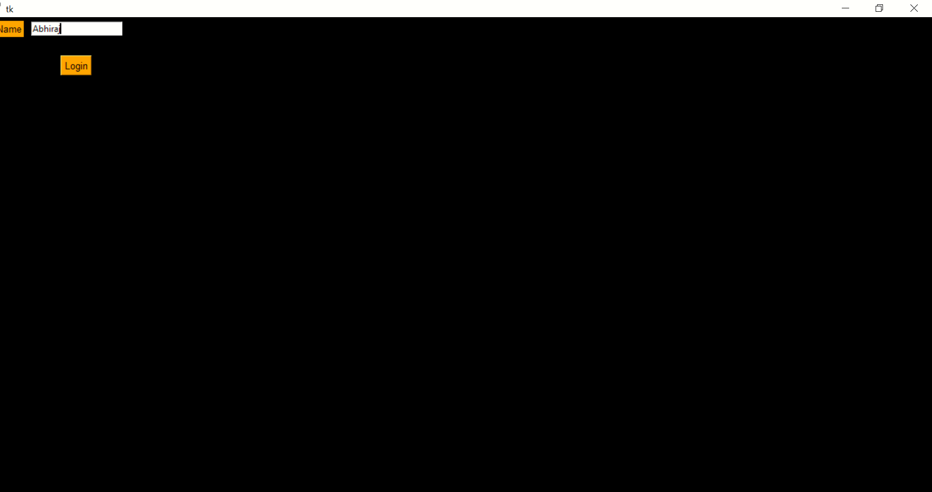

Login Page





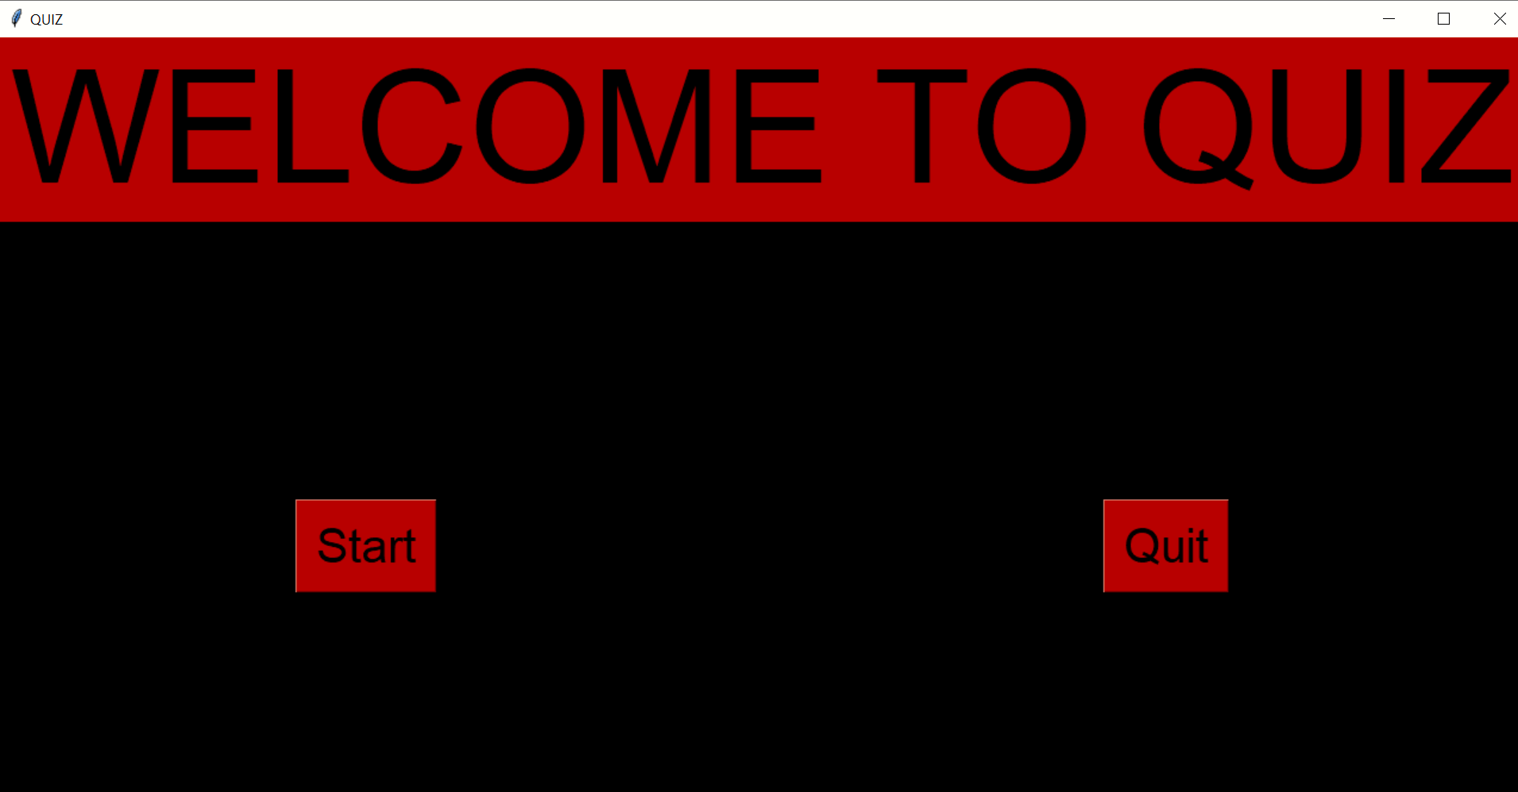

## Home Page



 Level Selection And Questions

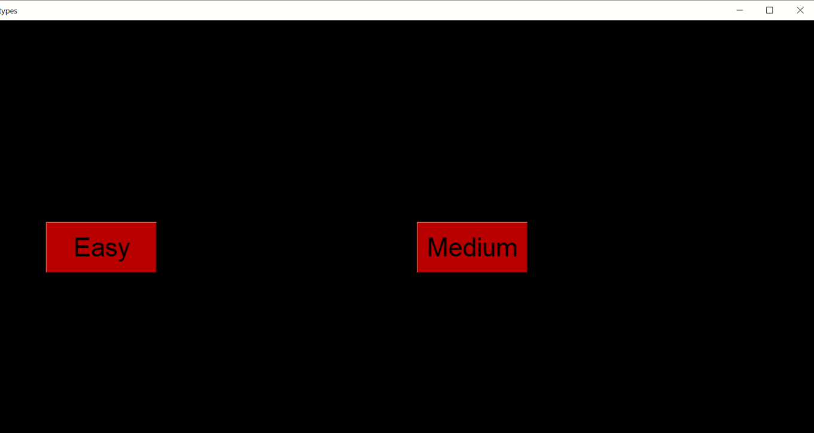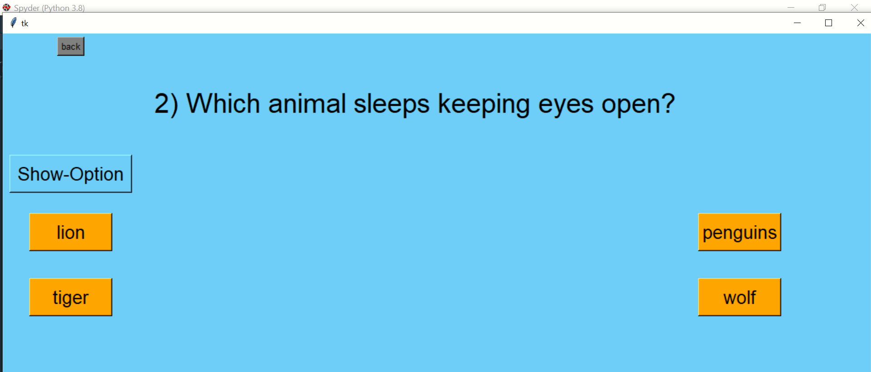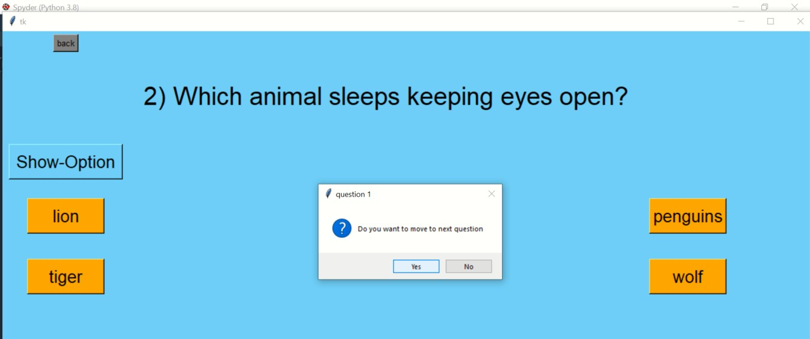





Aim

The main goal was to create a attractive and simple Quiz Application that can be used by everyone easily

Summary



Why I choose Pyhton ?

* Python offers multiple options for developing GUI (Graphical User Interface). Out of all the GUI methods, tkinter is the most commonly used method. It is a standard Python interface to the Tk GUI toolkit shipped with Python. Python with tkinter is the fastest and easiest way to create the GUI applications. Creating a GUI using tkinter is an asy task.



Technologies Used

* Python 3.7
* Tkinter Module



