LABORATORY MANUAL: MECHATRONICS DEPARTMENT

HAND TOOLS & PRECISION EQUIPMENT

1. Interchangeable Screwdriver Set
A. Description & Purpose This is a multi-purpose manual screwdriver set designed for versatility in electronics and mechanical assembly. It features a single high-torque handle with multiple detachable blades (bits), allowing a technician to switch between different tip types and sizes quickly.
B. Technical Specifications * Manufacturer: Taparia Tools
- Handle Material: High-grade CA (Cellulose Acetate) plastic; transparent green, non-flammable.
- Blade Material: High-grade Alloy Steel, hardened and tempered.
- Tip Types Included: Phillips (Cross), Slotted (Flathead), and Poker/Awl.
C. Lab Inventory Details * Brand: Taparia
- Set Type: Multi-blade / Interchangeable

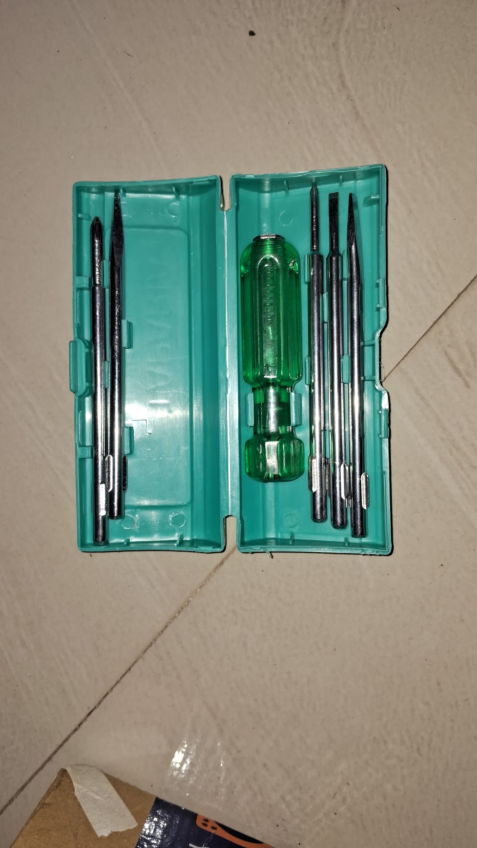

D. Proper Usage & Maintenance * Bit Engagement: Ensure the blade is fully clicked into the handle before applying torque.
- Alignment: Keep the screwdriver perpendicular to the screw head to avoid slipping.
- Storage: Return blades to the case after use to prevent loss and corrosion.
2.Snap-Off Utility Cutter & Spare Blades
A. Description & Purpose A precision cutting tool used for stripping wires, trimming PCBs, or opening packaging. The "snap-off" design ensures a fresh, razor-sharp edge is always available.
B. Technical Specifications * Manufacturer: Taparia Tools (Model SK-1)
- Body Material: High-quality ABS plastic with ergonomic rubberized grip.
- Blade Material: High-carbon steel.
- Locking Mechanism: Twist-lock / Auto-lock screw.
C. Lab Inventory Details * Brand: Taparia
- Blade Type: Multi-segment Snap-Off

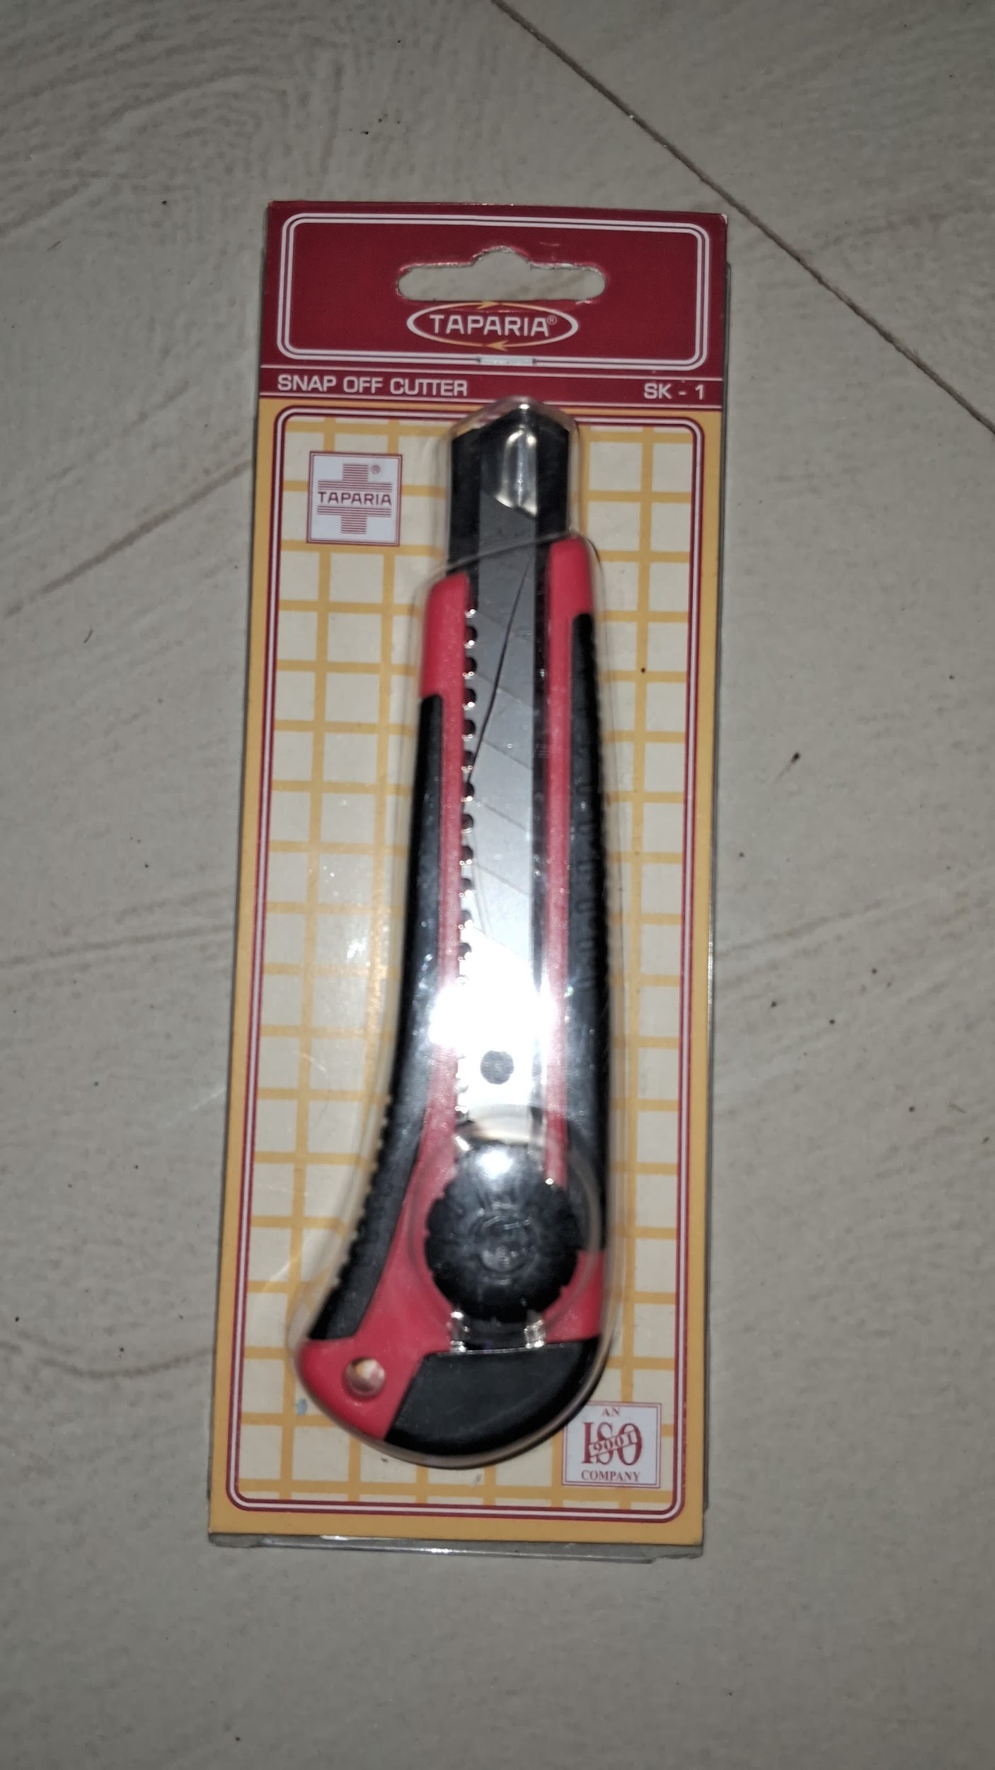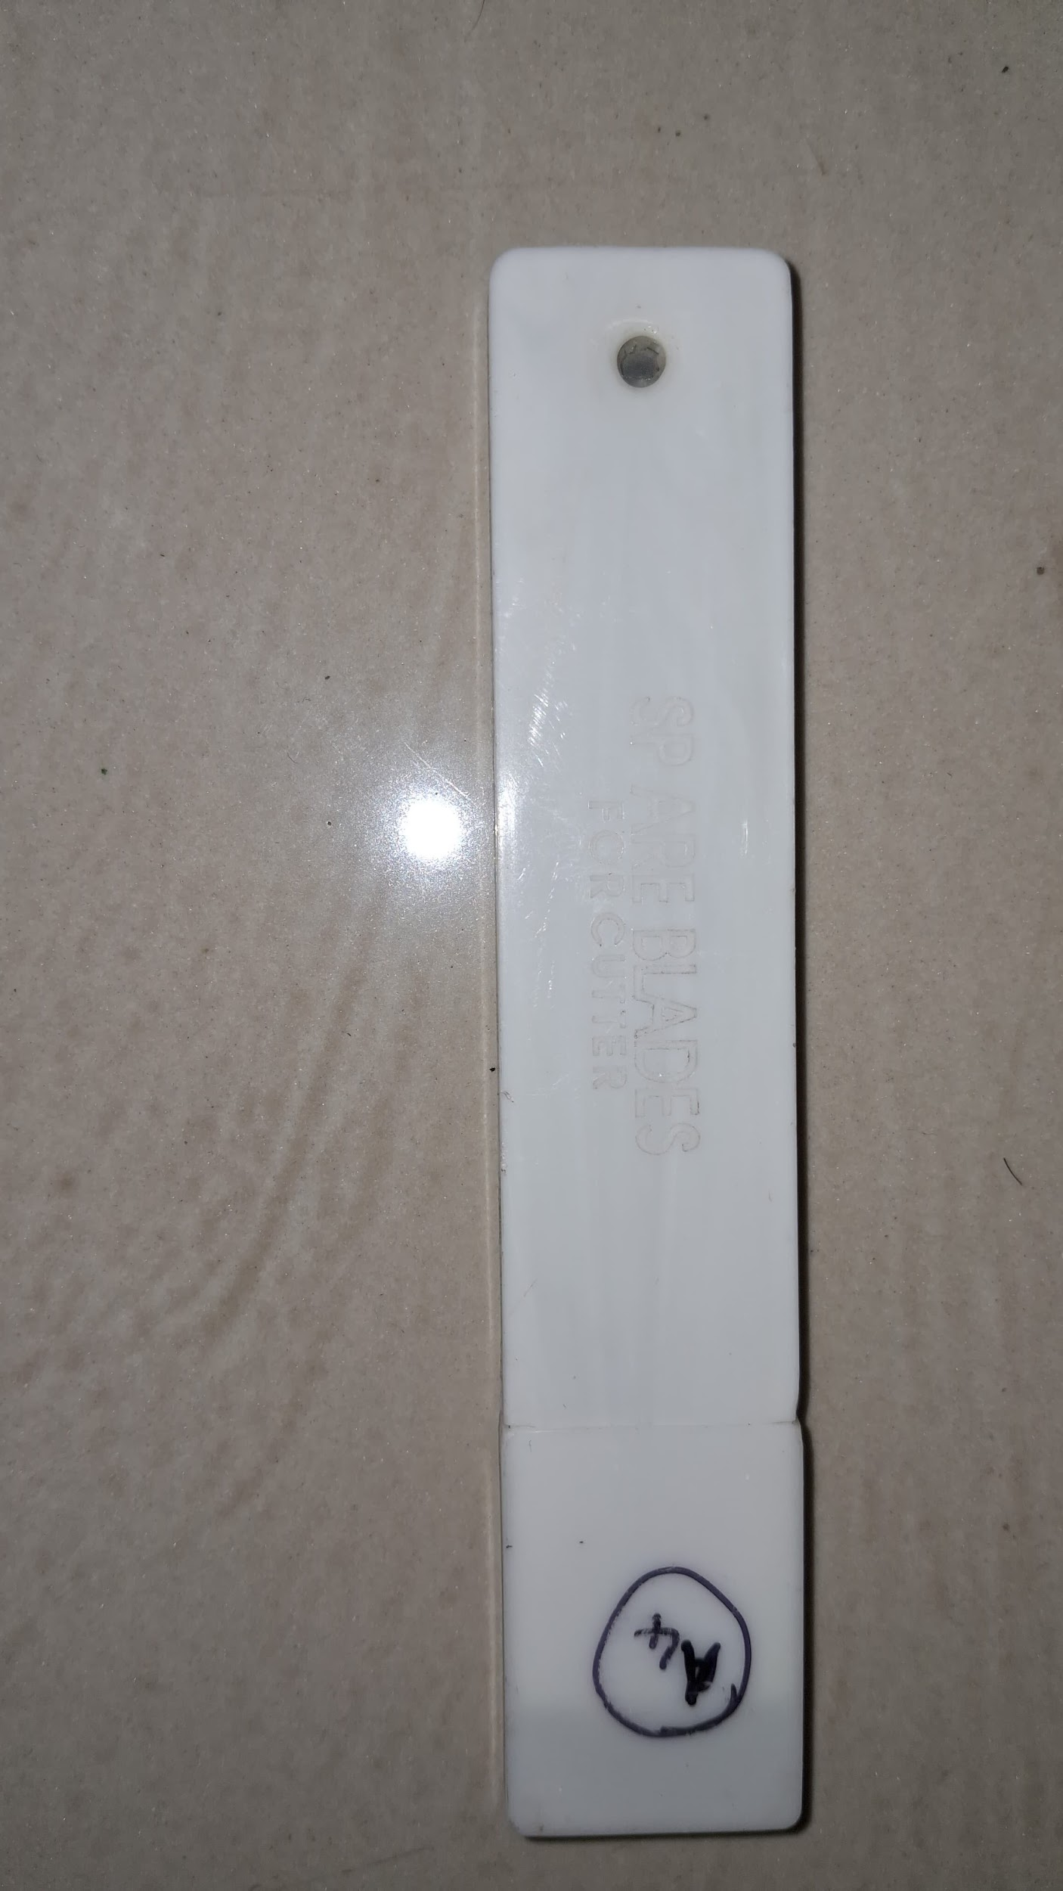

D. Proper Usage & Maintenance * Safety: Retract the blade fully into the handle whenever the tool is not in use.
- Blade Replacement: When segments are used, insert a fresh blade from the spare case.
3.Tin Cutter (Snips) with Spring
A. Description & Purpose Designed for making straight or curved cuts in sheet metal or thin plastic. Features a built-in spring mechanism to reduce hand fatigue during repetitive work.
B. Technical Specifications * Manufacturer: Taparia Tools (Model TCS 10)
- Size: 250 mm (10 inches)
- Blade Material: Drop-forged from high-grade carbon steel.
- Handle Grip: Insulated PVC sleeves in bright blue.
C. Lab Inventory Details * Brand: Taparia
- Type: Spring-loaded Snips

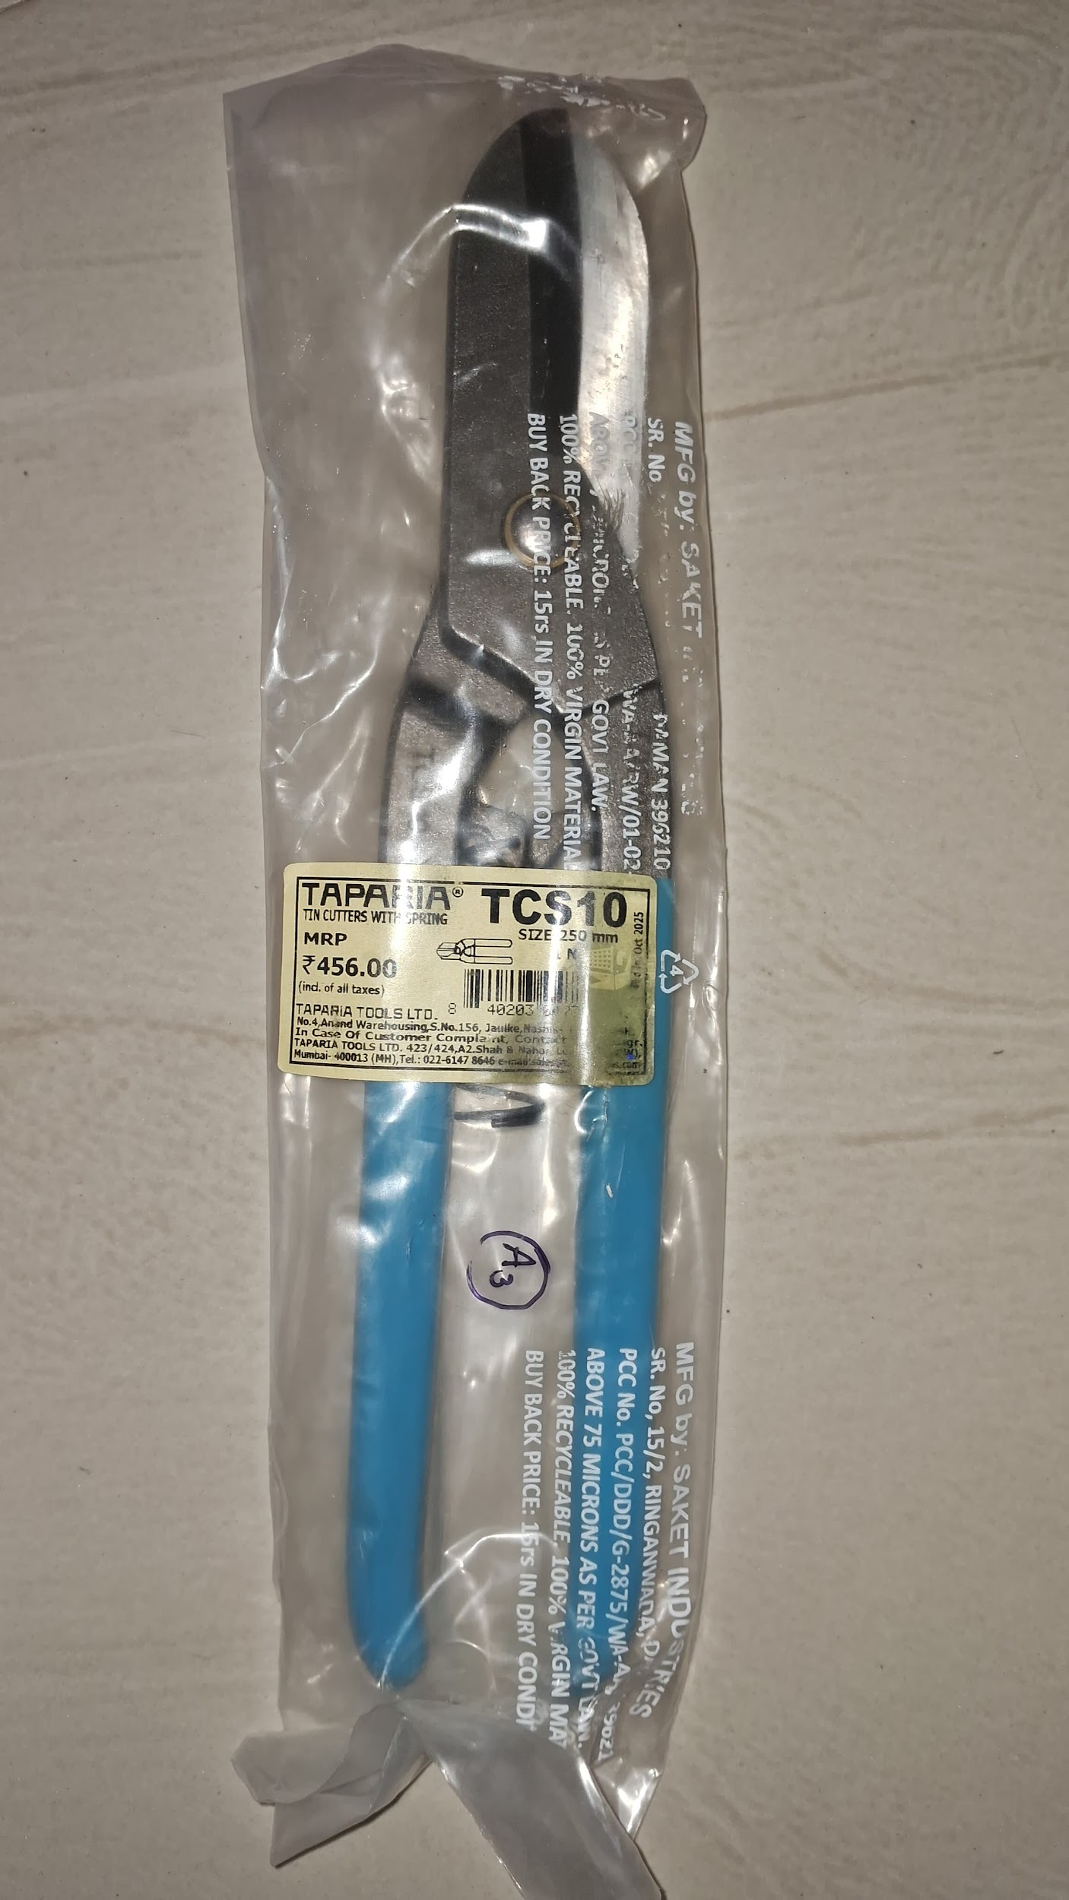

D. Proper Usage & Maintenance * Cutting Motion: Place material deep into the jaws for maximum leverage.
- Safety Lock: Always engage the safety latch after use to keep blades closed.

4.Hacksaw Blades (Replacement Set)
A. Description & Purpose Consumable cutting elements used in hacksaw frames to cut through mild steel, aluminum, and PVC. The bimetal version is virtually unbreakable.
B. Technical Specifications * Brand: Bulwark (Bimetal) / General Carbon Steel.
- Blade Material: 8% Cobalt HSS Bimetal (Orange) / Hardened Steel (Black).
- TPI: 24 Teeth Per Inch.
- Length: Standard 12-inch (300mm).
C. Lab Inventory Details * Type: Bimetal Cobalt & Carbon Steel
- Quantity: 1 Bimetal + 5 Carbon Steel

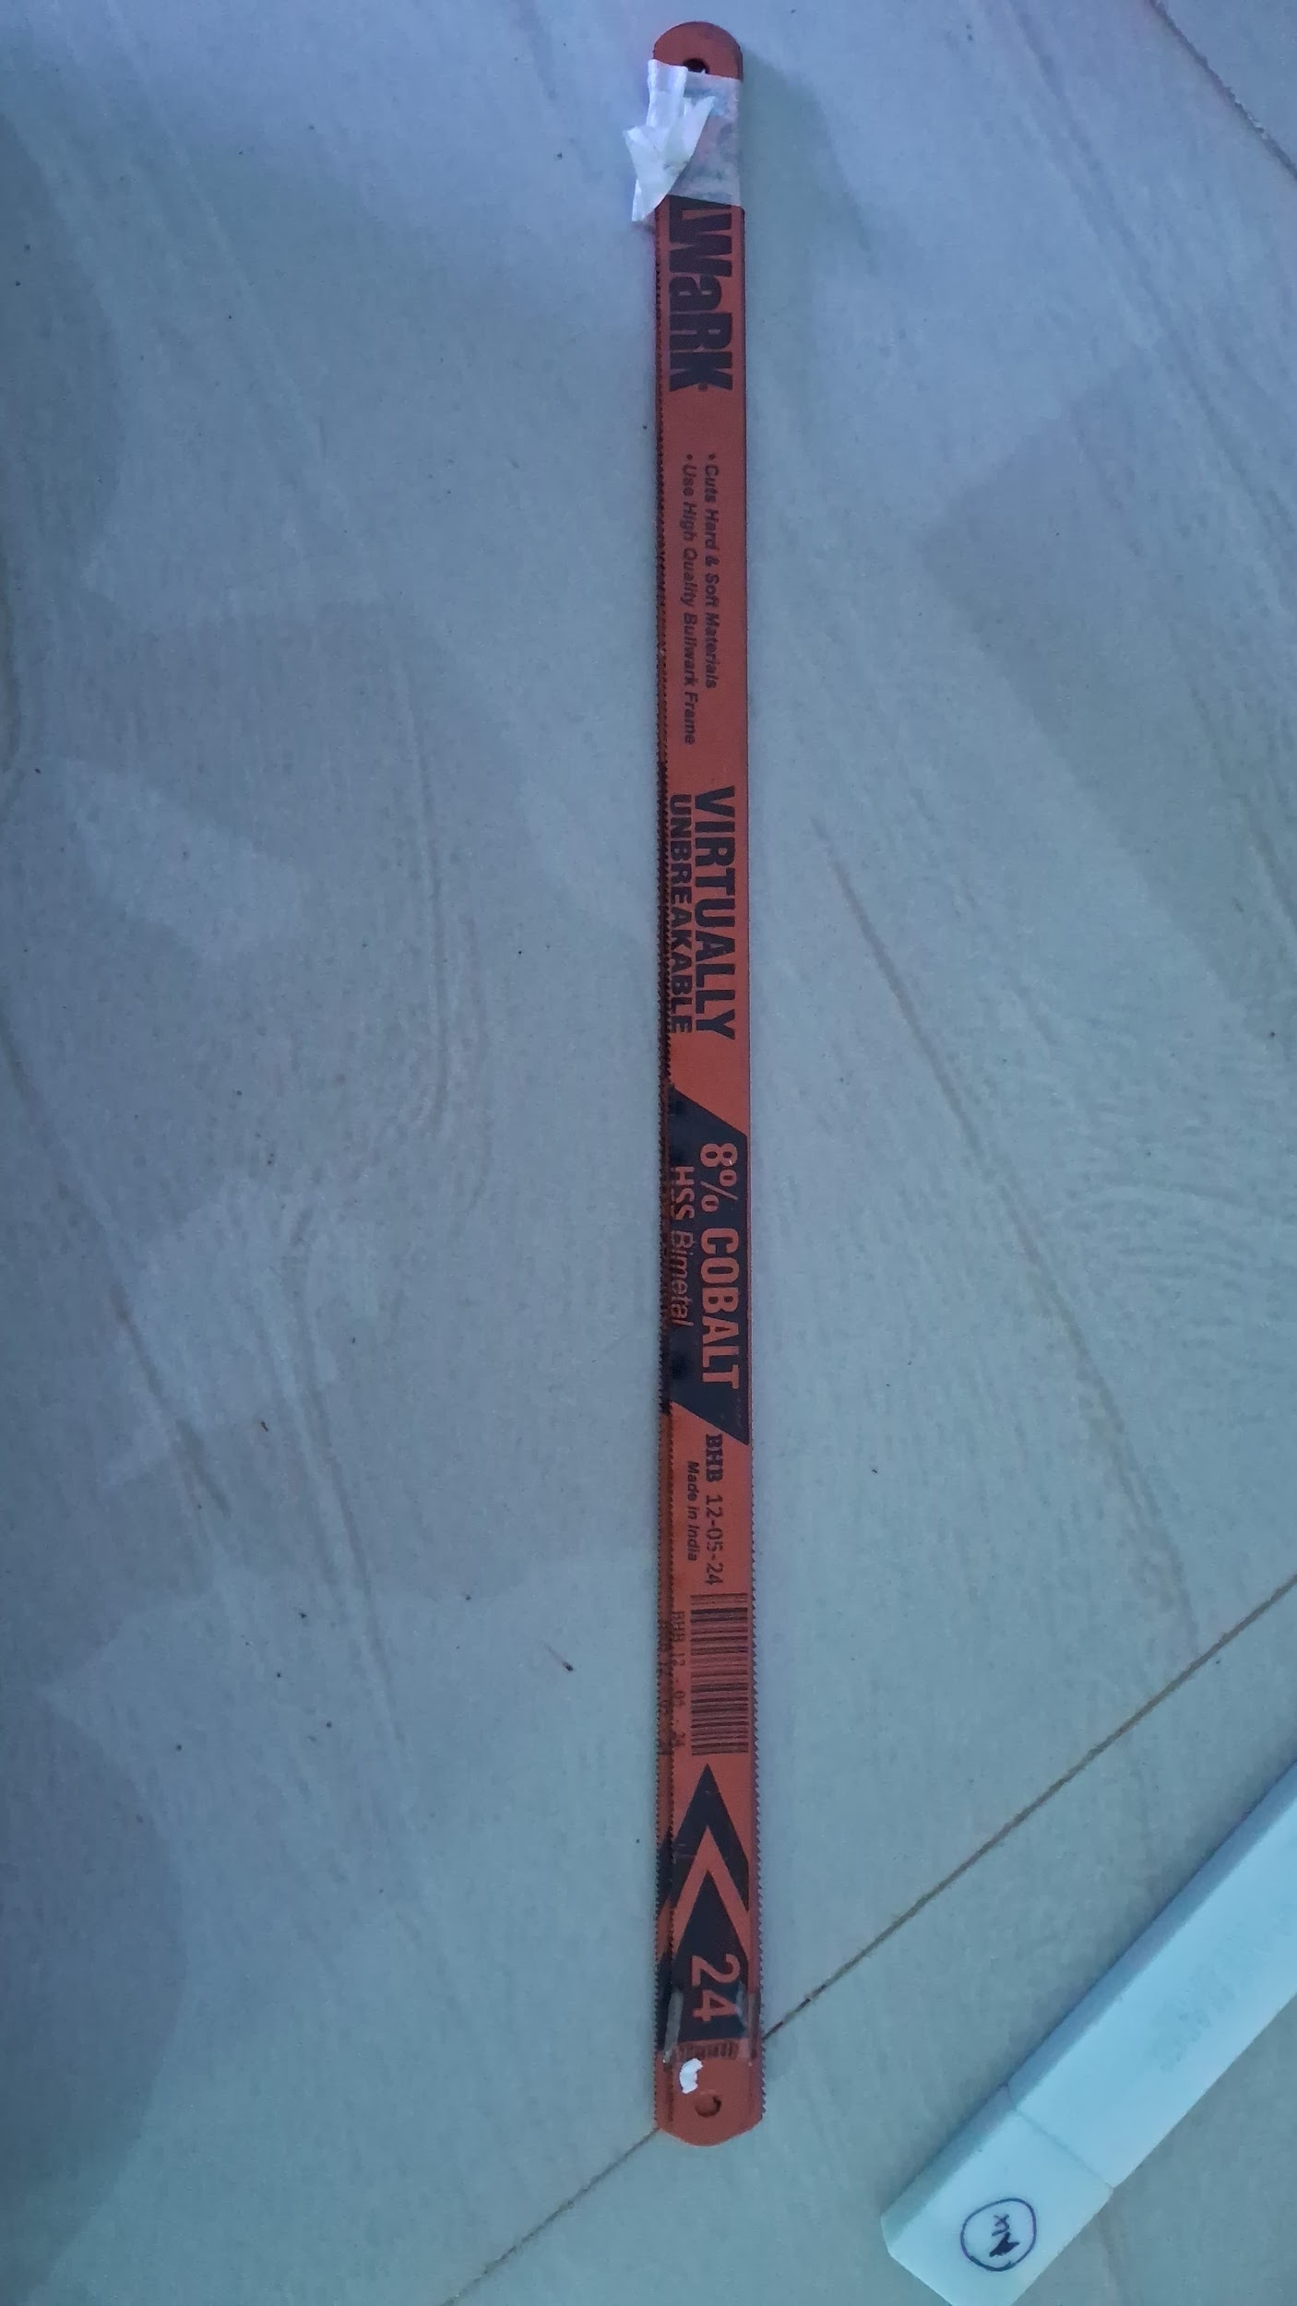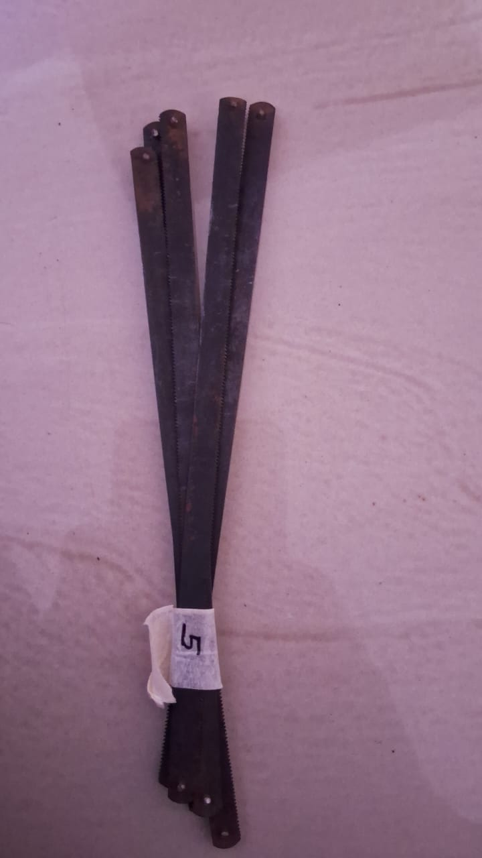
D. Proper Usage & Maintenance * Installation: Ensure teeth are pointing forward (away from the handle).
- Operation: Use long, steady strokes utilizing the full length of the blade.

5.Multi-Purpose Lubricant & Maintenance Spray
A. Description & Purpose Used for displacing moisture, preventing corrosion, and loosening rusted parts. Essential for protecting carbon steel tools from oxidation.
B. Technical Specifications * Brand: WD-40 Company
- Net Weight: 63.8 g
- Container Type: Aerosol can with red precision applicator straw.
- Properties: Non-conductive (once dry).
C. Lab Inventory Details * Brand: WD-40
- Size: Handheld

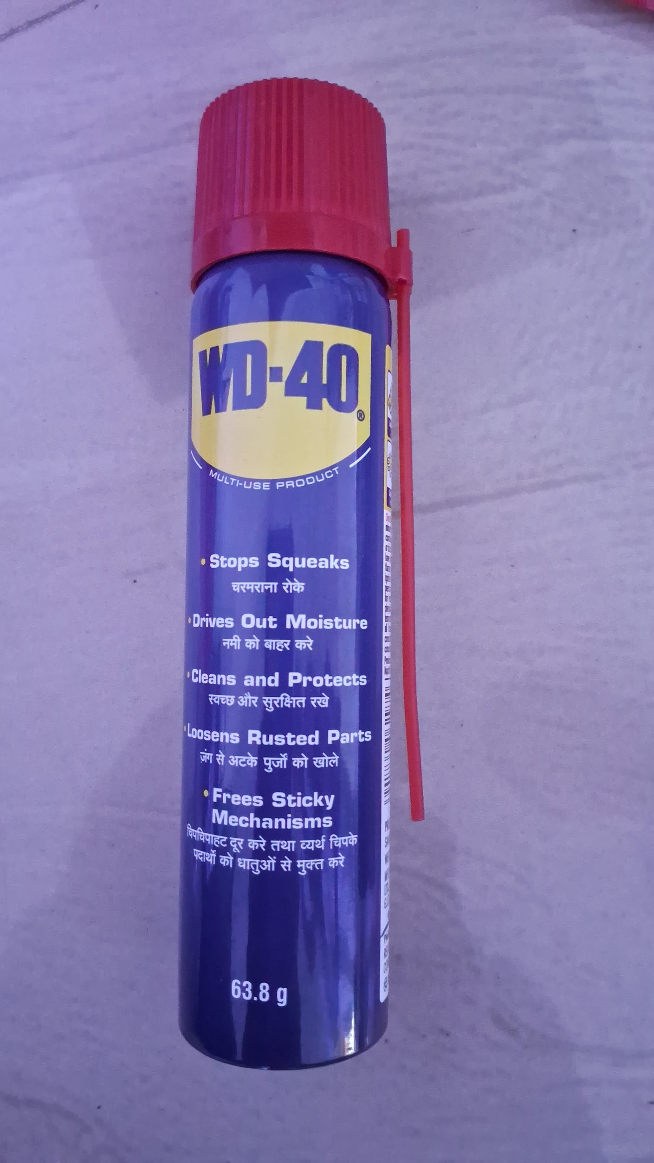

D. Proper Usage & Safety * Fire Safety: Extremely flammable. Do not spray near open flames or live circuits.
- Cleaning: Wipe away excess liquid to prevent tools from becoming slippery.

6.Personal Protective Equipment (PPE) - Safety Eyewear
A. Description & Purpose Primary defense against eye injuries from flying debris or chemical splashes. Hard-coated lenses ensure long-term visibility.
B. Technical Specifications * Manufacturer: Frontier™
- Certifications: ANSI & CE approved for impact resistance.
- Material: High-impact Polycarbonate.
- Design: Wraparound style for side protection.
C. Lab Inventory Details * Brand: Frontier
- Type: Clear Safety Glasses

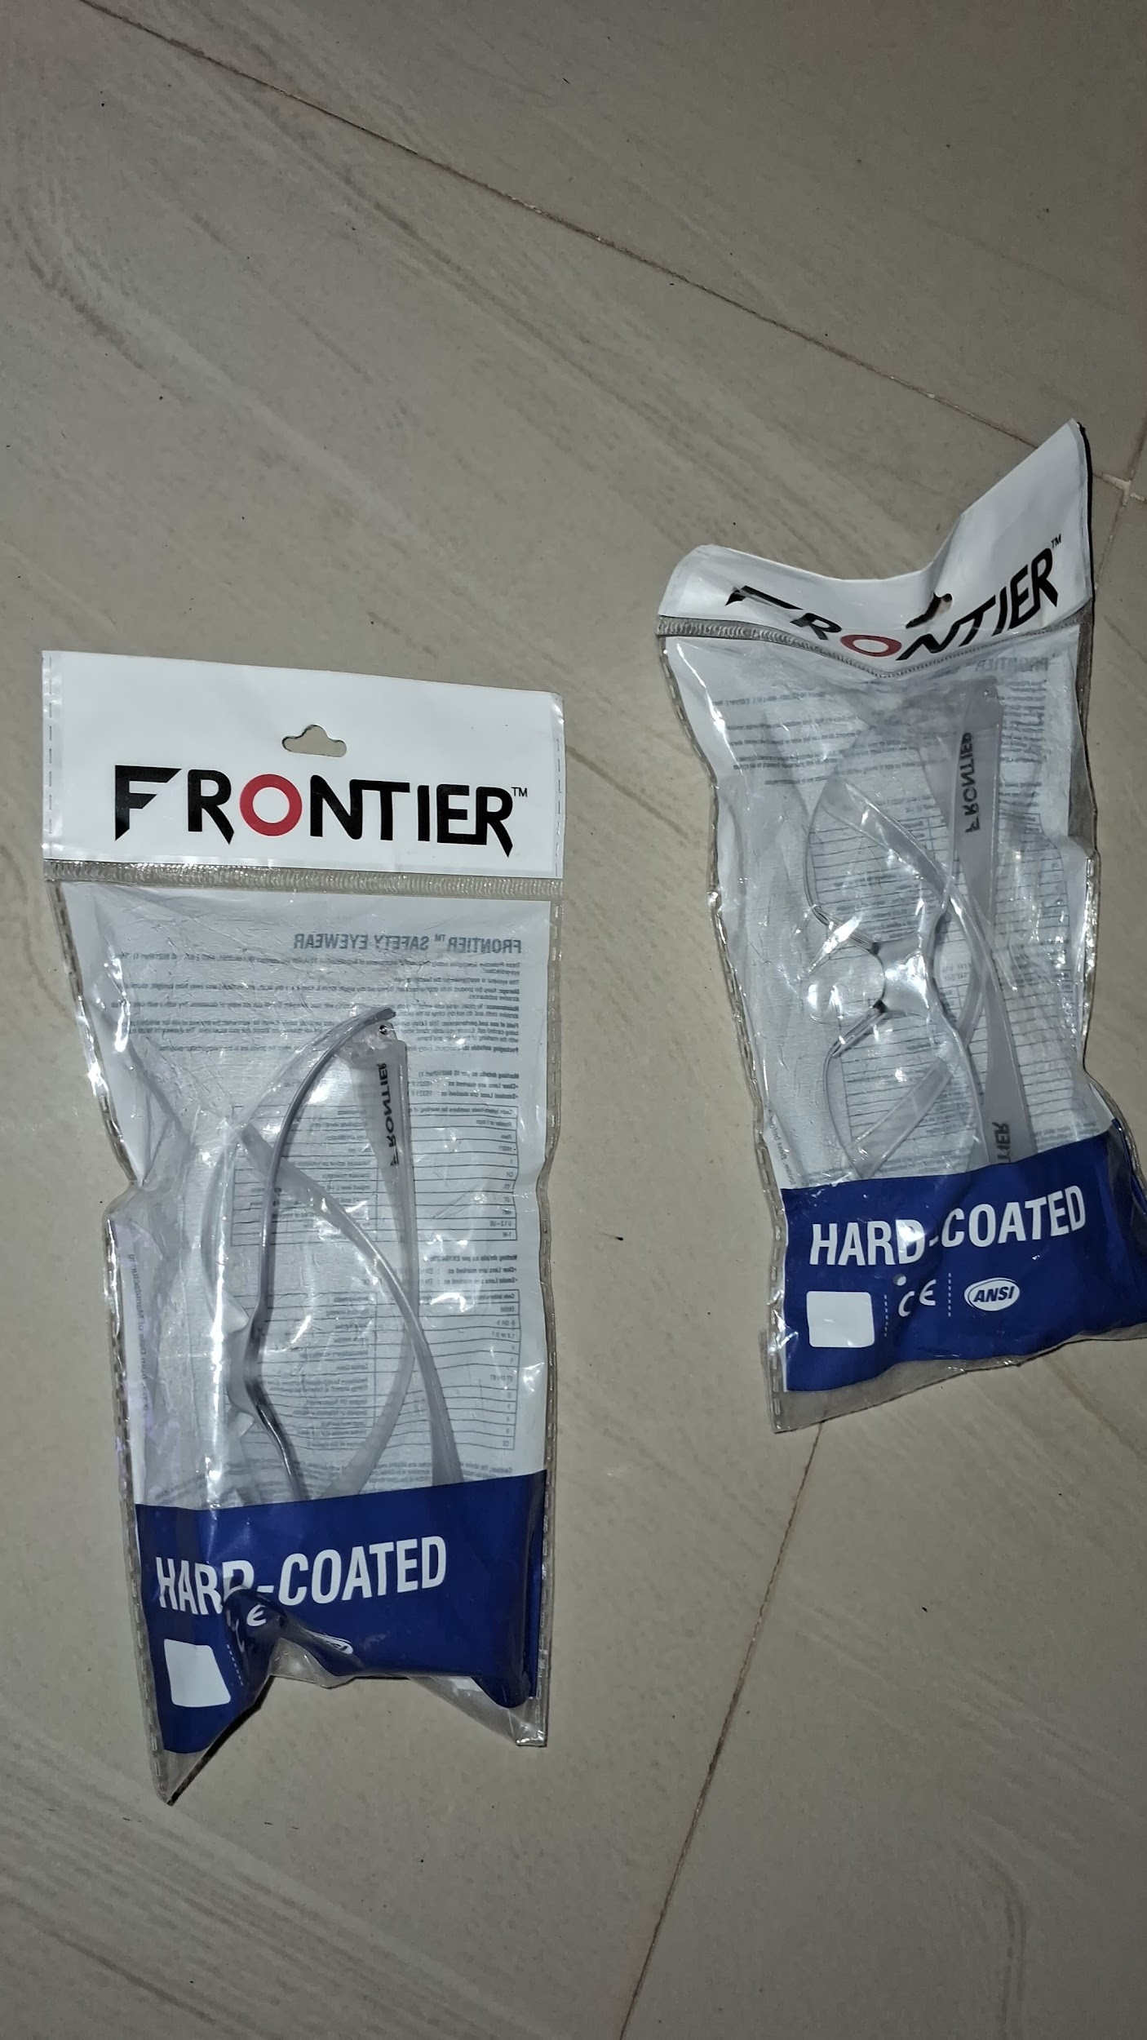

D. Proper Usage & Maintenance * Mandatory Use: Must be worn at all times when operating tools or soldering.
- Cleaning: Clean lenses only with a microfiber cloth or mild soap.

