- Ensure 3d fix is seen on GPS TEST app or from logcat on GNRMC. Observe in the third position A should be present to tell GPS has latched or not
- adb shell
- adb pull /vendor/etc/adr/adr.conf
- edit the pulled adr.conf in notepad++
- replace line number 91 open_data_store=0 by open_data_store=1
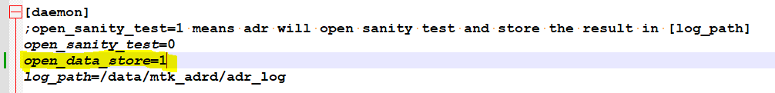
- adb push adr.conf /vendor/etc/adr/adr.conf
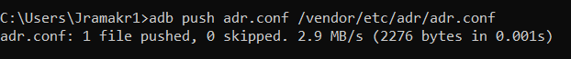
- Clear all vstlog and mtk_adrd (cd /data, rm -rf mtk_adrd and cd /data, rm -rf vstgloballogcontrol)
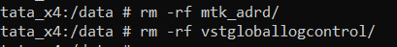
- do battery cycle
- Start the vehicle and leave for 5 mins
- adb shell
- cd /data/mtk_adrd/adr_log/
- cat …MEMS logs
- Ensure
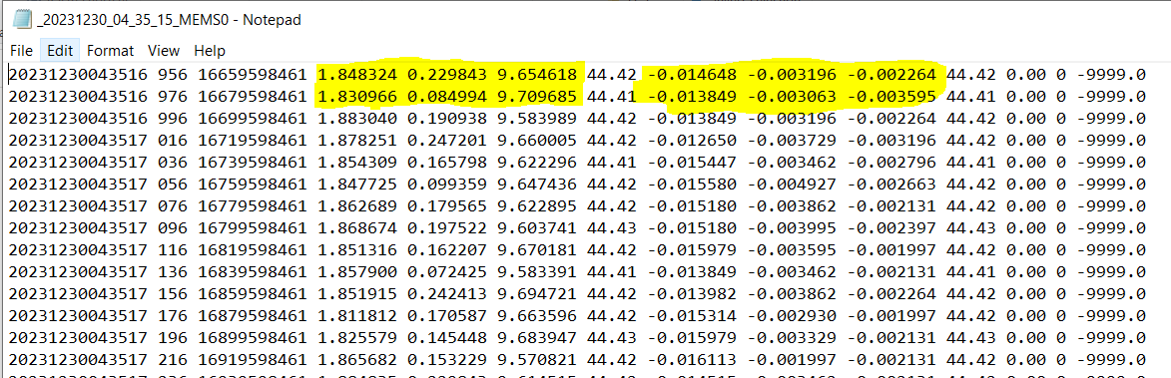
- collect the logs
- After collecting the logs, PLEASE ENSURE THIS STEP
- replace line number 91 open_data_store=0 by open_data_store=0
- adb push adr.conf /vendor/etc/adr/adr.conf and then reboot.

