STEPS TO GENERATE MLC CONFIGURATION FILE FOR IMU

Overview:
- IMU: ASM330LHHX
- Exposes ACC and GYRO sensors

Step 1: Sensor data collection
Please find below steps to collect gyro/Accel sensor data using the high_freq_sensor_tool binary:

- Push the Binary attached high_freq_sensor_tool binary to the device path:
/vendor/bin

- If an existing recorded file is present, remove it using the following commands in an ADB shell:
$ su
# rm -rf /data/sensor_gyro.txt
# rm -rf /data/vendor/sensor/*

- Run the Tool
Start the tool using the command below:
# high_freq_sensor_tool -c 1,1,0,0

Parameters:
- 1 → Sensor type: Accelerometer
- 1 → Enable sensor
- 0 → Default delay (nanoseconds)
- 0 → Default latency (nanoseconds)

- Perform Vehicle Test
Once the tool is running, start the vehicle and perform the following driving scenarios:
- Normal road driving
- Bumpy roads or speed breakers
- Sloped roads

This will help us to know how IMU data under various conditions.

- Collect Data After each test (adb pull):
- Retrieve /data/sensor_gyro.txt (Even though you have selected accelerometer, the log file will be named sensor_gyro.txt so, don’t get confused and clear the logs once pulled after collecting a particular sensor data)
- Collect contents from /data/vendor/sensor/

- Clear Logs Before Next Test
Before starting a new test, clear previous logs using:
$ su
# rm -rf /data/sensor_gyro.txt
# rm -rf /data/vendor/sensor/*

Sample data: The values are in m/s^2 unit.
data: [1,0,239835424936,-0.038000,0.238000,9.770000,3,1808679.000000]
data: [1,0,239837721875,-0.064000,0.239000,9.766000,3,1803436.125000]
data: [1,0,239840019796,-0.086000,0.228000,9.766000,3,1816217.125000]
data: [1,0,239842315721,-0.099000,0.215000,9.773000,3,1836709.250000]
Data overview:
ex: data: [1,0,239835424936,-0.038000,0.238000,9.770000,3,1808679.000000]
1 -> Sensor Type
0 -> reserved0
239835424936 -> Timestamp
-0.038000 -> ACC_X (m/s^2)
0.238000 -> ACC_Y (m/s^2)
9.770000 -> ACC_Z (m/s^2)
3 -> Sensor Status
1808679.000000 -> Avg Latency

Step 2: Format the above data in way compatible with MEMS Studio
Expected format sample: STMems_Machine_Learning_Core/application_examples/asm330lhhx/Tow detection/datalogs/Back_flatbed_Tow.txt at master · STMicroelectronics/STMems_Machine_Learning_Core
For our use-case, use the parser.py for format the collected data to expected format
Find the python script : here
command to execute: python3 parser.py /path/to/collected/data.txt /path/to/expected/data.txt
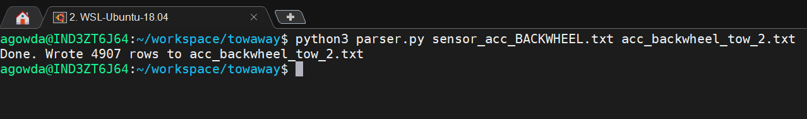

Sample formatted data:
A_X [mg] A_Y [mg] A_Z [mg]
-958 -2724 3750
-481 -1353 2373
-240 -668 1683
-119 -324 1338

Step 3 Pre-requisites:
- We are going to train a model which uses Decision Tree Algorithm, a supervised learning algo which expects data and class labels.
- So, when feeding the formatted data in MEMS studio, be mindful in assigning the class label to respective data.
Note: Enter Adv Features in MEMS studio and then follow the below steps
Step 3: Setting Data Patterns in MEMS STUDIO
- Select the IMU device (i.e, ASM330LHHX)
- Set the workspace path
- Load the formatted datalog (i.e: .txt file which was generated from parser.py) and enter the class label name. Finally click on “Load”

Ex: acc_park.txt -> class label: PARKING
acc_backwheel.txt -> class label: BACK_WHEEL
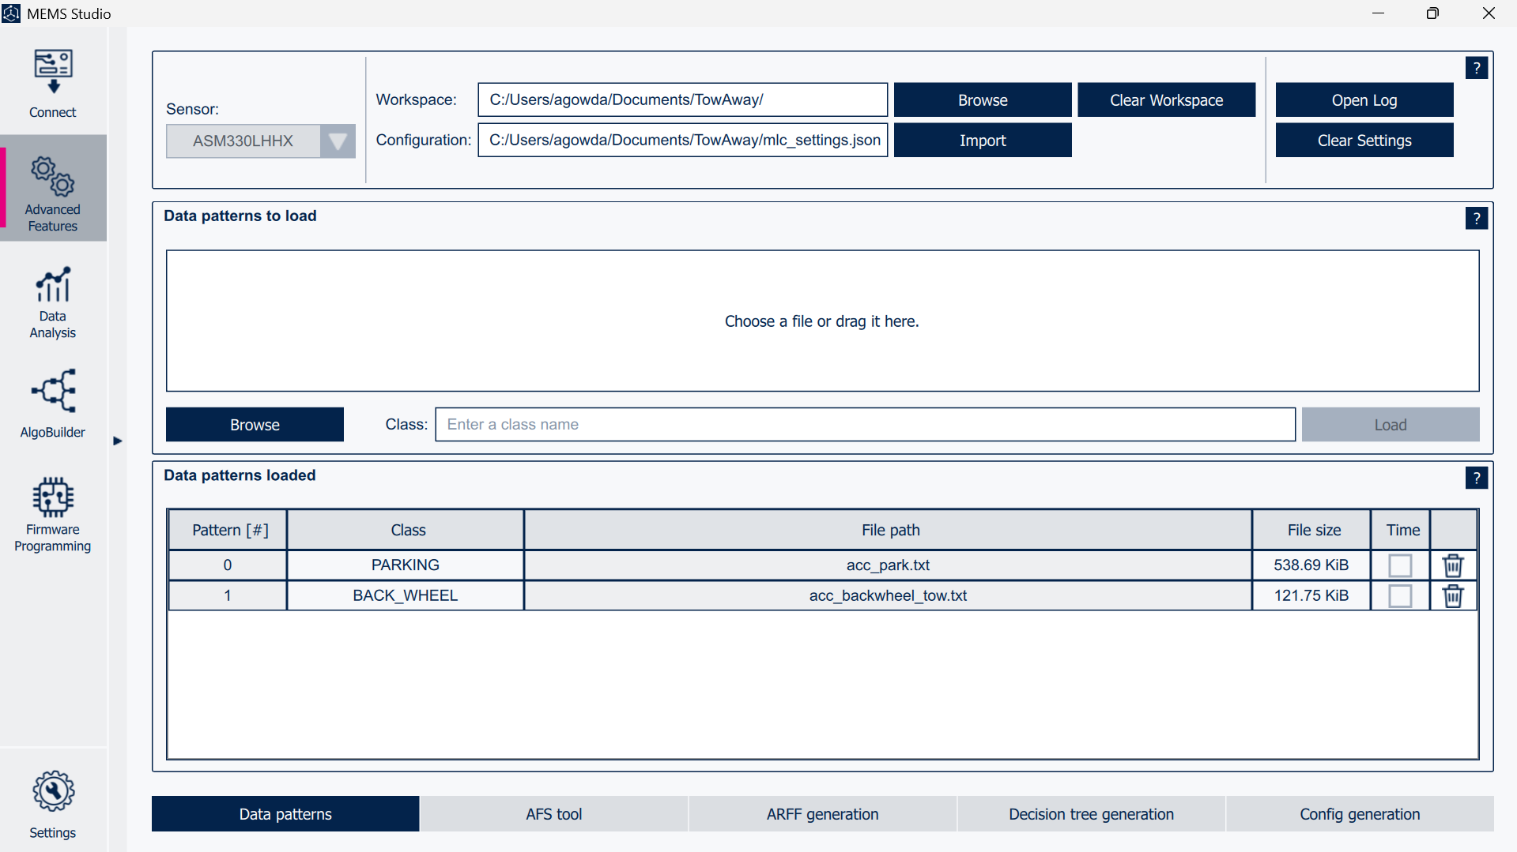
Step 4: Setting AFS tool
- Set the Output Data Rate accordingly. (Ex: 12.5Hz)
- Set what sensor type data was fed in Data Patterns section. (Ex: accelerometer_only)
- Set the accelerometer sensor configs (Ex: Full scale: 4g and ODR: 12.5Hz)

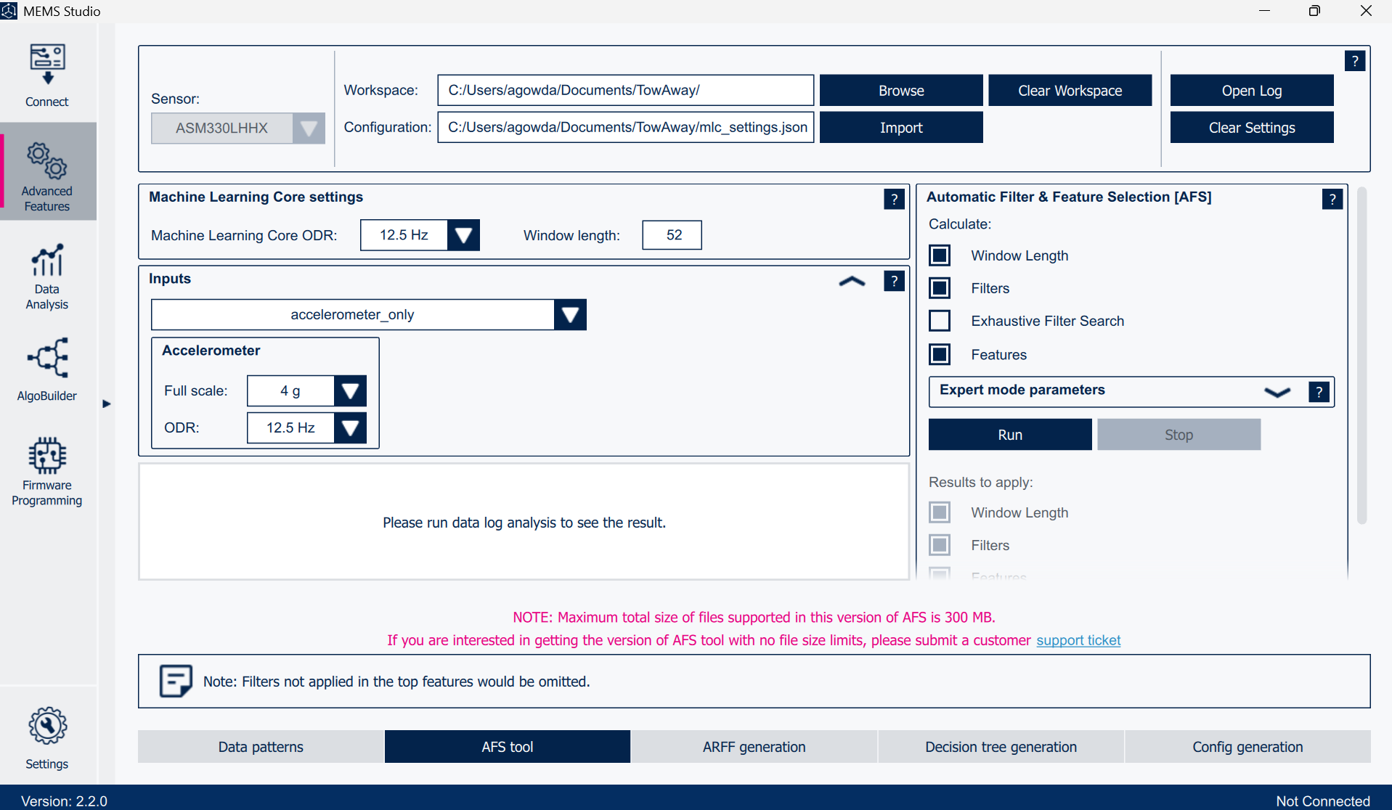

Step 5: Setting ARFF generation
- Set the path for features.arff file
- In Features section,
- Add the features which needs to be acted upon the data fed to the MEMS studio as shown in the below Image
- Click on Generate ARFF File button

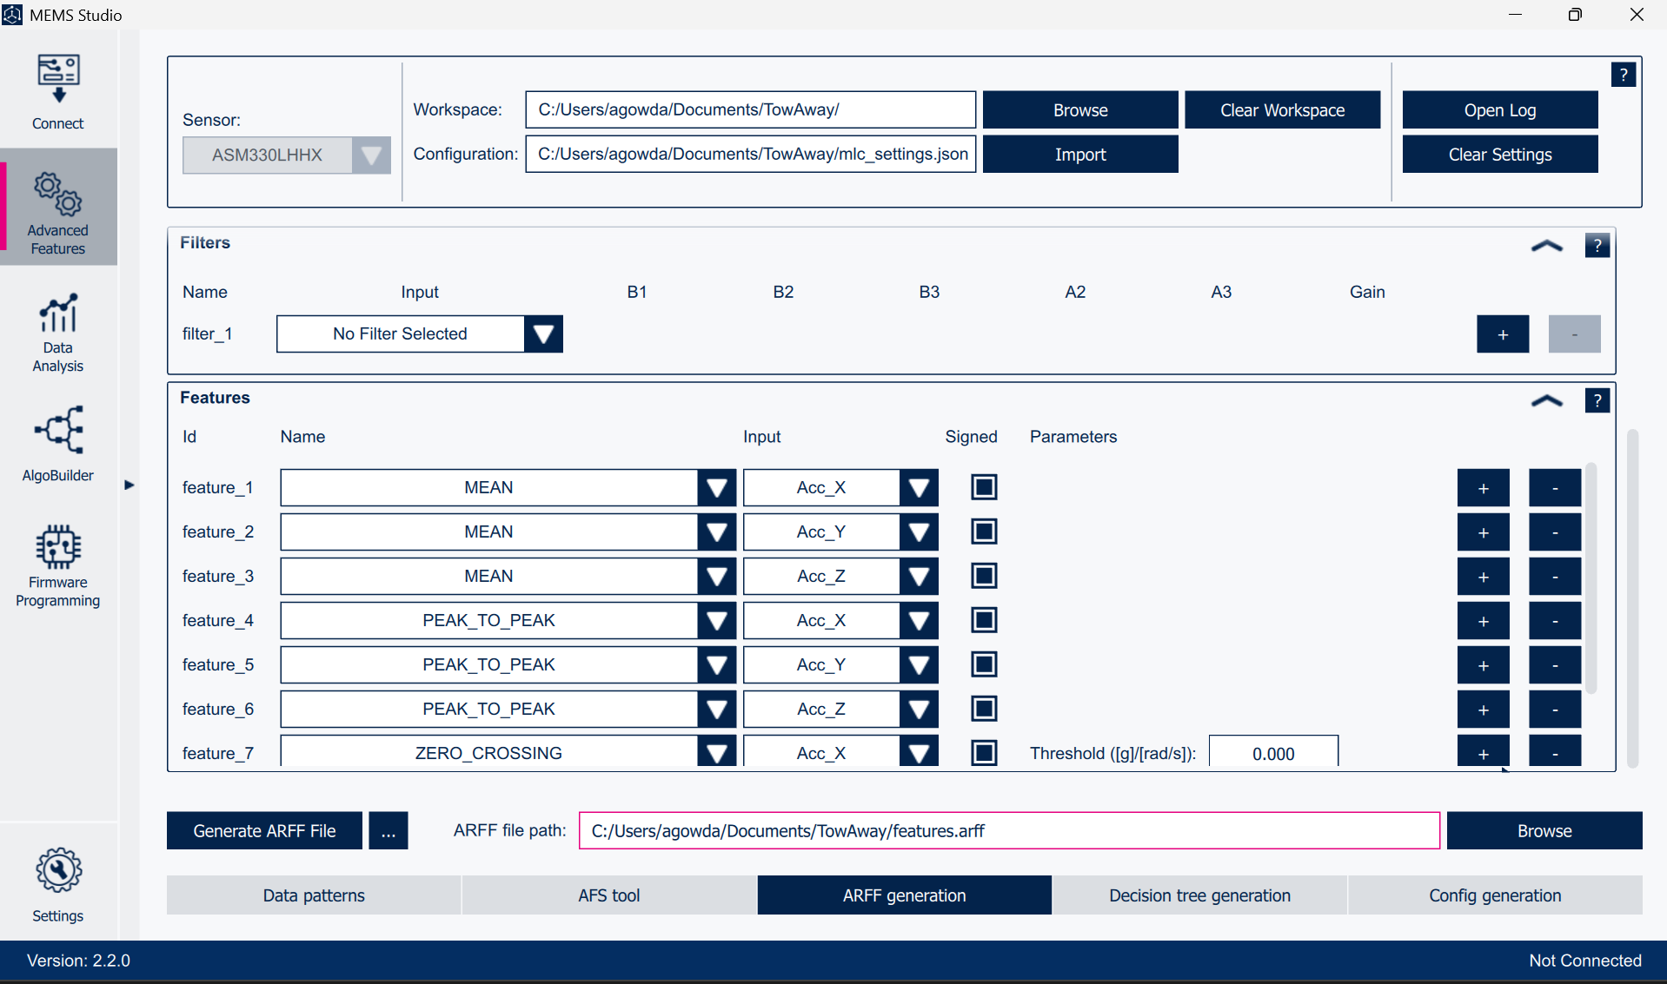

Step 6: Generating Decision Tree
- Enter the number of decision trees to be generated (Based on the fine-tuned value)
- Click on Generate Decision Tree button to generate tree and heat map for all the decision trees.

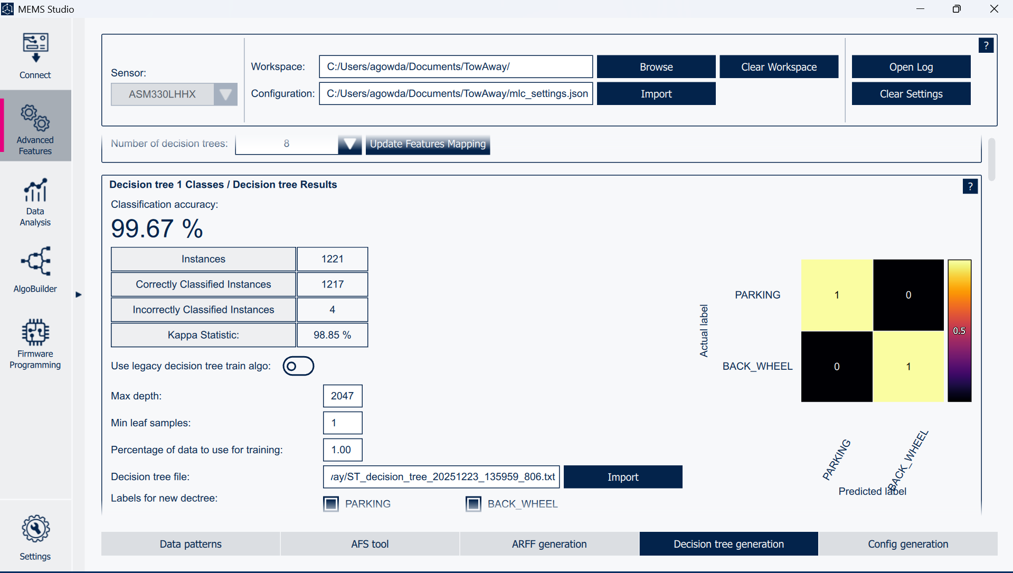

Step 7: Generating mlc.json file in Config Generation section
- Make sure the class output values are unique for each class in MetaClassifier section
- If yes, then click on Generate Config File button
- This downloads the mlc.json in the path specified.
