  - FLY-TECH / CPU4106-20C

BudgetWise
Group Project Pack
Project 13: Personal Budget Tracker with Visualization
Front-end implementation, team delivery plan and assessment evidence guide
15 October 2026

Project at a glance
BudgetWise helps users record income and expenses, plan category budgets and understand spending through charts. The implemented app uses HTML, CSS, JavaScript, Chart.js and localStorage. It has no backend database, account login or bank integration.
Member | Agreed responsibility
Maria | Product Owner / requirements and research synthesis
Juan Carlos | Scrum Master / coordination and project records
Rauf | UI/UX / research instruments, wireframes and accessibility
Teodor Onaci | Front-End / interaction, validation, calculations and storage
Alin | Visualisation and QA / charts, test design and results

Evidence status
Personas and research observations in this pack are illustrative planning examples, not participant findings. Named responsibilities are planned ownership, not a record of completed personal contributions. Meeting logs and reflections are templates. Technical results identify checks actually executed; browser and user acceptance tests remain pending.

What is included
- Working front-end app and source files with 25 automated logic tests.
- Five wireframe sheets, each showing desktop and mobile layouts; editable SVG files.
- Research examples, requirements, architecture, backlog, sprint schedule and member-by-member tasks.
- Test evidence, manual acceptance checklist, viva outline and reusable project-record templates.

1. Problem, users and research
Research question: can the tracker accurately summarise income and expenses and help users distinguish essential from discretionary spending?

Client scenario and need
Fly-Tech is preparing a budgeting demonstrator for a financial-education service supporting people with limited monthly disposable income. This is a proposed client scenario. The practical problem is fragmented expense recording and difficulty understanding how purchases affect the remaining monthly balance.
Planning persona | Needs and context | Design response
Alex, 24, working student | Variable work income; uses a phone; wants a quick view of essentials before spending on extras. | Fast entry form, clear monthly balance, mobile layout.
Priya, 36, employed parent | Several household categories; wants to understand overspending without connecting a bank account. | Category limits, transaction history, local saving and backup.

Illustrative observations to validate
Example observation | Proposed requirement | Validation task
A long expense list hides the monthly position. | Show income, expenses and remaining balance together. | Find the remaining balance without calculating manually.
Users may confuse needs and wants. | Provide labels, examples and category breakdowns. | Classify a grocery purchase and an entertainment purchase.
Users may worry about losing records. | Provide local persistence and an export backup. | Reload and verify entries; export and reimport.

Research and evaluation approach
Use prototype development supported by document analysis and authoritative technical sources. Before recruiting participants, follow course procedures. Ask consenting participants to complete the same tasks; record completion, errors and anonymous comments. Do not insert invented quotes, attendance, timings or satisfaction scores into the final evidence.

SDG rationale
SDG 12.8 provides an awareness link through reflection on discretionary consumption. SDG 1 provides an indirect financial-resilience context. Budget categories do not measure emissions, waste or poverty reduction. Behavioural impact needs evidence beyond a functioning interface.

2. Requirements and acceptance criteria
ID / priority | Owner | User story / feature | Acceptance
BW01 / Must | Teodor | Record income and expenses | Valid entries appear in history and update the correct month.
BW02 / Must | Teodor | Edit and delete transactions | Edit keeps one ID; delete asks for confirmation and updates totals.
BW03 / Must | Teodor | Monthly summary | Balance equals income minus needs minus wants in integer pence.
BW04 / Must | Teodor | Save records locally | Reload retains valid state on the same origin; save failures are reported.
BW05 / Must | Rauf / Teodor | Accessible responsive screens | Labels, keyboard access and narrow-screen layout pass manual checks.
BW06 / Must | Alin | Needs / Wants chart | Chart and numerical values match the same calculated totals.
BW07 / Should | Teodor | Monthly category budgets | Each month retains its own limits; zero means no limit.
BW08 / Should | Teodor | Search, filter and sort | History search and controls operate on the selected month.
BW09 / Should | Teodor / Alin | Backup export and import | Valid JSON round-trips; invalid backup leaves records unchanged.
BW10 / Must | Alin / team | Test evidence and defect review | Automated results retained; manual checks recorded honestly.
BW11 / Must | Maria / Juan Carlos | Research and project documentation | Requirements, schedule, meeting records and decisions are traceable.
BW12 / Must | All | Article, slides and viva | Each member can explain their contribution and project limitations.

Explicit scope limits
Single browser workspace, GBP, manually entered transactions, predefined categories and monthly limits. No shared accounts, automatic bank feeds, payment processing, personalised financial advice, currency conversion or verified sustainability scoring. Use static HTTP hosting; a backend service is unnecessary.

3. System analysis and design

Information architecture
Screen | Content | Main actions
01 Dashboard | Income, expenses, balance; spending mix; recent records. | Choose month; add entry; open history or budgets.
02 Add / Edit | Type, category, amount, date and description. | Validate; save; cancel.
03 Transactions | Selected-month history; search, filter and sort. | Edit; confirmed delete.
04 Budgets | Needs and wants limits; budget versus actual. | Save limits for selected month.
05 Insights | Spending mix, largest category and exact table. | Review proportions and category totals.

Use cases and flows
Actor / trigger | Flow | Outcome
User records a purchase | Open Add → choose type/category → amount/date → Save → History. | Stored transaction and recalculated summaries.
User corrects a record | History → Edit → modify form → Save. | Same identifier; no duplicate record.
User reviews spending | Select month → Dashboard / Insights → compare categories. | Consistent totals and numerical chart alternatives.
User restores a backup | Import → validate file → confirm replacement. | Valid state replaces records; rejection preserves existing data.

Logical data flow
User input → form validation → transaction state → summary calculations → dashboard, budget comparisons and charts. Valid state → JSON serialisation → localStorage. Reload → JSON parsing and validation → transaction state. Export / import exchange the same versioned JSON schema. There is no data flow to a server database.

Data model
Record | Fields and rules
Transaction | id: unique string; type: income / needs / wants; category: allowed for type; amount: positive integer pence; date: valid YYYY-MM-DD; description: ≤120 characters.
Budget | Month key YYYY-MM; category → non-negative integer pence; blank / zero is no limit.
State / backup | version = 1; transactions array; budgets object. Reject unsupported version, duplicates, invalid types, amounts or dates.
Separation of concerns: core.mjs holds testable validation and calculations; app.mjs handles DOM events and rendering; styles.css handles layout. Chart.js is bundled locally. Descriptions are escaped before insertion into HTML.

4. Delivery schedule and milestones
Revised planning baseline: four one-week sprints, with a runnable-code target of 2 November and assessment date of 9 November 2026.
Sprint | Dates | Goal | Definition of done
1 | 9–15 Oct | Research, scope and design baseline. | Prioritised backlog, roles, flows and initial wireframes reviewed.
2 | 16–22 Oct | Working core transaction journey. | Add/edit/delete, correct totals and local save demonstrated.
3 | 23–29 Oct | Budgets, charts and integration. | Monthly limits, chart/table consistency and backup exchange checked.
4 | 30 Oct–5 Nov | Testing, fixes and handover. | Code candidate by 2 Nov; defects, documentation and evidence reviewed.
Final preparation | 6–8 Nov | Articles, slides and rehearsal. | Each person checks their own article and rehearses live defence.

Milestone chart
Milestone | Target | Lead | Acceptance dependency
M1 Scope and wireframes | 15 Oct | Maria / Rauf | Requirements and navigation reviewed.
M2 Core working journey | 22 Oct | Teodor | CRUD, validation, calculations and storage checks.
M3 Feature integration | 29 Oct | Alin / Teodor | Budgets, charts, filtering and backups checked.
M4 Runnable GitHub candidate | 2 Nov | Teodor / team | README and tested source prepared for submission.
M5 Documentation ready | 5 Nov | Juan Carlos / all | Records, testing and articles checked.
M6 Live assessment | 9 Nov | All | 15-minute presentation and 5-minute Q&A prepared.

Gantt overview
Workstream | 9–15 Oct | 16–22 Oct | 23–29 Oct | 30 Oct–5 Nov | 6–9 Nov
Research and requirements | Active | Refine | Review | Evaluate | Present
UI/UX | Wireframes | Review build | Refine | Usability checks | Explain
Core development | Architecture | Build | Integrate | Fix / freeze | Demo
Visualisation / QA | Test plan | Core checks | Charts / checks | Regression | Defend
Documentation | Start | Update | Update | Complete | Submit
Planning allowance: about five hours per member per sprint, approximately 100 team hours. This is an estimate, not a timesheet. Actual workload must be recorded. Daily stand-ups can use a short agreed asynchronous update, with attendance and decisions preserved.

5. Maria
Product Owner / responsibilities across the full lifecycle
Stage | Actions | Evidence to retain
Research / requirements | Define intended users and client scenario; compare relevant literature; write measurable objectives. | Problem statement, SDG rationale and prioritised user stories.
Design | Review wireframes against user stories; settle scope disagreements. | Accepted scope and feature acceptance criteria.
Implementation | Review each increment; identify gaps without expanding the scope unnecessarily. | Backlog decisions and review comments.
Evaluation | Check whether completed functions meet user needs; distinguish benefits from untested claims. | Acceptance review and limitation summary.
Handover | Explain problem, users and sustainability link; write own article and reflections. | Research slides, individual writing and viva preparation.

Proposed effort: five hours per sprint
- Sprint 1: research 2h; requirements 2h; team review 1h.
- Sprint 2: backlog refinement 1h; feature review 2h; article notes 1h; coordination 1h.
- Sprint 3: acceptance review 2h; research synthesis 2h; team review 1h.
- Sprint 4: final acceptance 2h; article 2h; presentation 1h.

Handoffs and accountability
Discuss changes with the relevant owner and record the decision. Retain genuine dated work such as commits, design revisions, review comments and test logs. Supplied starter files are a starting point; the assigned member must review and understand their area before claiming authorship or defending it.

Individual assessment tasks
Write approximately 200 words for each weekly portfolio, linking personal work to skills learned and evidence. Prepare an individual article of approximately 1,500 words using the taught research structure and IEEE references. Explain your contribution and limitations in the live viva. Do not copy a shared personal reflection between members.

6. Juan Carlos
Scrum Master / responsibilities across the full lifecycle
Stage | Actions | Evidence to retain
Research / requirements | Facilitate role agreement; create task board, schedule and risk register. | Role allocation, sprint baseline and risks.
Design | Record dependencies between wireframes, data model and chart integration. | Updated task board and design-review decisions.
Implementation | Coordinate brief stand-ups; surface blockers; maintain review and retrospective records. | Actual meeting records, issue ownership and sprint updates.
Evaluation | Coordinate defect prioritisation and retests; track unresolved issues. | Defect log and release-readiness checklist.
Handover | Prepare planning slides; check deliverable ownership and submission readiness; write own article. | Schedule evidence, meeting index and viva plan.

Proposed effort: five hours per sprint
- Sprint 1: schedule 2h; board 1h; risks 1h; coordination 1h.
- Sprint 2: stand-ups / tracking 2h; dependencies 1h; records 1h; article notes 1h.
- Sprint 3: reviews 2h; issue management 1h; records 1h; article notes 1h.
- Sprint 4: release checklist 2h; article 2h; rehearsal 1h.

Handoffs and accountability
Discuss changes with the relevant owner and record the decision. Retain genuine dated work such as commits, design revisions, review comments and test logs. Supplied starter files are a starting point; the assigned member must review and understand their area before claiming authorship or defending it.

Individual assessment tasks
Write approximately 200 words for each weekly portfolio, linking personal work to skills learned and evidence. Prepare an individual article of approximately 1,500 words using the taught research structure and IEEE references. Explain your contribution and limitations in the live viva. Do not copy a shared personal reflection between members.

7. Rauf
UI/UX Designer / responsibilities across the full lifecycle
Stage | Actions | Evidence to retain
Research / requirements | Prepare interview / usability prompts; examine accessibility needs and task priorities. | Research instruments and design hypotheses.
Design | Review five desktop/mobile pairs; create navigation flow and visual specifications. | Annotated wireframes and design rationale.
Implementation | Compare built screens with wireframes; check labels, spacing and error presentation. | Design review notes and specific UI issues.
Evaluation | Run or observe consented task sessions; inspect keyboard navigation, focus and responsive layout. | Actual anonymous findings and accessibility observations.
Handover | Explain before/after design decisions; include final interface evidence; write own article. | Design slides, screen index and individual writing.

Proposed effort: five hours per sprint
- Sprint 1: research instruments 1h; flows 1h; wireframes 3h.
- Sprint 2: interface review 3h; accessibility criteria 1h; article notes 1h.
- Sprint 3: responsive refinements 2h; usability preparation 2h; review 1h.
- Sprint 4: usability / accessibility checks 2h; article 2h; slides 1h.

Handoffs and accountability
Discuss changes with the relevant owner and record the decision. Retain genuine dated work such as commits, design revisions, review comments and test logs. Supplied starter files are a starting point; the assigned member must review and understand their area before claiming authorship or defending it.

Individual assessment tasks
Write approximately 200 words for each weekly portfolio, linking personal work to skills learned and evidence. Prepare an individual article of approximately 1,500 words using the taught research structure and IEEE references. Explain your contribution and limitations in the live viva. Do not copy a shared personal reflection between members.

8. Teodor Onaci
Front-End Developer / responsibilities across the full lifecycle
Stage | Actions | Evidence to retain
Research / requirements | Review technical feasibility; define validation, amount representation and storage constraints. | Technical scope and transaction schema.
Design | Review layout feasibility; separate calculation logic from DOM rendering. | File structure, state schema and function responsibilities.
Implementation | Review and develop HTML/CSS/JS; build transaction flows, budgets, filtering, saving and backups. | Attributable commits, runnable app and documented interfaces.
Evaluation | Run logic checks; reproduce reported defects; fix and retest without changing expected outputs to hide failures. | Test runs, corrective commits and known limitations.
Handover | Prepare README and source; demonstrate core flow; explain algorithms and limits; write own article. | Runnable code, installation steps, technical slides and individual article.

Proposed effort: five hours per sprint
- Sprint 1: architecture 2h; schema 1h; initial layout 2h.
- Sprint 2: CRUD 2h; calculations 1h; persistence 1h; review 1h.
- Sprint 3: budgets / filters 2h; chart integration 1h; backup 1h; review 1h.
- Sprint 4: fixes 2h; README / article 2h; live demo 1h.

Handoffs and accountability
Discuss changes with the relevant owner and record the decision. Retain genuine dated work such as commits, design revisions, review comments and test logs. Supplied starter files are a starting point; the assigned member must review and understand their area before claiming authorship or defending it.

Individual assessment tasks
Write approximately 200 words for each weekly portfolio, linking personal work to skills learned and evidence. Prepare an individual article of approximately 1,500 words using the taught research structure and IEEE references. Explain your contribution and limitations in the live viva. Do not copy a shared personal reflection between members.

9. Alin
Visualisation and QA / responsibilities across the full lifecycle
Stage | Actions | Evidence to retain
Research / requirements | Translate objectives into checks; select readable charts and expected-output fixtures. | Test strategy and independent expected totals.
Design | Define chart labels, numerical alternatives and budget progress states. | Chart specifications and manual test cases.
Implementation | Review and develop Chart.js integration; check shared totals across all views. | Chart code changes and integration observations.
Evaluation | Run automated and manual cases; test backup validation, storage failure and edge cases. | Actual results with environment, pass/fail and retest history.
Handover | Summarise executed checks and unresolved limits; prepare testing slides; write own article. | Test evidence, defect summary and viva answers.

Proposed effort: five hours per sprint
- Sprint 1: test strategy 2h; fixtures 2h; chart review 1h.
- Sprint 2: core checks 2h; issue reporting 1h; chart preparation 1h; article notes 1h.
- Sprint 3: chart integration 2h; integration tests 2h; review 1h.
- Sprint 4: regression 2h; article 2h; testing slides 1h.

Handoffs and accountability
Discuss changes with the relevant owner and record the decision. Retain genuine dated work such as commits, design revisions, review comments and test logs. Supplied starter files are a starting point; the assigned member must review and understand their area before claiming authorship or defending it.

Individual assessment tasks
Write approximately 200 words for each weekly portfolio, linking personal work to skills learned and evidence. Prepare an individual article of approximately 1,500 words using the taught research structure and IEEE references. Explain your contribution and limitations in the live viva. Do not copy a shared personal reflection between members.

10. Testing and validation
Executed on 15 October 2026: Node.js built-in test runner; 25 tests passed, 0 failed. Full raw output is included.

Executed technical checks
Area | Evidence / outcome
Amounts and validation | Pounds-to-pence conversion; invalid inputs; real calendar dates; category/type match; description length.
Transactions | Creation without mutation; same-ID edit; selective deletion.
Summaries | Month isolation; empty state; correct balance; edit/delete recalculation; negative balance; category totals.
Planning dataset | Income £2,500; needs £1,225; wants £645; expenses £1,870; remaining £630.
Backup schema | Reject unknown versions, duplicate IDs, invalid amounts and months; accept zero limit.
Storage | In-memory storage adapter round-trip and failure propagation. This is not a real-browser storage test.
Source syntax | node --check passed for app.mjs and core.mjs.

Manual acceptance checks: pending
ID | Check | Expected result
UI01 | Desktop navigation | Open each of the five routes; correct active item and content; no console errors.
UI02 | Mobile / keyboard | Check 390px and 768px widths; all actions reachable; visible focus; labelled inputs.
UI03 | Form errors | Try invalid amount/date; see understandable error; no invalid record saved.
UI04 | Real persistence | Add record; reload same origin; record remains. Block storage; see save warning.
UI05 | Budgets / charts | Save limits; confirm progress and chart values after add/edit/delete.
UI06 | Backup files | Download JSON; import it after confirmation; malformed file preserves state.
UI07 | Destructive actions | Cancel delete / clear / demo replacement; no records change.
UI08 | Usability | Consenting users complete standard tasks; record actual errors and comments.
No browser-driven or participant tests have been executed. Do not convert the pending checklist into passed results without running it. Automated logic checks do not prove visual quality, browser compatibility, full accessibility or financial-behaviour improvement.

11. Risks, quality and handover
Risk | Response | Owner
Role confusion | Use the single allocation in this pack; approve changes in a decision log. | Juan Carlos
Scope growth / missed date | Must-have backlog first; freeze core code for the 2 Nov target. | Maria
Financial calculation error | Integer pence; independent expected values; regression suite. | Teodor / Alin
Browser data loss | Explain device-local storage; export backup; handle failure. | Teodor
Unreadable mobile charts | Exact numerical alternatives; viewport and keyboard checks. | Rauf / Alin
Overstated research evidence | Separate illustrative examples, observed findings and planned evaluation. | All
Unclear personal contribution | Individual commits, notes and own explanations. | All

Release readiness
- Run the app over HTTP and complete pending manual checks.
- Resolve or explicitly document open defects and test environment.
- Retain the exact source version demonstrated and submitted.
- Include README, source, third-party notices and test commands in GitHub.
- Each member checks their own article, weekly portfolio and authenticity statement.
- Prepare a reliable live demonstration; use example transactions rather than personal bank data.

Run and maintain
Run: python -m http.server 8000 --directory dist from the source folder. Open http://localhost:8000. Test: node --test tests/core.test.mjs. No package installation is needed. Use one browser tab for editing; after another tab changes records, reload before editing. Store private backup files securely.

Current implementation limitations
GBP only; predefined categories; local browser storage; no accounts or syncing; no bank feed. Charts describe entered data rather than independently verified spending. No full accessibility conformance or behavioural benefit is claimed. Larger datasets may require a different persistence strategy.

12. Academic article and live viva

Individual article structure
Section | Suggested main-body allocation | Evidence
Introduction | 200 words | Problem, context, need, contribution and measurable research question.
Literature review | 250 words | Evaluate sources using CRAMP; synthesise rather than list.
Methodology | 300 words | Prototype approach, technical tools, Agile/SDLC and role evidence.
Data collection | 150 words | Example fixtures; actual research instruments; consent if applicable.
Data analysis | 200 words | Expected outputs, pass/fail analysis and actual findings.
Results / discussion | 300 words | Executed results, interpretation, limitations and research question.
Conclusion | 100 words | Objectives addressed, supported findings and future work.
Abstract, references and appendices are excluded by the brief’s word-count rules. Use IEEE numbered citations in order of first appearance. The teaching deck contains one conflicting alphabetical-order instruction; the explicit IEEE guidance and assessment rubric support numerical order. Each member’s article must be their own analysis of the shared project.

18-slide / 15-minute presentation outline
Slides | Content | Lead / time
1–3 | Title; client problem; objectives and research question. | Maria / 2 min
4–6 | Research and SDGs; backlog and roles; schedule / risks. | Maria + Juan Carlos / 2.5 min
7–9 | User flows; wireframes; design and accessibility. | Rauf / 2 min
10–12 | Architecture; implementation decisions; live transaction demonstration. | Teodor / 4 min
13–15 | Charts and budgets; automated tests; manual/user findings when available. | Alin / 2.5 min
16–18 | Challenges; limitations / future work; conclusion and references. | All / 2 min
Allow a separate 5 minutes for Q&A. Rehearse the complete live session together. Each member should explain their choices, the local-storage limitations, what was tested and what remains uncertain. Keep the final version within the allotted time.

13. Working templates and next actions

Stand-up record: complete with actual activity
Field | Entry to record
Date / channel | Actual date, time and location or asynchronous channel.
Attendance | Names present; absence noted accurately.
Each member’s update | Completed since last update; next task; blocker.
Decision / action | What was agreed; named owner; target date.
Evidence link | Issue, commit, wireframe revision or document.

Weekly reflection prompts
What did I personally do? What evidence supports it? Which seminar or workshop helped? What difficulty did I encounter, and how did I respond? What did I learn? What will I change next week? Keep approximately 200 words, focused on learning rather than a generic task list.

Defect log template
ID | Environment / steps | Expected / actual | Owner / severity | Retest
To complete | Browser, viewport, version; reproducible steps. | Record both clearly. | Assign after triage. | Date, result, evidence.

Immediate next actions
- All: review scope, roles and revised dates; confirm tutor-specific deadlines on Moodle.
- Rauf: review supplied wireframes and annotate any agreed changes.
- Teodor and Alin: run source locally and complete manual acceptance checks.
- Maria: validate the user problem with real evidence where feasible.
- Juan Carlos: start genuine stand-up, decision and contribution records.

Source reading
Assessment brief; Week 2 Session 1 teaching slides; group presentation; Teodor’s formative reflection; project-planning workbook. External references: OECD/INFE 2023 financial-literacy survey (doi:10.1787/56003a32-en), UN SDG goals 1 and 12, MDN localStorage documentation, Chart.js documentation, Scrum Guide 2020 and WCAG 2.2. Full bibliographic entries are in the academic article.

Appendix A. Use-case diagram
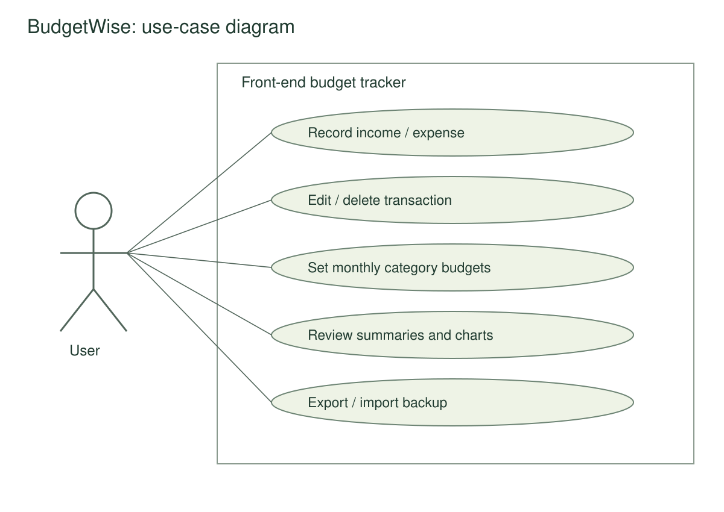
A single user operates a local browser workspace. All five use cases are within the front-end scope.

Appendix B. Data-flow diagram
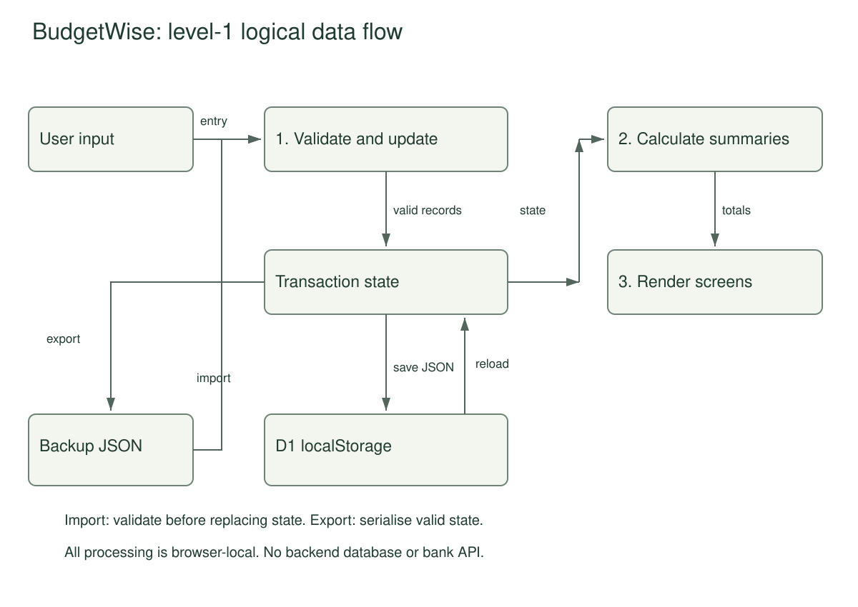
The diagram separates validation, calculation, rendering and persistence. Import is validated using the same state schema.

Appendix C. Gantt chart
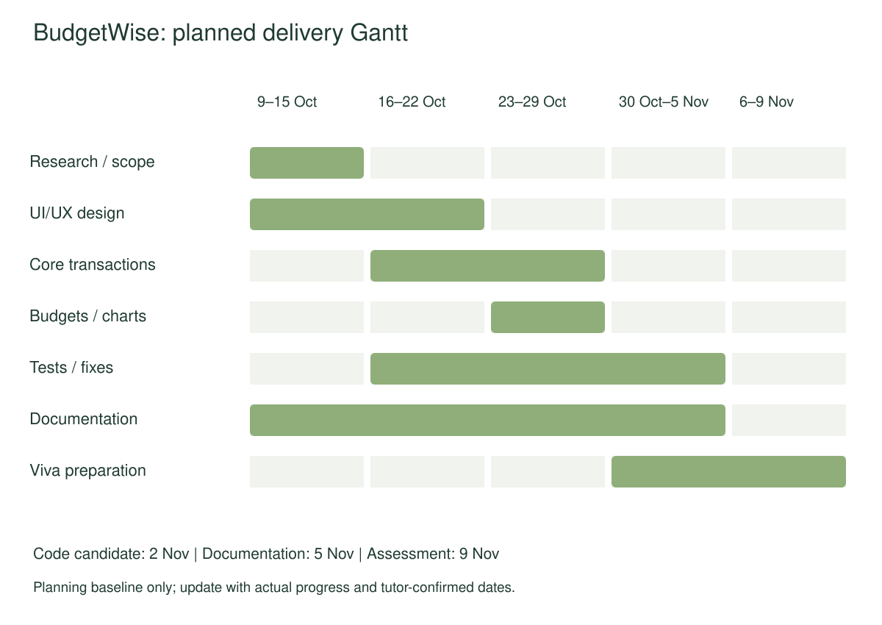
Bars show proposed work periods, not recorded completion. The source SVG can be edited as the schedule changes.

