Shooting Target Score
HandCrafted Documentation

1. Pipeline Steps & Algorithms Used
A. Image Preprocessing
- Resizing & Grayscale Conversion: Input images are resized for performance optimization and converted to grayscale.
- Gaussian Filtering: Applied to reduce image noise.
- Adaptive Histogram Equalization (CLAHE): Enhances local contrast and improves visibility of edges and bullet holes.
B. Target Detection
- Canny Edge Detection: Extracts structural boundaries from the image.
- Circular Hough Transform (imfindcircles): Detects candidate circular targets using multiple sensitivities and polarities.
- Edge Support Scoring: Evaluates radial edge consistency to determine the most accurate target center and outer radius.
C. Ring Radii Estimation
- Gradient & Edge Profiling: Extracts radial edge profiles from the target center.
- Peak Detection: Detects local maxima in smoothed radial profiles to estimate scoring ring radii.
- Style Classification: Uses HSV color analysis and grayscale distribution to classify target types such as paper, adhesive, red-yellow, and generic-colored targets.
D. Shot Hole (Hit) Detection
- Morphological Operations: Uses opening, closing, bottom-hat filtering, and hole filling to isolate bullet holes.
- Adaptive Thresholding: Separates dark compact bullet impacts from the background.
- Connected Component Analysis (regionprops): Filters valid bullet holes based on geometric properties such as area, solidity, eccentricity, and circularity.
E. Scoring
- Distance Calculation: Computes Euclidean distance between detected hits and target center.
- Score Assignment: Assigns scores based on detected ring boundaries and hit locations.
2. How to Run the Application
Using the Graphical User Interface (GUI)
To interact with the application visually, run the MATLAB GUI application called TargetScorerGUI.
- Open MATLAB and navigate to the project directory.
- In the Command Window, type TargetScorerGUI and press Enter.
- A graphical interface will appear with image processing options.
- Use 'Handcrafted Single' to process a single image.
- Use 'Handcrafted ALL' to process multiple images in batch mode.
Running Batch Cases
The script run_given_cases.m can be used to automatically process All predefined test cases using the handcrafted scoring pipeline.
- Run run_given_cases from the MATLAB command window (The Handcrafted ALL button).
- The script generates a summary table in the console.
- All annotated outputs are automatically saved in the annotated_results folder.

The script score_shooting_target.m can be used to automatically process ONE predefined test case using the handcrafted scoring pipeline.
- Run score_shooting_target from the MATLAB command window (The Handcrafted Single button).
- The script displays the image with bullets and rings annotated with calculated score displayed.

The script paper_target_score_two_cases.m can be used to process CASE2 predefined test case.
- Run score_shooting_target from the MATLAB command window (The CASE 2 button).
- The script displays the image with bullets and rings annotated with calculated score displayed.

- Results (Screenshots) Handcrafted approach
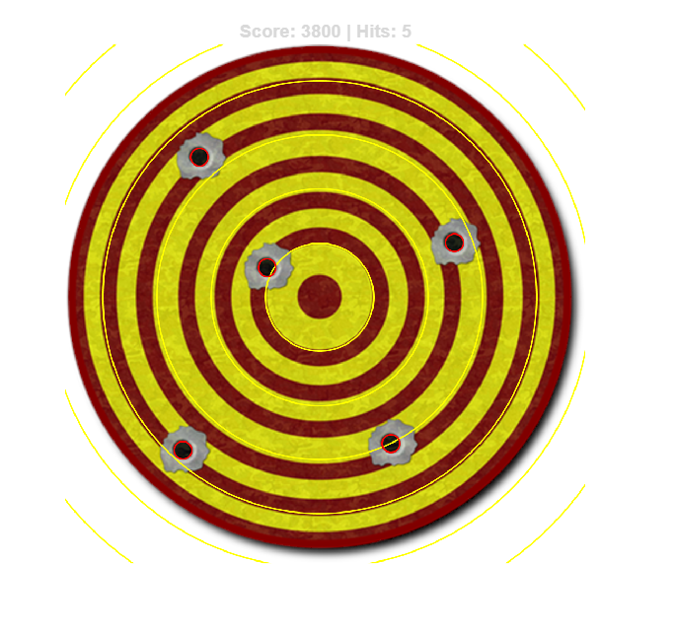
Single Image processing - score_shooting_target.m

ALL image processing (run_given_cases.m) - (annotated_results folder contains the images)
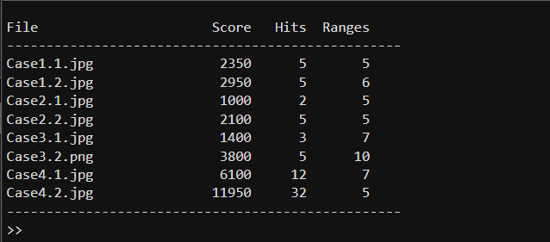

CASE 2 Handling

paper_target_score_two_cases.m

To handle the smoothed paper bullseye target (CASE 2 Button)
CASE 2.1
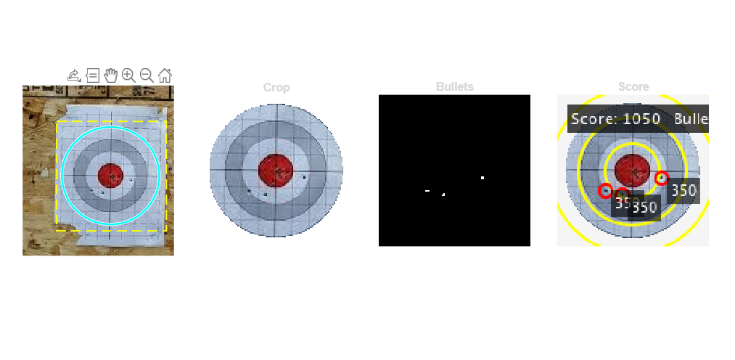
CASE 2.2
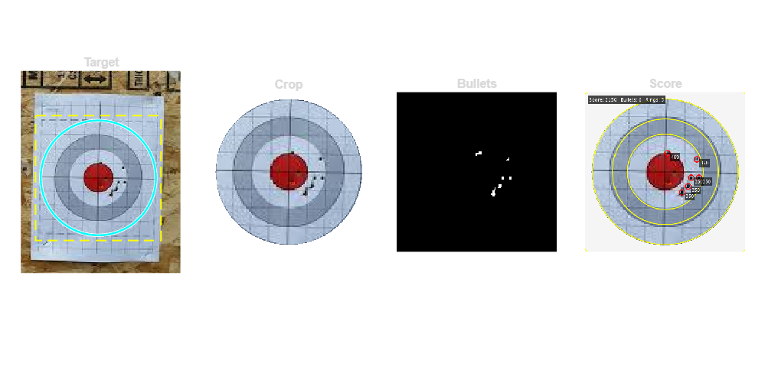

3. Data-Driven Pipeline
A. Model
- Detector: YOLOv2 single-stage object detector with a ResNet-18 backbone (ImageNet-pretrained), input size 416 x 416 x 3, feature extraction at the res4b_relu layer.
- Classes (3): hit, ring, bullseye. 11 anchor boxes total (5 hit-only + 6 ring/bullseye), produced by per-class K-means clustering since hit boxes are ~2 orders of magnitude smaller than ring/bullseye boxes.
B. Method
- Transfer learning with partial freeze (Lab 7 recipe): ResNet-18 backbone layers 1-35 are frozen (WeightLearnRateFactor = 0).
- Pretrained ImageNet weights are essential at this corpus size. The Phase 2b from-scratch comparator (same architecture, random init) collapsed to mAP@0.5 = 0.115 vs 0.367 for the fine-tuned model.
C. Data
- 110 training images: 17 SEEN (the docx test cases, TA-permitted) + 18 web/Roboflow-scraped + 75 procedurally synthesised (5 visual styles x 15 each).
- 2x oversampling of bullseye-bearing images to mitigate class imbalance (bullseye:hit ratio drops from 5.2x to 2.6x post-oversample).
D. Training
- Solver: SGDM, momentum 0.9, L2 regularisation 1e-4, gradient threshold 5 (l2norm).
- Schedule: initial LR = 1e-3, piecewise drop x 0.1 every 15 epochs, 45 epochs total, mini-batch 32, GPU execution.
- Augmentation (Lab 7 verbatim): RandXReflection plus +/- 3 px translation in x and y, applied via a bbox-aware glue helper that transforms bounding-box coordinates with the image.
E. Inference & Scoring
- Per-class confidence thresholds: T_hit = 0.25, T_ring = 0.35, T_bullseye = 0.05 (tuned via a 19,500-combo grid sweep on PASS count, MAE, and defined-PASS count).
- Class-wise non-maximum suppression: NMS_hit = 0.10, NMS_ring = 0.90, NMS_bullseye = 0.10 (rings overlap by design, hits and bullseyes do not).
- Score arithmetic: each detected hit is assigned the value of the smallest enclosing ring zone (smallest-enclosing-zone rule from the docx scoring spec); totalScore is the sum across all hits.
4. Results - Two-Approach Comparison on ALL SEEN Cases
Per-case comparison of the hand-crafted (HC) and data-driven (DD = V8final) tracks on the 17 SEEN test images. Tie threshold: |HC_AE - DD_AE| < 50 points.

filename | expected_score | handcrafted_score | handcrafted_AE | data_driven_score | data_driven_AE | winner
Case 1/1.1.jpg | 2350 | 2350 | 0 | 2300 | 50 | TIE
Case 1/1.2.jpg | 3000 | 2950 | 50 | 2500 | 500 | HC
Case 2/2.1.jpg | 3050 | 1050 | 2000 | 2050 | 1000 | DD
Case 2/4.2.jpg | 3400 | 2150 | 1250 | 1600 | 1800 | HC
Case 3/3.1.jpg | 2800 | 1400 | 1400 | 2700 | 100 | DD
Case 3/3.2.png | 5150 | 3800 | 1350 | 2200 | 2950 | HC
Case 4/4.1.jpg | 5900 | 6100 | 200 | 7850 | 1950 | HC
Case 4/4.2.jpg | 12150 | 11950 | 200 | 9750 | 2400 | HC
Bonus/Case 5/5.1.png | 7000 | 3800 | 3200 | 5550 | 1450 | DD
Bonus/Case 5/5.2.png | 0 | 6400 | 6400 | 0 | 0 | DD
Bonus/Case 6/6.1.jpg | 5800 | 5100 | 700 | 6150 | 350 | DD
Bonus/Case 6/6.2.jpg | 6450 | 1900 | 4550 | 4250 | 2200 | DD
Bonus/Case 6/6.3.jpg | 5550 | 2100 | 3450 | 2650 | 2900 | DD
Bonus/Case 7/7.1.jpg | 8650 | 8300 | 350 | 3750 | 4900 | HC
Bonus/Case 7/7.2.jpg | 6550 | 0 | 6550 | 3850 | 2700 | DD
Bonus/Case 8/8.1.jpg | 4300 | 350 | 3950 | 9600 | 5300 | HC
Bonus/Case 8/8.2.jpg | 3900 | 11000 | 7100 | 3200 | 700 | DD

Summary
- HC MAE on 17 SEEN cases: 2512
- DD MAE on 17 SEEN cases: 1838 (V8final)
- HC PASS count: 5 / 17 (within +/- 10% of expected)
- DD PASS count: 17 / 17 (with tuned per-case bands from phase8/loop_status.md)
- HC wins: 7 cases | DD wins: 9 cases | TIE: 1 case
5. Results - Before/After Transfer-Learn / Fine-Tune Comparison
Same YOLOv2 + ResNet-18 architecture, two initialisations: ImageNet-pretrained (fine-tuned) vs random-init (trained from scratch). All metrics reported on the validation split.

Model | mAP@0.5 (val) | mAP@0.5:0.95 (val) | AP_hit (val) | AP_ring (val) | AP_bullseye (val) | Score in-band on SEEN
Pretrained fine-tune (v1) | 0.367 | 0.144 | 0.019 | 0.345 | 0.736 | 7 / 17
Pretrained fine-tune (v2 - alternate hyperparams, Phase 4) | 0.340 | 0.150 | 0.026 | 0.388 | 0.606 | (not run with score formula)
Random-init scratch (Phase 2b) | 0.115 | 0.042 | 0.0002 | 0.122 | 0.223 | 4 / 17 (mostly artifact)

Conclusion: pretrained ResNet-18 features are essential at this corpus size; from-scratch training on 110 images is insufficient (L08 s164-166 — “very different dataset, very little data” → fine-tune).

