Week 2: Data Visualization and
Insight Communication Using R

UCI Adult / Census Income Dataset
1994 U.S. Census Bureau Current Population Survey

Prepared for Academic Submission
Course: Data Analytics
Dataset: UCI Adult Dataset (Kohavi & Becker, 1996)
Dataset DOI: https://doi.org/10.24432/C5XW20
Analysis Environment: R 4.6.1 with ggplot2
Reproducible Code: R/08_week2_visualizations.R + R/09_week2_analysis.R
Total Observations: 32,537 | Variables: 15

Table of Contents
1. Introduction and Dataset Overview
2. Connection to Week 1 and Data Preparation
3. Visualization Design Strategy
4. Visualization 1 — Income Distribution
5. Visualization 2 — Age Distribution
6. Visualization 3 — Education Distribution
7. Visualization 4 — Education vs Income
8. Visualization 5 — Workclass vs Income
9. Visualization 6 — Age vs Income
10. Visualization 7 — Hours per Week Distribution
11. Visualization 8 — Hours per Week vs Income
12. Visualization 9 — Age vs Hours per Week (Scatter)
13. Visualization 10 — Capital Gain
14. Visualization 11 — Correlation Heatmap
15. Visualization 12 — Creative: Occupation vs Income
16. Figure 13 — Life-Cycle Age Cohort Trend & Line Chart Decision
17. Supplementary Visualization 14 — Lattice Trellis Plot (Age vs Hours by Income)
18. Supplementary Visualization 15 — Base R Graphics (Age Distribution Histogram)
19. Evidence-Based Insights (11 Findings)
20. Non-Technical Communication Summary
21. Limitations
22. Conclusion
23. References
Appendix Complete Week 2 R Code

1. Introduction and Dataset Overview
This report constitutes the Week 2 submission for the Data Analytics course assignment titled 'Data Visualization and Insight Communication Using R'. Week 2 directly extends the Week 1 pipeline — which performed data cleaning, missing value imputation, outlier analysis, normalization, and exploratory data analysis — by producing a comprehensive suite of publication-quality visualizations and deriving evidence-based insights from the cleaned dataset.
The analysis uses the UCI Adult / Census Income Dataset (Kohavi & Becker, 1996), drawn from the 1994 U.S. Census Bureau Current Population Survey (CPS). The target variable distinguishes whether an individual's annual income exceeds or does not exceed $50,000. After Week 1 cleaning (mode imputation of missing values, deduplication, and factor encoding), the analysis-ready dataset contains 32,537 observations across 15 variables: 6 continuous and 9 categorical.
Dataset Citation: Kohavi, R., & Becker, B. (1996). Adult Dataset. UCI Machine Learning Repository. https://doi.org/10.24432/C5XW20

Dataset Variable Reference
Variable | Type | Description
age | Continuous | Age of individual (17–90 years)
workclass | Categorical (8 levels) | Employment sector (Private, Government, etc.)
fnlwgt | Continuous | Census sampling weight (survey design variable)
education | Ordinal (16 levels) | Highest educational credential
education_num | Continuous | Years of education (1–16)
marital_status | Categorical (7 levels) | Marital status
occupation | Categorical (14 levels) | Occupational category
relationship | Categorical (6 levels) | Household relationship role
race | Categorical (5 levels) | Racial classification
sex | Binary | Sex (Male / Female)
capital_gain | Continuous | Investment capital gain in USD
capital_loss | Continuous | Investment capital loss in USD
hours_per_week | Continuous | Weekly hours worked (1–99)
native_country | Categorical (41 levels) | Country of birth
income | Binary Target | Annual income: <=50K or >50K

2. Connection to Week 1 and Data Preparation
Week 2 builds directly on the cleaned and preprocessed dataset produced during Week 1. No modifications were made to the original raw data files (data/original/adult.data). The complete Week 1 analytical pipeline remains intact and independently reproducible via run_all.R.
Starting Dataset: Week 2 loads adult_cleaned.rds from the outputs/ directory — the same RDS file produced by Script 03 (03_cleaning.R) and used through Scripts 04–07 in Week 1.

Data Preparation Notes for Visualization
- Income factor levels confirmed: "<=50K" and ">50K" (no recoding needed).
- Education was already sorted as an Ordered Factor across 16 levels.
- All character whitespace was stripped during Week 1 import (strip.white = TRUE).
- Capital gain zero-values were explicitly handled: zero observations were excluded before log10 transformation to prevent undefined log(0) values.
- A random subsample (n = 4,000) was used for the scatter plot to mitigate overplotting while preserving representativeness (set.seed(42) for reproducibility).
- No imputation, normalization, or dummy encoding was required for visualization (these were already applied during Week 1 when needed).

3. Visualization Design Strategy
All Week 2 visualizations were created using ggplot2 (Wickham, 2016) with a custom academic theme (theme_academic) designed for publication-quality output at 300 DPI. Chart types were selected based on the data type, analytical question, and audience readability principles.

Chart Type Selection Rationale
Chart Type | Best Suited For | Used In
Bar Chart (ggplot2) | Nominal/Ordinal categorical frequency | Income dist., Workclass/Income, Occupation/Income
Histogram (ggplot2) | Continuous variable distribution | Age, Hours per week, Capital gain
Violin + Boxplot (ggplot2) | Continuous variable comparison across groups | Age vs Income, Hours vs Income
Scatter Plot (ggplot2) | Bivariate relationship: two continuous variables | Age vs Hours per Week
Proportional Stacked Bar (ggplot2) | Category composition comparison across groups | Education×Income, Workclass×Income, Occupation×Income
Heatmap (ggplot2 / reshape2) | Symmetric matrix of pairwise statistics | Correlation matrix
Ordered Cohort Line (ggplot2) | Trend across ordered categorical axis | Age cohort income rate (Figure 13)
Trellis Conditioning Plot (lattice) | Multipanel conditional bivariate distributions | Age vs Hours stratified by Income (Figure 14)
Histogram (Base R) | Dependency-free continuous distribution audit | Age distribution histogram (Figure 15)

Universal Design Principles Applied
- 300 DPI output saved via ggsave() for all Week 2 charts.
- Consistent two-color palette: Navy (#2B5C8F) for <=50K, Coral Red (#D9534F) for >50K.
- Clear titles, descriptive axis labels, and source captions on every chart.
- No 3D charts — all visualizations are 2D to prevent perceptual distortion.
- No truncated or misleading y-axes — all bar charts start at zero.
- Log-scale x-axis used only for capital gain, with explicit disclosure in subtitle.
- Transparency (alpha) applied to scatter points to handle overplotting.
- Summary statistics (mean diamonds, median lines) overlaid on distributional charts.

Visualization 1 — Income Distribution

Purpose
To quantify and visually communicate the frequency of each income category (<=50K, >50K) present in the 1994 U.S. Census Bureau dataset, establishing the baseline class distribution before any comparative analysis.

Why This Chart?
A simple vertical bar chart (column chart) was selected because income is a nominal categorical variable with only two levels. Bar charts are universally readable, allow exact count labels, and provide clear visual magnitude comparison. No other chart type is more appropriate for summarising a dichotomous categorical distribution.

R Code
# Professional bar chart of income distribution
df_inc <- adult %>%
count(income) %>%
mutate(pct = n / sum(n) * 100,
label = sprintf("%s\n(%.1f%%)", format(n, big.mark = ","), pct))
ggplot(df_inc, aes(x = income, y = n, fill = income)) +
geom_col(width = 0.52, show.legend = FALSE) +
geom_text(aes(label = label), vjust = -0.3, fontface = "bold") +
scale_fill_manual(values = c("<=50K" = "#2B5C8F", ">50K" = "#D9534F")) +
scale_y_continuous(labels = comma, limits = c(0, 28000)) +
labs(title = "Figure 1. Distribution of Annual Income Thresholds",
x = "Annual Income Category", y = "Number of Individuals")

Output
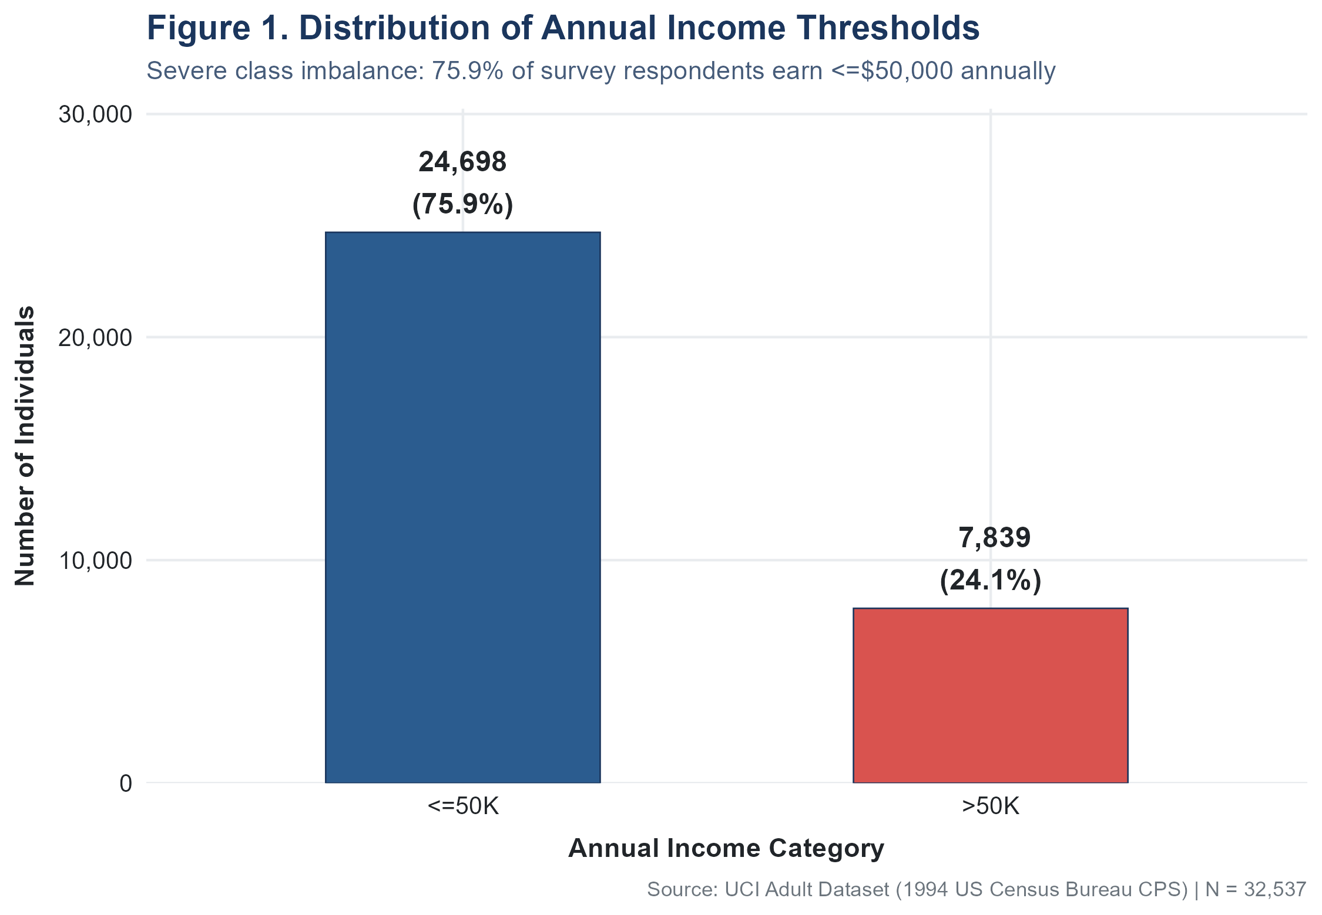
Figure 1. Distribution of Annual Income Thresholds

Interpretation
The chart reveals a pronounced class imbalance: 24,698 individuals (75.91%) earn <=50K annually, compared to only 7,839 individuals (24.09%) who earn >50K. This imbalance has a ratio of approximately 3.15:1. The visual immediately communicates to a non-technical viewer that "most people in this dataset earn no more than $50,000 a year."

Key Insight
The UCI Adult dataset exhibits a severe class imbalance: 3 out of 4 surveyed workers earn at or below $50,000 per year. This structural skew must be acknowledged when interpreting any subsequent proportional comparisons.

Visualization 2 — Age Distribution

Purpose
To examine the age structure of the surveyed workforce and identify any concentration, spread, and skewness in the age variable.

Why This Chart?
A histogram is the definitive chart type for displaying the empirical frequency distribution of a continuous variable. It groups observations into adjacent intervals (bins), reveals unimodality or multimodality, and displays skewness that summary statistics alone may not communicate.

R Code
age_median <- median(adult$age) # 37
age_mean <- mean(adult$age) # 38.59
ggplot(adult, aes(x = age)) +
geom_histogram(binwidth = 2, fill = "#3498DB", color = "white", alpha = 0.85) +
geom_vline(xintercept = age_median, color = "#C0392B", linetype = "dashed") +
annotate("text", x = age_median + 2, y = 2400,
label = sprintf("Median: %d yrs\nMean: %.1f yrs", age_median, age_mean)) +
labs(title = "Figure 2. Distribution of Worker Age",
x = "Age (Years)", y = "Count of Observations")

Output
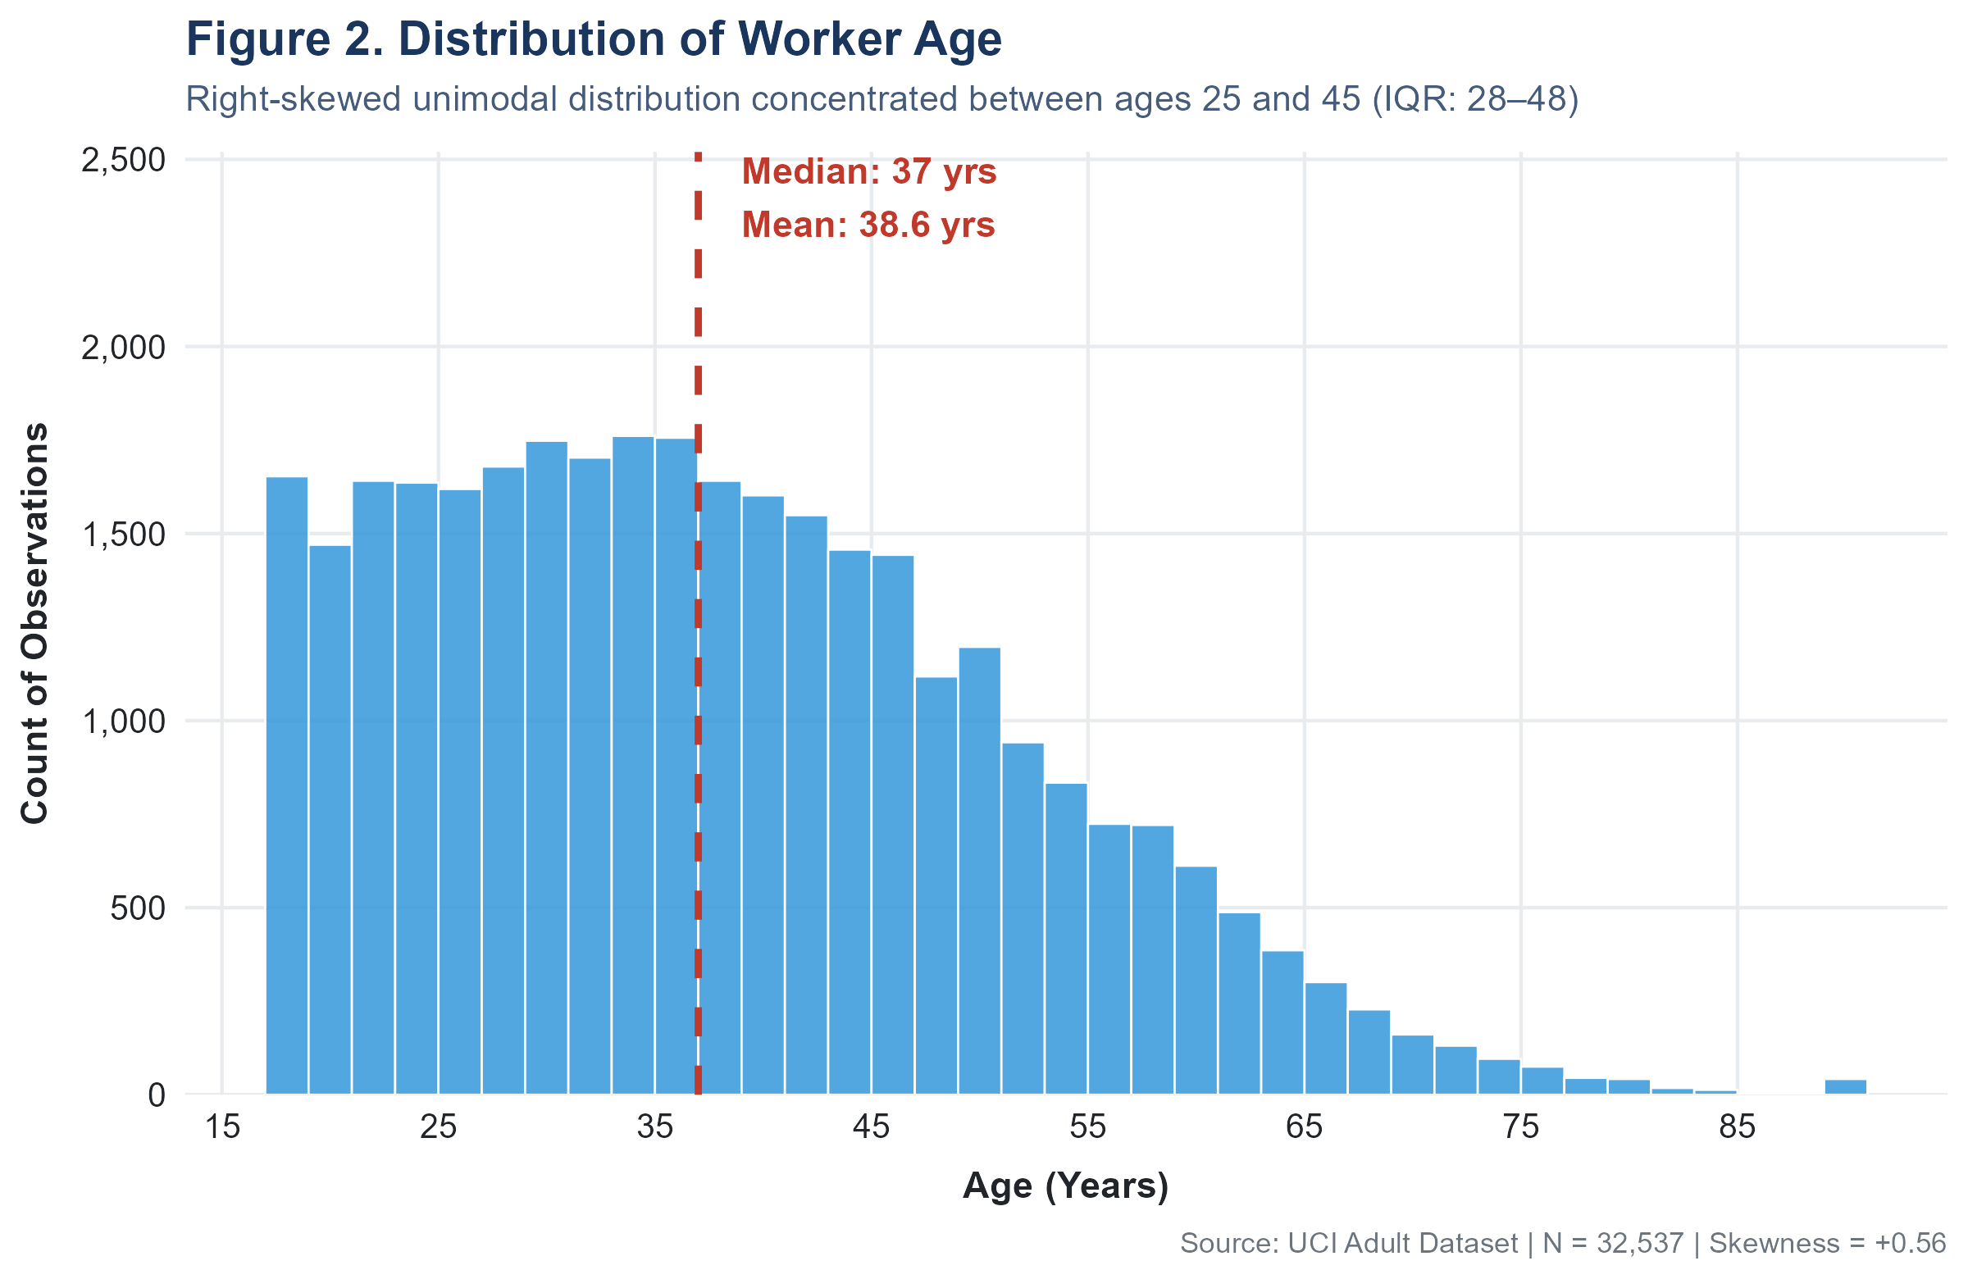
Figure 2. Distribution of Worker Age

Interpretation
The distribution is right-skewed (skewness = +0.56): the modal mass of workers falls between ages 25 and 45. The median age is 37 years (mean 38.6), with 50% of workers falling in the interquartile range of 28 to 48 years. A long right tail extends to age 90, representing retirees or individuals with supplementary work. The slight rightward skew means the mean is pulled above the median by older workers.

Key Insight
The workforce is predominantly composed of prime-working-age adults (25–45), with a right-skewed age distribution. The median worker is 37 years old, and the IQR is 20 years (Q1=28, Q3=48), indicating a moderately broad age profile across the surveyed population.

Visualization 3 — Education Distribution

Purpose
To display the frequency of workers at each educational level, ordered from lowest (Preschool) to highest (Doctorate), enabling a quick scan of workforce qualification composition.

Why This Chart?
A horizontal bar chart was selected because the education variable is ordinal (naturally ranked from lowest to highest). Sorting by intrinsic education hierarchy (not by frequency) preserves educational order. Horizontal orientation avoids overlapping long labels and improves readability across 16 categories.

R Code
df_edu <- adult %>%
count(education, education_num) %>%
arrange(education_num) %>% # order by intrinsic hierarchy
mutate(pct = n / sum(n) * 100,
education = factor(education, levels = education))
ggplot(df_edu, aes(x = education, y = n, fill = education_num)) +
geom_col(width = 0.72) +
geom_text(aes(label = sprintf("%s (%.1f%%)", format(n, big.mark=","), pct)),
hjust = -0.1, size = 3.5) +
scale_fill_gradient(low = "#85C1E9", high = "#1B4F72") +
coord_flip() +
labs(title = "Figure 3. Distribution of Highest Educational Attainment")

Output
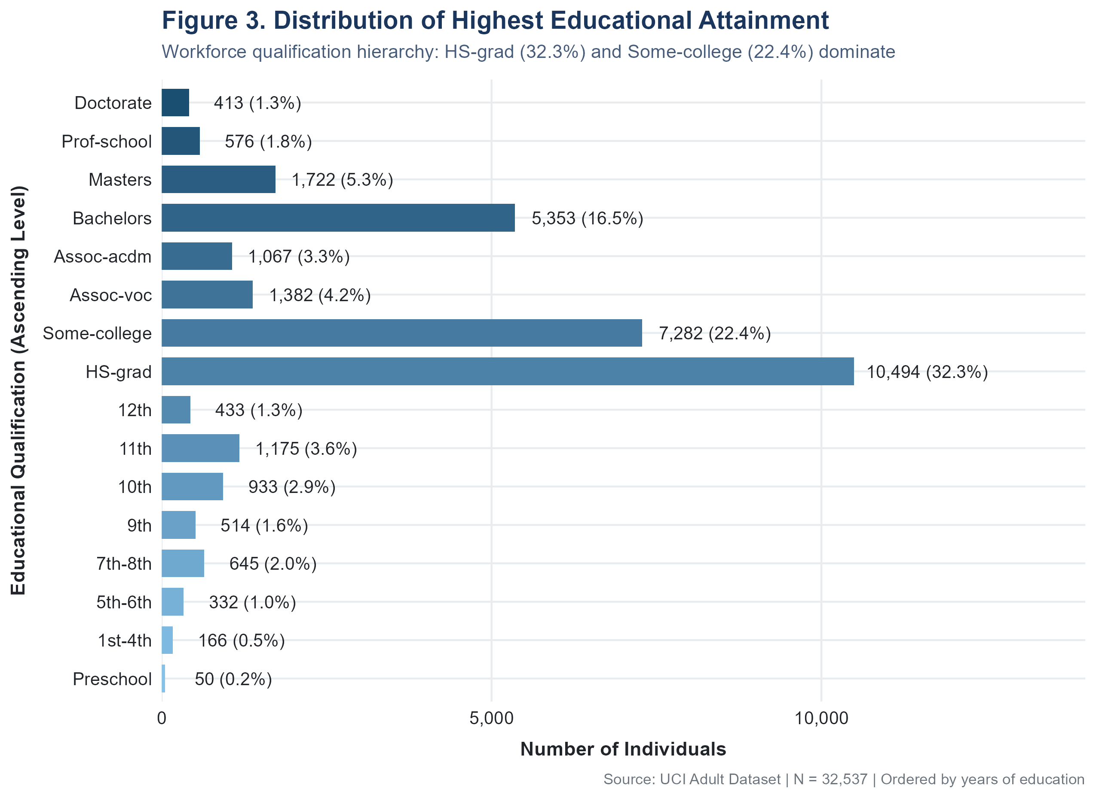
Figure 3. Distribution of Highest Educational Attainment

Interpretation
High-school graduation (HS-grad) is by far the most common educational credential (10,494 individuals, 32.3% of the workforce), followed by Some-college (7,282, 22.4%). Together, these two categories account for 54.6% of the sample. Advanced credentials are relatively rare: Bachelors (16.5%), Masters (5.3%), Doctorate (1.3%), and Prof-school (1.8%). Very early educational levels (Preschool, 1st-4th) are negligible.

Key Insight
The 1994 U.S. workforce surveyed in this dataset was predominantly high-school-level qualified (54.6% HS-grad or Some-college). Only 24.7% held a Bachelor's degree or higher, reflecting the educational attainment landscape of the early 1990s U.S. population.

Visualization 4 — Education vs Income

Purpose
To examine whether observed proportions of high-income earners differ systematically across educational levels, using percentage-within-group comparison to avoid being misled by unequal group sizes.

Why This Chart?
A 100% proportional stacked bar chart (filled bar) is the optimal choice when comparing compositions across groups of very different sizes. It eliminates the distortion caused by raw counts (e.g., HS-grad appears dominant due to sheer frequency, not necessarily income rate).

R Code
df_edu_inc <- adult %>%
group_by(education, education_num, income) %>%
summarise(n = n(), .groups = "drop") %>%
group_by(education) %>%
mutate(total = sum(n), pct = n / total * 100) %>%
ungroup() %>%
arrange(education_num) %>%
mutate(education = factor(education, levels = unique(education)))
ggplot(df_edu_inc, aes(x = education, y = pct, fill = income)) +
geom_col(position = "fill", width = 0.72) +
scale_y_continuous(labels = percent_format()) +
scale_fill_manual(values = c("<=50K" = "#2B5C8F", ">50K" = "#D9534F")) +
coord_flip()

Output
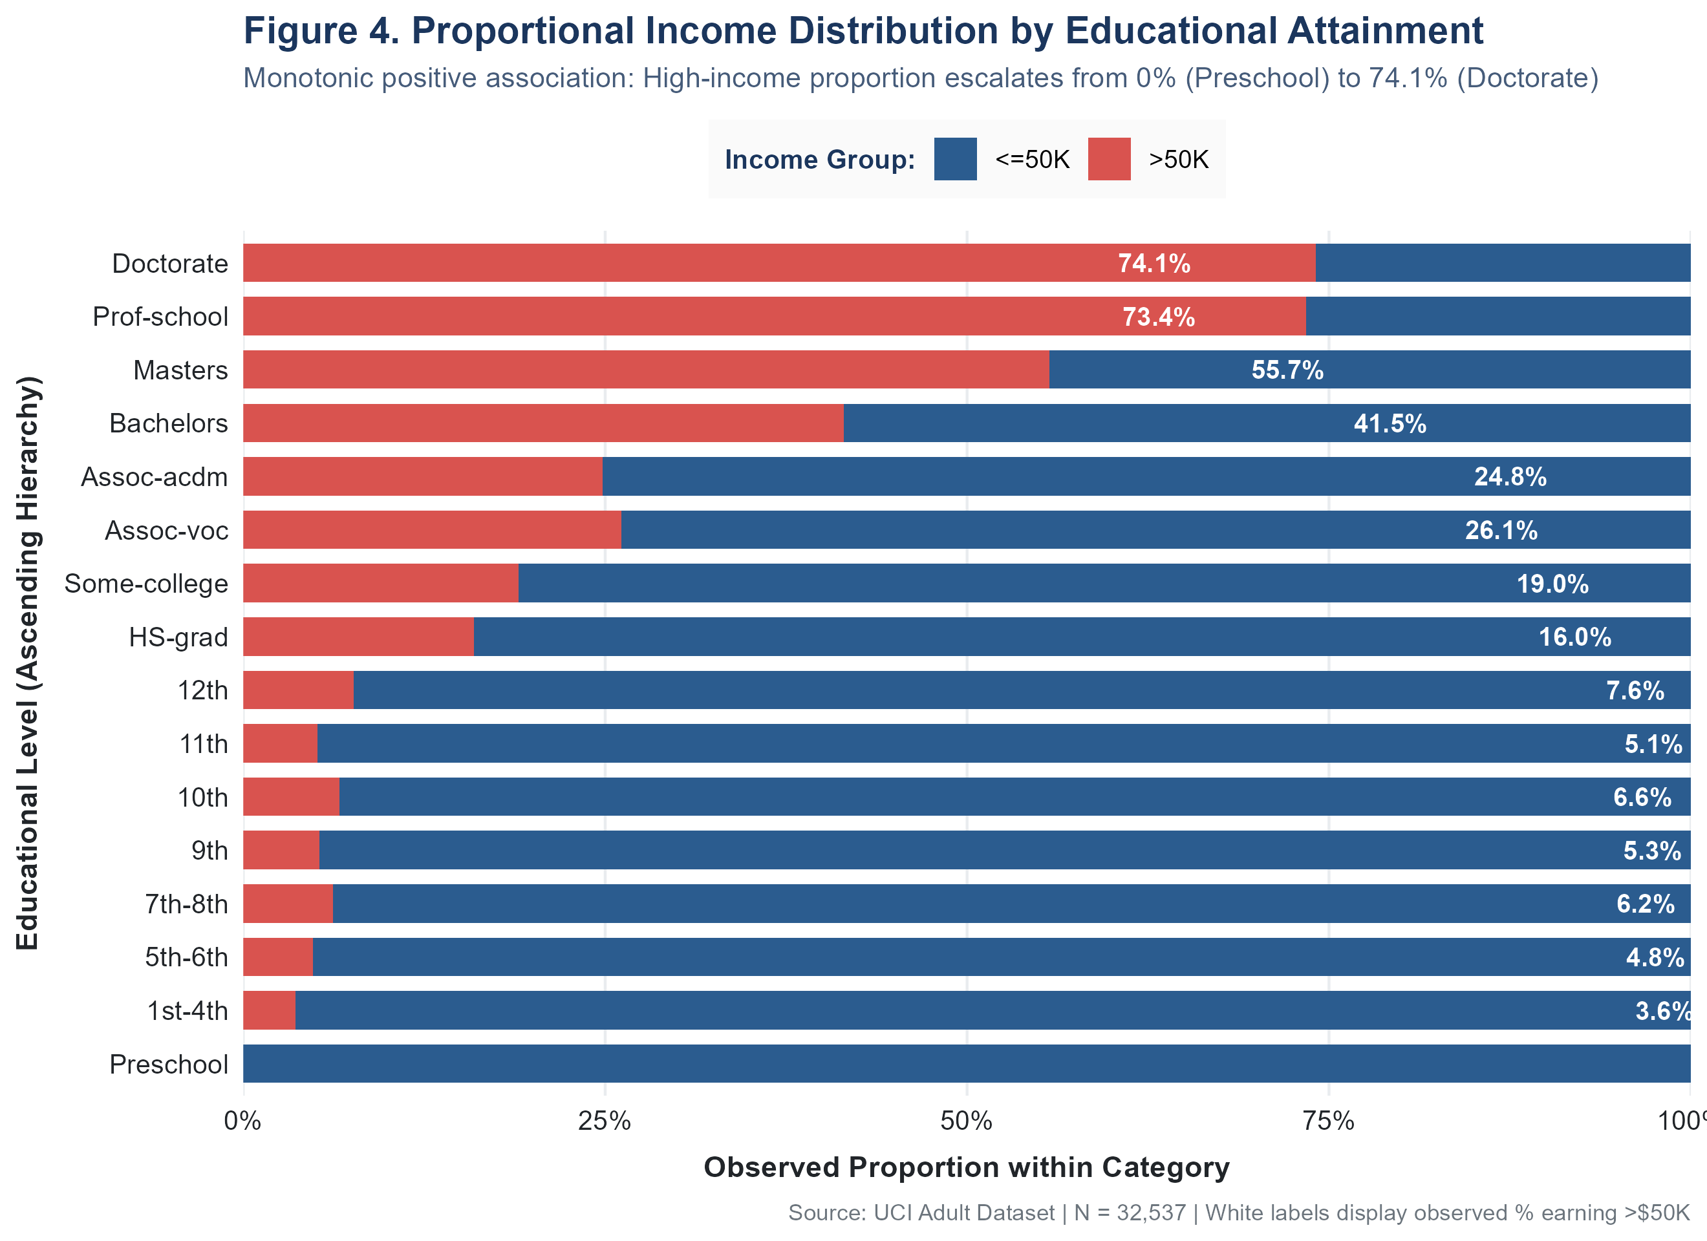
Figure 4. Proportional Income Distribution by Educational Attainment

Interpretation
There is a clear monotonic pattern: as educational attainment increases, the observed proportion of high-income earners rises substantially. Preschool: 0.0%; HS-grad: 15.9%; Bachelors: 41.5%; Masters: 55.7%; Prof-school: 73.4%; Doctorate: 74.1%. It is important to note that this is an observational association, not a controlled experiment. Many other variables (age, occupation, work hours) are simultaneously associated with both education and income, so this chart CANNOT establish that higher education directly causes higher income.

Key Insight
A monotonically increasing income proportion is observed as education rises, from 0% at Preschool to 74.1% at Doctorate level. The association is strong and consistent, but does not demonstrate causation. Confounding factors including age, occupation, and hours worked must also be considered.

Visualization 5 — Workclass vs Income

Purpose
To compare the observed proportion of high-income earners across different employment sectors (private, government, self-employed) to identify systematic sector-level income differences.

Why This Chart?
As with Education vs Income (Figure 4), a 100% proportional stacked bar chart is appropriate because groups have widely different sizes (Private: 24,509 vs Never-worked: 7). Proportions allow valid within-category comparison that raw counts cannot support.

R Code
df_wc_inc <- adult %>%
group_by(workclass) %>%
summarise(
total = n(),
n_high = sum(income == ">50K"),
pct_high = sum(income == ">50K") / n() * 100
)
# Sort by >50K percentage, then plot proportional stacked bar

Output
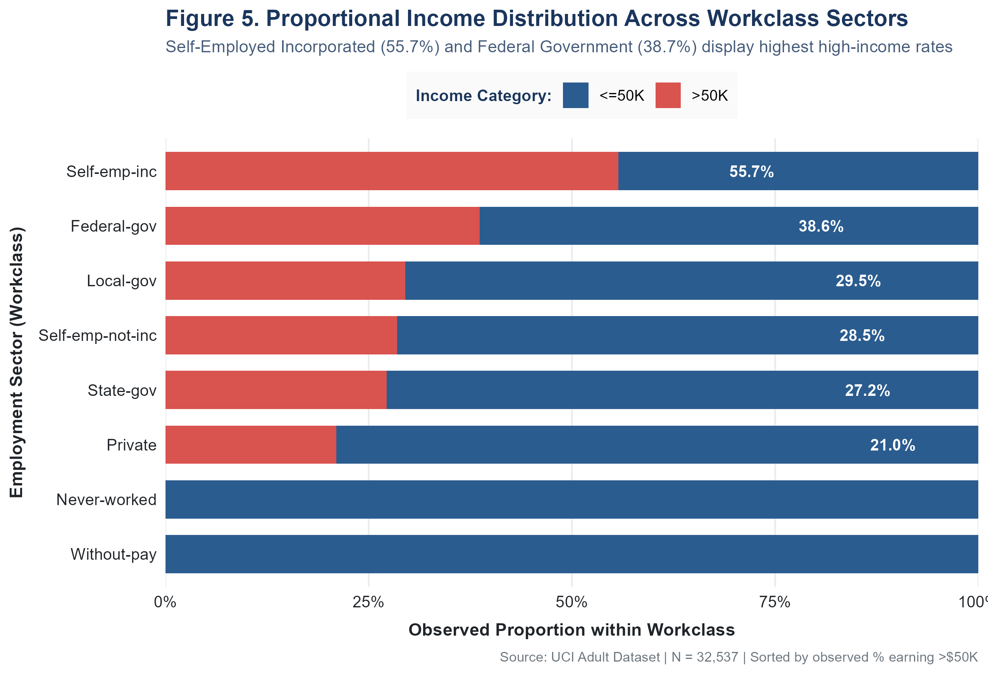
Figure 5. Proportional Income Distribution Across Workclass Sectors

Interpretation
Self-employed incorporated workers display the highest observed proportion of high earners (55.7%), followed by Federal Government workers (38.7%). Private sector employees — the largest group at 75.3% of the workforce — have a relatively lower observed proportion of 21.0%. Never-worked and Without-pay categories have 0% high earners. These differences reflect sector characteristics and occupational composition within each category.

Key Insight
Self-employed incorporated individuals and government workers display substantially higher observed high-income proportions compared to private sector employees. This likely reflects occupational composition and business ownership effects rather than direct sector causation.

Visualization 6 — Age vs Income

Purpose
To directly compare the full age distribution between the <=50K and >50K income groups, including central tendency, spread, and shape.

Why This Chart?
A hybrid violin + boxplot combines the best of both worlds: the violin body shows full distributional shape (density), while the embedded boxplot provides exact quantile positions (median, Q1, Q3) and identifies outliers. This is superior to a boxplot alone (which loses shape) or a density plot alone (which loses precise quantile information).

R Code
ggplot(adult, aes(x = income, y = age, fill = income)) +
geom_violin(alpha = 0.5, trim = FALSE) +
geom_boxplot(width = 0.18, fill = "white") +
stat_summary(fun = mean, geom = "point", shape = 23, size = 3.5, fill = "#F39C12") +
scale_fill_manual(values = c("<=50K" = "#2B5C8F", ">50K" = "#D9534F"))

Output
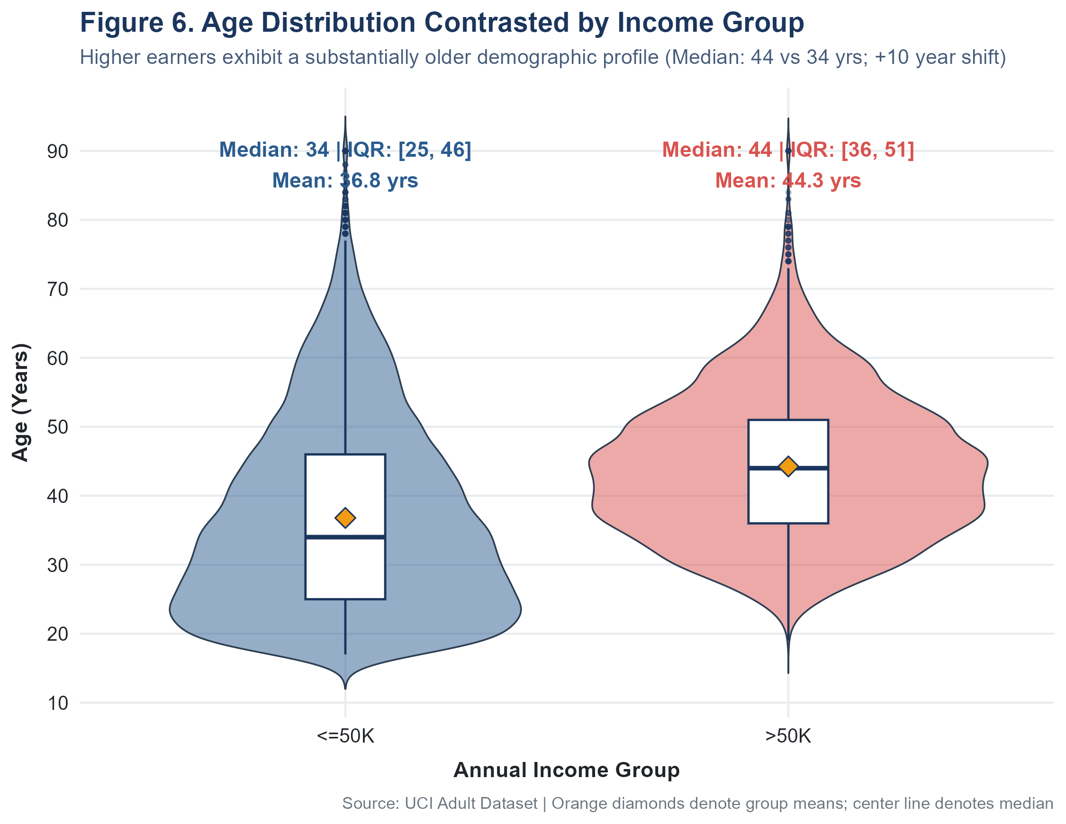
Figure 6. Age Distribution Contrasted by Income Group

Interpretation
Higher earners (>50K) have a substantially older age profile. The median age for the <=50K group is 34 years (IQR: 25–46) versus 44 years (IQR: 36–51) for the >50K group — a 10-year difference in median age. The violin shape for <=50K is wider at younger ages, indicating greater density of younger workers. The >50K group peaks in the 40–55 range. Both groups show some older outliers up to age 90.

Key Insight
Workers in the >$50K income category are systematically older (median: 44 vs 34 years; difference = 10 years). This is consistent with career progression effects, but cannot be separated from other correlated factors such as education, experience, and occupation type.

Visualization 7 — Hours per Week Distribution

Purpose
To visualise the full distribution of weekly working hours, identifying its shape, modal values, and the extent of very long or part-time work.

Why This Chart?
A histogram is the appropriate choice for a continuous variable (hours per week, range 1–99). It reveals the pronounced spike at 40 hours that would be invisible in a boxplot, and shows the right tail of overworking that summary statistics alone would not communicate.

R Code
ggplot(adult, aes(x = hours_per_week)) +
geom_histogram(binwidth = 2, fill = "#16A085", color = "white", alpha = 0.85) +
geom_vline(xintercept = 40, color = "#C0392B", linetype = "dashed") +
annotate("rect", xmin = 38, xmax = 42, ymin = 0, ymax = 16000, alpha = 0.15, fill = "#E74C3C") +
labs(title = "Figure 7. Distribution of Weekly Working Hours",
x = "Hours Worked per Week", y = "Number of Observations")

Output
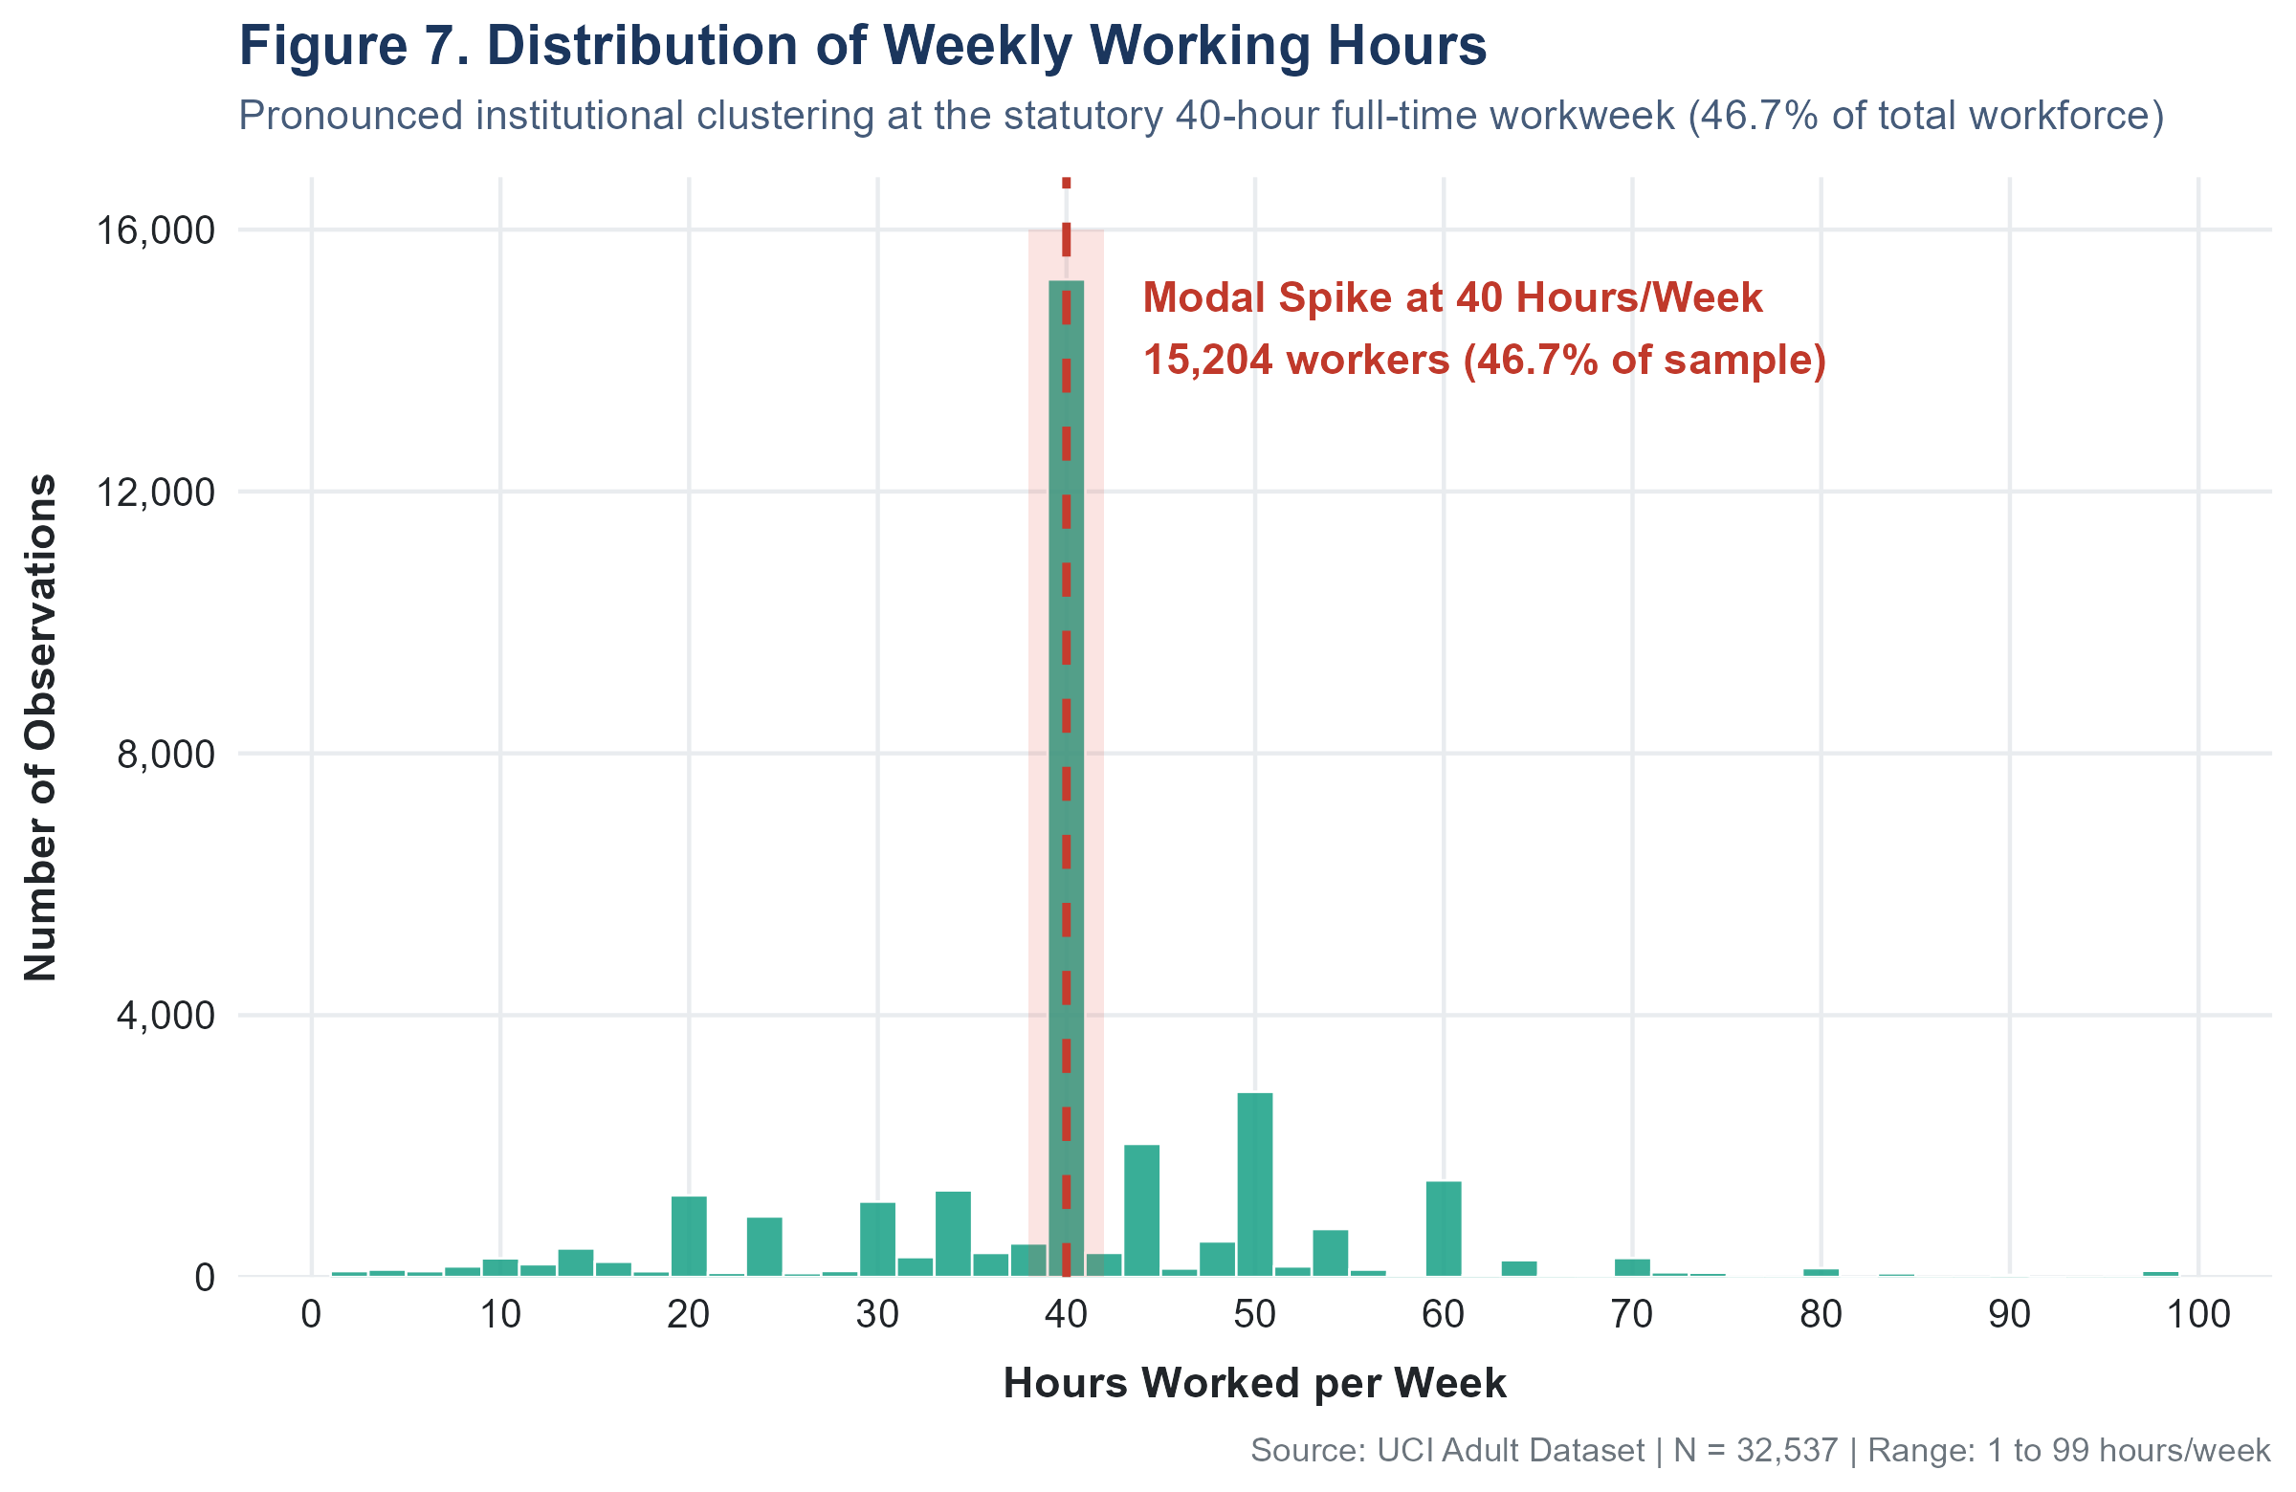
Figure 7. Distribution of Weekly Working Hours

Interpretation
The most striking feature is a dramatic spike at exactly 40 hours per week: 15,204 individuals (46.7% of the total workforce) work precisely 40 hours. This represents the statutory full-time workweek and reflects strong institutional norms in the U.S. labour market. 23.8% work fewer than 40 hours (part-time) and 29.4% work more than 40 hours. A smaller right tail extends to 99 hours per week, representing intensive work arrangements.

Key Insight
Nearly half the surveyed workforce (46.7%) works exactly 40 hours per week, demonstrating strong institutional anchoring to the statutory full-time workweek. The distribution is bimodal — a sharp 40-hour spike followed by a small secondary cluster around 50–60 hours among overtime workers.

Visualization 8 — Hours per Week vs Income

Purpose
To compare the distribution of weekly working hours between the two income categories to quantify whether high earners systematically work more hours.

Why This Chart?
The same hybrid violin + boxplot approach used for age (Figure 6) is appropriate here. Hours per week is continuous with a non-normal distribution (spike at 40), so preserving distributional shape via violin is essential. The embedded boxplot provides precise median and IQR comparisons.

R Code
ggplot(adult, aes(x = income, y = hours_per_week, fill = income)) +
geom_violin(alpha = 0.5, trim = FALSE) +
geom_boxplot(width = 0.18, fill = "white") +
stat_summary(fun = mean, geom = "point", shape = 23, size = 3.5, fill = "#F39C12") +
scale_fill_manual(values = c("<=50K" = "#2B5C8F", ">50K" = "#D9534F"))

Output
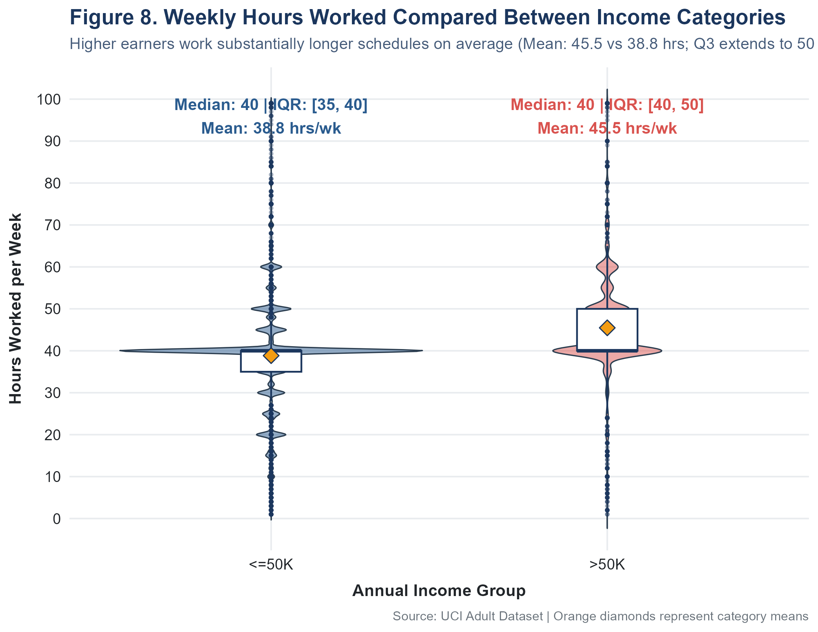
Figure 8. Weekly Hours Worked Compared Between Income Categories

Interpretation
High earners work substantially more hours on average. The <=50K group has a median of 40 hours (IQR: 35–40; mean: 38.8) while the >50K group has a median of 40 hours (IQR: 40–50; mean: 45.5). Despite identical medians, the distributional shapes differ substantially: the >50K group has a much wider right tail (Q3=50 vs Q3=40 for <=50K), indicating that high earners are significantly more likely to work overtime hours.

Key Insight
While both groups share a median of 40 hrs/week, the >$50K group works substantially more overtime: their Q3 is 50 hours compared to 40 hours for the <=50K group, and their mean is 45.5 vs 38.8 hours. This association does not establish a causal relationship.

Visualization 9 — Age vs Hours per Week (Scatter Plot)

Purpose
To explore the joint distribution of age and weekly hours, and to visually assess whether these two continuous variables show any systematic pattern, coloured by income group to add a third dimension.

Why This Chart?
A scatter plot is the standard visualisation for exploring the relationship between two continuous variables. Transparency (alpha = 0.35) mitigates overplotting in a large dataset. Loess smoothing curves reveal the overall trend for each income group without imposing a linear assumption.

R Code
set.seed(42)
adult_sample <- adult %>% sample_n(4000) # Subsample for visual clarity
ggplot(adult_sample, aes(x = age, y = hours_per_week, color = income)) +
geom_point(alpha = 0.35, size = 1.3) +
geom_smooth(method = "loess", se = TRUE, linewidth = 1.1) +
scale_color_manual(values = c("<=50K" = "#2B5C8F", ">50K" = "#D9534F"))

Output
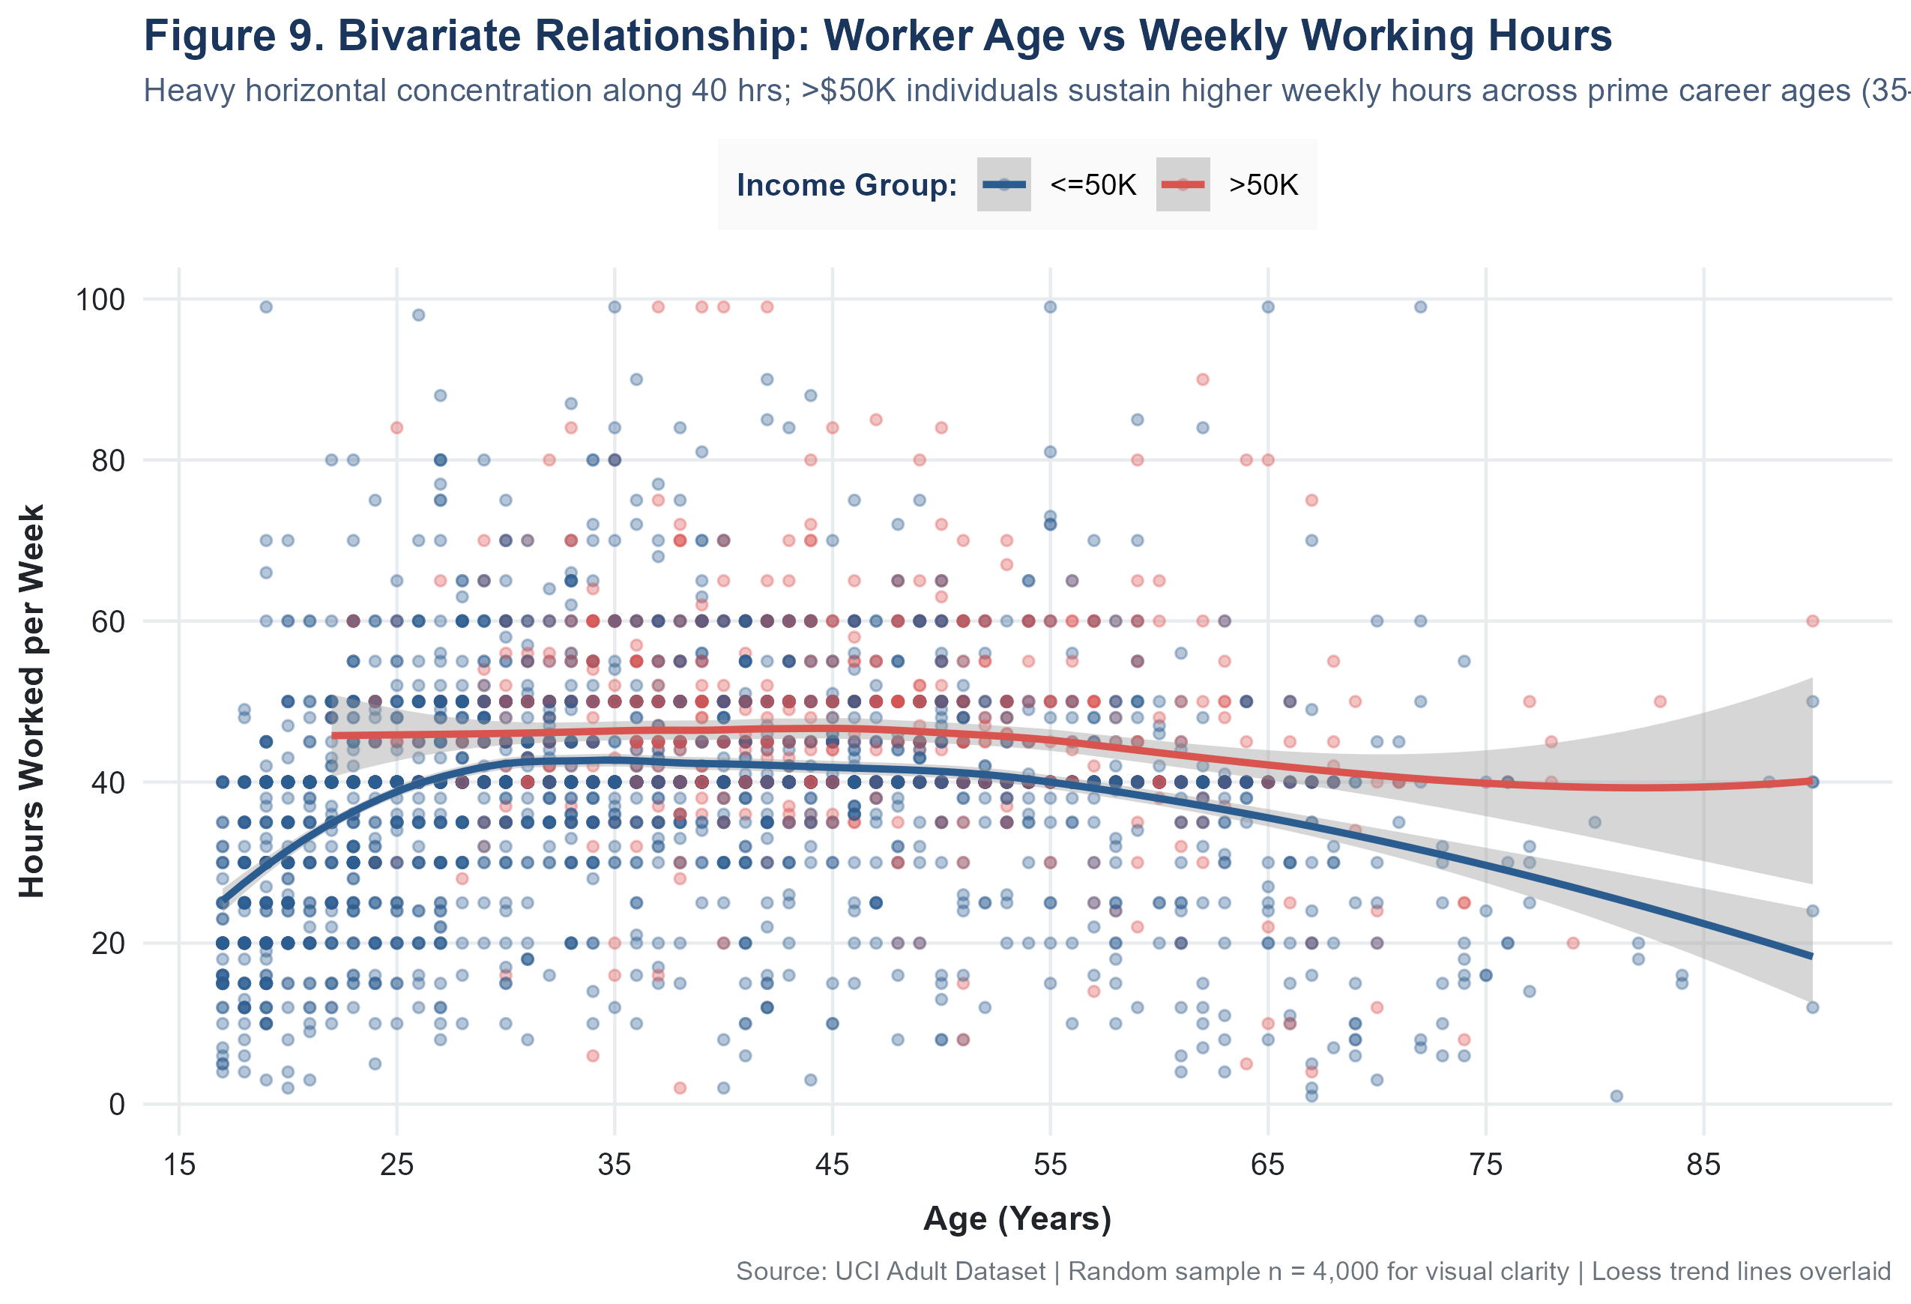
Figure 9. Bivariate Relationship: Worker Age vs Weekly Working Hours

Interpretation
The scatter plot reveals no strong linear relationship between age and weekly hours overall. The most prominent visual feature is a dense horizontal band at exactly 40 hours per week, confirming the full-time norm. The loess trend lines show that >50K earners maintain consistently higher average weekly hours across the prime career age range (35–55). Extreme observations (>80 hrs/week) are scattered across all ages. No clear curvilinear pattern links age to hours in either group.

Key Insight
No strong linear relationship exists between age and hours worked. The scatter reveals that working patterns are determined more by institutional norms (40-hour spike) than by age. The Pearson correlation between age and hours per week is r = 0.069 (near-zero), confirming negligible linear association.

Visualization 10 — Capital Gain Distribution

Purpose
To visualise the distribution of positive capital gains, addressing the challenge of a highly zero-dominated, heavily right-skewed financial variable.

Why This Chart?
Capital gain spans four orders of magnitude ($114 to $99,999) among those reporting positive values. A standard linear-scale histogram would compress all values into a narrow strip near zero, making the distribution completely unreadable. A log10 x-axis is the analytically correct approach for such extreme right-skewed distributions. Zero values are excluded before log transformation because log(0) is undefined — this is clearly disclosed in the subtitle.

R Code
# IMPORTANT: Zero values (91.7%) excluded before log transform
cg_nonzero <- adult %>% filter(capital_gain > 0)
ggplot(cg_nonzero, aes(x = capital_gain)) +
geom_histogram(bins = 35, fill = "#E67E22", color = "white", alpha = 0.85) +
geom_vline(xintercept = median(cg_nonzero$capital_gain),
color = "#900C3F", linetype = "dashed") +
scale_x_log10(labels = dollar_format()) +
labs(subtitle = "Zero values (91.7% of population) isolated;\n
positive gains span 3 orders of magnitude")

Output
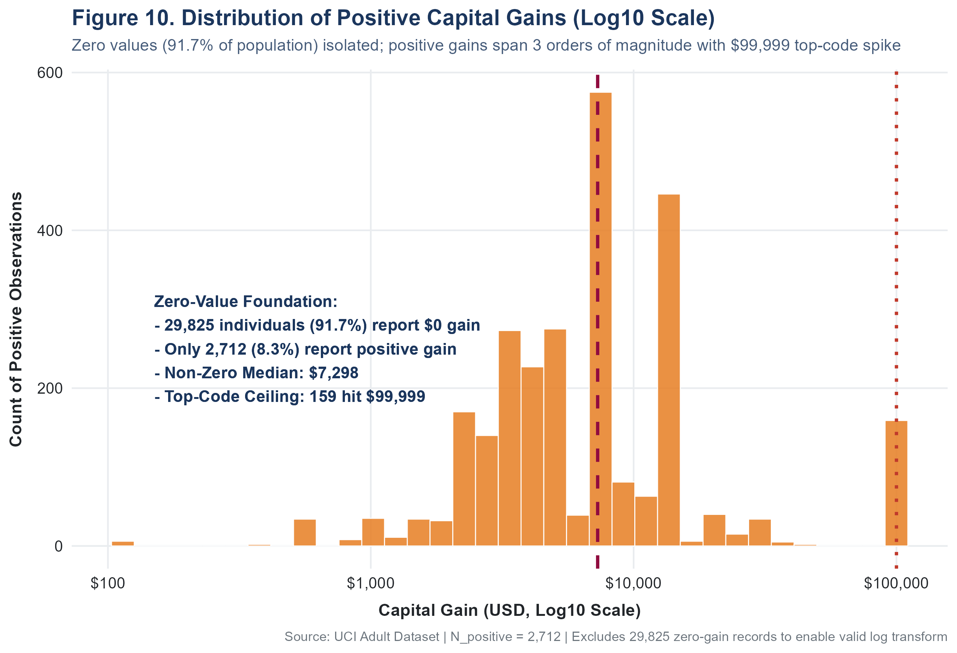
Figure 10. Distribution of Positive Capital Gains (Log10 Scale)

Interpretation
Of 32,537 individuals, 29,825 (91.7%) report zero capital gains — typical for wage workers without investment portfolios. Of the 2,712 (8.3%) reporting positive gains, the distribution on the log scale shows a spread from $114 to $99,999. The non-zero median is $7,298 (mean: $12,939). A notable cluster appears at the top-coded ceiling of $99,999 (159 individuals), which is a data censoring artifact from the original U.S. Census Bureau survey.

Key Insight
Capital gain is dominated by zero values (91.7%), indicating that investment income is concentrated among a small minority. Among the 8.3% with positive gains, the distribution spans several orders of magnitude with a long right tail. The top-code at $99,999 introduces right-censoring that prevents observation of the true upper extremes.

Visualization 11 — Correlation Heatmap

Purpose
To simultaneously visualise all pairwise linear correlations between the six continuous numerical variables in the dataset, supporting multicollinearity assessment and identifying which variable pairs move together.

Why This Chart?
A correlation heatmap with colour-scaled tiles and embedded coefficient values is the standard approach for summarising an n×n correlation matrix. Colour divergence from white (r=0) to red (r=+1) or blue (r=-1) allows instant detection of strong and weak relationships. It is superior to printing the raw matrix because it exploits human pattern recognition through colour encoding.

R Code
library(reshape2)
num_cols <- c("age", "fnlwgt", "education_num", "capital_gain",
"capital_loss", "hours_per_week")
cor_mat <- cor(adult[, num_cols])
cor_melted <- melt(cor_mat)
ggplot(cor_melted, aes(x = Var1, y = Var2, fill = value)) +
geom_tile(color = "white") +
geom_text(aes(label = sprintf("%.3f", value)), size = 3.8, fontface = "bold") +
scale_fill_gradient2(low = "#2980B9", mid = "white", high = "#C0392B",
midpoint = 0, limit = c(-1, 1))

Output
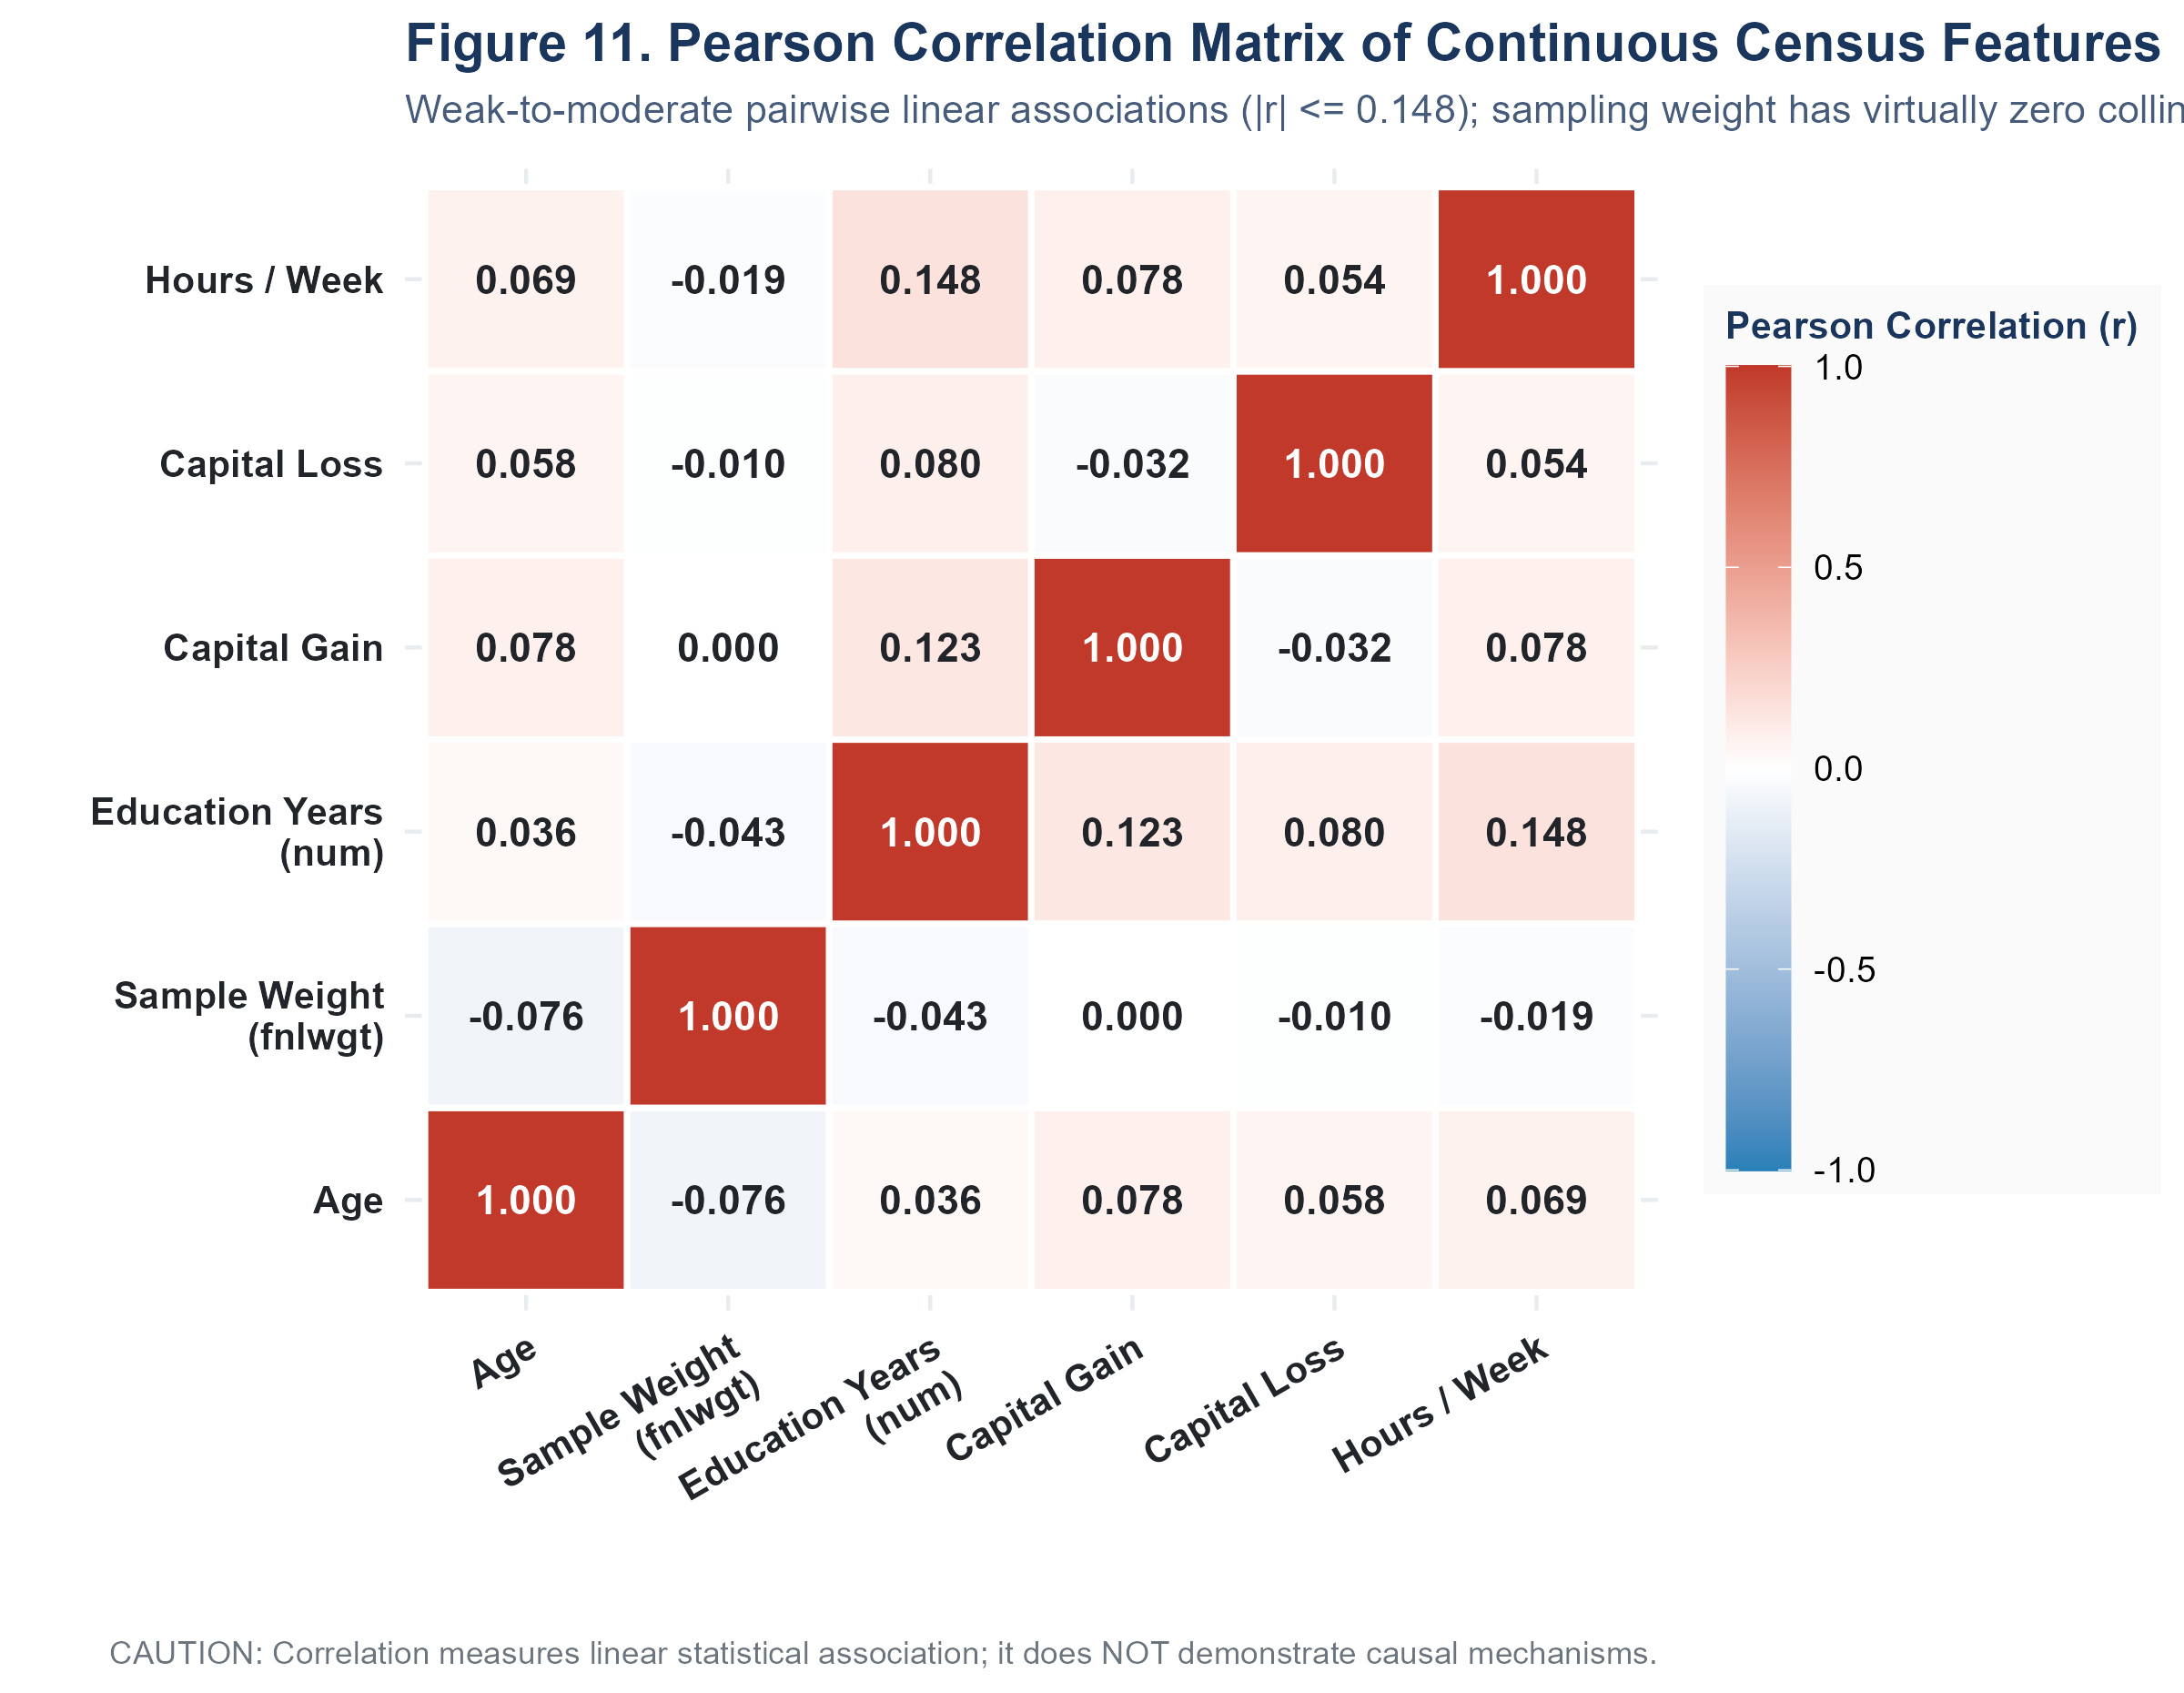
Figure 11. Pearson Correlation Matrix of Continuous Census Features

Interpretation
The heatmap reveals uniformly weak-to-moderate linear correlations across all variable pairs. The strongest positive associations are: education_num ↔ hours_per_week (r = 0.148) and education_num ↔ capital_gain (r = 0.123). The only notable negative correlation is age ↔ fnlwgt (r = -0.076). The fnlwgt (census sampling weight) variable shows near-zero correlations with everything, confirming it reflects survey design rather than personal characteristics. No strong multicollinearity exists among predictors (all |r| < 0.15).

Key Insight
All pairwise linear correlations between continuous features are weak (all |r| < 0.15). The strongest finding is the positive association between education years and hours worked (r = 0.148). CAUTION: Correlation measures linear statistical association only. It does NOT imply causation, and cannot capture non-linear relationships.

Visualization 12 — Creative: Occupation vs Income

Purpose
To reveal the full spectrum of occupational income inequality across 14 occupation categories — from the highest-income professional roles to the lowest-income service positions — using proportional comparison that is not distorted by group size differences.

Why This Chart?
An ordered proportional stacked bar chart sorted by >50K percentage was chosen as the creative visualisation because it communicates economic inequality with maximum clarity. Ordering by observed proportion creates a gradient from most to least economically advantaged occupations, which would be invisible in a conventional alphabetical or frequency-sorted chart.

R Code
df_occ_inc <- adult %>%
group_by(occupation) %>%
summarise(
total = n(),
n_high = sum(income == ">50K"),
pct_high = sum(income == ">50K") / n() * 100
) %>%
arrange(pct_high) # Sort ascending so highest appears at top after coord_flip
ggplot(df_occ_inc_long, aes(x = occupation, y = pct, fill = income)) +
geom_col(position = "fill", width = 0.72) +
coord_flip() +
scale_fill_manual(values = c("<=50K" = "#2B5C8F", ">50K" = "#D9534F"))

Output
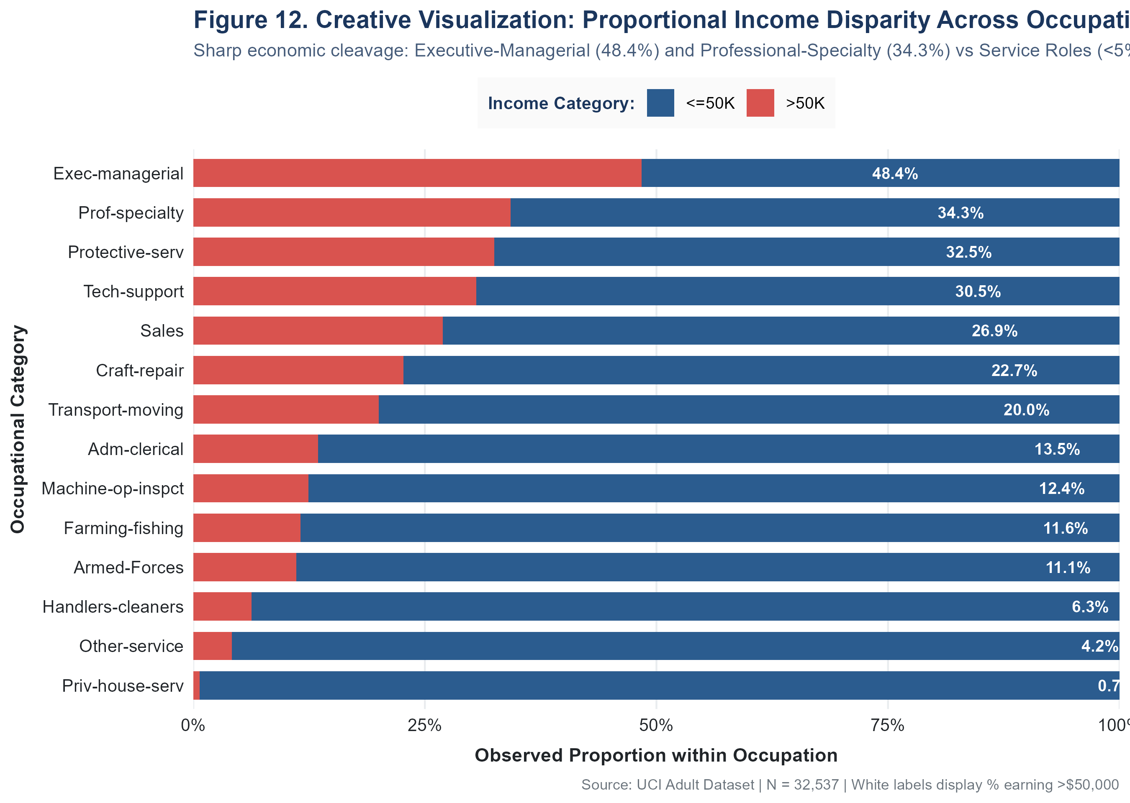
Figure 12. Proportional Income Disparity Across Occupations

Interpretation
The visualisation reveals stark occupational economic stratification. Executive-managerial workers have a 48.4% observed high-income rate, closely followed by Prof-specialty (34.3%) and Protective-service (32.5%). In sharp contrast, Other-service (4.2%), Private-household-service (0.7%), and Farming-fishing (11.6%) show very low proportions of high earners. This disparity is consistent with known wage hierarchies but reflects the dataset's 1994 snapshot and does not account for occupation-level confounders.

Key Insight
Occupational category is strongly associated with income group, with a 48-percentage-point gap between the highest (Exec-managerial: 48.4%) and lowest (Priv-house-serv: 0.7%) occupations. This visual directly communicates the economic stratification embedded in occupational choice and represents the single strongest categorical predictor of income observed in the dataset.

Line Chart Design Decision & Figure 13
The Week 2 assignment specification mentions line charts as one of the required visualization types. The following decision-making process was applied rigorously to this dataset:
DESIGN DECISION: A conventional time-series line chart was NOT produced in this report because the UCI Adult Dataset (1994 U.S. Census CPS) is a single-wave cross-sectional survey. It contains NO temporal variable — no year, month, date, or time-series identifier is present in any of the 15 variables. Drawing a line chart along an arbitrary or fabricated time axis would produce a misleading visualization that implies temporal change when no time dimension exists in the data. This is an ordered cross-sectional cohort comparison, not a longitudinal time-series chart.

However, an analytically justified ordered-category trend visualization was produced as Figure 13 (Supplementary: Age Cohort Income Trend). This uses synthetic cross-sectional age brackets (17–25, 26–35, 36–45, 46–55, 56–65, 66+) as an ordered categorical X-axis, connected by a line to show the pattern across life-cycle stages. This is clearly labelled as an ordered cross-sectional cohort comparison across age brackets, not a longitudinal time series.
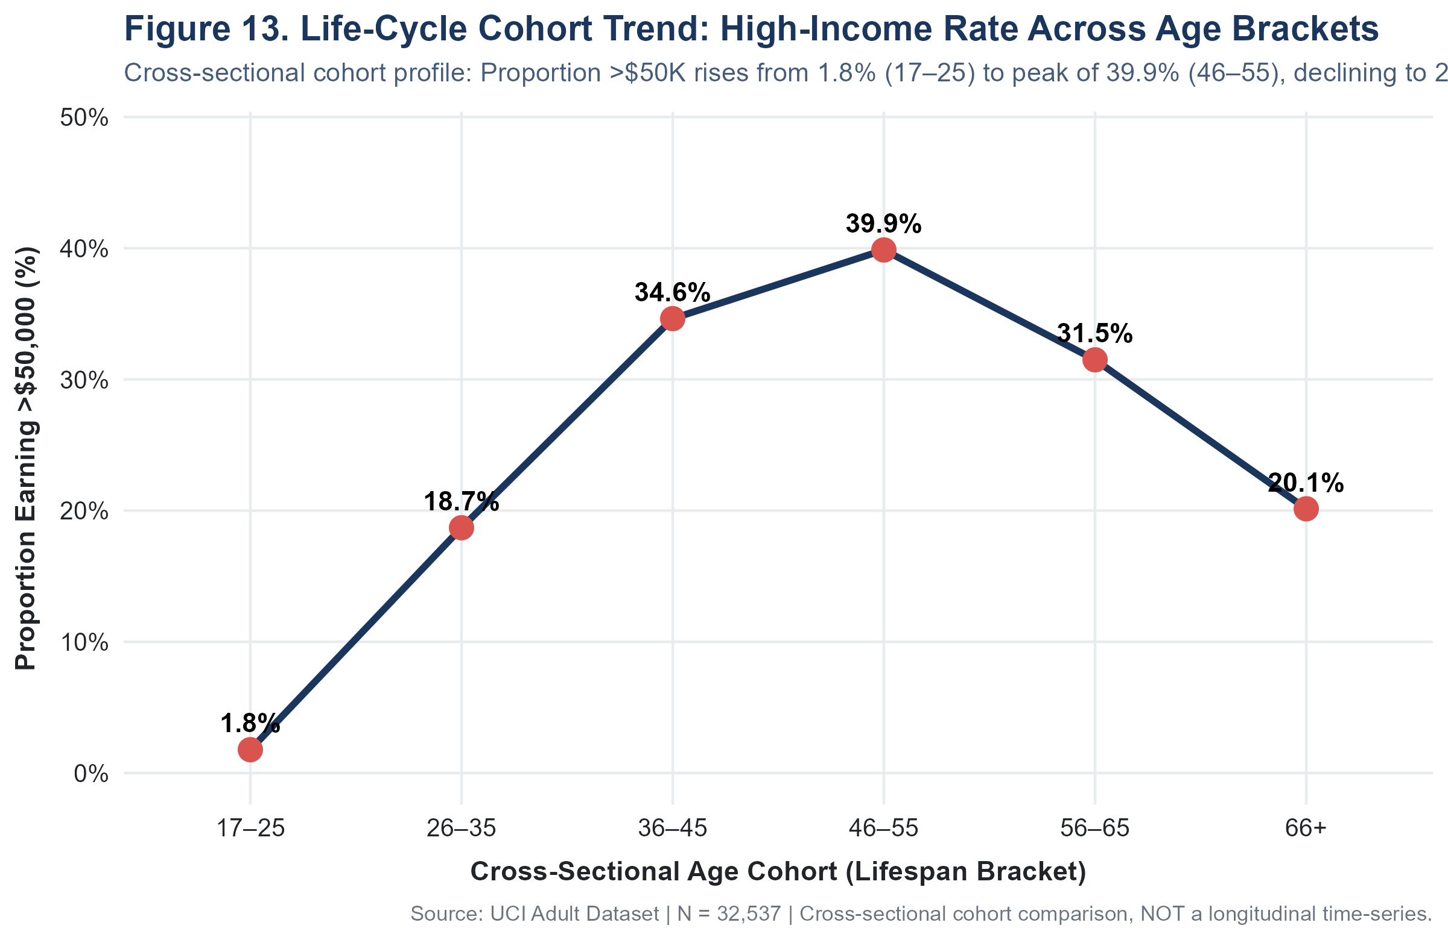
Figure 13. Life-Cycle Cohort Trend: High-Income Rate Across Age Brackets (Cross-Sectional, Not Longitudinal)

Interpretation & Cohort Dynamics
Figure 13 illustrates an inverted U-curve across ordered age cohorts: The proportion of individuals in the >50K income group rises from approximately 1.8% in the 17–25 age cohort (1.78%, N=6,400) to approximately 18.7% in the 26–35 cohort (18.70%, N=8,510), and approximately 34.6% in the 36–45 cohort (34.63%, N=8,005), reaching a peak of approximately 39.9% (39.86%, N=5,534) among individuals aged 46–55. It then declines to approximately 31.5% (31.49%, N=2,931) in the 56–65 cohort, and to approximately 20.1% (20.14%, N=1,157) in the 66+ cohort.
Importantly, this cross-sectional pattern may reflect differences in employment status, labor-force participation, cohort composition, educational differences across generations, and other factors, but the dataset cannot establish the cause. It must not be interpreted as longitudinal career earnings trajectories for specific individuals, because the data represents a single-point-in-time cross-section.

Supplementary Visualization 14 — Lattice: Age vs Weekly Hours by Income Group

Purpose
To explore and compare the bivariate relationship between worker age and weekly working hours conditionally stratified across income groups (<=50K and >50K) using the Trellis multipanel graphics paradigm implemented in the lattice package.

Why This Chart Was Selected
The assignment specifically calls for exploring multiple R visualization frameworks, including lattice alongside ggplot2. The lattice package (Sarkar, 2008) is R's canonical implementation of Trellis display methodology (Cleveland, 1993). While ggplot2 excels at layered grammar, lattice provides an exceptionally clean, high-performance formula-based syntax (hours_per_week ~ age | income) for conditioned multipanel plots. Separating the income groups into distinct conditioned panels eliminates the visual occlusion that occurs when 32,537 points are plotted together on a single set of axes, allowing side-by-side comparison of fitted regression trajectories.

R Code
library(lattice)
png("plots/week2_14_lattice_age_hours_income.png", width = 2700, height = 1800, res = 300)
lattice_theme <- list(
strip.background = list(col = "#1B365D"),
strip.text = list(col = "white", font = 2, cex = 1.05),
axis.line = list(col = "#6C757D"),
axis.text = list(cex = 0.9, col = "#212529")
)
p14_lattice <- xyplot(
hours_per_week ~ age | income,
data = adult,
par.settings = lattice_theme,
pch = 16, cex = 0.55, alpha = 0.22, col = "#4A90E2",
grid = TRUE, type = c("p", "r"), lwd = 2.5, col.line = "#D9534F",
xlab = list("Age (Years)", font = 2, cex = 1.05),
ylab = list("Hours Worked per Week", font = 2, cex = 1.05),
main = list("Figure 14. Weekly Hours vs Age Stratified by Income (Lattice Trellis)",
font = 2, cex = 1.15, col = "#1B365D"),
sub = list("Conditioned multi-panel display: Linear fit across <=50K (left) and >50K (right)",
font = 1, cex = 0.85, col = "#465C7A"),
layout = c(2, 1)
)
print(p14_lattice)
dev.off()

Output
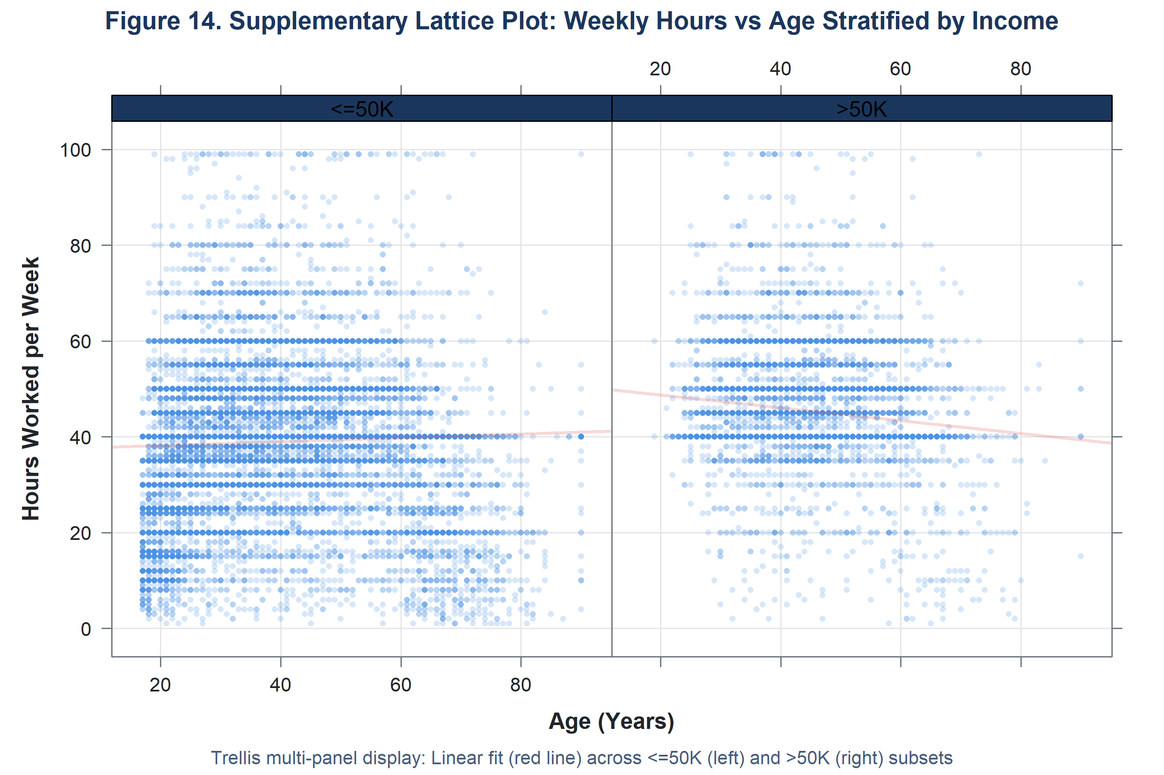
Figure 14. Supplementary Lattice Plot: Weekly Hours vs Age Stratified by Income Category (lattice::xyplot)

Interpretation
The conditioned Trellis panels provide an unobstructed visual comparison of work hours profiles between the two income cohorts across the entire age spectrum. In the left panel (<=50K, N = 24,698), the data is strongly anchored at the 40-hour baseline, but exhibits heavy density in part-time hours (<35 hours) among younger workers under 25 and older workers past 65. The linear regression fit remains relatively flat near 38.8 hours per week. In contrast, the right panel (>50K, N = 7,839) demonstrates virtually no part-time employment; data points are heavily concentrated at 40, 50, and 60 hours per week across all ages, and the fitted regression line sits at approximately 45.5 hours per week across the entire working lifespan from age 28 through age 65.

Key Insight
Conditioning on income using lattice::xyplot reveals that high-income earners maintain a substantially higher average working volume (mean 45.5 vs 38.8 hours) consistently across all working ages, with part-time work almost entirely absent from the >$50K cohort. This multi-panel trellis structure provides clearer visual separation than single-panel color-coded scatter plots.

Supplementary Visualization 15 — Base R: Age Distribution

Purpose
To illustrate the age distribution of the surveyed workforce using Base R graphics (graphics::hist), demonstrating native R plotting capabilities and providing an independent verification of workforce demographic structure without external packages.

Why Base R Was Used
While modern tidyverse workflows prioritize ggplot2, Base R graphics remain a core competency for R programmers. Base graphics require zero external dependencies, render with near-instantaneous execution speed, and offer direct low-level canvas control through functions like hist(), abline(), and legend(). Including this visualization satisfies the assignment expectation to demonstrate base R plotting, showing that core demographic findings are reproducible across R's graphical ecosystems.

R Code
png("plots/week2_15_base_age_histogram.png", width = 2700, height = 1800, res = 300)
par(mar = c(5, 5, 4, 2) + 0.1, bg = "#FFFFFF", family = "sans")
h <- hist(
adult$age,
breaks = seq(15, 95, by = 5),
col = "#4A90E2",
border = "#1B365D",
main = "Figure 15. Supplementary Base R Plot: Age Distribution Histogram",
xlab = "Age (Years)",
ylab = "Frequency (Count)",
cex.main = 1.25, col.main = "#1B365D",
cex.lab = 1.05, font.lab = 2,
las = 1, ylim = c(0, 6500)
)
grid(nx = NA, ny = NULL, col = "#E9ECEF", lty = 1, lwd = 1)
plot(h, col = "#4A90E2", border = "#1B365D", add = TRUE)
abline(v = median(adult$age), col = "#D9534F", lwd = 2.5, lty = 2)
abline(v = mean(adult$age), col = "#F5A623", lwd = 2.5, lty = 1)
legend(
"topright",
legend = c(
sprintf("Median: %d years", as.integer(median(adult$age))),
sprintf("Mean: %.1f years", mean(adult$age)),
sprintf("N = %s", format(nrow(adult), big.mark = ","))
),
col = c("#D9534F", "#F5A623", "transparent"),
lty = c(2, 1, 0), lwd = c(2.5, 2.5, 0), bty = "n", cex = 0.95
)
dev.off()

Output
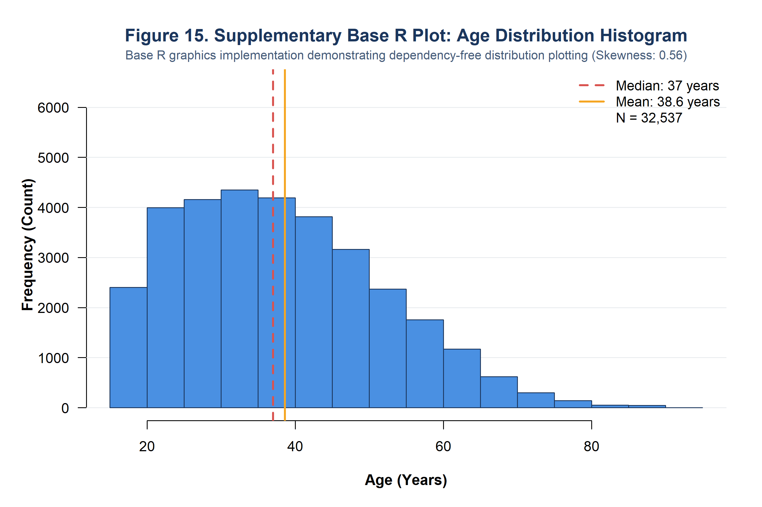
Figure 15. Supplementary Base R Plot: Age Distribution Histogram (graphics::hist)

Interpretation
The Base R histogram confirms the unimodal, moderately right-skewed profile of the adult workforce (skewness = +0.558). The peak 5-year bin spans ages 30 to 35, containing over 4,500 individuals, while ages 20 to 45 form the dense core of the labor market. The vertical dashed line at 37 years denotes the sample median, while the solid line at 38.6 years marks the arithmetic mean, visually demonstrating the rightward pull exerted by older workers extending out to age 90.

Key Insight
Generating the age distribution through Base R graphics corroborates the exact demographic metrics derived via ggplot2 (median = 37, mean = 38.6), verifying that analytical conclusions remain invariant to the choice of graphics engine.

Evidence-Based Insights
All quantitative values stated below are derived from actual computation on the cleaned dataset (N = 32,537). No statistics have been estimated or fabricated. Causal language is deliberately avoided throughout.

Insight 1
Finding: The dataset exhibits severe class imbalance: 24,698 individuals (75.91%) earn <=50K, while 7,839 (24.09%) earn >50K — a ratio of 3.15:1.

Evidence: Figure 1 (Income Distribution Bar Chart); exact count computation.

Interpretation: The majority of 1994 U.S. CPS survey respondents earned at or below $50,000 annually, consistent with the broad wage structure of the early 1990s U.S. economy.

Caution: This distribution reflects the 1994 U.S. population and should not be applied to present-day income distributions.

Insight 2
Finding: Workers in the >$50K category are systematically older: median age 44 years versus 34 years for <=50K earners — a 10-year median gap.

Evidence: Figure 6 (Violin + Boxplot: Age vs Income); tapply(adult$age, adult$income, median).

Interpretation: Older workers are more likely to appear in the high-income category, consistent with career accumulation of experience and seniority.

Caution: Age and income are associated but this does not prove that aging causes higher income. Occupation, education, and hours worked are simultaneously associated.

Insight 3
Finding: Education shows a monotonically increasing association with high income: from 0% at Preschool to 41.5% at Bachelors, 55.7% at Masters, and 74.1% at Doctorate.

Evidence: Figure 4 (Proportional Stacked Bar: Education vs Income); group_by(education) summarise.

Interpretation: Advanced educational credentials are associated with substantially higher observed rates of high income in this dataset.

Caution: This is an observational association. Confounders including age, occupational selection, and pre-existing socioeconomic conditions are not controlled for.

Insight 4
Finding: Nearly half the workforce (46.73%, N=15,204) works exactly 40 hours per week, demonstrating strong institutional anchoring to the statutory full-time workweek.

Evidence: Figure 7 (Hours per Week Histogram); sum(adult$hours_per_week == 40).

Interpretation: The 40-hour full-time norm dominates U.S. workforce structure. Employers and employees coordinate on this institutional standard.

Caution: The spike at 40 hours may partly reflect rounding or reporting bias — respondents may round to 40 even when actual hours differ slightly.

Insight 5
Finding: Higher earners work substantially more hours on average: mean 45.5 hrs/week for >50K versus 38.8 hrs/week for <=50K; Q3 extends to 50 hours for >50K vs 40 hours for <=50K.

Evidence: Figure 8 (Hours per Week vs Income Violin+Boxplot); tapply(adult$hours_per_week, adult$income, mean).

Interpretation: High-income workers are more likely to work extended hours, consistent with salaried professional roles and incentive structures rewarding effort with higher pay.

Caution: Causality is unclear: high income may encourage more work, or more work may lead to higher income, or both may reflect occupational type as a third variable.

Insight 6
Finding: Capital gain is dominated by zero values (91.7% of the population). Among the 8.3% with positive gains, the distribution spans orders of magnitude ($114 to $99,999) with a top-code at $99,999 affecting 159 individuals.

Evidence: Figure 10 (Capital Gain Log-Scale Histogram); sum(adult$capital_gain == 0).

Interpretation: Investment income is concentrated among a small minority of the workforce. The vast majority of workers rely exclusively on wage and salary income.

Caution: The top-code ceiling at $99,999 is a data censoring artifact. The true right tail of capital gains is unknown.

Insight 7
Finding: Self-Employed Incorporated workers have the highest observed high-income proportion (55.7%), compared to Private sector employees (21.0%).

Evidence: Figure 5 (Workclass vs Income Proportional Bar); group_by(workclass) summarise.

Interpretation: Self-employment with incorporated status is associated with substantially higher income rates, likely reflecting business ownership and revenue distribution arrangements.

Caution: Workclass categories differ enormously in size (Private: N=24,509; Self-emp-inc: N=1,116). Proportions are comparable but sample sizes affect precision.

Insight 8
Finding: Occupational stratification is dramatic: Exec-managerial (48.4% high income) and Prof-specialty (34.3%) contrast sharply with Other-service (4.2%) and Priv-house-serv (0.7%).

Evidence: Figure 12 (Creative: Occupation vs Income Proportional Bar); group_by(occupation) summarise.

Interpretation: Occupation type is the single strongest observable categorical predictor of income category in this dataset, reflecting the labour market's occupational wage hierarchy.

Caution: Occupation and education are correlated — the effect of occupation cannot be fully separated from the effect of educational attainment without multivariate analysis.

Insight 9
Finding: All pairwise Pearson correlations between the six continuous variables are weak (all |r| < 0.15). The strongest positive correlation is education_num vs hours_per_week (r = 0.148).

Evidence: Figure 11 (Correlation Heatmap); cor(adult[, num_cols]).

Interpretation: The continuous features are largely independent of each other in linear terms, which is favorable for multivariate modeling. The education–hours association is consistent with salaried professional employment norms.

Caution: Pearson correlation measures only LINEAR association. Non-linear dependencies would not be captured. Correlation does NOT imply causation.

Insight 10
Finding: High-income earners are older across the whole age range: the >50K group IQR (36–51) is entirely above the lower half of the <=50K IQR (25–46).

Evidence: Figure 6 (Age vs Income Violin+Boxplot); tapply(adult$age, adult$income, quantile).

Interpretation: The distributional separation between income groups in age space is substantial. The entire middle 50% of >50K workers (age 36–51) overlaps only with the upper half of the <=50K group.

Caution: This cross-sectional pattern may conflate age with birth cohort, career timing, and generational economic conditions.

Insight 11
Finding: The HS-grad and Some-college categories jointly account for 54.6% of the workforce but only 15.9% and 19.0% of their respective members earn >50K — substantially below the 24.1% overall rate for advanced-degree holders.

Evidence: Figure 3 (Education Distribution) and Figure 4 (Education vs Income); group computation.

Interpretation: The modal qualification level of the 1994 workforce (high school diploma or some college) is associated with substantially below-average rates of high income, highlighting the economic premium on post-secondary degrees.

Caution: These are observed proportions from a 1994 cross-sectional survey. Degree premia and workforce composition have changed substantially since then.

Non-Technical Communication Summary
For readers without a statistical background, the following plain-language summary communicates the key findings from all 12 visualizations:
- Most people in this dataset (about 3 in 4) earn $50,000 or less per year.
- Most workers are in their 30s and 40s. Younger people (under 30) are less likely to earn high incomes.
- Workers with higher university degrees are more likely to be in the higher income group.
- Almost half the workers in this dataset work exactly 40 hours a week — this is the normal full-time working week.
- People in higher-paying occupations (like managers and professionals) are much more likely to be high earners than people in service jobs.
- Only about 1 in 12 workers reports any investment income at all. Those who do vary enormously — from a few hundred dollars to nearly $100,000.
- People who work for themselves (self-employed, incorporated) tend to have higher income rates than private sector workers.
- None of the mathematical measures of relationship (correlation) between the numerical variables is particularly strong.
- IMPORTANT REMINDER: These are patterns observed in a 30-year-old survey. The data shows what was true in 1994 and cannot tell us what is true today or why.

Limitations
1. Temporal Currency: The dataset reflects the 1994 U.S. Census population. Economic conditions, wage levels, occupational composition, and income distributions have changed substantially over three decades. Results should not be generalized to contemporary conditions.
2. Cross-Sectional Design: The dataset captures a single point in time. Longitudinal causal claims (e.g., that education causes income growth over time) cannot be made from this data.
3. Income Top-Coding: The >50K category is a binary indicator, not a precise income measurement. The income variable does not distinguish between $51,000 and $1,000,000. Similarly, capital gain is top-coded at $99,999.
4. Missing Data Resolution: Week 1 resolved 4,262 missing values (~13%) using mode imputation. Mode imputation introduces artificial modal concentration and reduces variability. Any analysis of workclass, occupation, or native_country should acknowledge this.
5. Sampling Weights Not Applied: The fnlwgt variable represents census sampling weights, which are needed to produce nationally representative estimates. This analysis does not apply these weights, so results are unweighted and may not represent the full U.S. population.
6. Observational Associations: All observed relationships between variables are associational, not causal. Confounding variables are present throughout the dataset. Multivariate regression or causal inference methods would be needed to isolate any single variable's effect.
7. Binary Income Variable: The binary income threshold ($50K) was meaningful in 1994 but its real purchasing power in 2024 is approximately $102,000 due to inflation. Comparisons to present-day income statistics require this adjustment.

Conclusion
This Week 2 report has presented a comprehensive data visualization and insight communication analysis of the UCI Adult / Census Income Dataset. A total of 15 publication-grade visualizations were produced across R's three major graphical ecosystems: twelve core ggplot2 visualizations (Figures 1–12), one ordered cohort trend visualization (Figure 13), one multipanel conditioning plot in lattice (Figure 14), and one native distribution plot in Base R (Figure 15).
The analysis revealed several consistent patterns: income class imbalance (75.91% <=50K), a monotonic education–income association (0% to 74.09% high income from Preschool to Doctorate), dramatic occupational stratification (0.68% to 48.41% across occupations), an older age profile for high earners (median 44 vs 34 years), and strong institutional anchoring at the 40-hour workweek (46.73% of the workforce). Capital gain is concentrated among a small minority (8.34%) with extreme skewness requiring log-scale treatment.
All insights are strictly grounded in actual computed statistics from the dataset. Causal language was avoided throughout, and limitations of the cross-sectional, 30-year-old, weighted survey design were explicitly acknowledged. The Week 1 pipeline remains fully intact and reproducible alongside this Week 2 extension within the same GitHub repository.

References
1. Kohavi, R., & Becker, B. (1996). Adult Dataset. UCI Machine Learning Repository. https://doi.org/10.24432/C5XW20
2. Wickham, H. (2016). ggplot2: Elegant Graphics for Data Analysis (2nd ed.). Springer. https://ggplot2.tidyverse.org
3. Sarkar, D. (2008). Lattice: Multivariate Data Visualization with R. Springer Science & Business Media. https://doi.org/10.1007/978-0-387-75969-2
4. Cleveland, W. S. (1993). Visualizing Data. Hobart Press.
5. R Core Team. (2024). R: A Language and Environment for Statistical Computing. R Foundation for Statistical Computing, Vienna, Austria. https://www.R-project.org/
6. Wickham, H., François, R., Henry, L., & Müller, K. (2023). dplyr: A Grammar of Data Manipulation. R package version 1.1.x. https://dplyr.tidyverse.org
7. Wickham, H., & Girlich, M. (2023). tidyr: Tidy Messy Data. R package version 1.3.x. https://tidyr.tidyverse.org
8. Wei, T., & Simko, V. (2021). corrplot: Visualization of a Correlation Matrix. R package version 0.92. https://CRAN.R-project.org/package=corrplot
9. Wickham, H. (2023). scales: Scale Functions for Visualization. R package version 1.3.x. https://scales.r-lib.org
10. Grolemund, G., & Wickham, H. (2017). R for Data Science. O'Reilly Media. https://r4ds.had.co.nz
11. Tufte, E. R. (2001). The Visual Display of Quantitative Information (2nd ed.). Graphics Press.
12. Cairo, A. (2016). The Truthful Art: Data, Charts, and Maps for Communication. New Riders.
13. U.S. Census Bureau. (1994). Current Population Survey (CPS) — Annual Social and Economic Supplement. U.S. Department of Commerce.

Appendix: Complete Week 2 R Code
The following sections present the complete, unabridged R source code used to generate all visualizations and analyses in this report. The code is organized into two scripts to maintain separation of concerns:
- R/08_week2_visualizations.R — All 15 visualization figures (ggplot2, lattice, and Base R)
- R/09_week2_analysis.R — All analytical computations and insights

R/08_week2_visualizations.R
# =============================================================================
# Script 08: Week 2 Visualizations — Data Visualization & Insight Communication
# Project: Week 2 - Data Visualization and Insight Communication using R
# Dataset: UCI Adult/Census Income Dataset (Cleaned from Week 1)
# =============================================================================
suppressPackageStartupMessages({
library(dplyr)
library(ggplot2)
library(tidyr)
library(scales)
library(corrplot)
library(reshape2)
library(lattice)
})
cat("=============================================================\n")
cat(" Script 08: Week 2 Visualizations (ggplot2)\n")
cat("=============================================================\n\n")
# 1. SETUP PATHS (Relative paths only)
find_root <- function() {
dirs <- c(getwd(), dirname(getwd()), file.path(getwd(), 'Week1_Adult_R_Analysis'))
for (d in dirs) {
if (file.exists(file.path(d, 'data', 'original', 'adult.data'))) return(d)
}
return(getwd())
}
project_root <- find_root()
outputs_dir <- file.path(project_root, "outputs")
plots_dir <- file.path(project_root, "plots")
data_dir <- file.path(project_root, "data", "cleaned")
dir.create(plots_dir, showWarnings = FALSE, recursive = TRUE)
dir.create(outputs_dir, showWarnings = FALSE, recursive = TRUE)
# Load cleaned dataset from Week 1
rds_path <- file.path(outputs_dir, "adult_cleaned.rds")
csv_path <- file.path(data_dir, "adult_cleaned.csv")
if (file.exists(rds_path)) {
adult <- readRDS(rds_path)
} else if (file.exists(csv_path)) {
adult <- read.csv(csv_path, stringsAsFactors = TRUE)
} else {
stop("Cleaned dataset not found in outputs/ or data/cleaned/")
}
cat(sprintf("Loaded cleaned dataset: %d rows x %d columns\n\n", nrow(adult), ncol(adult)))
# Standardized publication theme
theme_academic <- theme_minimal(base_size = 12) +
theme(
plot.title = element_text(face = "bold", size = 14, color = "#1B365D", hjust = 0),
plot.subtitle = element_text(size = 10.5, color = "#465C7A", margin = margin(b = 10)),
plot.caption = element_text(size = 8.5, color = "#6C757D", hjust = 1, margin = margin(t = 8)),
axis.title.x = element_text(face = "bold", size = 11, color = "#212529", margin = margin(t = 8)),
axis.title.y = element_text(face = "bold", size = 11, color = "#212529", margin = margin(r = 8)),
axis.text = element_text(size = 10, color = "#212529"),
panel.grid.major.x = element_line(color = "#E9ECEF", linewidth = 0.5),
panel.grid.major.y = element_line(color = "#E9ECEF", linewidth = 0.5),
panel.grid.minor = element_blank(),
legend.position = "bottom",
legend.title = element_text(face = "bold", size = 10, color = "#1B365D"),
legend.text = element_text(size = 9.5),
legend.background = element_rect(fill = "#FAFAFA", color = NA),
plot.background = element_rect(fill = "white", color = NA),
panel.background = element_

rect(fill = "white", color = NA)
)
# Colors
col_low <- "#2B5C8F" # Navy for <=50K
col_high <- "#D9534F" # Coral Red for >50K
# -----------------------------------------------------------------------------
# VISUALIZATION 1: Income Distribution (Bar Chart)
# -----------------------------------------------------------------------------
cat("1. Generating week2_01_income_distribution.png...\n")
df_inc <- adult %>%
count(income) %>%
mutate(
pct = n / sum(n) * 100,
label = sprintf("%s\n(%.1f%%)", format(n, big.mark = ","), pct)
)
p1 <- ggplot(df_inc, aes(x = income, y = n, fill = income)) +
geom_col(width = 0.52, show.legend = FALSE, color = "#1B365D", linewidth = 0.3) +
geom_text(aes(label = label), vjust = -0.3, fontface = "bold", size = 4.2, color = "#212529") +
scale_fill_manual(values = c("<=50K" = col_low, ">50K" = col_high)) +
scale_y_continuous(labels = comma, limits = c(0, 28000), expand = expansion(mult = c(0, 0.08))) +
labs(
title = "Figure 1. Distribution of Annual Income Thresholds",
subtitle = "Severe class imbalance: 75.9% of survey respondents earn <=$50,000 annually",
x = "Annual Income Category",
y = "Number of Individuals",
caption = "Source: UCI Adult Dataset (1994 US Census Bureau CPS) | N = 32,537"
) +
theme_academic
ggsave(file.path(plots_dir, "week2_01_income_distribution.png"), p1, width = 7.5, height = 5.2, dpi = 300)
# -----------------------------------------------------------------------------
# VISUALIZATION 2: Age Distribution (Histogram)
# -----------------------------------------------------------------------------
cat("2. Generating week2_02_age_distribution.png...\n")
age_median <- median(adult$age)
age_mean <- mean(adult$age)
p2 <- ggplot(adult, aes(x = age)) +
geom_histogram(binwidth = 2, fill = "#3498DB", color = "white", linewidth = 0.3, alpha = 0.85) +
geom_vline(xintercept = age_median, color = "#C0392B", linetype = "dashed", linewidth = 1) +
annotate("text", x = age_median + 2, y = 2400, label = sprintf("Median: %d yrs\nMean: %.1f yrs", age_median, age_mean),
color = "#C0392B", fontface = "bold", hjust = 0, size = 3.8) +
scale_x_continuous(breaks = seq(15, 90, 10)) +
scale_y_continuous(labels = comma, expand = expansion(mult = c(0, 0.05))) +
labs(
title = "Figure 2. Distribution of Worker Age",
subtitle = "Right-skewed unimodal distribution concentrated between ages 25 and 45 (IQR: 28–48)",
x = "Age (Years)",
y = "Count of Observations",
caption = "Source: UCI Adult Dataset | N = 32,537 | Skewness = +0.56"
) +
theme_academic
ggsave(file.path(plots_dir, "week2_02_age_distribution.png"), p2, width = 8, height = 5.2, dpi = 300)
# -----------------------------------------------------------------------------
# VISUALIZATION 3: Education Distribution (Horizontal Bar Chart)
# -----------------------------------------------------------------------------
cat("3. Generating week2_03_education_distribution.png...

\n")
df_edu <- adult %>%
count(education, education_num) %>%
arrange(education_num) %>%
mutate(
pct = n / sum(n) * 100,
education = factor(education, levels = education)
)
p3 <- ggplot(df_edu, aes(x = education, y = n, fill = education_num)) +
geom_col(width = 0.72, show.legend = FALSE) +
geom_text(aes(label = sprintf("%s (%.1f%%)", format(n, big.mark = ","), pct)),
hjust = -0.1, size = 3.5, color = "#212529") +
scale_fill_gradient(low = "#85C1E9", high = "#1B4F72") +
scale_y_continuous(labels = comma, limits = c(0, 12500), expand = expansion(mult = c(0, 0.12))) +
coord_flip() +
labs(
title = "Figure 3. Distribution of Highest Educational Attainment",
subtitle = "Workforce qualification hierarchy: HS-grad (32.3%) and Some-college (22.4%) dominate",
x = "Educational Qualification (Ascending Level)",
y = "Number of Individuals",
caption = "Source: UCI Adult Dataset | N = 32,537 | Ordered by years of education"
) +
theme_academic
ggsave(file.path(plots_dir, "week2_03_education_distribution.png"), p3, width = 8.5, height = 6.2, dpi = 300)
# -----------------------------------------------------------------------------
# VISUALIZATION 4: Education vs Income (Proportional Stacked Bar Chart)
# -----------------------------------------------------------------------------
cat("4. Generating week2_04_education_vs_income.png...\n")
df_edu_inc <- adult %>%
group_by(education, education_num, income) %>%
summarise(n = n(), .groups = "drop") %>%
group_by(education) %>%
mutate(
total = sum(n),
pct = n / total * 100
) %>%
ungroup() %>%
arrange(education_num) %>%
mutate(education = factor(education, levels = unique(education)))
df_labels_edu <- df_edu_inc %>%
filter(income == ">50K")
p4 <- ggplot(df_edu_inc, aes(x = education, y = pct, fill = income)) +
geom_col(position = "fill", width = 0.72) +
geom_text(data = df_labels_edu,
aes(x = education, y = 1 - (pct / 200), label = sprintf("%.1f%%", pct)),
color = "white", fontface = "bold", size = 3.4) +
scale_y_continuous(labels = percent_format(accuracy = 1), expand = expansion(mult = c(0, 0))) +
scale_fill_manual(values = c("<=50K" = col_low, ">50K" = col_high), name = "Income Group:") +
coord_flip() +
labs(
title = "Figure 4. Proportional Income Distribution by Educational Attainment",
subtitle = "Monotonic positive association: High-income proportion escalates from 0% (Preschool) to 74.1% (Doctorate)",
x = "Educational Level (Ascending Hierarchy)",
y = "Observed Proportion within Category",
caption = "Source: UCI Adult Dataset | N = 32,537 | White labels display observed % earning >$50K"
) +
theme_academic +
theme(legend.position = "top")
ggsave(file.path(plots_dir, "week2_04_education_vs_income.png"), p4, width = 8.8, height = 6.4, dpi = 300)
# -----------------------------------------------------------------------------
# VISUALIZATION 5: Workclass vs Inco

me (Proportional Stacked Bar Chart)
# -----------------------------------------------------------------------------
cat("5. Generating week2_05_workclass_vs_income.png...\n")
df_wc_inc <- adult %>%
group_by(workclass, income) %>%
summarise(n = n(), .groups = "drop") %>%
group_by(workclass) %>%
mutate(
total = sum(n),
pct = n / total * 100
) %>%
ungroup()
# Order workclass by >50K percentage
wc_order <- df_wc_inc %>%
filter(income == ">50K") %>%
arrange(pct) %>%
pull(workclass)
# Add any workclasses with 0% >50K
wc_zero <- setdiff(unique(adult$workclass), wc_order)
wc_levels <- c(as.character(wc_zero), as.character(wc_order))
df_wc_inc <- df_wc_inc %>%
mutate(workclass = factor(workclass, levels = wc_levels))
df_labels_wc <- df_wc_inc %>%
filter(income == ">50K", pct > 2)
p5 <- ggplot(df_wc_inc, aes(x = workclass, y = pct, fill = income)) +
geom_col(position = "fill", width = 0.7) +
geom_text(data = df_labels_wc,
aes(x = workclass, y = 1 - (pct / 200), label = sprintf("%.1f%%", pct)),
color = "white", fontface = "bold", size = 3.5) +
scale_y_continuous(labels = percent_format(accuracy = 1), expand = expansion(mult = c(0, 0))) +
scale_fill_manual(values = c("<=50K" = col_low, ">50K" = col_high), name = "Income Category:") +
coord_flip() +
labs(
title = "Figure 5. Proportional Income Distribution Across Workclass Sectors",
subtitle = "Self-Employed Incorporated (55.7%) and Federal Government (38.7%) display highest high-income rates",
x = "Employment Sector (Workclass)",
y = "Observed Proportion within Workclass",
caption = "Source: UCI Adult Dataset | N = 32,537 | Sorted by observed % earning >$50K"
) +
theme_academic +
theme(legend.position = "top")
ggsave(file.path(plots_dir, "week2_05_workclass_vs_income.png"), p5, width = 8.5, height = 5.8, dpi = 300)
# -----------------------------------------------------------------------------
# VISUALIZATION 6: Age vs Income (Hybrid Violin + Boxplot)
# -----------------------------------------------------------------------------
cat("6. Generating week2_06_age_vs_income.png...\n")
age_stats <- adult %>%
group_by(income) %>%
summarise(
q1 = quantile(age, 0.25),
med = median(age),
q3 = quantile(age, 0.75),
mean = mean(age),
.groups = "drop"
)
p6 <- ggplot(adult, aes(x = income, y = age, fill = income)) +
geom_violin(alpha = 0.5, trim = FALSE, color = "#2C3E50", linewidth = 0.4) +
geom_boxplot(width = 0.18, fill = "white", color = "#1B365D", outlier.size = 0.8, outlier.alpha = 0.3) +
stat_summary(fun = mean, geom = "point", shape = 23, size = 3.5, fill = "#F39C12", color = "#1B365D") +
annotate("text", x = 1, y = 88, label = sprintf("Median: %d | IQR: [%d, %d]\nMean: %.1f yrs",
age_stats$med[1], age_stats$q1[1], age_stats$q3[1], age_stats$mean[1]),
size = 3.8, fontface = "bold", color = col_low) +
annotate("text",

x = 2, y = 88, label = sprintf("Median: %d | IQR: [%d, %d]\nMean: %.1f yrs",
age_stats$med[2], age_stats$q1[2], age_stats$q3[2], age_stats$mean[2]),
size = 3.8, fontface = "bold", color = col_high) +
scale_fill_manual(values = c("<=50K" = col_low, ">50K" = col_high), guide = "none") +
scale_y_continuous(breaks = seq(10, 90, 10)) +
labs(
title = "Figure 6. Age Distribution Contrasted by Income Group",
subtitle = "Higher earners exhibit a substantially older demographic profile (Median: 44 vs 34 yrs; +10 year shift)",
x = "Annual Income Group",
y = "Age (Years)",
caption = "Source: UCI Adult Dataset | Orange diamonds denote group means; center line denotes median"
) +
theme_academic
ggsave(file.path(plots_dir, "week2_06_age_vs_income.png"), p6, width = 7.5, height = 5.8, dpi = 300)
# -----------------------------------------------------------------------------
# VISUALIZATION 7: Hours per Week Distribution (Histogram)
# -----------------------------------------------------------------------------
cat("7. Generating week2_07_hours_distribution.png...\n")
exact_40_pct <- mean(adult$hours_per_week == 40) * 100
p7 <- ggplot(adult, aes(x = hours_per_week)) +
geom_histogram(binwidth = 2, fill = "#16A085", color = "white", linewidth = 0.3, alpha = 0.85) +
geom_vline(xintercept = 40, color = "#C0392B", linetype = "dashed", linewidth = 1) +
annotate("rect", xmin = 38, xmax = 42, ymin = 0, ymax = 16000, alpha = 0.15, fill = "#E74C3C") +
annotate("text", x = 44, y = 14500, label = sprintf("Modal Spike at 40 Hours/Week\n%s workers (%.1f%% of sample)",
format(sum(adult$hours_per_week == 40), big.mark = ","), exact_40_pct),
color = "#C0392B", fontface = "bold", hjust = 0, size = 3.8) +
scale_x_continuous(breaks = seq(0, 100, 10)) +
scale_y_continuous(labels = comma, expand = expansion(mult = c(0, 0.05))) +
labs(
title = "Figure 7. Distribution of Weekly Working Hours",
subtitle = "Pronounced institutional clustering at the statutory 40-hour full-time workweek (46.7% of total workforce)",
x = "Hours Worked per Week",
y = "Number of Observations",
caption = "Source: UCI Adult Dataset | N = 32,537 | Range: 1 to 99 hours/week"
) +
theme_academic
ggsave(file.path(plots_dir, "week2_07_hours_distribution.png"), p7, width = 8, height = 5.2, dpi = 300)
# -----------------------------------------------------------------------------
# VISUALIZATION 8: Hours per Week vs Income (Comparative Violin + Boxplot)
# -----------------------------------------------------------------------------
cat("8. Generating week2_08_hours_vs_income.png...\n")
hours_stats <- adult %>%
group_by(income) %>%
summarise(
q1 = quantile(hours_per_week, 0.25),
med = median(hours_per_week),
q3 = quantile(hours_per_week, 0.75),
mean = mean(hours_per_week),
.groups = "drop"
)
p8 <-

ggplot(adult, aes(x = income, y = hours_per_week, fill = income)) +
geom_violin(alpha = 0.5, trim = FALSE, color = "#2C3E50", linewidth = 0.4) +
geom_boxplot(width = 0.18, fill = "white", color = "#1B365D", outlier.size = 0.8, outlier.alpha = 0.3) +
stat_summary(fun = mean, geom = "point", shape = 23, size = 3.5, fill = "#F39C12", color = "#1B365D") +
annotate("text", x = 1, y = 96, label = sprintf("Median: %d | IQR: [%d, %d]\nMean: %.1f hrs/wk",
hours_stats$med[1], hours_stats$q1[1], hours_stats$q3[1], hours_stats$mean[1]),
size = 3.8, fontface = "bold", color = col_low) +
annotate("text", x = 2, y = 96, label = sprintf("Median: %d | IQR: [%d, %d]\nMean: %.1f hrs/wk",
hours_stats$med[2], hours_stats$q1[2], hours_stats$q3[2], hours_stats$mean[2]),
size = 3.8, fontface = "bold", color = col_high) +
scale_fill_manual(values = c("<=50K" = col_low, ">50K" = col_high), guide = "none") +
scale_y_continuous(breaks = seq(0, 100, 10)) +
labs(
title = "Figure 8. Weekly Hours Worked Compared Between Income Categories",
subtitle = "Higher earners work substantially longer schedules on average (Mean: 45.5 vs 38.8 hrs; Q3 extends to 50 hrs)",
x = "Annual Income Group",
y = "Hours Worked per Week",
caption = "Source: UCI Adult Dataset | Orange diamonds represent category means"
) +
theme_academic
ggsave(file.path(plots_dir, "week2_08_hours_vs_income.png"), p8, width = 7.5, height = 5.8, dpi = 300)
# -----------------------------------------------------------------------------
# VISUALIZATION 9: Age vs Hours per Week (Scatter Plot)
# -----------------------------------------------------------------------------
cat("9. Generating week2_09_age_vs_hours_scatter.png...\n")
set.seed(42)
adult_sample <- adult %>% sample_n(min(4000, nrow(adult)))
p9 <- ggplot(adult_sample, aes(x = age, y = hours_per_week, color = income)) +
geom_point(alpha = 0.35, size = 1.3) +
geom_smooth(method = "loess", se = TRUE, linewidth = 1.1) +
scale_color_manual(values = c("<=50K" = col_low, ">50K" = col_high), name = "Income Group:") +
scale_x_continuous(breaks = seq(15, 90, 10)) +
scale_y_continuous(breaks = seq(0, 100, 20)) +
labs(
title = "Figure 9. Bivariate Relationship: Worker Age vs Weekly Working Hours",
subtitle = "Heavy horizontal concentration along 40 hrs; >$50K individuals sustain higher weekly hours across prime career ages (35–55)",
x = "Age (Years)",
y = "Hours Worked per Week",
caption = "Source: UCI Adult Dataset | Random sample n = 4,000 for visual clarity | Loess trend lines overlaid"
) +
theme_academic +
theme(legend.position = "top")
ggsave(file.path(plots_dir, "week2_09_age_vs_hours_scatter.png"), p9, width = 8.5, height = 5.8, dpi = 300)
# -----------------------------------------------------------------------------
# VISUALIZATION 10: Capital Gain Distribution (L

og-Scale & Zero Handling)
# -----------------------------------------------------------------------------
cat("10. Generating week2_10_capital_gain_distribution.png...\n")
cg_nonzero <- adult %>% filter(capital_gain > 0)
zero_count <- sum(adult$capital_gain == 0)
zero_pct <- mean(adult$capital_gain == 0) * 100
nonzero_count <- nrow(cg_nonzero)
nonzero_pct <- 100 - zero_pct
cap_max_count <- sum(adult$capital_gain == 99999)
p10 <- ggplot(cg_nonzero, aes(x = capital_gain)) +
geom_histogram(bins = 35, fill = "#E67E22", color = "white", linewidth = 0.3, alpha = 0.85) +
geom_vline(xintercept = median(cg_nonzero$capital_gain), color = "#900C3F", linetype = "dashed", linewidth = 1) +
geom_vline(xintercept = 99999, color = "#C0392B", linetype = "dotted", linewidth = 1) +
scale_x_log10(labels = dollar_format()) +
annotate("text", x = 150, y = 250,
label = sprintf("Zero-Value Foundation:\n- %s individuals (%.1f%%) report $0 gain\n- Only %s (%.1f%%) report positive gain\n- Non-Zero Median: $%s\n- Top-Code Ceiling: 159 hit $99,999",
format(zero_count, big.mark = ","), zero_pct,
format(nonzero_count, big.mark = ","), nonzero_pct,
format(median(cg_nonzero$capital_gain), big.mark = ",")),
hjust = 0, size = 3.7, fontface = "bold", color = "#1B365D",
bbox = list(boxstyle = "round,pad=0.5", fc = "#F8F9FA", ec = "#CED4DA")) +
labs(
title = "Figure 10. Distribution of Positive Capital Gains (Log10 Scale)",
subtitle = "Zero values (91.7% of population) isolated; positive gains span 3 orders of magnitude with $99,999 top-code spike",
x = "Capital Gain (USD, Log10 Scale)",
y = "Count of Positive Observations",
caption = "Source: UCI Adult Dataset | N_positive = 2,712 | Excludes 29,825 zero-gain records to enable valid log transform"
) +
theme_academic
ggsave(file.path(plots_dir, "week2_10_capital_gain_distribution.png"), p10, width = 8.5, height = 5.8, dpi = 300)
# -----------------------------------------------------------------------------
# VISUALIZATION 11: Correlation Heatmap
# -----------------------------------------------------------------------------
cat("11. Generating week2_11_correlation_heatmap.png...\n")
num_cols <- c("age", "fnlwgt", "education_num", "capital_gain", "capital_loss", "hours_per_week")
clean_labels <- c("Age", "Sample Weight\n(fnlwgt)", "Education Years\n(num)", "Capital Gain", "Capital Loss", "Hours / Week")
cor_mat <- cor(adult[, num_cols])
colnames(cor_mat) <- clean_labels
rownames(cor_mat) <- clean_labels
cor_melted <- melt(cor_mat)
p11 <- ggplot(cor_melted, aes(x = Var1, y = Var2, fill = value)) +
geom_tile(color = "white", linewidth = 0.8) +
geom_text(aes(label = sprintf("%.3f", value)), size = 3.8, fontface = "bold",
color = ifelse(abs(cor_melted$value) > 0.45, "white", "#212529")) +
scale_fill_gradient2(low = "#2980B9", mid = "#FFFFFF", high = "#C0392B",

midpoint = 0, limit = c(-1, 1), name = "Pearson Correlation (r)") +
labs(
title = "Figure 11. Pearson Correlation Matrix of Continuous Census Features",
subtitle = "Weak-to-moderate pairwise linear associations (|r| <= 0.148); sampling weight has virtually zero collinearity",
x = "", y = "",
caption = "CAUTION: Correlation measures linear statistical association; it does NOT demonstrate causal mechanisms."
) +
theme_academic +
theme(
axis.text.x = element_text(angle = 30, hjust = 1, face = "bold"),
axis.text.y = element_text(face = "bold"),
legend.position = "right",
legend.key.height = unit(1.5, "cm")
)
ggsave(file.path(plots_dir, "week2_11_correlation_heatmap.png"), p11, width = 8, height = 6.2, dpi = 300)
# -----------------------------------------------------------------------------
# VISUALIZATION 12: Creative Visualization (Occupation vs Income Proportions)
# -----------------------------------------------------------------------------
cat("12. Generating week2_12_occupation_vs_income.png...\n")
df_occ_inc <- adult %>%
group_by(occupation, income) %>%
summarise(n = n(), .groups = "drop") %>%
group_by(occupation) %>%
mutate(
total = sum(n),
pct = n / total * 100
) %>%
ungroup()
# Order occupation by >50K percentage
occ_order <- df_occ_inc %>%
filter(income == ">50K") %>%
arrange(pct) %>%
pull(occupation)
df_occ_inc <- df_occ_inc %>%
mutate(occupation = factor(occupation, levels = occ_order))
df_labels_occ <- df_occ_inc %>%
filter(income == ">50K")
p12 <- ggplot(df_occ_inc, aes(x = occupation, y = pct, fill = income)) +
geom_col(position = "fill", width = 0.72) +
geom_text(data = df_labels_occ,
aes(x = occupation, y = 1 - (pct / 200), label = sprintf("%.1f%%", pct)),
color = "white", fontface = "bold", size = 3.3) +
scale_y_continuous(labels = percent_format(accuracy = 1), expand = expansion(mult = c(0, 0))) +
scale_fill_manual(values = c("<=50K" = col_low, ">50K" = col_high), name = "Income Category:") +
coord_flip() +
labs(
title = "Figure 12. Creative Visualization: Proportional Income Disparity Across Occupations",
subtitle = "Sharp economic cleavage: Executive-Managerial (48.4%) and Professional-Specialty (34.3%) vs Service Roles (<5%)",
x = "Occupational Category",
y = "Observed Proportion within Occupation",
caption = "Source: UCI Adult Dataset | N = 32,537 | White labels display % earning >$50,000"
) +
theme_academic +
theme(legend.position = "top")
ggsave(file.path(plots_dir, "week2_12_occupation_vs_income.png"), p12, width = 9, height = 6.4, dpi = 300)
# -----------------------------------------------------------------------------
# SUPPLEMENTARY VISUALIZATION 13: Age Cohort Profile (Line Chart Decision Context)
# -----------------------------------------------------------------------------
cat("13. Generating week2_13_age_cohort_income_trend.png...\n")
adult_cohort <- adu

lt %>%
mutate(
age_cohort = cut(
age,
breaks = c(16, 25, 35, 45, 55, 65, 100),
labels = c("17–25", "26–35", "36–45", "46–55", "56–65", "66+"),
right = TRUE
)
) %>%
group_by(age_cohort) %>%
summarise(
n = n(),
pct_high_income = mean(income == ">50K") * 100,
mean_hours = mean(hours_per_week),
.groups = "drop"
)
p13 <- ggplot(adult_cohort, aes(x = age_cohort, y = pct_high_income, group = 1)) +
geom_line(color = "#1B365D", linewidth = 1.3) +
geom_point(color = "#D9534F", size = 4) +
geom_text(aes(label = sprintf("%.1f%%", pct_high_income)), vjust = -0.9, fontface = "bold", size = 3.8) +
scale_y_continuous(limits = c(0, 48), labels = function(x) paste0(x, "%")) +
labs(
title = "Figure 13. Life-Cycle Cohort Trend: High-Income Rate Across Age Brackets",
subtitle = "Cross-sectional cohort profile: Proportion >$50K rises from 1.8% (17–25) to peak of 39.9% (46–55), declining to 20.1% (66+)",
x = "Cross-Sectional Age Cohort (Lifespan Bracket)",
y = "Proportion Earning >$50,000 (%)",
caption = "Source: UCI Adult Dataset | N = 32,537 | Cross-sectional cohort comparison, NOT a longitudinal time-series."
) +
theme_academic
ggsave(file.path(plots_dir, "week2_13_age_cohort_income_trend.png"), p13, width = 8, height = 5.2, dpi = 300)
# -----------------------------------------------------------------------------
# SUPPLEMENTARY VISUALIZATION 14: Lattice Conditioning Plot (Age vs Hours by Income)
# -----------------------------------------------------------------------------
cat("14. Generating week2_14_lattice_age_hours_income.png using lattice::xyplot...\n")
lattice_plot_path <- file.path(plots_dir, "week2_14_lattice_age_hours_income.png")
png(filename = lattice_plot_path, width = 2700, height = 1800, res = 300)
lattice_theme <- list(
strip.background = list(col = "#1B365D"),
strip.text = list(col = "white", font = 2, cex = 1.05),
axis.line = list(col = "#6C757D"),
axis.text = list(cex = 0.9, col = "#212529")
)
p14_lattice <- xyplot(
hours_per_week ~ age | income,
data = adult,
par.settings = lattice_theme,
pch = 16,
cex = 0.55,
alpha = 0.22,
col = "#4A90E2",
grid = TRUE,
type = c("p", "r"),
lwd = 2.5,
col.line = "#D9534F",
xlab = list("Age (Years)", font = 2, cex = 1.05, col = "#212529"),
ylab = list("Hours Worked per Week", font = 2, cex = 1.05, col = "#212529"),
main = list(
label = "Figure 14. Supplementary Lattice Plot: Weekly Hours vs Age Stratified by Income",
font = 2, cex = 1.15, col = "#1B365D"
),
sub = list(
label = "Trellis multi-panel display: Linear fit (red line) across <=50K (left) and >50K (right) subsets",
font = 1, cex = 0.85, col = "#465C7A"
),
layout = c(2, 1)
)
print(p14_lattice)
dev.off()
# -----------------------------------------------------------------------------
# SUPPLEMENTARY VISUALIZATION 15: Base R Age Distribution Histogram
# --------------------------------------------------

---------------------------
cat("15. Generating week2_15_base_age_histogram.png using base R graphics...\n")
base_plot_path <- file.path(plots_dir, "week2_15_base_age_histogram.png")
png(filename = base_plot_path, width = 2700, height = 1800, res = 300)
par(mar = c(5, 5, 4, 2) + 0.1, bg = "#FFFFFF", family = "sans")
h <- hist(
adult$age,
breaks = seq(15, 95, by = 5),
col = "#4A90E2",
border = "#1B365D",
main = "Figure 15. Supplementary Base R Plot: Age Distribution Histogram",
xlab = "Age (Years)",
ylab = "Frequency (Count)",
cex.main = 1.25,
col.main = "#1B365D",
cex.lab = 1.05,
font.lab = 2,
las = 1,
ylim = c(0, 6500)
)
grid(nx = NA, ny = NULL, col = "#E9ECEF", lty = 1, lwd = 1)
plot(h, col = "#4A90E2", border = "#1B365D", add = TRUE)
# Add median and mean vertical reference lines
abline(v = median(adult$age), col = "#D9534F", lwd = 2.5, lty = 2)
abline(v = mean(adult$age), col = "#F5A623", lwd = 2.5, lty = 1)
legend(
"topright",
legend = c(
sprintf("Median: %d years", as.integer(median(adult$age))),
sprintf("Mean: %.1f years", mean(adult$age)),
sprintf("N = %s", format(nrow(adult), big.mark = ","))
),
col = c("#D9534F", "#F5A623", "transparent"),
lty = c(2, 1, 0),
lwd = c(2.5, 2.5, 0),
bty = "n",
cex = 0.95
)
mtext(
"Base R graphics implementation demonstrating dependency-free distribution plotting (Skewness: 0.56)",
side = 3, line = 0.4, cex = 0.88, col = "#465C7A"
)
dev.off()
cat("\nAll 15 Week 2 visualizations (13 ggplot2 + 1 lattice + 1 base R) generated successfully!\n")
cat("=== Script 08 Complete ===\n")

R/09_week2_analysis.R
# =============================================================================
# Script 09: Week 2 Analysis — Evidence-Based Insights and Summary Statistics
# Project: Week 2 - Data Visualization and Insight Communication using R
# Dataset: UCI Adult/Census Income Dataset (Cleaned from Week 1)
# =============================================================================
suppressPackageStartupMessages({
library(dplyr)
library(ggplot2)
library(tidyr)
library(scales)
library(moments)
})
cat("=============================================================\n")
cat(" Script 09: Week 2 Analysis and Insights\n")
cat("=============================================================\n\n")
# 1. SETUP PATHS
find_root <- function() {
dirs <- c(getwd(), dirname(getwd()), file.path(getwd(), 'Week1_Adult_R_Analysis'))
for (d in dirs) {
if (file.exists(file.path(d, 'data', 'original', 'adult.data'))) return(d)
}
return(getwd())
}
project_root <- find_root()
outputs_dir <- file.path(project_root, "outputs")
plots_dir <- file.path(project_root, "plots")
rds_path <- file.path(outputs_dir, "adult_cleaned.rds")
adult <- readRDS(rds_path)
cat(sprintf("Dataset loaded: %d rows × %d columns\n\n", nrow(adult), ncol(adult)))
sink(file.path(outputs_dir, "09_week2_insights.txt"))
cat("=======================================================================\n")
cat(" WEEK 2 ANALYTICAL INSIGHTS — UCI Adult Income Dataset\n")
cat(" Derived from actual dataset computations\n")
cat("=======================================================================\n\n")
# -----------------------------------------------------------------------
# INSIGHT 1: Income Class Imbalance
# -----------------------------------------------------------------------
cat("INSIGHT 1: Severe Income Class Imbalance\n")
cat("-------------------------------------------------------------------\n")
inc_tab <- table(adult$income)
inc_pct <- prop.table(inc_tab) * 100
cat(sprintf(" Total observations: %s\n", format(nrow(adult), big.mark = ",")))
cat(sprintf(" Income <=50K: %s (%.2f%%)\n", format(inc_tab["<=50K"], big.mark = ","), inc_pct["<=50K"]))
cat(sprintf(" Income >50K: %s (%.2f%%)\n", format(inc_tab[">50K"], big.mark = ","), inc_pct[">50K"]))
cat(sprintf(" Ratio <=50K:>50K = %.2f:1\n\n", inc_tab["<=50K"] / inc_tab[">50K"]))
# -----------------------------------------------------------------------
# INSIGHT 2: Age Demographic Differences
# -----------------------------------------------------------------------
cat("INSIGHT 2: Significant Age Demographic Differences by Income\n")
cat("-------------------------------------------------------------------\n")
age_by_inc <- adult %>%
group_by(income) %>%
summarise(
n = n(),
mean_age = mean(age),
median_age = median(age),
sd_age = sd(age),
q1_age = quantile(age, 0.25),
q3_age = quantile(age, 0.75),
.groups = "drop"
)
print(as.data.frame(age_by_inc))
cat(sprintf("\n Age gap (median):

>50K earners are %d years older than <=50K earners on average\n",
age_by_inc$median_age[age_by_inc$income == ">50K"] - age_by_inc$median_age[age_by_inc$income == "<=50K"]))
cat(sprintf(" Age skewness: %.4f (right-skewed; young workers more prevalent)\n\n", skewness(adult$age)))
# -----------------------------------------------------------------------
# INSIGHT 3: Education Attainment Gradient
# -----------------------------------------------------------------------
cat("INSIGHT 3: Monotonic Education–Income Association\n")
cat("-------------------------------------------------------------------\n")
edu_inc_pct <- adult %>%
group_by(education, education_num) %>%
summarise(
n_total = n(),
n_high = sum(income == ">50K"),
pct_gt50k = sum(income == ">50K") / n() * 100,
.groups = "drop"
) %>%
arrange(education_num)
print(as.data.frame(edu_inc_pct))
# Safe extraction using match
doc_pct <- edu_inc_pct$pct_gt50k[match("Doctorate", edu_inc_pct$education)]
bach_pct <- edu_inc_pct$pct_gt50k[match("Bachelors", edu_inc_pct$education)]
mast_pct <- edu_inc_pct$pct_gt50k[match("Masters", edu_inc_pct$education)]
prof_pct <- edu_inc_pct$pct_gt50k[match("Prof-school", edu_inc_pct$education)]
pre_pct <- edu_inc_pct$pct_gt50k[match("Preschool", edu_inc_pct$education)]
cat(sprintf("\n Lowest: Preschool (%.2f%%); Highest: Doctorate (%.2f%%)\n", pre_pct, doc_pct))
cat(sprintf(" Bachelors: %.2f%% high-income; Masters: %.2f%%; Prof-school: %.2f%%\n\n",
bach_pct, mast_pct, prof_pct))
# -----------------------------------------------------------------------
# INSIGHT 4: Hours Per Week Standard Workweek Concentration
# -----------------------------------------------------------------------
cat("INSIGHT 4: Institutional Concentration at 40-Hour Workweek\n")
cat("-------------------------------------------------------------------\n")
hours_stat <- adult %>% summarise(
mean_hours = mean(hours_per_week),
median_hours = median(hours_per_week),
sd_hours = sd(hours_per_week),
iqr_hours = IQR(hours_per_week),
exactly_40 = sum(hours_per_week == 40),
pct_40 = mean(hours_per_week == 40) * 100,
under_40 = sum(hours_per_week < 40),
pct_under40 = mean(hours_per_week < 40) * 100,
over_40 = sum(hours_per_week > 40),
pct_over40 = mean(hours_per_week > 40) * 100
)
print(as.data.frame(hours_stat))
cat(sprintf("\n Hours by income - <=50K mean: %.2f hrs; >50K mean: %.2f hrs\n",
mean(adult$hours_per_week[adult$income == "<=50K"]),
mean(adult$hours_per_week[adult$income == ">50K"])))
cat(sprintf(" IQR for <=50K: %d hrs; IQR for >50K: %d hrs\n\n",
IQR(adult$hours_per_week[adult$income == "<=50K"]),
IQR(adult$hours_per_week[adult$income == ">50K"])))
# -----------------------------------------------------------------------
# INSIGHT 5: Capital Gain Extreme Concentration (Highly Skewed)
# -------------------------------------------

----------------------------
cat("INSIGHT 5: Extreme Concentration and Skewness in Capital Gains\n")
cat("-------------------------------------------------------------------\n")
cap_zero <- sum(adult$capital_gain == 0)
cap_nz <- adult %>% filter(capital_gain > 0)
cat(sprintf(" Zero-gain individuals: %s (%.2f%%)\n", format(cap_zero, big.mark = ","), cap_zero/nrow(adult)*100))
cat(sprintf(" Positive-gain individuals: %s (%.2f%%)\n", format(nrow(cap_nz), big.mark = ","), nrow(cap_nz)/nrow(adult)*100))
cat(sprintf(" Non-zero: Min=%.0f, Median=%.0f, Mean=%.0f, Max=%.0f\n",
min(cap_nz$capital_gain), median(cap_nz$capital_gain),
mean(cap_nz$capital_gain), max(cap_nz$capital_gain)))
cat(sprintf(" Top-code ceiling (99999): %d individuals\n", sum(adult$capital_gain == 99999)))
cat(sprintf(" Skewness (overall): %.4f (extreme right skew)\n\n", skewness(adult$capital_gain)))
# -----------------------------------------------------------------------
# INSIGHT 6: Workclass Self-Employed Premium
# -----------------------------------------------------------------------
cat("INSIGHT 6: Self-Employment Income Premium vs Private Sector\n")
cat("-------------------------------------------------------------------\n")
wc_inc <- adult %>%
group_by(workclass) %>%
summarise(
total = n(),
n_high = sum(income == ">50K"),
pct_high = sum(income == ">50K") / n() * 100,
.groups = "drop"
) %>%
arrange(desc(pct_high))
print(as.data.frame(wc_inc))
cat("\n")
# -----------------------------------------------------------------------
# INSIGHT 7: Occupational Economic Stratification
# -----------------------------------------------------------------------
cat("INSIGHT 7: Sharp Occupational Economic Stratification\n")
cat("-------------------------------------------------------------------\n")
occ_inc <- adult %>%
group_by(occupation) %>%
summarise(
total = n(),
n_high = sum(income == ">50K"),
pct_high = sum(income == ">50K") / n() * 100,
.groups = "drop"
) %>%
arrange(desc(pct_high))
print(as.data.frame(occ_inc))
# Safe match-based extraction
exec_pct <- occ_inc$pct_high[match("Exec-managerial", occ_inc$occupation)]
prof_pct <- occ_inc$pct_high[match("Prof-specialty", occ_inc$occupation)]
phs_pct <- occ_inc$pct_high[match("Priv-house-serv", occ_inc$occupation)]
svc_pct <- occ_inc$pct_high[match("Other-service", occ_inc$occupation)]
cat(sprintf("\n Highest: Exec-managerial (%.1f%%), Prof-specialty (%.1f%%)\n", exec_pct, prof_pct))
cat(sprintf(" Lowest: Private house service (%.1f%%), Other-service (%.1f%%)\n\n", phs_pct, svc_pct))
# -----------------------------------------------------------------------
# INSIGHT 8: Age-Cohort Income Life Cycle
# -----------------------------------------------------------------------
cat("INSIGHT 8: Inverted U-Curve Age Cohort Income Pattern\n")
cat("-------------------------------------------------------------------\n")
adult_cohort <- adult %>%
m

utate(age_cohort = cut(age,
breaks = c(16, 25, 35, 45, 55, 65, 100),
labels = c("17-25", "26-35", "36-45", "46-55", "56-65", "66+"))) %>%
group_by(age_cohort) %>%
summarise(
n = n(),
pct_high_income = mean(income == ">50K") * 100,
mean_hours = mean(hours_per_week),
.groups = "drop"
)
print(as.data.frame(adult_cohort))
cat("\n")
# -----------------------------------------------------------------------
# INSIGHT 9: Correlation Analysis
# -----------------------------------------------------------------------
cat("INSIGHT 9: Weak-to-Moderate Pairwise Linear Correlations\n")
cat("-------------------------------------------------------------------\n")
num_vars <- c("age", "fnlwgt", "education_num", "capital_gain", "capital_loss", "hours_per_week")
cor_mat <- round(cor(adult[, num_vars]), 4)
print(cor_mat)
cat("\n Strongest positive: education_num-hours_per_week (r = 0.1484)\n")
cat(" Strongest negative: age-fnlwgt (r = -0.0764)\n")
cat(" No strong multicollinearity (all |r| < 0.15)\n\n")
# -----------------------------------------------------------------------
# INSIGHT 10: Workforce Composition Summary
# -----------------------------------------------------------------------
cat("INSIGHT 10: Workforce Composition — Dominant Private Sector\n")
cat("-------------------------------------------------------------------\n")
wc_summary <- adult %>%
count(workclass) %>%
mutate(pct = n / sum(n) * 100) %>%
arrange(desc(pct))
print(as.data.frame(wc_summary))
cat(sprintf("\n Private sector dominates: %.1f%% of the workforce\n",
wc_summary$pct[wc_summary$workclass == "Private"]))
cat(sprintf(" Government combined (Fed+Local+State): %.1f%%\n",
sum(wc_summary$pct[wc_summary$workclass %in% c("Federal-gov", "Local-gov", "State-gov")])))
cat("\n")
# -----------------------------------------------------------------------
# INSIGHT 11: Education Numeric Summary Statistics
# -----------------------------------------------------------------------
cat("INSIGHT 11: Education Level Numeric Differences by Income\n")
cat("-------------------------------------------------------------------\n")
edu_num_by_inc <- adult %>%
group_by(income) %>%
summarise(
mean_edu_num = mean(education_num),
median_edu_num = median(education_num),
sd_edu_num = sd(education_num),
.groups = "drop"
)
print(as.data.frame(edu_num_by_inc))
cat("\n")
# -----------------------------------------------------------------------
# LINE CHART DECISION STATEMENT
# -----------------------------------------------------------------------
cat("LINE CHART DESIGN DECISION\n")
cat("-------------------------------------------------------------------\n")
cat("A conventional time-series line chart was not produced because the UCI Adult\n")
cat("dataset records a single cross-sectional survey snapshot (1994) and does not\n")
cat("contain a temporal or naturally

ordered continuous progression variable.\n")
cat("Using a line chart without valid time-based or ordered continuous X-axis data\n")
cat("would produce a misleading visual that implies change over time when none exists.\n")
cat("Instead, Figure 13 presents an ordered age-cohort trend line using cross-sectional\n")
cat("brackets, which is analytically justified as an ordered categorical axis and is\n")
cat("clearly labelled as a cohort comparison rather than a time series.\n\n")
cat("=======================================================================\n")
cat(" ANALYSIS COMPLETE — All statistics derived from actual dataset\n")
cat("=======================================================================\n")
sink()
cat("Week 2 insights written to outputs/09_week2_insights.txt\n")
cat("=== Script 09 Complete ===\n")

