WEEK 1 PROJECT PLAN

Customer Churn Prediction
and Retention Strategy
A Python-Based Data Science Project Planning Document

Internship Task | Week 1 — Data Science Project Planning and Strategy Design
Project Type | Hypothetical business analytics project
Planned Effort | 33 hours
Implementation Status | Planning only — no dataset or model is being built in this task
Prepared By | Hariom Upadhyay
Organization | YuvaIntern
Internship Role | Virtual Data Science Explorer Intern
Submission Date | 10 October 2026

Prepared as a strategic blueprint for a future, data-driven retention solution.

Executive Summary
This document proposes a hypothetical customer churn prediction project for a subscription-based service provider. Customer churn occurs when a customer stops using or paying for a service. When churn is high, an organization can lose recurring revenue and spend more to replace customers than it would spend improving the experience of existing customers. The proposed solution uses Python to organize customer and service data, identify patterns associated with churn, build and evaluate predictive models, and translate validated findings into retention actions.
The task is deliberately focused on planning rather than implementation. No real dataset is required or analyzed. The plan defines the business question, scope, proposed data requirements, quality controls, exploratory analysis, model development, evaluation metrics, privacy considerations, delivery outputs, risks, and a 33-hour work schedule. It also sets measurable acceptance criteria so that future technical work can be evaluated consistently.

Document Roadmap
- 1. Project background and motivation
- 2. Objectives, research questions, scope, and assumptions
- 3. Data strategy, methodology, and conceptual architecture
- 4. Modeling and evaluation strategy
- 5. Tools, deliverables, timeline, and acceptance criteria
- 6. Risks, mitigation, expected outcomes, and future work

1. Project Background and Motivation

1.1 Business problem
A hypothetical subscription business provides a recurring service to individual customers. Its management team has noticed that some customers cancel or do not renew, but it does not have a consistent, evidence-based way to identify groups that may be at higher risk of leaving. The proposed project will investigate whether historical customer, billing, service-usage, contract, and support-interaction information can help estimate churn risk and reveal patterns that the business can act on.

1.2 Why the problem matters
- Retention can protect recurring revenue and reduce the cost of repeatedly acquiring replacement customers.
- Descriptive analysis can reveal whether churn differs by contract type, tenure, service usage, billing issues, or support experience.
- A carefully evaluated risk score may help prioritize customer-service outreach, provided that actions are fair, useful, and respectful.
- A documented Python workflow can be repeated and improved as new data becomes available.

1.3 Problem statement
Given an appropriately governed historical dataset, can a Python-based analysis identify reliable patterns and estimate which active customers are more likely to churn within a defined future period, so that a business team can test targeted retention interventions?

1.4 Stakeholders
Stakeholder | Interest / responsibility
Business sponsor | Defines the business goal, constraints, and acceptable cost of interventions.
Data analyst / data scientist | Plans data preparation, exploration, modeling, validation, and documentation.
Customer success / support team | Explains operational context and assesses whether proposed actions are practical.
Data / IT owner | Provides approved data access, data definitions, security, and refresh arrangements.
Privacy / governance reviewer | Checks lawful use, minimization, access controls, and retention requirements.

2. Project Objectives and Scope

2.1 SMART-style objectives
- Define churn precisely—for example, cancellation or non-renewal within a specified 30- or 60-day prediction horizon—before modeling begins.
- Create a documented inventory of candidate data sources, field definitions, access permissions, and potential data-quality risks.
- Specify reproducible cleaning and feature-engineering rules, including treatment of missing values, duplicates, invalid ranges, and categorical fields.
- Plan exploratory analysis to quantify churn prevalence and examine relationships between churn and customer tenure, contracts, usage, billing, and support experience.
- Compare a simple baseline with at least two candidate classification approaches, such as logistic regression and a tree-based model, during the implementation phase.
- Evaluate predictive performance with metrics suited to an imbalanced classification problem and examine errors and subgroup performance before any operational use.
- Deliver a documented, reproducible project structure and a set of business recommendations that can be tested in a controlled pilot.

2.2 In scope
- Business understanding and a clear churn label / prediction horizon.
- Planning data access, data dictionary, privacy controls, and data-quality checks.
- Exploratory data analysis and visual communication of findings.
- Feature engineering and supervised classification planning.
- Train/validation/test design, cross-validation where appropriate, metric selection, and error analysis.
- Recommendations for a human-reviewed retention pilot and a future monitoring plan.

2.3 Out of scope
- Collecting or processing real customer records as part of this planning-only assignment.
- Deploying a production model, creating a live scoring API, or integrating with billing / CRM systems.
- Automatically contacting customers or making consequential decisions without human review.
- Claiming causal effects from observational correlations or guaranteeing that a model will reduce churn.
- Using sensitive personal attributes or opaque proxy variables without a documented legal, ethical, and business justification.
- Estimating actual business savings before real data, costs, and an intervention experiment are available.

2.4 Assumptions and dependencies
The future implementation assumes that an authorized data owner can provide a lawful, access-controlled extract with a reliable customer identifier, timestamps, relevant predictor fields, and a trustworthy churn outcome. The exact dataset, business domain, prediction horizon, data volume, and final metric thresholds must be confirmed with stakeholders. The present document does not assume that these data already exist or that any model will meet a particular performance level.

3. Data Strategy and Governance

3.1 Candidate data sources
Candidate source | Potential fields | Purpose / caution
Customer / account records | Customer tenure, signup date, plan type, region at an appropriate level | Customer context; avoid unnecessary identifiers.
Billing and payment records | Recurring charge, payment method, failed payments, billing disputes | Billing friction; verify timestamps and definitions.
Product or service usage | Usage frequency, feature adoption, inactivity, usage trend | Engagement indicators; define an observation window.
Support interactions | Ticket count, issue category, resolution time, satisfaction score if available | Service experience; free-text may contain personal data.
Contract and subscription history | Contract length, renewal date, upgrades/downgrades, cancellation status | Potentially strong predictors; prevent target leakage.

3.2 Data access and privacy controls
- Obtain approval from the data owner and document the purpose and permitted use before access.
- Use the minimum fields needed; exclude direct identifiers from modeling tables wherever possible.
- Store data in an access-controlled workspace and do not upload customer-level records to public repositories.
- Record the source, extraction date, schema version, transformations, and exclusions for reproducibility.
- Set retention and deletion rules with the data owner; use synthetic or anonymized examples for demonstrations.
- Review whether features could unfairly disadvantage a customer group or act as an unjustified proxy for sensitive information.

3.3 Data quality plan
Quality dimension | Planned checks | Response if a problem is found
Completeness | Missingness percentage by field and churn class | Investigate cause; impute only when defensible; preserve missingness indicators if useful.
Validity | Allowed values, date logic, numeric ranges, impossible values | Correct from source where possible; otherwise flag, set missing, or exclude with a documented rule.
Uniqueness | Duplicate account IDs and duplicate time-window records | Define the unit of analysis and resolve duplicates using an explicit rule.
Consistency | Conflicting plan labels, currencies, time zones, category spelling | Standardize using a documented mapping and retain raw-source traceability.
Leakage risk | Fields created after cancellation or after prediction cutoff | Remove leakage-prone fields and enforce time-aware feature windows.
Representativeness | Coverage by period, plan, tenure, and customer segment | Document gaps and avoid unsupported generalization.

3.4 Proposed analysis unit
The preferred unit is one customer at a defined scoring date, with predictors calculated only from information available before that date. The label records whether the customer churns within the agreed future horizon. If customers can appear at multiple scoring dates, the split strategy must keep related records together or use a time-based split to avoid the same customer's history leaking across training and testing.

4. Methodology and Strategy
The project will follow an iterative lifecycle inspired by CRISP-DM: business understanding, data understanding, data preparation, modeling, evaluation, and delivery. The sequence is a planning guide, not a rigid one-way pipeline. Findings from quality checks or validation may require revisiting earlier decisions.
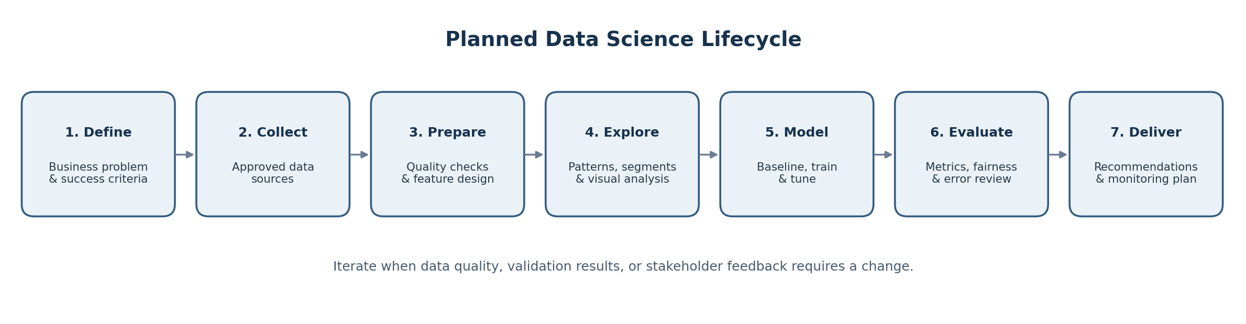
Figure 1. Planned lifecycle from problem definition to business delivery.

4.1 Stage 1 — Business understanding
- Confirm the business decision the analysis should support and identify who will use the results.
- Agree the churn definition, observation window, prediction horizon, intervention options, and constraints.
- Define success criteria in advance and identify the costs of false positives and false negatives.

4.2 Stage 2 — Data understanding
- Request a data dictionary, lineage, refresh frequency, collection context, and known limitations.
- Profile row counts, date ranges, column types, unique values, missingness, and the churn rate.
- Check whether the label is available consistently and whether any feature is recorded only after churn.

4.3 Stage 3 — Data preparation
- Use pandas to load approved extracts and validate schema, types, duplicate keys, date ranges, and category values.
- Separate raw, intermediate, and analysis-ready data; never overwrite the source extract.
- Choose imputation, encoding, scaling, and outlier treatment based on variable meaning and model requirements.
- Build transformations in a reproducible pipeline; fit preprocessing steps on training data only to prevent leakage.
- Create features such as tenure, recent usage trend, support-contact rate, billing friction, and contract timing only if available before the prediction date.

4.4 Stage 4 — Exploratory data analysis
- Calculate churn prevalence and compare it across meaningful customer and service segments.
- Visualize distributions and missingness; inspect relationships between usage, tenure, charges, support experience, and churn.
- Use appropriate plots: bar charts for category rates, histograms or boxplots for numeric variables, and trend plots over time.
- Distinguish association from causation, check confounding, and avoid drawing conclusions from tiny or unstable subgroups.

4.5 Stage 5 — Feature design and modeling
- Create a simple majority-class or rule-based baseline so that complex models must demonstrate added value.
- Evaluate logistic regression as an interpretable starting point and a tree-based model such as Random Forest or gradient boosting as a candidate.
- Use a stratified split for independent records or a time-based split where the real use case predicts future churn.
- Place imputation, encoding, scaling, and model fitting inside a scikit-learn Pipeline or ColumnTransformer.
- Tune only with training/validation data or cross-validation; preserve the final test set for a single final evaluation.

4.6 Stage 6 — Evaluation and error analysis
- Report precision, recall, F1-score, confusion matrix, ROC-AUC, and precision-recall AUC where class imbalance makes it informative.
- Compare model performance with the baseline and explain the trade-off between catching likely churners and contacting customers who would stay.
- Select a probability threshold based on intervention capacity and business costs rather than assuming 0.50 is automatically optimal.
- Inspect false positives and false negatives, calibration, performance over time, and subgroup differences where sample sizes support responsible comparison.
- Do not proceed to operational use if performance is unstable, data leakage is detected, or risks cannot be mitigated.

4.7 Stage 7 — Communication and future monitoring
- Prepare a concise executive summary, data-quality report, EDA visuals, model comparison table, limitations, and recommendations.
- Propose a small, human-reviewed pilot; where feasible, evaluate intervention impact through a controlled experiment.
- Monitor data drift, churn prevalence, precision/recall, calibration, and business outcomes after deployment; define retraining triggers with stakeholders.

5. Proposed Conceptual Architecture
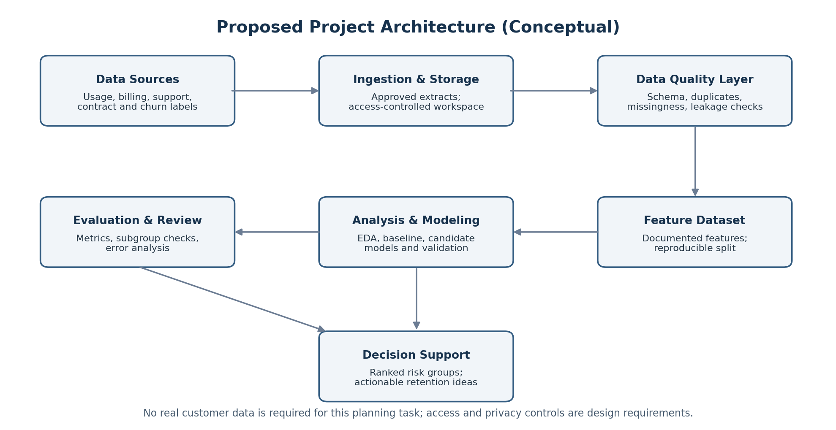
Figure 2. Conceptual information flow and controls for a future implementation.
The architecture is intentionally tool-agnostic at the data-ingestion boundary. The future implementation may use CSV or database extracts approved by the data owner. Raw data remains separate from cleaned and feature-engineered data. Every transformation should be traceable, and only reviewed outputs should be shared with business stakeholders.

6. Python Tools and Working Environment
Tool / library | Planned role | Reason for selection
Python 3.x | Primary language | Readable, widely used ecosystem for analysis and machine learning.
Jupyter Notebook / JupyterLab | Exploration and communicating analytical steps | Supports code, notes, tables, and plots together.
pandas | Tabular ingestion, cleaning, joins, aggregation | Practical data-frame operations and missing-value handling.
NumPy | Numerical operations | Efficient array and mathematical operations.
Matplotlib / Seaborn | Charts and exploratory visuals | Flexible plots for distributions, comparisons, and trends.
scikit-learn | Preprocessing, pipelines, splitting, models, metrics, cross-validation | Consistent and reproducible machine-learning workflow.
SciPy / statsmodels (as needed) | Statistical tests and interpretable statistical analysis | Useful for formal tests and statistical summaries.
Git / GitHub or an approved version-control system | Version history and collaboration | Tracks changes to code and documentation; never commit confidential data.
Excel / CSV viewer (as needed) | Inspect small, approved extracts | Convenient review tool, not a substitute for reproducible transformations.

6.1 Proposed project structure
customer-churn-project/
├── README.md
├── requirements.txt
├── data/
│ ├── raw/ # access-controlled; not committed
│ ├── processed/ # generated analysis-ready files
│ └── README.md # data dictionary / provenance notes
├── notebooks/
│ ├── 01_data_profile.ipynb
│ ├── 02_eda.ipynb
│ └── 03_model_evaluation.ipynb
├── src/
│ ├── data_validation.py
│ ├── preprocessing.py
│ ├── features.py
│ └── modeling.py
├── reports/
│ ├── figures/
│ └── project_report.md
└── tests/
└── test_data_rules.py

6.2 Reproducibility practices
- Pin library versions in requirements.txt after the environment is confirmed.
- Use a fixed random seed where randomness is involved and record the split strategy.
- Keep analysis steps modular and reusable; validate inputs and document exclusions.
- Use Git for code and documentation history, while keeping private data and credentials out of the repository.
- Record model parameters, feature definitions, evaluation metrics, and known limitations.

7. Timeline and Effort Allocation
The planned effort is 33 hours, within the required 30–35-hour range. The schedule assumes a planning deliverable rather than a completed model. Actual implementation time may change after data access and stakeholder requirements are confirmed.
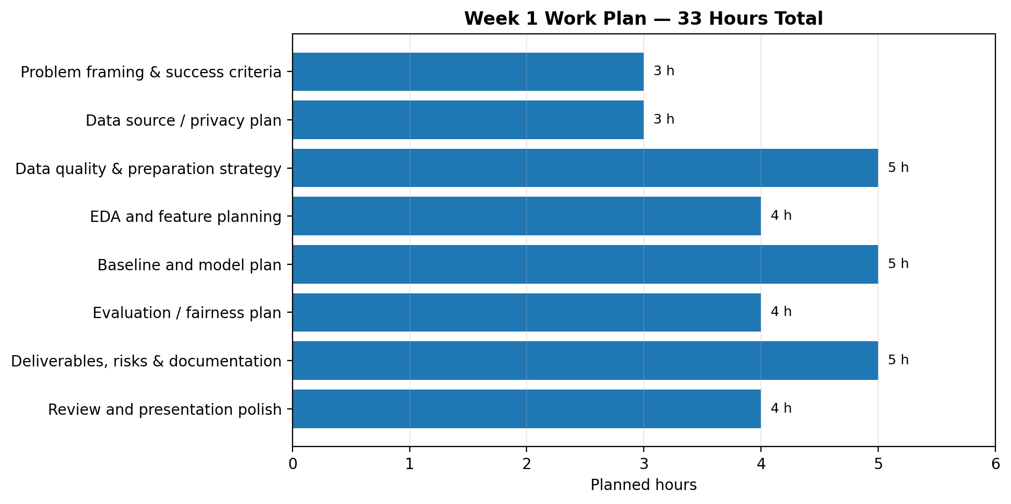
Figure 3. Planned effort by workstream; total = 33 hours.
Workstream | Hours | Planned activity / output
Problem framing & success criteria | 3 | Problem statement, stakeholders, churn definition, acceptance criteria.
Data source / privacy plan | 3 | Source inventory, access assumptions, governance and minimization controls.
Data quality & preparation strategy | 5 | Quality checklist, transformation rules, leakage prevention plan.
EDA and feature planning | 4 | Analysis questions, proposed visualizations, candidate features.
Baseline and model plan | 5 | Candidate models, split strategy, pipeline and validation design.
Evaluation / fairness plan | 4 | Metric selection, error analysis, threshold and subgroup-review plan.
Deliverables, risks & documentation | 5 | Architecture diagram, risk register, expected outcomes, final report.
Review and presentation polish | 4 | Proofread, verify consistency, check diagrams, finalize document.
TOTAL | 33 | Within the required 30–35-hour allocation.

7.1 Milestones
Milestone | Evidence of completion
M1 — Problem defined | Approved problem statement, scope, stakeholders, and churn definition.
M2 — Data strategy drafted | Source inventory, data dictionary needs, privacy and quality checklist.
M3 — Analysis and modeling plan complete | EDA questions, feature plan, baseline, candidate models, split and metrics.
M4 — Delivery plan complete | Architecture, timeline, risk register, outcomes, and acceptance criteria.
M5 — Final review | Consistent terminology, diagrams legible, document proofread and ready to submit.

8. Evaluation Criteria and Acceptance Plan
The following criteria are proposed for the future technical project. Thresholds are provisional and must be agreed with the business sponsor after the data distribution, class balance, and intervention costs are understood.
Area | How it will be assessed | Acceptance evidence
Data quality | Completeness, validity, uniqueness, consistency, leakage checks | Documented profile and reproducible quality checks; unresolved issues disclosed.
Analytical value | Useful, interpretable patterns supported by appropriate visuals | EDA summary with clear caveats and business interpretation.
Predictive value | Performance compared with baseline on untouched test data | Metric table, confusion matrix, ROC/PR analysis as appropriate.
Generalization | Cross-validation / temporal validation and stability review | Split design documented; no test-set tuning; variance or drift discussed.
Responsible use | Privacy, access control, explainability, subgroup error review | Risk review and human-review plan completed.
Business usefulness | Actions feasible for operations and measurable in a pilot | Prioritized recommendations and proposed impact measurement.
Reproducibility | Code, environment, definitions, and transformations documented | Repository structure, README, versioned code, and data provenance notes.

A high accuracy score alone will not be treated as success, particularly if churn is uncommon. The model must add value beyond a baseline, provide useful ranking or probability estimates, and perform acceptably for the intended decision. Any numeric performance target should be set after a baseline is available rather than invented in the planning stage.

9. Expected Outcomes and Benefits
- A structured and reproducible plan for turning an ambiguous business problem into a measurable data science task.
- A documented inventory of required data, field definitions, governance needs, and quality controls.
- A clear EDA plan for understanding churn prevalence and differences across customer groups and time periods.
- A defensible modeling and validation strategy that compares candidate methods with a baseline.
- A future shortlist of risk segments and possible retention interventions, subject to evidence from actual analysis.
- A monitoring and experimentation plan to determine whether model-informed actions improve outcomes in practice.

9.1 Expected final technical deliverables in a later phase
Deliverable | Contents
Data quality report | Source details, schema, missingness, duplicates, invalid values, leakage review.
EDA report | Descriptive statistics, charts, segment comparisons, limitations.
Modeling notebook / scripts | Preprocessing pipeline, baseline, candidate models, validation.
Evaluation report | Metrics, confusion matrix, ROC/PR curves, threshold rationale, error review.
Business summary | Practical recommendations, pilot plan, risks, and monitoring approach.
Reproducibility package | README, dependency list, version history, documented assumptions.

10. Anticipated Challenges and Mitigation Strategies
Challenge | Potential impact | Mitigation strategy
Incomplete or inconsistent data | Biased patterns or unreliable predictions | Profile first, clarify definitions with owners, document exclusions, and run sensitivity checks.
Class imbalance | Accuracy may look high while churners are missed | Use baseline comparisons, precision/recall, F1, PR-AUC, and appropriate threshold selection.
Target leakage | Inflated test performance that fails in real use | Define a prediction cutoff, use only prior information, and perform time-aware validation.
Historical bias / subgroup gaps | Unequal error rates or harmful prioritization | Review permitted subgroup metrics, investigate causes, limit use, and require human oversight.
Model drift | Performance falls as products or customer behavior change | Monitor input distributions and outcomes; define review and retraining triggers.
Low interpretability | Stakeholders may not trust or understand predictions | Start with interpretable baselines, document drivers carefully, and communicate uncertainty.
No clear intervention | Risk scores do not translate into business value | Co-design actions with operations and test them through a controlled pilot.
Privacy / access constraints | Unauthorized exposure or inappropriate use | Minimize fields, enforce access controls, avoid public data uploads, and follow retention rules.

11. Responsible Use and Limitations
A churn model estimates patterns from historical observations; it does not establish why a customer leaves or prove that a specific retention offer will prevent churn. Correlation should not be presented as causation. Historical data may underrepresent some groups or reflect previous business practices. Predictions can be wrong, so any future use should include human review, clear purpose limitation, monitoring, and a route for stakeholders to challenge harmful or implausible outputs. The project should not use sensitive personal information merely because it is available.

12. Conclusion and Next Steps
This plan establishes a practical route for a hypothetical Python-based customer churn project, from business framing and governed data access through data preparation, exploration, modeling, evaluation, and communication. Its main strength is that it defines the decisions and controls before analysis begins: what churn means, what data is needed, how leakage will be prevented, which metrics matter, and how results may be used responsibly. The 33-hour schedule provides a realistic allocation for completing the planning assignment while leaving implementation for a later phase.

Recommended next steps
1. Confirm the business sponsor, churn definition, prediction horizon, and intended decision.
2. Obtain authorization and inspect the data dictionary before accessing any customer-level data.
3. Create a data-quality profile and verify that the label and timestamps support a valid prediction setup.
4. Implement the baseline and candidate models only after preprocessing and split design are finalized.
5. Review model errors and stakeholder needs before proposing a pilot; measure actual retention impact separately.

Appendix A — Example Research Questions
- How does churn prevalence vary by contract type and customer tenure?
- Are recent declines in service usage associated with higher observed churn?
- Do billing difficulties or repeated unresolved support cases co-occur with churn?
- How well does a model rank future churn risk compared with a simple baseline?
- At a realistic outreach capacity, what precision and recall can the model achieve?
- Are errors or calibration materially different across adequately sized customer groups?

Appendix B — Planning Checklist
☐ Business problem, motivation, stakeholders, and intended decision are clear.
☐ Objectives are specific and measurable; in-scope and out-of-scope work are explicit.
☐ Data sources, definitions, quality rules, privacy controls, and provenance are documented.
☐ Cleaning, EDA, feature design, modeling, evaluation, and delivery stages are described.
☐ A conceptual lifecycle diagram, architecture diagram, and 33-hour timeline are included.
☐ Python libraries and their planned roles are identified.
☐ Expected outcomes, limitations, risks, mitigation strategies, and next steps are covered.
☐ No real data, fabricated results, or unverified model metrics are claimed.

